Supporting Information
Novel anthraquinone amino-derivatives as anticancer targeting human serine/threonine kinase PAK4

Hamad M. Hasan¹*, Faisal H. M. Koua^{2,║}*,#, Hajer A. Beit¹, Reem M. A. Ebrahim³, Amar Mohamed Ismail^{4,5,#}

¹ Department of Chemistry, Faculty of Science, Omar Al-Mokhtar University, Al-Bayda 0463, Libya. ² National University Biomedical Research Institute (NUBRI), National University-Sudan, PO Box 3783 AlRaqi District, Khartoum 11111, Sudan. ³ Department of Biochemistry, African City of Technology, Khartoum 11111, Sudan. ⁴ Department of Biomedical Science, Faculty of Pharmacy, Omar Al-Mokhtar University, Al-Bayda 0463, Libya. ⁵ Department of Biochemistry and Molecular Biology, Faculty of Science and Technology, Al Neelain University, PO Box 12702 El Baladiya Ave, Khartoum 11111, Sudan.

#To whom correspondence should be addressed: amarqqqu@yahoo.com (AMI), and faisal.koua@xfel.eu (FK)

*These authors contributed equally and shared first co-authorship.
║ Current address: European X-Ray Free Electron Laser facility, Holzkoppel 4, Schenefeld 22869, Schleswig-Holstein, Germany.

Supporting Information
Table S1 IUPAC nomenclatures the Schiff bases, molecular weights and their amino acid substrates.
Compd. | IUPAC nomenclature | Amino acid substrate
1 | 1-hydroxy-2-[(10-oxo-9,10-dianthracene-9-ylidene) amino] butanoic acid | threonine
2 | 5-amino-5-oxo-2-[(10-oxo-9,10-dianthracene-9-ylidene) amino] pentanoic acid | glutamine
3 | 4-methyl-2-[(10-oxo-9,10-dianthracene-9-ylidene) amino] pentanoic acid | leucine
4 | 4-amino-4-oxo-2-[(10-oxo-9,10-dianthracene-9-ylidene) amino] butanoic acid | asparagine
5 | 3-(1H-indol-3-yl)-2-[(10-oxo-9,10-dianthracene-9-ylidene) amino] propanoic acid | tryptophan
6 | 2-[(10-oxo-9,10-dianthracene-9-ylidene) amino] ethanoic acid | glycine
7 | 3-sulfohydryl-2-[(10-oxo-9,10-dianthracene-9-ylidene) amino] propanoic acid | cysteine
8 | 5-guanidino-2-[(10-oxo-9,10-dianthracene-9-ylidene) amino] pentanoic acid | arginine
9 | 4-thiomethyl -2-[(10-oxo-9,10-dianthracene-9-ylidene) amino] butanoic acid | methionine
PF-3758309 | N-[(1S)-2-(dimethylamino)-1-phenylethyl]-6,6-dimethyl-3-[(2-methylthieno[3,2-d]pyrimidin-4-yl)amino]-1,4-dihydropyrrolo[3,4-c]pyrazole-5-carboxamide | n.a

Table S2 FT-IR stretching frequencies of the Schiff bases of the nine amino-anthraquinone compounds.
Functional groups | Schiff base characteristic IR spectra of different compounds, cm^{–1}
Functional groups | (1) | (2) | (3) | (4) | (5) | (6) | (7) | (8) | (9)
OH | 2974 | 3200 | 3005 | 3012 | 3011 | - | 2657 | 3075 | 2917
C═O | 1671 | 1700 | 1700 | 1700 | 1700 | 1760 | - | 1670 | 1671
C═N | 1587 | 1625 | 1573 | 1577 | 1570 | 1572 | 1573 | 1571 | 1559
C═C | 1671 | 1673 | 1661 | 1661 | 1558 | 1760 | 1617 | 1670 | 1619
N–H | 3400 | 3400 | 3401 | - | 3400 | - | - | 3318 | -
NH₂ | - | 3500 | - | 3401 | - | - | - | 3196 | -
CH¹ | 1472 | 1574 | 1511 | 1493 | 1658 | 1448 | 1547 | 1472 | 1510
CH² | 2974 | 2800 | 2958 | 2837 | 3075 | 3100 | 3015 | 3196 | 3169
C–C | 1449 | 1409 | 1405 | 1400 | 1407 | 1327 | 1404 | 1409 | 1444
¹aromatic CH; ²aliphatic CH

Table S3 Residues involving direct or indirect molecular interactions with ligands in cav-1 and cav-4 binding sites of the human PAK4.
Compd. | Interacting residues in cav-1 | Interacting residues in cav-4
1 | I327, G328, E329, G330, V335, M395, L398, G401, A402, T404, D405, D444, L447, D458 | I506, D510, E512, P513, P514, Y515, N517, E518, P533, R534, L535, K536
2 | I327, G328, E329, G330, S331, V335, M395, L398, G401, A402, T404, D444, L447, S457, D458 | I506, D510, E512, P513, P514, Y515, F516, N517, E518, P532, P533, R534, L535, K536
3 | I327, G328, E329, G330, V335, F397, L398, G401, A402, T404, D444, S445, L447, D458 | I506, D510, E512, P513, P514, Y515, N517, E518, P533, R534, K536
4 | L326, I327, G328, E329, V335, A348, M395, F397, L398, E399, G400, G401, A402, L447 | I506, D510, E512, P513, P514, Y515, N517, E518, P533, R534, L535, K536
5 | I327, G328, E329, G330, S331, V335, A348, M395, F397, L398, E399, G401, A402, T404, K442, D444, L447, S457, D458 | I506, D510, E512, P513, P514, Y515, F516, N517, E518, P533, R534, L535, K536, N537
6 | I327, G328, E329, V335, A348, M395, E396, F397, L398, G401, A402, D444, L447, S457, D458 | I506, D510, E512, P513, P514, Y515, F516, N517, E518, P533, R534, L535, K536
7 | I327, G328, E329, G330, V335, M395, G401, A402, T404, D444, S445, L447, S457, D458 | I506, D510, E512, P513, P514, Y515, F516, N517, E518, P533, R534, L535, K536
8 | I327, G328, E329, G330, S331, T332, V335, M395, L398, G401, A402, T404, D440, K442, D444, S445, L447, S457, D458, F461 | I506, D510, E512, P513, P514, Y515, F516, N517, E518, P533, R534, L535, K536
9 | Cav-1: I327, G328, E329, G330, V335, L398, G401, A402, T404, D405, D444, L447, D458 | I506, D510, E512, P513, P514, Y515, F516, N517, E518, R534, K536
PF-3758309 | I327, G328, E329, G330, V335, A348, M395, F397, L398, E399, G400, G401, A402, T404, D405, D444, L447, D458, M585, R586, Q587 | V407, T410, R411, I506, M508, V509, D510, G511, E512, P513, P514, Y515, F516, N517, R534, L535, N537, K540

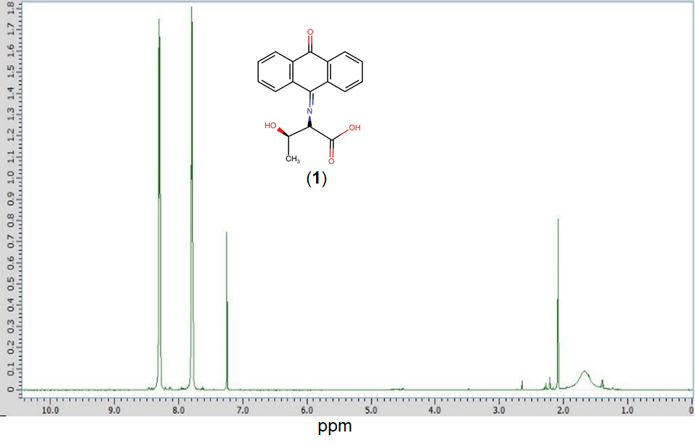
Figure S1 ¹H NMR spectrum of compound 1 (anthraquinone with threonine Schiff base).

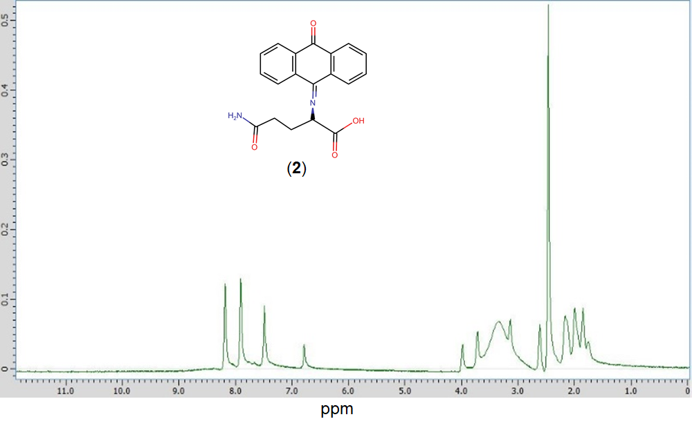
Figure S2 ¹H NMR spectrum of compound 2 (anthraquinone with glutamine Schiff base).
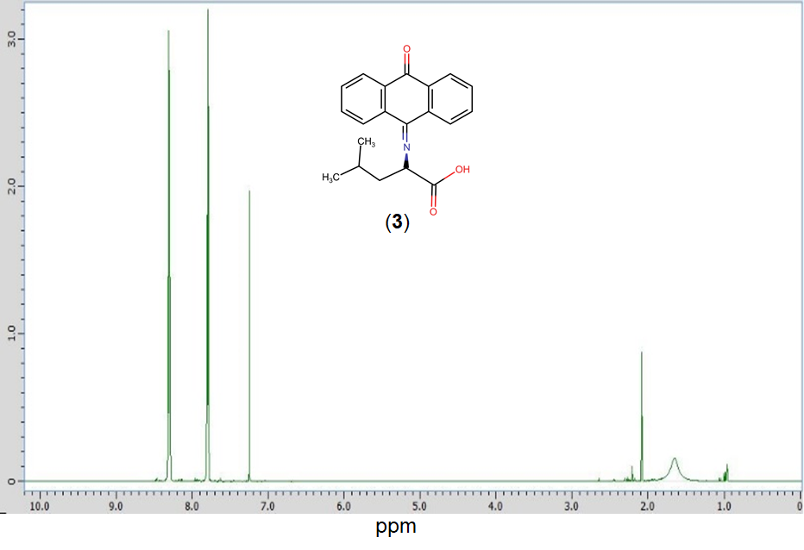
Figure S3 ¹H NMR spectrum of compound 3 (anthraquinone with leucine Schiff base).

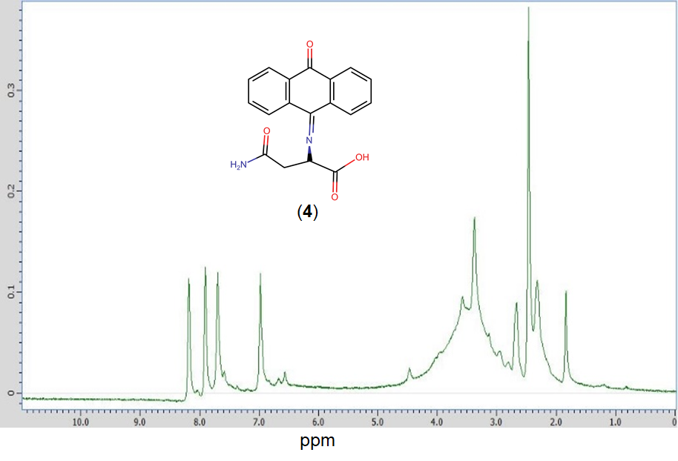
Figure S4 ¹H NMR spectrum of compound 4 (anthraquinone with asparagine Schiff base).
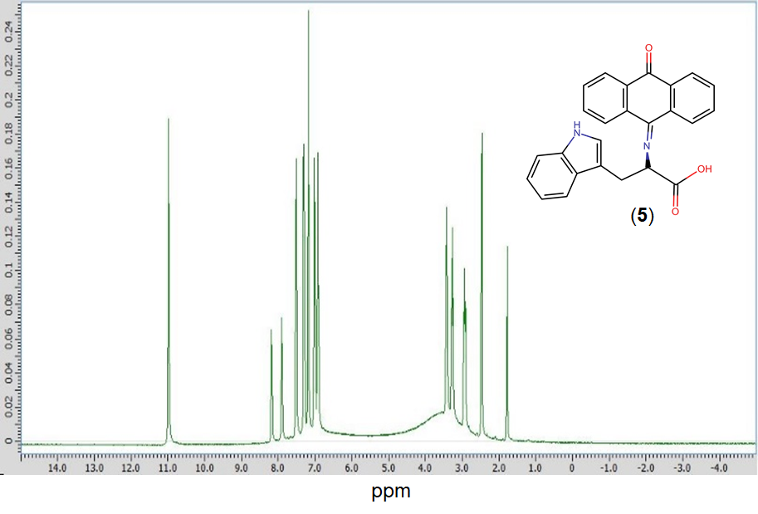
Figure S5 ¹H NMR spectrum of compound 5 (anthraquinone with tryptophan Schiff base).

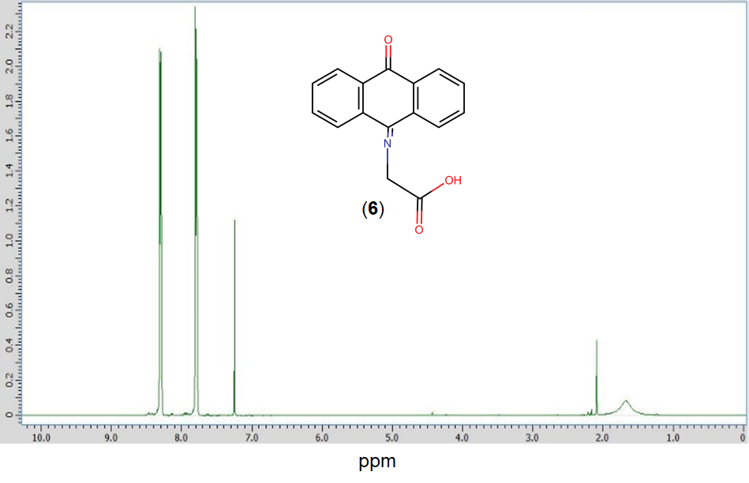
Figure S6 ¹H NMR spectrum of compound 6 (anthraquinone with glycine Schiff base).
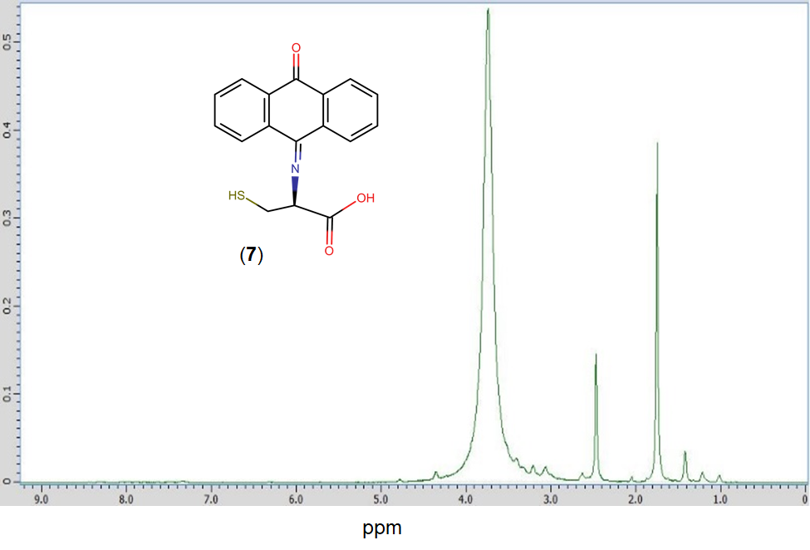
Figure S7 ¹H NMR spectrum of compound 7 (anthraquinone with cysteine Schiff base).

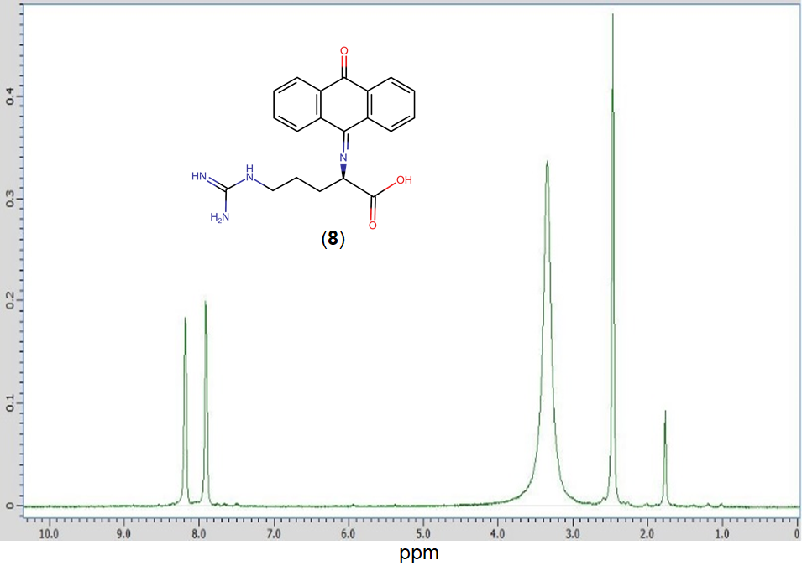
Figure S8 ¹H NMR spectrum of compound 8 (anthraquinone with arginine Schiff base).
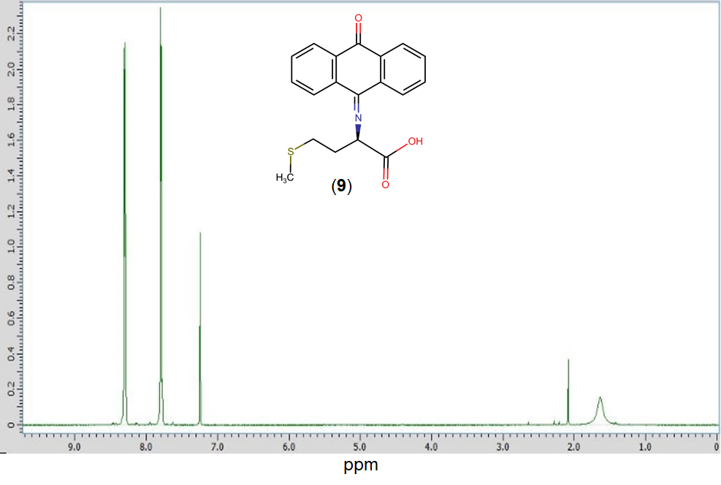
Figure S9 ¹H NMR spectrum of compound 9 (anthraquinone with arginine Schiff base).

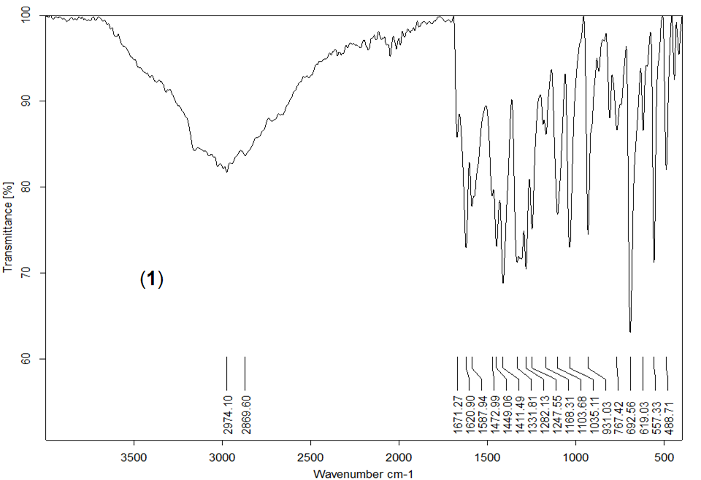
Figure S10 FT-IR spectrum of compound 1.

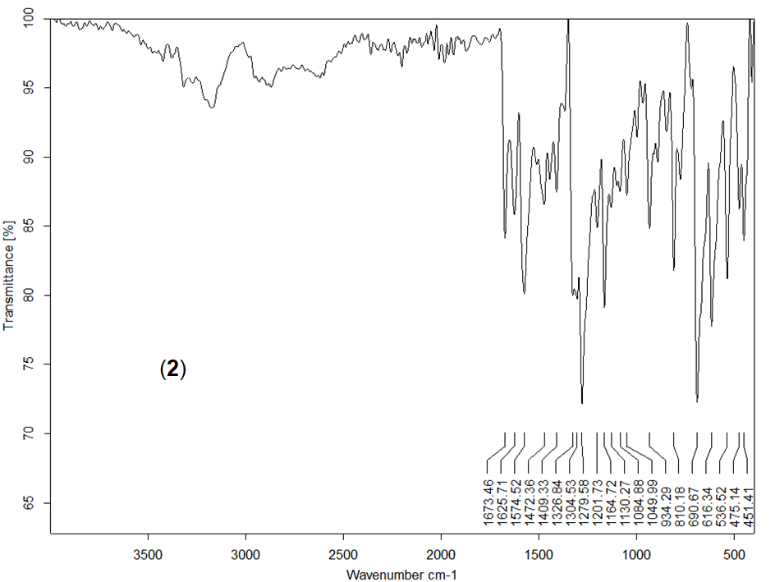
Figure S11 FT-IR spectrum of compound 2.

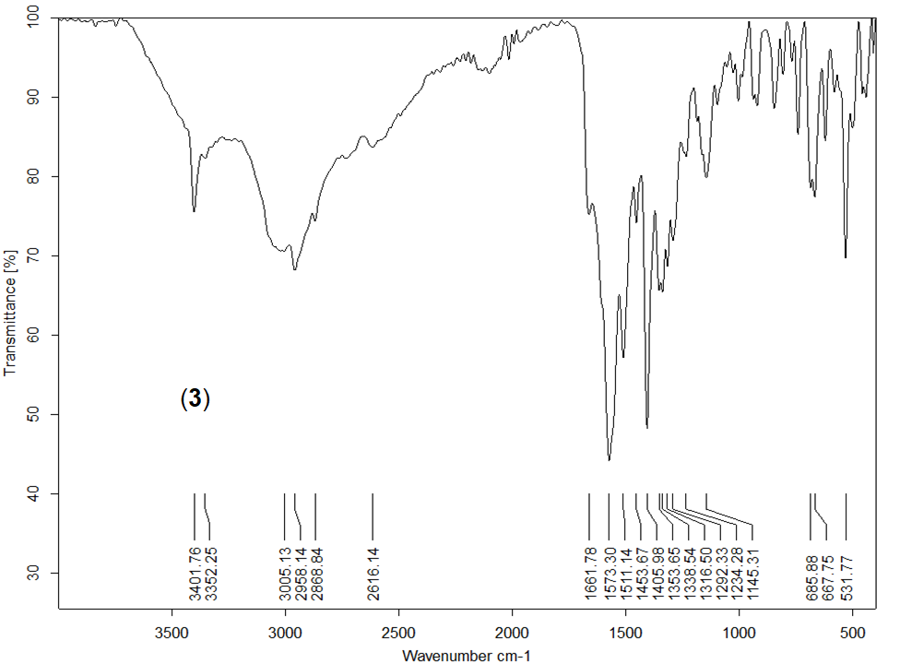
Figure S12 FT-IR spectrum of compound 3.

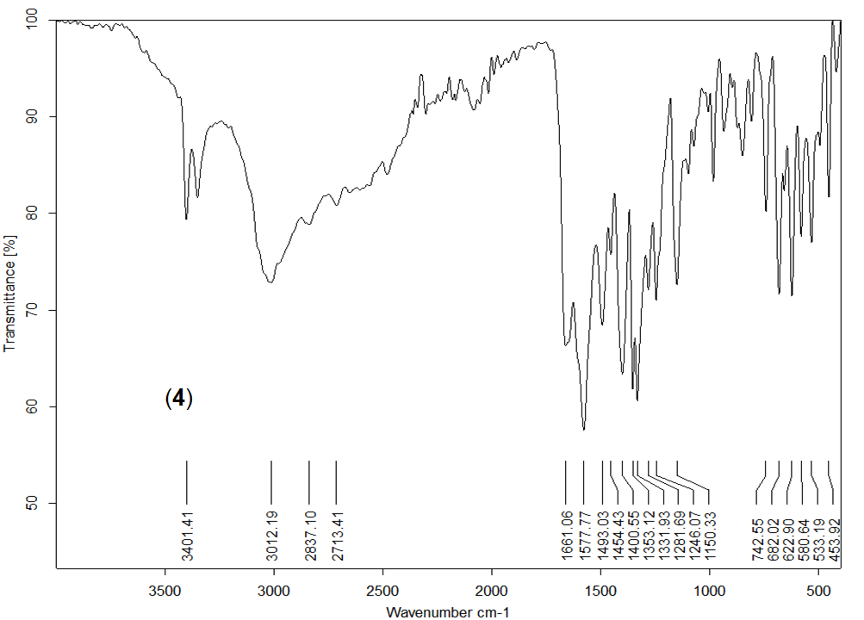
Figure S13 FT-IR spectrum of compound 4.

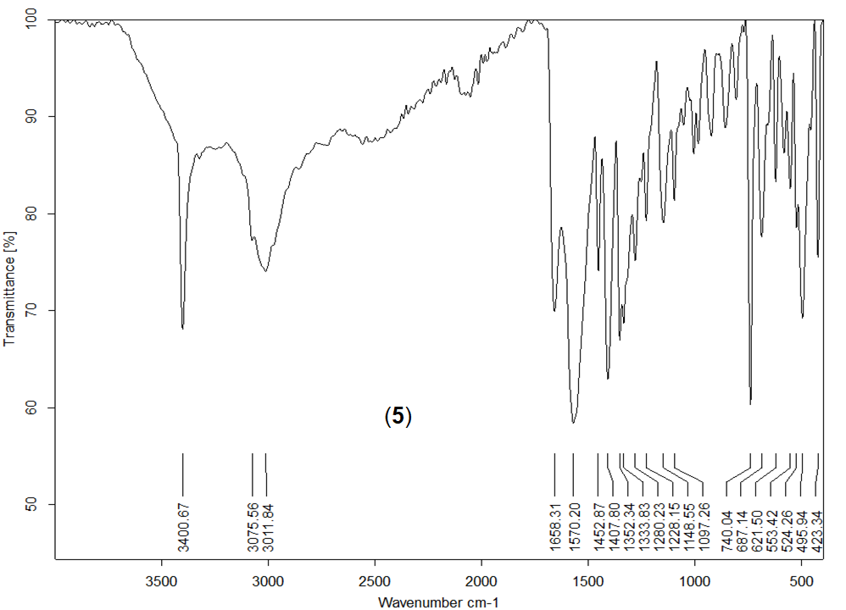
Figure S14 FT-IR spectrum of compound 5.

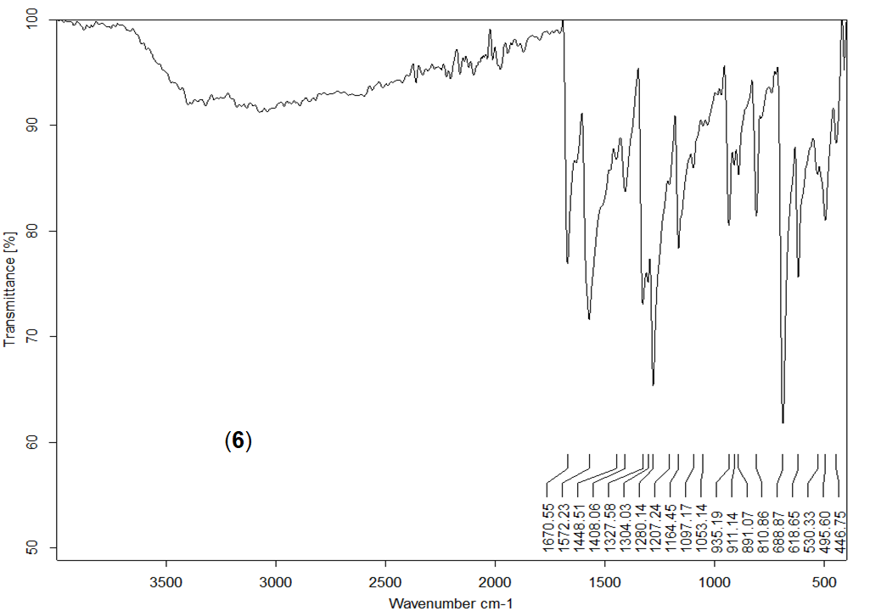
Figure S15 FT-IR spectrum of compound 6.

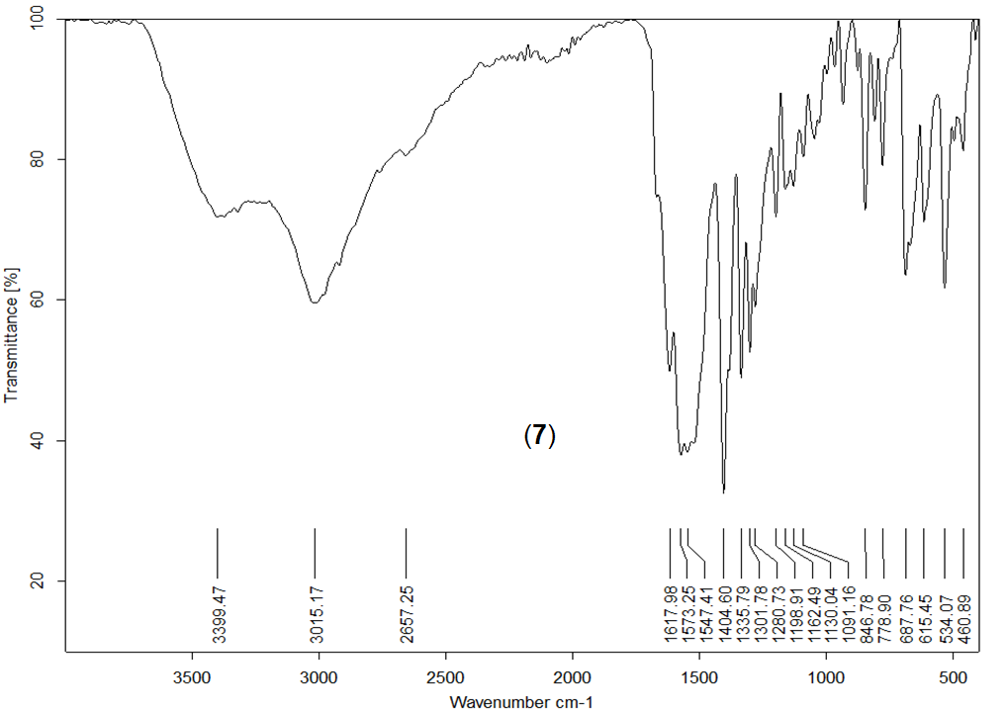
Figure S16 FT-IR spectrum of compound 7.

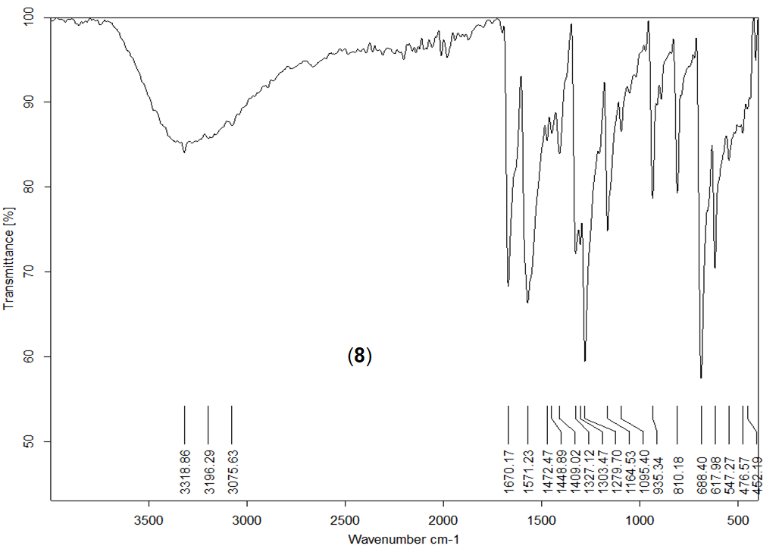
Figure S17 FT-IR spectrum of compound 8.

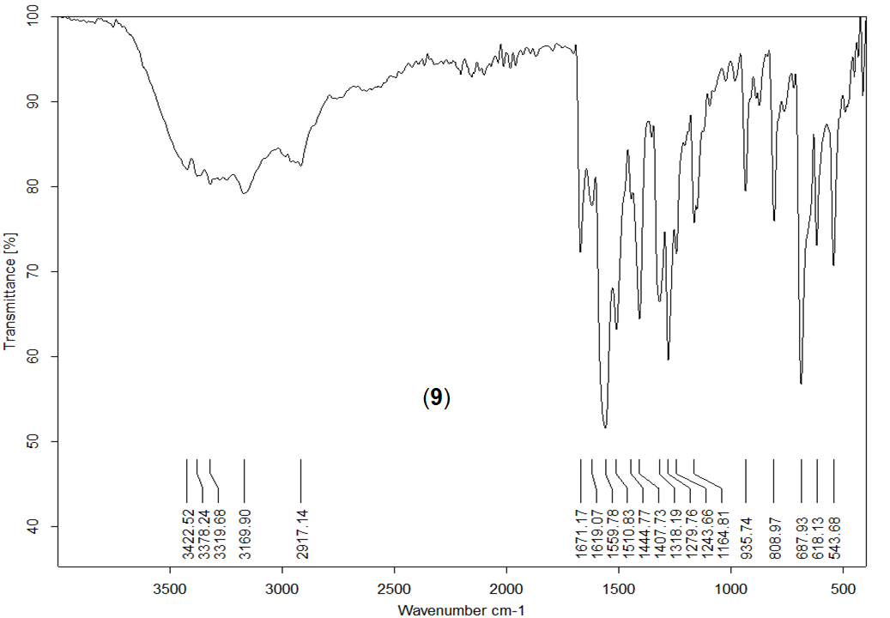
Figure S18 FT-IR spectrum of compound 9.

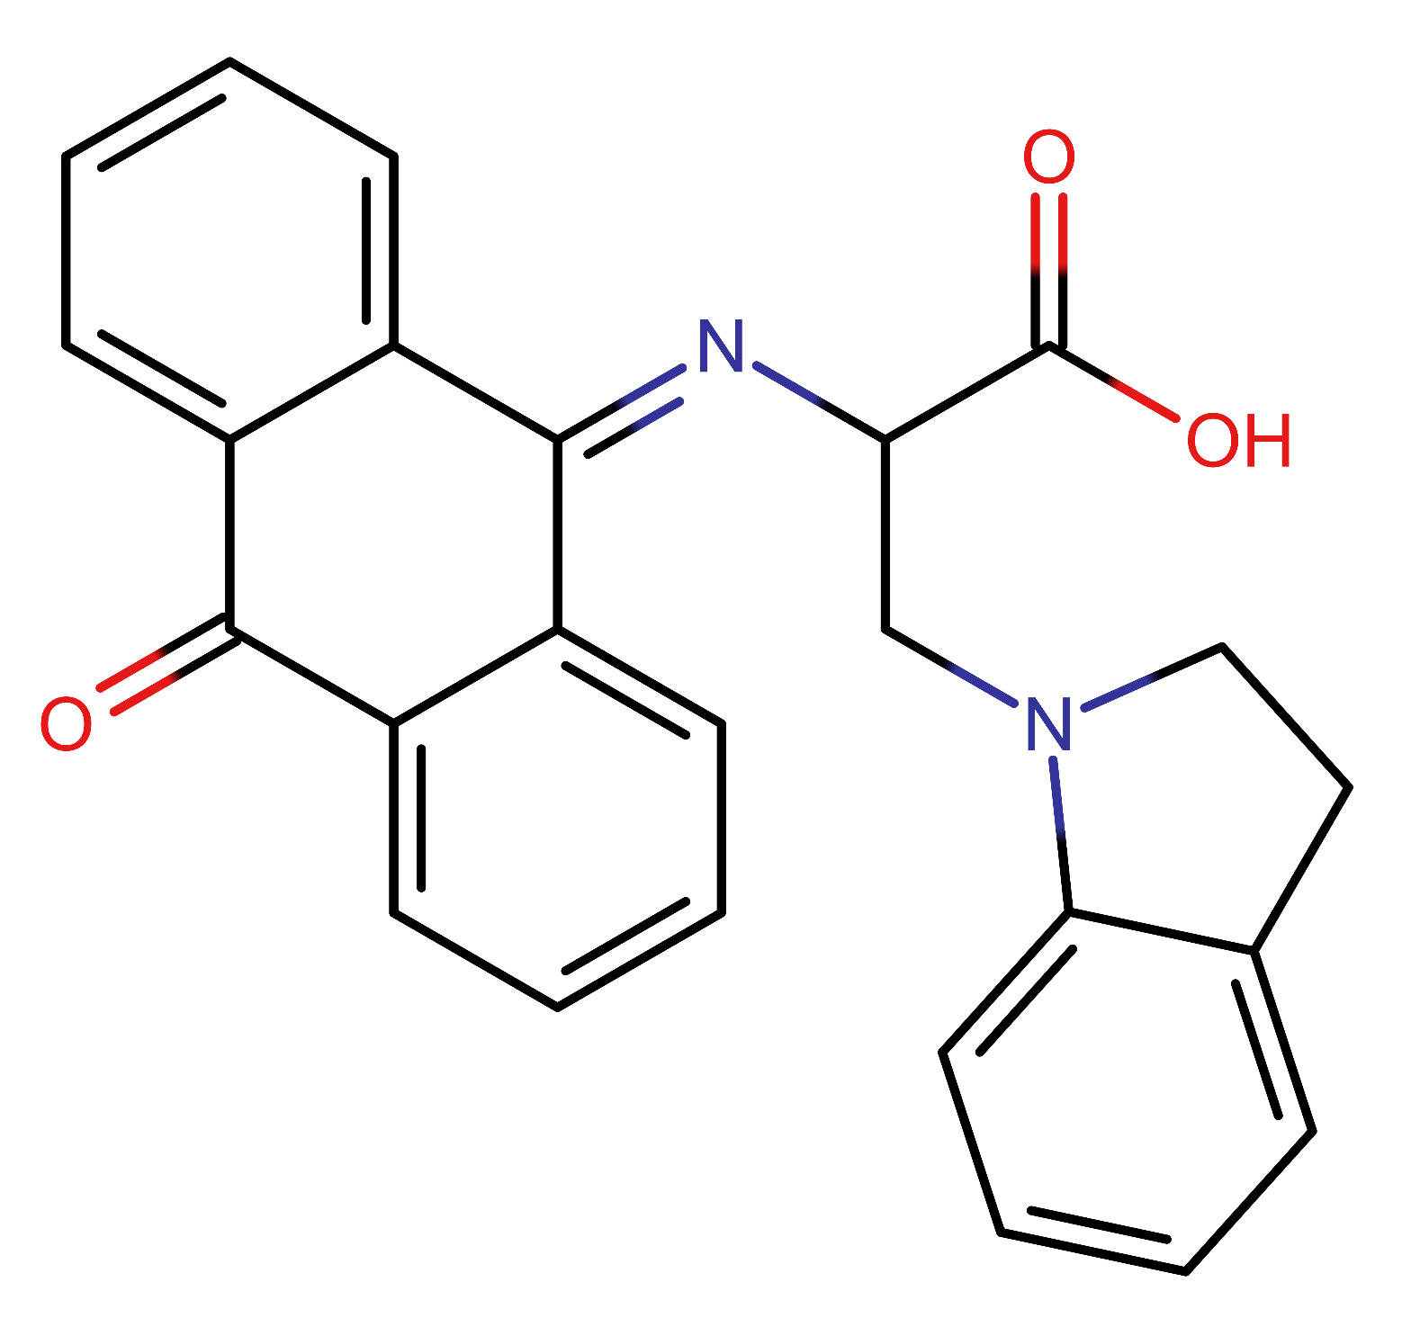
Figure S19 The chemical structure of compound 5b.

