Supplement 3

Figure: Actual set up of the evacuation system test

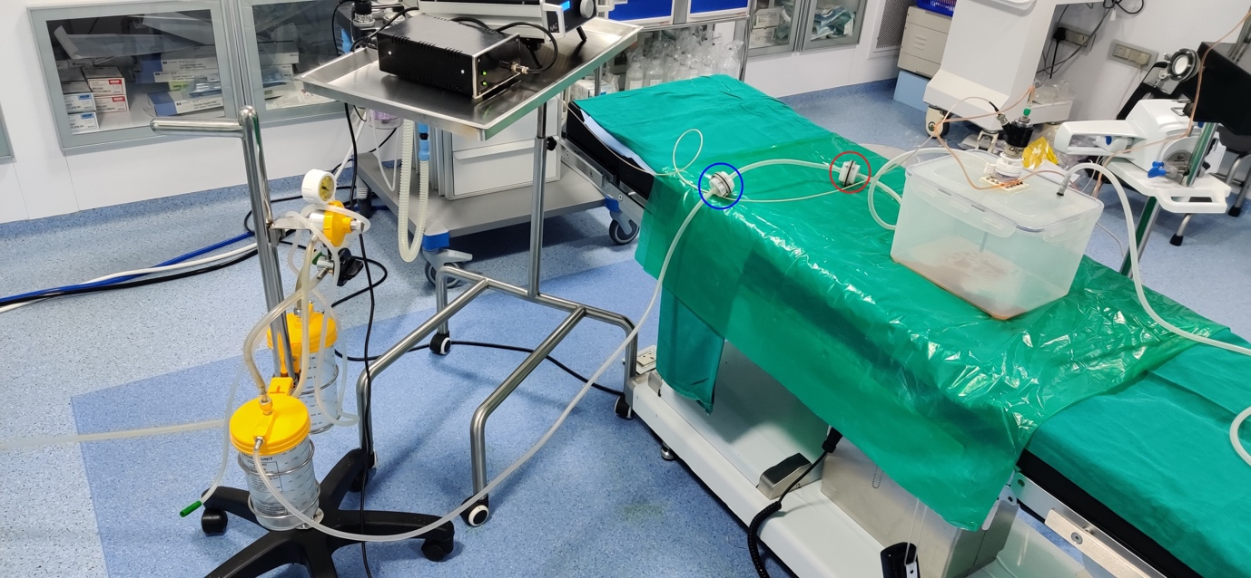

Red circle: NP filter 1
Blue circle: NP filter 2

