Mechanism of Droplet Formation
Atomization occurs owing to the competition between destructive and cohesive forces on the liquid surface, leading to fluctuations and disturbances in the liquid. [15] The cohesive effect of surface tension of the liquid keeps it in a state that has the lowest surface energy. The viscosity of the liquid has a stabilizing effect that counteracts any variation in the liquid geometry. Contrary to this, external forces that can be aerodynamic, centrifugal or electrostatic, act on the surface of the liquid and promote its disintegration. [16]
An equation to calculate the size of droplets was developed based on multiple parameters by Robert Lang and this is described in detail in Supplement 1. [18,19,20] By changing the wavelength of the ultrasound waves, the droplet size can be altered. On the basis of Kelvin’s equation, Rayleigh’s instability of liquid column or film, and stability limit wavelength, Robert Lang had correlated his experimental data of the number-median diameter of droplets with the capillary wavelength. [18, 19, 20]
The effect of the forces acting on the liquid is resumed by the dimensionless numbers of Reynolds (Re), Weber (We), and Ohnesorge (Oh):

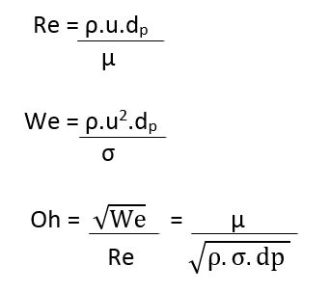

Where 𝜌 is the liquid density, 𝑢 is the liquid velocity, 𝑑𝑝 is the jet diameter (primary atomization) or drop diameter (secondary atomization), 𝜇 is the liquid viscosity, and 𝜎 is the surface tension. [16]
The Reynolds number expresses the ratio between inertial and viscous forces. The Weber number is a measure of the relative importance of fluid’s inertia compared to its surface tension. By combining the two dimensionless numbers to eliminate the liquid velocity, the Ohnesorge number, containing fluid properties, is obtained. Thus, the droplet’s diameter can be predicted by correlations mainly based on liquid properties (density, viscosity, surface tension), on the atomizer geometry (orifice size) and on operative parameters, such as liquid flow rate. [16] However, physical phenomena involved in the atomization processes have not been understood yet to such an extent to allow droplet size to be predicted by equations directly derivable from these first principles.
On the basis of Kelvin’s equation, Rayleigh’s instability of liquid column or film, and stability limit wavelength, Robert Lang had correlated his experimental data of the number-median diameter of droplets with the capillary wavelength.[18, 19, 20] The average diameter was successfully predicted with the following equation: where dav is average droplet diameter, a is constant, σ is interfacial tension, ρ is liquid density, and f is ultrasonic frequency. The equation indicates that the mean diameter is a constant fraction of the capillary wavelength. Lang determined the constant 0.34 for the number-averaged diameter of droplets produced with ultrasound of 10–800 kHz. [20]
This correlation is only applicable when liquid phase viscosity and liquid flow rate have no effect on droplet size.
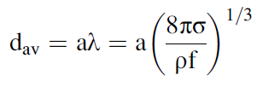

Thus, by altering the wavelength, the droplet size can be changed and can be calculated using this equation. [20]

