Supplementary Materials: The topical application of Sphistin₁₂₋₃₈ in combination with sponge spicules for the Acne treatment
Weiyi He^{a,1}, Chi Zhang^{a,b,1}, Lai Huijung^{c,1}, Guopeng Wu^{d}, Ming Xiong^{a,b}, Hui Peng^{a,b}, Ming Chen^{a,b,d,}* and Ke-Jian Wang^{a,b,}*

ªDepartment of Marine Biological Science & Technology, College of Ocean & Earth Sciences, Xiamen University, Xiamen 361102, China.
^{b}State-Province Joint Engineering Laboratory of Marine Bioproducts and Technology, Xiamen University, Xiamen 361102, China.
^{c} Department of Dermatology Xiang’an Hospital of Xiamen University，School of Medicine, Xiamen University, Xiamen 361102, China.
^{d} Pingtan Research Institute of Xiamen University, Pingtan 350400, China.

*Corresponding author. Department of Marine Biological Science & Technology, College of Ocean and Earth Sciences, Xiamen University, Xiamen, China 361102
E-mail addresses: ming.chen@xmu.edu.cn (M.Chen); wkjian@xmu.edu.cn (K.-J. Wang).
¹These authors contributed equally to this work.
1 Material and Method
1.1 Bacterial culture
The strain of P. acnes (ATCC6919) was purchased from Guangdong microbial culture collection center (Guangzhou, China). Agar medium inoculated with P. acnes was placed in an AnaeroPack (Mitsubishi Gas chemical company, Tokyo, Japan) at 37 °C for 48 h. Then, Bacteria colony were transferred to liquid medium coated with sterile paraffin layer and cultured on a shaker (200 rpm/min) at 37 °C for 48 h[1]. After 48 h, Bacteria were collected by centrifugation (3000 g/5min, 4 °C), washed three times and suspended in PBS at 10⁷ CFU/ml for experiment.
1.2 Antimicrobial activity study
To demonstrate the bactericidal activity of various AMPs (Sphistin, Sph₁₂₋₃₈, Sph₂₀₋₃₈, AS-hepc3) and antibiotics (Clindamycin, Doxycycline Hyclate). AMPs solution (dissolved by ddH₂O, 1 mg/ml) was filtered through 0.22 μm low protein binding non-pyrogenic membrane. All the AMPs and antibiotics were diluted to a concentration of 96 µM, 48 µM, 24 µM, 12 µM, 6 µM, 3 µM, 1.5 µM, 0.75 µM and 0.4 µM. 50 µL of AMPs or antibiotic solution and 50 µL of P. acnes suspension (10⁷ CFU/ml) were mixed in 96-well plate. Then, the 96-well plate was placed in an AnaeroPack and cultured at 37 °C for 16 h[2]. The mixture of P. acnes suspension and AMPs or antibiotics were then coated onto 1053# agar medium and incubated at 37 °C for 48 h without oxygen. The Minimum bactericidal concentration (MBC) is the lowest concentration that showed no visible bacterial growth after incubation[3].
1.3 Scanning electron microscopy (SEM) study
SEM analysis was performed to investigate the effect of AMPs and antibiotics on morphology of P. acnes. In brief, the suspension of P. acnes was incubated with AMPs or antibiotics (MBC) at 37 °C for 20 min and 2 h. P. acnes were collected by centrifugation (3000×g, 5 min, 4 °C) and then immersed in 2.5% glutaraldehyde at 4 °C for 2 hours. The glutaraldehyde was later removed and P. acnes was washed by PBS for 10 minutes. Afterwards, samples were dehydrated by gradient ethanol (30%, 50%, 70%, 90%, 95% and 100%, 10 min for each concentration). After dehydration, samples were plated with platinum by a Metal spraying machine (Leica CPD300 , Leica, Germany) and then observed with SUPRA 55 scanning electron microscopy at 15 KV[4].
1.4 Keratinocyte culture
Human keratinocytes (HKs) from foreskin were purchased from PromoCell (Heidelberg, Germany). HKs were cultured in cell culture flasks containing 5 mL of keratinocyte growth medium (KGM) at 37 °C with 5% CO₂ for 48-72h. KGM was replaced every 24 h.
1.5 In vitro cytotoxicity study
To assess the toxicity of Sph₁₂₋₃₈ to human keratinocytes, MTT (methyl thiazolyl tetrazolium) colorimetric method was carried out following the instructions provided by the manufacturer [4]. HKs were diluted with KGM to a concentration of 10⁴ cells/ml. 100 µL of KGM was added to a 96-well plate (5000 cells/hole) and then incubated to make sure the confluence of cell achieve 70%. 100 μL of Sph₁₂₋₃₈ solution with different concentrations (33.52 μM, 16.76 μM, 8.38 μM, 0 μM) was added into different holes. After 24h incubation at 37°C with 5% CO₂[2], 10 µL of MTT reagent was added to each hole and incubated with HKs at 37 °C for 4 h. The absorbance of each hole was measured by a ﬂuorescence spectroscopy at 570 nm to calculate viability percentage [5].
1.6 The stability study of Sph₁₂₋₃₈
Sph₁₂₋₃₈ solutions (7 μM) were kept for 30 min under the conditions of 4 °C, 50 °C, 60 °C, 70 °C and 5, 10, 15, 25, 30min at 80 °C, respectively. After that, the antibacterial activity of Sph₁₂₋₃₈ in terms of MBC was measured as mentioned above.

Figure S1. Mass spectrum of different AMPs. (a) Sphistin, (b) Sph₁₂₋₃₈, (c) AS-hepc3, (d) FITC-Sph₁₂₋₃₈.
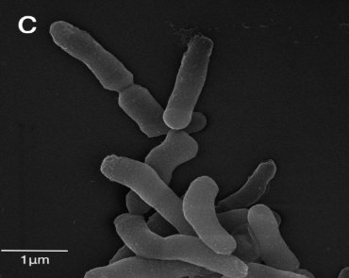
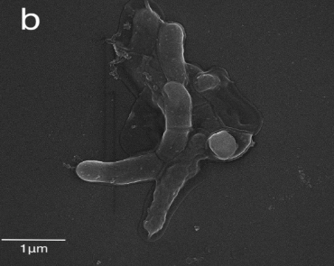
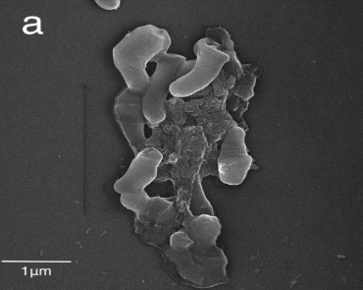
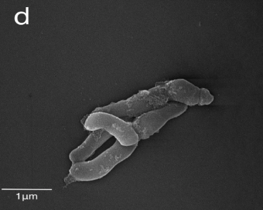
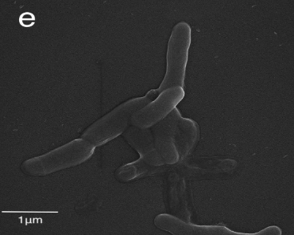
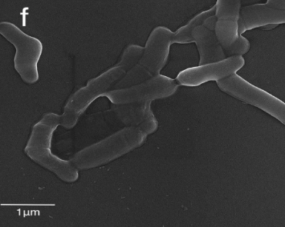
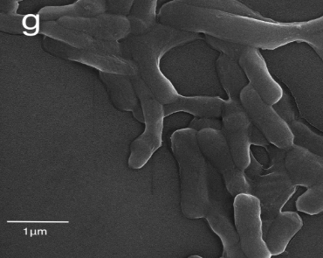

Figure S2. Morphological changes of P. acnes ATCC6919 observed with SEM induced by (a)Sph₁₂₋₃₈; (b)Sphistin; (c)Sph₂₀₋₃₈; (d) AS-hepc3; (e) Clindamycin; (f) Doxycycline hydrochloride; (g) PBS in 20 mins incubation.

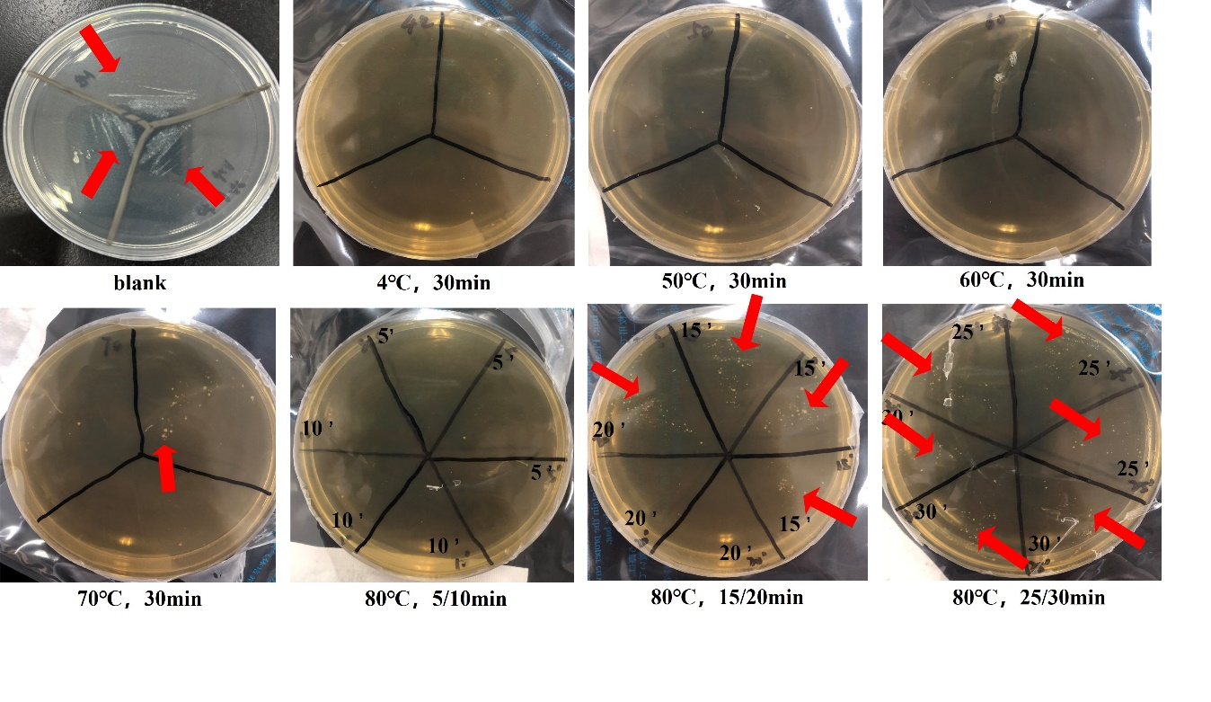
Figure S3. The colonies of P. acnes after a 48-hour anaerobic culture with Sph12-38 at its MBC under various temperatures and incubation times.

Reference
[1] NeginNaghdi., MasoodGhane., Determination of antibiotic susceptibility and Minimum Inhibitory Concentration (MIC) of the Propionibacterium acnes to the prevalent antibiotics in the treatment of Acne vulgaris, International Journal of Molecular and Clinical Microbiology (2015) 543-548.
[2] B. Chen, D.Q. Fan, K.X. Zhu, Z.G. Shan, F.Y. Chen, L. Hou, L. Cai, K.J. Wang, Mechanism study on a new antimicrobial peptide Sphistin derived from the N-terminus of crab histone H2A identified in haemolymphs of Scylla paramamosain, Fish Shellfish Immunol 47(2) (2015) 833-46.
[3] S. Ryu, H.M. Han, P.I. Song, C.A. Armstrong, Y. Park, Suppression of Propionibacterium acnes Infection and the Associated Inflammatory Response by the Antimicrobial Peptide P5 in Mice, PLoS One 10(7) (2015) e0132619.
[4] S. Ryu, Y. Park, B. Kim, S.M. Cho, J. Lee, H.H. Lee, C. Gurley, K. Song, A. Johnson, C.A. Armstrong, P.I. Song, Inhibitory and anti-inflammatory effects of the Helicobacter pylori-derived antimicrobial peptide HPA3NT3 against Propionibacterium acnes in the skin, Br J Dermatol 171(6) (2014) 1358-67.
[5] S. Ryu, S.Y. Choi, S. Acharya, Y.J. Chun, C. Gurley, Y. Park, C.A. Armstrong, P.I. Song, B.J. Kim, Antimicrobial and anti-inflammatory effects of Cecropin A(1-8)-Magainin2(1-12) hybrid peptide analog p5 against Malassezia furfur infection in human keratinocytes, J Invest Dermatol 131(8) (2011) 1677-83.

