Animals and monitoring. The breeding colony at the BNITM facilities is kept outbred, with 1:1 pairing. Health monitoring of the colony is done according to FELASA guidelines using sentinel animals (mouse strain RjOrl:SWISS, Janvier Labs, Le Genest-Saint-Isle, France) kept under the same conditions that are exposed to bedding, droppings, and food from M. natalensis cages. Animals from the breeding colony on occasion test positive for Helicobacter sp.. Otherwise, the breeding colony is tested free of infectious agents outlined in the official FELASA recommendations¹. Animals were provided with cage enrichment, including houses, swings and running wheels. Regular food was on occasion supplemented with nuts (peanuts, walnuts, hazelnuts), sunflower seeds or dried millet. The permanent marking of Mastomys younger than 2 weeks is challenging, moreover, reduction of a litter could result in the loss of the whole litter due to stress-based parental aggression, thus, whole litters were used for all experiments. Juvenile Mastomys were weaned at the age of three weeks. The sex of animals was determined at the time of weaning. Males and females were distributed equally for sample collection (terminal sampling) based on initial litter composition. Animals younger than three weeks with unknown sex were chosen at random for terminal sampling. The number of animals euthanized for terminal sampling varied based on initial litter size and composition, however, for each experimental group at least two individuals were sacrificed per sampling period. To ensure the safety of experimenters and animals, additional safety nets and cut-resistant gloves (ActivArmr®, Carl Roth, Karlsruhe, Germany) were used while handling Mastomys natalensis during the experiments. Animals were trained to seek out and enter boxes (Anesthesia induction chamber, UNO Life Science Solutions, Zevenaar, Netherlands), for taking body weight or changing cages therefore no anesthesia was required for the day-to-day handling.
Inoculation. Neonates showed strong reactions to anesthesia. However, animals younger than two weeks display a strong pinch-induced behavioral inhibition once grasped in the scruff of the neck and thus were inoculated without anesthesia to avoid complications. Individuals aged two weeks or older were anesthetized with isoflurane for the procedure. Following anesthesia animals were closely monitored until they fully regained consciousness. Inoculated neonates and juveniles were kept separated from their parents for at least 20 min, before returning the adult animals into the cage to prevent aggression from parents towards offspring. Two whole litters per experiment group were inoculated to account for the genetic variations of the parents. Naïve females inoculated during gestation gave birth to one litter each. No randomization or blinding of experimental groups was performed.
Transmission experiments. All animals used for breeding were at least 12 weeks old. Persistently infected females used in the breeding experiments originated from either day 6 inoculation or the inoculation of a pregnant female. A total of four breeding pairs was used for the initial round. Two breeding pairs were used for each subsequent generation. Based on breeding performance and litter size across the whole group, each female gave birth to 2–4 litters. All persistently infected males used for breeding were born to infected mothers. Infected males were used for multiple breeding rounds and always paired with a naïve female for each round. Depending on breeding performance and litter size each male fathered 2–3 litters.
Sampling procedures. Amniotic fluid was collected by puncturing the amniotic sac after removing the conceptus from the uterus of pregnant females (<14 days into gestation) following euthanasia. Epididymal plasma (cell-free content of the epididymis) was gained by dissecting the caudal part of the epididymis in 1 mL PBS, followed by incubation for 5 min at RT. Spermatozoa and cell debris were removed via centrifugation at 500x g for 5 min. The supernatant was used for further analysis.
In vitro infectivity assays. The tested body fluids originate from animals inoculated at day 6 or individuals borne to persistently infected females. Samples were chosen based on virus titer (≥10⁶ copies/mL) and sample availability.
Neutralization capacity of LASV-specific antibodies. The tested plasma samples were obtained from animals that were inoculated with LASV strain Ba366 (n = 37), offspring borne to infected mothers (n = 28), or adult animals exposed to infected individuals (n = 15). Anti-NP-specific IgG-positive samples (determined by ELISA) from viremic and non-viremic animals were selected based on sample availability covering a time span of 14–240 days post initial exposure.
References
1. Mähler, M. et al. FELASA recommendations for the health monitoring of mouse, rat, hamster, guinea pig and rabbit colonies in breeding and experimental units. Lab Anim 48, 178–192 (2014).

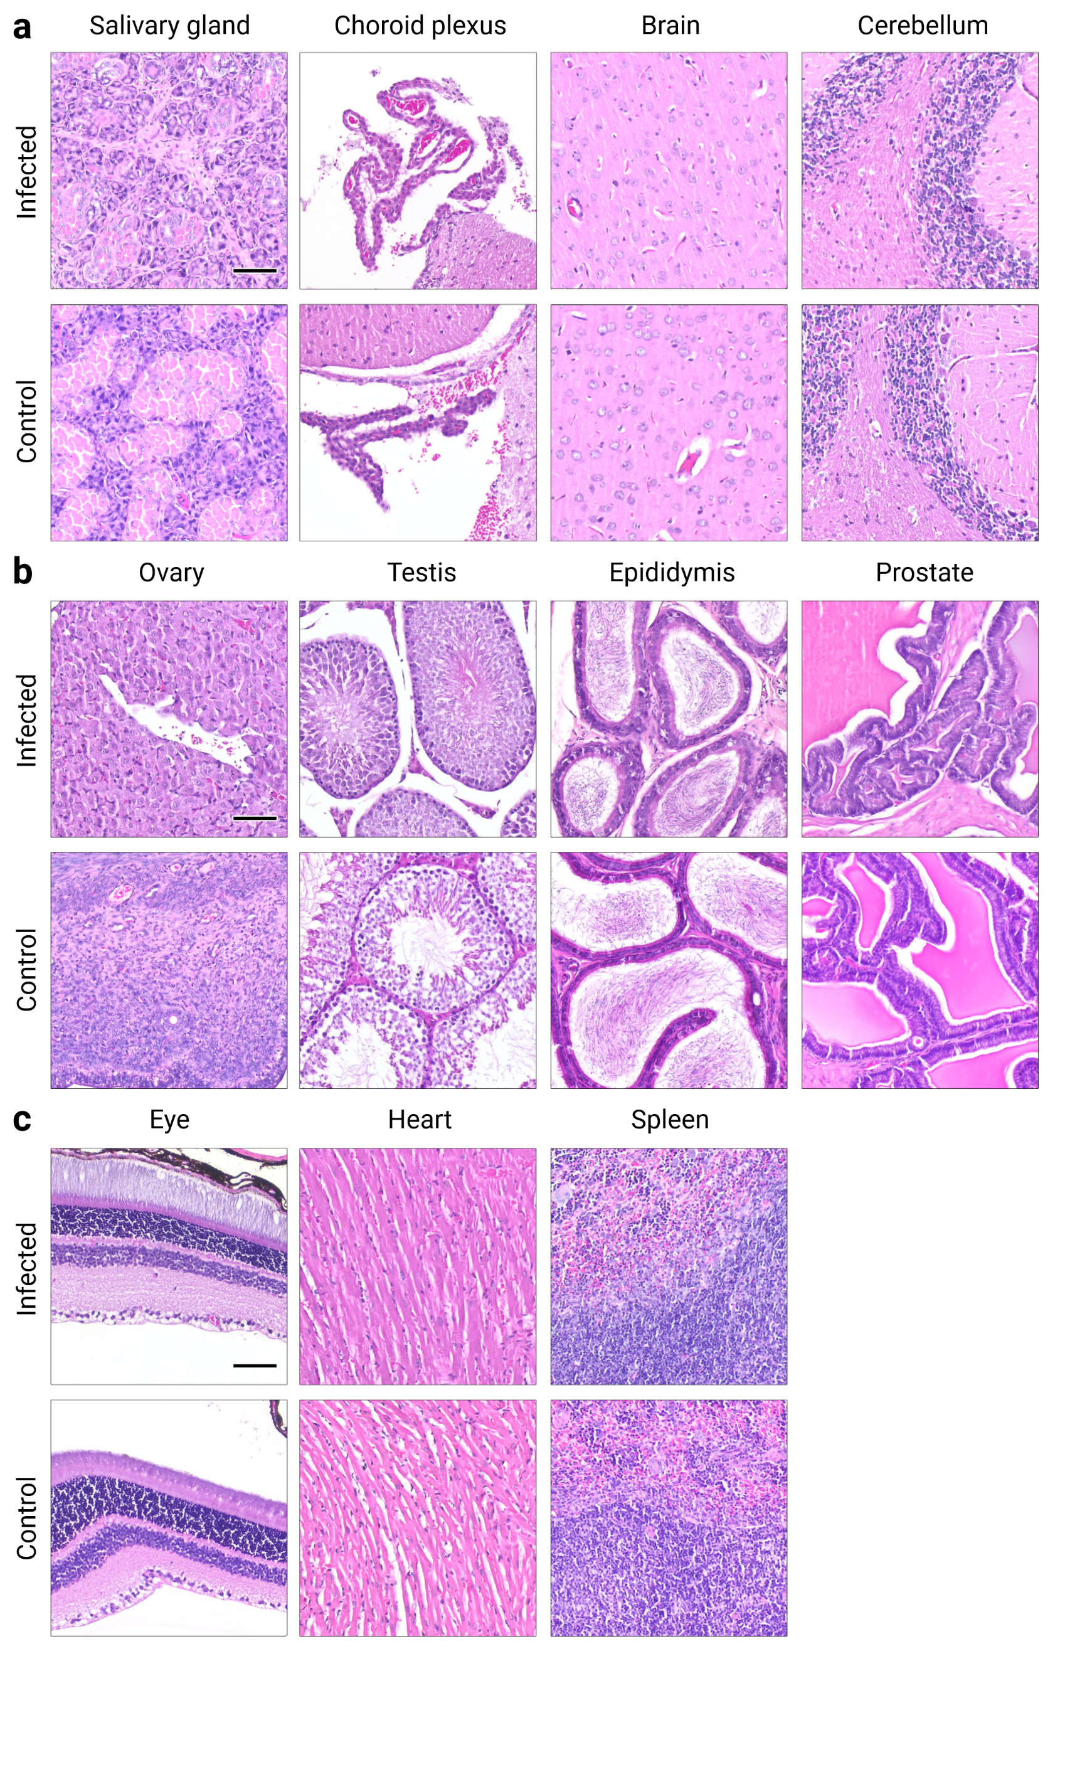
Fig. S1. Histological analysis of organs following inoculation with LASV. Organs of female and male Mastomys inoculated s.c. with 1,000 FFU of LASV Ba366 on day 6–7 (n = 5) were compared to uninfected control (n = 2) animals. Infected animals (≥120 days post-inoculation) displayed no signs of immune infiltration, cell loss, or degeneration. Representative images of H&E-stained tissue sections are shown (from left to right): salivary gland, choroid plexus, brain, cerebellum (a); ovary, testis, epididymis, prostate (b); eye, heart, and spleen (c). Black scale bar equals 50 µm.
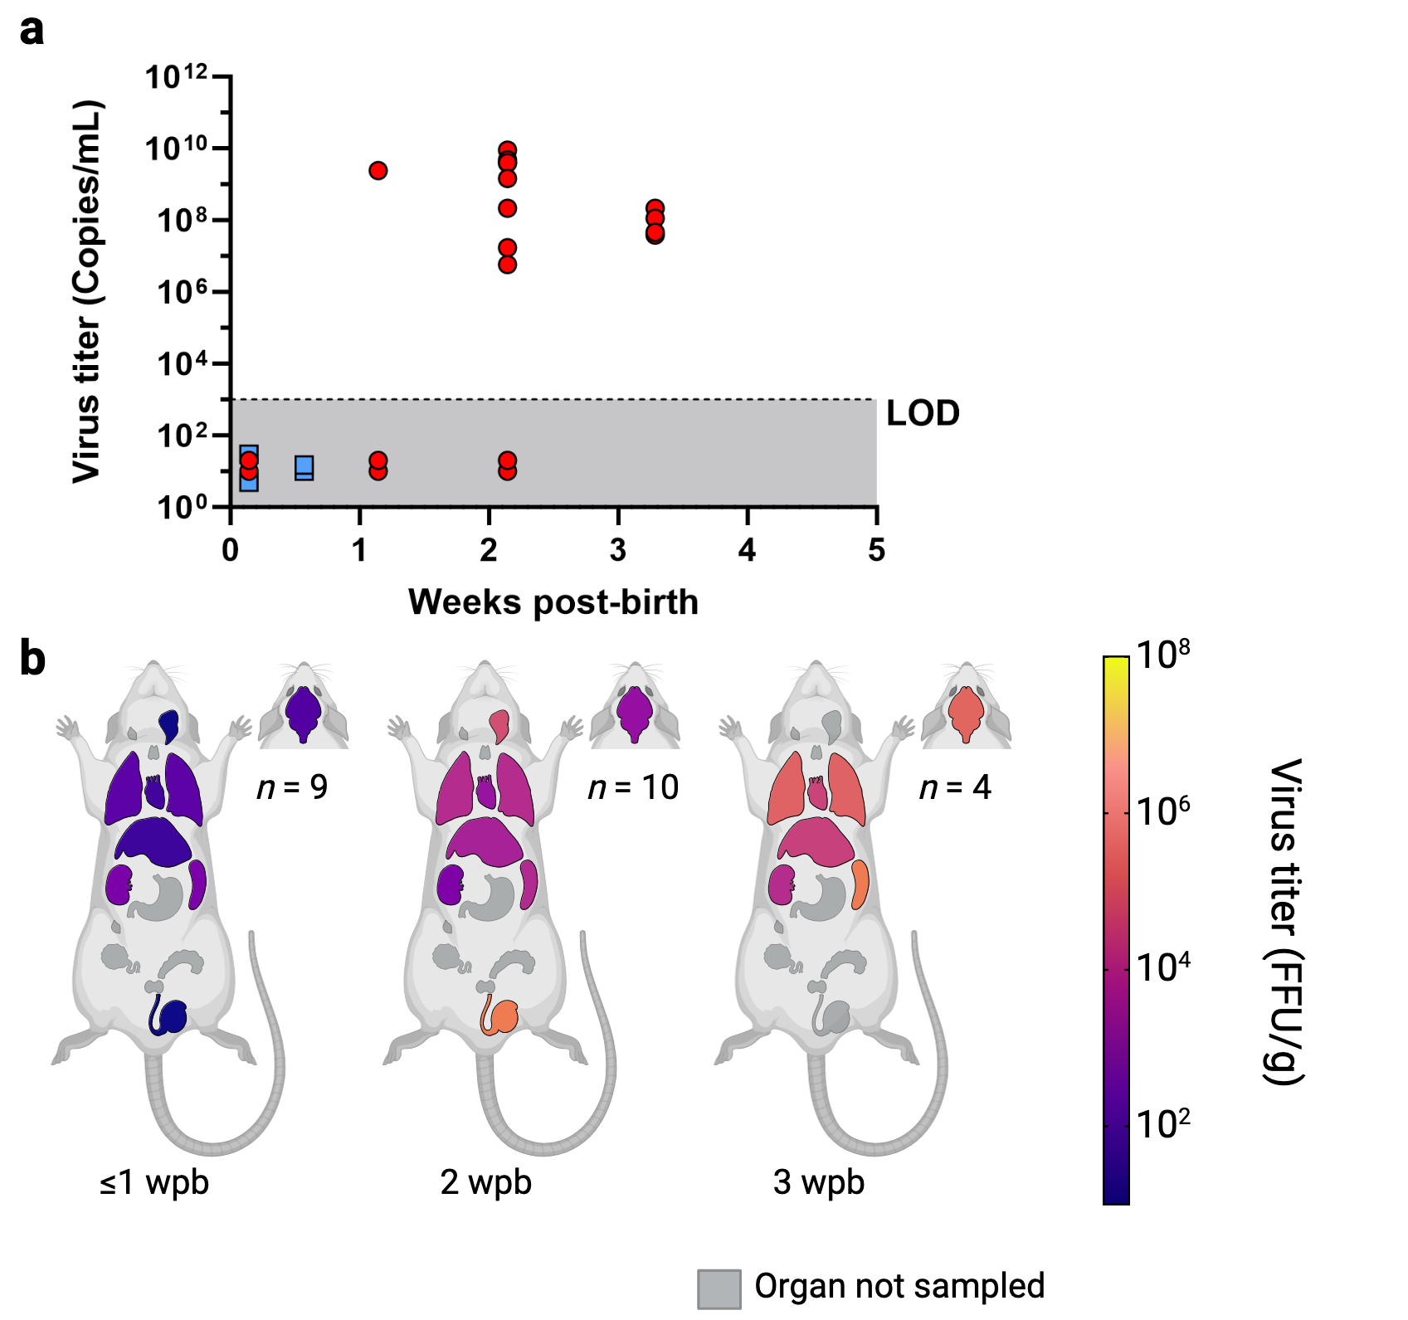
Fig. S2. Virus titers in blood and organs of Mastomys exposed to LASV-infected individuals. Neonates (n = 23) were exposed since birth to previously inoculated older siblings. Virus titers in blood (copies/mL) and serological status are shown over time (a). Blood was sampled at regular intervals and tested for the presence of LASV RNA with qRT-PCR. Ct values were converted into copy numbers using a standard curve. Plasma was inactivated and analyzed for the presence of LASV-specific anti-NP IgG antibodies with ELISA. IgG-positive blood samples are indicated by red dots and IgG-negative samples are depicted as blue squares. Virus titers in organs (b) were determined by immunofocus assay. The number of animals euthanized for organ collection (n) is shown for each sampling period (weeks post-birth). Organs are shown as schematic (from cranial to caudal): eyes, brain, salivary glands, cervical lymphnodes, thymus, lung, heart, liver, spleen, kidneys, stomach, inguinal lymphnodes, ovaries, seminal glands, prostate, and testes. Geometric means of LASV-titers in organs are depicted as spectral heat-map. Dark blue: Limit of detection, negative samples have been assigned a default value at the limit of detection. 10¹ FFU/g; yellow: 10⁸ FFU/g; Black: All samples in the time period tested negative; Grey: Organ not sampled. The limit of detection (LOD) for the qRT-PCR assay is indicated by the dotted line and dark grey colouration. PCR-negative samples have been assigned a default value below the limit of detection.
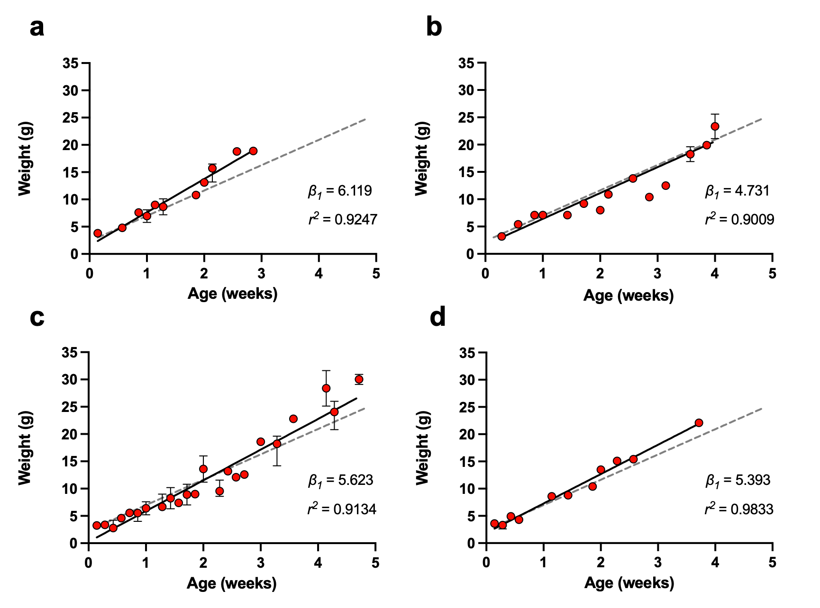
Fig. S3. Growth and development of Mastomys exposed or borne to infected individuals. The body weight of animals exposed to previously inoculated individuals (a, n = 23), borne to females inoculated during gestation (b, n = 27), borne to persistently infected females (c, n = 149), or fathered by persistently infected males (d, n = 92) has been measured during the first four weeks of life. The body weight shown as median with error is depicted as red dots. The weight gain in gram per week (β₁) for each group was determined by simple linear regression. The linear regression line of the naïve control group is depicted in grey. No significant differences in the weight gain of inoculated individuals compared to the naïve control were detected, as determined by one-way ANOVA and Dunnett’s multiple comparison.
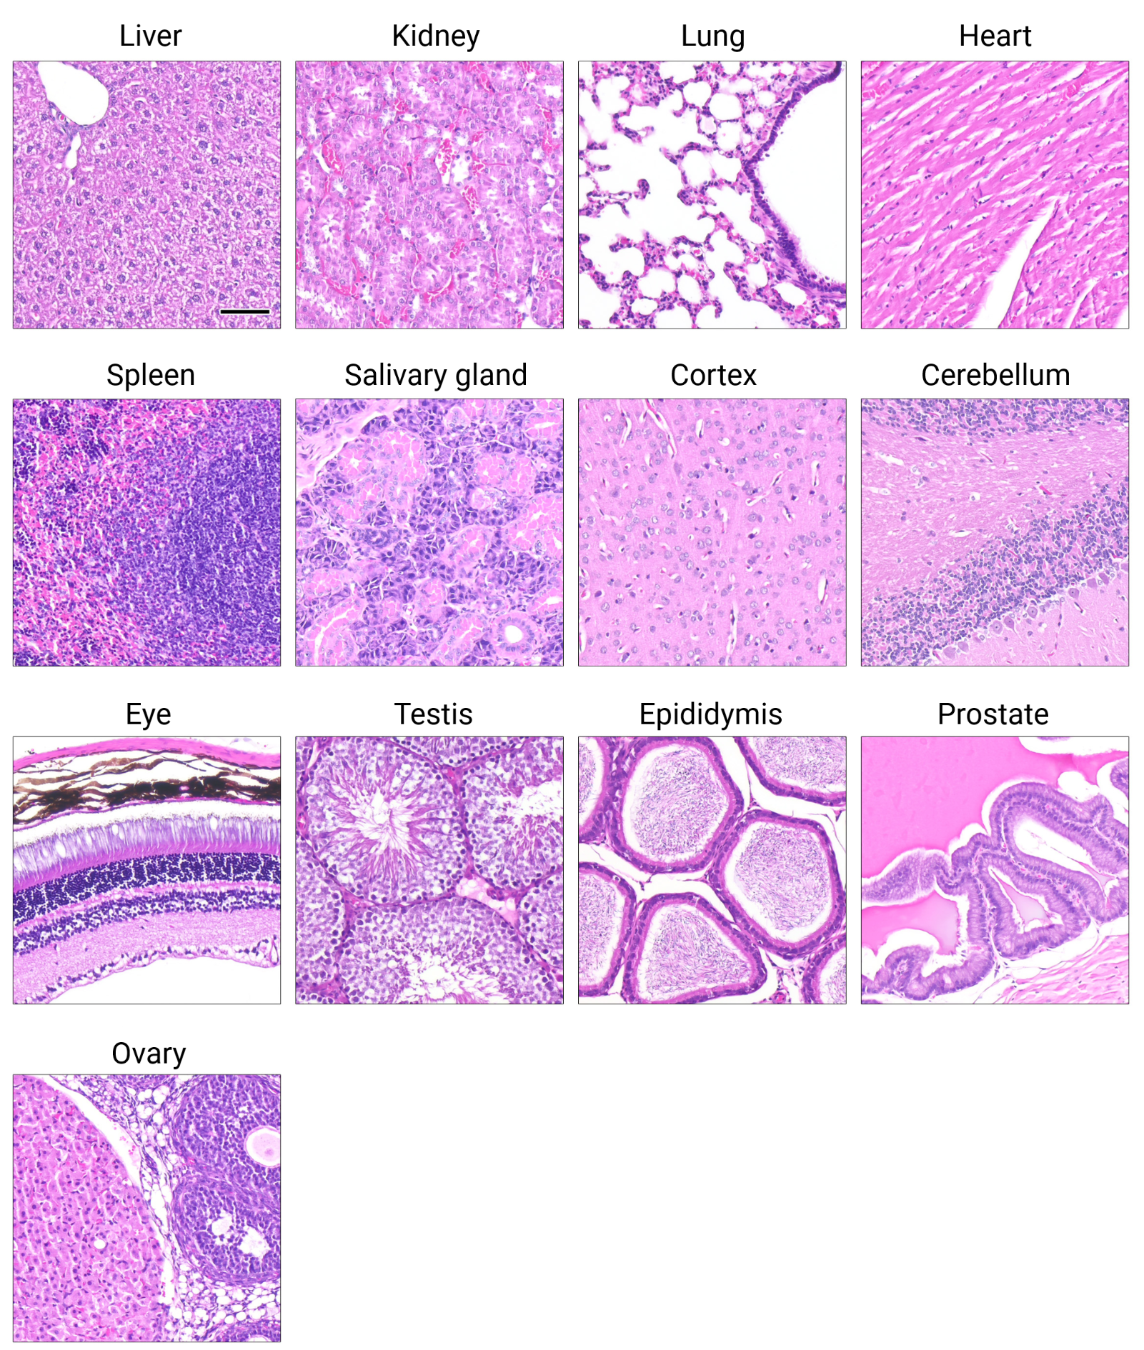
Fig. S4. Histological analysis of organs following prenatal infection with LASV. Pregnant females were inoculated i.v. with 10,000 FFU of LASV Ba366 approximately two weeks into gestation. Organs of female and male offspring (n = 4) were analyzed in histopathology. Infected animals (≥245 days post-birth) displayed no signs of immune infiltration, cell loss, or degeneration. Representative images of H&E-stained tissue sections are shown (from left to right): liver, kidney, lung, heart, spleen, salivary gland, cortex, cerebellum, eye, testis, epididymis, prostate, and ovary. Black scale bar equals 50 µm.
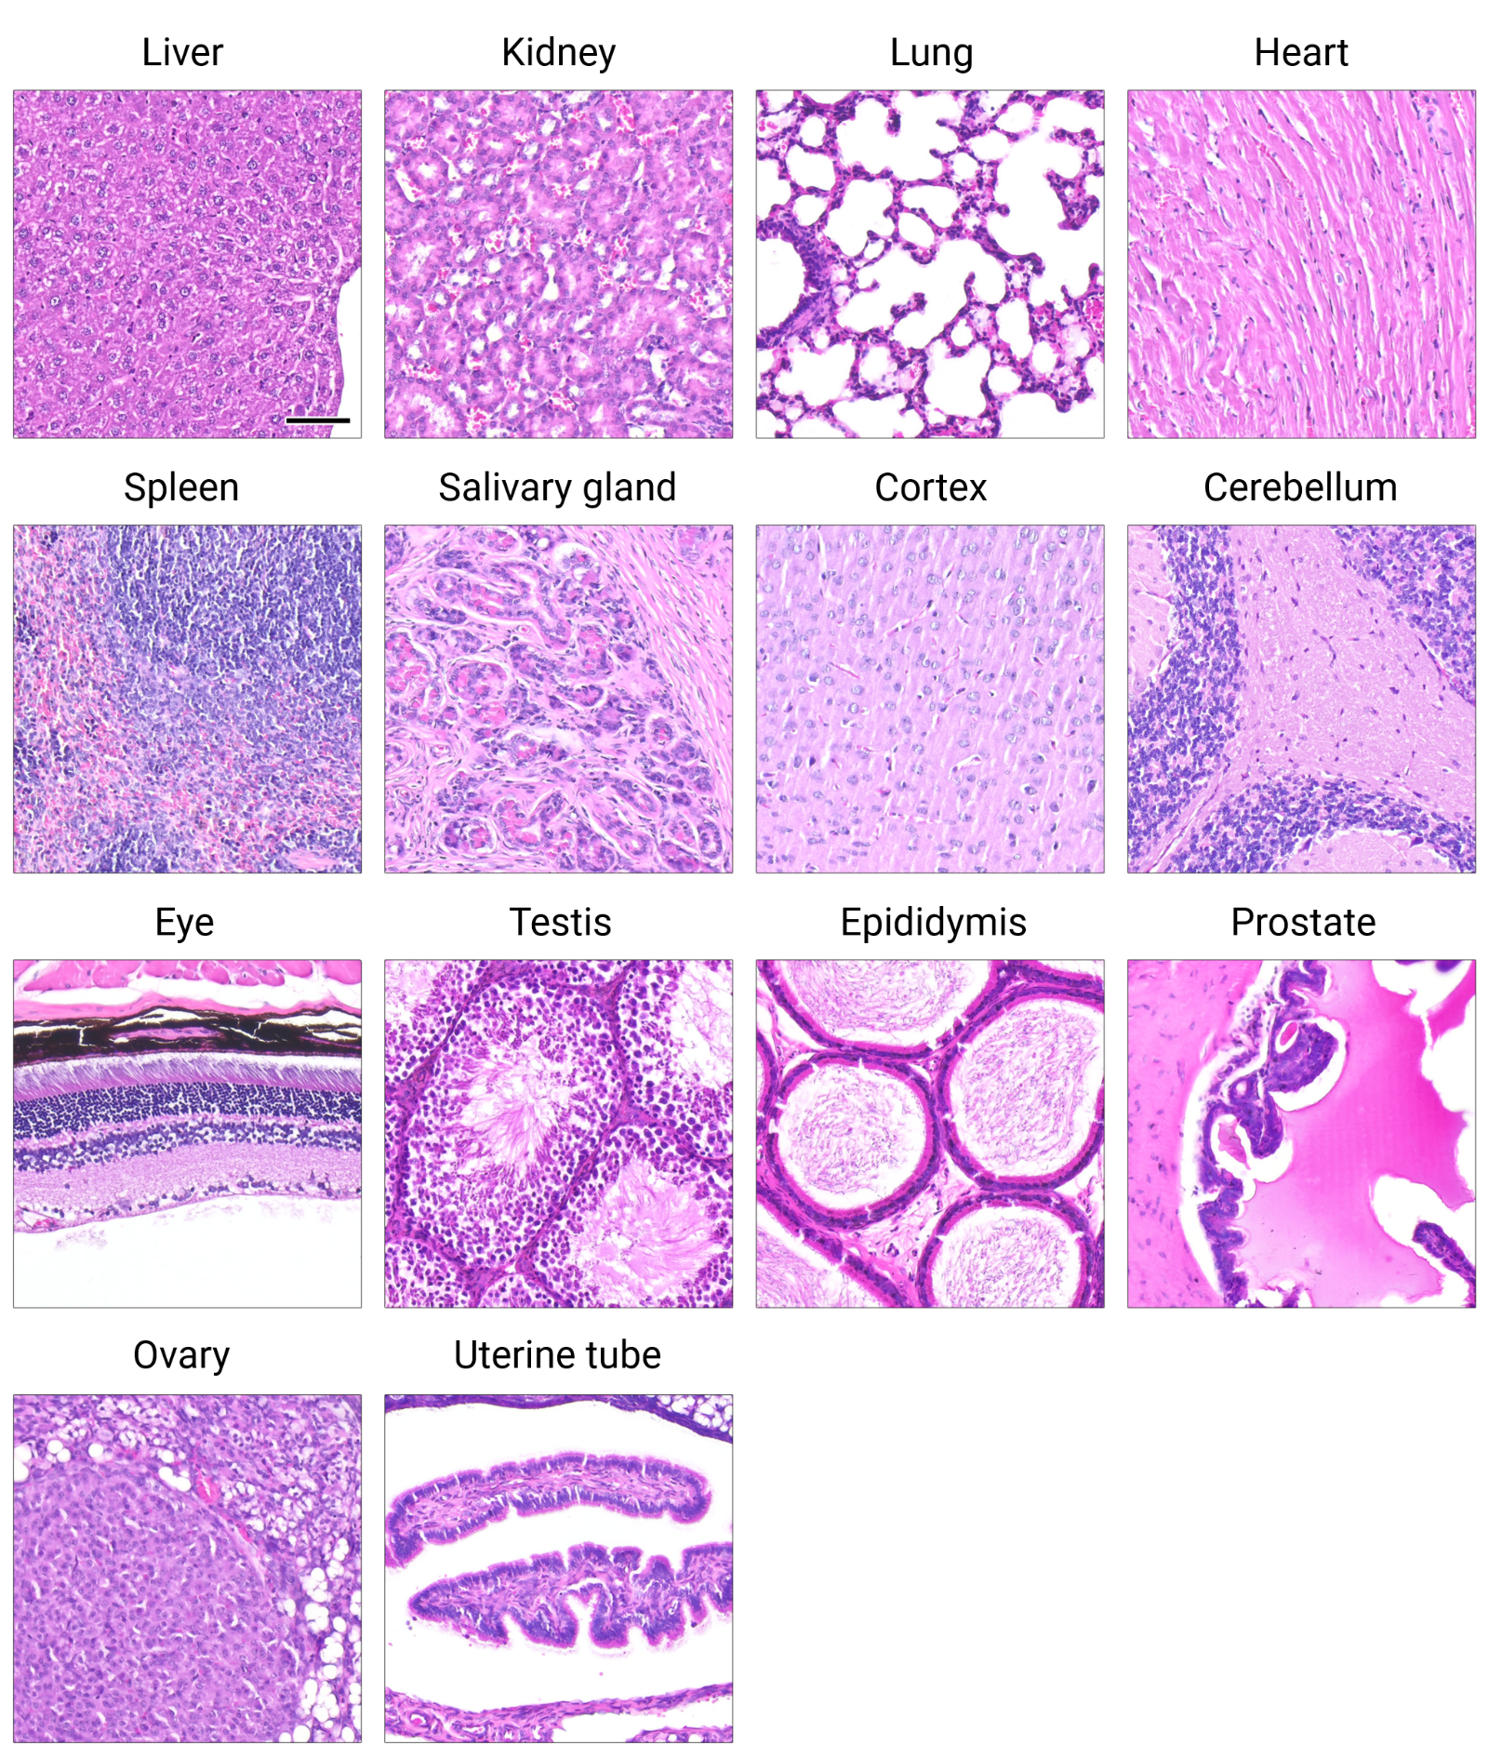
Fig. S5. Histological analysis of organs from animals borne to persistently infected females. Persistently infected females were bred with naïve males. Organs of female and male offspring (n = 27) were analyzed. Infected animals (≥159 days post-birth) displayed no signs of immune infiltration, cell loss, or degeneration. Representative images of H&E-stained tissue sections are shown (from left to right): liver, kidney, lung, heart, spleen, salivary gland, cortex, cerebellum, eye, testis, epididymis, prostate, ovary, and uterine tube. Black scale bar equals 50 µm.
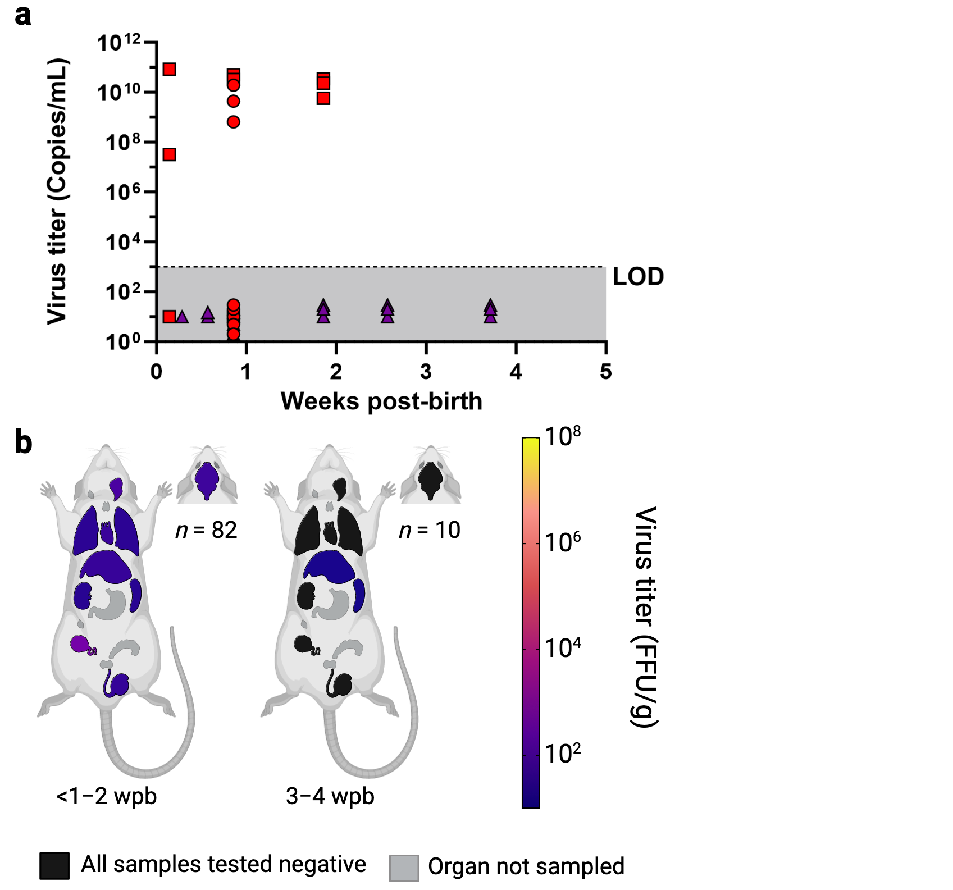
Fig. S6. Virus titers in blood and organs of Mastomys fathered by LASV-infected males. Persistently infected males were bred with naive females. Pregnant females were separated from their mate roughly two weeks into gestation. The resulting offspring (n = 92) never had direct or indirect contact with their fathers except through their mother. Data is shown for litters with at least one LASV-positive (blood and/or organs) individual. Virus titers in blood (copies/mL) are shown over time (a). Blood was sampled at regular intervals and tested for the presence of LASV RNA with qRT-PCR. Ct values were converted into copy numbers using a standard curve. Plasma was inactivated and analyzed for the presence of LASV-specific anti-NP IgG antibodies with ELISA. Samples from the two viremic litters are depicted in red. Litters were considered viremic if at least one individual tested positive for LASV in blood. Samples from non-viremic litters that showed LASV-presence in organs, depicted as purple triangles, were pooled. All tested animals were IgG-positive. Virus titers in organs (b) were determined by immunofocus assay. The number of animals euthanized for organ collection (n) is shown for each sampling period (weeks post-birth). Organs are shown as schematic (from cranial to caudal): eyes, brain, salivary glands, cervical lymphnodes, thymus, lung, heart, liver, spleen, kidneys, stomach, inguinal lymphnodes, ovaries, seminal glands, prostate, and testes. Geometric means of LASV-titers in organs are depicted as spectral heat-map. Dark blue: Limit of detection, negative samples have been assigned a default value at the limit of detection. 10¹ FFU/g; yellow: 10⁸ FFU/g; Black: All samples in the time period tested negative; Grey: Organ not sampled. The limit of detection (LOD) for the qRT-PCR assay is indicated by the dotted line and dark grey coloration. PCR-negative samples have been assigned a default value below the limit of detection.
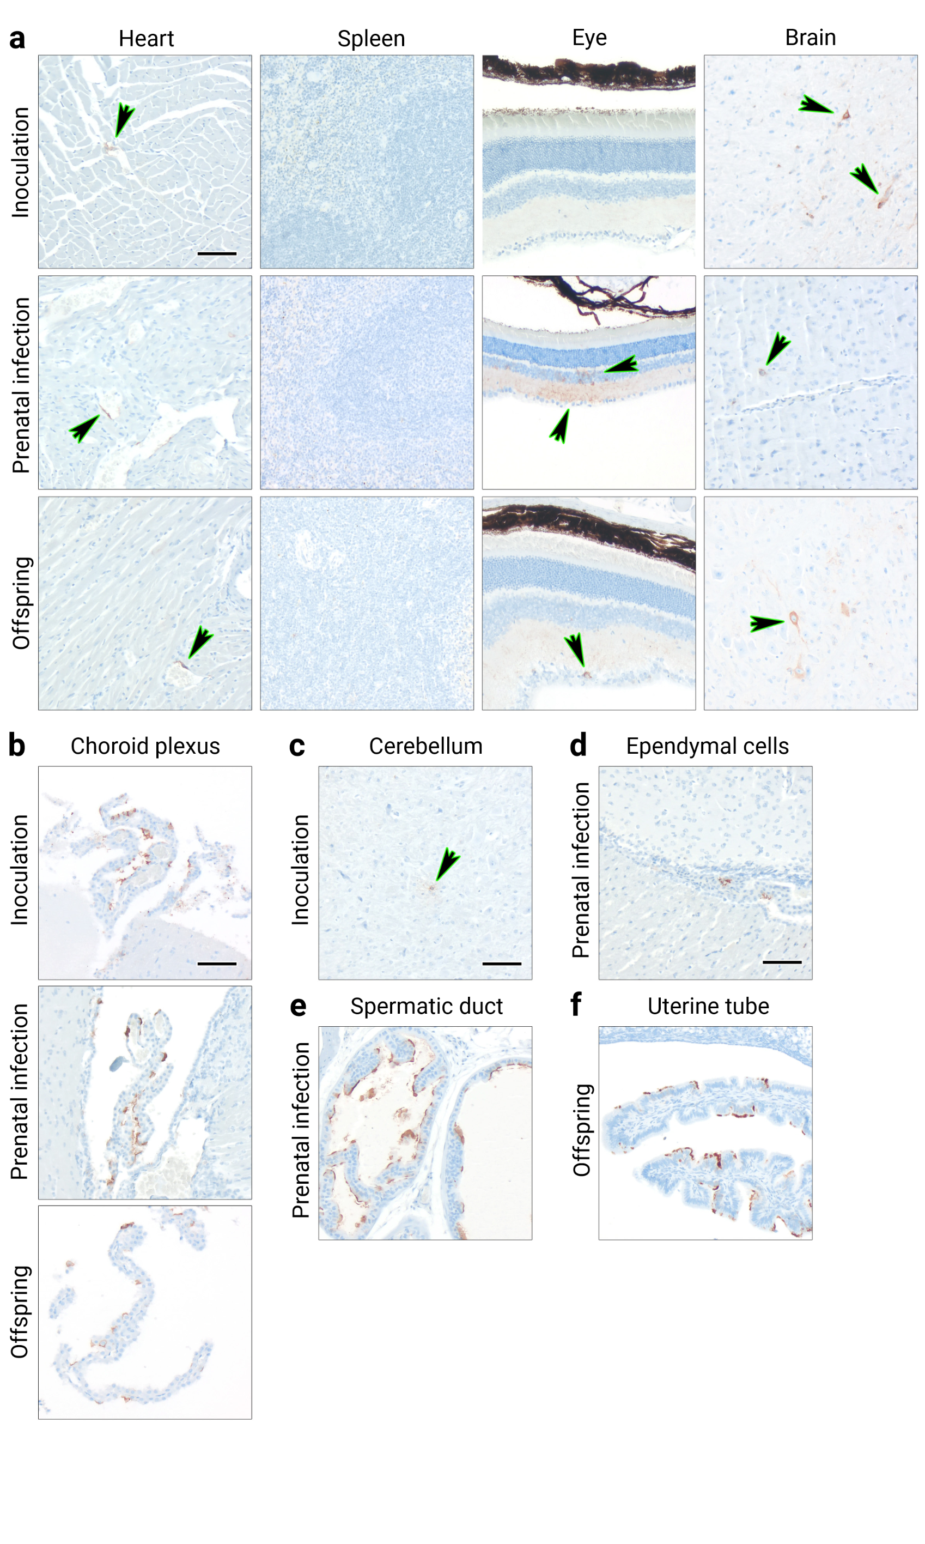
Fig. S7. LASV in organs of persistently infected animals. Animals were either inoculated s.c. with 1,000 FFU of LASV Ba366 at 6–7 days of age (inoculation, n = 5), borne to females inoculated during gestation (prenatal infection, n = 4), or borne to persistently infected females (offspring, n = 27). Organs were sampled from persistently infected individuals (stable virus titers in blood for ≥120 days). Immunohistochemical analysis of heart spleen, eye, and brain (a) shows LASV presence in vascular endothelial cells, the plexiform and inner granular layer, as well as ganglion cells of the retina. Virus positive neurons and endothelial cells were found in the brain. No positive signal could be detected in spleens. Epithelial cells in the choroid plexus (b), oligodendrocytes in the cerebellum (c), ependymal cells (d), as well as epithelial cells in the spermatic duct (e) and uterine tube (f) were also infected with LASV. Representative images of the immunohistochemical analysis are shown. Arrows serve as visual aid indicating infected cells. Black scale bar equals 50 µm.
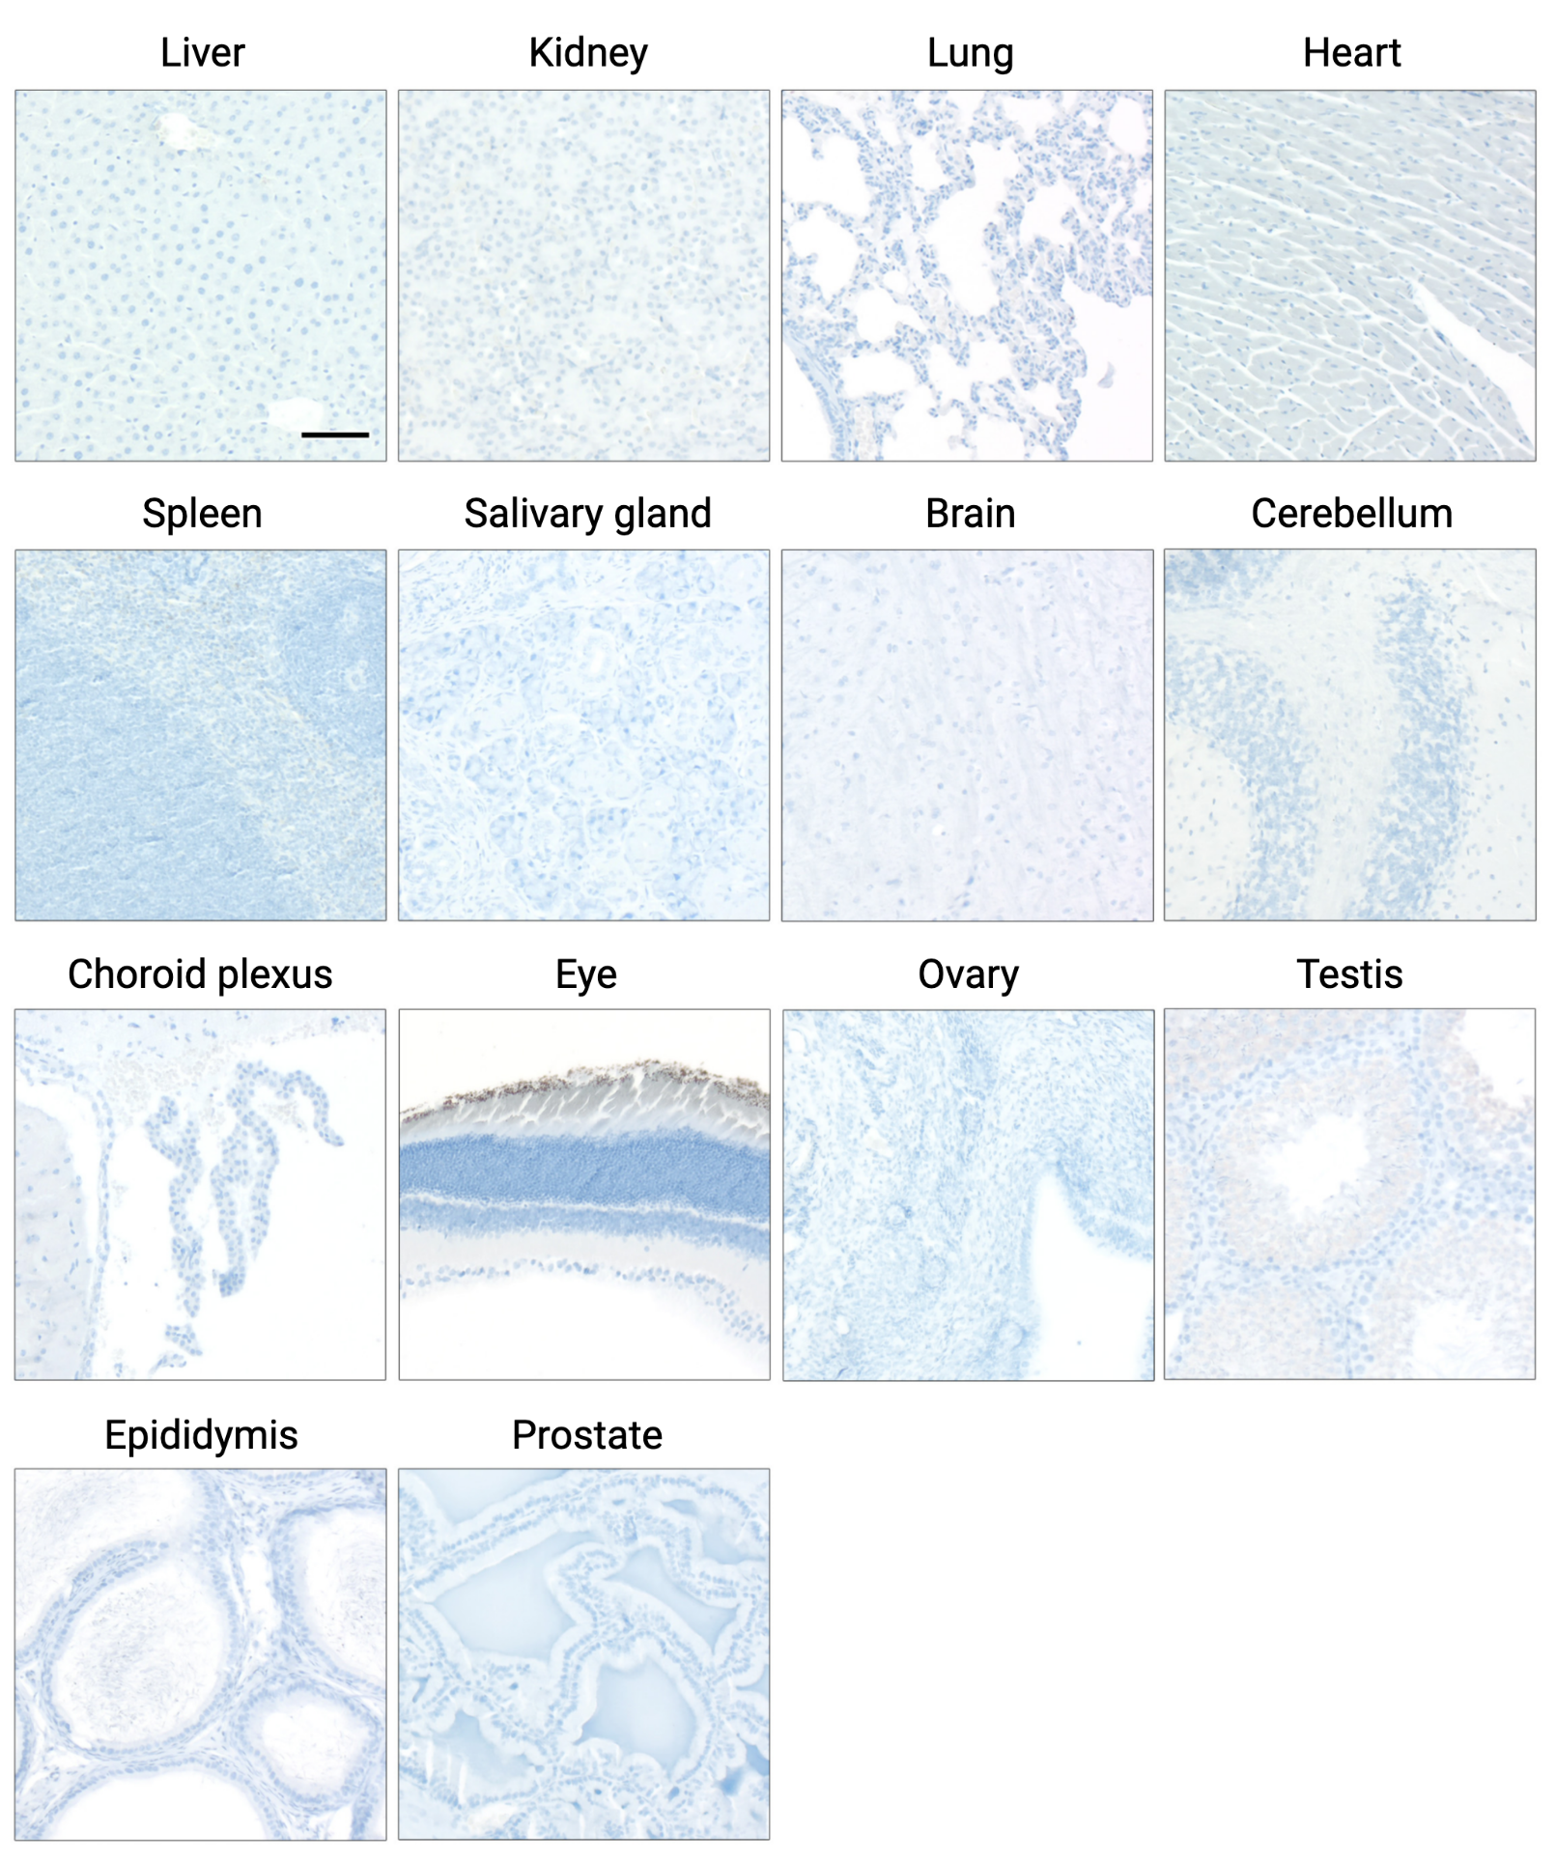
Fig. S8. Immunohistochemical analysis of naïve control animals. Organs of naïve Mastomys (n = 2) were also stained for LASV glycoprotein. No positive signal was detected in the control group. Representative images of the immunohistochemical analysis are shown. Black scale bar equals 50 µm.
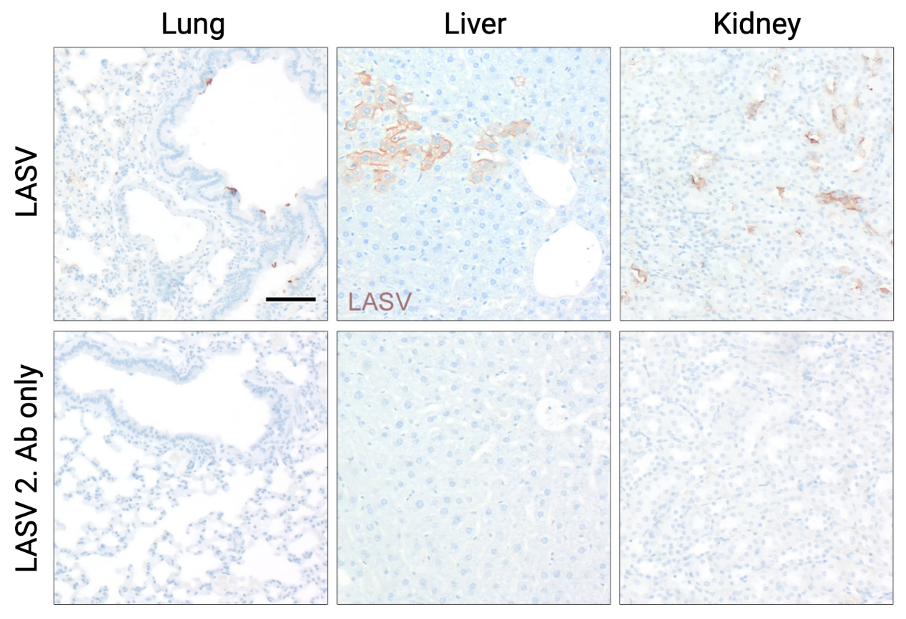
Fig. S9. Antibody staining control. Lung, liver, and kidney from animals inoculated with 1,000 FFU of LASV Ba366 at 6–7 days of age showing specific staining for LASV compared to the staining controls only treated with the secondary antibody. Representative images of the immunohistochemical analysis are shown. Black scale bar equals 50 µm.
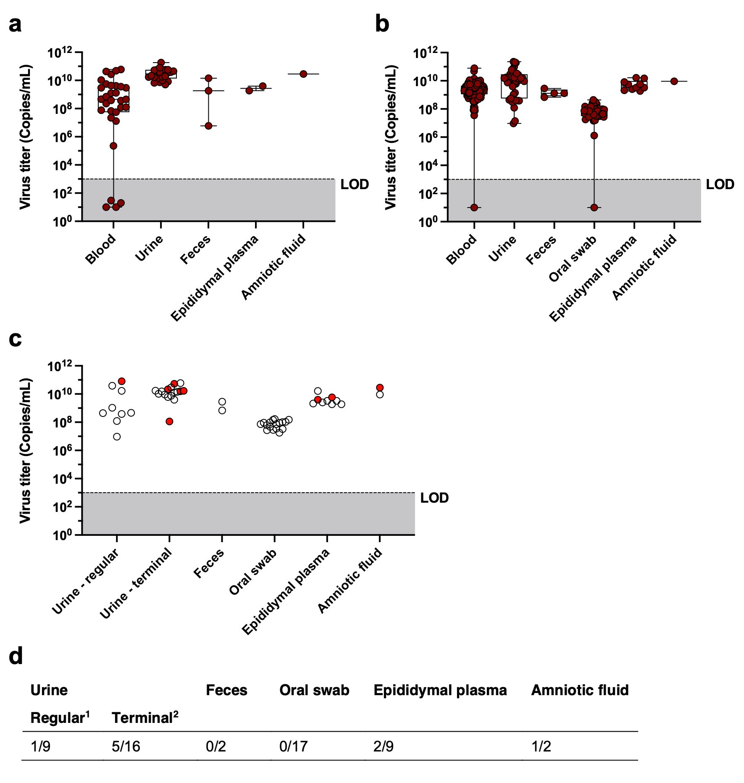
Fig. S10. LASV in body fluids and excretions. Virus titers (copies/mL) in blood, urine, feces, oral swabs, epididymal plasma, and amniotic fluid of animals inoculated with 1,000 FFU of LASV Ba366 at 6–7 days of age (a) or animals borne to persistently infected females (b). Body fluid samples were tested for the presence of LASV RNA with qRT-PCR. Ct values were converted into copy numbers using a standard curve. Selected samples from both groups were used for virus isolation (c). Samples where virus isolation was successful are depicted as bright red dots and samples where isolation attempts failed are indicated by white dots. The limit of detection (LOD) for the qRT-PCR assay is shown by the dotted line and dark grey coloration. Results of the in vitro isolations from collected body fluids are summarized in the table (d). Given are the numbers of successful isolations from all isolation attempts. ¹ Regular urine samples have been collected following voiding. ² Terminal urine samples were acquired via bladder puncture following euthanasia.
Table S1. Overview of the infection status of Mastomys following inoculation with Lassa virus (LASV) strain Ba366.
Group | Sampling Period  (Weeks Post-Inoculation) | Blood |  | Urine | Organs
Group | Sampling Period  (Weeks Post-Inoculation) | PCR Positive Samples/Tested Samples¹ per Sampling Period | Ab Positive Samples/Tested Samples¹ per Sampling Period | PCR Positive Samples/Tested Samples¹ per Sampling Period | Virus Positive Animals/Tested Animals² per Sampling Period
Inoculation 1,000 FFU day 6–7  (n = 18) | 1–3 | 12/12 | 5/11 | 4/4 | 10/10
Inoculation 1,000 FFU day 6–7  (n = 18) | 4–8 | 5/5 | 5/6 | 11/11 | n.t.
Inoculation 1,000 FFU day 6–7  (n = 18) | 9–15 | 5/5 | 4/4 | 4/4 | n.t.
Inoculation 1,000 FFU day 6–7  (n = 18) | 17–23 | 3/7 | 7/7 | 4/4 | 6/6
Inoculation 1,000 FFU day 6–7  (n = 18) | 29–34 | 2/2 | 2/2 | n.t. | 2/2
Inoculation 1,000 FFU day 11  (n = 36) | 1–2 | 12/12 | 7/12 | 4/5 | 12/12
Inoculation 1,000 FFU day 11  (n = 36) | 3–5 | 10/11 | 11/11 | 5/5 | 8/8
Inoculation 1,000 FFU day 11  (n = 36) | 6–10 | 10/13 | 12/13 | 1/1 | 11/11
Inoculation 1,000 FFU day 11  (n = 36) | 12–15 | 2/6 | 4/5 | n.t. | n.t.
Inoculation 1,000 FFU day 11  (n = 36) | 24–27 | 1/3 | 3/3 | n.t. | 3/3
Inoculation 1,000 FFU day 15  (n = 24) | 1 | 2/2 | 0/2 | 1/1 | 2/2
Inoculation 1,000 FFU day 15  (n = 24) | 2 | 8/8 | 8/8 | 2/3 | 8/8
Inoculation 1,000 FFU day 15  (n = 24) | 4–7 | 10/14 | 14/14 | n.t. | 10/11
Inoculation 1,000 FFU day 28–29  (n = 17) | 1 | 7/8 | 0/8 | 1/3 | 6/8
Inoculation 1,000 FFU day 28–29  (n = 17) | 2 | 1/3 | 3/3 | n.t. | 3/3
Inoculation 1,000 FFU day 28–29  (n = 17) | 4–5 | 0/6 | 6/6 | n.t. | 0/6
Inoculation 1,000 FFU day 57–59  (n = 21) | 1–3 | 2/13 | 12/13 | n.t. | 3/9
Inoculation 1,000 FFU day 57–59  (n = 21) | 4–5 | 0/8 | 6/8 | n.t. | 1/8
¹ For blood and urine, the number of positive samples versus the total number of samples tested during a given time period is shown. Since individuals were sampled up to 3 times per sampling period, the number of tested samples can exceed the number of animals per group. ² For organs, the number of positive animals versus the total number of tested animals is shown. Animals were considered positive, if one or more of the tested organs contained infectious virus. n.t. = not tested.

Table S2. Virus titers in liver, spleen, kidney, and heart of M. natalensis following the inoculation with LASV strain Ba366.
Group | Sampling  Period (Weeks Post-Inoculation) | Liver |  |  | Spleen |  |  | Kidney |  |  | Heart
Group | Sampling  Period (Weeks Post-Inoculation) | Positive  /Tested¹ | FFU/Organ |  | Positive  /Tested¹ | FFU/Organ |  | Positive  /Tested¹ | FFU/Organ |  | Positive  /Tested¹ | FFU/Organ
Group | Sampling  Period (Weeks Post-Inoculation) | Positive  /Tested¹ | Min | Max | Positive  /Tested¹ | Min | Max | Positive  /Tested¹ | Min | Max | Positive  /Tested¹ | Min | Max
Inoculation  1,000 FFU  day 6–7  (n = 18) | 1–3 | 9/10 | 5,00E+03 | 5,36E+07 | 9/10 | 8,79E+04 | 1,93E+07 | 8/10 | 6,00E+05 | 2,83E+07 | 9/10 | 1,35E+03 | 1,58E+07
Inoculation  1,000 FFU  day 6–7  (n = 18) | 17–23 | 3/6 | 2,08E+04 | 3,21E+04 | 4/6 | 7,78E+03 | 1,75E+07 | 6/6 | 5,19E+03 | 5,00E+06 | 3/6 | 5,00E+03 | 1,83E+08
Inoculation  1,000 FFU  day 6–7  (n = 18) | 29–34 | 2/2 | 1,15E+04 | 2,67E+04 | 2/2 | 1,37E+03 | 5,00E+05 | 2/2 | 1,09E+06 | 4,79E+06 | 2/2 | 1,28E+03 | 1,56E+04
Inoculation  1,000 FFU  day 11  (n = 34) | 1–2 | 10/12 | 2,04E+02 | 7,89E+06 | 11/12 | 7,14E+02 | 6,33E+06 | 11/12 | 2,50E+02 | 5,00E+06 | 11/12 | 6,88E+02 | 3,14E+06
Inoculation  1,000 FFU  day 11  (n = 34) | 3–10 | 10/19 | 8,00E+02 | 1,30E+05 | 16/19 | 7,46E+02 | 2,84E+06 | 18/19 | 1,72E+02 | 2,49E+07 | 17/19 | 2,78E+01 | 1,31E+06
Inoculation  1,000 FFU  day 11  (n = 34) | 24–27 | 1/3 | 1,15E+03 |  | 1/3 | 6,15E+03 |  | 2/3 | 2,07E+04 | 1,14E+06 | 2/3 | 1,35E+03 | 6,11E+03
Inoculation  1,000 FFU  day 15  (n = 21) | 1 | 2/2 | 4,00E+06 | 2,04E+07 | 2/2 | 5,00E+07 | 7,14E+07 | 2/2 | 5,50E+02 | 5,45E+04 | 2/2 | 1,07E+05 | 1,11E+05
Inoculation  1,000 FFU  day 15  (n = 21) | 2 | 3/8 | 2,17E+02 | 2,00E+03 | 3/8 | 3,85E+02 | 5,36E+03 | 3/8 | 8,33E+02 | 8,50E+03 | 6/8 | 2,50E+02 | 7,27E+04
Inoculation  1,000 FFU  day 15  (n = 21) | 4–7 | 0/11 | negative |  | 5/11 | 1,36E+02 | 3,27E+03 | 2/11 | 6,67E+02 | 1,78E+04 | 5/11 | 1,25E+02 | 1,30E+03
Inoculation  1,000 FFU  day 28–29  (n = 17) | 1 | 6/8 | 2,66E+04 | 3,68E+06 | 6/8 | 5,24E+04 | 5,59E+06 | 0/8 | negative |  | 2/8 | 3,82E+02 | 2,92E+03
Inoculation  1,000 FFU  day 28–29  (n = 17) | 2 | 0/3 | negative |  | 0/3 | negative |  | 0/3 | negative |  | 0/3 | negative
Inoculation  1,000 FFU  day 28–29  (n = 17) | 4–5 | 0/6 | negative |  | 0/6 | negative |  | 0/6 | negative |  | 0/6 | negative
Inoculation  1,000 FFU  day 57–59  (n = 17) | 1–2 | 1/9 | 9,04E+02 |  | 1/9 | 1,67E+02 |  | 0/9 | negative |  | 1/9 | 2,39E+02
Inoculation  1,000 FFU  day 57–59  (n = 17) | 3–5 | 0/8 | negative |  | 0/8 | negative |  | 0/8 | negative |  | 0/8 | negative
¹The number of positive organs versus the total number of tested organs is shown. n.t. = not tested.
Table S3. Virus titers in lung, brain, testis, and ovary of M. natalensis following the inoculation with LASV strain Ba366.
Group | Sampling  Period (Weeks Post-Inoculation) | Lung |  |  | Brain |  |  | Testis |  |  | Ovary
Group | Sampling  Period (Weeks Post-Inoculation) | Positive  /Tested¹ | FFU/Organ |  | Positive  /Tested¹ | FFU/Organ |  | Positive  /Tested¹ | FFU/Organ |  | Positive  /Tested¹ | FFU/Organ
Group | Sampling  Period (Weeks Post-Inoculation) | Positive  /Tested¹ | Min | Max | Positive  /Tested¹ | Min | Max | Positive  /Tested¹ | Min | Max | Positive  /Tested¹ | Min | Max
Inoculation  1,000 FFU  day 6–7  (n = 18) | 1–3 | 9/10 | 1,18E+05 | 8,33E+07 | 9/10 | 2,31E+02 | 3,71E+07 | 3/4 | 5,00E+02 | 1,44E+06 | n.t.
Inoculation  1,000 FFU  day 6–7  (n = 18) | 17–23 | 3/6 | 5,67E+05 | 9,00E+07 | 6/6 | 1,48E+02 | 5,95E+05 | 2/2 | 3,41E+03 | 1,81E+05 | 3/4 | 1,16E+02 | 3,30E+06
Inoculation  1,000 FFU  day 6–7  (n = 18) | 29–34 | 2/2 | 6,85E+05 | 6,79E+05 | 2/2 | 4,10E+04 | 3,63E+05 | n.t. |  |  | 2/2 | 2,94E+04 | 1,16E+05
Inoculation  1,000 FFU  day 11  (n = 34) | 1–2 | 12/12 | 1,30E+05 | 3,83E+08 | 11/12 | 1,00E+02 | 1,05E+07 | 5/5 | 1,14E+03 | 3,30E+06 | 1/1 | 6,00E+04
Inoculation  1,000 FFU  day 11  (n = 34) | 3–10 | 17/19 | 2,27E+02 | 5,71E+06 | 18/19 | 2,86E+02 | 3,41E+06 | 7/10 | 5,06E+04 | 7,78E+06 | 4/6 | 5,59E+04 | 3,25E+06
Inoculation  1,000 FFU  day 11  (n = 34) | 24–27 | 1/3 | 5,81E+04 |  | 2/3 | 6,06E+02 | 1,80E+05 | n.t. |  |  | 1/3 | 2,30E+04
Inoculation  1,000 FFU  day 15  (n = 21) | 1 | 2/2 | 8,89E+05 | 2,88E+06 | 2/2 | 1,20E+03 | 2,50E+03 | 1/1 | 9,29E+02 |  | 1/1 | 4,67E+03
Inoculation  1,000 FFU  day 15  (n = 21) | 2 | 8/8 | 1,00E+03 | 1,30E+07 | 7/8 | 3,85E+01 | 5,87E+06 | 2/6 | 3,75E+03 | 7,25E+03 | 0/2 | negative
Inoculation  1,000 FFU  day 15  (n = 21) | 4–7 | 2/11 | 2,60E+03 | 2,67E+03 | 6/11 | 1,86E+02 | 7,50E+05 | 1/3 | 3,27E+02 |  | 1/8 | 6,25E+02
Inoculation  1,000 FFU  day 28–29  (n = 17) | 1 | 6/8 | 5,10E+03 | 1,05E+06 | 1/8 | 4,03E+02 |  | 1/4 | 1,03E+03 |  | 1/4 | 3,95E+02
Inoculation  1,000 FFU  day 28–29  (n = 17) | 2 | 3/3 | 1,01E+02 | 1,05E+03 | 1/3 | 1,56E+02 |  | 0/1 | negative |  | 0/2 | negative
Inoculation  1,000 FFU  day 28–29  (n = 17) | 4–5 | 0/6 | negative |  | 0/6 | negative |  | 0/3 | negative |  | 0/3 | negative
Inoculation  1,000 FFU  day 57–59  (n = 17) | 1–2 | 1/9 | 1,35E+03 |  | 0/9 | negative |  | 0/5 | negative |  | 0/4 | negative
Inoculation  1,000 FFU  day 57–59  (n = 17) | 3–5 | 0/8 | negative |  | 0/8 | negative |  | 0/4 | negative |  | 0/4 | negative
¹The number of positive organs versus the total number of tested organs is shown. n.t. = not tested.
Table S4. Virus titers in salivary glands and thymus of M. natalensis following the inoculation with LASV strain Ba366.
Group | Sampling  Period (Weeks Post-Inoculation) | Salivary glands |  |  | Thymus
Group | Sampling  Period (Weeks Post-Inoculation) | Positive  /Tested¹ | FFU/Organ |  | Positive  /Tested¹ | FFU/Organ
Group | Sampling  Period (Weeks Post-Inoculation) | Positive  /Tested¹ | Min | Max | Positive  /Tested¹ | Min | Max
Inoculation  1,000 FFU  day 6–7  (n = 18) | 1–3 | 7/8 | 3,75E+04 | 2,28E+07 | 2/2 | 8,75E+05 | 1,65E+07
Inoculation  1,000 FFU  day 6–7  (n = 18) | 17–23 | 4/6 | 2,91E+03 | 3,24E+05 | n.t.
Inoculation  1,000 FFU  day 6–7  (n = 18) | 29–34 | 2/2 | 2,56E+02 | 7,23E+05 | n.t.
Inoculation  1,000 FFU  day 11  (n = 34) | 1–2 | 10/12 | 2,14E+02 | 1,65E+06 | 7/8 | 3,00E+03 | 5,75E+05
Inoculation  1,000 FFU  day 11  (n = 34) | 3–10 | 14/19 | 7,41E+02 | 9,47E+06 | 4/5 | 3,67E+03 | 7,50E+05
Inoculation  1,000 FFU  day 11  (n = 34) | 24–27 | 1/3 | 2,34E+05 |  | 1/2 | 2,25E+03
Inoculation  1,000 FFU  day 15  (n = 21) | 1 | 2/2 | 7,86E+04 | 5,50E+06 | n.t.
Inoculation  1,000 FFU  day 15  (n = 21) | 2 | 6/8 | 7,14E+01 | 2,00E+04 | 5/6 | 1,25E+02 | 3,67E+04
Inoculation  1,000 FFU  day 15  (n = 21) | 4–7 | 2/11 | 3,57E+01 | 8,62E+02 | 3/6 | 2,00E+02 | 3,03E+03
Inoculation  1,000 FFU  day 28–29  (n = 17) | 1 | 1/8 | 2,66E+02 |  | n.t.
Inoculation  1,000 FFU  day 28–29  (n = 17) | 2 | 2/3 | 1,31E+02 | 7,81E+02 | n.t.
Inoculation  1,000 FFU  day 28–29  (n = 17) | 4–5 | 0/6 | negative |  | n.t.
Inoculation  1,000 FFU  day 57–59  (n = 17) | 1–2 | 0/9 | negative |  | n.t.
Inoculation  1,000 FFU  day 57–59  (n = 17) | 3–5 | 1/8 | 5,26E+02 |  | n.t.
¹The number of positive organs versus the total number of tested organs is shown. n.t. = not tested.

Table S5. Overview of the infection status of Mastomys following exposure to LASV-infected individuals.
Group | Sampling Period (Weeks Post-Birth) | Blood |  | Urine | Organs
Group | Sampling Period (Weeks Post-Birth) | PCR Positive Samples/Tested Samples¹ per Sampling Period | Ab Positive Samples/Tested Samples¹ per Sampling Period | PCR Positive Samples/Tested Samples¹ per Sampling Period | Virus Positive Animals/Tested Animals² per Sampling Period
Natural exposure since birth (n = 23) | ≤1 | 1/9 | 5/9 | n.t. | 3/9
Natural exposure since birth (n = 23) | 2 | 8/10 | 10/10 | 1/1 | 8/10
Natural exposure since birth (n = 23) | 3 | 4/4 | 4/4 | 2/2 | 4/4
Exposure of adults to infected individuals (n = 33) | 16–52 | 0/33 | 30/33 | n.t. | 0/6
¹ For blood and urine, the number of positive samples versus the total number of samples tested during a given time period is shown. Since individuals were sampled up to 3 times per sampling period, the number of tested samples can exceed the number of animals per group. ² For organs, the number of positive animals versus the total number of tested animals is shown. Animals were considered positive, if one or more of the tested organs contained infectious virus. n.t. = not tested.

Table S6. Virus titers in liver, spleen, kidney, and heart of M. natalensis following exposure to LASV-infected individuals.
Group | Sampling  Period (Weeks Post-Birth) | Liver |  |  | Spleen |  |  | Kidney |  |  | Heart
Group | Sampling  Period (Weeks Post-Birth) | Positive  /Tested¹ | FFU/Organ |  | Positive  /Tested¹ | FFU/Organ |  | Positive  /Tested¹ | FFU/Organ |  | Positive  /Tested¹ | FFU/Organ
Group | Sampling  Period (Weeks Post-Birth) | Positive  /Tested¹ | Min | Max | Positive  /Tested¹ | Min | Max | Positive  /Tested¹ | Min | Max | Positive  /Tested¹ | Min | Max
Natural exposure since birth (n = 23) | ≤1 | 2/9 | 1,30E+03 | 6,69E+06 | 2/3 | 9,09E+02 | 4,17E+06 | 2/3 | 5,00E+02 | 1,02E+07 | 2/5 | 1,43E+02 | 3,33E+06
Natural exposure since birth (n = 23) | 2 | 8/10 | 8,44E+03 | 1,80E+06 | 8/10 | 2,88E+03 | 8,70E+06 | 7/10 | 5,75E+01 | 8,46E+05 | 8/10 | 7,03E+02 | 1,05E+06
Natural exposure since birth (n = 23) | 3 | 4/4 | 9,66E+02 | 2,16E+06 | 4/4 | 1,02E+04 | 6,72E+06 | 3/4 | 1,35E+05 | 4,24E+06 | 4/4 | 1,96E+03 | 7,89E+05
¹The number of positive organs versus the total number of tested organs is shown. n.t. = not tested.
Table S7. Virus titers in lung, brain, testis, and salivary gland of M. natalensis following exposure to LASV-infected individuals.
Group | Sampling  Period (Weeks Post-Birth) | Lung |  |  | Brain |  |  | Testes |  |  | Salivary glands
Group | Sampling  Period (Weeks Post-Birth) | Positive  /Tested¹ | FFU/Organ |  | Positive  /Tested¹ | FFU/Organ |  | Positive  /Tested¹ | FFU/Organ |  | Positive  /Tested¹ | FFU/Organ
Group | Sampling  Period (Weeks Post-Birth) | Positive  /Tested¹ | Min | Max | Positive  /Tested¹ | Min | Max | Positive  /Tested¹ | Min | Max | Positive  /Tested¹ | Min | Max
Natural exposure since birth (n = 23) | ≤1 | 3/5 | 3,03E+02 | 2,89E+07 | 1/3 | 5,72E+07 |  | 0/2 | negative |  | 0/2 | negative
Natural exposure since birth (n = 23) | 2 | 8/10 | 1,22E+04 | 3,52E+07 | 8/10 | 1,20E+01 | 2,84E+07 | 5/5 | 2,57E+03 | 1,59E+08 | 6/7 | 1,79E+03 | 4,02E+07
Natural exposure since birth (n = 23) | 3 | 4/4 | 2,54E+02 | 2,61E+07 | 4/4 | 1,27E+03 | 6,33E+06 | n.t. |  |  | n.t.
¹The number of positive organs versus the total number of tested organs is shown. n.t. = not tested.

Table S8. Overview of the infection status of Mastomys following prenatal infection or of individuals borne to persistently infected parents.
Group |  | Sampling Period (Weeks Post-Birth) | Blood |  | Urine | Oral Swab | Organs
 |  | Sampling Period (Weeks Post-Birth) | PCR Positive Samples/Tested Samples¹ per Sampling Period | Ab Positive Samples/Tested Samples¹ per Sampling Period | PCR Positive Samples/Tested Samples¹ per Sampling Period | PCR Positive Samples/Tested Samples¹ per Sampling Period | Virus Positive Animals/Tested Animals² per Sampling Period
Prenatal infection (n = 27) |  | ≤1 | 2/7 | 5/7 | n.t. | n.t. | 5/9
 |  | 4–8 | 7/7 | 4/7 | 2/2 | n.t. | 3/3
 |  | 12–22 | 7/10 | 5/7 | n.t. | n.t. | n.t.
 |  | 35–40 | 6/10 | 8/10 | 1/3 | n.t. | 7/10
Offspring chronic female  early embryonic stages (n = 44) |  | unborn | n.t. | n.t. | n.t. | n.t. | 44/44
Offspring chronic female (n = 149) | F1 Generation (n = 43) | <1–4 | 24/25 | 9/25 | 5/5 | n.t. | 27/28
Offspring chronic female (n = 149) | F1 Generation (n = 43) | 23–30 | 4/4 | 1/4 | 2/2 | 4/4 | 3/3
Offspring chronic female (n = 149) | F1 Generation (n = 43) | 32–61 | 12/12 | 4/12 | 11/11 | 12/12 | 12/12
Offspring chronic female (n = 149) | F2 Generation (n = 81) | 3–10 | 54/54 | 0/54 | 1/1 | 7/7 | 10/10
Offspring chronic female (n = 149) | F2 Generation (n = 81) | 14–19 | 8/8 | 1/7 | n.t. | 9/9 | 7/7
Offspring chronic female (n = 149) | F2 Generation (n = 81) | 21–28 | 19/19 | 1/19 | 15/15 | 2/2 | 19/19
Offspring chronic female (n = 149) | F3 Generation (n = 8) | 2–3 | 8/8 | 0/8 | n.t. | n.t. | 8/8
Offspring chronic female (n = 149) | F4 Generation (n = 12) | 5–69 | 10/10 | 0/8 | 1/1 | 3/3 | n.t.
Offspring chronic female (n = 149) | F5 Generation (n = 5) | 27–49 | 4/4 | 0/4 | 2/2 | 5/5 | n.t.
Offspring chronic male (n = 92) |  | <1 | 2/6 | 6/6 | n.t. | n.t. | 2/7
 |  | 1 | 5/39 | 39/39 | n.t. | n.t. | 9/66
 |  | 2 | 3/9 | 9/9 | n.t. | n.t. | 3/9
 |  | 3–4 | 0/10 | 10/10 | n.t. | n.t. | 2/10
¹ For blood and urine, the number of positive samples versus the total number of samples tested during a given time period is shown. Since individuals were sampled up to 3 times per sampling period, the number of tested samples can exceed the number of animals per group. ² For organs, the number of positive animals versus the total number of tested animals is shown. Animals were considered positive, if one or more of the tested organs contained infectious virus. n.t. = not tested.
Table S9. Virus titers in liver, spleen, and kidney of M. natalensis following prenatal infection or individuals borne to persistently infected parents.
Group |  | Sampling  Period (Weeks Post-Birth) | Liver |  |  | Spleen |  |  | Kidney
 |  | Sampling  Period (Weeks Post-Birth) | Positive  /Tested¹ | FFU/Organ |  | Positive  /Tested¹ | FFU/Organ |  | Positive  /Tested¹ | FFU/Organ
 |  | Sampling  Period (Weeks Post-Birth) | Positive  /Tested¹ | Min | Max | Positive  /Tested¹ | Min | Max | Positive  /Tested¹ | Min | Max
Prenatal infection (n = 22) |  | ≤1 | 3/9 | 7,27E+03 | 2,44E+05 | 3/7 | 3,00E+03 | 2,33E+06 | 3/9 | 1,58E+03 | 1,60E+05
 |  | 4–8 | 2/3 | 4,12E+05 | 9,38E+05 | 3/3 | 1,30E+04 | 9,17E+06 | 3/3 | 9,72E+03 | 7,86E+07
 |  | 35–40 | 6/10 | 1,38E+03 | 6,39E+05 | 7/10 | 8,41E+03 | 1,13E+06 | 7/10 | 2,41E+04 | 3,56E+07
Offspring chronic female (n = 87) | F1 Generation (n = 43) | <1–4 | 26/28 | 5,10E+01 | 5,20E+06 | 21/23 | 4,00E+03 | 1,33E+07 | 26/28 | 1,50E+04 | 2,41E+07
Offspring chronic female (n = 87) | F1 Generation (n = 43) | 29 | 3/3 | 8,62E+04 | 1,56E+05 | 3/3 | 4,71E+05 | 2,18E+06 | 2/2 | 3,61E+06 | 6,43E+06
Offspring chronic female (n = 87) | F1 Generation (n = 43) | 36–61 | 12/12 | 3,54E+04 | 1,63E+06 | 11/12 | 2,26E+04 | 3,64E+06 | 12/12 | 7,20E+05 | 4,22E+07
Offspring chronic female (n = 87) | F2 Generation (n = 36) | 3–10 | 10/10 | 8,31E+02 | 5,27E+04 | 9/10 | 9,90E+01 | 2,20E+05 | 10/10 | 3,19E+02 | 4,80E+06
Offspring chronic female (n = 87) | F2 Generation (n = 36) | 14–19 | 7/7 | 1,17E+05 | 2,52E+06 | 7/7 | 2,82E+05 | 2,44E+06 | 7/7 | 4,17E+06 | 3,41E+07
Offspring chronic female (n = 87) | F2 Generation (n = 36) | 21–28 | 19/19 | 6,61E+03 | 3,37E+06 | 19/19 | 5,07E+04 | 1,93E+06 | 19/19 | 9,82E+05 | 2,37E+07
Offspring chronic female (n = 87) | F3 Generation (n = 8) | 2–3 | 8/8 | 6,91E+03 | 3,20E+05 | 8/8 | 1,95E+03 | 2,29E+05 | 8/8 | 1,73E+05 | 4,15E+06
Offspring chronic male  (n = 92) |  | <1 | 1/7 | 1,86E+04 |  | 1/3 | 5,00E+04 |  | 2/6 | 4,00E+03 | 5,83E+06
 |  | 1 | 2/8 | 1,27E+05 | 2,65E+06 | 7/66 | 6,25E+05 | 6,08E+07 | 8/66 | 1,34E+02 | 1,34E+08
 |  | 2 | 3/9 | 1,22E+05 | 4,76E+05 | 3/9 | 3,06E+05 | 1,39E+06 | 3/9 | 1,08E+04 | 1,50E+06
 |  | 3–4 | 1/10 | 4,42E+02 |  | 1/10 | 1,56E+02 |  | 0/10 | negative
¹The number of positive organs versus the total number of tested organs is shown. n.t. = not tested.
Table S10. Virus titers in heart, lung, and brain of M. natalensis following prenatal infection or individuals borne to persistently infected parents.
Group |  | Sampling  Period (Weeks Post-Birth) | Heart |  |  | Lung |  |  | Brain
 |  | Sampling  Period (Weeks Post-Birth) | Positive  /Tested¹ | FFU/Organ |  | Positive  /Tested¹ | FFU/Organ |  | Positive  /Tested¹ | FFU/Organ
 |  | Sampling  Period (Weeks Post-Birth) | Positive  /Tested¹ | Min | Max | Positive  /Tested¹ | Min | Max | Positive  /Tested¹ | Min | Max
Prenatal infection (n = 22) |  | ≤1 | 3/9 | 1,05E+04 | 3,50E+06 | 2/9 | 1,41E+05 | 7,86E+05 | 2/7 | 1,92E+01 | 3,33E+03
 |  | 4–8 | 3/3 | 5,50E+03 | 2,35E+06 | 3/3 | 1,30E+05 | 3,03E+07 | 3/3 | 2,46E+06 | 7,25E+06
 |  | 35–40 | 7/10 | 8,85E+03 | 1,08E+05 | 6/9 | 2,03E+03 | 1,31E+06 | 6/10 | 6,06E+04 | 3,72E+05
Offspring chronic female (n = 87) | F1 Generation (n = 43) | <1–4 | 26/28 | 1,83E+03 | 7,97E+05 | 26/28 | 4,86E+03 | 8,33E+06 | 21/23 | 5,41E+02 | 1,50E+06
Offspring chronic female (n = 87) | F1 Generation (n = 43) | 29 | 3/3 | 8,70E+04 | 2,50E+05 | 3/3 | 4,76E+06 | 5,39E+06 | 3/3 | 2,22E+05 | 9,51E+05
Offspring chronic female (n = 87) | F1 Generation (n = 43) | 36–61 | 12/12 | 3,26E+04 | 4,44E+05 | 12/12 | 3,60E+04 | 6,25E+06 | 12/12 | 7,92E+04 | 6,07E+06
Offspring chronic female (n = 87) | F2 Generation (n = 36) | 3–10 | 2/2 | 2,80E+04 | 2,06E+05 | 10/10 | 2,96E+04 | 2,30E+06 | 2/2 | 2,35E+04 | 2,50E+05
Offspring chronic female (n = 87) | F2 Generation (n = 36) | 14–19 | 7/7 | 6,03E+04 | 4,87E+05 | 7/7 | 1,26E+06 | 7,87E+06 | 7/7 | 4,94E+04 | 9,51E+05
Offspring chronic female (n = 87) | F2 Generation (n = 36) | 21–28 | 19/19 | 4,98E+03 | 4,11E+05 | 19/19 | 2,78E+05 | 9,92E+06 | 19/19 | 4,21E+04 | 4,10E+06
Offspring chronic female (n = 87) | F3 Generation (n = 8) | 2–3 | n.t. |  |  | 8/8 | 3,93E+05 | 2,23E+06 | n.t.
Offspring chronic male  (n = 92) |  | <1 | 2/6 | 1,05E+04 | 5,56E+05 | 2/6 | 3,50E+03 | 1,35E+06 | 1/6 | 1,07E+07
 |  | 1 | 2/8 | 1,05E+05 | 3,06E+05 | 8/66 | 7,39E+02 | 4,25E+07 | 2/8 | 6,28E+06 | 7,41E+06
 |  | 2 | 3/9 | 4,26E+02 | 4,17E+04 | 3/9 | 1,24E+06 | 1,23E+07 | 3/9 | 5,31E+04 | 6,25E+06
 |  | 3–4 | 0/10 | negative |  | 0/10 | negative |  | 0/10 | negative
¹The number of positive organs versus the total number of tested organs is shown. n.t. = not tested.
Table S11. Virus titers in testis, ovary, and salivary gland of M. natalensis following prenatal infection or individuals borne to persistently infected parents.
Group |  | Sampling  Period (Weeks Post-Birth) | Testis |  |  | Ovary |  |  | Salivary gland
 |  | Sampling  Period (Weeks Post-Birth) | Positive  /Tested¹ | FFU/Organ |  | Positive  /Tested¹ | FFU/Organ |  | Positive  /Tested¹ | FFU/Organ
 |  | Sampling  Period (Weeks Post-Birth) | Positive  /Tested¹ | Min | Max | Positive  /Tested¹ | Min | Max | Positive  /Tested¹ | Min | Max
Prenatal infection (n = 22) |  | ≤1 | 3/6 | 3,33E+03 | 4,83E+06 | n.t. |  |  | 2/4 | 2,50E+03 | 6,25E+04
 |  | 4–8 | 3/3 | 1,72E+04 | 7,10E+06 | n.t. |  |  | 3/3 | 1,67E+04 | 5,24E+07
 |  | 35–40 | 3/5 | 1,21E+05 | 1,75E+06 | 3/5 | 2,88E+04 | 1,67E+06 | 7/10 | 2,18E+04 | 4,36E+06
Offspring chronic female (n = 87) | F1 Generation (n = 43) | <1–4 | 11/13 | 1,00E+04 | 6,63E+06 | 7/7 | 1,48E+05 | 8,75E+05 | 21/22 | 5,00E+02 | 2,93E+08
Offspring chronic female (n = 87) | F1 Generation (n = 43) | 29 | 3/3 | 1,80E+05 | 1,22E+06 | n.t. |  |  | 3/3 | 1,32E+06 | 5,62E+06
Offspring chronic female (n = 87) | F1 Generation (n = 43) | 36–61 | 4/4 | 1,71E+03 | 6,83E+05 | 7/7 | 3,54E+05 | 1,44E+06 | 11/11 | 3,55E+05 | 4,49E+06
Offspring chronic female (n = 87) | F2 Generation (n = 36) | 3–10 | 2/2 | 4,72E+04 | 2,75E+05 | n.t. |  |  | 2/2 | 2,16E+05 | 6,47E+05
Offspring chronic female (n = 87) | F2 Generation (n = 36) | 14–19 | 1/1 | 1,24E+06 |  | 6/6 | 3,21E+05 | 2,22E+06 | 7/7 | 4,66E+05 | 5,56E+06
Offspring chronic female (n = 87) | F2 Generation (n = 36) | 21–28 | 7/7 | 1,37E+05 | 1,43E+06 | 11/11 | 4,60E+04 | 1,71E+06 | 18/18 | 6,58E+05 | 1,00E+07
Offspring chronic female (n = 87) | F3 Generation (n = 8) | 2–3 | n.t. |  |  | n.t. |  |  | n.t.
Offspring chronic male  (n = 92) |  | <1 | n.t. |  |  | n.t. |  |  | 0/1 | negative
 |  | 1 | 2/3 | 2,00E+05 | 4,58E+06 | n.t. |  |  | 3/7 | 3,60E+04 | 1,00E+08
 |  | 2 | 0/6 | negative |  | 2/3 | 5,89E+03 | 3,85E+04 | 3/9 | 3,08E+05 | 5,18E+06
 |  | 3–4 | 0/5 | negative |  | 0/5 | negative |  | 0/10 | negative
¹The number of positive organs versus the total number of tested organs is shown. n.t. = not tested.
Table S12. Virus titers in eye thymus, and stomach of M. natalensis following prenatal infection or individuals borne to persistently infected parents.
Group |  | Sampling  Period (Weeks Post-Birth) | Eye |  |  | Thymus |  |  | Stomach
 |  | Sampling  Period (Weeks Post-Birth) | Positive  /Tested¹ | FFU/Organ |  | Positive  /Tested¹ | FFU/Organ |  | Positive  /Tested¹ | FFU/Organ
 |  | Sampling  Period (Weeks Post-Birth) | Positive  /Tested¹ | Min | Max | Positive  /Tested¹ | Min | Max | Positive  /Tested¹ | Min | Max
Prenatal infection (n = 22) |  | ≤1 | n.t. |  |  | 2/2 | 8,75E+05 | 1,65E+07 | 4/4 | 5,00E+02 | 2,00E+06
 |  | 4–8 | n.t. |  |  | n.t. |  |  | n.t.
 |  | 35–40 | 4/4 | 4,65E+04 | 2,69E+05 | n.t. |  |  | n.t.
Offspring chronic female (n = 87) | F1 Generation (n = 43) | <1–4 | n.t. |  |  | 6/6 | 6,67E+03 | 1,67E+06 | 5/8 | 1,68E+03 | 1,24E+06
Offspring chronic female (n = 87) | F1 Generation (n = 43) | 29 | 3/3 | 2,46E+04 | 4,22E+05 | n.t. |  |  | n.t.
Offspring chronic female (n = 87) | F1 Generation (n = 43) | 36–61 | 11/12 | 4,38E+03 | 1,00E+06 | n.t. |  |  | n.t.
Offspring chronic female (n = 87) | F2 Generation (n = 36) | 3–10 | 2/2 | 2,45E+04 | 6,32E+04 | n.t. |  |  | n.t.
Offspring chronic female (n = 87) | F2 Generation (n = 36) | 14–19 | 6/6 | 2,93E+04 | 4,02E+05 | n.t. |  |  | n.t.
Offspring chronic female (n = 87) | F2 Generation (n = 36) | 21–28 | 18/18 | 5,35E+04 | 1,53E+07 | n.t. |  |  | n.t.
Offspring chronic female (n = 87) | F3 Generation (n = 8) | 2–3 | n.t. |  |  | n.t. |  |  | n.t.
¹The number of positive organs versus the total number of tested organs is shown. n.t. = not tested.

Table S13. Virus titers in testis, ovary, and salivary gland of M. natalensis following prenatal infection or individuals borne to persistently infected parents.
Group |  | Sampling  Period (Weeks Post-Birth) | Prostate |  |  | Seminal gland
 |  | Sampling  Period (Weeks Post-Birth) | Positive  /Tested¹ | FFU/Organ |  | Positive  /Tested¹ | FFU/Organ
 |  | Sampling  Period (Weeks Post-Birth) | Positive  /Tested¹ | Min | Max | Positive  /Tested¹ | Min | Max
Prenatal infection (n = 22) |  | ≤1 | n.t. |  |  | n.t.
 |  | 4–8 | n.t. |  |  | n.t.
 |  | 35–40 | 2/2 | 5,00E+04 | 1,28E+05 | 2/2 | 1,60E+05 | 1,80E+05
Offspring chronic female (n = 87) | F1 Generation (n = 43) | <1–4 | n.t. |  |  | n.t.
Offspring chronic female (n = 87) | F1 Generation (n = 43) | 29 | n.t. |  |  | n.t.
Offspring chronic female (n = 87) | F1 Generation (n = 43) | 36–61 | 3/3 | 9,13E+05 | 2,00E+06 | 4/4 | 4,37E+05 | 9,82E+06
Offspring chronic female (n = 87) | F2 Generation (n = 36) | 3–10 | n.t. |  |  | 1/1 | 3,59E+05
Offspring chronic female (n = 87) | F2 Generation (n = 36) | 14–19 | n.t. |  |  | n.t.
Offspring chronic female (n = 87) | F2 Generation (n = 36) | 21–28 | 7/7 | 8,33E+04 | 5,63E+05 | 7/7 | 3,56E+05 | 1,79E+07
Offspring chronic female (n = 87) | F3 Generation (n = 8) | 2–3 | n.t. |  |  | n.t.
¹The number of positive organs versus the total number of tested organs is shown. n.t. = not tested.
Table S14. Virus titers in lymph nodes of M. natalensis borne to persistently infected females.
Group |  | Sampling  Period (Weeks Post-Birth) | Lymph node (cervical) |  |  | Lymph node (inguinal)
 |  | Sampling  Period (Weeks Post-Birth) | Positive  /Tested¹ | FFU/Organ |  | Positive  /Tested¹ | FFU/Organ
 |  | Sampling  Period (Weeks Post-Birth) | Positive  /Tested¹ | Min | Max | Positive  /Tested¹ | Min | Max
Offspring chronic female (n = 87) | F1 Generation (n = 43) | <1–4 | n.t. |  |  | n.t.
Offspring chronic female (n = 87) | F1 Generation (n = 43) | 29 | n.t. |  |  | n.t.
Offspring chronic female (n = 87) | F1 Generation (n = 43) | 36–61 | 8/8 | 1,30E+06 | 7,86E+06 | 8/8 | 2,96E+05 | 1,35E+07
Offspring chronic female (n = 87) | F2 Generation (n = 36) | 3–10 | n.t. |  |  | n.t.
Offspring chronic female (n = 87) | F2 Generation (n = 36) | 14–19 | 5/5 | 3,43E+06 | 8,33E+06 | 5/5 | 1,35E+06 | 2,65E+06
Offspring chronic female (n = 87) | F2 Generation (n = 36) | 21–28 | 18/18 | 1,36E+06 | 1,43E+07 | 18/18 | 1,17E+04 | 6,73E+06
Offspring chronic female (n = 87) | F3 Generation (n = 8) | 2–3 | n.t. |  |  | n.t.
¹The number of positive organs versus the total number of tested organs is shown. n.t. = not tested.

Table S15. Virus titers in placenta and early embryonic stages of M. natalensis borne to persistently infected females.
Group | Placenta¹ |  |  | Blastocyst |  |  | Embryo (whole) |  |  | Fetal liver
Group | Positive  /Tested² | FFU/Organ |  | Positive  /Tested² | FFU/Organ |  | Positive  /Tested² | FFU/Organ |  | Positive  /Tested² | FFU/Organ
Group | Positive  /Tested² | Min | Max | Positive  /Tested² | Min | Max | Positive  /Tested² | Min | Max | Positive  /Tested² | Min | Max
Early embryonic stages | 7/7 | 5,21E+02 | 6,19E+05 | 14/14 | 7,04E+02 | 9,62E+06 | 25/25 | 8,65E+03 | 3,17E+07 | 5/5 | 2,73E+04 | 1,45E+06
¹Placentas were collected from persistently infected females (2nd generation) aged 21–28 weeks. ²The number of positive organs versus the total number of tested organs is shown. n.t. = not tested.
Table S16. Overview of the neutralization capacity of LASV-specific antibodies.
Days since first exposure¹ |  | Inoculation¹ | Offspring¹ | Contact¹
<50 |  | n = 23 | n = 3 | n = 7
<50 | no neutralization | 23/23 | 2/3 | 7/7
<50 | neutralization | 0/23 | 1/3 | 0/7
<50 | IC₅₀ (min – max) | – | 1:3 | –
50–99 |  | n = 4 | n.t. | n = 7
50–99 | no neutralization | 4/4 | n.t. | 7/7
50–99 | neutralization | 0/4 | n.t. | 0/7
50–99 | IC₅₀ (min – max) | – | – | –
100–200 |  | n = 8 | n = 8 | n = 1
100–200 | no neutralization | 3/8 | 7/8 | 1/1
100–200 | neutralization | 5/8 | 1/8 | 0/1
100–200 | IC₅₀ (min – max) | 1:3 – 1:235 | 1:128 | –
>200 |  | n = 2 | n = 17 | n.t.
>200 | no neutralization | 0/2 | 15/17 | n.t.
>200 | neutralization | 2/2 | 2/17 | n.t.
>200 | IC₅₀ (min – max) | 1:19 – 1:255 | 1:31 – 1:122 | –
¹ The time since the first exposure to LASV is depicted in days. Animals were inoculated at various time points (Inoculation), borne to persistently infected females or females inoculated during gestation (Offspring), and adults were exposed to infected mates or inoculated offspring (Contact)
Table S17. Neutralization capacity of LASV-specific antibodies of animals inoculated with LASV.
Days since inoculation¹ |  | Age at inoculation (days)¹ | IC50 | Viremia status
<50 (n = 23) | 14 | 57 | – | negative
<50 (n = 23) | 14 | 57 | – | negative
<50 (n = 23) | 14 | 57 | – | negative
<50 (n = 23) | 15 | 29 | – | negative
<50 (n = 23) | 15 | 29 | – | negative
<50 (n = 23) | 15 | 29 | – | positive
<50 (n = 23) | 28 | 57 | – | negative
<50 (n = 23) | 28 | 57 | – | negative
<50 (n = 23) | 28 | 57 | – | negative
<50 (n = 23) | 28 | 57 | – | negative
<50 (n = 23) | 29 | 117 | – | negative
<50 (n = 23) | 30 | 29 | – | negative
<50 (n = 23) | 30 | 29 | – | negative
<50 (n = 23) | 30 | 29 | – | negative
<50 (n = 23) | 35 | 29 | – | negative
<50 (n = 23) | 35 | 29 | – | negative
<50 (n = 23) | 35 | 29 | – | negative
<50 (n = 23) | 35 | 57 | – | negative
<50 (n = 23) | 35 | 57 | – | negative
<50 (n = 23) | 35 | 57 | – | negative
<50 (n = 23) | 35 | 57 | – | negative
<50 (n = 23) | 49 | 15 | – | negative
<50 (n = 23) | 49 | 15 | – | positive
50–99 (n = 4) | 71 | 11 | – | negative
50–99 (n = 4) | 71 | 383 | – | negative
50–99 (n = 4) | 71 | 11 | – | positive
50–99 (n = 4) | 71 | 11 | – | positive
100–200 (n = 8) | 120 | 7 | – | positive
100–200 (n = 8) | 127 | 7 | 1:235 | positive
100–200 (n = 8) | 158 | 6 | 1:32 | negative
100–200 (n = 8) | 158 | 6 | 1:3 | negative
100–200 (n = 8) | 158 | 6 | – | negative
100–200 (n = 8) | 167 | 11 | 1:155 | positive
100–200 (n = 8) | 167 | 11 | – | negative
100–200 (n = 8) | 190 | 11 | 1:21 | negative
>200 (n = 2) | 206 | 7 | 1:255 | positive
>200 (n = 2) | 240 | 7 | 1:19 | positive
¹ The time since the first exposure to LASV is depicted in days. Animals were inoculated s.c., or i.v. (1,000 or 10,000 FFU) with LASV strain Ba366 at either the age of 6–7, 11, 15, 29, 57, 117, or 383 days.

Table S18. Neutralization capacity of LASV-specific antibodies of animals borne to infected mothers.
Days since birth¹ |  | Origin¹ | IC50 | Viremia status
<50 (n = 3) | 28 | Inoculation of pregnant female | – | positive
<50 (n = 3) | 28 | Inoculation of pregnant female | 1:3 | positive
<50 (n = 3) | 28 | Inoculation of pregnant female | – | positive
100–200 (n = 8) | 152 | Persistently infected mother | 1:128 | positive
100–200 (n = 8) | 152 | Persistently infected mother | – | positive
100–200 (n = 8) | 152 | Persistently infected mother | – | positive
100–200 (n = 8) | 155 | Persistently infected mother | – | positive
100–200 (n = 8) | 169 | Persistently infected mother | – | positive
100–200 (n = 8) | 169 | Persistently infected mother | – | positive
100–200 (n = 8) | 174 | Persistently infected mother | – | positive
100–200 (n = 8) | 198 | Persistently infected mother | – | positive
>200 (n = 17) | 245 | Inoculation of pregnant female | – | positive
>200 (n = 17) | 249 | Inoculation of pregnant female | 1:122 | positive
>200 (n = 17) | 251 | Inoculation of pregnant female | 1:31 | positive
>200 (n = 17) | 280 | Inoculation of pregnant female | – | positive
>200 (n = 17) | 280 | Inoculation of pregnant female | – | negative
>200 (n = 17) | 280 | Inoculation of pregnant female | – | negative
>200 (n = 17) | 281 | Inoculation of pregnant female | – | positive
>200 (n = 17) | 281 | Inoculation of pregnant female | – | negative
>200 (n = 17) | 281 | Inoculation of pregnant female | – | negative
>200 (n = 17) | 408 | Persistently infected mother | – | positive
>200 (n = 17) | 422 | Persistently infected mother | – | positive
>200 (n = 17) | 422 | Persistently infected mother | – | positive
>200 (n = 17) | 424 | Persistently infected mother | – | positive
>200 (n = 17) | 424 | Persistently infected mother | – | positive
>200 (n = 17) | 425 | Persistently infected mother | – | positive
>200 (n = 17) | 425 | Persistently infected mother | – | positive
>200 (n = 17) | 425 | Persistently infected mother | – | positive
¹ The age at the time of sampling is depicted in days. Animals were borne to either persistently infected mothers, or females that were inoculated during gestation.

Table S19. Neutralization capacity of LASV-specific antibodies of adult animals exposed to infected individuals.
Days since first exposure¹ |  | Origin¹ | IC50 | Viremia status
<50 (n = 7) | 30 | Natural exposure | – | negative
<50 (n = 7) | 31 | Natural exposure | – | negative
<50 (n = 7) | 33 | Natural exposure | – | negative
<50 (n = 7) | 34 | Natural exposure | – | negative
<50 (n = 7) | 35 | Natural exposure | – | negative
<50 (n = 7) | 46 | Natural exposure | – | negative
<50 (n = 7) | 49 | Natural exposure | – | negative
50–99 (n = 7) | 51 | Natural exposure | – | negative
50–99 (n = 7) | 56 | Natural exposure | – | negative
50–99 (n = 7) | 65 | Natural exposure | – | negative
50–99 (n = 7) | 70 | Natural exposure | – | negative
50–99 (n = 7) | 71 | Natural exposure | – | negative
50–99 (n = 7) | 77 | Natural exposure | – | negative
50–99 (n = 7) | 93 | Natural exposure | – | negative
100–200 (n = 1) | 129 | Natural exposure | – | negative
¹ Adults were exposed to persistently infected mates or inoculated offspring. Days were counted from the moment of the first exposure, i.e., placement in the same cage or inoculation of offspring.
Table S20. Scoring and Humane endpoint criteria.
Monitoring | Score¹
I Bodyweight
compared to starting weight (for adult animals)
compared to control group (for neonates/juveniles up to 12 weeks post-birth)
Unchanged or increase | 0
Reduction > 5 % | 1
Reduction > 10 % | 2
Reduction > 20 % | 3
II General well being
Smooth, glossy, close-lying coat; clean orifices | 0
dull, matted or ruffled coat; cloudy eyes | 1
orifices moist or clotted by secretions; abnormal posture; high muscle tone; dehydration | 2
cramps or spasms; paralysis; raspy breathing; hypothermia | 3
III Behaviour
normal behaviour (sleep, reaction to stimuli, curiosity, social behaviour) | 0
abnormal behaviour, impaired motor skills or hyperkinetics | 1
Isolation; signs of pain; apathy; pronounced hyperkinetics or stereotypy; ataxia | 2
Automutilation | 3
IV Experiment specific criteria
no experiment specific symptoms are expected
Evaluation, measures taken | Total Score
No burden | 0
minor burden: continue close monitoring (1x daily),  supportive measures (e.g., heat supply, special food, therapy) | 1
medium burden: animal is euthanized | 2
high burden: not applicable, since animals are euthanized at medium burden | 3
¹ Scores (0/1/2/3) are assigned once at least one criteria is fulfilled. If multiple criteria are fulfilled in the same category, only the highest possible score is assigned.

