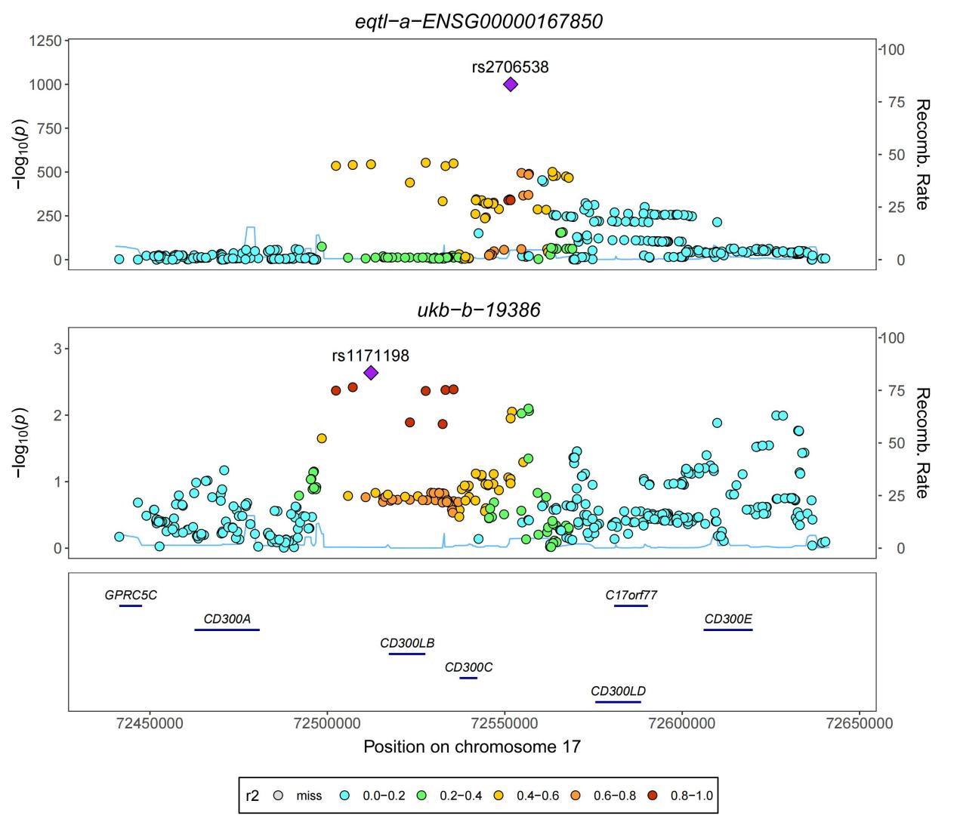
Figure S1. Bayesian co localization map of CD300C gene and ulcerative colitis.

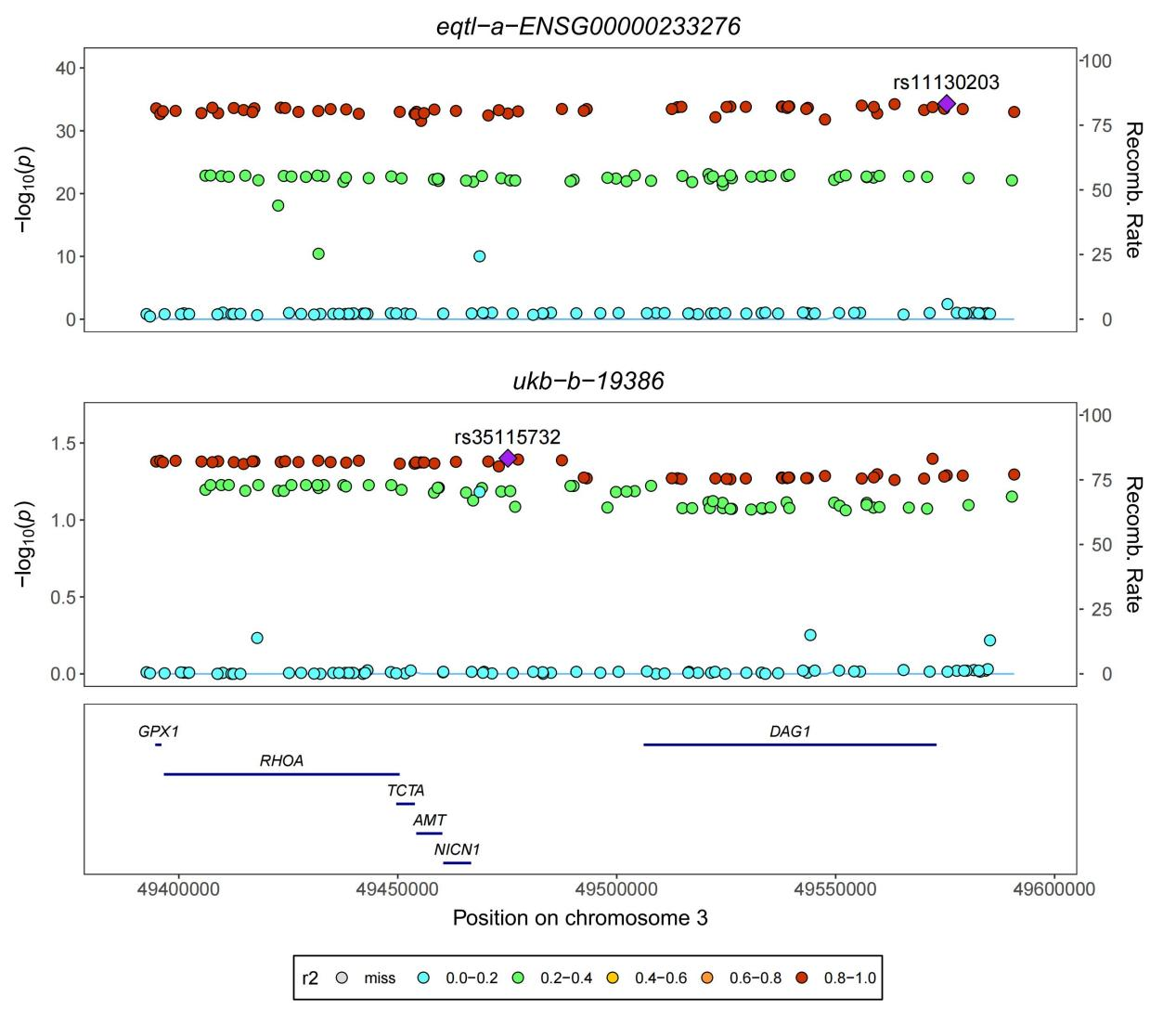
Figure S2. Bayesian co localization map of GPX1 gene and ulcerative colitis.
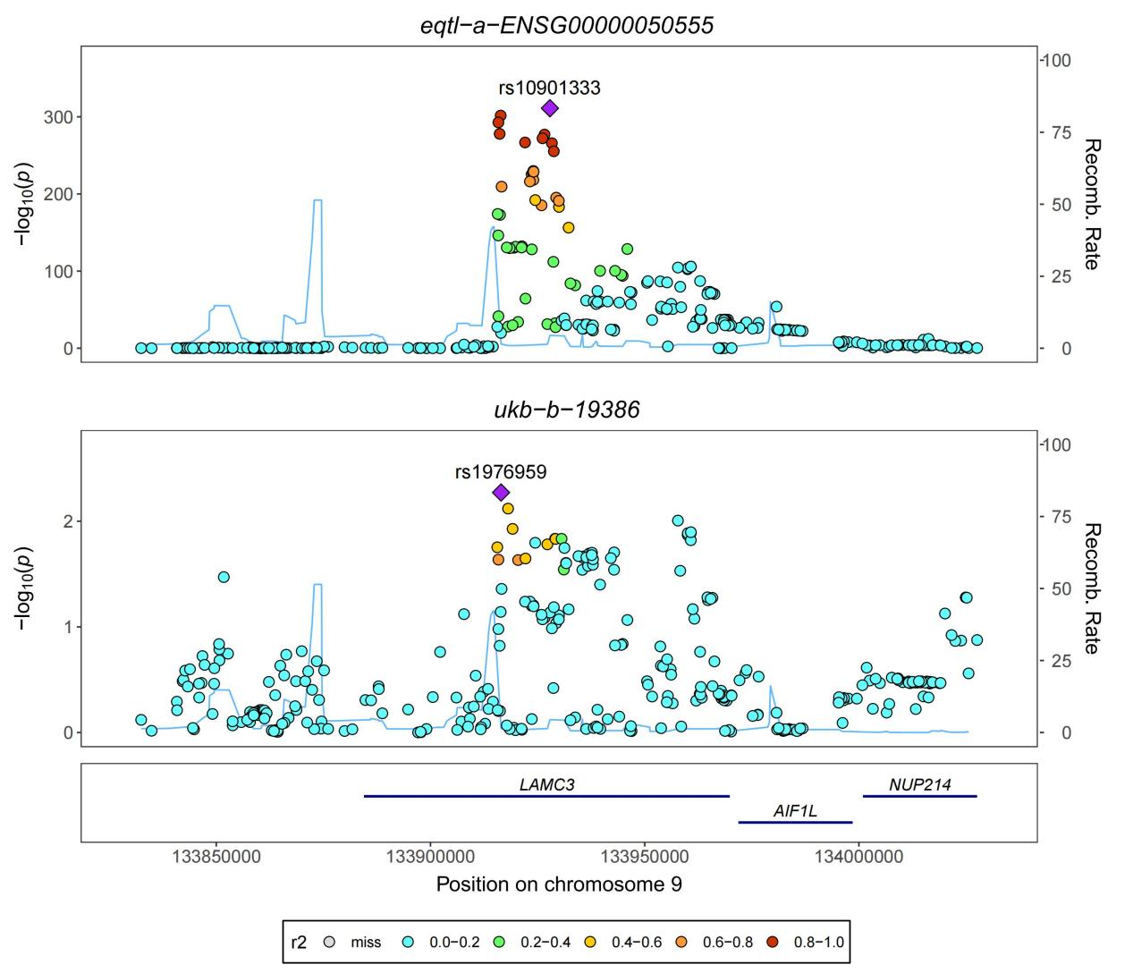Figure S3. Bayesian co localization map of LAMC3 gene and ulcerative colitis.
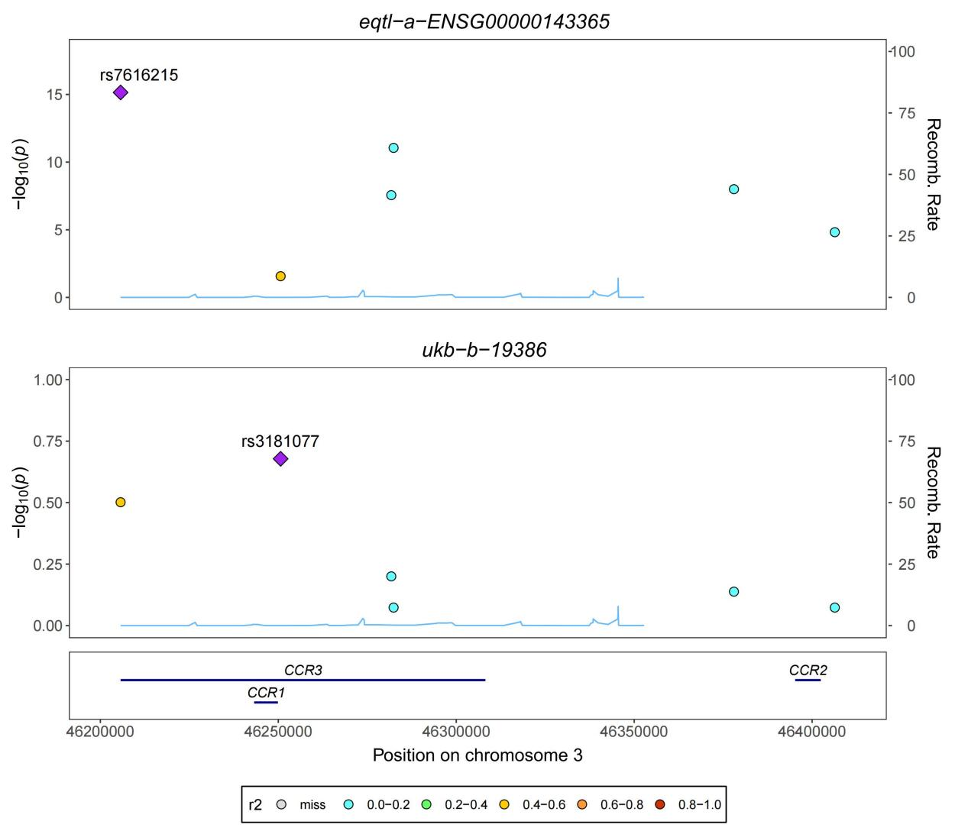Figure S4. Bayesian co localization map of RORC gene and ulcerative colitis.
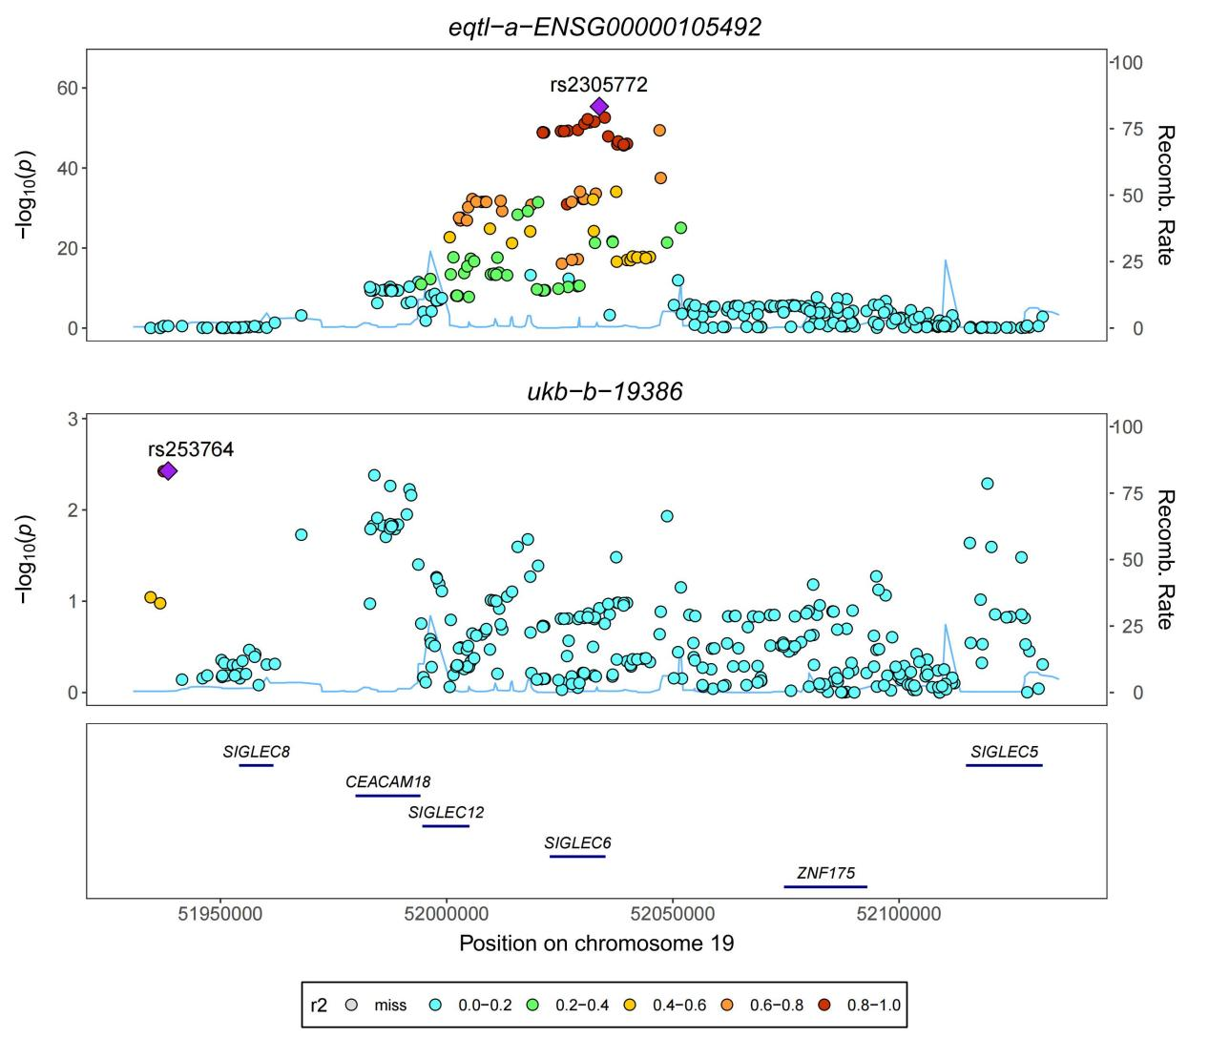Figure S5. Bayesian co localization map of SIGLEC6 gene and ulcerative colitis.
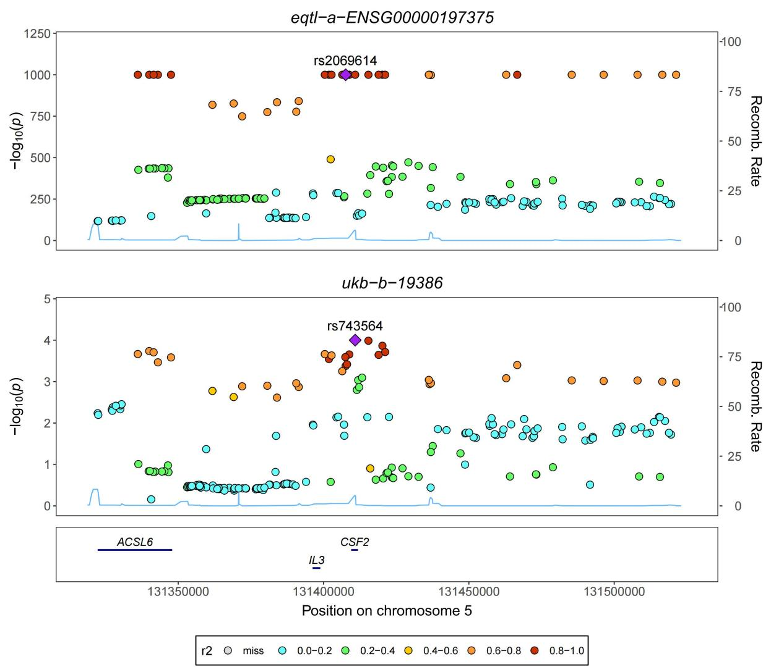Figure S6. Bayesian co localization map of SLC22A5 gene and ulcerative colitis.
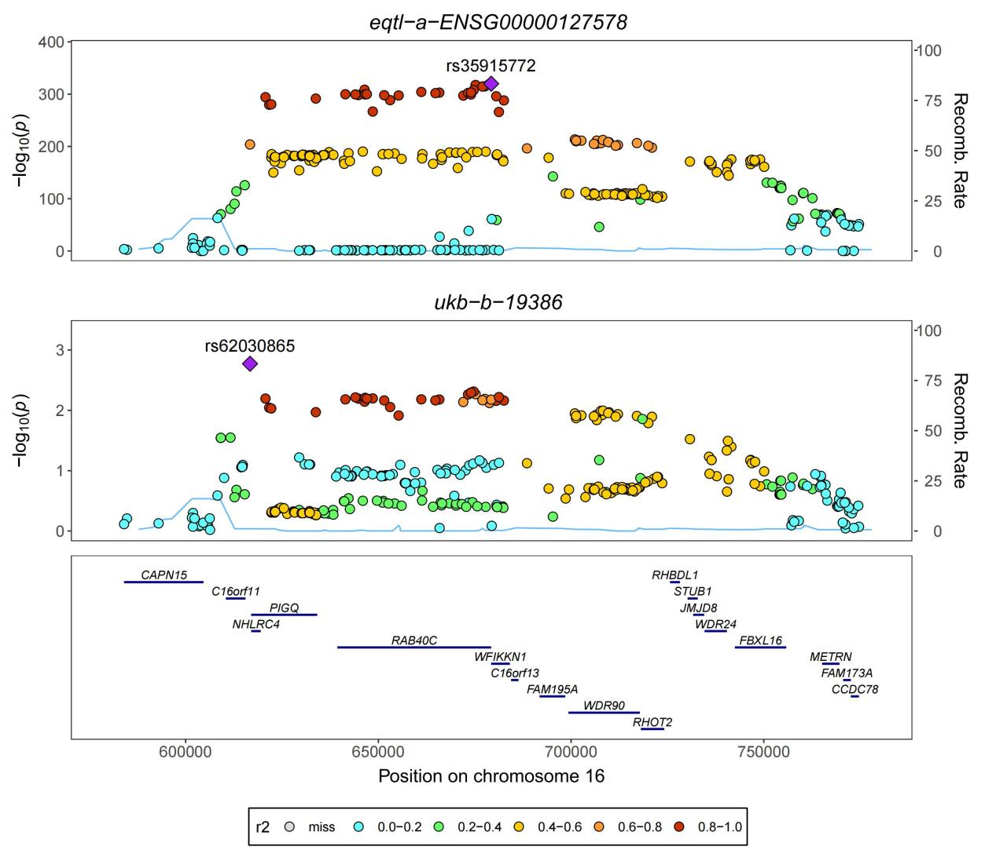Figure S7. Bayesian co localization map of WFIKKN1 gene and ulcerative colitis.

