Attachment Table
S1:Single factor Cox regression results
variable | level | HR(95%CI) | p
Gender
 | Men | reference
 | Women | 0.754 (0.532, 1.068) | 0.112
Age |  | 1.038 (1.025, 1.052) | <0.001
Coronary artery disease
 | No | reference
 | Yes | 1.495 (0.971, 2.302) | 0.068
Hypertension
 | No | reference
 | Yes | 0.971 (0.701, 1.344) | 0.858
Diabetes mellitus
 | No | reference
 | Yes | 1.073 (0.731, 1.575) | 0.718
Chronic kidney disease
 | No | reference
 | Yes | 1.957 (1.333, 2.874) | 0.001
Chronic obstructive pulmonary disease
 | No | reference
 | Yes | 1.790 (1.219, 2.627) | 0.003
Active malignancy
 | No | reference
 | Yes | 0.896 (0.576, 1.393) | 0.626
Clinical stages
 | Mild | reference
 | Moderate | 0.772 (0.456, 1.305) | 0.334
 | Severe | 3.071 (1.833, 5.145) | <0.001
 | Critical | 8.114 (4.835, 13.618) | <0.001
White blood cells |  | 1.034 (1.015, 1.054) | 0.001
Red blood cells |  | 0.862 (0.718, 1.035) | 0.112
Hemoglobin |  | 0.994 (0.987, 1.000) | 0.064
Platelets |  | 0.997 (0.996, 0.999) | 0.002
Neutrophil |  | 1.041 (1.022, 1.060) | <0.001
Lymphocyte |  | 0.501 (0.357, 0.704) | <0.001
Monocyte |  | 1.059 (0.965, 1.162) | 0.230
Eosinophil |  | 0.013 (0.001, 0.234) | 0.003
Basophil |  | 0.000 (0.000, 12.037) | 0.133
Alanine aminotransferase |  | 1.001 (1.000, 1.002) | 0.254
Aspartate aminotransferase |  | 1.000 (1.000, 1.000) | 0.532
Glutamyl transpeptidase |  | 1.001 (0.999, 1.002) | 0.501
Alkaline phosphatase |  | 1.002 (1.001, 1.004) | 0.005
Cholinesterase |  | 1.000 (1.000, 1.000) | <0.001
Total protein |  | 0.969 (0.948, 0.991) | 0.005
Albumin |  | 0.921 (0.897, 0.946) | <0.001
Globulin |  | 1.027 (1.004, 1.051) | 0.022
Total bilirubin |  | 1.007 (1.003, 1.011) | <0.001
Direct bilirubin |  | 1.009 (1.005, 1.013) | <0.001
Indirect bilirubin |  | 1.007 (0.988, 1.026) | 0.467
Total bile acid |  | 1.005 (1.001, 1.009) | 0.025
Prealbumin |  | 0.994 (0.992, 0.996) | <0.001
Alpha-fucosidase |  | 1.016 (1.004, 1.027) | 0.007
Urea |  | 1.012 (1.006, 1.017) | <0.001
Creatinine |  | 1.001 (1.000, 1.001) | 0.001
Glomerular filtration rate |  | 0.992 (0.989, 0.996) | <0.001
Uric acid |  | 1.003 (1.002, 1.004) | <0.001
Total carbon dioxide |  | 0.918 (0.889, 0.948) | <0.001
Prothrombin time |  | 1.031 (1.002, 1.062) | 0.037
International standardization ratio |  | 0.993 (0.955, 1.033) | 0.727
Fibrinogen |  | 0.967 (0.866, 1.079) | 0.548
Activated partial thromboplastin time |  | 1.004 (0.998, 1.009) | 0.163
Thrombin time |  | 1.009 (1.000, 1.019) | 0.051
Antithrombin-III |  | 0.975 (0.966, 0.984) | <0.001
Prothrombin activity |  | 0.980 (0.971, 0.988) | <0.001
D-dimer |  | 1.010 (0.990, 1.030) | 0.315
Data are n (%) or median (IQR).

S2:Baseline characteristics of patients were included after 1 : 1 propensity score matching.
Variable | Level | Control group | Azvudine group | P | SMD
N |  | 920 | 920
Age (mean,SD) |  | 66.44 (15.76) | 66.88 (15.56) | 0.549 | 0.028
Coronary artery disease (%) | No | 805 (87.5) | 815 (88.6) | 0.518 | 0.034
 | Yes | 115 (12.5) | 105 (11.4)
Chronic Kidney Disease (%) | No | 813 (88.4) | 811 (88.2) | 0.942 | 0.007
 | Yes | 107 (11.6) | 109 (11.8)
Chronic obstructive pulmonary disease (%) | No | 792 (86.1) | 798 (86.7) | 0.734 | 0.019
 | Yes | 128 (13.9) | 122 (13.3)
Clinical stages (%) | Mild | 197 (21.4) | 201 (21.8) | 0.491 | 0.073
 | Moderate | 589 (64.0) | 566 (61.5)
 | Severe | 95 (10.3) | 115 (12.5)
 | Critical | 39 ( 4.2) | 38 ( 4.1)
White blood cells (mean,SD) |  | 7.00 (3.88) | 7.12 (4.35) | 0.544 | 0.028
Hemoglobin (mean,(SD) |  | 120.12 (23.26) | 119.56 (24.61) | 0.617 | 0.023
Platelets (mean,SD) |  | 226.56 (112.11) | 223.82 (107.40) | 0.593 | 0.025
Neutrophil count (mean,SD) |  | 5.18 (3.71) | 5.35 (3.95) | 0.366 | 0.042
Lymphocyte count (mean,SD) |  | 1.14 (0.69) | 1.10 (1.12) | 0.398 | 0.039
Monocyte count (mean,SD) |  | 0.06 (0.13) | 0.05 (0.10) | 0.057 | 0.089
Alkaline phosphatase (mean,SD) |  | 81.69 (44.56) | 81.26 (51.22) | 0.848 | 0.009
Cholinesterase (mean,SD) |  | 6106.78 (2090.41) | 5965.91 (2098.36) | 0.149 | 0.067
Total protein (mean,SD) |  | 62.67 (7.30) | 62.14 (7.26) | 0.118 | 0.073
Albumin (mean,SD) |  | 35.74 (5.36) | 35.09 (5.68) | 0.012 | 0.118
Glob ulin (mean,SD) |  | 26.94 (5.71) | 27.04 (4.97) | 0.684 | 0.019
Total bilirubin (mean,SD) |  | 12.14 (13.32) | 11.84 (12.56) | 0.612 | 0.024
Direct bilirubin (mean,SD) |  | 6.27 (10.16) | 6.14 (10.27) | 0.791 | 0.012
Total bile acid (mean,SD) |  | 7.68 (19.23) | 7.43 (17.67) | 0.772 | 0.014
Prealbumin (mean,SD) |  | 166.44 (80.91) | 157.34 (78.10) | 0.014 | 0.114
Alpha-fucosidase (mean,SD) |  | 23.16 (10.53) | 22.89 (11.16) | 0.595 | 0.025
Urea (mean,SD) |  | 7.54 (6.76) | 7.79 (9.52) | 0.522 | 0.03
Creatinine (mean,SD) |  | 131.72 (193.86) | 137.90 (211.14) | 0.514 | 0.03
Glomerular filtration rate (mean,SD) |  | 98.97 (46.13) | 97.99 (46.98) | 0.65 | 0.021
Uric acid (mean,SD) |  | 304.47 (127.05) | 305.76 (132.37) | 0.832 | 0.01
Total carbon dioxide (mean,SD) |  | 24.36 (5.70) | 24.45 (15.91) | 0.871 | 0.008
Prothrombin time (mean ,SD) |  | 11.95 (2.08) | 11.92 (1.65) | 0.69 | 0.019
Thrombin time (mean,SD) |  | 16.59 (9.60) | 16.25 (7.64) | 0.401 | 0.039
Antithrombin-III (mean,SD) |  | 83.99 (16.63) | 83.18 (15.20) | 0.278 | 0.051
Prothrombin activity (mean,SD) |  | 83.74 (15.74) | 83.45 (14.69) | 0.68 | 0.019

Data are n (%) or median (IQR).

S3:Baseline characteristics of patients were included inverse probability of treatment weighting.
Variable | Level | Control | Azvudine | P | SMD
N |  | 2877 | 2867
Age (mean,SD) |  | 65.74 (17.29) | 65.90 (16.29) | 0.84 | 0.009
Coronary artery disease (%) | No | 2520.1 (87.6) | 2522.9 (88.0) | 0.77 | 0.012
 | Yes | 357.1 (12.4) | 344.5 (12.0)
Chronic Kidney Disease (%) | No | 2541.9 (88.3) | 2539.4 (88.6) | 0.876 | 0.007
 | Yes | 335.3 (11.7) | 328.0 (11.4)
Chronic obstructive pulmonary disease (%) | No | 2496.7 (86.8) | 2469.3 (86.1) | 0.676 | 0.019
 | Yes | 380.4 (13.2) | 398.1 (13.9)
Clinical stages (%) | Mild | 837.5 (29.1) | 848.5 (29.6) | 0.978 | 0.019
 | Moderate | 1581.7 (55.0) | 1580.2 (55.1)
 | Severe | 348.9 (12.1) | 331.3 (11.6)
 | Critical | 109.0 ( 3.8) | 107.4 ( 3.7)
White blood cells (mean,SD) |  | 7.16 (4.75) | 7.15 (4.29) | 0.968 | 0.002
Hemoglobin (mean,(SD) |  | 120.00 (23.51) | 119.08 (25.95) | 0.472 | 0.037
Platelets (mean,SD) |  | 226.25 (111.40) | 222.94 (108.42) | 0.512 | 0.03
Neutrophil count (mean,SD) |  | 5.36 (4.53) | 5.30 (3.80) | 0.757 | 0.013
Lymphocyte count (mean,SD) |  | 1.11 (0.68) | 1.12 (1.02) | 0.87 | 0.007
Monocyte count (mean,SD) |  | 0.06 (0.10) | 0.06 (0.12) | 0.665 | 0.02
Alkaline phosphatase (mean,SD) |  | 82.58 (55.39) | 84.24 (72.79) | 0.721 | 0.026
Cholinesterase (mean,SD) |  | 6057.19 (2125.13) | 6019.60 (2100.57) | 0.695 | 0.018
Total protein (mean,SD) |  | 62.39 (7.51) | 62.40 (7.11) | 0.983 | 0.001
Albumin (mean,SD) |  | 35.49 (5.61) | 35.45 (5.66) | 0.897 | 0.006
Glob ulin (mean,SD) |  | 26.90 (5.77) | 26.95 (4.97) | 0.828 | 0.01
Total bilirubin (mean,SD) |  | 12.19 (17.60) | 12.96 (20.76) | 0.583 | 0.04
Direct bilirubin (mean,SD) |  | 6.42 (13.75) | 7.20 (18.64) | 0.547 | 0.047
Total bile acid (mean,SD) |  | 7.59 (18.72) | 8.21 (21.75) | 0.62 | 0.031
Prealbumin (mean,SD) |  | 161.16 (80.09) | 161.63 (80.74) | 0.898 | 0.006
Alpha-fucosidase (mean,SD) |  | 23.15 (10.28) | 23.16 (10.71) | 0.994 | <0.001
Urea (mean,SD) |  | 7.70 (6.95) | 7.78 (9.65) | 0.824 | 0.01
Creatinine (mean,SD) |  | 131.79 (189.97) | 135.57 (200.25) | 0.631 | 0.019
Glomerular filtration rate (mean,SD) |  | 98.80 (47.14) | 98.19 (45.83) | 0.759 | 0.013
Uric acid (mean,SD) |  | 308.31 (131.44) | 310.16 (135.68) | 0.755 | 0.014
Total carbon dioxide (mean,SD) |  | 24.33 (9.24) | 24.26 (14.17) | 0.897 | 0.005
Prothrombin time (mean ,SD) |  | 11.99 (2.26) | 12.04 (2.95) | 0.705 | 0.016
Thrombin time (mean,SD) |  | 16.56 (9.63) | 16.55 (9.83) | 0.974 | 0.002
Antithrombin-III (mean,SD) |  | 83.67 (16.72) | 83.47 (15.46) | 0.778 | 0.013
Prothrombin activity (mean,SD) |  | 83.54 (15.77) | 83.26 (15.46) | 0.692 | 0.018
Data are n (%) or median (IQR).

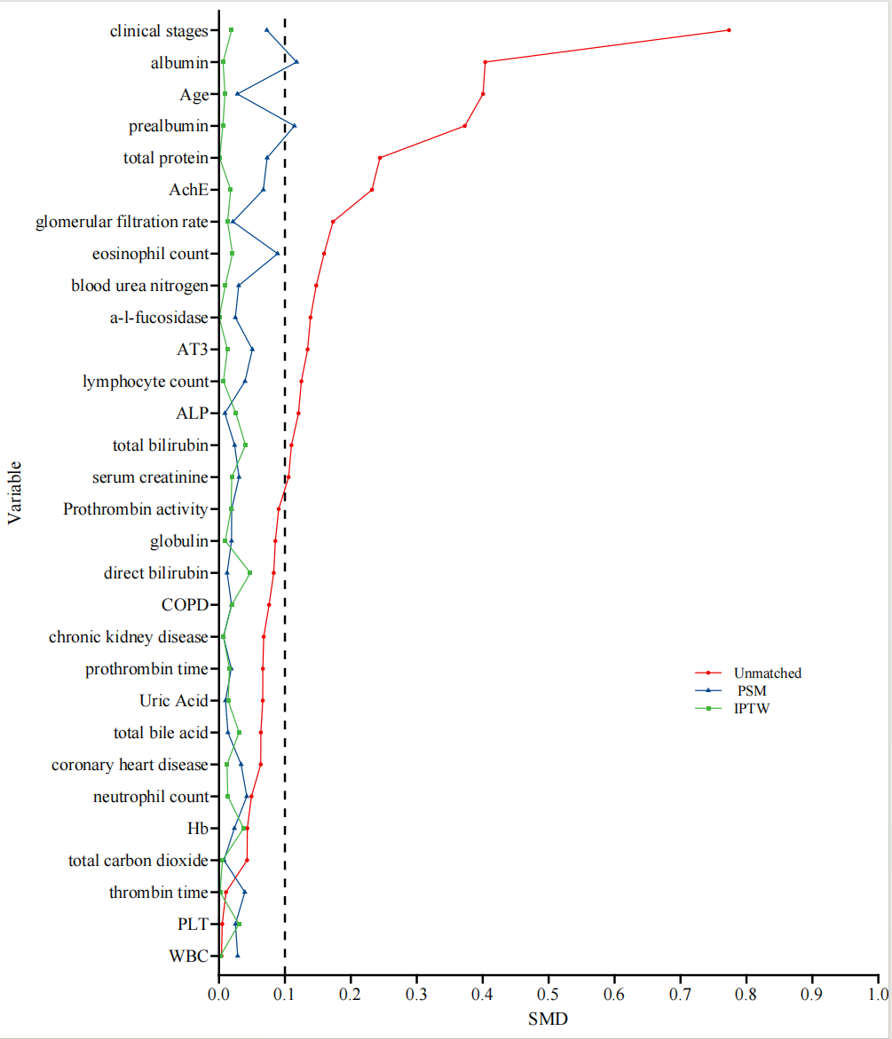
S4:Standardized mean difference before and after propensity score matching and inverse probability of treatment weighting.
Abbreviations:AchE,Cholinesterase;AT3,Antithrombin-III;ALP,Alkaline phosphatase;COPD,Chronic obstructive pulmonary diseaseHb,Hemoglobin;PLT,Platelets;WB,White blood cells;PSM,propensity score matching;IPTW;Inverse Probability of Treatment Weighting;SMD,Standardized mean difference.

