After feature selection, 15, 3, 14, and 13 texture features were left to build GM-model, WM-model, CSF-model and Rad-model, respectively. The Logistic Regression (LR) classifier, a commonly used method, was employed to compare the four models. The AUC of Rad-model was higher than other three models.

WM-model：15 texture features（ log(λ) = -7.072，α = 0.75 ）
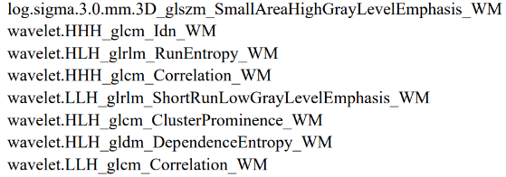
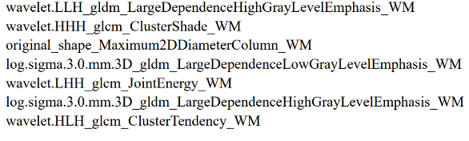
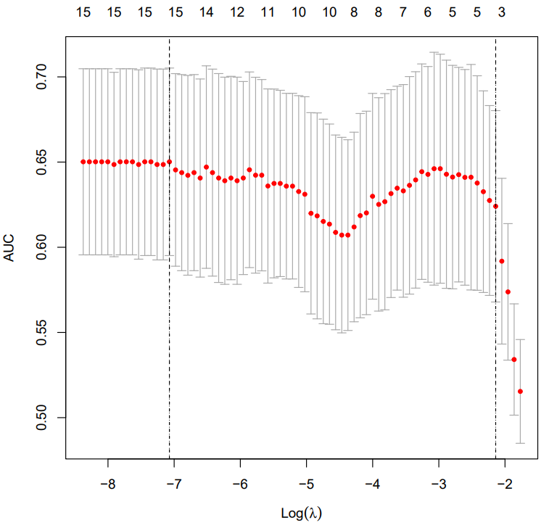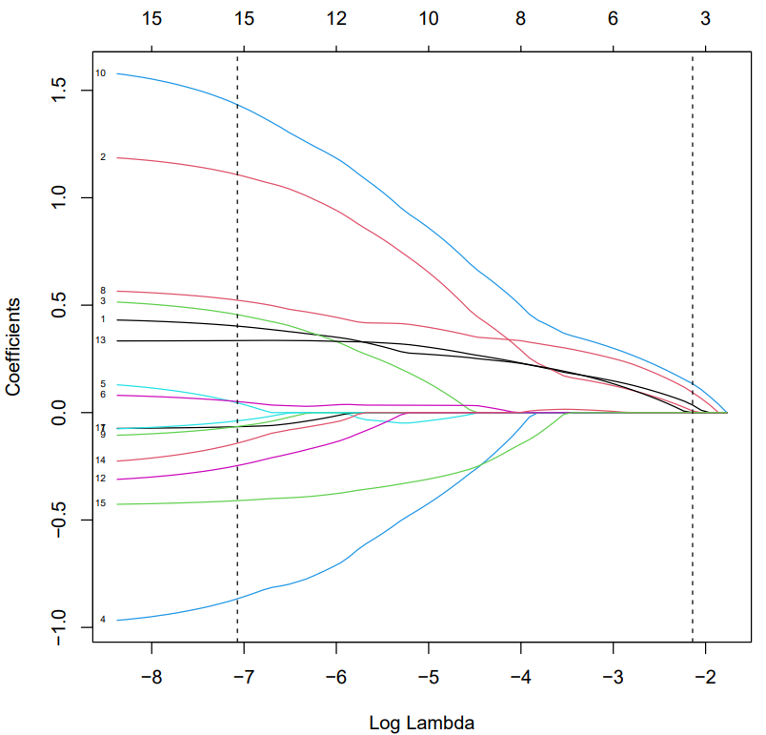

GM-model：3 texture features（ log(λ) = -1.524，α = 0.5 ）
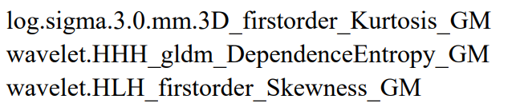
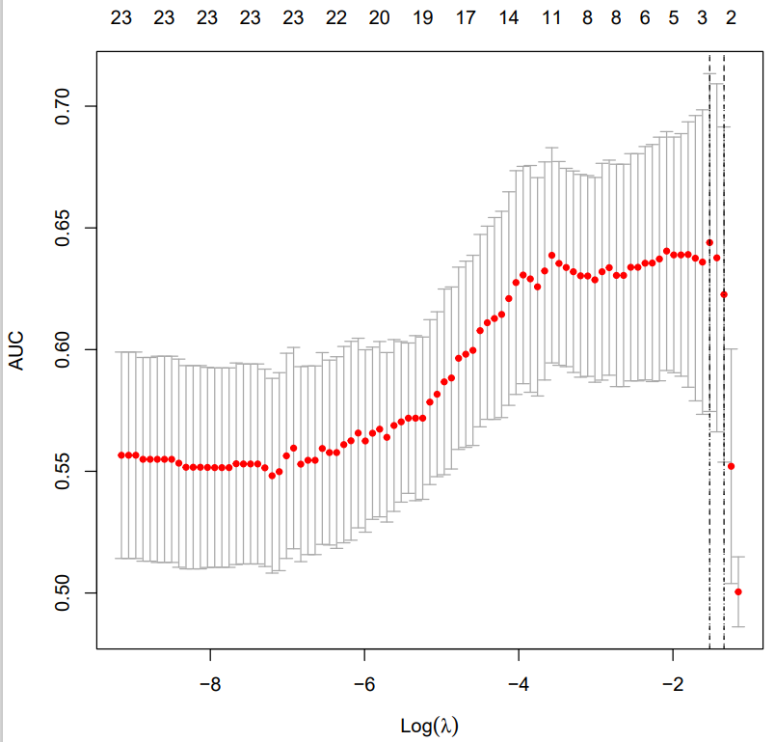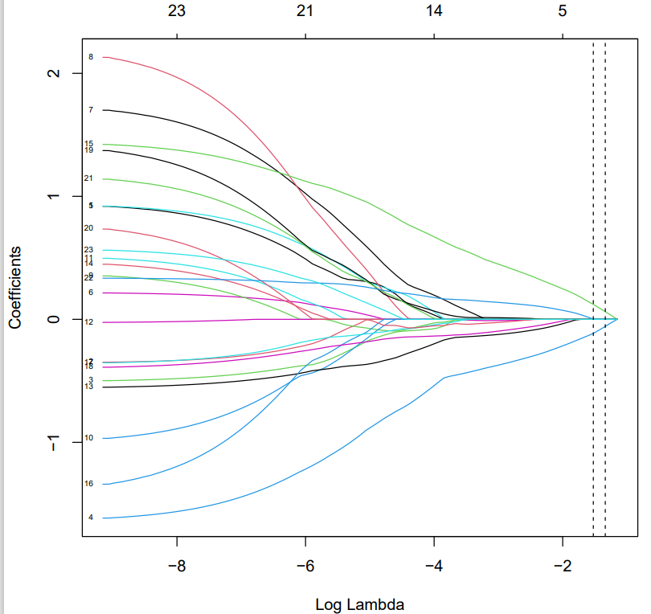

CSF-model：14 texture features（ log(λ) = -5.722，$α$ = 1 ）
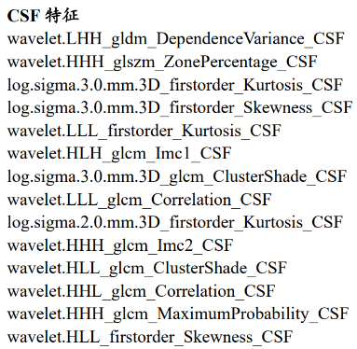
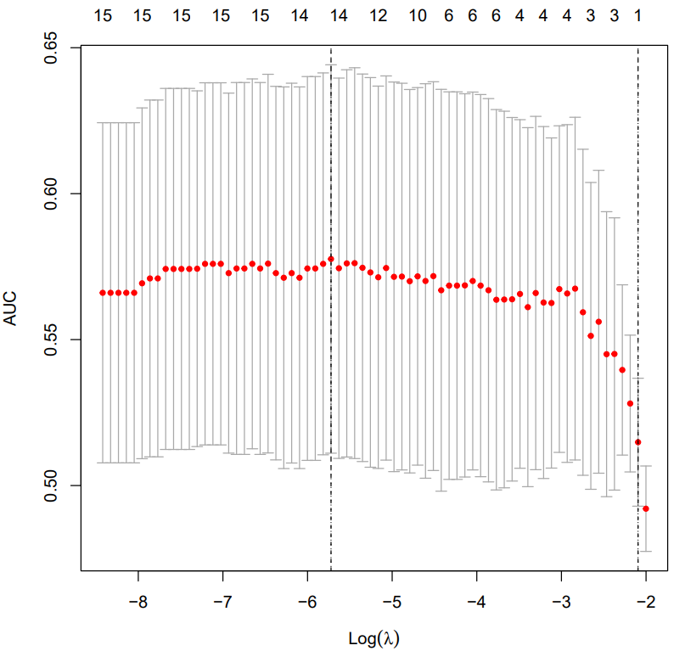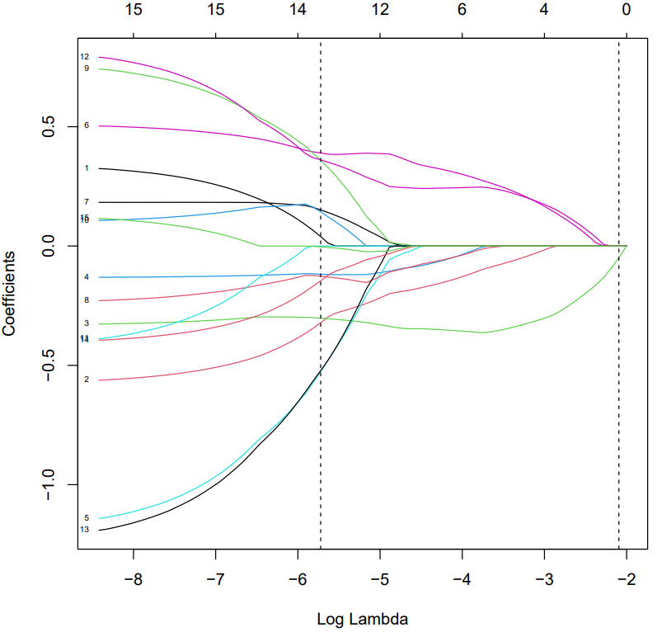

Rad-model：13 texture features（ log(λ) = -3.291，$α$ = 0.5 ）
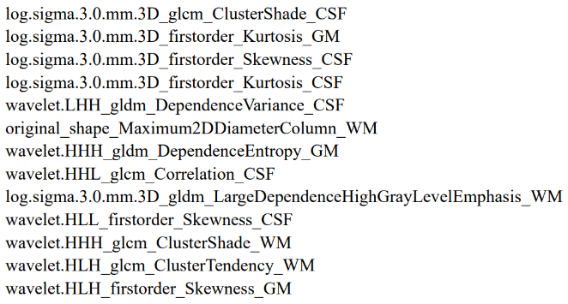
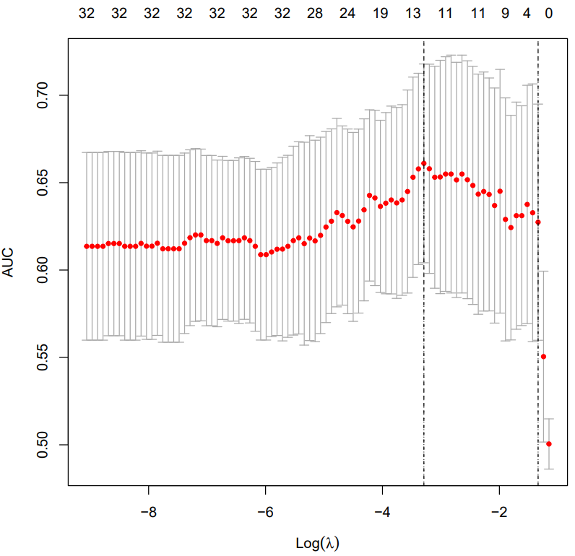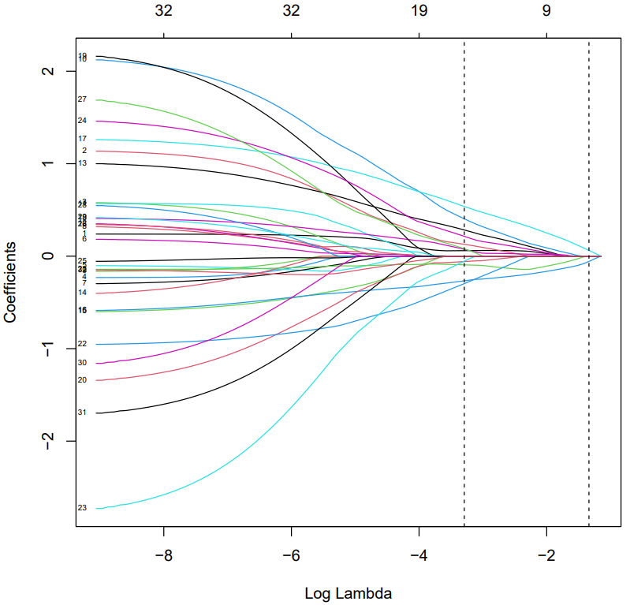

Table S1. Diagnostic performance of radiomics models based on different ROIs.
 | Model | AUC (95% CI) | Accuracy | Sensitivity | Specificity
Training set | WM-model | 0.752 (0.658-0.841) | 0.687 | 0.625 | 0.791
Training set | GM-model | 0.705 (0.590-0.800) | 0.739 | 0.903 | 0.465
Training set | CSF-model | 0.714 (0.615-0.807) | 0.704 | 0.833 | 0.488
Training set | Rad-model | 0.838 (0.751-0.909) | 0.722 | 0.833 | 0.535
Testing set | WM-model | 0.625 (0.456-0.788) | 0.600 | 0.516 | 0.737
Testing set | GM-model | 0.593 (0.421-0.764) | 0.620 | 0.839 | 0.263
Testing set | CSF-model | 0.594 (0.429-0.766) | 0.660 | 0.839 | 0.368
Testing set | Rad-model | 0.733 (0.586-0.865) | 0.720 | 0.839 | 0.526

