Appendix for Targeted Protest and Affective Polarization

November 6, 2023

Table of Contents
Appendix A. Descriptive Data. 2
Appendix B. Alternative Specifications (Like-Dislike Score for the Ruling Parties) 6
Appendix C. Alternative Specifications (Affective Polarization) 10

Appendix A. Descriptive Data.

Table A1 Descriptive Statistics of Variables in the Main Models
Variables | N | Mean | Median | SD | Min. | Max.
Country-Year Level
Number of Targeted Protests | 100 | 0.01 | 0 | 0.06 | 0 | 0.55
Societal Polarization _{t-1} | 100 | -1.05 | -1.16 | 1.27 | -3.87 | 3.08
ln(Population)_{t-1} | 100 | 16.76 | 16.24 | 1.33 | 13.34 | 19.16
GDP growth_{t-1} | 100 | 2.10 | 2.18 | 3.66 | -10.87 | 24.37
Unemployment_{t-1} | 100 | 7.73 | 6.73 | 4.59 | 2.12 | 26.49
Electoral Democracy_{t-1} | 100 | 0.83 | 0.87 | 0.10 | 0.47 | 0.92
ENP | 100 | 4.04 | 3.51 | 1.87 | 2.09 | 13.27
ln(District Magnitude) | 100 | 1.77 | 2.04 | 1.53 | 0 | 5.01
Individual Level
Attitude toward Government Partyª | 80,383 | 5.19 | 5 | 3.20 | 0 | 10
Weighted AP Score | 77,624 | 2.63 | 2.61 | 1.06 | 0 | 5.14
Government Party ID | 80,383 |  | 0 |  | 0 | 1
Female | 80,383 |  | 0 |  | 0 | 1
Post-Secondary Education^{b} | 80,383 |  | 0 |  | 0 | 1
Secondary Education^{b} | 80,383 |  | 0 |  | 0 | 1
Unemployed | 80,383 |  | 0 |  | 0 | 1
Income | 80,383 | 2.21 | 2 | 1.97 | 0 | 6
Political Sophistication^{c} | 80,383 | 0.49 | 0.50 | 0.33 | 0 | 1
Satisfaction to System^{d} | 80,383 | 1.76 | 1 | 1.24 | 0 | 4
Ideological Polarization | 70,820 | 2.56 | 2.58 | 1.51 | 0 | 163.25
Religious Attendance^{e} | 70,820 | 1.98 | 1 | 1.81 | 0 | 5
Urban | 73,546 |  | 0 |  | 0 | 1
Media Consumption^{f} | 26,686 | 1.86 | 2 | 0.78 | 0 | 3
Protest Participation^{g} | 14,305 |  | 0 |  | 0 | 1
ª The precise wording for the like-dislike question is: ‘I’d like to know what you think about each of our political parties. After I read the name of a political party, please rate it on a scale from 0 to 10, where 0 means you strongly dislike that party and 10 means that you strongly like that party.
^{b} Reference group for the education is the individuals with less than secondary education.
^{c} The respondents are asked to answer the 3 to 4 politically relevant questions, and the number of correct answers is counted. Then, I standardized the respondents’ level of political sophistication between 0 and 1 based on the number of correct answers to the political questions.
^{d} The precise question wording is: ‘On the whole, are you very satisfied, fairly satisfied, not very satisfied, or not at all satisfied with the way democracy works in [COUNTRY]?’ The rate is on a scale from 0 to 4, where 0 means you are very satisfied with democracy and 5 means that you are not at all satisfied.
^{e} Responder’s religious service attendance is coded between 0-5 from “never” to “more than once a week.”
^{f} This question is only included in Module 5. The precise question wording is: “how closely do you follow politics on TV, radio, newspapers, or the Internet?” I recode the scale between 0 (not at all) and 3 (very closely).
^{g} This question is only included in Module 2. The precise question wording is: “Over the past five years or so, have you done any of the following things to express your views about something the government should or should not be doing? Yes is coded as 1 and 0 otherwise.

Table A2 List of the Countries and Surveys Used in the Study (1996-2021)
Country | Year | Average Weighted AP Score | No. of Respondents
Albania | 2005 | 3.46 | 723
Albania | 2017 | 2.86 | 609
Austria | 2008 | 2.67 | 615
Austria | 2013 | 2.68 | 288
Belgium | 2003 | 1.82 | 448
Belgium | 2019 | 2.79 | 418
Brazil | 2002 | 2.66 | 1,252
Brazil | 2014 | 2.50 | 751
Brazil | 2018 | 2.61 | 352
Canada | 2019 | 2.30 | 1,679
Chile | 2017 | 2.43 | 352
Costa Rica | 2018 | 2.42 | 250
Croatia | 2007 | 2.44 | 571
Czech Republic | 1996 | 3.10 | 590
Czech Republic | 2002 | 2.90 | 410
Czech Republic | 2006 | 3.06 | 999
Czech Republic | 2010 | 2.90 | 876
Czech Republic | 2013 | 2.80 | 662
Czech Republic | 2017 | 2.90 | 480
Denmark | 2019 | 2.68 | 822
El Salvador | 2019 | 2.06 | 670
Finland | 2015 | 2.20 | 1,026
Finland | 2019 | 2.64 | 532
France | 2002 | 2.74 | 400
France | 2007 | 2.51 | 1,708
France | 2012 | 2.88 | 1,491
France | 2017 | 2.92 | 1,153
Germany | 1998 | 2.60 | 1,123
Germany | 2002 | 2.69 | 1,454
Germany | 2005 | 3.66 | 1,002
Germany | 2013 | 2.52 | 1,112
Germany | 2017 | 2.74 | 1,166
Germany | 2021 |  | 1,890
Greece | 2009 | 2.60 | 703
Greece | 2012 | 2.81 | 509
Greece | 2015 | 2.96 | 593
Greece | 2019 | 3.00 | 574
Hungary | 2002 | 3.33 | 878
Ireland | 2002 | 2.34 | 1,086
Ireland | 2016 | 2.68 | 600
Italy | 2006 | 2.68 | 278
Italy | 2018 | 2.76 | 954
Japan | 1996 | N.D. | 1,327
Japan | 2004 | N.D. | 612
Japan | 2007 | N.D. | 862
Japan | 2013 | N.D. | 1,081
Japan | 2017 | 2.20 | 416
Latvia | 2011 | 2.89 | 244
Latvia | 2018 | 2.67 | 370
Lithuania | 2016 | 2.53 | 357
Lithuania | 2020 | 2.94 | 712
Mexico | 2000 | 2.62 | 933
Mexico | 2003 | 2.79 | 1,031
Mexico | 2006 | 2.63 | 939
Mexico | 2009 | 2.41 | 1,244
Mexico | 2012 | 2.42 | 251
Mexico | 2015 | 2.26 | 561
Mexico | 2018 | 3.00 | 397
Montenegro | 2012 | 2.79 | 388
Netherlands | 1998 | 1.72 | 1,280
Netherlands | 2002 | 1.96 | 912
Netherlands | 2006 | 1.84 | 745
Netherlands | 2010 | 2.04 | 648
Netherlands | 2021 | 2.52 | 1,989
Norway | 1997 | 2.39 | 1,237
Norway | 2017 | 2.68 | 1,101
Philippines | 2016 | 1.48 | 201
Poland | 1997 | 3.03 | 1,027
Poland | 2001 | 2.76 | 795
Poland | 2007 | 2.78 | 1,103
Poland | 2011 | 2.96 | 982
Poland | 2019 | 3.15 | 824
Portugal | 2002 | 2.60 | 661
Portugal | 2005 | 2.58 | 1,462
Portugal | 2009 | 2.56 | 428
Portugal | 2015 | 3.25 | 626
Portugal | 2019 | 2.45 | 364
Romania | 2004 | 2.74 | 392
South Korea | 2012 | 2.24 | 569
South Korea | 2016 | 1.66 | 972
Slovakia | 2010 | 2.94 | 837
Slovakia | 2016 | 2.92 | 468
Slovakia | 2020 | 2.87 | 348
Slovenia | 2004 | 2.52 | 331
Slovenia | 2011 | 2.94 | 132
South Africa | 2009 | 2.77 | 817
Sweden | 1998 | 2.44 | 734
Sweden | 2002 | 2.51 | 775
Sweden | 2006 | 2.51 | 712
Sweden | 2014 | 2.65 | 688
Sweden | 2018 | 3.00 | 2,543
Switzerland | 1999 | 2.40 | 1,127
Switzerland | 2007 | 3.01 | 715
Switzerland | 2011 | 2.86 | 976
United Kingdom | 1997 | 2.61 | 2,041
United Kingdom | 2005 | 2.30 | 498
United Kingdom | 2015 | 2.61 | 613
United Kingdom | 2017 | 2.76 | 656
United Kingdom | 2019 | 2.53 | 1,326
Uruguay | 2019 | 3.10 | 1,026
Note: Country-years listed are included in the main models. Affective polarization scores are calculated based on the responders’ like-dislike score for each political party included in the CSES’s opinion survey dataset.

Figure A1 Levels of Affective Polarization across Countries and Years (1996-2021)

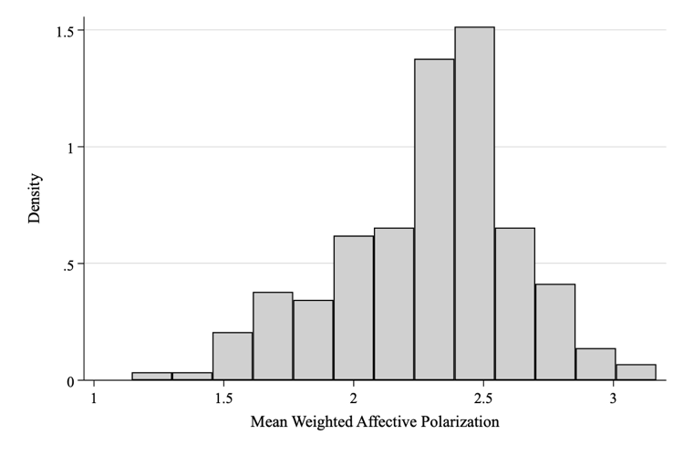

Figure A2 Levels of Affective Polarization across Countries and Years (1996-2021)
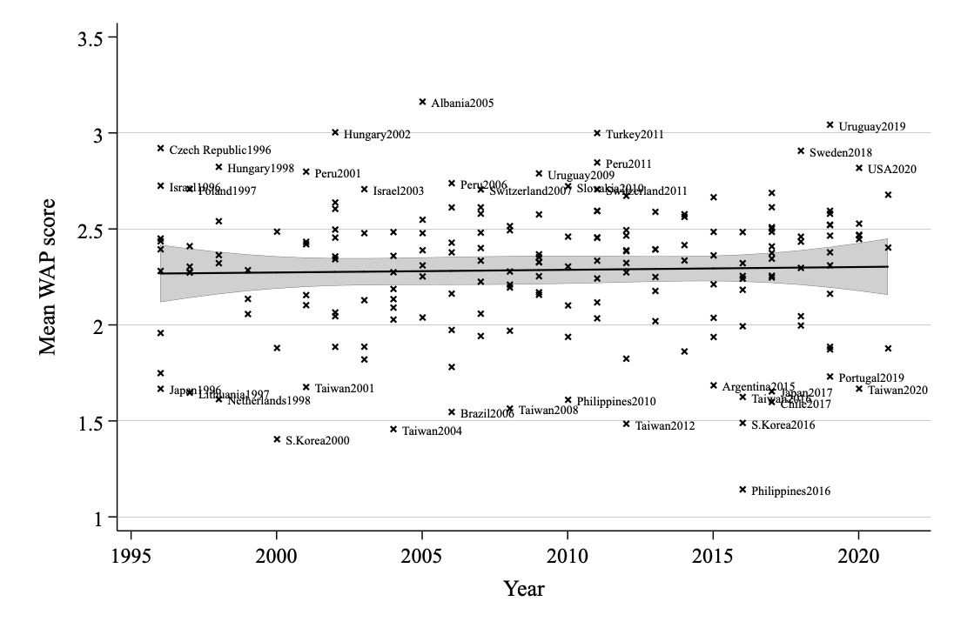

Appendix B. Alternative Specifications (Like-Dislike Score for the Ruling Parties)

Table B1 Effects of Protest on Evaluation to the Ruling Party (Full Model Specification)
 | (1) | (2) | (3)
Protests Participants per Population_{t-1} | -1.20 | -1.95** | 1.30
 | (0.82) | (0.79) | (0.78)
Government Party ID | 2.05*** | 2.10*** | 1.71***
 | (0.40) | (0.39) | (0.42)
Protest_{t-1} * Gov. Party ID | 4.96*** | 4.80*** | 5.63***
 | (1.02) | (0.95) | (0.85)
Country Level Variables
Societal Polarization _{t-1} | -0.21*** | -0.17* | -0.13
 | (0.08) | (0.10) | (0.46)
ln(population size) _{t-1} | 0.18** | 0.07 | -0.36
 | (0.08) | (0.10) | (1.81)
GDP growth_{t-1} | -0.00 | 0.02 | -0.04
 | (0.01) | (0.02) | (0.03)
Unemployment_{t-1} | -0.03 | -0.04* | -0.03
 | (0.02) | (0.02) | (0.04)
Electoral Democracy_{t-1} | -0.77 | 0.21 | -4.09
 | (0.81) | (0.75) | (4.47)
ENP | -0.07 | -0.01 | -0.30**
 | (0.06) | (0.06) | (0.12)
ln(District Magnitude) | 0.11 | 0.04 | -2.04***
 | (0.07) | (0.10) | (0.20)
Individual Level Variables
Female | 0.07 | 0.07 | 0.06
 | (0.06) | (0.06) | (0.06)
Post-Secondary Education | -0.21** | -0.10 | -0.15
 | (0.10) | (0.08) | (0.09)
Secondary Education | -0.14* | -0.11* | -0.05
 | (0.07) | (0.06) | (0.08)
Unemployed | 0.02 | 0.04 | -0.00
 | (0.10) | (0.09) | (0.08)
Income | 0.05** | 0.05** | 0.02
 | (0.02) | (0.02) | (0.02)
Political Sophistication | 0.18* | -0.03 | 0.09
 | (0.10) | (0.13) | (0.12)
Satisfaction to the System | -0.44*** | -0.40*** | -0.35***
 | (0.05) | (0.05) | (0.06)
Constant | 2.81* | 3.26 | 15.53
 | (1.51) | (1.95) | (26.87)
Observations | 80,383 | 80,383 | 70,541
No. of surveys | 100 | 100 | 85
No. Countries | 38 | 38 | 24
R² | 0.16 | 0.18 | 0.15
Country fixed effects | No | No | Yes
Year fixed effects | No | Yes | No
Note: Robust standard errors clustered by countries in parentheses.
* p<0.1, ** p<0.05, *** p<0.0
Figure B1. Predicted Attitude toward the Government Party, Gov. ID vs. Non-Gov. ID

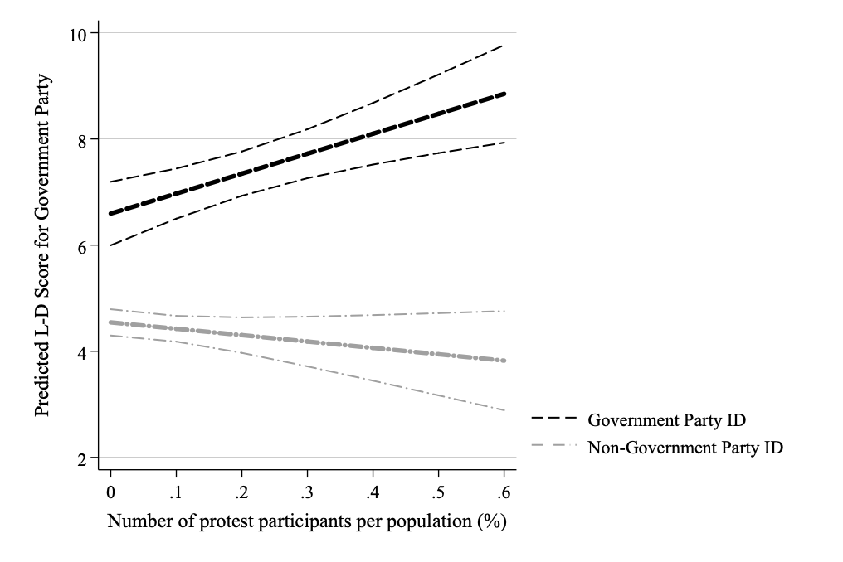
Note: Line shows the predicted like-dislike score for the government party contingent on the range of a number of targeted protests among both ruling party supporters and non-ruling party supporters (Model 1 in Table B1). Other control variables are held at their mean (continuous) and modes (binary). Outer boundaries display 95% confidence intervals.

Table B2 Effects of Protest on Evaluation to the Ruling Party (Mechanism)
 | (4) | (5) | (6) | (7) | (8)
IV | Protest Participations per Population_{t-1} |  |  |  | Protest Participation
Conditions | Urban |  |  | Media
Protest _{t-1} | -1.00 | -2.30 | 54.05 | 0.61 | 0.26
 | (1.19) | (1.63) | (357.89) | (1.33) | (0.44)
Government Party ID | 2.34*** | 2.38*** | 2.04*** | 4.15*** | 1.08
 | (0.41) | (0.41) | (0.47) | (0.48) | (0.75)
Protest_{t-1} * Gov. Party ID | 3.09* | 3.04* | 136.63 | -0.88 | -1.69*
 | (1.74) | (1.72) | (446.23) | (4.42) | (0.88)
Condition | -0.02 | -0.07 | 0.06 | -0.13
 | (0.11) | (0.11) | (0.09) | (0.12)
Protest _{t-1} * Condition | -2.09*** | -1.87*** | -328.21 | 1.41
 | (0.55) | (0.52) | (263.48) | (0.88)
Gov. Party ID * Condition | -0.51** | -0.51** | -0.67** | -0.22
 | (0.24) | (0.25) | (0.26) | (0.21)
Protest _{t-1} * Gov. Party ID | 4.41*** | 4.39*** | 380.81 | 2.42**
* Condition | (1.13) | (1.12) | (355.34) | (1.15)
Country Level Variables
Political Polarization _{t-1} | -0.21*** | -0.19* | -0.18 | -0.01 | -0.49***
 | (0.07) | (0.10) | (0.45) | (0.12) | (0.17)
ln(Population size)_{t-1} | 0.19** | 0.13 | 2.08 | 0.09 | -0.04
 | (0.08) | (0.10) | (1.93) | (0.09) | (0.16)
GDP growth_{t-1} | 0.00 | -0.01 | -0.03 | 0.01 | -0.01
 | (0.01) | (0.02) | (0.03) | (0.02) | (0.12)
Unemployment_{t-1} | -0.03 | -0.05** | -0.06 | -0.09*** | 0.05
 | (0.02) | (0.02) | (0.04) | (0.02) | (0.05)
Electoral Democracy_{t-1} | -0.76 | -0.15 | -1.68 | 3.05* | -3.64**
 | (0.84) | (0.70) | (5.13) | (1.53) | (1.48)
ENP | -0.09 | -0.04 | -0.31** | 0.01 | -0.07
 | (0.06) | (0.07) | (0.12) | (0.04) | (0.11)
ln(District Magnitude) | 0.12* | 0.08 | -2.06*** | 0.11 | 0.07
 | (0.07) | (0.10) | (0.19) | (0.07) | (0.19)
Individual Level Variables
Female | 0.08 | 0.08 | 0.08 | 0.00 | 0.13
 | (0.06) | (0.06) | (0.07) | (0.09) | (0.09)
Post-Secondary Education | -0.09 | 0.00 | -0.04 | 0.40 | 0.04
 | (0.07) | (0.06) | (0.07) | (0.25) | (0.23)
Secondary Education | -0.13* | -0.11* | -0.05 | 0.28 | -0.48**
 | (0.07) | (0.07) | (0.07) | (0.21) | (0.21)
Unemployed | 0.00 | 0.02 | -0.01 | 0.02 | 0.01
 | (0.11) | (0.09) | (0.07) | (0.14) | (0.11)
Income | 0.06*** | 0.05** | 0.04* | -0.01 | 0.07*
 | (0.02) | (0.02) | (0.02) | (0.04) | (0.04)
Political Sophistication | 0.17 | 0.01 | 0.12 | 0.50* | 0.16
 | (0.11) | (0.13) | (0.12) | (0.28) | (0.19)
Satisfaction to the System | -0.42*** | -0.41*** | -0.33*** | -0.52*** | -0.34***
 | (0.05) | (0.05) | (0.06) | (0.08) | (0.11)
Constant | 2.57* | 2.95 | -21.78 | 0.71 | 8.18***
 | (1.52) | (1.92) | (27.72) | (2.33) | (2.23)
Observations | 73,546 | 73,546 | 62,809 | 32,347 | 17,976
No. of Surveys | 93 | 93 | 75 | 33 | 33
No. of Countries | 38 | 38 | 21 | 31 | 31
R² | 0.16 | 0.17 | 0.18 | 0.39 | 0.39
Country fixed effects | No | No | Yes | No | No
Year fixed effects | No | Yes | No | No | No
Note: Robust standard errors clustered by countries in parentheses. Models for media (Model 7) and protest participation (Model 8) do not include year- and country-fixed effects because of the limited number of observations. These questions were only asked in the one survey wave.
* p<0.1, ** p<0.05, *** p<0.01

Appendix C. Alternative Specifications (Affective Polarization)

Table C1 Effects of Targeted Protests on Affective Polarization (Fully Specified Models)
 | (1) | (2) | (3) | (4) | (5) | (6)
Protests Participants per | 0.08 | 0.27 | 0.30 | -0.06 | 0.14 | 0.12
Population_{t-1} | (0.21) | (0.20) | (0.21) | (0.21) | (0.20) | (0.18)
Government Party ID | 0.10** | 0.10** | 0.05 | 0.09** | 0.10** | 0.05
 | (0.04) | (0.04) | (0.04) | (0.04) | (0.04) | (0.04)
Protest_{t-1} * |  |  |  | 0.26*** | 0.24*** | 0.33***
Government Party ID |  |  |  | (0.08) | (0.08) | (0.08)
Country Level Variables
Political Polarization _{t-1} | 0.02 | 0.03 | 0.08 | 0.02 | 0.03 | 0.08
 | (0.03) | (0.03) | (0.06) | (0.03) | (0.03) | (0.06)
ln(population size) _{t-1} | -0.05* | -0.06** | 1.00 | -0.05* | -0.06** | 1.00
 | (0.03) | (0.03) | (0.97) | (0.03) | (0.03) | (0.97)
GDP growth_{t-1} | 0.00 | 0.02** | -0.01 | 0.00 | 0.02** | -0.01
 | (0.01) | (0.01) | (0.01) | (0.01) | (0.01) | (0.01)
Unemployment_{t-1} | 0.02** | 0.03*** | 0.01 | 0.02** | 0.03*** | 0.01
 | (0.01) | (0.01) | (0.01) | (0.01) | (0.01) | (0.01)
Electoral Democracy_{t-1} | 0.23 | 0.37 | -0.49 | 0.23 | 0.37 | -0.49
 | (0.23) | (0.23) | (0.87) | (0.23) | (0.23) | (0.87)
ENP | -0.01 | -0.02 | -0.08*** | -0.01 | -0.02 | -0.08***
 | (0.01) | (0.02) | (0.02) | (0.01) | (0.02) | (0.02)
ln(District Magnitude) | -0.04 | -0.05** | -0.14** | -0.04 | -0.05** | -0.14**
 | (0.03) | (0.03) | (0.06) | (0.03) | (0.03) | (0.06)
Individual Level Variables
Female | 0.09*** | 0.09*** | 0.08*** | 0.09*** | 0.09*** | 0.08***
 | (0.01) | (0.01) | (0.01) | (0.01) | (0.01) | (0.01)
Post-Secondary Education | -0.10*** | -0.13*** | -0.06* | -0.10*** | -0.13*** | -0.06*
 | (0.03) | (0.03) | (0.03) | (0.03) | (0.03) | (0.03)
Secondary Education | -0.03 | -0.05** | -0.04 | -0.03 | -0.05** | -0.04
 | (0.03) | (0.02) | (0.03) | (0.03) | (0.02) | (0.03)
Unemployed | -0.02 | -0.02 | 0.01 | -0.02 | -0.02 | 0.01
 | (0.02) | (0.02) | (0.02) | (0.02) | (0.02) | (0.02)
Political Sophistication | 0.01 | 0.01 | 0.01 | 0.01 | 0.01 | 0.01
 | (0.01) | (0.01) | (0.01) | (0.01) | (0.01) | (0.01)
Income | -0.08 | 0.01 | -0.09*** | -0.08 | 0.01 | -0.09***
 | (0.05) | (0.03) | (0.03) | (0.05) | (0.03) | (0.03)
Satisfaction to the System | 0.00 | -0.00 | -0.01 | 0.00 | -0.00 | -0.01
 | (0.01) | (0.01) | (0.01) | (0.01) | (0.01) | (0.01)
Ideological polarization | 0.18*** | 0.17*** | 0.18*** | 0.18*** | 0.17*** | 0.19***
 | (0.04) | (0.03) | (0.02) | (0.04) | (0.03) | (0.02)
Religiosity | -0.02** | -0.02** | -0.02* | -0.02** | -0.02** | -0.02*
 | (0.01) | (0.01) | (0.01) | (0.01) | (0.01) | (0.01)
Constant | 2.91*** | 3.32*** | -11.67 | 2.91*** | 3.32*** | -11.67
 | (0.56) | (0.56) | (14.27) | (0.56) | (0.56) | (14.27)
Observations | 70,820 | 70,820 | 60,246 | 70,820 | 70,820 | 60,246
No. of Surveys | 91 | 91 | 75 | 91 | 91 | 75
No. of Countries | 37 | 37 | 22 | 37 | 37 | 22
R² | 0.08 | 0.10 | 0.10 | 0.08 | 0.10 | 0.10
Country fixed effects | No | No | Yes | No | No | Yes
Year fixed effects | No | Yes | No | No | Yes | No
Note: Robust standard errors clustered by countries in parentheses.
* p<0.1, ** p<0.05, *** p<0.01

Figure C1. Predicted Affective Polarization Score, Gov. ID vs. Non-Gov. ID
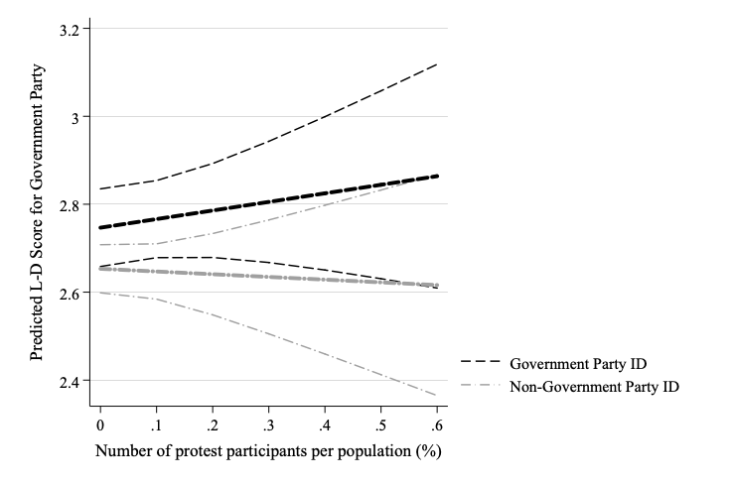

Note: Lines show the predicted affective polarization score (left) and their difference between ruling party supporters and non-ruling party supporters (right) contingent on the range of protest participants (Model 4 in Table C1). Outer boundaries display 90% confidence intervals.

Table C2 Effects of Total/Policy Protests on the Level of Affective Polarization
 | (7) | (8) | (9) | (10) | (11) | (12)
IVs | Total Protests |  |  | Policy Protests
Protests Participants per | -0.04** | 0.00 | -0.05*** | -0.04*** | -0.01 | -0.06***
Population_{t1} | (0.01) | (0.01) | (0.01) | (0.01) | (0.01) | (0.01)
Country Level Variables
Political Polarization _{t-1} | 0.03 | 0.04 | 0.09 | 0.03 | 0.04 | 0.09
 | (0.03) | (0.03) | (0.07) | (0.03) | (0.03) | (0.07)
ln(population size)_{t-1} | -0.05* | -0.06** | 0.85 | -0.05* | -0.06** | 0.87
 | (0.03) | (0.03) | (0.98) | (0.03) | (0.03) | (0.97)
GDP growth_{t-1} | 0.00 | 0.02** | -0.01 | 0.00 | 0.02** | -0.01
 | (0.01) | (0.01) | (0.01) | (0.01) | (0.01) | (0.01)
Unemployment_{t-1} | 0.02** | 0.03*** | 0.01 | 0.02** | 0.03*** | 0.01
 | (0.01) | (0.01) | (0.01) | (0.01) | (0.01) | (0.01)
Electoral Democracy_{t-1} | 0.31 | 0.37 | -0.25 | 0.33 | 0.38 | -0.36
 | (0.24) | (0.23) | (0.86) | (0.24) | (0.23) | (0.80)
ENP | -0.01 | -0.02 | -0.06*** | -0.01 | -0.02 | -0.06***
 | (0.01) | (0.02) | (0.02) | (0.01) | (0.02) | (0.02)
ln(District Magnitude) | -0.05 | -0.05** | -0.14** | -0.05 | -0.06** | -0.14**
 | 0.03 | 0.04 | 0.09 | 0.03 | 0.04 | 0.09
Individual Level Variables
Government Party ID | 0.10** | 0.10** | 0.06 | 0.10** | 0.10** | 0.06
 | (0.04) | (0.04) | (0.04) | (0.04) | (0.04) | (0.04)
Female | 0.09*** | 0.09*** | 0.08*** | 0.09*** | 0.09*** | 0.08***
 | (0.01) | (0.01) | (0.01) | (0.01) | (0.01) | (0.01)
Post-Secondary Education | -0.10*** | -0.13*** | -0.06* | -0.10*** | -0.13*** | -0.06*
 | (0.03) | (0.03) | (0.03) | (0.03) | (0.03) | (0.03)
Secondary Education | -0.03 | -0.05** | -0.04 | -0.03 | -0.05** | -0.04
 | (0.03) | (0.02) | (0.03) | (0.03) | (0.02) | (0.03)
Unemployed | -0.02 | -0.02 | 0.00 | -0.02 | -0.02 | 0.00
 | (0.02) | (0.02) | (0.02) | (0.02) | (0.02) | (0.02)
Income | 0.01 | 0.01 | 0.01 | 0.01 | 0.01 | 0.01
 | (0.01) | (0.01) | (0.01) | (0.01) | (0.01) | (0.01)
Political Sophistication | -0.07 | 0.00 | -0.08*** | -0.07 | 0.00 | -0.08**
 | (0.05) | (0.03) | (0.03) | (0.05) | (0.03) | (0.03)
Satisfaction to the System | 0.00 | -0.00 | -0.01 | 0.00 | -0.00 | -0.01
 | (0.01) | (0.01) | (0.01) | (0.01) | (0.01) | (0.01)
Ideological polarization | 0.18*** | 0.17*** | 0.18*** | 0.18*** | 0.17*** | 0.18***
 | (0.04) | (0.03) | (0.02) | (0.04) | (0.03) | (0.02)
Religiosity | -0.02*** | -0.02** | -0.02* | -0.03*** | -0.02** | -0.02*
 | (0.01) | (0.01) | (0.01) | (0.01) | (0.01) | (0.01)
Constant | 2.88*** | 3.31*** | -9.53 | 2.88*** | 3.31*** | -9.70
 | (0.56) | (0.56) | (14.43) | (0.56) | (0.56) | (14.32)
Observations | 70,820 | 70,820 | 60,246 | 70,820 | 70,820 | 60,246
No. of Surveys | 91 | 91 | 75 | 91 | 91 | 75
No. of Countries | 37 | 37 | 22 | 37 | 37 | 22
R² | 0.08 | 0.10 | 0.10 | 0.08 | 0.10 | 0.10
Country fixed effects | No | No | Yes | No | No | Yes
Year fixed effects | No | Yes | No | No | Yes | No
Note: Robust standard errors clustered by countries in parentheses.
* p<0.1, ** p<0.05, *** p<0.01

