Extended data figures and tables
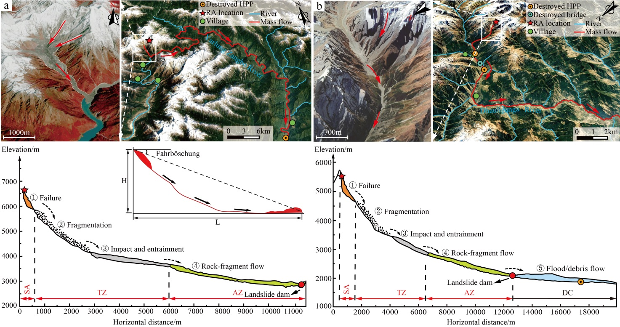
Extended Data Fig. A1. Typical RAs with disaster chains being caused (a: Sedongpu RA, b: Chamoli RA)
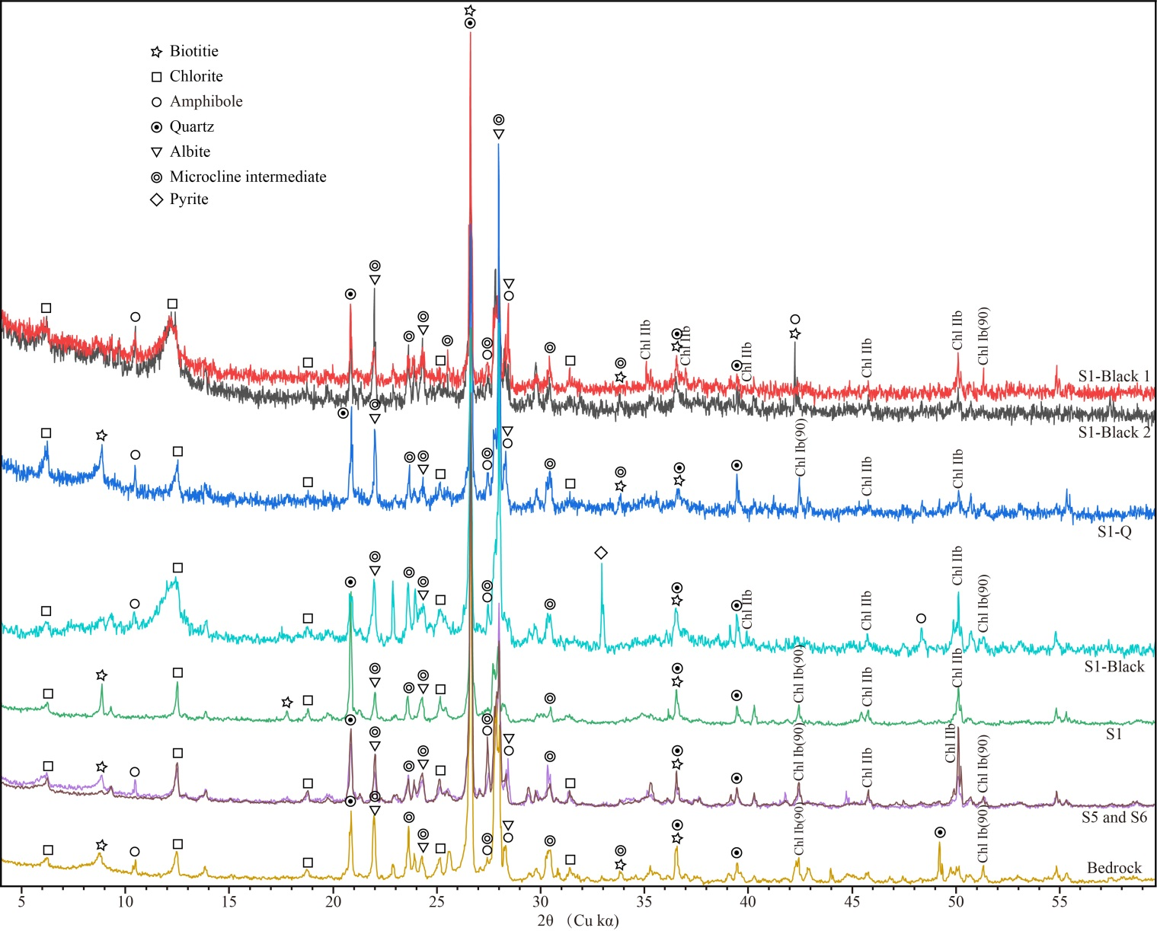
Extended Data Fig. A2. The normalized peak intensities of the XRD powder analyses of the samples tested in SWJTU (Bedrock, S1, S1-Black, S5, and S6) and CUG-Wuhan (S1-Q, S1-Black1 and S1-Black2)
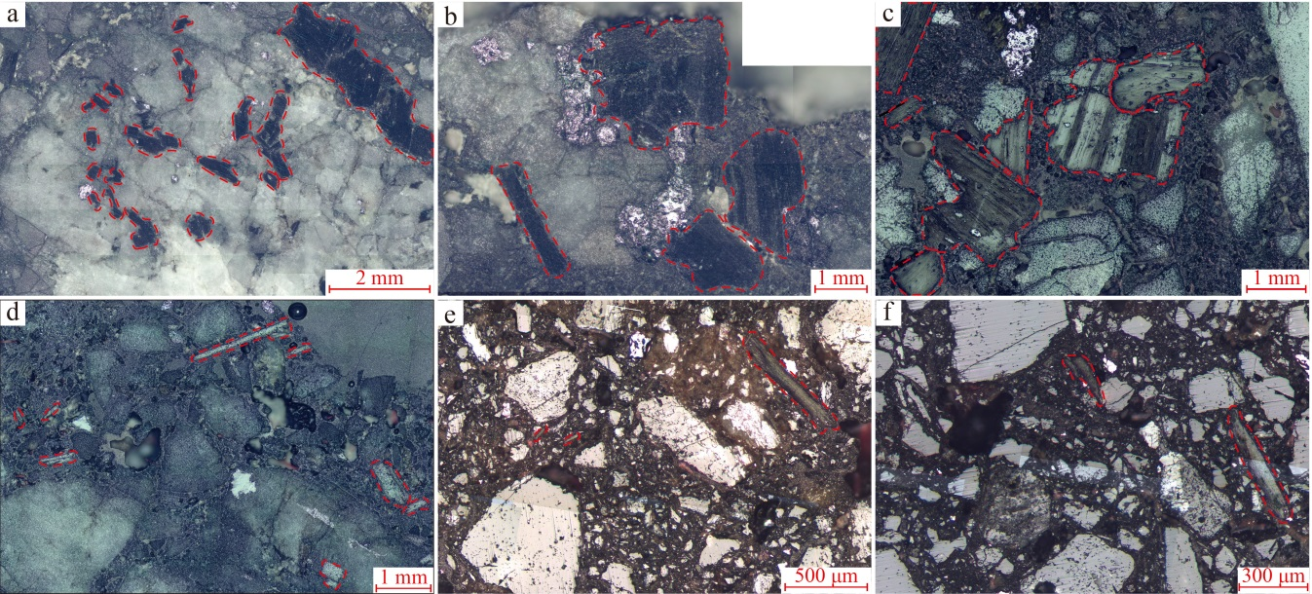
Extended Data Fig. A3. Section images of S1 (a-b), S2 (c), S3 (d) and S6 (e-f) to show the distribution of biotite and chlorite under monopolarized light
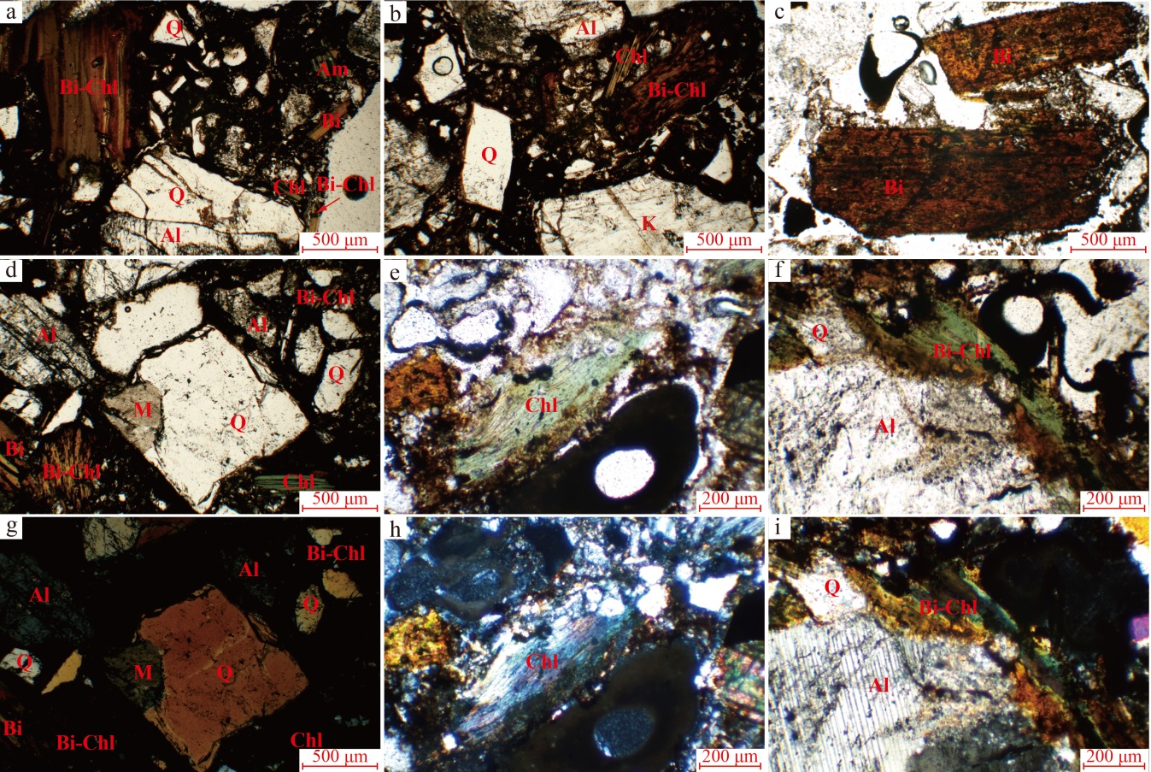
Extended Data Fig. A4. Thin-section images (d-l) of S4 and S5 under both of monopolarized and orthogonal polarized lights
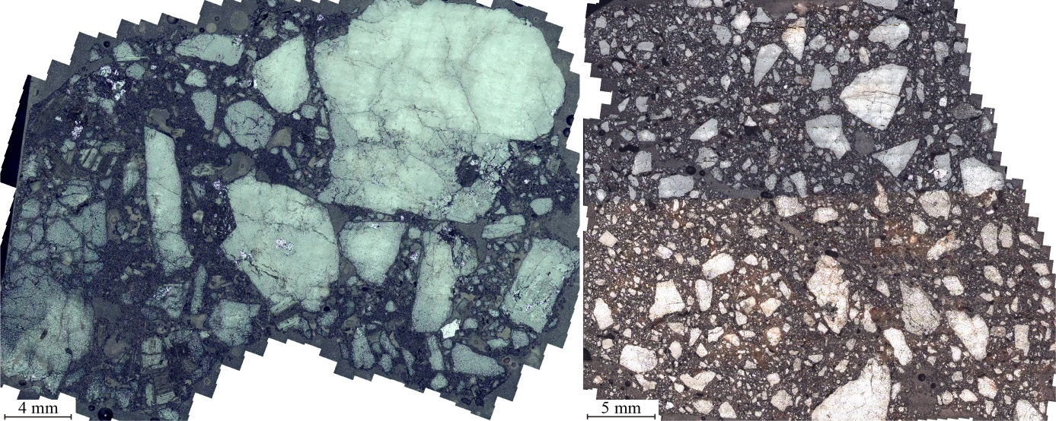
Extended Data Fig. A5. Section images of S2 (a) and S6 (b) to show the distribution of mineral grains in microscope under monopolarized polarized light

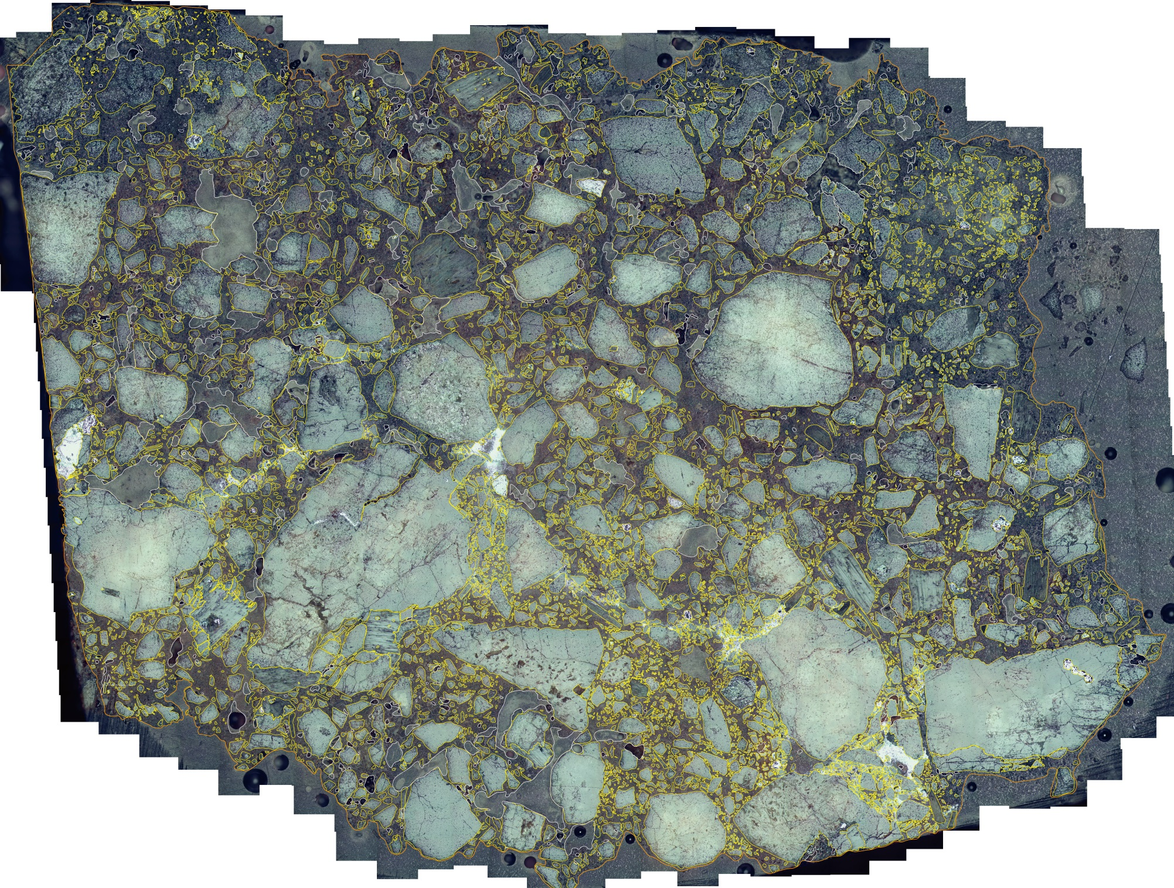
Extended Data Fig. A6. Section image of S4 to show the boundaries of clasts and voids
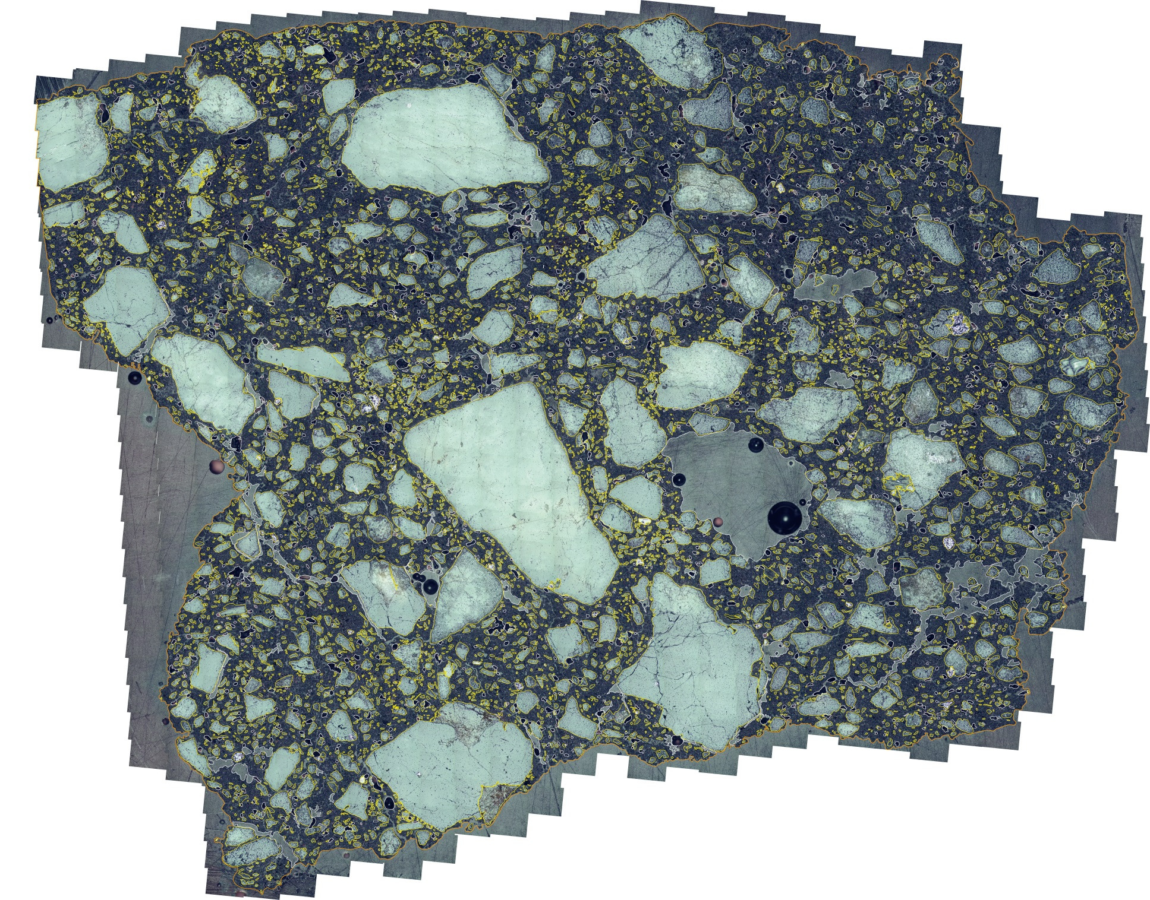
Extended Data Fig. A7. Section image of S5 to show the boundaries of clasts and voids

Extended Data Table A1. Electron microprobe analyses of chlorite and biotite of S5, numbers of cations recalculated on the basis of 14 oxygens, and calculated temperature
No. | 5-1 | 5-2 | 5-3 | 5-4 | 5-5 | 5-6 | 5-7 | 5-8 | 5-9 | 5-10 | 5-11 | 5-12
Na₂O | 0.018 | 0.058 | 0.101 | 0.085 | 0.091 | 0.119 | 0.073 | 0.082 | 0.041 | 0.031 | 0.197 | 0.204
MgO | 17.391 | 11.345 | 11.35 | 11.328 | 11.214 | 11.105 | 11.461 | 11.959 | 14.442 | 14.705 | 14.472 | 15.458
K₂O | 0.04 | 9.59 | 9.399 | 9.134 | 9.675 | 9.636 | 8.715 | 7.405 | 0.141 | 0.209 | 4.067 | 3.321
CaO | 0.183 | 0.07 | 0.122 | 0.164 | 0.055 | 0.095 | 0.295 | 0.41 | 0.076 | 0.163 | 0.408 | 0.493
FeOª | 21.328 | 17.896 | 17.83 | 17.699 | 17.702 | 17.934 | 18.501 | 18.504 | 24.454 | 24.778 | 15.92 | 16.216
SiO₂ | 28.028 | 37.676 | 37.254 | 37.116 | 36.75 | 36.889 | 36.614 | 35.358 | 26.51 | 27.997 | 32.972 | 32.174
Al₂O₃ | 18.23 | 15.437 | 15.337 | 15.602 | 15.03 | 15.056 | 15.708 | 15.637 | 21.241 | 21.402 | 14.837 | 15.154
NiO | 0.01 | 0.028 | 0.036 | 0.009 | 0 | 0.012 | 0.018 | 0.007 | 0 | 0.019 | 0 | 0
MnO | 0.943 | 0.531 | 0.608 | 0.603 | 0.648 | 0.62 | 0.584 | 0.571 | 0.245 | 0.313 | 0.447 | 0.49
Cr₂O₃ | 0.004 | 0.051 | 0.038 | 0.018 | 0.064 | 0.03 | 0.032 | 0 | 0.033 | 0 | 0.051 | 0.063
TiO₂ | 0.024 | 3.488 | 3.263 | 3.284 | 3.941 | 3.649 | 2.277 | 2.412 | 0.068 | 0.081 | 3.257 | 3.194
Total  (wt%) | 86.199 | 96.17 | 95.338 | 95.042 | 95.17 | 95.145 | 94.278 | 92.345 | 87.251 | 88.698 | 86.628 | 86.767
Mineral | Chl | Bi | Bi | Bi | Bi | Bi | Bi-Chl | Bi-Chl | Chl | Chl | Chl | Chl
Na | 0.004 | 0.011 | 0.019 | 0.016 | 0.017 | 0.022 | 0.014 | 0.016 | 0.008 | 0.006 | 0.039 | 0.041
Mg | 2.727 | 1.616 | 1.632 | 1.63 | 1.62 | 1.606 | 1.667 | 1.77 | 2.265 | 2.27 | 2.227 | 2.374
K | 0.005 | 1.169 | 1.157 | 1.125 | 1.196 | 1.192 | 1.085 | 0.938 | 0.019 | 0.028 | 0.536 | 0.437
Ca | 0.021 | 0.007 | 0.013 | 0.017 | 0.006 | 0.01 | 0.031 | 0.044 | 0.009 | 0.018 | 0.045 | 0.054
Fe | 1.874 | 1.428 | 1.436 | 1.427 | 1.433 | 1.453 | 1.508 | 1.534 | 2.148 | 2.143 | 1.373 | 1.395
Si | 2.948 | 3.6 | 3.594 | 3.583 | 3.562 | 3.578 | 3.574 | 3.511 | 2.279 | 2.796 | 3.404 | 3.315
Al | 2.26 | 1.739 | 1.744 | 1.775 | 1.717 | 1.721 | 1.807 | 1.83 | 2.634 | 2.613 | 1.805 | 1.841
Ni | 0.001 | 0.002 | 0.003 | 0.001 | 0 | 0.001 | 0.001 | 0.001 | 0 | 0.002 | 0 | 0
Mn | 0.084 | 0.043 | 0.05 | 0.049 | 0.053 | 0.051 | 0.048 | 0.048 | 0.022 | 0.027 | 0.039 | 0.043
Gr | 0 | 0.004 | 0.003 | 0.001 | 0.005 | 0.002 | 0.002 | 0 | 0.003 | 0 | 0.004 | 0.005
Ti | 0.002 | 0.251 | 0.237 | 0.238 | 0.287 | 0.266 | 0.167 | 0.18 | 0.005 | 0.006 | 0.253 | 0.248
Fe/(Fe+Mg) | 0.407 |  |  |  |  |  |  |  | 0.487 | 0.486 | 0.381 | 0.37
Al^{IV} | 1.208 |  |  |  |  |  |  |  | 1.422 | 1.409 | 1.209 | 1.156
Al^{VI} | 1.052 |  |  |  |  |  |  |  | 1.211 | 1.204 | 0.596 | 0.685
Xie T^{b} (℃) | 285 |  |  |  |  |  |  |  | 320 | 316 | 297 | 284
E-S T^{c} (℃) | 262 |  |  |  |  |  |  |  | 303 | 300 | 263 | 252
a: Total iron as FeO; b-c: Temperature of chlorite formation using different empirical thermometers

Extended Data Table A2. Electron microprobe analyses of chlorite and biotite of S4, numbers of cations recalculated on the basis of 14 oxygens, and calculated temperature
No. | 4-1 | 4-2 | 4-3 | 4-4 | 4-5 | 4-6 | 4-7 | 4-8 | 4-9 | 4-10 | 4-11 | 4-12 | 4-13 | 4-14 | 4-15 | 4-16 | 4-17 | 4-18
Na₂O | 0.008 | 0.055 | 0.051 | 0.108 | 0.094 | 0.08 | 0.072 | 0.063 | 0.048 | 0.071 | 0.025 | 0.035 | 0.089 | 0.076 | 0.02 | 0.072 | 0.103 | 0.065
MgO | 17.049 | 11.28 | 11.103 | 10.974 | 11.732 | 11.254 | 11.385 | 10.932 | 9.425 | 10.298 | 15.069 | 15.211 | 10.939 | 10.216 | 13.54 | 10.302 | 11.902 | 16.716
K₂O | 0.035 | 8.752 | 7.95 | 7.328 | 6.377 | 8.44 | 9.493 | 8.94 | 5.881 | 7.416 | 0.018 | 0.005 | 9.002 | 8.007 | 2.665 | 6.989 | 9.276 | 0.013
CaO | 0.016 | 0.266 | 0.516 | 0.724 | 0.315 | 0.152 | 0.139 | 0.211 | 0.567 | 0.363 | 0.038 | 0.066 | 0.203 | 0.274 | 0.297 | 0.448 | 0.11 | 0.043
FeOª | 21.137 | 17.903 | 17.347 | 17.716 | 21.15 | 18.65 | 18.5 | 18.444 | 19.876 | 19.204 | 24.186 | 25.07 | 17.769 | 17.893 | 18.001 | 18.411 | 17.078 | 21.903
SiO₂ | 26.805 | 36.243 | 35.594 | 36.366 | 33.342 | 36.789 | 36.682 | 37.06 | 31.088 | 34.555 | 24.827 | 24.591 | 36.711 | 35.981 | 31.254 | 35.428 | 37.121 | 26.466
Al₂O₃ | 20.478 | 15.444 | 14.521 | 15.002 | 15.412 | 15.833 | 14.403 | 14.628 | 12.657 | 14.175 | 21.419 | 20.826 | 14.876 | 14.728 | 15.538 | 14.596 | 15.703 | 20.511
NiO | 0.006 | 0.008 | 0.007 | 0 | 0 | 0 | 0.003 | 0 | 0.025 | 0 | 0 | 0.021 | 0.03 | 0.001 | 0.014 | 0 | 0 | 0
MnO | 0.983 | 0.536 | 0.521 | 0.557 | 0.368 | 0.349 | 0.589 | 0.615 | 0.465 | 0.514 | 0.573 | 0.531 | 0.549 | 0.554 | 0.443 | 0.524 | 0.483 | 0.812
Cr₂O₃ | 0 | 0.046 | 0.006 | 0.039 | 0.016 | 0.028 | 0.01 | 0.017 | 0.319 | 0.033 | 0.017 | 0.04 | 0.01 | 0.002 | 0 | 0 | 0.02 | 0.053
TiO₂ | 0.026 | 2.673 | 3.034 | 2.971 | 2.021 | 2.794 | 3.822 | 3.502 | 2.805 | 3.359 | 0.065 | 0.022 | 3.589 | 3.477 | 2.986 | 2.739 | 2.74 | 0.038
Total  (wt%) | 86.543 | 93.206 | 90.65 | 91.785 | 90.827 | 94.369 | 95.098 | 94.412 | 83.156 | 89.988 | 86.237 | 86.418 | 93.767 | 91.209 | 84.758 | 89.509 | 94.536 | 86.62
Mineral | Chl | Bi-Chl | Bi-Chl | Bi-Chl | Bi-Chl | Bi | Bi | Bi | Bi-Chl | Bi-Chl | Chl | Chl | Bi-Chl | Bi-Chl | Chl | Bi-Chl | Bi | Chl
Na | 0.002 | 0.011 | 0.01 | 0.021 | 0.019 | 0.015 | 0.014 | 0.012 | 0.01 | 0.014 | 0.005 | 0.007 | 0.017 | 0.015 | 0.004 | 0.014 | 0.019 | 0.013
Mg | 2.659 | 1.658 | 1.672 | 1.625 | 1.788 | 1.63 | 1.652 | 1.59 | 1.579 | 1.577 | 2.403 | 2.437 | 1.6 | 1.53 | 2.139 | 1.57 | 1.717 | 2.616
K | 0.005 | 1.101 | 1.025 | 0.929 | 0.832 | 1.046 | 1.179 | 1.113 | 0.843 | 0.972 | 0.002 | 0.001 | 1.126 | 1.026 | 0.36 | 0.911 | 1.145 | 0.002
Ca | 0.002 | 0.028 | 0.056 | 0.077 | 0.035 | 0.016 | 0.015 | 0.022 | 0.068 | 0.04 | 0.004 | 0.008 | 0.021 | 0.029 | 0.034 | 0.049 | 0.011 | 0.005
Fe | 1.847 | 1.474 | 1.464 | 1.47 | 1.806 | 1.513 | 1.504 | 1.503 | 1.865 | 1.648 | 2.161 | 2.25 | 1.455 | 1.501 | 1.593 | 1.572 | 1.38 | 1.921
Si | 2.805 | 3.573 | 3.6 | 3.612 | 3.408 | 3.575 | 3.572 | 3.616 | 3.493 | 3.55 | 2.656 | 2.643 | 3.599 | 3.615 | 3.312 | 3.621 | 3.591 | 2.779
Al | 2.526 | 1.795 | 1.729 | 1.756 | 1.857 | 1.813 | 1.653 | 1.682 | 1.676 | 1.716 | 2.701 | 2.638 | 1.719 | 1.744 | 1.941 | 1.758 | 1.791 | 2.539
Ni | 0.001 | 0.001 | 0.001 | 0 | 0 | 0 | 0 | 0 | 0.002 | 0 | 0 | 0.002 | 0.002 | 0 | 0.001 | 0 | 0 | 0
Mn | 0.087 | 0.045 | 0.045 | 0.047 | 0.032 | 0.029 | 0.049 | 0.051 | 0.044 | 0.045 | 0.052 | 0.048 | 0.046 | 0.047 | 0.04 | 0.045 | 0.04 | 0.072
Gr | 0 | 0.004 | 0.001 | 0.003 | 0.001 | 0.002 | 0.001 | 0.001 | 0.028 | 0.003 | 0.001 | 0.003 | 0.001 | 0 | 0 | 0 | 0.002 | 0.004
Ti | 0.002 | 0.198 | 0.231 | 0.222 | 0.155 | 0.204 | 0.28 | 0.257 | 0.237 | 0.26 | 0.005 | 0.002 | 0.265 | 0.263 | 0.238 | 0.211 | 0.199 | 0.003
Fe/(Fe+Mg) | 0.41 |  |  |  |  |  |  |  |  |  | 0.473 | 0.48 |  |  | 0.427 |  |  | 0.423
Al^{IV} | 1.33 |  |  |  |  |  |  |  |  |  | 1.357 | 1.282 |  |  | 1.253 |  |  | 1.317
Al^{VI} | 1.195 |  |  |  |  |  |  |  |  |  | 1.344 | 1.357 |  |  | 0.688 |  |  | 1.221
Xie T^{b} (℃) | 324 |  |  |  |  |  |  |  |  |  | 305 | 278 |  |  | 292 |  |  | 314
E-S T^{c} (℃) | 287 |  |  |  |  |  |  |  |  |  | 290 | 274 |  |  | 270 |  |  | 284
a: Total iron as FeO; b-c: Temperature of chlorite formation using different empirical thermometers

