Blood metabolome profiling for patient stratification and assessment of disease severity among Asian Indian patients with Type 2 diabetes mellitus
Sneha Rana¹, Vivek Mishra², Prajval Nakrani², Ega Lakshman Kumar³, Manisha Sahay⁴, Rakesh Kumar Sahay^{3*}, Pramod P. Wangikar^{1,2*}

¹Department of Chemical Engineering, Indian Institute of Technology Bombay, Powai, Mumbai 400076, India
²Clarity Bio Systems India Pvt. Ltd., Pune, India
³Department of Endocrinology, Osmania Medical College, Hyderabad, Telangana, India
⁴Department of Nephrology, Osmania Medical College, Hyderabad, Telangana, India

ORCID identifiers: 0000-0003-0108-7585 (for PPW).

* Corresponding author
Pramod P. Wangikar (wangikar@iitb.ac.in)
Co-corresponding author
Rakesh Kumar Sahay (sahayrk@gmail.com)

Supplementary Information
Materials:
Li-Heparinized tubes were procured from Sparsh Mediplus, India. LCMS and GCMS analyses were performed using HPLC grade reagents [Methanol, Acetonitrile (ACN), water] purchased from Honeywell (Charlotte, NC, USA). Norvaline, Methoxyamine HCl, and N-methyl-N-trimethylsilyltrifluoroacetamide (MSTFA) were purchased from Sigma Aldrich (St. Louis, MO, USA). Pyridine, carbohydrate standard kit, and sugar alcohol standard kit were purchased from Millipore Sigma (Burlington, MA, USA).
Table S1. Number of features acquired from LCMS analysis using MSOne
 | Positive ionization | Negative ionization
Total no. of features | 8574 | 9576
No. of annotated features | 1437 | 513
No. of features after removing peaks from Blank | 1030 | 424
After removing repetitive metabolites, insource fragment | 174 | 82

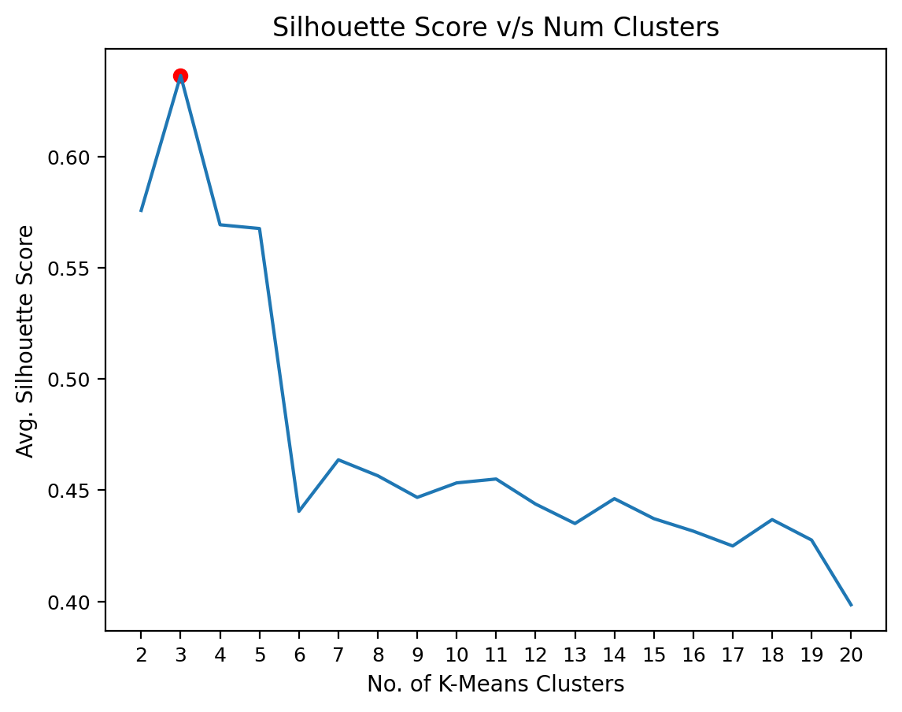
Figure S1. K-means optimization plot for non-diabetic and Type 2 Diabetes groups using metabolites having q < 0.05 and VIP score >1.0 suggests three clusters.

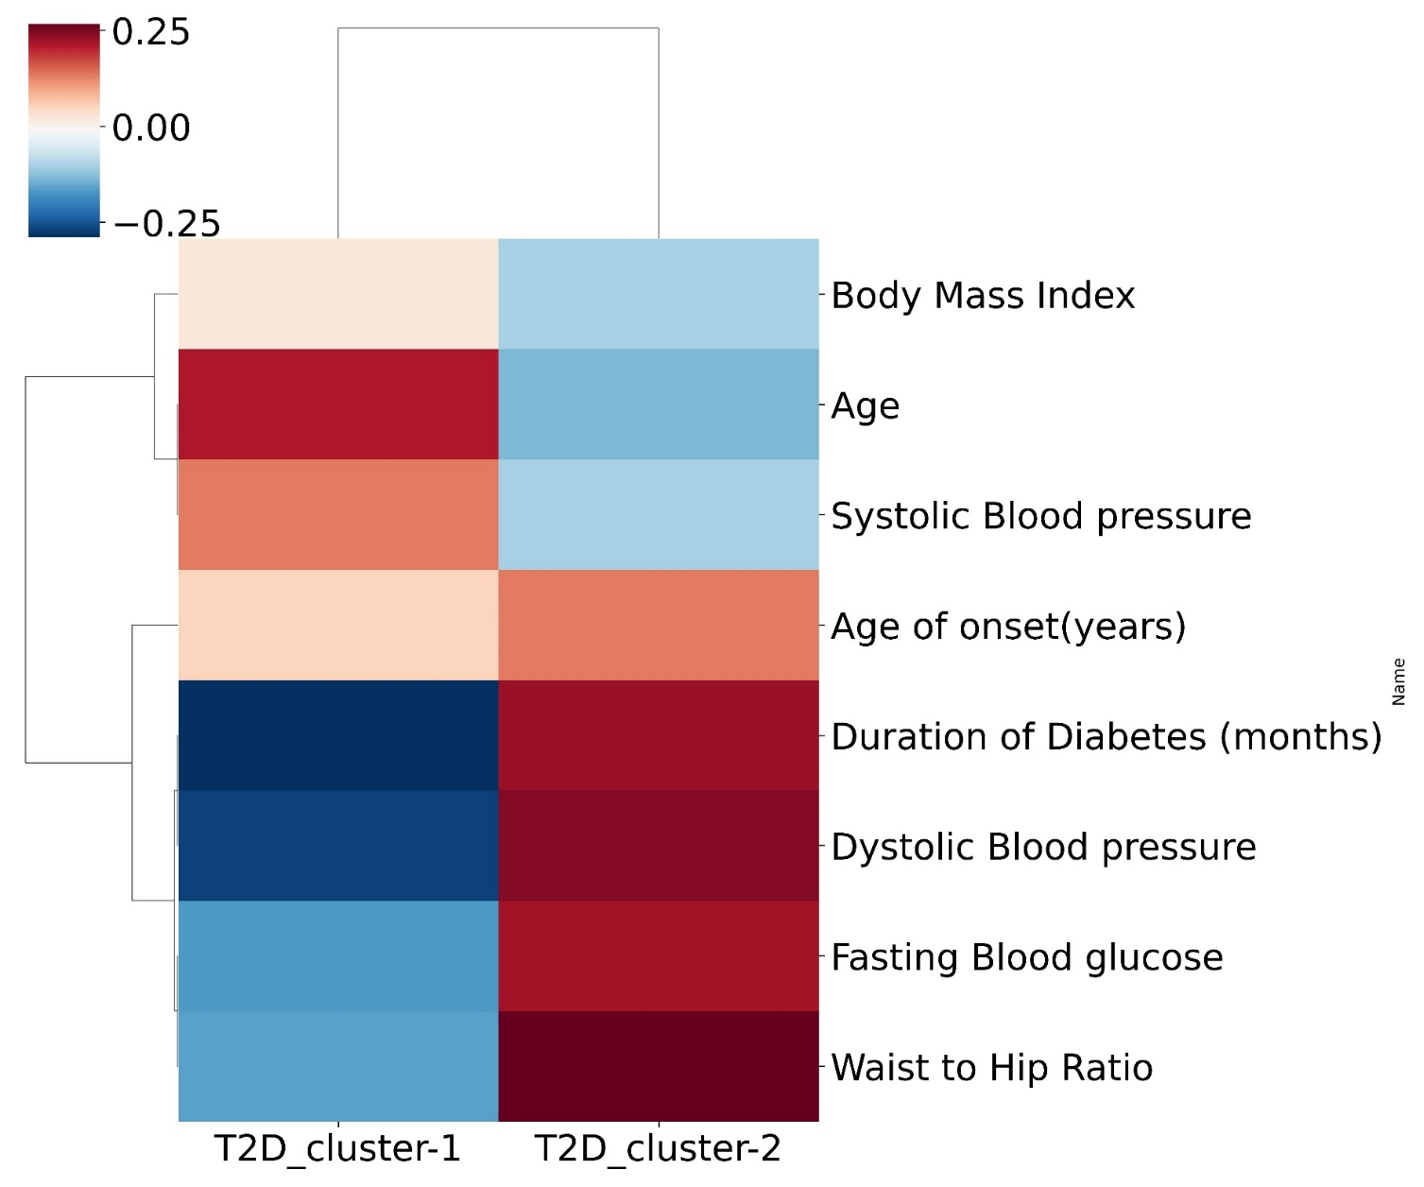

Figure S2. Heatmap depicting differences in clinical parameters (average) between the two patient clusters in the type 2 diabetes group. T2D_cluster-1: Type 2 diabetes cluster-1 and T2D_cluster-2: Type 2 diabetes cluster-2 (Figure 2b)

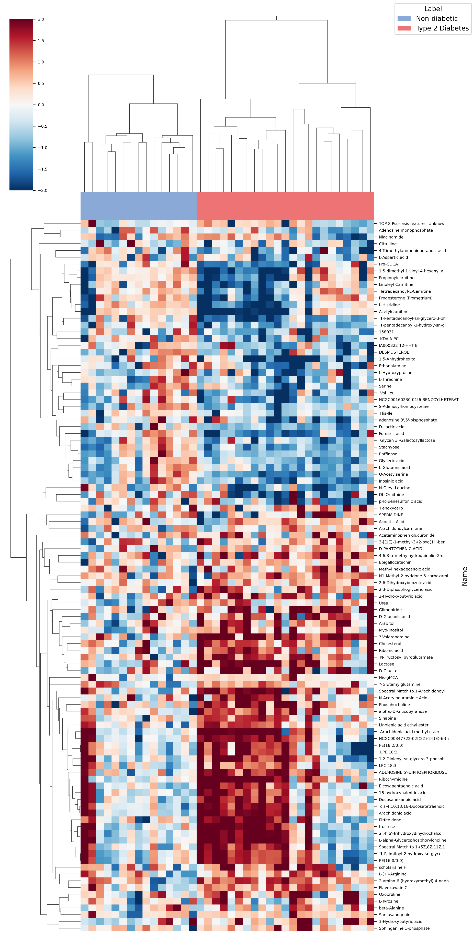
Figure S3. Heatmap depicting hierarchical clustering of non-diabetic and type 2 diabetes groups using metabolites having q < 0.05 and VIP score >1.0.

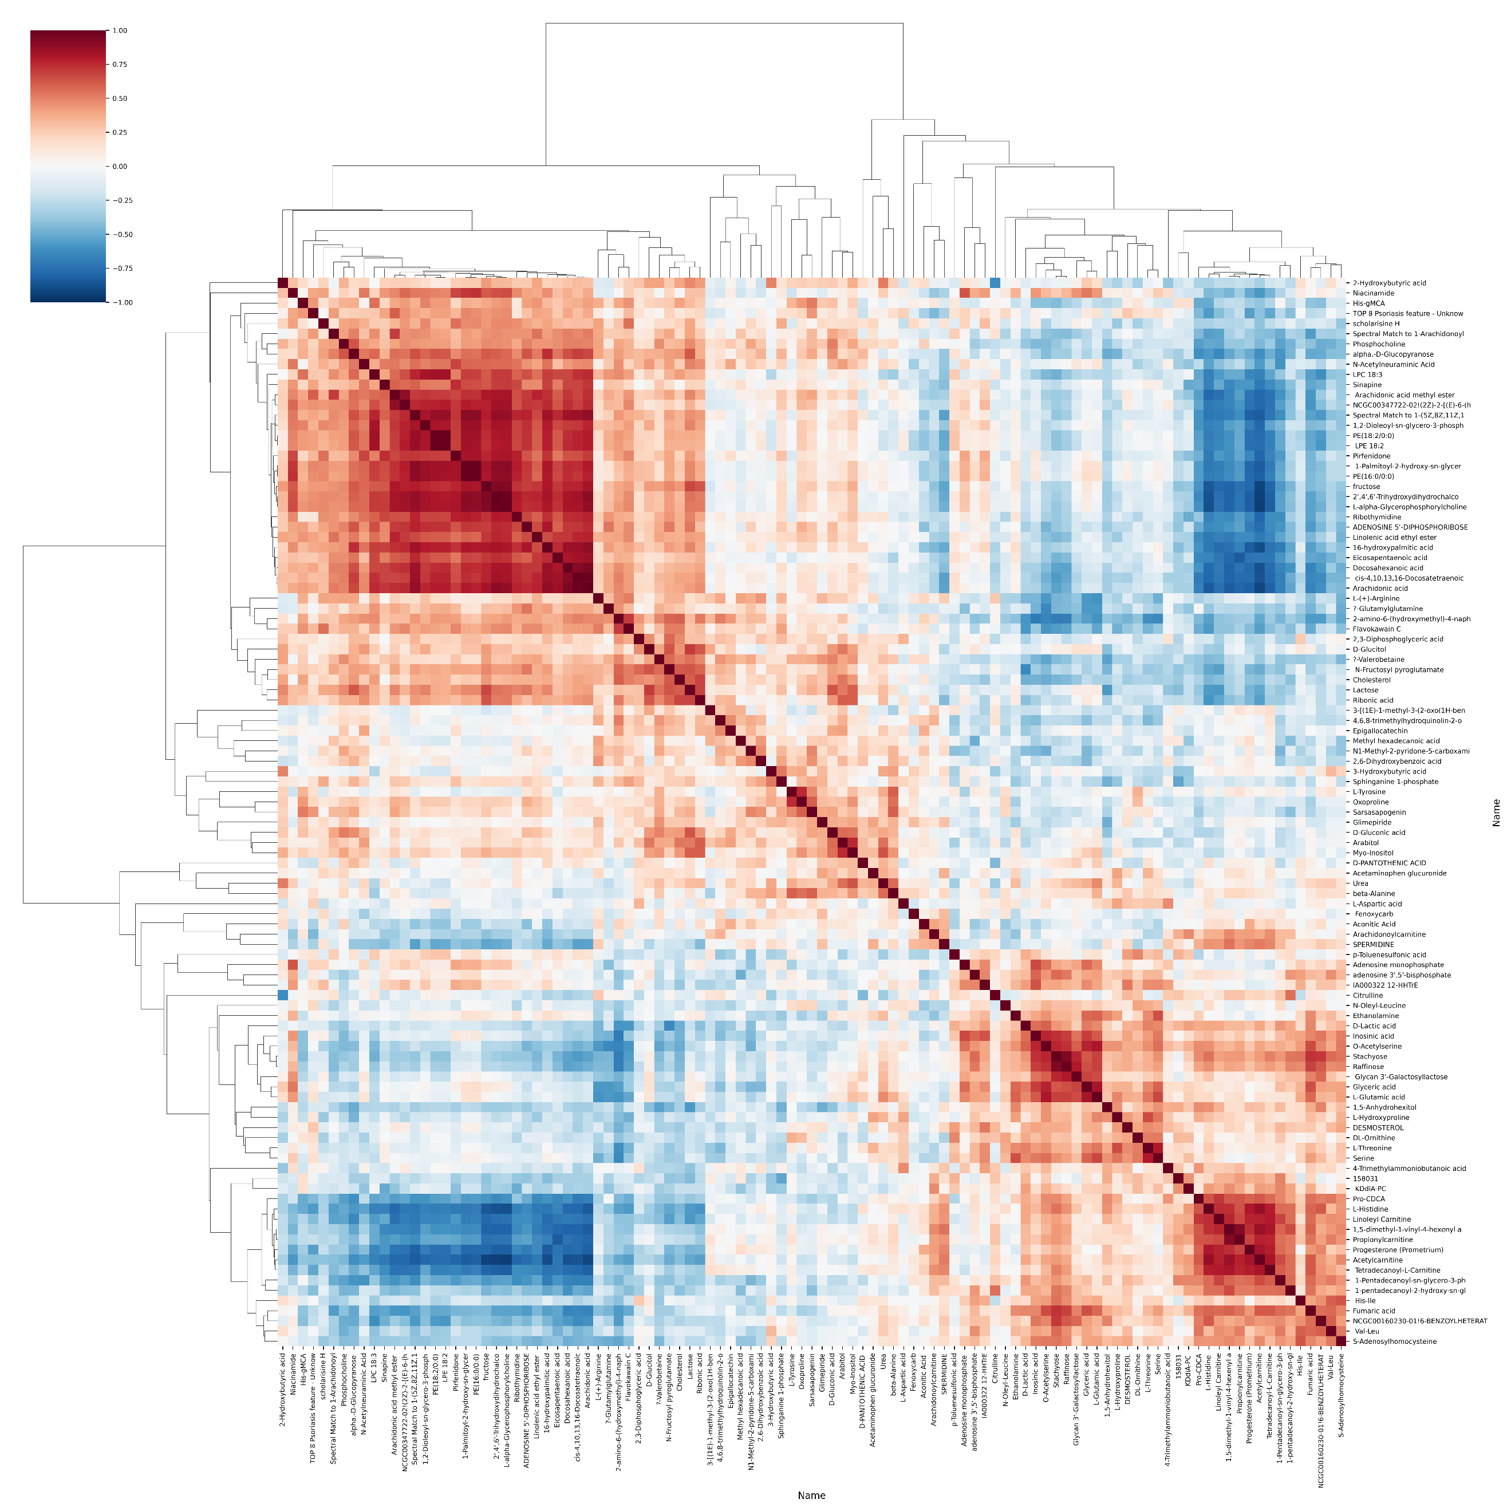
Figure S4. Correlation plot of metabolites (q<0.05, VIP score > 1.0) from non-diabetic and type 2 diabetes subsets.

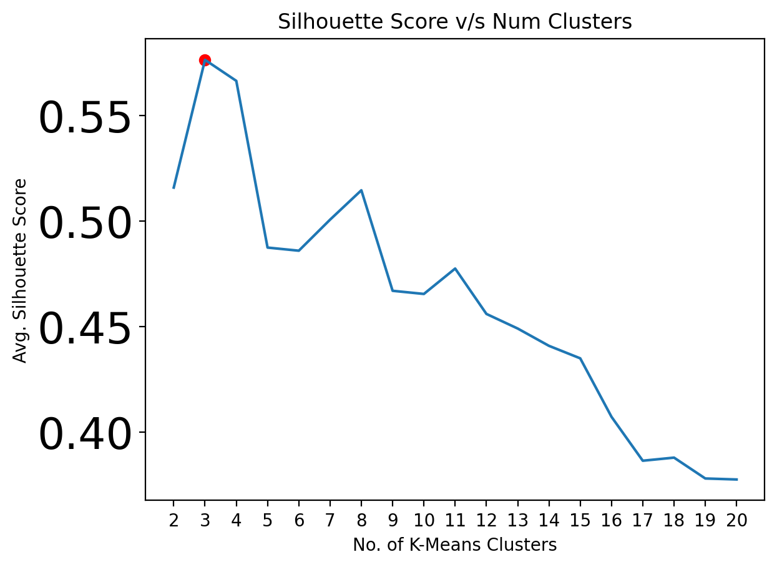
Figure S5. K-means optimization plot for non-diabetic, type 2 diabetes, and diabetic kidney disease (DKD) groups using metabolites having q < 0.05 and VIP score >1.0 suggests three clusters.

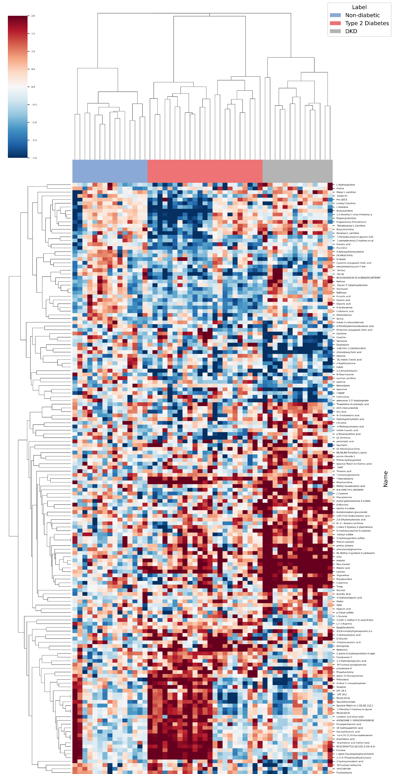
Figure S6. Heatmap depicting hierarchical clustering of non-diabetic, type 2 diabetes, and DKD groups using metabolites having q < 0.05 and VIP score >1.0.

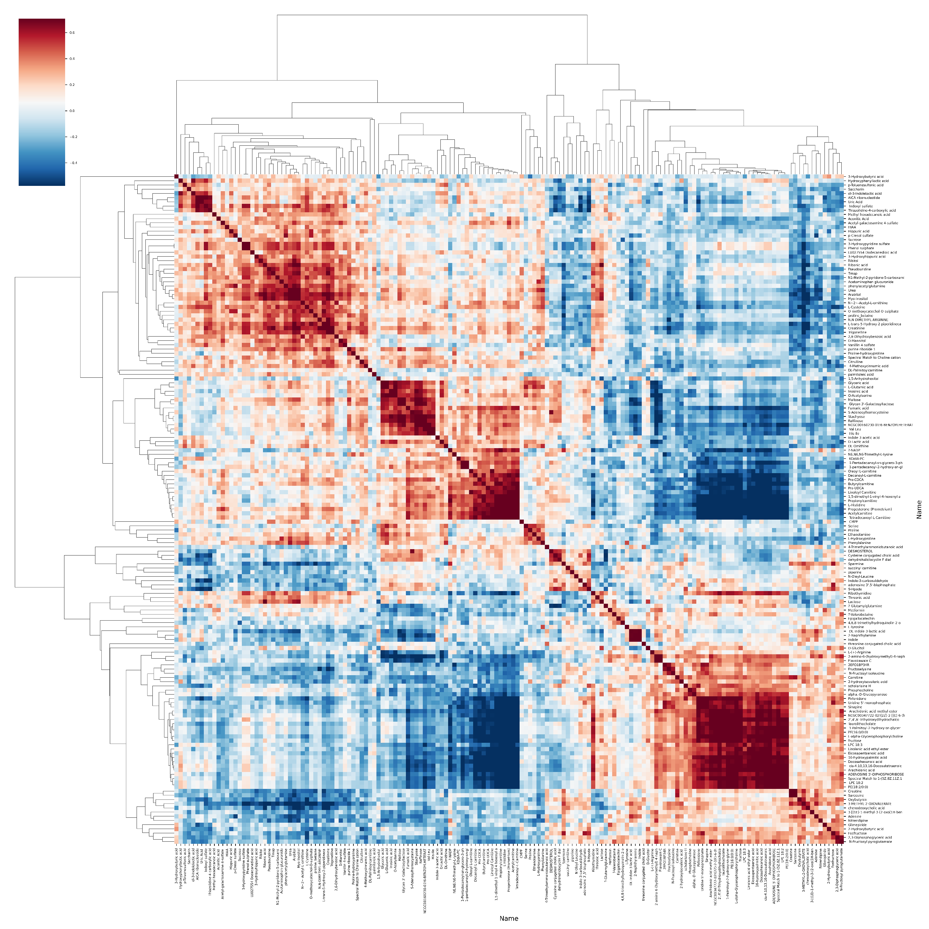

Figure S7. Correlation plot of metabolites (q < 0.05 and VIP score >1.0) from non-diabetic, type 2 diabetes, and DKD subsets. DKD: Type 2 diabetes related kidney disease.

