Supplementary Materials
General Methods
CHEMISTRY
All solvents and commercially available reagents were used as obtained. Oxygen and/or moisture sensitive reactions were carried out under a nitrogen atmosphere in oven- or flame-dried glassware. Chromatography purification was performed using a Teledyne ISCO Combiflash System Rf200 and/or Agilent 1260 Infinity Preparative LC System.
Nuclear magnetic resonance (NMR) analysis was performed on a Varian Palo Alto 400MHz NMR spectrometer. NMR chemical shifts are expressed in parts per million (ppm) and coupling constants (J) are expressed in Hz. Data were reported as follows: (s) singlet, (d) doublet, (t) triplet, (q) quartet, (m) multiplet, (br) broad.
Target compounds and/or intermediates were characterized by liquid chromatography/mass spectrometry (LCMS) using an Agilent 1260 Infinity LC/MS System. General conditions are as follows. Mass spectra were acquired on LC/MS systems using electrospray ionization methods from Agilent 1260 Infinity Analytic LC System with a SQ (single quadrupole) MS. [M+H]⁺ refers to the protonated molecular ion of the chemical species. The mobile phase was 0.1% formic acid in water (solvent A) and 0.1% formic acid in ACN (solvent B).
Abbreviations used: H₂O for water, DCM for dichloromethane, DMSO for dimethyl sulfoxide, TEA for triethylamine, DIPEA for N,N-diisopropylethylamine, MeOH for methanol, DMF for N,Ndimethylformamide, HATU for 1-[bis(dimethylamino)methylene]-1H-1,2,3-triazolo[4,5-b]pyridinium 3-oxid hexafluoro-phosphate, TFA for trifluoroacetic acid, 2-Me-THF for 2-Methyltetrahydrofuran, ACN for acetonitrile, K₂CO₃ for potassium carbonate, RT for room temperature, N₂ for nitrogen.
Synthesis of type II warhead based PROTACs
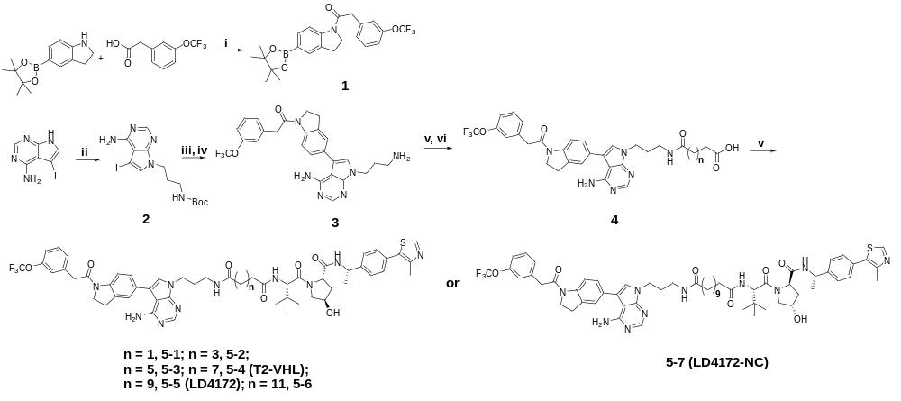
Scheme 1. Reagents and conditions: i) HATU, TEA, DMF, 65ºC; ii) tert-butyl (3-bromopropyl)carbamate, K₂CO₃, DMF, 50ºC; iii) Pd(dppf)₂Cl₂.CH₂Cl₂, K₂CO_{3,} dioxane/H2O = 5/1, 90 ºC; iv) 3 N HCl in MeOH, DCM, RT; v) Various carboxylate acid, HATU, DIPEA, DMF, RT; vi) TFA, DCM, RT; vii) (S,R,S)-AHPC-Me hydrochlorideor or (S,S,R)-AHPC-Me hydrochloride, HATU, TEA, DMF, RT.
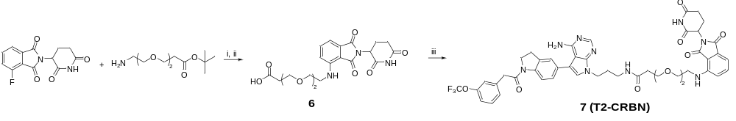
Scheme 2. Reagents and conditions: i) DIPEA, DMF, 90ºC; ii) TFA, DCM, RT; iii) 3, HATU, DIPEA, DMF, RT.
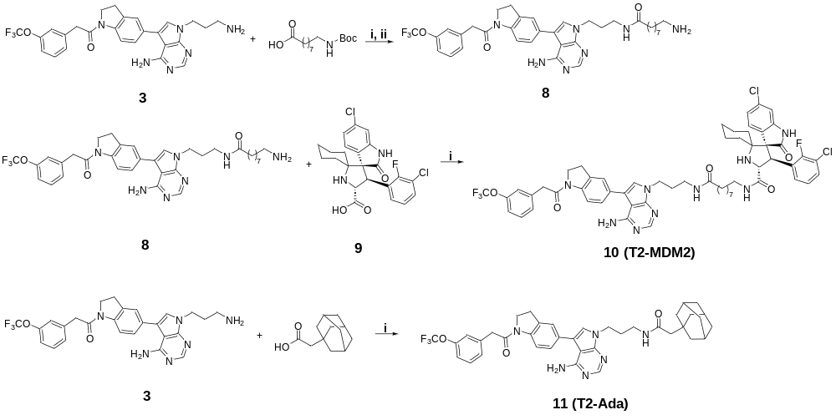
Scheme 3. Reagents and conditions: i) HATU, DIPEA, DMF, RT; ii) TFA, DCM, RT.
Synthesis of type III warhead based PROTACs
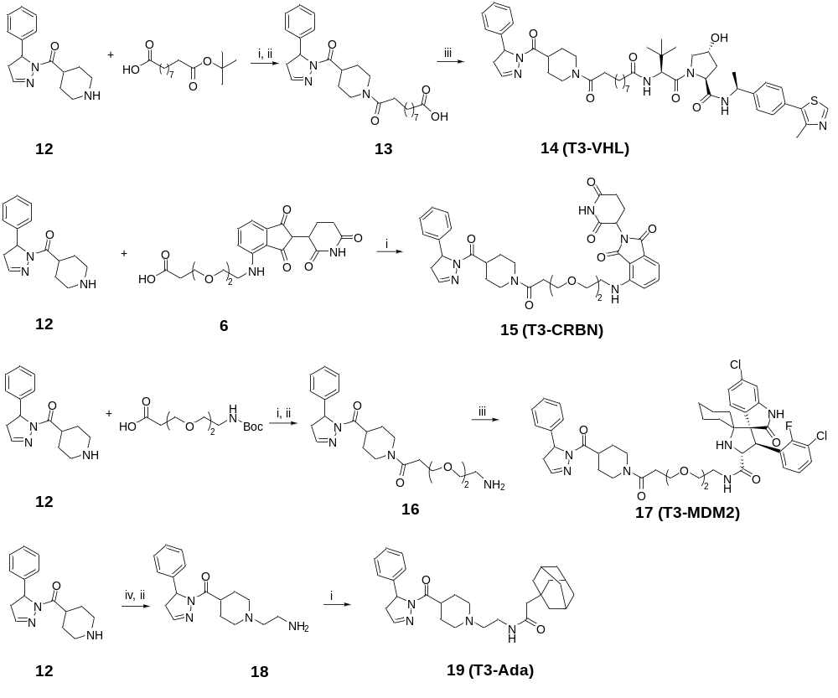
Scheme 4. Reagents and conditions: i) HATU, DIPEA, 2-Me-THF, RT; ii) TFA, DCM, RT; iii) (S,R,S)-AHPC-Me hydrochlorideor or 9 or 2-(adamantan-1-yl)acetic acid, HATU, DIPEA, DMF, RT; iv) tert-butyl (2-bromoethyl)carbamate, K₂CO₃, DMF, RT.
Synthesis of RIPK1 tracers
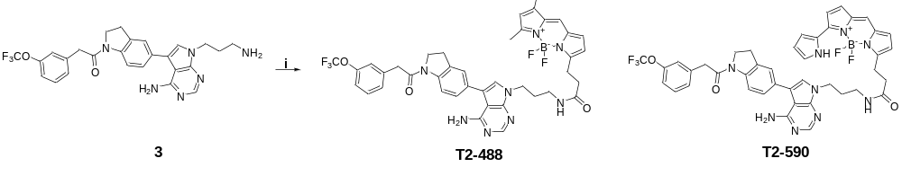
Scheme 5. Reagents and conditions: i) BDP FL NHS ester or BDP 576/589 NHS ester, DIPEA, DMF, RT
Synthetic procedure
1-(5-(4,4,5,5-tetramethyl-1,3,2-dioxaborolan-2-yl)indolin-1-yl)-2-(3-(trifluoromethoxy)phenyl)ethan-1-one (1): To a solution of 5-(4,4,5,5-tetramethyl-1,3,2-dioxaborolan-2-yl)indoline (1.5 g, 6.12 mmol) in DMF (50 mL) was added 2-(3-(trifluoromethoxy)phenyl)acetic acid (2.81 g, 6.7 mmol) and TEA (1.77 mL, 12.24 mmol). The mixture was stirred at 65 °C for 3 hours before adding water (100 mL). The resulting mixture was extracted with ethyl acetate (2×100 mL), the combined organic phases were dried over anhydrous Na₂SO₄, and concentrated under reduced pressure to give the title compound without further purification (2.18 g, 80% yield). ¹H NMR (400 MHz, CDCl₃) δ 8.21 (d, J = 8.1 Hz, 1H), 7.67 (d, J = 8.2 Hz, 1H), 7.62 (s, 1H), 7.37 (t, J = 7.9 Hz, 1H), 7.24 (s, 1H), 7.17 – 7.10 (m, 2H), 4.09 (t, J = 8.5 Hz, 2H), 3.81 (s, 2H), 3.18 (t, J = 8.4 Hz, 2H), 1.33 (s, 12H). ¹³C NMR (100 MHz, CDCl₃) δ 168.38, 149.37, 145.38, 136.2, 134.93,130.85, 130.39, 129.92, 127.72, 121.96, 119.42, 116.40, 83.69, 48.29, 42.84, 27.71, 24.84. MS (ESI) m/z: [M + H]⁺, 448.2
tert-butyl (3-(4-amino-5-iodo-7H-pyrrolo[2,3-d]pyrimidin-7-yl)propyl)carbamate (2): To a solution of 5-iodo-7H-pyrrolo[2,3-d]pyrimidin-4-amine (1.0 g, 3.8 mmol) and tert-butyl (3-bromopropyl)carbamate (1.1 g, 4.6 mmol) in DMF ( 40 mL) was added K₂CO₃ (0.63 g, 4.6 mmol). The mixture was stirred at 50 °C for 5 hours before adding water (100 mL). The resulting mixture was extracted with DCM (2×100 mL) and the combined organic phases were dried over anhydrous Na₂SO₄ and concentrated under reduced pressure to give the title compound without further purification (1.15 g, 72% yield). ¹H NMR (400 MHz, DMSO-d₆) δ 8.06 (s, 1H), 7.46 (s, 1H), 6.85 (s, 1H), 6.57 (s, 2H), 4.07 (t, J = 6.8 Hz, 2H), 2.84 (dd, J = 12.2, 6.1 Hz, 2H), 1.89 – 1.71 (m, 2H), 1.35 (s, 9H). MS (ESI) m/z: [M + H]⁺, 418.1
1-(5-(4-amino-7-(3-aminopropyl)-7H-pyrrolo[2,3-d]pyrimidin-5-yl)indolin-1-yl)-2-(3-(trifluoromethoxy)phenyl)ethan-1-one (3): A solution of 1 (1.0 g, 2.2 mmol), 2 (766 mg, 1.83 mmol), K₂CO₃ (505 mg, 3.66 mmol) and Pd(dppf)₂Cl₂.CH₂Cl₂ (75 mg, 0.09 mmol) in 1,4-dioxane (50 mL) and water (10 mL) was degassed and fulfilled with N₂ for three times. Then the mixture was stirred at 90 °C for 12 hours before it was quenched with water. The resulting mixture was extracted with DCM (3×100 mL), the combined organic phases were dried over anhydrous Na₂SO₄ and concentrated under reduced pressure. The residue was purified by silica gel flash column chromatography to give the product. The product was dissolved in DCM (30 mL) and the solution was slowly added 3 N HCl in methanol (2 mL) in an ice bath. Then the solution was stirred at RT overnight. The mixture was filtered and the solid was dried under vacuum to give the title compound (330 mg, 36% yield, two steps). ¹H NMR (400 MHz, DMSO-d₆) δ 8.49 (s, 1H), 8.17 – 8.01 (m, 4H), 7.69 (s, 1H), 7.46 (t, J = 7.9 Hz, 1H), 7.34 – 7.28 (m, 3H), 7.24 (d, J = 8.2 Hz, 3H), 4.34 (t, J = 6.6 Hz, 2H), 4.24 (t, J = 8.5 Hz, 2H), 3.97 (s, 2H), 3.22 (d, J = 8.2 Hz, 2H), 2.76 (d, J = 6.5 Hz, 2H), 2.16 – 2.05 (m, 2H). MS (ESI) m/z: [M + H]⁺, 511.2
General Procedure for Synthesis of Compounds 5：To a solution of 3 (50 mg, 0.1 mmol) and carboxylic acid (0.12 mmol) in DMF (5 mL) was added HATU (57 mg, 0.15 mmol) and DIPEA (43 µL, 0.3 mmol). The mixture was stirred at RT overnight. The reaction was concentrated and then was purified by silica gel flash column chromatography to give the title compound. The compound was dissolved in DCM (2 mL) and was added TFA (0.5 mL). The mixture was stirred at RT for 5 hours before it was concentrated under reduced pressure. The crude product was used directly in the next step.
To a solution of 4 (0.04 mmol) and (S,R,S)-AHPC-Me hydrochloride or (S,S,R)-AHPC-Me hydrochloride (0.05 mmol) in DMF (5 mL) was added HATU (28 mg, 0.07 mmol) and DIPEA (17 µL, 0.12 mmol). The mixture was stirred at RT for 1 hour. The reaction was concentrated and then was purified by reverse phase preparative HPLC to provide compound 5.
N1-(3-(4-amino-5-(1-(2-(3-(trifluoromethoxy)phenyl)acetyl)indolin-5-yl)-7H-pyrrolo[2,3-d]pyrimidin-7-yl)propyl)-N4-((S)-1-((2S,4R)-4-hydroxy-2-(((S)-1-(4-(4-methylthiazol-5-yl)phenyl)ethyl)carbamoyl)pyrrolidin-1-yl)-3,3-dimethyl-1-oxobutan-2-yl)succinimide (5-1, 63% yield): ¹H NMR (400 MHz, DMSO-d₆) δ 8.97 (s, 1H), 8.49 – 8.32 (m, 1H), 8.24 – 7.92 (m, 1H), 7.84 (s, 2H), 7.41 (s, 3H), 7.37 (s, 2H), 7.25 (d, J = 12.1 Hz, 3H), 7.12 – 6.85 (m, 1H), 5.08 (s, 1H), 4.90 (s, 1H), 4.43 (d, J = 23.0 Hz, 1H), 4.21 (d, J = 36.1 Hz, 2H), 3.91 (s, 1H), 3.57 (s, 2H), 2.49 (s, 4H), 2.44 (s, 3H), 2.35 (s, 1H), 2.29 (s, 2H), 1.99 (s, 1H), 1.76 (s, 2H), 1.36 (s, 3H), 0.90 (s, 9H). MS (ESI) m/z: [M + H]⁺, 1037.4
N1-(3-(4-amino-5-(1-(2-(3-(trifluoromethoxy)phenyl)acetyl)indolin-5-yl)-7H-pyrrolo[2,3-d]pyrimidin-7-yl)propyl)-N6-((S)-1-((2S,4R)-4-hydroxy-2-(((S)-1-(4-(4-methylthiazol-5-yl)phenyl)ethyl)carbamoyl)pyrrolidin-1-yl)-3,3-dimethyl-1-oxobutan-2-yl)adipamide (5-2, 65% yield): ¹H NMR (400 MHz, DMSO-d₆) δ 8.97 (s, 1H), 8.62 (s, 2H), 8.41 (d, J = 8.4 Hz, 1H), 8.36 (d, J = 8.0 Hz, 1H), 8.10 (d, J = 11.6 Hz, 1H), 7.85 (s, 1H), 7.77 (d, J = 8.9 Hz, 1H), 7.43 (d, J = 22.0 Hz, 3H), 7.37 (s, 1H), 7.31 (s, 2H), 7.27 – 7.20 (m, 1H), 5.09 (s, 1H), 4.89 (s, 1H), 4.48 (d, J = 9.5 Hz, 1H), 4.40 (s, 1H), 4.24 (d, J = 8.8 Hz, 2H), 4.14 (s, 2H), 3.95 (s, 2H), 3.58 (s, 2H), 3.10 (d, J = 6.2 Hz, 3H), 2.44 (s, 3H), 2.21 (s, 2H), 2.05 (s, 2H), 1.89 (s, 2H), 1.45 (s, 2H), 1.35 (d, J = 6.9 Hz, 2H), 1.23 (s, 8H), 0.89 (s, 8H). MS (ESI) m/z: [M + H]⁺, 1065.5
N1-(3-(4-amino-5-(1-(2-(3-(trifluoromethoxy)phenyl)acetyl)indolin-5-yl)-7H-pyrrolo[2,3-d]pyrimidin-7-yl)propyl)-N8-((S)-1-((2S,4R)-4-hydroxy-2-(((S)-1-(4-(4-methylthiazol-5-yl)phenyl)ethyl)carbamoyl)pyrrolidin-1-yl)-3,3-dimethyl-1-oxobutan-2-yl)octanediamide (5-3, 49% yield): ¹H NMR (400 MHz, DMSO-d₆) δ 8.97 (s, 1H), 8.36 (d, J = 6.9 Hz, 1H), 8.25 – 7.89 (m, 1H), 7.76 (d, J = 7.0 Hz, 2H), 7.42 (d, J = 7.2 Hz, 3H), 7.36 (d, J = 7.2 Hz, 2H), 7.31 – 7.15 (m, 4H), 5.09 (s, 1H), 4.96 – 4.84 (m, 1H), 4.50 (d, J = 9.5 Hz, 1H), 4.41 (t, J = 7.7 Hz, 1H), 4.21 (d, J = 38.5 Hz, 2H), 3.94 (d, J = 22.2 Hz, 1H), 3.58 (s, 2H), 2.44 (s, 3H), 2.14 (d, J = 45.0 Hz, 2H), 1.99 (s, 2H), 1.77 (s, 2H), 1.43 (s, 4H), 1.35 (d, J = 6.3 Hz, 3H), 1.20 (s, 5H), 0.91 (s, 9H). MS (ESI) m/z: [M + H]⁺, 1093.5
N1-(3-(4-amino-5-(1-(2-(3-(trifluoromethoxy)phenyl)acetyl)indolin-5-yl)-7H-pyrrolo[2,3-d]pyrimidin-7-yl)propyl)-N10-((S)-1-((2S,4R)-4-hydroxy-2-(((S)-1-(4-(4-methylthiazol-5-yl)phenyl)ethyl)carbamoyl)pyrrolidin-1-yl)-3,3-dimethyl-1-oxobutan-2-yl)decanediamide (5-4, T2-VHL, 51% yield): 1H NMR (400 MHz, DMSO-d₆) δ 8.96 (s, 1H), 8.36 (d, J = 7.3 Hz, 1H), 8.27 (s, 1H), 8.10 (d, J = 9.4 Hz, 2H), 7.83 (s, 1H), 7.77 (d, J = 8.9 Hz, 1H), 7.43 (dd, J = 14.3, 8.2 Hz, 4H), 7.36 (d, J = 8.2 Hz, 3H), 7.30 (s, 3H), 7.28 – 7.19 (m, 2H), 6.00 (s, 1H), 4.89 (s, 1H), 4.49 (d, J = 9.1 Hz, 1H), 4.40 (s, 1H), 4.24 (d, J = 9.2 Hz, 4H), 4.13 (s, 2H), 3.95 (s, 2H), 3.58 (s, 4H), 3.23 (d, J = 7.8 Hz, 4H), 3.02 (s, 3H), 2.43 (s, 3H), 2.20 (s, 1H), 2.03 (s, 5H), 1.87 (s, 2H), 1.77 (s, 1H), 1.35 (d, J = 6.9 Hz, 4H), 1.21 (s, 12H), 0.91 (s, 9H). ¹³C NMR (100 MHz, DMSO-d₆) δ 172.54, 171.07, 170.06, 157.67, 151.92, 150.50, 148.21, 145.11, 142.23, 138.47, 130.42, 129.37, 127.60, 126.83, 125.39, 123.69, 122.70, 119.46, 116.63, 69.21, 56.79, 48.15, 41.70, 38.19, 36.39, 35.96, 35.64, 35.35, 30.37, 29.17, 27.96, 26.90, 25.81, 22.89, 16.44. MS (ESI) m/z: [M + H]⁺, 1121.5
N1-(3-(4-amino-5-(1-(2-(3-(trifluoromethoxy)phenyl)acetyl)indolin-5-yl)-7H-pyrrolo[2,3-d]pyrimidin-7-yl)propyl)-N4-((S)-1-((2S,4R)-4-hydroxy-2-(((S)-1-(4-(4-methylthiazol-5-yl)phenyl)ethyl)carbamoyl)pyrrolidin-1-yl)-3,3-dimethyl-1-oxobutan-2-yl)succinimide (5-5, LD4172, 56% yield): ¹H NMR (400 MHz, DMSO-d₆) δ 8.96 (s, 1H), 8.36 (d, J = 7.8 Hz, 1H), 8.11 (d, J = 8.3 Hz, 1H), 8.07 (d, J = 8.8 Hz, 1H), 7.77 (d, J = 9.4 Hz, 1H), 7.67 (t, J = 5.5 Hz, 1H), 7.46 (t, J = 7.9 Hz, 1H), 7.41 (d, J = 8.3 Hz, 2H), 7.38 – 7.31 (m, 4H), 7.29 (t, J = 6.6 Hz, 2H), 7.25 (d, J = 7.6 Hz, 2H), 6.98 (s, 2H), 6.52 (s, 1H), 4.90 (dd, J = 14.1, 6.8 Hz, 1H), 4.49 (d, J = 9.3 Hz, 1H), 4.39 (t, J = 8.0 Hz, 1H), 4.25 (d, J = 7.5 Hz, 2H), 4.14 (t, J = 7.3 Hz, 2H), 3.96 (s, 2H), 3.57 (s, 1H), 3.22 (d, J = 8.4 Hz, 2H), 2.87 – 2.79 (m, 2H), 2.43 (s, 3H), 2.20 (dd, J = 14.3, 7.2 Hz, 1H), 2.07 (dd, J = 13.7, 7.0 Hz, 1H), 2.02 – 1.94 (m, 1H), 1.92 (t, J = 7.4 Hz, 2H), 1.76 (ddd, J = 12.8, 8.4, 4.6 Hz, 1H), 1.69 – 1.58 (m, 2H), 1.34 (d, J = 6.9 Hz, 3H), 1.18 (d, J = 19.8 Hz, 16H), 0.90 (s, 9H). ¹³C NMR (100 MHz, DMSO-d₆) δ 172.40, 171.04, 170.03, 169.15, 157.51, 151.91, 151.39, 148.67, 148.18, 145.10, 143.27, 138.34, 136.67, 133.03, 131.54, 130.46, 130.11, 129.45, 129.25, 128.08, 127.58, 126.80, 125.52, 122.68, 119.46, 116.39, 102.89, 99.08, 69.18, 58.96, 56.75, 48.34, 48.13, 41.70, 38.17, 36.30, 35.88, 35.62, 35.32, 30.38, 29.25, 27.85, 26.86, 25.87, 25.64, 22.88, 16.43. MS (ESI) m/z: [M + H]⁺, 1149.5
N1-(3-(4-amino-5-(1-(2-(3-(trifluoromethoxy)phenyl)acetyl)indolin-5-yl)-7H-pyrrolo[2,3-d]pyrimidin-7-yl)propyl)-N14-((S)-1-((2S,4R)-4-hydroxy-2-(((S)-1-(4-(4-methylthiazol-5-yl)phenyl)ethyl)carbamoyl)pyrrolidin-1-yl)-3,3-dimethyl-1-oxobutan-2-yl)tetradecanediamide (5-6, 53% yield): ¹H NMR (400 MHz, DMSO-d₆) δ 8.97 (s, 1H), 8.36 (d, J = 7.6 Hz, 1H), 8.25 (s, 2H), 8.10 (d, J = 8.7 Hz, 2H), 7.83 (s, 1H), 7.76 (d, J = 9.5 Hz, 1H), 7.43 (dd, J = 15.5, 7.4 Hz, 3H), 7.39 – 7.32 (m, 3H), 7.30 (s, 3H), 7.27 – 7.17 (m, 2H), 6.05 (s, 1H), 4.90 (s, 1H), 4.50 (d, J = 9.1 Hz, 1H), 4.39 (d, J = 8.3 Hz, 1H), 4.28 – 4.19 (m, 4H), 4.14 (s, 2H), 3.96 (s, 2H), 3.22 (s, 2H), 3.02 (s, 2H), 2.44 (s, 3H), 2.21 (s, 1H), 2.13 – 1.95 (m, 4H), 1.88 (s, 2H), 1.77 (s, 1H), 1.35 (d, J = 6.4 Hz, 3H), 1.20 (s, 20H), 0.91 (s, 9H). MS (ESI) m/z: [M + H]⁺, 1177.6
N1-(3-(4-amino-5-(1-(2-(3-(trifluoromethoxy)phenyl)acetyl)indolin-5-yl)-7H-pyrrolo[2,3-d]pyrimidin-7-yl)propyl)-N12-((S)-1-((2R,4S)-4-hydroxy-2-(((S)-1-(4-(4-methylthiazol-5-yl)phenyl)ethyl)carbamoyl)pyrrolidin-1-yl)-3,3-dimethyl-1-oxobutan-2-yl)dodecanediamide (5-7, LD4172-NC, 35% yield). ¹H NMR (400 MHz, DMSO-d₆) δ 8.95 (s, 1H), 8.14 (s, 1H), 8.09 (d, J = 9.5 Hz, 2H), 8.00 (d, J = 8.0 Hz, 1H), 7.93 (s, 1H), 7.88 (d, J = 7.6 Hz, 1H), 7.81 (d, J = 5.6 Hz, 1H), 7.46 (dd, J = 14.7, 7.0 Hz, 1H), 7.39 (d, J = 9.1 Hz, 3H), 7.31 (d, J = 13.4 Hz, 4H), 7.22 (dd, J = 14.7, 8.6 Hz, 2H), 4.93 – 4.82 (m, 1H), 4.36 (t, J = 6.6 Hz, 2H), 4.21 (t, J = 8.4 Hz, 2H), 4.12 (t, J = 6.7 Hz, 2H), 3.94 (s, 2H), 3.79 (dd, J = 10.3, 5.4 Hz, 1H), 3.47 (dd, J = 10.2, 3.8 Hz, 2H), 3.21 (t, J = 8.3 Hz, 2H), 3.02 – 2.98 (m, 2H), 2.40 (d, J = 13.1 Hz, 3H), 2.27 – 2.13 (m, 1H), 2.10 – 1.98 (m, 4H), 1.97 – 1.93 (m, 1H), 1.90 – 1.84 (m, 2H), 1.28 (d, J = 6.9 Hz, 3H), 1.27 – 1.06 (m, 16H), 0.93 (s, 9H). ¹³C NMR (100 MHz, DMSO-d₆) δ 172.59, 168.89, 162.73, 157.64, 151.88, 150.47, 138.43, 133.25, 130.35, 130.07, 129.43, 129.19, 127.57, 126.97, 125.35, 123.64, 122.67, 119.42, 116.61, 115.44, 100.38, 68.80, 59.13, 57.54, 55.61, 48.29, 47.92, 42.07, 41.67, 36.28, 35.93, 35.16, 34.65, 31.21, 30.35, 29.86, 28.71, 27.94, 27.08, 26.48, 26.01, 25.57, 22.94, 16.42. MS (ESI) m/z: [M + H]⁺, 1149.5
3-(2-(2-((2-(2,6-dioxopiperidin-3-yl)-1,3-dioxoisoindolin-4-yl)amino)ethoxy)ethoxy)propanoic acid (6): To a solution of 3-(4-fluoro-1,3-dioxo-2,3-dihydro-1H-inden-2-yl)piperidine-2,6-dione (50 mg, 0.18 mmol) in DMF (10 mL) was added tert-butyl 3-(2-(2-aminoethoxy)ethoxy)propanoate (50 mg, 0.22 mmol) and DIPEA (51 µL, 0.36 mmol). The mixture was stirred at 90 °C for 2 hours. The reaction was concentrated and then was purified by silica gel flash column chromatography to give the title compound. The compound was dissolved in DCM (2 mL) and TFA (0.5 mL). The mixture was stirred at RT for 7 hours before it was concentrated under reduced pressure to give compound 6 without further purification (65 mg, 51% yield, two steps). MS (ESI) m/z: [M + H]⁺, 434.1
N-(3-(4-amino-5-(1-(2-(3-(trifluoromethoxy)phenyl)acetyl)indolin-5-yl)-7H-pyrrolo[2,3-d]pyrimidin-7-yl)propyl)-3-(2-(2-((2-(2,6-dioxopiperidin-3-yl)-1,3-dioxoisoindolin-4-yl)amino)ethoxy)ethoxy)propanamide (7, T2-CRBN): To a solution of 6 (65 mg, 0.15 mmol), 3 (76 mg, 0.15 mmol) in DMF (10 mL) was added HATU (85 mg, 0.22 mmol) and DIPEA (65 µL, 0.45 mmol). The mixture was stirred at RT overnight. The reaction was concentrated and then was purified by reverse phase preparative HPLC to provide compound 7 (T2-CRBN) (27 mg, 20% yield). 1H NMR (400 MHz, DMSO-d₆) δ 11.09 (s, 1H), 8.09 (d, J = 12.6 Hz, 2H), 7.89 (s, 1H), 7.53 (t, J = 7.8 Hz, 1H), 7.46 (t, J = 7.7 Hz, 1H), 7.31 (d, J = 14.3 Hz, 4H), 7.23 (dd, J = 17.2, 7.8 Hz, 2H), 7.06 (d, J = 8.6 Hz, 1H), 7.00 (d, J = 7.0 Hz, 1H), 6.55 (s, 1H), 6.04 (s, 1H), 5.03 (dd, J = 12.5, 4.9 Hz, 1H), 4.22 (t, J = 8.1 Hz, 2H), 4.13 (s, 2H), 3.95 (s, 2H), 3.61 – 3.52 (m, 8H), 3.39 (s, 6H), 3.22 (d, J = 8.1 Hz, 2H), 3.02 (d, J = 5.6 Hz, 2H), 2.84 (d, J = 13.3 Hz, 1H), 2.56 (d, J = 16.9 Hz, 1H), 2.29 (t, J = 5.9 Hz, 2H), 2.00 (s, 1H), 1.88 (d, J = 6.5 Hz, 2H). MS (ESI) m/z: [M + H]⁺, 926.3
(3'R,4'S,5'R)-N-(9-((3-(4-amino-5-(1-(2-(3-(trifluoromethoxy)phenyl)acetyl)indolin-5-yl)-7H-pyrrolo[2,3-d]pyrimidin-7-yl)propyl)amino)-9-oxononyl)-6''-chloro-4'-(3-chloro-2-fluorophenyl)-2''-oxodispiro[cyclohexane-1,2'-pyrrolidine-3',3''-indoline]-5'-carboxamide (10, T2-MDM2): To a solution of 3 (50 mg, 0.1 mmol), 9-((tert-butoxycarbonyl)amino)nonanoic acid (33 mg, 0.12 mmol) in DMF (5 mL) was added HATU (57 mg, 0.15 mmol) and DIPEA (43 µL, 0.3 mmol). The mixture was stirred at RT overnight and was concentrated and then was purified by silica gel flash column chromatography to give the title compound. The compound was dissolved in DCM (2 mL) and TFA (0.5 mL). The mixture was stirred at RT for 1 hour before it was concentrated under reduced pressure to give compound 8 without further purification (30 mg, 46% yield, two steps). ¹H NMR (400 MHz, DMSO-d₆) δ 8.54 – 8.46 (m, 1H), 7.92 (s, 5H), 7.70 (d, J = 10.6 Hz, 1H), 7.50 – 7.44 (m, 1H), 7.31 (d, J = 12.4 Hz, 2H), 7.26 (s, 2H), 4.24 (s, 2H), 3.98 (s, 1H), 3.09 (d, J = 4.4 Hz, 2H), 3.03 (d, J = 5.5 Hz, 2H), 2.72 (s, 2H), 2.03 (t, J = 6.7 Hz, 2H), 1.97 – 1.85 (m, 2H), 1.50 (d, J = 6.9 Hz, 2H), 1.45 (s, 2H), 1.28 – 1.24 (m, 8H), 1.23 (s, 4H). MS (ESI) m/z: [M + H]⁺, 666.3
Compound 9 was prepared according to reported procedures in the literature.¹ Compound 9 (20 mg, 0.043 mmol) and HATU (25 mg, 0.068 mmol) in DMF (10 mL) was added compound 8 (33 mg, 0.05 mmol) and DIPEA (20 µL, 0.135 mmol). The mixture was stirred at RT overnight. The reaction was concentrated and then was purified by reverse phase preparative HPLC to provide compound 10 (T2-MDM2) (17 mg, 35% yield) MS (ESI) m/z: [M + H]⁺, 1110.4
2-(adamantan-1-yl)-N-(3-(4-amino-5-(1-(2-(3-(trifluoromethoxy)phenyl)acetyl)indolin-5-yl)-7H-pyrrolo[2,3-d]pyrimidin-7-yl)propyl)acetamide (11, T2-Ada): To a solution of 3 (20 mg, 0.039 mmol), 2-(adamantan-1-yl)acetic acid (11 mg, 0.058 mmol) in DMF (2 mL) was added HATU (22 mg, 0.058 mmol) and DIPEA (20 µL, 0.135 mmol). The mixture was stirred at RT overnight. The reaction was concentrated and then was purified by reverse phase preparative HPLC to provide compound 11 (T2-Ada) (5.6 mg, 21% yield). ¹H NMR (400 MHz, DMSO-d₆) δ 8.22 (s, 1H), 7.97 (s, 1H), 7.68 (s, 2H), 7.44 (s, 2H), 7.27 (s, 6H), 4.16 (s, 2H), 3.91 (s, 2H), 1.87 (s, 4H), 1.78 (s, 2H), 1.60 (s, 5H), 1.52 (s, 12H), 1.22 (s, 2H). MS (ESI) m/z: [M + H]⁺, 687.3
10-oxo-10-(4-(5-phenyl-4,5-dihydro-1H-pyrazole-1-carbonyl)piperidin-1-yl)decanoic acid (13): Compound 12 was prepared according to reported procedures in the literature.² To a solution of 10-(tert-butoxy)-10-oxodecanoic acid (10 mg, 0.042 mmol), 12 (9 mg, 0.035 mmol) in 2-methyltetrahydrofuran (3 mL) was added HATU (17 mg, 0.045 mmol) and DIPEA (15 µL, 0.1 mmol). The mixture was stirred at room temperature overnight. The reaction was concentrated and then was purified by silica gel flash column chromatography to give the intermediate.
The above intermediate was dissolved in DCM (2 mL) and TFA (0.5 mL) and the solution was stirred at RT for 5 hours before it was concentrated under reduced pressure to give title compound without further purification (10 mg, 61% yield, two steps). MS (ESI) m/z: [M + H]⁺, 442.2
(2S,4R)-1-((2S)-3,3-dimethyl-2-(10-oxo-10-(4-(5-phenyl-4,5-dihydro-1H-pyrazole-1-carbonyl)piperidin-1-yl)decanamido)butanoyl)-4-hydroxy-N-((S)-1-(4-(4-methylthiazol-5-yl)phenyl)ethyl)pyrrolidine-2-carboxamide (14, T3-VHL): Compound 14 was prepared using the procedure described for the synthesis of compound 5 by using compound 13 instead of compound 4. Yield 23%. ¹H NMR (400 MHz, DMSO-d₆) δ 9.39 (s, 1H), 9.00 (s, 1H), 8.61 (s, 1H), 8.39 (s, 1H), 8.18 (d, J = 15.1 Hz, 2H), 7.79 (s, 1H), 7.47 – 7.32 (m, 5H), 7.24 (s, 1H), 7.11 (s, 1H), 5.30 (s, 1H), 5.11 (s, 1H), 4.93 (s, 2H), 4.52 (s, 1H), 4.29 (s, 1H), 3.87 (s, 2H), 3.59 (s, 1H), 2.82 (s, 2H), 2.67 (d, J = 20.1 Hz, 2H), 2.47 (s, 3H), 2.28 (s, 3H), 2.12 (s, 1H), 2.02 (s, 1H), 1.81 (s, 2H), 1.74 (s, 6H), 1.47 (s, 5H), 1.38 (s, 3H), 1.25 (s, 8H), 0.94 (s, 9H). MS (ESI) m/z: [M + H]⁺, 868.5
2-(2,6-dioxopiperidin-3-yl)-4-((2-(2-(3-oxo-3-(4-(5-phenyl-4,5-dihydro-1H-pyrazole-1-carbonyl)piperidin-1-yl)propoxy)ethoxy)ethyl)amino)isoindoline-1,3-dione (15, T3-CRBN): To a solution of 6 (18 mg, 0.042 mmol), 12 (9 mg, 0.035 mmol) in 2-methyltetrahydrofuran (3 mL) was added HATU (17 mg, 0.045 mmol) and DIPEA (15 µL, 0.1 mmol). The mixture was stirred at room temperature overnight. The reaction was concentrated and then was purified by reverse phase preparative HPLC to give the title compound (9.8 mg, 42% yield). ¹H NMR (400 MHz, DMSO-d₆) δ 11.10 (d, J = 10.0 Hz, 1H), 7.88 (d, J = 53.4 Hz, 1H), 7.57 (s, 3H), 7.37 (s, 2H), 7.14 (d, J = 7.6 Hz, 1H), 7.05 – 6.93 (m, 2H), 6.60 (s, 1H), 5.04 (d, J = 9.3 Hz, 1H), 4.36 (s, 1H), 3.87 (s, 1H), 3.61 (s, 4H), 3.57 – 3.43 (m, 8H), 3.04 (s, 2H), 2.87 (s, 2H), 2.57 (d, J = 15.8 Hz, 2H), 2.03 (s, 1H), 1.72 (s, 2H), 1.58 (s, 2H), 1.37 (s, 2H). MS (ESI) m/z: [M + H]⁺, 673.3
(3'R,4'S,5'R)-6''-chloro-4'-(3-chloro-2-fluorophenyl)-2''-oxo-N-(2-(2-(3-oxo-3-(4-(5-phenyl-4,5-dihydro-1H-pyrazole-1-carbonyl)piperidin-1-yl)propoxy)ethoxy)ethyl)dispiro[cyclohexane-1,2'-pyrrolidine-3',3''-indoline]-5'-carboxamide (17, T3-MDM2): Compound 17 was prepared using the procedure described for the synthesis of 14 by using 2,2-dimethyl-4-oxo-3,8,11-trioxa-5-azatetradecan-14-oic acid instead of 10-(tert-butoxy)-10-oxodecanoic acid. Yield 23%. ¹H NMR (400 MHz, DMSO-d₆) δ 10.52 (s, 1H), 8.17 (s, 1H), 8.04 (s, 1H), 7.57 (s, 1H), 7.37 (s, 1H), 7.30 (s, 1H), 7.25 – 7.11 (m, 2H), 7.08 (d, J = 7.7 Hz, 1H), 7.04 – 6.94 (m, 1H), 6.86 (s, 1H), 6.65 (s, 1H), 4.52 (d, J = 8.8 Hz, 1H), 4.39 (d, J = 9.0 Hz, 1H), 3.90 (s, 2H), 3.63 (s, 2H), 3.50 (s, 4H), 2.70 (s, 2H), 2.01 (s, 2H), 1.89 – 1.67 (m, 4H), 1.56 (s, 4H), 1.53 (s, 2H), 1.22 (s, 2H), 0.86 (t, J = 6.4 Hz, 10H). MS (ESI) m/z: [M + H]⁺, 861.3
(1-(2-aminoethyl)piperidin-4-yl)(5-phenyl-4,5-dihydro-1H-pyrazol-1-yl)methanone (18): Compound 12 (50 mg, 0.19 mmol) and tert-butyl (2-bromoethyl)carbamate (65 mg, 0.29 mmol) were dissolved in DMF (5 mL). The solution was added K₂CO₃ (55 mg, 0.4 mmol) and the mixture was stirred at RT overnight before it was quenched with water. The resulting mixture was extracted with DCM (3×100 mL), the combined organic phases were dried over anhydrous Na₂SO₄ and concentrated under reduced pressure. The residue was purified by silica gel flash column chromatography to give the product. The product was dissolved in DCM (3 mL) and the solution was slowly added 3 N HCl in methanol (1 mL) in an ice bath. Then the solution was stirred at RT for 2 hours. The mixture was filtered and the solid was dried under vacuum to give the title compound (45 mg, 77% yield, two steps). MS (ESI) m/z: [M + H]⁺, 301.2
2-(adamantan-1-yl)-N-(2-(4-(5-phenyl-4,5-dihydro-1H-pyrazole-1-carbonyl)piperidin-1-yl)ethyl)acetamide (19, T3-Ada): Compound 19 was prepared using the procedure described for the synthesis of 11 by using compound 18 instead of compound 3. Yield: 23%. ¹H NMR (400 MHz, DMSO-d₆) δ 8.13 (s, 1H), 7.55 (s, 1H), 7.29 (d, J = 7.2 Hz, 1H), 7.22 (d, J = 7.5 Hz, 1H), 7.18 (s, 1H), 7.07 (d, J = 7.2 Hz, 2H), 5.27 (d, J = 8.3 Hz, 1H), 3.12 (d, J = 5.4 Hz, 2H), 2.91 (d, J = 9.2 Hz, 2H), 2.36 (s, 2H), 2.03 (s, 2H), 1.87 (s, 3H), 1.77 (d, J = 14.3 Hz, 3H), 1.61 (d, J = 9.6 Hz, 4H), 1.53 (s, 11H). MS (ESI) m/z: [M + H]⁺, 477.3
N-(3-(4-amino-5-(1-(2-(3-(trifluoromethoxy)phenyl)acetyl)indolin-5-yl)-7H-pyrrolo[2,3-d]pyrimidin-7-yl)propyl)-3-(5,5-difluoro-7,9-dimethyl-5H-5l4,6l4-dipyrrolo[1,2-c:2',1'-f][1,3,2]diazaborinin-3-yl)propenamide (T2-488): To a solution of 3 (8 mg, 0.015 mmol) in DMF (2 mL) was added BDP FL NHS ester (5 mg, 0.013 mmol) and DIPEA (8 µL, 0.05 mmol). The mixture was stirred at room temperature for 5 hours. The reaction was concentrated and then was purified by reverse phase preparative HPLC to give the title compound (8.8 mg, 86% yield). Yield: 86%. ¹H NMR (400 MHz, DMSO-d₆) δ 8.20 (s, 1H), 8.15 – 8.04 (m, 2H), 8.00 (s, 1H), 7.64 (s, 1H), 7.47 – 7.41 (m, 1H), 7.29 (t, J = 8.3 Hz, 3H), 7.20 (d, J = 8.7 Hz, 1H), 7.04 (s, 1H), 6.32 (s, 1H), 6.25 (s, 1H), 4.19 (d, J = 8.0 Hz, 2H), 4.12 (s, 2H), 3.93 (s, 2H), 3.20 (s, 2H), 3.05 (s, 4H), 2.46 (s, 6H), 2.42 (s, 2H), 2.21 (s, 2H), 1.88 (s, 2H). ¹³C NMR (100 MHz, DMSO-d₆) δ 171.28, 168.91, 159.58, 158.22, 157.66, 151.95, 150.49, 148.68, 144.52, 142.20, 138.46, 134.89, 133.42, 133.28, 130.41, 130.32, 129.46, 129.36, 127.58, 125.37, 124.73 (q, J = 208 Hz), 122.69, 120.71, 119.44, 116.99, 116.62, 115.46, 100.41, 48.30, 42.07, 41.68, 36.52, 34.72, 34.23, 30.26, 27.93, 24.45, 14.94, 11.43. MS (ESI) m/z: [M + H]⁺, 785.3
N-(3-(4-amino-5-(1-(2-(3-(trifluoromethoxy)phenyl)acetyl)indolin-5-yl)-7H-pyrrolo[2,3-d]pyrimidin-7-yl)propyl)-3-(5,5-difluoro-9-(1H-pyrrol-2-yl)-5H-4l4,5l4-dipyrrolo[1,2-c:2',1'-f][1,3,2]diazaborinin-3-yl)propenamide (T2-590): Compound T2-590 was prepared using the procedure described for the synthesis of T2-488 by using BDP 576/589 NHS ester instead of BDP FL NHS ester. Yield: 71%. ¹H NMR (400 MHz, CDCl₃) δ 10.42 (s, 1H), 8.30 (d, J = 7.9 Hz, 1H), 8.26 (s, 1H), 7.39 (t, J = 7.8 Hz, 1H), 7.29 (s, 1H), 7.22 – 7.13 (m, 2H), 7.10 (s, 1H), 7.03 (d, J = 10.8 Hz, 2H), 6.96 (d, J = 7.6 Hz, 2H), 6.90 (s, 1H), 6.85 (s, 1H), 6.82 (s, 1H), 6.33 (d, J = 9.8 Hz, 2H), 5.42 (s, 2H), 5.29 (s, 1H), 4.17 – 4.11 (m, 2H), 3.85 (s, 2H), 3.38 (t, J = 7.2 Hz, 2H), 3.24 (t, J = 7.9 Hz, 2H), 3.14 (d, J = 4.0 Hz, 2H), 2.72 (t, J = 7.0 Hz, 2H), 1.96 (s, 2H), 1.25 (s, 1H). ¹³C NMR (100 MHz, CDCl₃) δ 171.85, 168.25, 156.86, 155.18, 151.43, 150.50, 149.45, 142.25, 137.33, 136.24, 133.44, 132.17, 131.57, 130.02, 127.61, 127.15 (q, J = 206 Hz), 125.81, 125.01, 123.25, 122.66, 121.86, 120.36, 119.52, 117.82, 117.50, 116.65, 116.58, 111.45, 100.78, 48.38, 42.84, 41.43, 36.06, 35.63, 30.17, 28.06, 24.80. MS (ESI) m/z: [M + H]⁺, 822.3

