Supplementary Figure 1.
Figure 3C:
SIRT1:
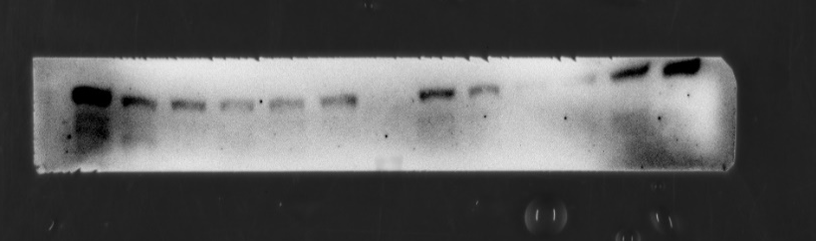
120KD
PGC-1α：
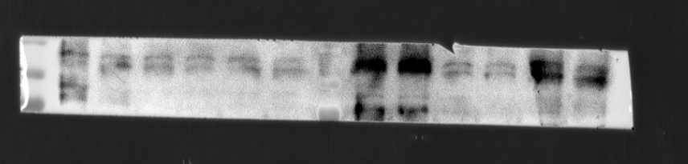
100KD
NRF-1：
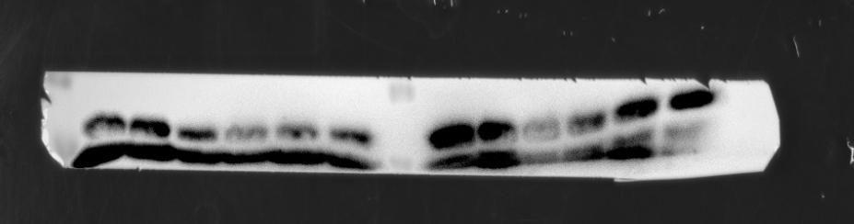
60KD
TFAM：
28KD
GAPDH：
37KD
Figure 3F：
ATP5A：
53KD
CytC:
14KD
OPA-1:
112KD
DRP-1:
82KD
MFN-1:
84KD
MFN-2:
80KD
GAPDH:
37KD
Figure 4E：
p-PI3K:
84KD
PI3K:
110KD
p-AKT:
60KD
AKT:
60KD
GLUT4:
50KD
GAPDH:
37KD
Figure 6C:
SIRT1:
120KD
PGC-1α：
100KD
NRF-1：
60KD
TFAM：
28KD
GAPDH：
37KD
Figure 6E:
ATP5A:
53KD
CytC:
14KD
OPA-1:
112KD
DRP-1:
82KD
MFN-1:
84KD
MFN-2:
80KD
GAPDH:
37KD
Figure 7B:
p-PI3K:
84KD
PI3K:
110KD
p-AKT:
60KD
AKT:
60KD
GLUT4:
50KD
GAPDH:
37KD
Figure 7E:
SIRT1：
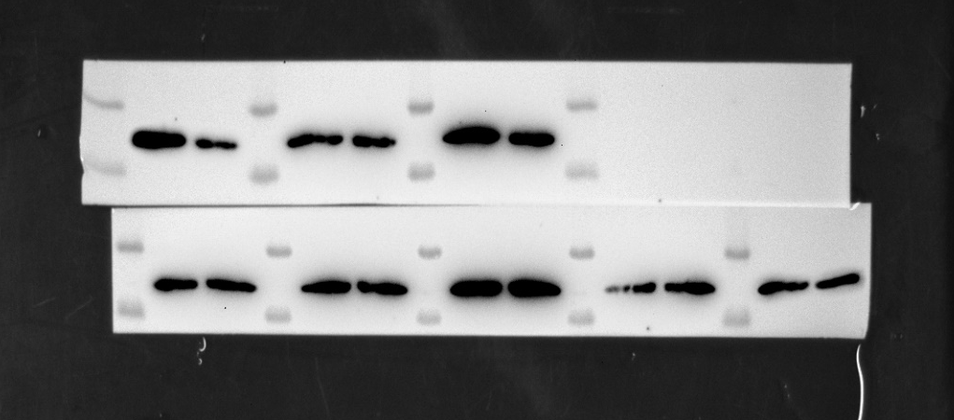
120KD
GAPDH：
37KD
Figure 7G:
p-PI3K:
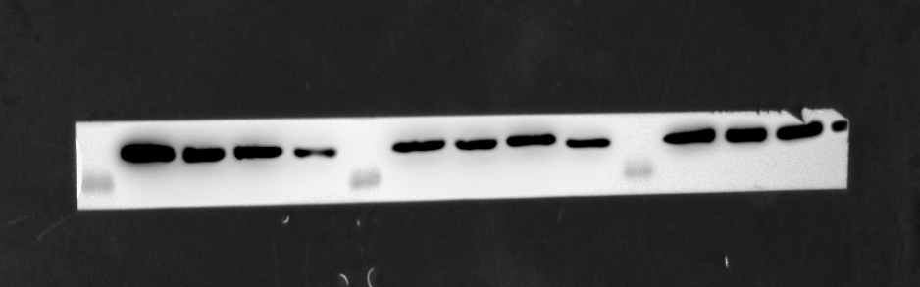
84KD
PI3K:
110KD
p-AKT：
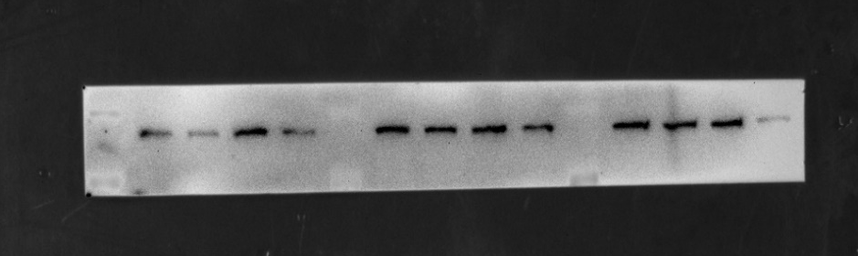
60KD
AKT：
60KD
GLUT4：
50KD
GAPDH：
37KD

Figure legends: Uncropped gels and blots are shown in supplementary figure 1, with locations of figures, molecular types, and weights has been shown. Due to the verification of protein expression in different animals or cell batches within the same experiment, a single exposure image may contain multiple sets of gels, with those shown in the final results are included.

