Supplementary Material
1 Supplementary Table
Supplementary Table S1 Characteristics of participants with/without CRDs
Table S1.1 Characteristics of participants with/without emphysema.
Table S1.2 Characteristics of participants with/without tracheitis.
Table S1.3 Characteristics of participants with/without COPD.
Table S1.4 Characteristics of participants with/without asthma.

Supplementary Table S2 Associations of serum trace metals with CRDs in American adults.
Table S2.1 model 1
Table S2.2 model 2
Table S2.3 model 3

2 Supplementary Figure
Supplementary Figure S1 Causal effects of MR. (A) Scatter plot between Cu on COPD. (B) Scatter plot between Cu on chronic tracheitis. (C) Scatter plot between Zn on COPD. (D) Scatter plot between Se on chronic tracheitis.
Supplementary Figure S2 Causal effects of reverse MR. (A) Scatter plot between COPD on Cu. (B) Scatter plot between chronic tracheitis on Cu. (C) Scatter plot between COPD on Zn. (D) Scatter plot between chronic tracheitis on Se.
Supplementary Figure S3 Leave−one−out sensitivity analysis of MR. (A) Leave−one−out plot between Cu on COPD. (B) Leave−one−out plot between Cu on chronic tracheitis. (C) Leave−one−out plot between Zn on COPD. (D) Leave−one−out plot between Se on chronic tracheitis.
Supplementary Figure S4 Leave−one−out sensitivity analysis of reverse MR. (A) Leave−one−out plot between COPD on Cu. (B) Leave−one−out plot between chronic tracheitis on Cu. (C) Leave−one−out plot between COPD on Zn. (D) Leave−one−out plot between chronic tracheitis on Se.

Supplementary Table S1.1 Characteristics of participants with/without emphysema.

characteristics |  | kind |  | emphysema |  |  | n |  | p
 |  |  | no |  | yes
age category | 20-39 |  | 999 |  | 2 | 1001 |  | <0.001
 |  |  | 36.40% |  | 3.20% | 35.70%
 | 40-59 |  | 905 |  | 13 | 918
 |  |  | 33.00% |  | 21.00% | 32.70%
 | 60-80 |  | 841 |  | 47 | 888
 |  |  | 30.60% |  | 75.80% | 31.60%
gender | male |  | 1350 |  | 34 | 1384 |  | 0.378
 |  |  | 49.20% |  | 54.80% | 49.30%
 | female |  | 1395 |  | 28 | 1423
 |  |  | 50.80% |  | 45.20% | 50.70%
race | Mexican American |  | 417 |  | 6 | 423 |  | <0.001
 |  |  | 15.20% |  | 9.70% | 15.10%
 | Other Hispanic |  | 293 |  | 6 | 299
 |  |  | 10.70% |  | 9.70% | 10.70%
 | Non-Hispanic White |  | 1113 |  | 43 | 1156
 |  |  | 40.50% |  | 69.40% | 41.20%
 | Non-Hispanic Black |  | 536 |  | 4 | 540
 |  |  | 19.50% |  | 6.50% | 19.20%
 | Other Race |  | 386 |  | 3 | 389
 |  |  | 14.10% |  | 4.80% | 13.90%
education | Less than 9th grade |  | 242 |  | 12 | 254 |  | 0.005
 |  |  | 8.80% |  | 19.40% | 9.00%
 | 9-11th grade |  | 314 |  | 11 | 325
 |  |  | 11.40% |  | 17.70% | 11.60%
 | High school graduate |  | 614 |  | 14 | 628
 |  |  | 22.40% |  | 22.60% | 22.40%
 | Some college or AA degree |  | 845 |  | 18 | 863
 |  |  | 30.80% |  | 29.00% | 30.70%
 | College graduate or above |  | 730 |  | 7 | 737
 |  |  | 26.60% |  | 11.30% | 26.30%
marriage | Married |  | 1394 |  | 22 | 1416 |  | <0.001
 |  |  | 50.80% |  | 35.50% | 50.40%
 | Widowed |  | 172 |  | 12 | 184
 |  |  | 6.30% |  | 19.40% | 6.60%
 | Divorced |  | 305 |  | 13 | 318
 |  |  | 11.10% |  | 21.00% | 11.30%
 | Separated |  | 75 |  | 6 | 81
 |  |  | 2.70% |  | 9.70% | 2.90%
 | Never married |  | 550 |  | 3 | 553
 |  |  | 20.00% |  | 4.80% | 19.70%
 | Living with partner |  | 249 |  | 6 | 255
 |  |  | 9.10% |  | 9.70% | 9.10%
drink | yes |  | 1965 |  | 55 | 2020 |  | 0.003
 |  |  | 71.60% |  | 88.70% | 72.00%
 | no |  | 780 |  | 7 | 787
 |  |  | 28.40% |  | 11.30% | 28.00%
exercise | yes |  | 548 |  | 11 | 559 |  | 0.665
 |  |  | 20.00% |  | 17.70% | 19.90%
 | no |  | 2197 |  | 51 | 2248
 |  |  | 80.00% |  | 82.30% | 80.10%
smoke | yes |  | 1171 |  | 55 | 1226 |  | <0.001
 |  |  | 42.70% |  | 88.70% | 43.70%
 | no |  | 1574 |  | 7 | 1581
 |  |  | 57.30% |  | 11.30% | 56.30%
hyper | yes |  | 946 |  | 46 | 992 |  | <0.001
 |  |  | 34.50% |  | 74.20% | 35.30%
 | no |  | 1799 |  | 16 | 1815
 |  |  | 65.50% |  | 25.80% | 64.70%
diabetes | yes |  | 378 |  | 20 | 398 |  | <0.001
 |  |  | 13.80% |  | 32.30% | 14.20%
 | no |  | 2367 |  | 42 | 2409
 |  |  | 86.20% |  | 67.70% | 85.80%
Copper category | below 105.0 |  | 919 |  | 9 | 928 |  | <0.001
 |  |  | 33.50% |  | 14.50% | 33.10%
 | 105.0 -126.4 |  | 907 |  | 18 | 925
 |  |  | 33.00% |  | 29.00% | 33.00%
 | 126.4 above |  | 919 |  | 35 | 954
 |  |  | 33.50% |  | 56.50% | 34.00%
Zinc category | below 73.700 |  | 908 |  | 19 | 927 |  | 0.249
 |  |  | 33.10% |  | 30.60% | 33.00%
 | 73.700 - 86.396 |  | 909 |  | 16 | 925
 |  |  | 33.10% |  | 25.80% | 33.00%
 | 86.396 above |  | 928 |  | 27 | 955
 |  |  | 33.80% |  | 43.50% | 34.00%
Selenium category | below 122.2 |  | 910 |  | 19 | 929 |  | 0.894
 |  |  | 33.20% |  | 30.60% | 33.10%
 | 122.2 - 135.4 |  | 907 |  | 22 | 929
 |  |  | 33.00% |  | 35.50% | 33.10%
 | 135.4 above |  | 928 |  | 21 | 949
 |  |  | 33.80% |  | 33.90% | 33.80%
new income | below 1.34 |  | 862 |  | 33 | 895 |  | <0.001
 |  |  | 31.40% |  | 53.20% | 31.90%
 | 1.34 - 3.20 |  | 1036 |  | 22 | 1058
 |  |  | 37.70% |  | 35.50% | 37.70%
 | 3.20 above |  | 847 |  | 7 | 854
 |  |  | 30.90% |  | 11.30% | 30.40%
bmi_quantile | below 25.7 |  | 920 |  | 16 | 936 |  | 0.284
 |  |  | 33.50% |  | 25.80% | 33.30%
 | 25.7-30.8 |  | 916 |  | 20 | 936
 |  |  | 33.40% |  | 32.30% | 33.30%
 | 30.8 above |  | 909 |  | 26 | 935
 |  |  | 33.10% |  | 41.90% | 33.30%

Supplementary Table S1.2 Characteristics of participants with/without tracheitis.

characteristics | kind | tracheitis | 11231 | n | p
 |  | no | yes
age category | 20-39 | 963 | 38 | 1001 | 0.002
 |  | 36.30% | 24.80% | 35.70%
 | 40-59 | 870 | 48 | 918
 |  | 32.80% | 31.40% | 32.70%
 | 60-80 | 821 | 67 | 888
 |  | 30.90% | 43.80% | 31.60%
gender | male | 1334 | 50 | 1384 | <0.001
 |  | 50.30% | 32.70% | 49.30%
 | female | 1320 | 103 | 1423
 |  | 49.70% | 67.30% | 50.70%
race | Mexican American | 413 | 10 | 423 | <0.001
 |  | 15.60% | 6.50% | 15.10%
 | Other Hispanic | 284 | 15 | 299
 |  | 10.70% | 9.80% | 10.70%
 | Non-Hispanic White | 1062 | 94 | 1156
 |  | 40.00% | 61.40% | 41.20%
 | Non-Hispanic Black | 514 | 26 | 540
 |  | 19.40% | 17.00% | 19.20%
 | Other Race | 381 | 8 | 389
 |  | 14.40% | 5.20% | 13.90%
education | Less than 9th grade | 239 | 15 | 254 | 0.05
 |  | 9.00% | 9.80% | 9.00%
 | 9-11th grade | 304 | 21 | 325
 |  | 11.50% | 13.70% | 11.60%
 | High school graduate | 590 | 38 | 628
 |  | 22.20% | 24.80% | 22.40%
 | Some college or AA degree | 808 | 55 | 863
 |  | 30.40% | 35.90% | 30.70%
 | College graduate or above | 713 | 24 | 737
 |  | 26.90% | 15.70% | 26.30%
marriage | Married | 1363 | 53 | 1416 | <0.001
 |  | 51.40% | 34.60% | 50.40%
 | Widowed | 168 | 16 | 184
 |  | 6.30% | 10.50% | 6.60%
 | Divorced | 280 | 38 | 318
 |  | 10.60% | 24.80% | 11.30%
 | Separated | 74 | 7 | 81
 |  | 2.80% | 4.60% | 2.90%
 | Never married | 528 | 25 | 553
 |  | 19.90% | 16.30% | 19.70%
 | Living with partner | 241 | 14 | 255
 |  | 9.10% | 9.20% | 9.10%
drink | yes | 1904 | 116 | 2020 | 0.275
 |  | 71.70% | 75.80% | 72.00%
 | no | 750 | 37 | 787
 |  | 28.30% | 24.20% | 28.00%
exercise | yes | 527 | 32 | 559 | 0.75
 |  | 19.90% | 20.90% | 19.90%
 | no | 2127 | 121 | 2248
 |  | 80.10% | 79.10% | 80.10%
smoke | yes | 1124 | 102 | 1226 | <0.001
 |  | 42.40% | 66.70% | 43.70%
 | no | 1530 | 51 | 1581
 |  | 57.60% | 33.30% | 56.30%
hyper | yes | 917 | 75 | 992 | <0.001
 |  | 34.60% | 49.00% | 35.30%
 | no | 1737 | 78 | 1815
 |  | 65.40% | 51.00% | 64.70%
diabetes | yes | 366 | 32 | 398 | 0.014
 |  | 13.80% | 20.90% | 14.20%
 | no | 2288 | 121 | 2409
 |  | 86.20% | 79.10% | 85.80%
Copper category | below 105.0 | 905 | 23 | 928 | <0.001
 |  | 34.10% | 15.00% | 33.10%
 | 105.0 -126.4 | 863 | 62 | 925
 |  | 32.50% | 40.50% | 33.00%
 | 126.4 above | 886 | 68 | 954
 |  | 33.40% | 44.40% | 34.00%
Zinc category | below 73.700 | 885 | 42 | 927 | 0.052
 |  | 33.30% | 27.50% | 33.00%
 | 73.700 - 86.396 | 861 | 64 | 925
 |  | 32.40% | 41.80% | 33.00%
 | 86.396 above | 908 | 47 | 955
 |  | 34.20% | 30.70% | 34.00%
Selenium category | below 122.2 | 868 | 61 | 929 | 0.078
 |  | 32.70% | 39.90% | 33.10%
 | 122.2 - 135.4 | 890 | 39 | 929
 |  | 33.50% | 25.50% | 33.10%
 | 135.4 above | 896 | 53 | 949
 |  | 33.80% | 34.60% | 33.80%
new income | below 1.34 | 862 | 33 | 895 | <0.001
 |  | 31.40% | 53.20% | 31.90%
 | 1.34 - 3.20 | 1036 | 22 | 1058
 |  | 37.70% | 35.50% | 37.70%
 | 3.20 above | 847 | 7 | 854
 |  | 30.90% | 11.30% | 30.40%
bmi_quantile | below 25.7 | 906 | 30 | 936 | <0.001
 |  | 34.10% | 19.60% | 33.30%
 | 25.7-30.8 | 887 | 49 | 936
 |  | 33.40% | 32.00% | 33.30%
 | 30.8 above | 861 | 74 | 935
 |  | 32.40% | 48.40% | 33.30%

Supplementary Table S1.3 Characteristics of participants with/without COPD.

characteristics | kind | COPD |  |  | n | p
 |  | no | yes
age_category | 20-39 | 997 | 4 | 1001 |  | <0.001
 |  | 36.70% | 4.40% | 35.70%
 | 40-59 | 895 | 23 | 918
 |  | 33.00% | 25.30% | 32.70%
 | 60-80 | 824 | 64 | 888
 |  | 30.30% | 70.30% | 31.60%
gender | male | 1332 | 52 | 1384 |  | 0.128
 |  | 49.00% | 57.10% | 49.30%
 | female | 1384 | 39 | 1423
 |  | 51.00% | 42.90% | 50.70%
race | Mexican American | 416 | 7 | 423 |  | <0.001
 |  | 15.30% | 7.70% | 15.10%
 | Other Hispanic | 298 | 1 | 299
 |  | 11.00% | 1.10% | 10.70%
 | Non-Hispanic White | 1086 | 70 | 1156
 |  | 40.00% | 76.90% | 41.20%
 | Non-Hispanic Black | 531 | 9 | 540
 |  | 19.60% | 9.90% | 19.20%
 | Other Race | 385 | 4 | 389
 |  | 14.20% | 4.40% | 13.90%
education | Less than 9th grade | 243 | 11 | 254 |  | 0.1
 |  | 8.90% | 12.10% | 9.00%
 | 9-11th grade | 311 | 14 | 325
 |  | 11.50% | 15.40% | 11.60%
 | High school graduate | 605 | 23 | 628
 |  | 22.30% | 25.30% | 22.40%
 | Some college or AA degree | 833 | 30 | 863
 |  | 30.70% | 33.00% | 30.70%
 | College graduate or above | 724 | 13 | 737
 |  | 26.70% | 14.30% | 26.30%
marriage | Married | 1370 | 46 | 1416 |  | <0.001
 |  | 50.40% | 50.50% | 50.40%
 | Widowed | 169 | 15 | 184
 |  | 6.20% | 16.50% | 6.60%
 | Divorced | 299 | 19 | 318
 |  | 11.00% | 20.90% | 11.30%
 | Separated | 74 | 7 | 81
 |  | 2.70% | 7.70% | 2.90%
 | Never married | 551 | 2 | 553
 |  | 20.30% | 2.20% | 19.70%
 | Living with partner | 253 | 2 | 255
 |  | 9.30% | 2.20% | 9.10%
drink | yes | 1941 | 79 | 2020 |  | 0.001
 |  | 71.50% | 86.80% | 72.00%
 | no | 775 | 12 | 787
 |  | 28.50% | 13.20% | 28.00%
exercise | yes | 544 | 15 | 559 |  | 0.405
 |  | 20.00% | 16.50% | 19.90%
 | no | 2172 | 76 | 2248
 |  | 80.00% | 83.50% | 80.10%
smoke | yes | 1149 | 77 | 1226 |  | <0.001
 |  | 42.30% | 84.60% | 43.70%
 | no | 1567 | 14 | 1581
 |  | 57.70% | 15.40% | 56.30%
hyper | yes | 926 | 66 | 992 |  | <0.001
 |  | 34.10% | 72.50% | 35.30%
 | no | 1790 | 25 | 1815
 |  | 65.90% | 27.50% | 64.70%
diabetes | yes | 372 | 26 | 398 |  | <0.001
 |  | 13.70% | 28.60% | 14.20%
 | no | 2344 | 65 | 2409
 |  | 86.30% | 71.40% | 85.80%
Copper category | below 105.0 | 914 | 14 | 928 |  | 0.001
 |  | 33.70% | 15.40% | 33.10%
 | 105.0 -126.4 | 892 | 33 | 925
 |  | 32.80% | 36.30% | 33.00%
 | 126.4 above | 910 | 44 | 954
 |  | 33.50% | 48.40% | 34.00%
Zinc category | below 73.700 | 906 | 21 | 927 |  | 0.062
 |  | 33.40% | 23.10% | 33.00%
 | 73.700 - 86.396 | 895 | 30 | 925
 |  | 33.00% | 33.00% | 33.00%
 | 86.396 above | 915 | 40 | 955
 |  | 33.70% | 44.00% | 34.00%
Selenium category | below 122.2 | 899 | 30 | 929 |  | 0.71
 |  | 33.10% | 33.00% | 33.10%
 | 122.2 - 135.4 | 902 | 27 | 929
 |  | 33.20% | 29.70% | 33.10%
 | 135.4 above | 915 | 34 | 949
 |  | 33.70% | 37.40% | 33.80%
new income | below 1.34 | 862 | 33 | 895 |  | 0.001
 |  | 31.40% | 53.20% | 31.90%
 | 1.34 - 3.20 | 1036 | 22 | 1058
 |  | 37.70% | 35.50% | 37.70%
 | 3.20 above | 847 | 7 | 854
 |  | 30.90% | 11.30% | 30.40%
bmi_quantile | below 25.7 | 909 | 27 | 936 |  | 0.725
 |  | 33.50% | 29.70% | 33.30%
 | 25.7-30.8 | 905 | 31 | 936
 |  | 33.30% | 34.10% | 33.30%
 | 30.8 above | 902 | 33 | 935
 |  | 33.20% | 36.30% | 33.30%

Supplementary Table S1.4 Characteristics of participants with/without asthma.

characteristics | kind | asthma | 1231 | n | p
 |  | no | yes
age category | 20-39 | 815 | 186 | 1001 | 0.006
 |  | 34.40% | 42.30% | 35.70%
 | 40-59 | 793 | 125 | 918
 |  | 33.50% | 28.40% | 32.70%
 | 60-80 | 759 | 129 | 888
 |  | 32.10% | 29.30% | 31.60%
gender | male | 1201 | 183 | 1384 | <0.001
 |  | 50.70% | 41.60% | 49.30%
 | female | 1166 | 257 | 1423
 |  | 49.30% | 58.40% | 50.70%
race | Mexican American | 369 | 54 | 423 | 0.142
 |  | 15.60% | 12.30% | 15.10%
 | Other Hispanic | 254 | 45 | 299
 |  | 10.70% | 10.20% | 10.70%
 | Non-Hispanic White | 954 | 202 | 1156
 |  | 40.30% | 45.90% | 41.20%
 | Non-Hispanic Black | 454 | 86 | 540
 |  | 19.20% | 19.50% | 19.20%
 | Other Race | 336 | 53 | 389
 |  | 14.20% | 12.00% | 13.90%
education | Less than 9th grade | 222 | 32 | 254 | <0.001
 |  | 9.40% | 7.30% | 9.00%
 | 9-11th grade | 276 | 49 | 325
 |  | 11.70% | 11.10% | 11.60%
 | High school graduate | 537 | 91 | 628
 |  | 22.70% | 20.70% | 22.40%
 | Some college or AA degree | 705 | 158 | 863
 |  | 29.80% | 35.90% | 30.70%
 | College graduate or above | 627 | 110 | 737
 |  | 26.50% | 25.00% | 26.30%
marriage | Married | 1220 | 196 | 1416 | 0.012
 |  | 51.50% | 44.50% | 50.40%
 | Widowed | 157 | 27 | 184
 |  | 6.60% | 6.10% | 6.60%
 | Divorced | 248 | 70 | 318
 |  | 10.50% | 15.90% | 11.30%
 | Separated | 67 | 14 | 81
 |  | 2.80% | 3.20% | 2.90%
 | Never married | 458 | 95 | 553
 |  | 19.30% | 21.60% | 19.70%
 | Living with partner | 217 | 38 | 255
 |  | 9.20% | 8.60% | 9.10%
drink | yes | 1678 | 342 | 2020 | 0.003
 |  | 70.90% | 77.70% | 72.00%
 | no | 689 | 98 | 787
 |  | 29.10% | 22.30% | 28.00%
exercise | yes | 469 | 90 | 559 | 0.757
 |  | 19.80% | 20.50% | 19.90%
 | no | 1898 | 350 | 2248
 |  | 80.20% | 79.50% | 80.10%
smoke | yes | 1013 | 213 | 1226 | 0.029
 |  | 42.80% | 48.40% | 43.70%
 | no | 1354 | 227 | 1581
 |  | 57.20% | 51.60% | 56.30%
hyper | yes | 811 | 181 | 992 | 0.006
 |  | 34.30% | 41.10% | 35.30%
 | no | 1556 | 259 | 1815
 |  | 65.70% | 58.90% | 64.70%
diabetes | yes | 328 | 70 | 398 | 0.257
 |  | 13.90% | 15.90% | 14.20%
 | no | 2039 | 370 | 2409
 |  | 86.10% | 84.10% | 85.80%
Copper category | below 105.0 | 810 | 118 | 928 | <0.001
 |  | 34.20% | 26.80% | 33.10%
 | 105.0 -126.4 | 791 | 134 | 925
 |  | 33.40% | 30.50% | 33.00%
 | 126.4 above | 766 | 188 | 954
 |  | 32.40% | 42.70% | 34.00%
Zinc category | below 73.700 | 784 | 143 | 927 | 0.985
 |  | 33.10% | 32.50% | 33.00%
 | 73.700 - 86.396 | 780 | 145 | 925
 |  | 33.00% | 33.00% | 33.00%
 | 86.396 above | 803 | 152 | 955
 |  | 33.90% | 34.50% | 34.00%
Selenium category | below 122.2 | 767 | 162 | 929 | 0.166
 |  | 32.40% | 36.80% | 33.10%
 | 122.2 - 135.4 | 796 | 133 | 929
 |  | 33.60% | 30.20% | 33.10%
 | 135.4 above | 804 | 145 | 949
 |  | 34.00% | 33.00% | 33.80%
new income | below 1.34 | 733 | 162 | 895 | 0.053
 |  | 31.00% | 36.80% | 31.90%
 | 1.34 - 3.20 | 905 | 153 | 1058
 |  | 38.20% | 34.80% | 37.70%
 | 3.20 above | 729 | 125 | 854
 |  | 30.80% | 28.40% | 30.40%
bmi_quantile | below 25.7 | 811 | 125 | 936 | <0.001
 |  | 34.30% | 28.40% | 33.30%
 | 25.7-30.8 | 807 | 129 | 936
 |  | 34.10% | 29.30% | 33.30%
 | 30.8 above | 749 | 186 | 935
 |  | 31.60% | 42.30% | 33.30%

Supplementary Table S2.1 model 1

model 1 |  |  |  | B |  | SE |  |  | P Exp(B)
emphysema |  | gender |  |  | -.657 |  | 0.284 | 0.021 |  | 0.518
 |  | race |  |  | -.084 |  | 12.30% | 0.494 |  | 0.919
 |  | education |  |  | -.079 |  | 0.116 | 0.498 |  | 0.924
 |  | marriage |  |  | .138 |  | 8.40% | 0.097 |  | 1.148
 |  | new income |  |  | -.530 |  | 21.30% | 0.013 |  | 0.589
 |  | age category |  |  | 1.550 |  | 0.247 | 0 |  | 4.713
 |  | Selenium category |  |  | -.118 |  | 16.80% | 0.485 |  | 0.889
 |  | Zinc category |  |  | .249 |  | 0.171 | 0.144 |  | 1.283
 |  | Copper category |  |  | .717 |  | 0.195 | 0 |  | 2.048
tracheitis |  | gender |  |  | 0.543 |  | 0.195 | 0.005 |  | 1.72
 |  | race |  |  | 0.033 |  | 0.075 | 0.657 |  | 1.034
 |  | education |  |  | -0.007 |  | 0.076 | 0.925 |  | 0.993
 |  | marriage |  |  | 0.105 |  | 0.05 | 0.036 |  | 1.111
 |  | new income |  |  | -0.361 |  | 0.124 | 0.004 |  | 0.697
 |  | age category |  |  | 0.444 |  | 0.113 | 0 |  | 1.558
 |  | Selenium category |  |  | -0.081 |  | 0.107 | 0.447 |  | 0.922
 |  | Zinc category |  |  | 0.079 |  | 0.107 | 0.458 |  | 1.082
 |  | Copper category |  |  | 0.273 |  | 0.118 | 0.021 |  | 1.314
COPD |  | gender |  |  | -0.722 |  | 0.24 | 0.003 |  | 0.486
 |  | race |  |  | 0.036 |  | 0.101 | 0.721 |  | 1.037
 |  | education |  |  | 0.051 |  | 0.098 | 0.599 |  | 1.053
 |  | marriage |  |  | -0.14 |  | 0.079 | 0.075 |  | 0.869
 |  | new income |  |  | -0.595 |  | 0.171 | 0.001 |  | 0.552
 |  | age category |  |  | 1.221 |  | 0.185 | 0 |  | 3.392
 |  | Selenium category |  |  | -0.136 |  | 0.139 | 0.329 |  | 0.873
 |  | Zinc category |  |  | 0.363 |  | 0.141 | 0.01 |  | 1.437
 |  | Copper category |  |  | 0.635 |  | 0.158 | 0 |  | 1.887
asthma |  | gender |  |  | 0.201 |  | 0.12 | 0.093 |  | 1.223
 |  | race |  |  | 0.013 |  | 0.046 | 0.777 |  | 1.013
 |  | education |  |  | 0.086 |  | 0.05 | 0.084 |  | 1.09
 |  | marriage |  |  | 0.014 |  | 0.03 | 0.644 |  | 1.014
 |  | new income |  |  | -0.166 |  | 0.074 | 0.026 |  | 0.847
 |  | age category |  |  | -0.139 |  | 0.069 | 0.045 |  | 0.87
 |  | Selenium category |  |  | -0.057 |  | 0.067 | 0.396 |  | 0.945
 |  | Zinc category |  |  | 0.044 |  | 0.066 | 0.507 |  | 1.045
 |  | Copper category |  |  | 0.218 |  | 0.072 | 0.002 |  | 1.244

Supplementary Table S2.2 model 2

model2 |  | B | SE | P | Exp(B)
emphysema | gender | -.040 | 0.302 | 0.895 | 0.961
 | race | -.092 | 0.137 | 0.5 | 0.912
 | education | -.102 | 12.30% | 0.41 | 0.903
 | marriage | .083 | 0.087 | 0.339 | 1.087
 | new income | -.482 | 21.50% | 0.025 | 0.618
 | age category | 1.534 | 26.00% | 0 | 4.636
 | Selenium category | -.037 | 0.172 | 0.83 | 0.964
 | Zinc category | .172 | 17.50% | 0.325 | 1.188
 | Copper category | .657 | 0.201 | 0.001 | 1.929
 | smoke | -1.789 | 43.10% | 0 | 0.167
 | exercise | -.170 | 0.365 | 0.641 | 0.843
 | drink | -.870 | 43.90% | 0.048 | 0.419
tracheitis | gender | 0.862 | 0.205 | 0 | 2.369
 | race | 0.039 | 0.079 | 0.627 | 1.039
 | education | -0.005 | 0.079 | 0.952 | 0.995
 | marriage | 0.072 | 0.051 | 0.156 | 1.075
 | new income | -0.311 | 0.126 | 0.013 | 0.732
 | age category | 0.408 | 0.116 | 0 | 1.504
 | Selenium category | -0.048 | 0.108 | 0.654 | 0.953
 | Zinc category | 0.044 | 0.108 | 0.683 | 1.045
 | Copper category | 0.22 | 0.12 | 0.067 | 1.246
 | smoke | -0.957 | 0.196 | 0 | 0.384
 | exercise | -0.242 | 0.217 | 0.264 | 0.785
 | drink | -0.189 | 0.218 | 0.385 | 0.828
COPD | gender | -0.175 | 0.258 | 0.498 | 0.84
 | gender | 0.062 | 0.111 | 0.577 | 1.064
 | race | 0.058 | 0.103 | 0.573 | 1.06
 | education | -0.21 | 0.083 | 0.011 | 0.81
 | marriage | -0.584 | 0.175 | 0.001 | 0.557
 | new income | 1.166 | 0.193 | 0 | 3.21
 | age category | -0.062 | 0.142 | 0.664 | 0.94
 | Selenium category | 0.301 | 0.145 | 0.038 | 1.352
 | Zinc category | 0.555 | 0.163 | 0.001 | 1.742
 | smoke | -1.602 | 0.319 | 0 | 0.201
 | exercise | 0.099 | 0.31 | 0.749 | 1.104
 | drink | -0.691 | 0.346 | 0.046 | 0.501
asthma | gender | 0.343 | 0.126 | 0.006 | 1.408
 | race | 0.029 | 0.047 | 0.541 | 1.029
 | education | 0.078 | 0.051 | 0.124 | 1.082
 | marriage | 0.002 | 0.03 | 0.956 | 1.002
 | new income | -0.173 | 0.075 | 0.021 | 0.841
 | age category | -0.14 | 0.071 | 0.049 | 0.87
 | Selenium category | -0.05 | 0.067 | 0.457 | 0.951
 | Zinc category | 0.031 | 0.066 | 0.634 | 1.032
 | Copper category | 0.197 | 0.073 | 0.007 | 1.217
 | smoke | -0.196 | 0.115 | 0.089 | 0.822
 | exercise | -0.049 | 0.135 | 0.718 | 0.952
 | drink | -0.396 | 0.136 | 0.003 | 0.673

Supplementary Table S2.3 model 3

model 3 |  | B | SE | P | Exp(B)
emphysema | gender | -.003 | 0.305 | 0.991 | 0.997
 | race | -.101 | 0.137 | 0.461 | 0.904
 | education | -.084 | 0.123 | 0.495 | 0.919
 | marriage | .087 | 0.088 | 0.325 | 1.091
 | drink | -.844 | 0.439 | 0.055 | 0.43
 | exercise | -.219 | 0.367 | 0.552 | 0.804
 | smoke | -1.800 | 0.431 | 0 | 0.165
 | hyper | -.704 | 0.322 | 0.029 | 0.494
 | diabetes | -.141 | 0.312 | 0.652 | 0.868
 | Copper category | .594 | 0.204 | 0.004 | 1.811
 | Zinc category | .166 | 0.176 | 0.346 | 1.181
 | Selenium category | -.043 | 0.174 | 0.807 | 0.958
 | age category | 1.375 | 0.274 | 0 | 3.957
 | new income | -.456 | 0.215 | 0.034 | 0.634
 | bmi quantile | .108 | 0.183 | 0.554 | 1.114
 | gender | 0.847 | 0.207 | 0 | 2.332
tracheitis | race | 0.066 | 0.081 | 0.414 | 1.068
 | education | 0.006 | 0.08 | 0.944 | 1.006
 | marriage | 0.078 | 0.051 | 0.127 | 1.081
 | drink | -0.181 | 0.218 | 0.406 | 0.834
 | exercise | -0.245 | 0.217 | 0.26 | 0.783
 | smoke | -0.957 | 0.195 | 0 | 0.384
 | hyper | -0.134 | 0.194 | 0.49 | 0.875
 | diabetes | -0.064 | 0.23 | 0.781 | 0.938
 | Copper category | 0.136 | 0.124 | 0.273 | 1.145
 | Zinc category | 0.052 | 0.109 | 0.631 | 1.054
 | Selenium category | -0.038 | 0.109 | 0.726 | 0.963
 | age category | 0.372 | 0.128 | 0.004 | 1.45
 | new income | -0.309 | 0.126 | 0.014 | 0.734
 | bmi quantile | 0.388 | 0.115 | 0.001 | 1.474
COPD | gender | -0.113 | 0.258 | 0.663 | 0.894
 | race | 0.037 | 0.112 | 0.743 | 1.037
 | education | 0.069 | 0.104 | 0.507 | 1.071
 | marriage | -0.219 | 0.084 | 0.009 | 0.803
 | drink | -0.67 | 0.347 | 0.053 | 0.512
 | exercise | 0.059 | 0.312 | 0.851 | 1.06
 | smoke | -1.623 | 0.32 | 0 | 0.197
 | hyper | -0.83 | 0.265 | 0.002 | 0.436
 | diabetes | -0.117 | 0.268 | 0.663 | 0.89
 | Copper category | 0.498 | 0.164 | 0.002 | 1.645
 | Zinc category | 0.299 | 0.147 | 0.041 | 1.349
 | Selenium category | -0.076 | 0.144 | 0.601 | 0.927
 | age category | 0.961 | 0.205 | 0 | 2.613
 | new income | -0.543 | 0.175 | 0.002 | 0.581
 | bmi quantile | -0.078 | 0.151 | 0.606 | 0.925
asthma | gender | 0.374 | 0.126 | 0.003 | 1.453
 | race | 0.035 | 0.048 | 0.472 | 1.035
 | education | 0.09 | 0.052 | 0.079 | 1.095
 | marriage | 0.004 | 0.03 | 0.907 | 1.004
 | drink | -0.386 | 0.136 | 0.005 | 0.68
 | exercise | -0.052 | 0.135 | 0.701 | 0.949
 | smoke | -0.188 | 0.116 | 0.104 | 0.829
 | hyper | -0.362 | 0.126 | 0.004 | 0.697
 | diabetes | -0.149 | 0.159 | 0.348 | 0.861
 | Copper category | 0.131 | 0.075 | 0.079 | 1.14
 | Zinc category | 0.032 | 0.066 | 0.625 | 1.033
 | Selenium category | -0.053 | 0.067 | 0.432 | 0.948
 | age category | -0.252 | 0.079 | 0.001 | 0.777
 | new income | -0.16 | 0.075 | 0.034 | 0.852
 | bmi quantile | 0.177 | 0.069 | 0.01 | 1.194

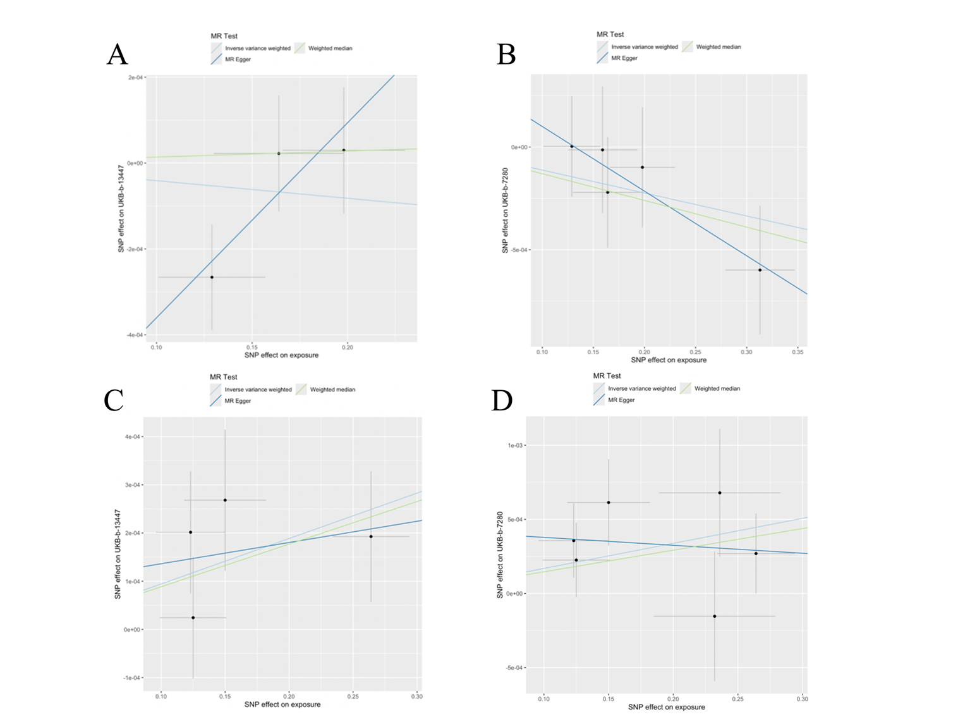
Supplementary Figure S1
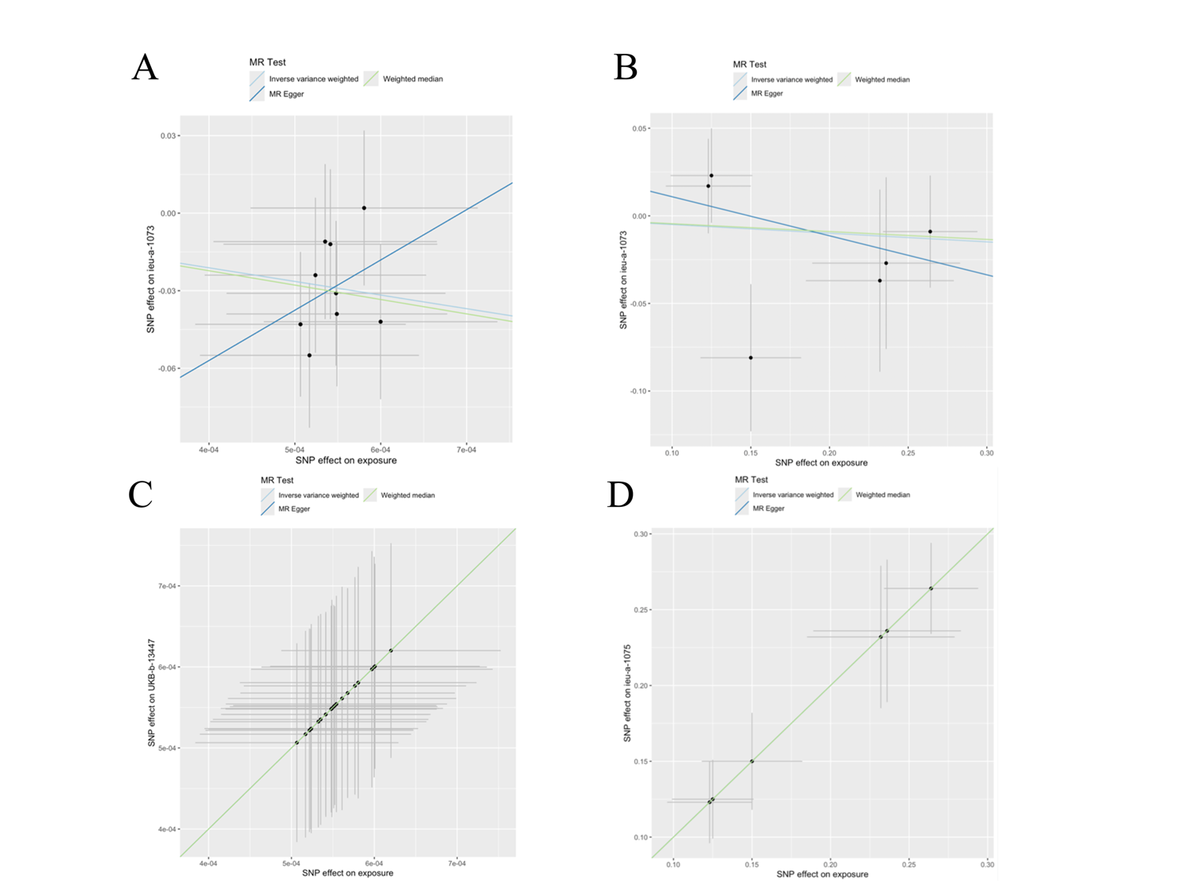
Supplementary Figure S2
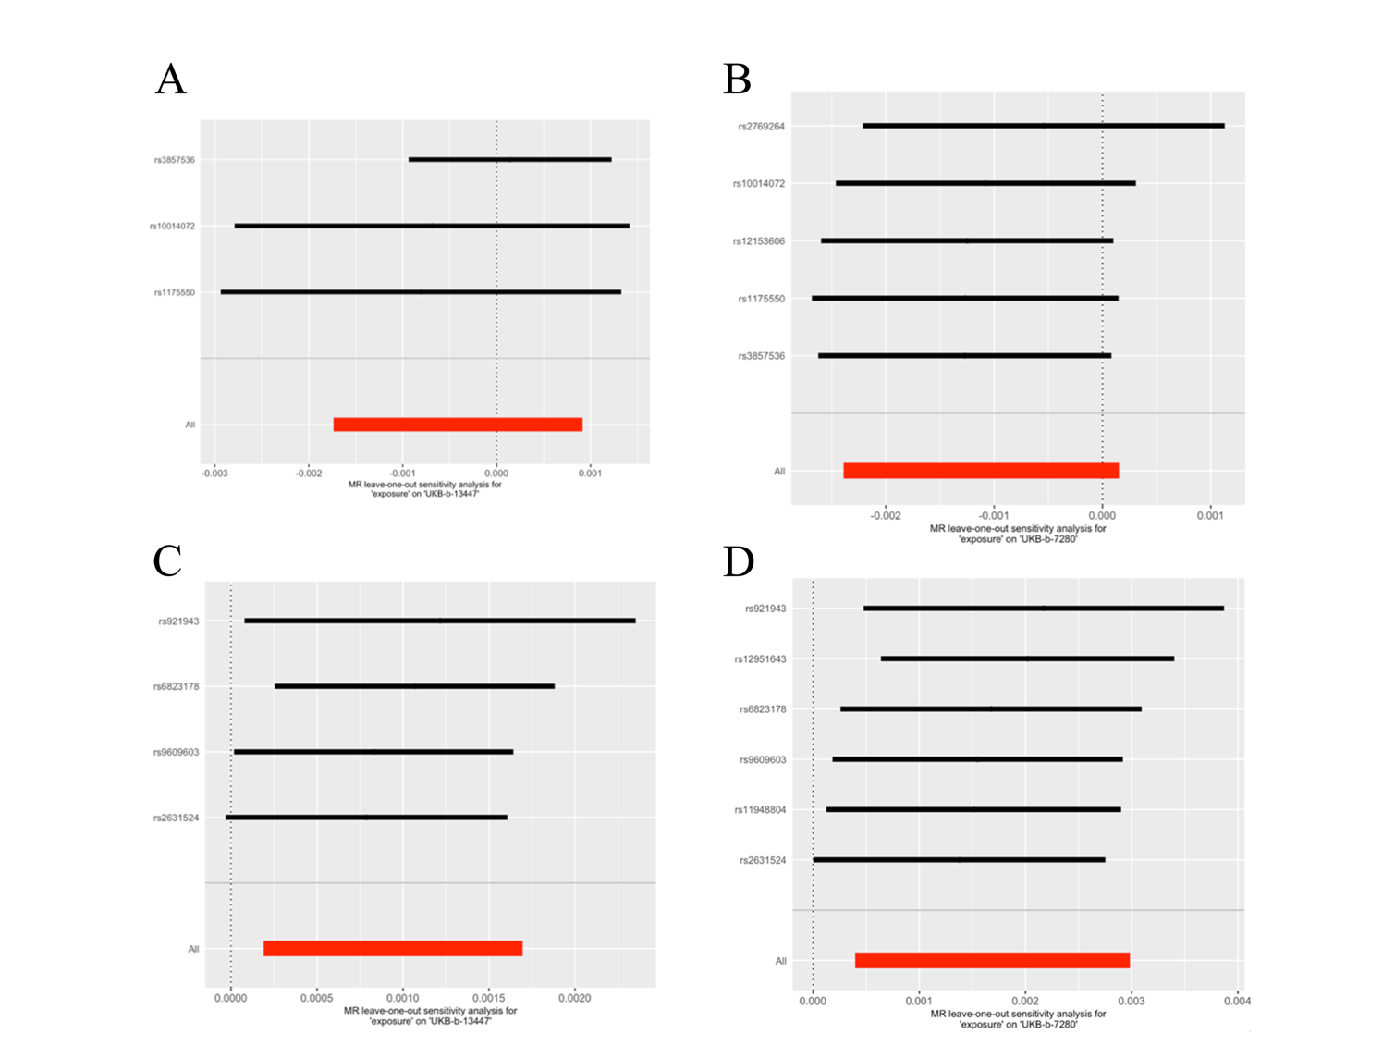
Supplementary Figure S3
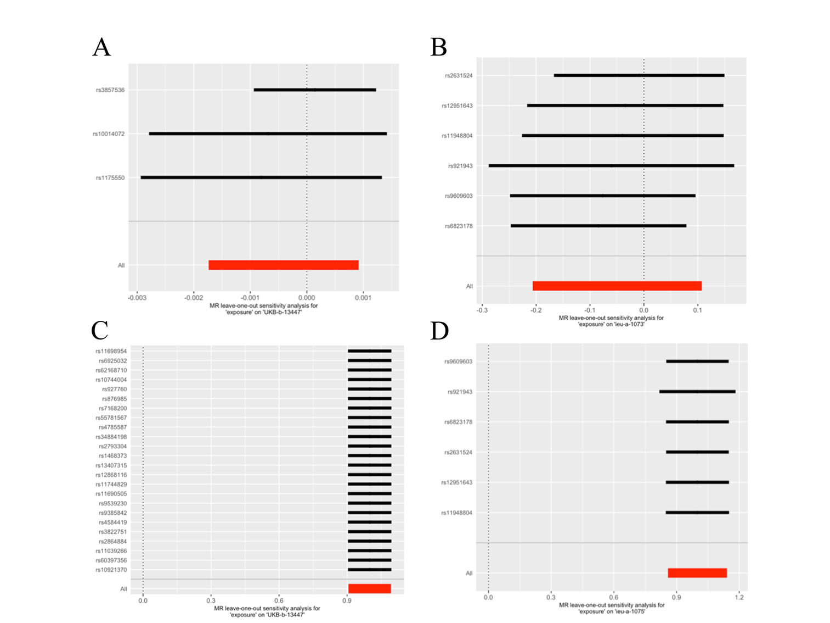
Supplementary Figure S4

