Table 2. Preparation of spirooxindole derivatives using MnFe₂O₄@SiO₂/APTPOSS catalysta
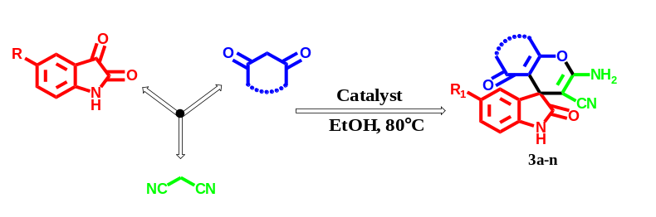
Entry | Product numbering | Substrate | Product | Time | Yield^{b}(%) | M.P.( ̊C)
1 | 3a | 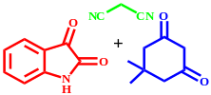 | 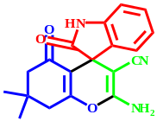 | 10 | 97 | 304-306
2 | 3b | 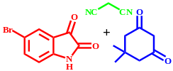 | 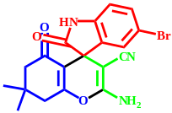 | 12 | 97 | 305-307
3 | 3c | 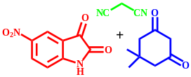 | 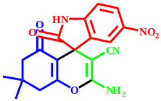 | 11 | 95 | 303-306
4 | 3d | 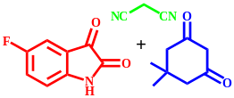 | 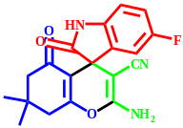 | 13 | 96 | >300
5 | 3e | 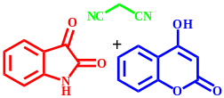 | 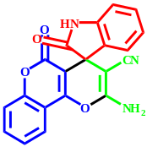 | 10 | 94 | >300
6 | 3f | 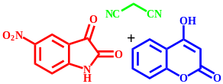 | 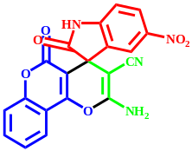 | 14 | 97 | >300
7 | 3g | 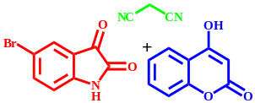 | 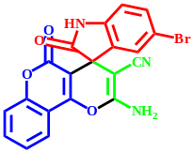 | 13 | 92 | >300
8 | 3h | 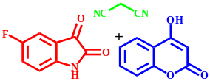 | 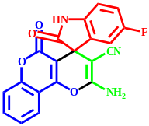 | 15 | 94 | >300
9 | 3i | 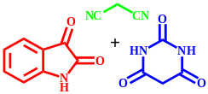 | 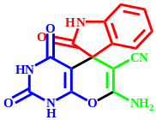 | 12 | 93 | 273-275
10 | 3j | 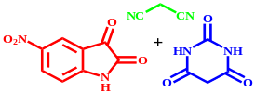 | 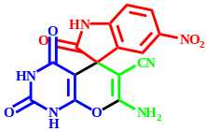 | 10 | 95 | 284-288
11 | 3k | 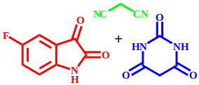 | 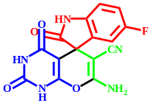 | 14 | 95 | 209-212
12 | 3l | 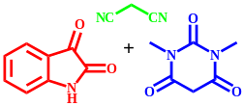 | 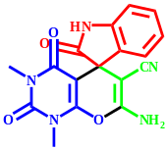 | 20 | 90 | 228-231
13 | 3m | 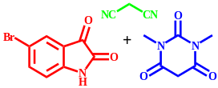 | 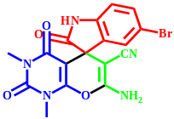 | 15 | 97 | 259-263
14 | 3n | 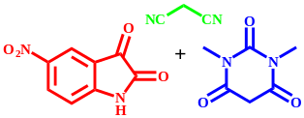 | 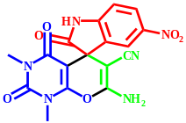 | 10 | 95 | 280-283

ª Reaction conditions: isatin (1mmol), malononitrile (1 mmol), and 1,3 dicarbonyl compounds (1 mmol) in presence MnFe₂O₄@SiO₂/APTPOSS (10 mg) in EtOH under reflux conditions
^{b} Isolated yields

