Table 1: Identification of Binding Pockets in Human DNA pol β Protein and Grid Box Generation and total amino acid residues present in the binding pockets of DNA pol βfor Molecular Docking Studies.

Protein Name | Coordinate Of Docking Box | Structure | Amino Acid Residues
DNA polymerase β | X:3.672; Y:12.247; Z:6.153 | 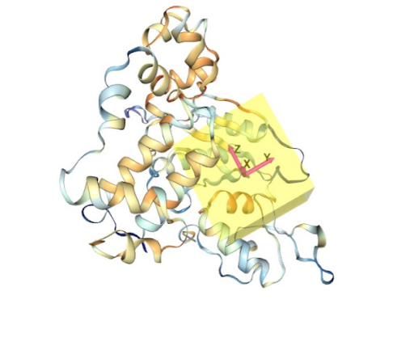 | P-151, K-167, K168, V-169, E-172, G-179, F-181, R-182, G-184, A-185, M-191, D-192, V-193, L-194, L-195, T-196, H-197, P-198, S-199, F-200, T-201, S-202, E-203, K-206, Q-207, P-208, K-209, L-210, L-211, H-212, Q-213, V-214, V-215, E-216, Q-217, L-218, D-226, T-227, K-230, G-231, E-232, T-233, K-234, F-235, G-237, V-238, L-241, P-242, R-253, I-255, D-256, I-257, R-258, L-259, I-260, P-261, K-262, D-263, Q-264, Y-265, Y-266, G-268, V-269, L-270, F-272, T-273, G-274

Table 4. The two-dimensional structures and binding energies of four compounds against the target proteins.

Molecular ID | Compound Name | Chemical Structure | Binding Energy
SN00305418 | (E)-2-(1,3,4-trihydroxy-5-((3-(4-hydroxyphenyl)acryloyl)oxy)cyclohexyl)acetic acid | 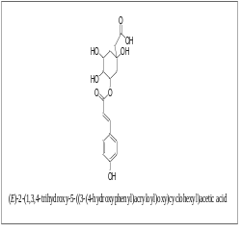 | -15.9181±4.5020
SN00158342 | (E)-5-((3-(3,4-dihydroxyphenyl)acryloyl)oxy)-3,4-dihydroxycyclohex-1-enecarboxylate | 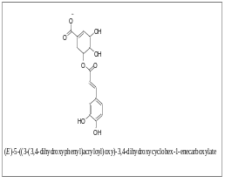 | -22.0327±3.8493
SN00004251 | N-(3-((2-amino-2-oxoethyl)carbamoyl)-5,6-dihydroxycyclohex-2-en-1-yl)-2-bromobenzamide | 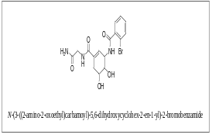 | -29.7465±6.7833
SN00341636 | (E)-4,5-dihydroxy-6-(((Z)-8-hydroxy-3,7-dimethylocta-1,6-dien-3-yl)oxy)-2-(hydroxymethyl)tetrahydro-2H-pyran-3-yl3-(4-hydroxyphenyl)acrylate | 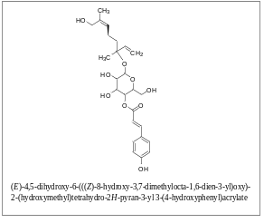 | -27.3184±5.1579

