SUPPLEMENTARY DATA

Sr. No. | Oxd. CMC:Oxd. Dextrin:Gelatin | Borax  ( mol/L ) | Glutaraldehyde  ( mol/L ) | Solvent  ( mL ) | Gelling time (minutes)
1. | 1:1:7.5 | 0.021 | 0.035 | 6 | 2
2. | 1:1:10 | 0.021 | 0.035 | 6 | 1
3. | 1:1:12.5 | 0.021 | 0.035 | 6 | 5
4. | 1:1:15 | 0.021 | 0.035 | 6 | 6
5. | 1:1:20 | 0.021 | 0.035 | 6 | 8
6. | 1:1:25 | 0.021 | 0.035 | 6 | 10
7. | 1:1:30 | 0.021 | 0.035 | 6 | 15
8. | 1:1:10 | 0.009 | 0.035 | 6 | 5
9. | 1:1:10 | 0.017 | 0.035 | 6 | 124
10. | 1:1:10 | 0.021 | 0.035 | 6 | 2
12. | 1:1:10 | 0.034 | 0.035 | 6 | 4
13. | 1:1:10 | 0.044 | 0.035 | 6 | 6
14. | 1:1:10 | 0.052 | 0.035 | 6 | 4
15. | 1:1:10 | 0.021 | 0.035 | 3 | 10
16. | 1:1:10 | 0.021 | 0.035 | 6 | 8
17. | 1:1:10 | 0.021 | 0.035 | 9 | 677
18. | 1:1:10 | 0.021 | 0.035 | 12 | Not formed
19. | 1:1:10 | 0.021 | 0.014 | 6 | 73
20. | 1:1:10 | 0.021 | 0.021 | 6 | 140
21. | 1:1:10 | 0.021 | 0.028 | 6 | 8
22. | 1:1:10 | 0.021 | 0.035 | 6 | 1
23. | 1:1:10 | 0.021 | 0.042 | 6 | 9
24. | 1:1:10 | 0.021 | 0.049 | 6 | 2
Table 1 Optimization of different parameters for the synthesis with respect to gelling time
Table 2: Different parameters analyzed from the XRD spectrum
Sr. No. | Sample | Intensity (a. u.) | d-spacing  (A˚) | 2θ in degrees | FWHM (degrees) | Crystalline size (A˚) | % Crystallinity
1. | CMC | 1875.07 | 4.84 | 18.32 | 0.13 | 0.29 | 12.42
2. | Oxd. CMC | 172.38 | 3.95 | 22.50 | 16.50 | 0.36 | 29.20
3. | Dextrin | 378.11 | 4.68 | 18.92 | 22.03 | 0.30 | 70.29
4. | Oxd.Dex | 296.14 | 4.78 | 18.55 | 27.79 | 0.29 | 80.10
5. | Gelatin | 435.96 | 4.45 | 19.93 | 27.20 | 0.32 | 80.65
6. | CMC_{ox}-Dex_{ox}-Gel | 318.16 | 4.78 | 18.54 | 27.62 | 0.29 | 82.08

Table 3: Literature survey of viscosity and shear rate of different self-healing hydrogels and their applications

Sr. No. | Sample | Viscosity  (Pa.s) | Shear rate  (1/s) | Applications | Reference
1. | HA based injectable hydrogel | 1-1000 | 0-50 | Self-healing property,mechanical strength, and clinical application | Chen et al., 2017
2. | Blend hydrogel | 60-10,000 | 0.01-10 | Antibacterial Property,  Self-recovering Property,  Wound Healing and  Good Inject ability | Zheng et al., 2018
3. | PEG hydrogel | 10-10000 | 1-100 | Self-healing,biomedical applications, and biocompatibility | Talebian et al., 2019
4. | HA based hydrogel | 0-870 | 1-100 | Injectable property, cell seeding and culture on scaffolds enhances structure stability | Ouyang, Highley, Rodell, Sun, & Burdick, 2016
5. | PNP hydrogel | 10-1200 | 0.01-100 | In vitro cell injectioncell delivery | Grosskopf et al., 2019
6. | poly(NIPAAm-co-APBA-coAAm) hydrogel | 80-1000 | 0.01-10 | Injectable, self-healing properties, tissue engineering and cell therapeutics | Amaral, Emamzadeh & Pasparakis, 2018
7. | PNC hydrogel | 10-10000 | 1-800 | 3D-printing and bio-fabrication | Boere et al., 2015
8. | HIPN hydrogel | 10-10000 | 0.01-10 | 3D-biological printing | Shen, Yang, Cui & Cao, 2019
9. | PNP hydrogel | 0.01-1000 | 0.1-1000 | In vivo efficacy in a rat model of pericardial adhesion, and biocompatibility | Stapleton et al., 2019
10. | CMC_{ox}-Dex_{ox}-Gel | 19.5-420 | 1-50 | Injectable hydrogels, biomedical applications and 3D-printing | Present study

Table 4: Degradation study of Gel-CMC_{ox}-Dex_{ox} hydrogel in different types of solutions
Solution | % Weight change after
Solution | 0 day | 1 day | 2 days | 3 days | 6 days | 7 days
5 M urea | 0% | 267.41% | 351.08% | 352.48% | 299.91% | Complete degradation
Phosphate Buffer | 0% | 57.44% | 90.18% | 79.24% | Complete degradation | -
pH 2.93 | 0% | 88.54% | 118.01% | 31.18% | Complete degradation | -
pH 4.98 | 0% | 78.08% | 116.37% | 137.48% | Complete degradation | -
pH 7.79 | 0% | 226.52% | 277.08% | 177.56% | Complete degradation | -
pH 9.19 | 0% | 87.93% | 121.29% | 82.81% | Complete degradation | -
pH 11.03 | 0% | 92.09% | 132.51% | 109.63% | Complete degradation | -

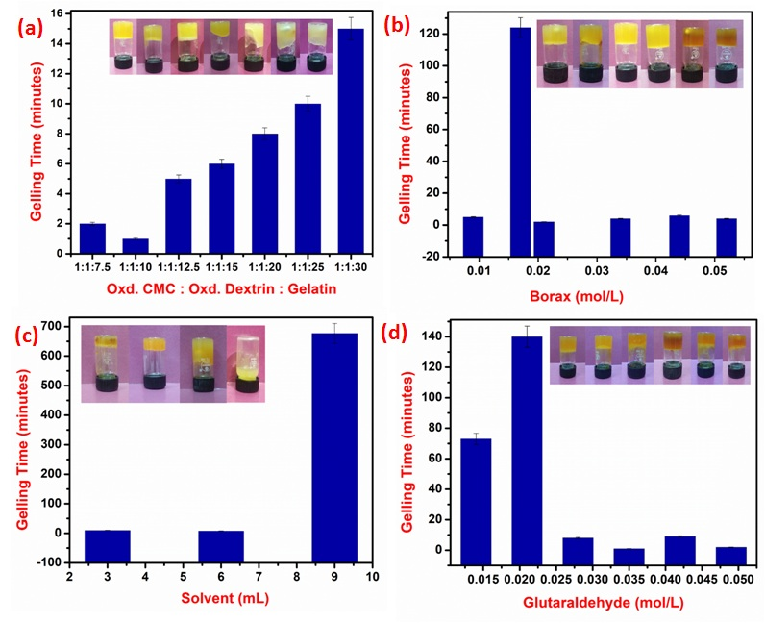
Fig. 1 Optimization of different parameters; (a) Oxd. CMC: Oxd. Dextrin: Gelatin with respect to gelling time(b) Borax (mol/L) with respect to gelling time (c) Glutaraldehyde (mol/L)with respect to gelling time(d) Solvent (mL) with respect to gelling time
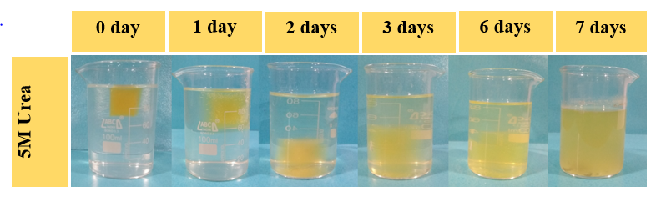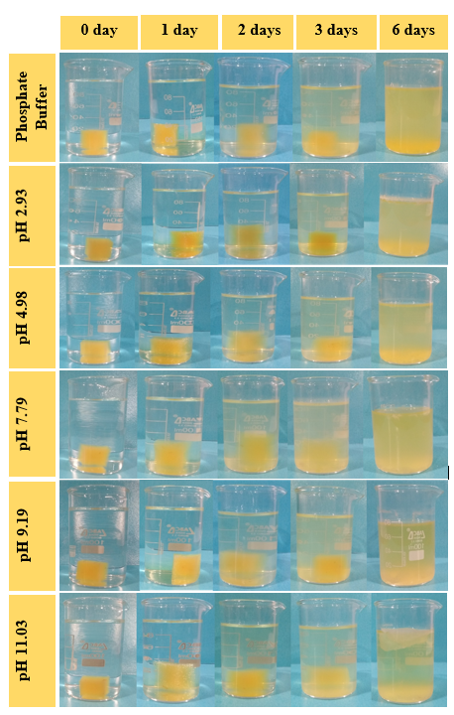
Fig. 2 Degradation study of Gel-CMC_{ox}-Dex_{ox}hydrogel in different types of solutions on different days

Fig. 3 Degradation study of Gel-CMC_{ox}-Dex_{ox}hydrogel in different types of solutions

