Supplement figure

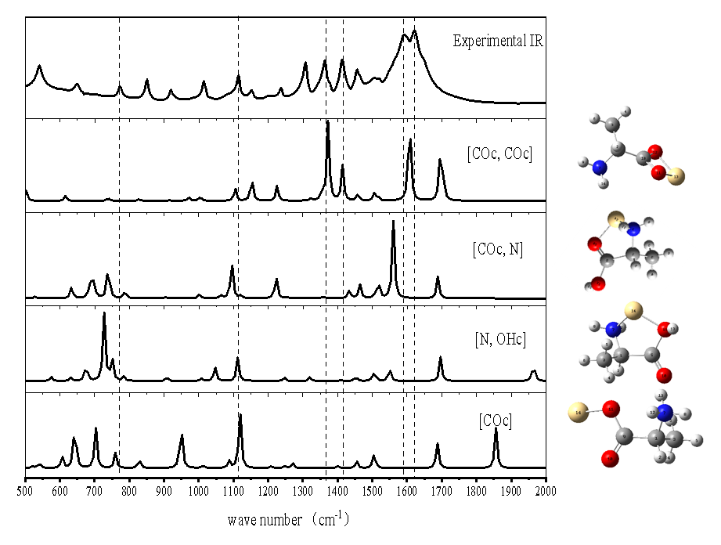
Fig.S1 The IR spectrum of AlaCd²⁺

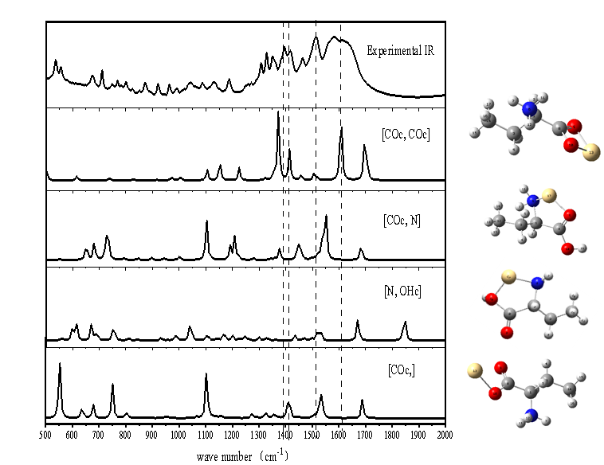
Fig.S2 The IR spectrum of LeuCd²⁺

