Supplementary Information

Phosphate ester-linked carbonized polymer nanosheets as efficient filters for removing Vibrio parahaemolyticus from aquaculture water

Anisha Anand^{1,†}, Binesh Unnikrishnan^{2,†}, Chen-Yow Wang², Jui-Yang Lai^{1,3,4,5,}*, Han-Jia Lin^{2,6}, and Chih-Ching Huang^{2,6,7,}*

¹Department of Biomedical Engineering, Chang Gung University, Taoyuan, 33302, Taiwan
²Department of Bioscience and Biotechnology, National Taiwan Ocean University, Keelung, 20204, Taiwan
³Department of Ophthalmology, Chang Gung Memorial Hospital, Linkou, Taoyuan, 33305, Taiwan
⁴Department of Materials Engineering, Ming Chi University of Technology, New Taipei City, 24301, Taiwan
⁵Research Center for Chinese Herbal Medicine, College of Human Ecology, Chang Gung University of Science and Technology, Taoyuan, 33303, Taiwan
⁶Center of Excellence for the Oceans, National Taiwan Ocean University, Keelung, 202301, Taiwan
⁷School of Pharmacy, College of Pharmacy, Kaohsiung Medical University, Kaohsiung, 80708, Taiwan

† These authors contributed equally to this work

Corresponding authors: Prof. J.-Y. Lai, Prof. C.-C. Huang
Email addresses: jylai@mail.cgu.edu.tw (J.-Y. Lai); huanging@ntou.edu.tw (C.-C. Huang)

Supplementary Methods
Materials
Sodium alginate (Alg, >98%) and ammonium chloride (NH₄Cl) were purchased from ACROS (Geel, Belgium). Diammonium hydrogen phosphate ((NH₄)₂HPO₄) and ammonium dihydrogen phosphate ((NH₄)H₂PO₄) were purchased from Showa Chemical (Tokyo, Japan). Ammonium sulfate ((NH₄)₂SO₄), ammonium sulfite ((NH₄)₂SO₃), and sodium sulfite (Na₂SO₃) were obtained from Sigma-Aldrich (St. Louis, MO, USA). Hydrochloric acid and ammonium hydroxide were purchased from Honeywell (NC, USA). Qualitative filter paper-Advantec® 2, thickness 0.26 mm and pore size 5 µm was used as a substrate to prepare the CPNSs membrane for water filtration application. Ultrapure water (18.2 MΩ cm) from a Milli-Q ultrapure water system (Millipore, Billerica, MA, USA) was used for all experiments.
Characterization of carbonized polymer nanosheets (CPNSs)
The CPNSs were characterized by transmission electron microscopy (TEM) using an HT-7700 system (Hitachi, USA), operated at 75 kV and high-resolution transmission electron microscopy (HRTEM, Tecnai-F20-G2 Philips/FEI, Hillsboro, OR, USA) at 200 kV. The samples for TEM were prepared using diluted solutions of the CPNSs, dropped onto carbon-coated copper grids followed by vacuum drying. The UV–vis absorption spectra of the CPNSs were recorded using SynergyTM 4 multi-mode microplate reader (Biotek Instruments, Winooski, VT, USA). The zeta potential and hydrodynamic size were measured using Zetasizer 3000HS analyzer (Malvern Instruments, Malvern, Worcestershire, UK). The XRD spectra of the samples were recorded using Powder X-ray diffractometer (Bruker, D2 Phaser). The atomic force microscopy (AFM) analysis of the materials was performed using Bruker’s Dimension Icon® AFM (Bruker Daltonics, Bremen, Germany). Scanning electron microscopy (SEM) measurements (HR-FESEM S-4800, Hitachi, Tokyo, Japan) of the CPNSs-coated membranes were carried out after sputtering the membrane with platinum to understand the morphology of the membrane surfaces. X-ray photoelectron spectroscopy (XPS) was carried out using ESCALAB 250 spectrometer (VG Scientific, East Grinstead, UK) with Al Kα X-ray radiation for excitation. Nuclear magnetic resonance (NMR) spectroscopy measurements were obtained using Bruker AVANCEIII 600 WB Solid State NMR Spectrometer-NMR005200 (Billerica, Massachusetts, USA). The samples for the NMR spectroscopy were purified by dialysis (MWCO = 0.5−1 kD) against deionized water with water replaced every hour for 6 hours, and then after 12 hours. High resolution transmission electron microscopy (HRTEM) images were taken using Philips/FEI Tecnai 20 G2 S-Twin transmission electron microscope (Hillsboro, Oregon, USA).
Removal of V. parahaemolyticus and shrimp challenge experiments
To test the effectiveness of the CPNS-modified filter paper for removing V. parahaemolyticus under circulation conditions, we used 2 L of bacteria-contaminated aquarium water at a higher bacterial concentration of 10⁷ CFU mL⁻¹ in an aquarium tank. The CPNSs-180-modified filter papers (filtration area 17.34 cm²) were placed in a syringe holder, and water was circulated at a flow rate of 11.5 L min^{–1} m^{–2} by a micro diaphragm pump. Samples were taken out from the tank at regular intervals and screened for bacterial viability. Pristine filter paper was the control, and the results were compared with graphene oxide (GO)-modified filter paper. We further evaluated the effectiveness of the CPNSs-180-modified filter paper in the survival rate of shrimp infected with V. parahaemolyticus (10⁶ CFU mL⁻¹). The Litopenaeus vannamei shrimp (body-weight; 1.0 ± 0.2 g) were purchased from Taikong Corporation (Taipei, Taiwan). 2.5 L aquarium tanks with 10 shrimps in each tank were used for the study. The tank was aerated throughout the experiment and water was circulated through the CPNSs-180-modified filter paper as described above. The tank with water circulation without using any membrane and the one with filter paper without modification served as control group and control membrane group, respectively. All the experiments were performed in triplicates.

Supplementary Table 1. DLS measurements of Alg and CPNSs synthesized at different temperatures.
Material | Zeta potential (mV)ª | Hydrodynamic diameter (nm)ª | Polydispersity index (PDI)
Alg | −49.5 ± 6.5 | 490.5 ± 176.4 | 0.285
CPNSs-120 | −41.4 ± 5.1 | 1005.3 ± 180.7 | 0.376
CPNSs-150 | −43.2 ± 6.6 | 370.4 ± 161.5 | 0.449
CPNSs-180 | −45.8 ± 6.2 | 443.5 ± 154.8 | 0.453
CPNSs-210 | −11.3 ± 3.7 | 2314.3 ± 97.0 | 0.885
CPNSs-240 | −11.5 ± 3.9 | 1905.3 ± 88.6 | 0.862
ª The data are presented as average ± standard deviation (n = 5).

Supplementary Table 2. DLS measurements of CPNSs formed at 180 °C at different heating time.
Material | Zeta potential (mV)ª | Hydrodynamic diameter (nm)ª | Polydispersity index (PDI)
CPNSs-180 0 min | −51.1 ± 5.0 | 364.9 ± 39.0 | 0.61
CPNSs-180 5 min | −38.9 ± 4.1 | 493.9 ±59.6 | 0.47
CPNSs-180 15 min | −51.4± 7.2 | 529.7 ± 22.1 | 0.65
CPNSs-180 30 min | −38.5 ± 5.4 | 2216.9 ± 14.7 | 0.52
CPNSs-180 1 h | −43.4 ± 5.1 | 208.9 ± 48.1 | 0.39
CPNSs-180 3 h | −45.8 ± 6.2 | 443.5 ± 154.8 | 0.45
ª The data are presented as average ± standard deviation (n = 5).

Supplementary Table 3. Elemental analysis (EA) of purified CPNSs formed at 180 °C at different times.
Material | Element (wt%)
Material | C | H | O | N | Pª
Alg | 29.16 | 0.29 | 59.24 | 0.16 | -
CPNSs-180 0 min | 19.94 | 5.94 | 43.34 | 7.46 | 1.75
CPNSs-180 5 min | 26.77 | 5.10 | 36.90 | 9.42 | 20.25
CPNSs-180 15 min | 27.06 | 5.20 | 49.42 | 2.79 | 4.05
CPNSs-180 30 min | 27.37 | 5.00 | 46.84 | 5.10 | 5.26
CPNSs-180 1 h | 28.06 | 5.06 | 44.69 | 6.86 | 6.94
CPNSs-180 3 h | 38.73 | 4.85 | 33.93 | 6.82 | 12.45
ª wt% of P as determined by ICP-OES

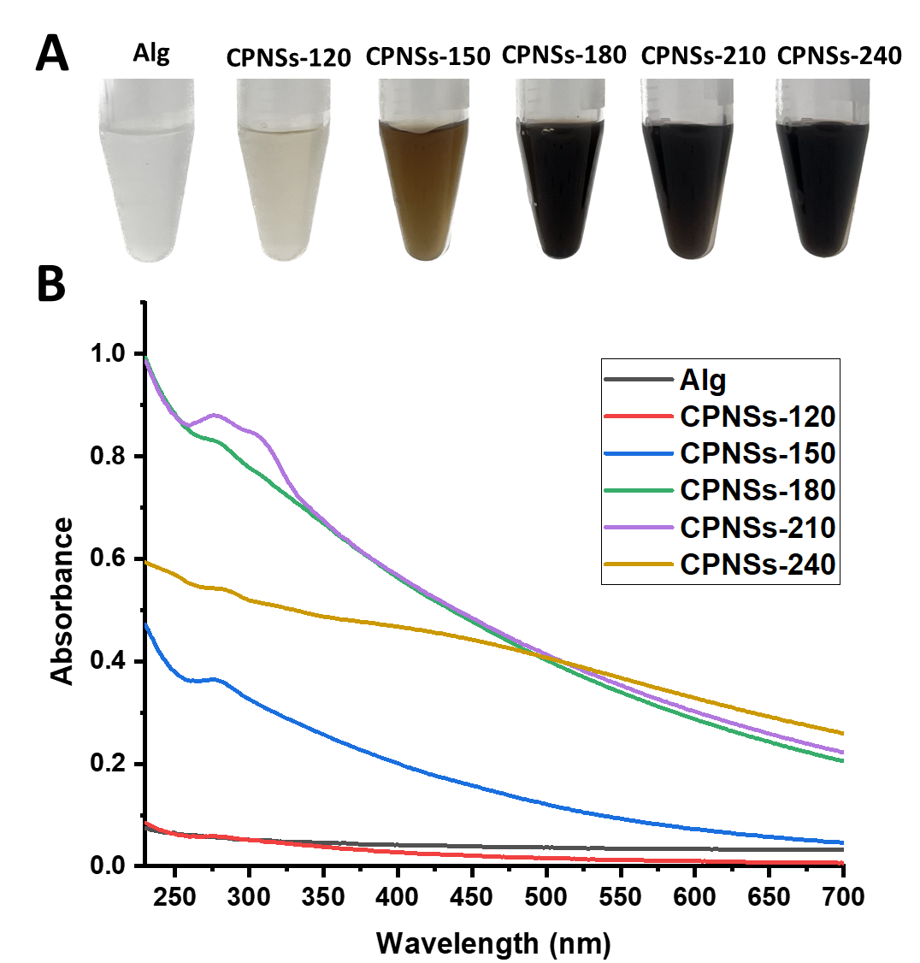
Supplementary Fig. 1. (A) Photographs and (B) UV-Vis absorption spectra of Alg and CPNSs. The concentration of Alg and CPNSs in (A) and (B) are 1.0 mg mL^{–1} and 0.1 mg mL⁻¹, respectively.

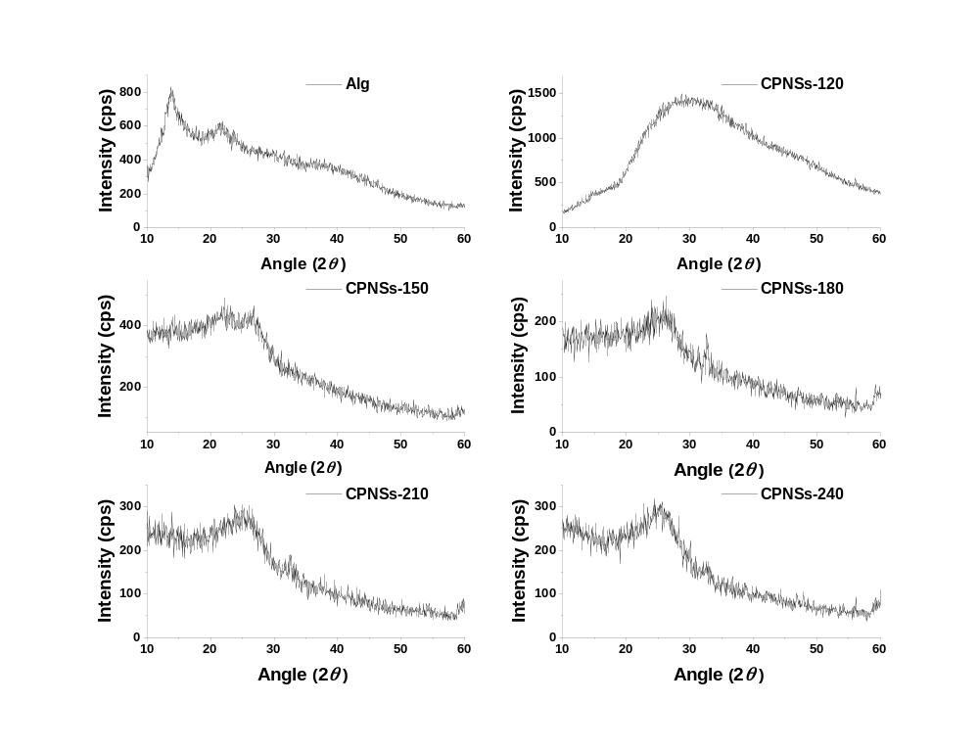
Supplementary Fig. 2. XRD pattern of Alg and CPNSs prepared at different temperatures.

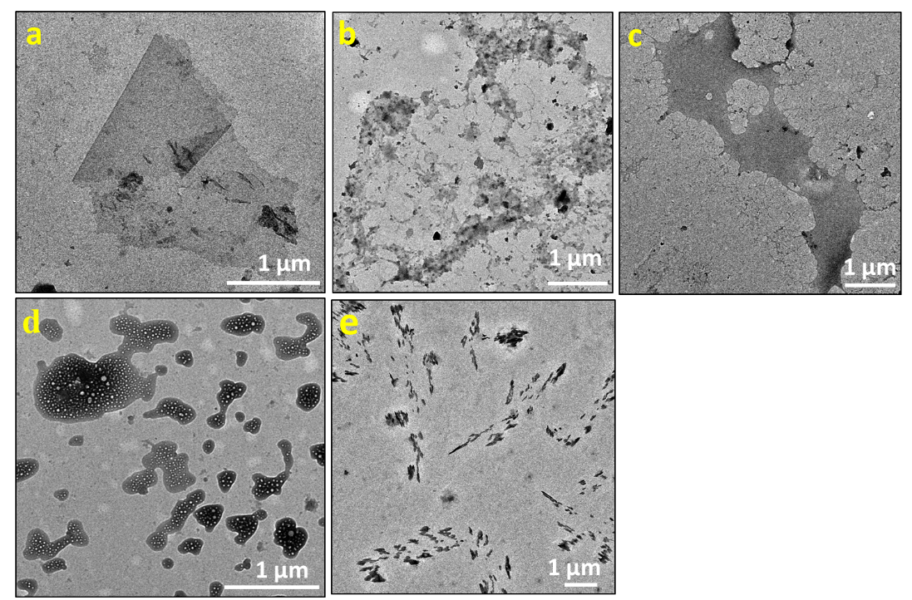
Supplementary Fig. 3. TEM images of carbonized materials obtained after heating a mixture of Alg and ammonium- or phosphate-related compounds (a) Alg + (NH₄)H₂PO_{4,}, (b) Alg + H₃PO₄, (c) Alg + NH₄OH, (d) Alg + NH₄OH + H₃PO₄, and (e) Alg + Na₂HPO₄ with a mass ratio of 1:5 at180 °C for 3 h.

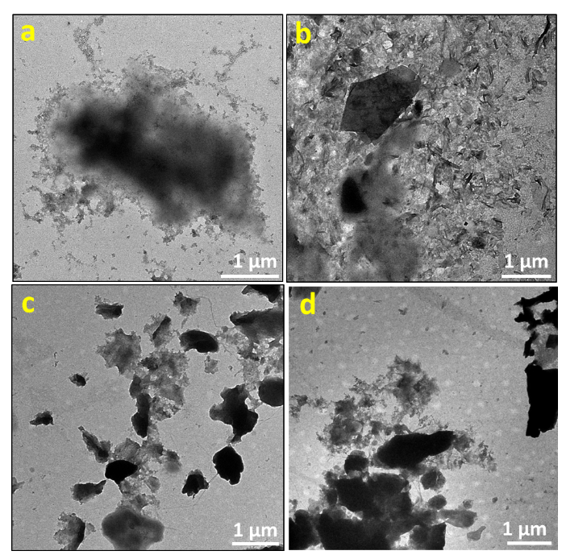
Supplementary Fig. 4. TEM images of carbonized materials obtained from the heating of a mixture of Alg and different salts (a) (NH₄)₂SO₃, (b) (NH₄)₂SO_{4,} (c) NH₄Cl, and (d) Na₂SO₃ in a 1:5 mass ratio at 180 °C for 3 h.

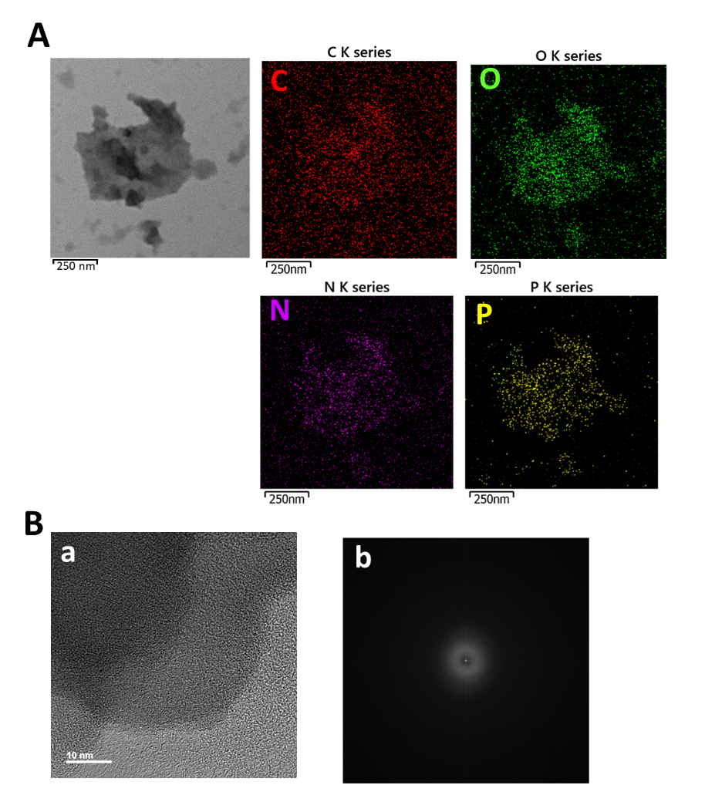
Supplementary Fig. 5. (A) TEM-EDS mapping of the CPNSs-180 for the elements C, O, N, and P, and (B) (a) HRTEM image and (b) selected area electron diffraction (SAED) pattern.

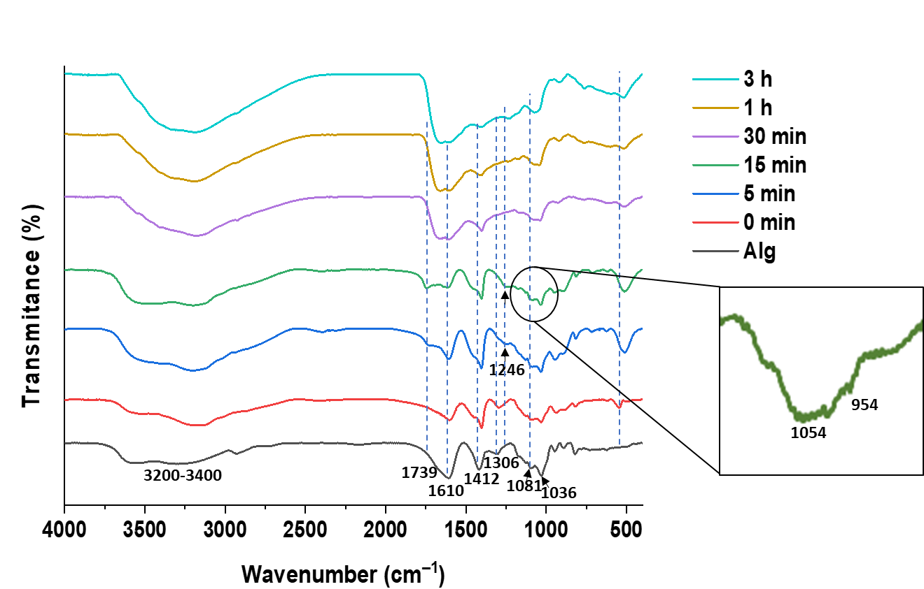
Supplementary Fig. 6. Time course FTIR spectra of Alg and CPNSs prepared at 180 °C.

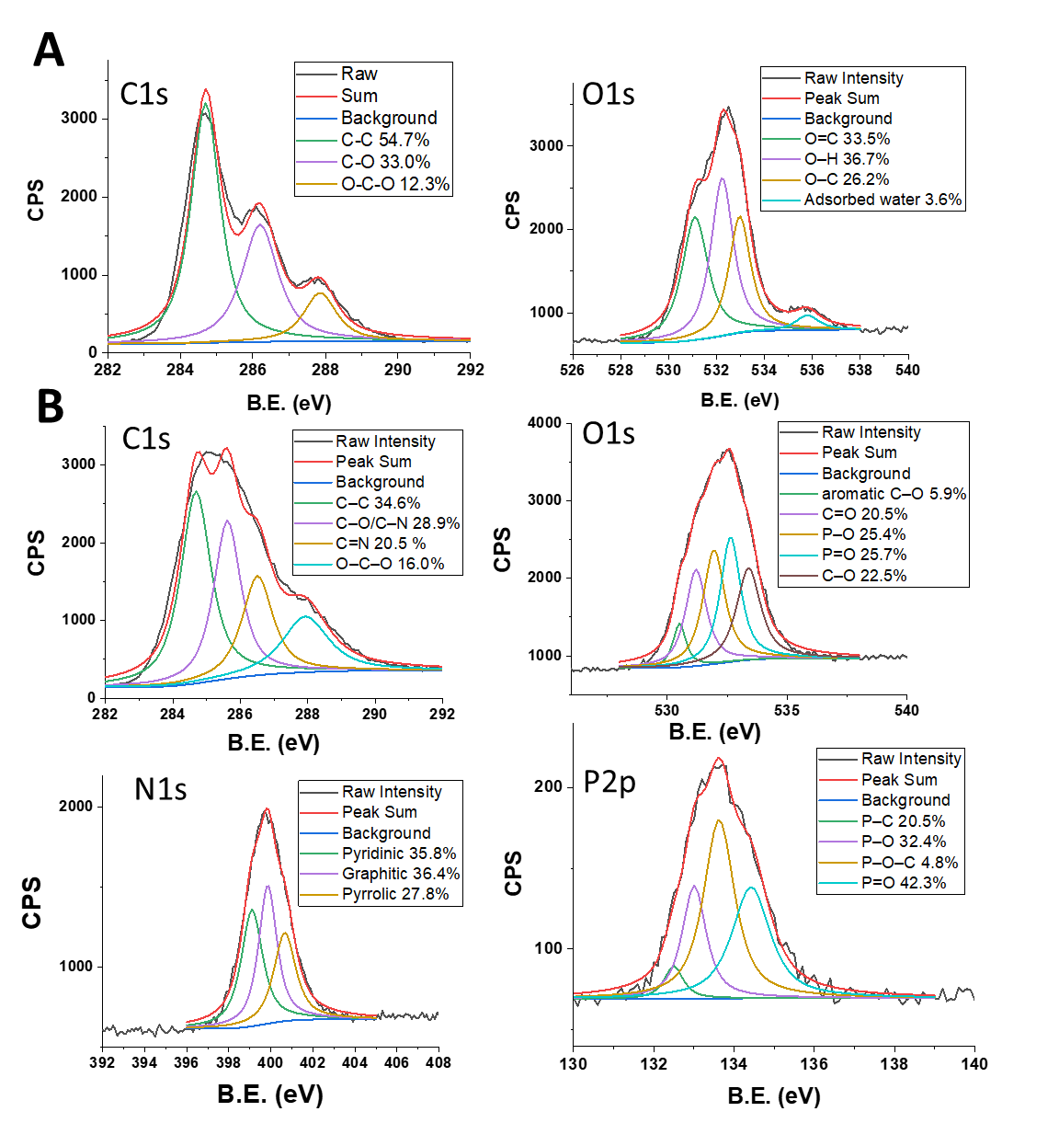
Supplementary Fig. 7. Deconvoluted XPS spectra (A) C1s and O1s for Alg and (B) C1s, O1s, N1s, and P2p for CPNSs-180.

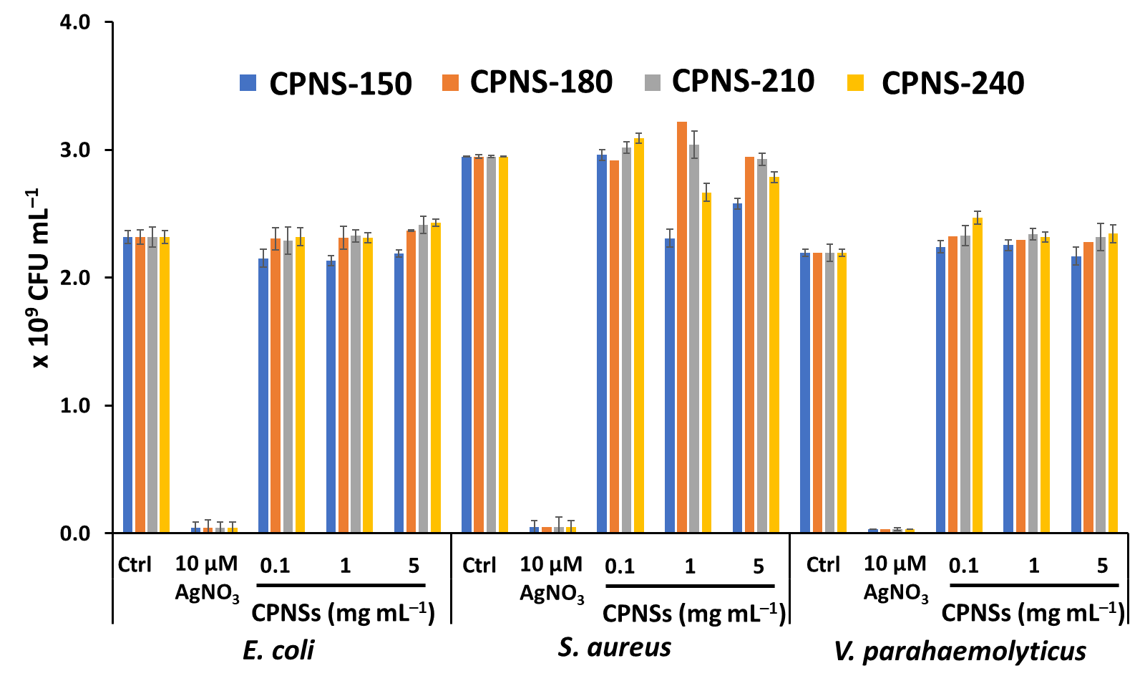
Supplementary Fig. 8. Antibacterial activity of CPNSs-150, CPNSs-180, CPNSs-210, and CPNSs-240 against E. coli, S. aureus and V. parahaemolyticus. AgNO₃ (10 μM) is the positive control. Error bars represent the standard deviations from triplicate experiments.

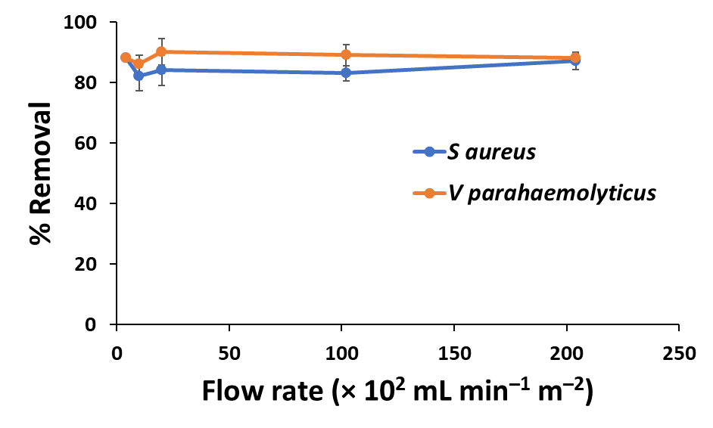
Supplementary Fig. 9. Efficiency of CPNSs-180 modified filter paper in the removal of S. aureus and V. parahaemolyticus at different flow rates. Error bars represent the standard deviations from triplicate experiments.

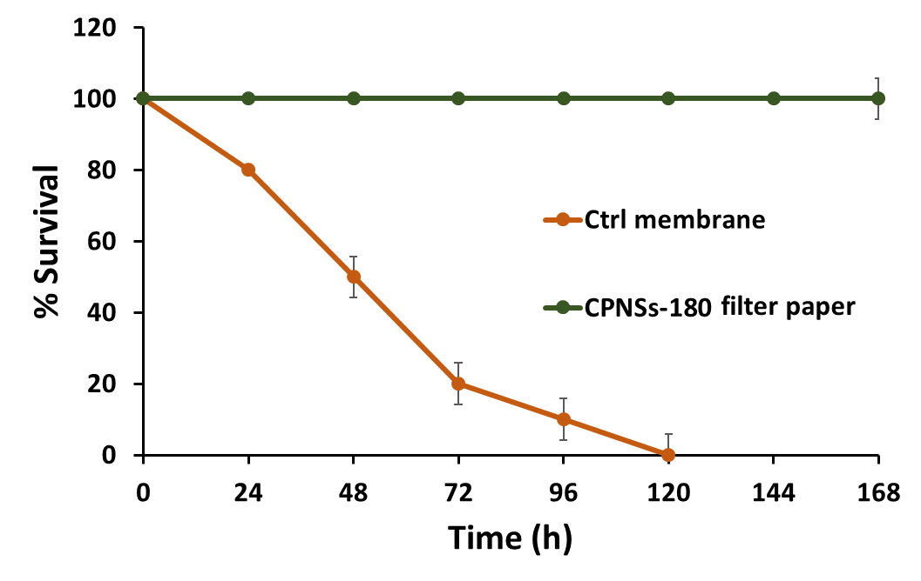
Supplementary Fig. 10. The survival of shrimp infected with 10⁶ CFU mL⁻¹ V. parahaemolyticus and circulating water through control membrane (uncoated filter paper) and CPNSs-180-coated filter paper, with membrane replaced every 48 h. Error bars represent the standard deviation of triplicate experiments.

