SUPPLEMENTARY FIGURES

Table S1. Double logistic with seven parameters of the three clusters retained in this study.
DL Parameters | Early snowmelt grasslands | Intermediate snowmelt grasslands | Late snowmelt grasslands
m1 | -0.0289 | -0.0383 | -0.0393
m2 | 1.2640 | 1.0419 | 0.4204
m3 | 154.30 | 170.53 | 180.39
m4 | 0.0678 | 0.0784 | 0.0799
m5 | 313.26 | 305.23 | 292.51
m6 | 0.1081 | 0.1162 | 0.0965
m7 | 0.0022 | 0.0020 | 0.0005

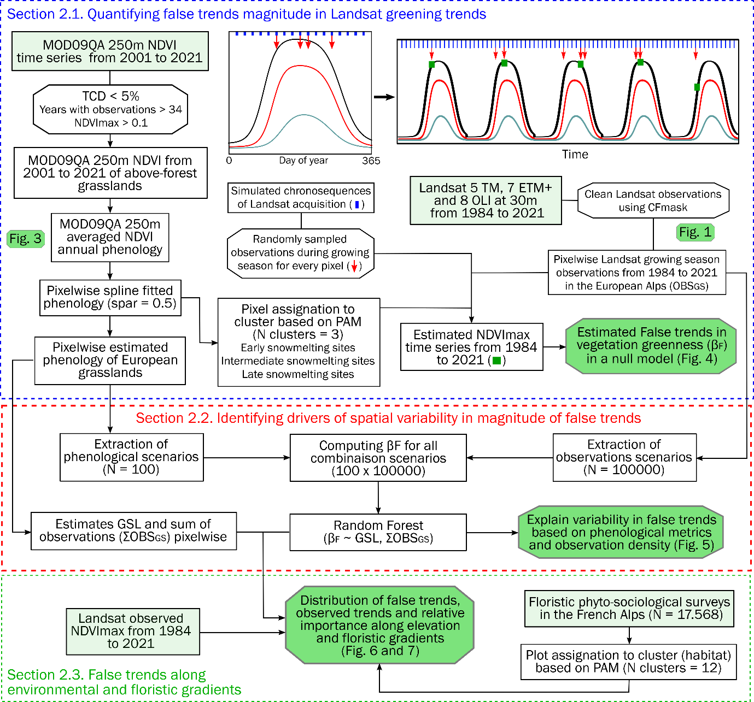
Figure S1. Flow chart illustrating the procedure to investigate the Landsat sampling bias and its effects on estimation of greening trends in the European Alps. Following conventional symbology, datasets are represented by rectangles and processing is represented by ovals. Initial unprocessed datasets are represented in green shaded rectangles while red shaded rectangles correspond to final metrics. The dotted rectangles represent the three main processing steps and correspond to sections presented in the Material and Methods section.

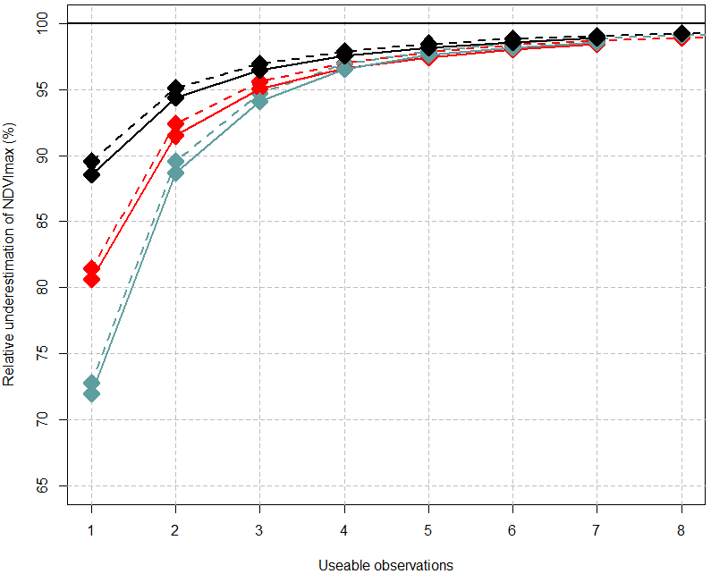

Figure S2. Relative underestimation of NDVImax as a function of the number of usable observations during the growing season. Full lines are obtained with a 16-day simulated Landsat acquisition. Dashed lines are obtained with a 4-day simulated Landsat acquisition.

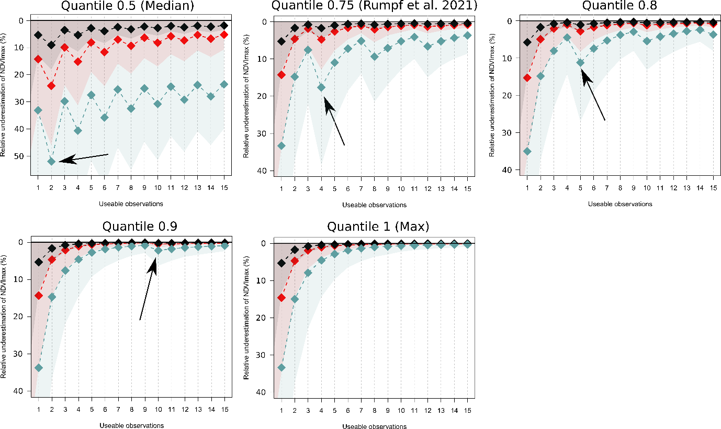
Figure S3. Relative underestimation of NDVImax as a function of the number of usable observations during the growing season. Each dashed line depicts the median bias for a specific type of alpine grassland, while the shaded area depicts the interquartile ranges. The underestimation is computed for median, q75, q80, q90 and q100 (maximum) in R using the discontinuous sample quantile approach (type = 1 ). Arrows indicate “ladder effect” patterns.

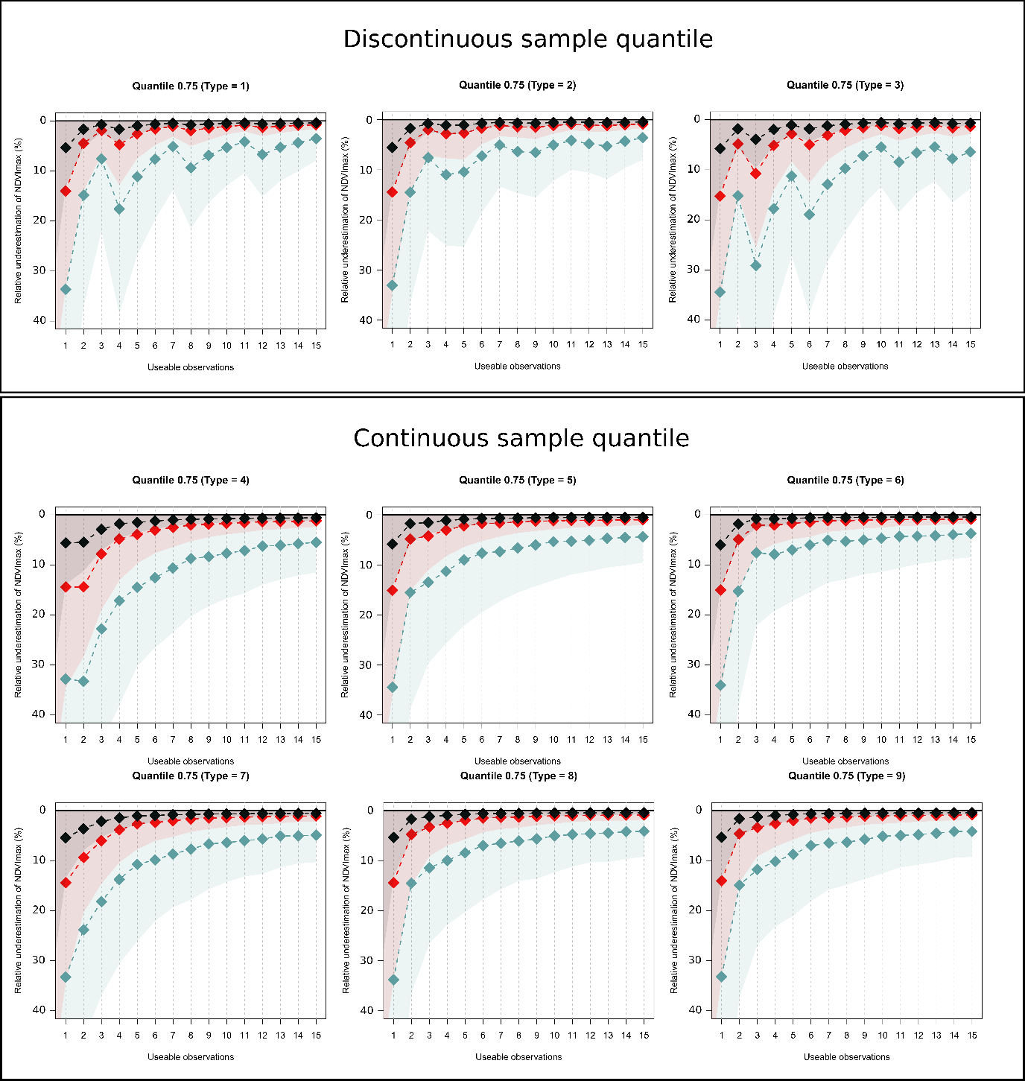
Figure S4. Relative underestimation of NDVImax as a function of the number of usable observations during the growing season. Each dashed line depicts the median bias for a specific type of alpine grassland, while the shaded area depicts interquartile ranges.

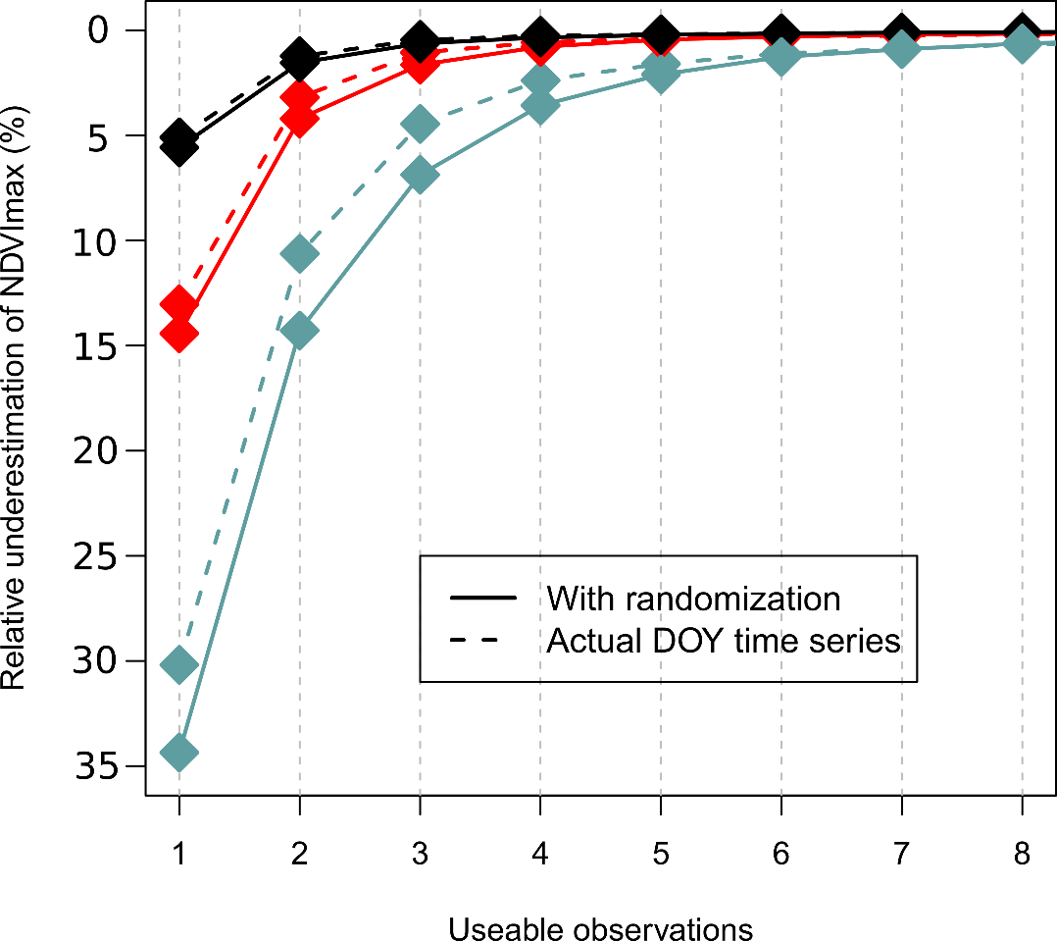
Figure S5. Relative underestimation of NDVImax as a function of the number of usable observations during the growing season. Full lines are obtained from randomization of observations acquisition dates while dashed lines are obtained using actual day of year from Landsat observations.

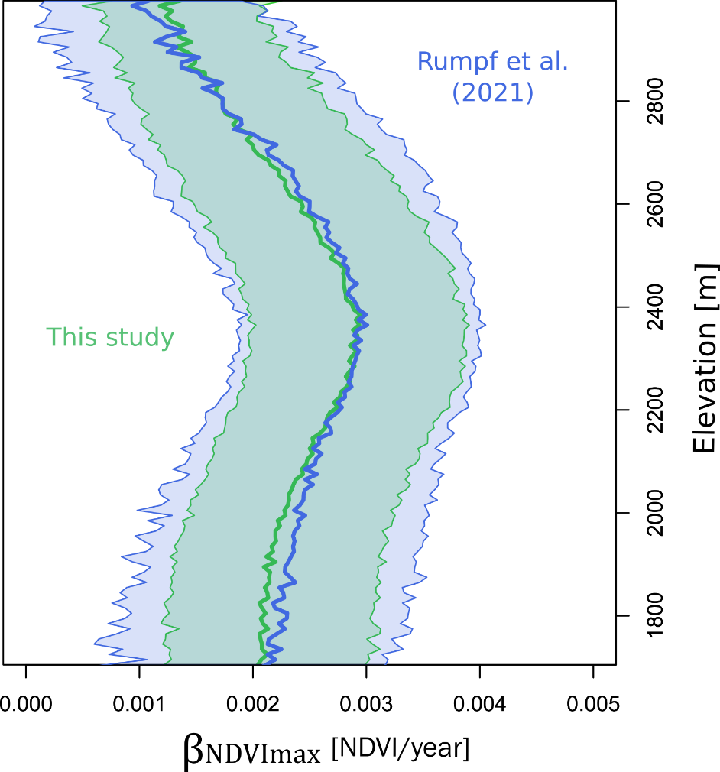
Figure S6. Distribution of observed greening trends along elevational gradients from Rumpf et al. (2022) and this study.

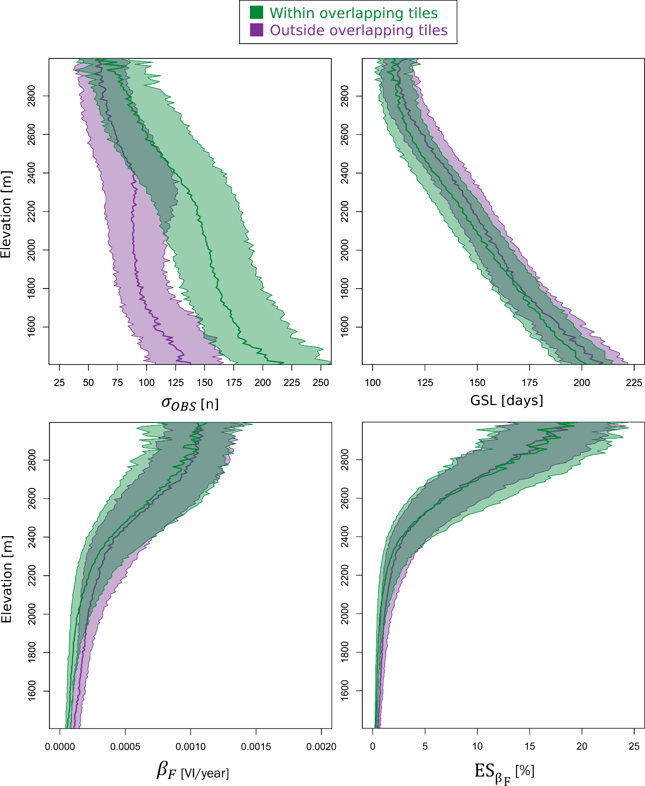
Figure S7. Distribution of the sum of usable observations, growing season length, absolute false trends, and relative false trends along an elevation gradient in the European Alps with pixels within or outside overlapping tiles shown separately.

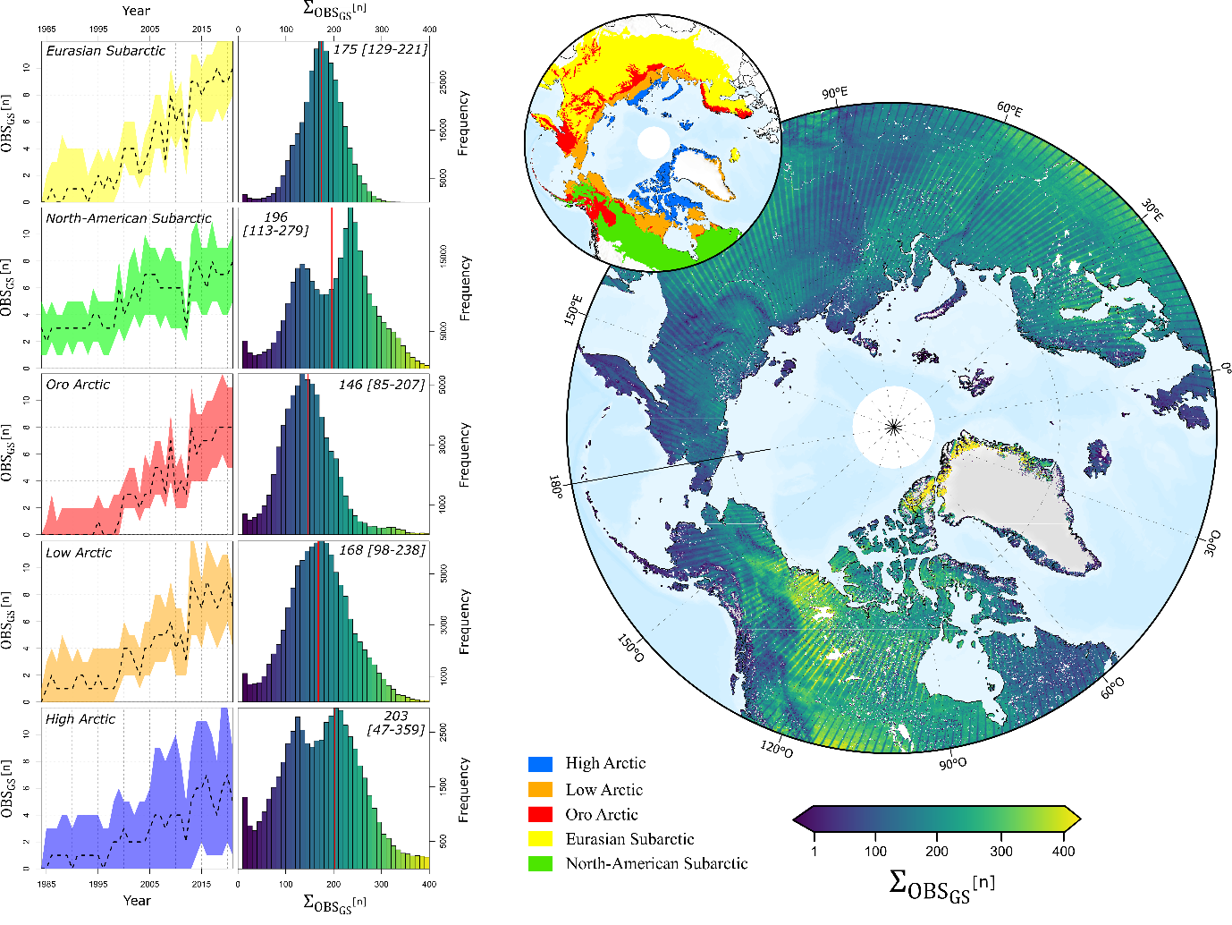
Figure S8. Spatio-temporal distribution of Landsat summer useable observations around the North Pole. For each of the five subregions, time series of ${OBS}_{GS}$ is shown from 1984 to 2021 with the distribution of its sum. Median values of $Σ_{{OBS}_{GS}}$ are indicated by red vertical lines and are also expressed in written form alongside the associated interquartile range. The map shows the spatial distribution of $Σ_{{OBS}_{GS}}$ with inland and oceanic water removed with a spatial resolution of 1km.

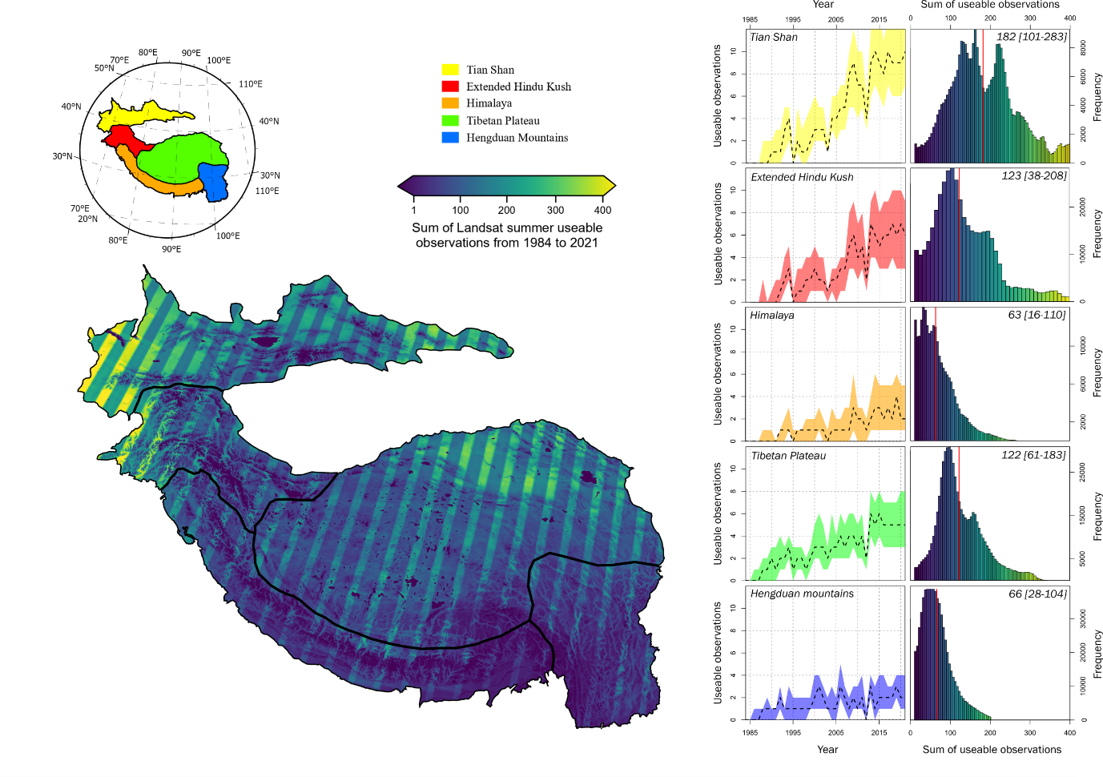
Figure S9. Spatio-temporal distribution of Landsat summer useable observations around the Asian mountain ranges. For each of the five subregions, time series of ${OBS}_{GS}$ is shown from 1984 to 2021 with the distribution of its sum. Median values of $Σ_{{OBS}_{GS}}$ are indicated by red vertical lines and are also expressed in written form alongside the associated interquartile range. The map shows the spatial distribution of $Σ_{{OBS}_{GS}}$.

SUPPLEMENTARY MATERIALS

Effect of greenness metrics on the sampling bias
Annual maximum NDVI is a commonly used metric of vegetation greenness. However, as demonstrated in the main analysis, it is biased following an asymptotic relation with observation number and the growing season length of the underlying annual NDVI curve. Other metrics besides maximum (i.e., q100) vegetation greenness could be more robust (e.g., q50). Here, we test how the sampling bias behaves when using quantile metrics (q50, q75, q80, and q90 compared to q100). Furthermore, there are nine different methods to compute quantiles according to Hyndman and Fan (1996), so we further explored how sampling biases vary among quantile methods when computing q75. All methods are available in R using the “type” parameter in the function “quantile”. There are two main methods to compute quantiles. Algorithms either return the value of a score that exists in the set of scores (nearest-rank methods or discontinuous sample quantile) or interpolate between existing scores and are either exclusive or inclusive (continuous sample quantile). The discontinuous sample quantile method corresponds to types 1 to 3 in R, while types 4 to 9 correspond to continuous sample quantiles (default is type 7). For visualization purposes, we compared the metrics to maximum NDVI and not the metric used to compare each method to a similar value.
First, we reproduced Figure 4 of the main text using different quantiles with type = 1 (discontinuous quantile sample). We found that irrespective of the method, estimates of maximum NDVI are biased according to the number of observations available (Figure S2). Interestingly, we found a so-called “ladder effect” in the asymptotic patterns. This pattern is due to using the nearest-rank method on lists with fewer than 100 distinct values, which result in the same value being used for more than one percentile. Hence, for q75, with one, two and three observations, it is the maximum value that is used and not the q75. With 4 observations, it is the third highest value that is used, which will be on average lower than the maximum value with three observations. For q80, the same pattern is observed but for every five observations (including zero observations). For the median, the pattern is hence observed every two observations. In addition, we tested the q75 using each type of method to compute quantiles according to Hyndman and Fan (1996). As expected, we found that none of these methods prevent the NDVImax sampling bias (Figure S3). Continuous sample quantile methods exhibit similar patterns as the maximum metric.

Effect of randomizing observation day of year compared to using exact day of year
In the main analysis, we randomized the day of year (DOY) used when selecting NDVI observations, meaning that for ${OBS}_{GS}$ = 3, the DOY of each of these 3 observations was randomized between DOY 152 and 243 (June through August). We used this approach because it drastically simplified the computation, but it might introduce bias as usable observations are not homogeneously distributed between DOY 152 and 243 due to cloud cover variability. Therefore, we randomly selected 30,000 points over the European Alps for which we extracted the exact day of year of each observation from 1984 to 2021 using the R package ‘LandsatTS’ (Berner et al. 2023; Berner et al. 2020). We computed NDVImax of the ‘intermediate snowmelt grasslands’ phenological curve using either (1) the exact DOY for each observation, or (2) by randomizing the DOY of each observation. We then compared the relative underestimation of NDVImax of both methods and found a maximum of 5% reduction in the underestimation of the NDVImax when using the first scenario (Figure S4). We argue that randomizing the DOY of observations does not substantially alter quantification of the sampling bias in our analysis.

Comparison between observed trends and Rumpf et al. (2022) greening trends
Rumpf et al. (2022) recently studied the alpine greening across the European Alps using the Landsat time series. We used this study as a reference and compared our observed trends with theirs. The main difference lies in the metric used as a proxy of vegetation greenness. They used the quantile 0.75 from GEE which relies on the nearest-rank method, while we used the maximum. We performed the same set of reflectance corrections as they did and analyzed the distribution of both vegetation greenness trend datasets along the elevation gradient. It is possible to estimates of NDVImax sampling bias on their results (Figure S5).

Effect of overlapping tiles on observations and false trends
We reproduce Figure 7 with pixels within and outside of overlapping tiles to test whether the increase in observation due to overlapping tiles was sufficient to overrule the sampling bias at high elevations. We found that ${OBS}_{GS}$ tends to be increasingly similar as elevation increases (Figure S7) which was already observed in Figure 1. Consequently, the increase in observations due to overlapping tiles is mostly observed at lower elevations, and false trends are not diminished at higher elevations (Figure S6). In the specific context of the European Alps, restraining the analysis to overlapping tiles is insufficient to avoid the sampling bias.

Spatio-temporal patterns of Landsat observations in the Arctic and Asian mountains
To illustrate how the Landsat NDVImax sampling bias could affect vegetation greenness trends in other regions, we investigated the spatio-temporal variability of Landsat ${OBS}_{GS}$ in two of the most studied world’s cold regions, the Arctic (above 50° Latitude) and the Asian mountain ranges (extended Hindu Kush Himalaya Mountain ranges and Tibetan Plateau). For the North Pole, we used the biozone delineation from Virtanen et al. (2016) that split the Arctic into the (i) High, (ii) Low and (iii) Oro Arctic as used in Berner et al. (2020). In addition, we used the Ecoregion from Dinerstein et al. (2017) to delineate sub-Arctic vegetation types using the Boreal Forests/Taiga biome. We differentiate between the (iv) North American and (v) Eurasian sub-Arctic as these domains exhibit different patterns of Landsat time series due to historical specificity in data acquisition (Figure S7). For the Asian mountain ranges, we used a combination of natural mountain ranges natural delineation and alpine biome bioclimatic classification from Testolin et al. (2020). We obtained 5 sub-regions: the (i) Tian shan, (ii) Extended Hindu Kush, (iii) Himalaya, (iv) Tibetan Plateau and (v) Hengduan mountain ranges (Figure S8). For each of the 10 sub regions described above, we obtained time series of ${OBS}_{GS}$ using the same procedure as described in section 2.1. (Figure S8).

