Supplementary Information
CRISPR/Cas9-engineering of Kell null erythrocytes to unveil host targeted irresistible antimalarial
Geeta Kumari^{1#}, Pragya Gupta^{2,3#}, Sangam G. Goswami^{2,3}, Ravi Jain¹, Sakshi Anand¹, Shreeja Biswas¹, Swati Garg¹, Priya Thakur^{2,3}, Vinodh Saravanakumar², Bidhan Goswami⁴, Ipshita Bhowmick⁵, Narla Mohandas⁶, Jeremy Burrows⁷, Sivaprakash Ramalingam^{2,3}*, and Shailja Singh¹*
Affiliations
¹Special Centre for Molecular Medicine, Jawaharlal Nehru University, New Delhi-110067, India
²CSIR- Institute of Genomics and Integrative Biology, Mathura Road, Sukhdev Vihar, New Delhi-110025, India
³Academy of Scientific and Innovative Research (AcSIR), Ghaziabad-201002, India
⁴Agartala Government Medical college, Agartala, Tripura, India
⁵Regional Medical Research Center-Northeast Region (RMRC-NE)-ICMR, Dibrugarh, India
⁶Laboratory of Red Cell Physiology, New York Blood Center, 310 E 67th St, New York, NY 10065, United States
⁷Medicines for Malaria Venture, Geneva, Switzerland.

# Equal contribution
*Corresponding authors: Prof. Shailja Singh, email: shailja.jnu@gmail.com and Dr. Sivaprakash Ramalingam, email: sivaramalingam@igib.res.in.

This file includes
Figures and Figure legend, Supplementary Figure S1 to S5
Supplementary Table 1 to Table 4
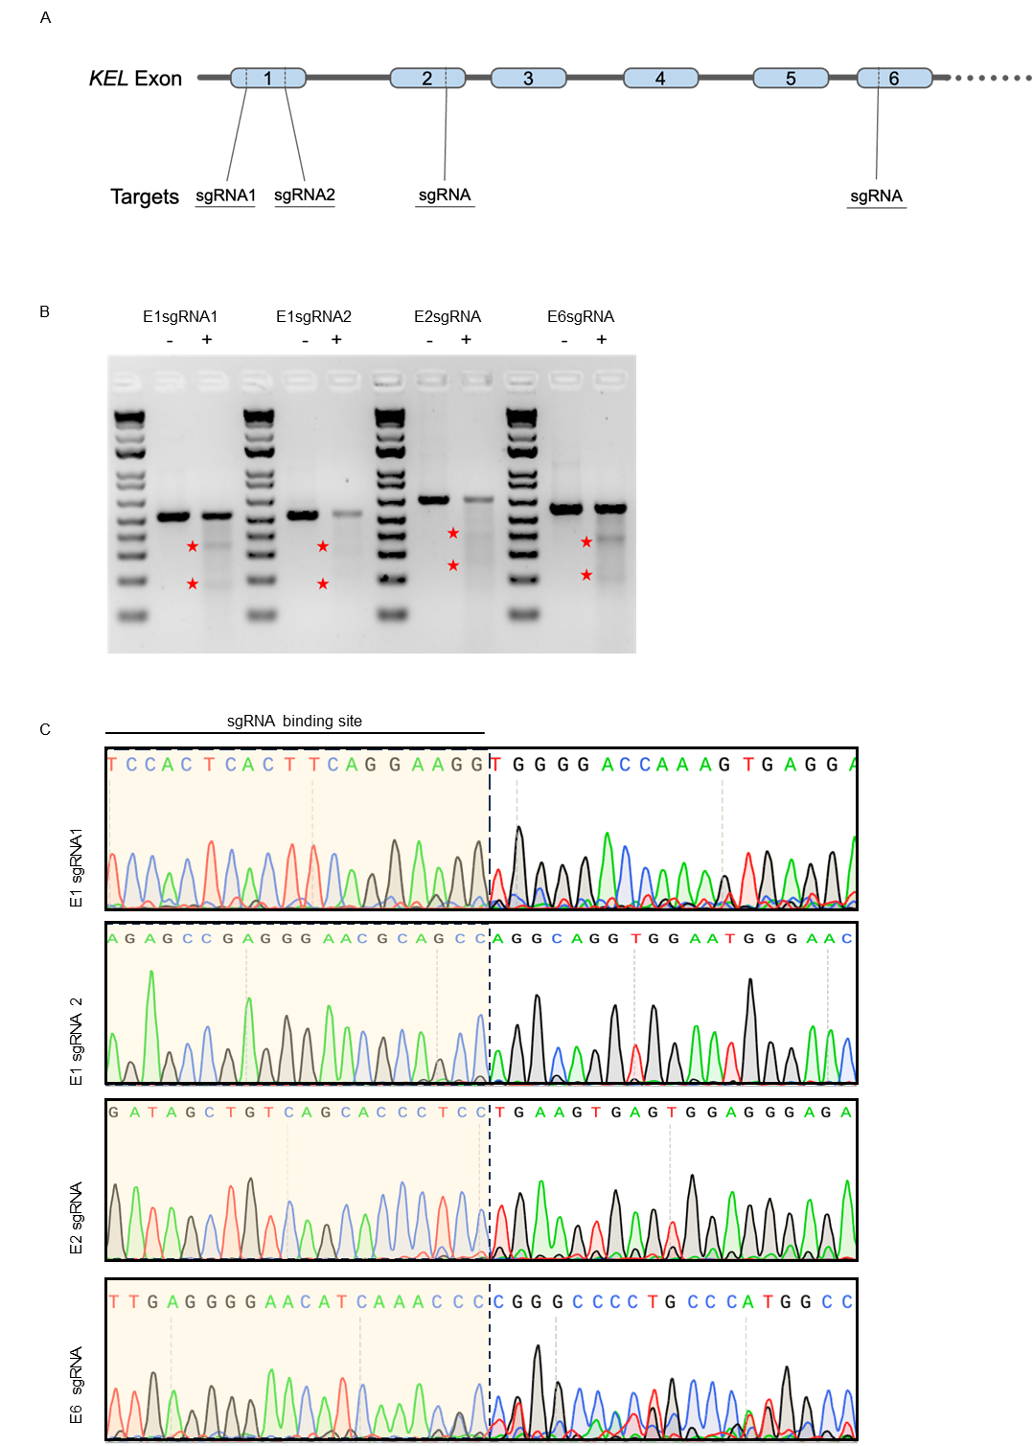
Figure. S1

Figure. S1. CRISPR-Cas9-mediated Kell-KO sgRNA validation in HEK293T cells. (A) Schematic representation of the Kell genomic locus depicting the location of each sgRNA, with each box representing a genic exon. (B) Agarose gel depicting the cleavage efficiency of each sgRNA using Surveyor assay. Expected cleavage bands are highlighted with a red star. (C) Sanger chromatogram demonstrating the disruption in reads due to editing.

Figure. S2
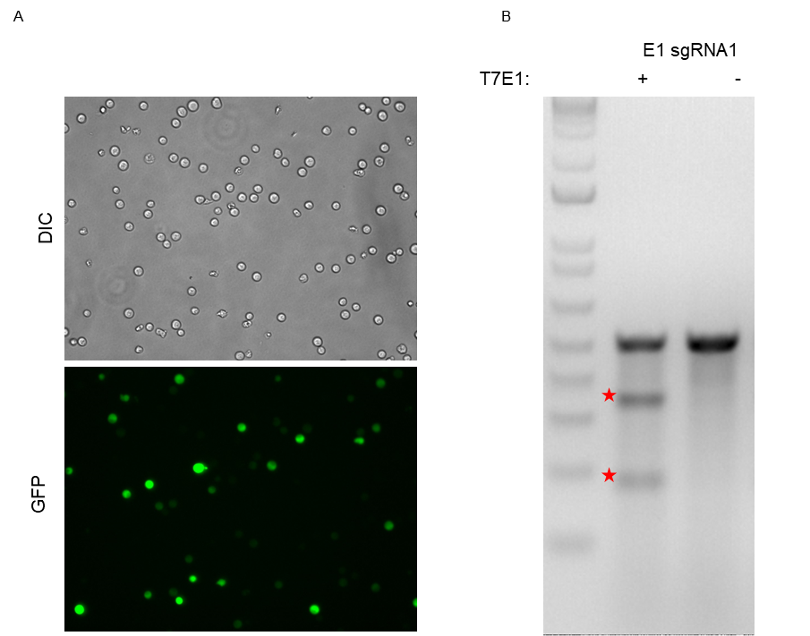

Figure. S2. Transfection in BEL-A cells targeting the Kell gene using CRISPR-Cas9-mediated gene editing Selected sgRNA cloned in px459-TurboGFP vector was electroporated in BEL-A cells. (A) Microscopic images of transfected BEL-A cells exhibiting the expression of the reporter gfp gene, confirming successful transfection. (B) T7 Endonuclease I assay performed on genomic DNA extracted from transfected BEL-A cells, indicating the formation of indels in cells treated with plasmids targeting endogenous genes. Expected cleavage bands are highlighted with a red star.
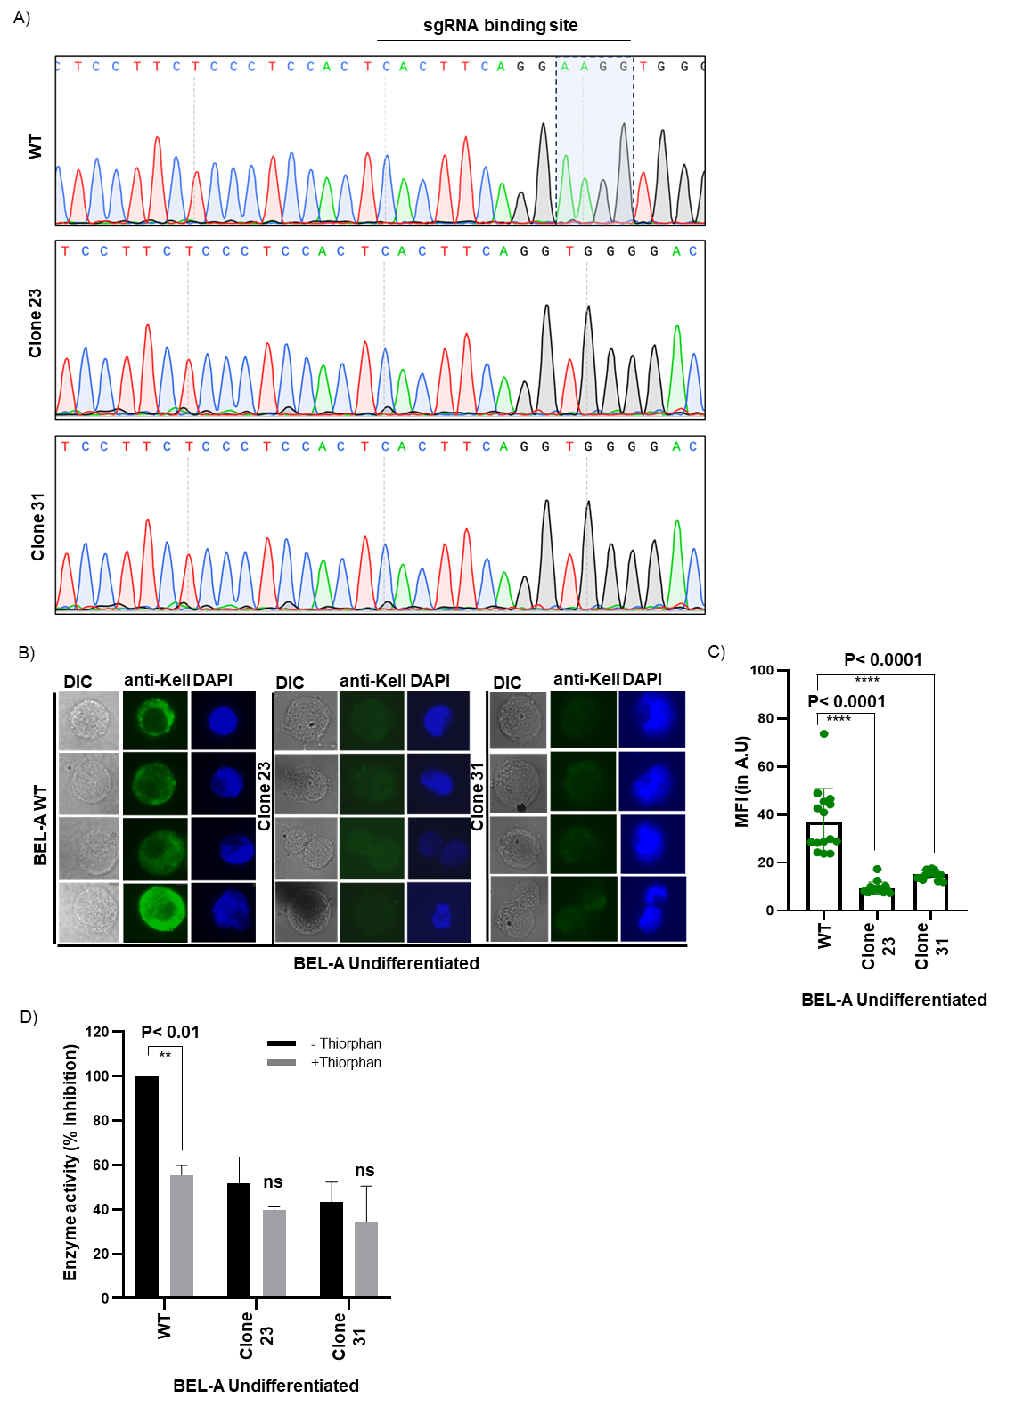
Figure. S3

Figure. S3. Characterization of Kell expression in undifferentiated form of BEL-A cells. (A) Sequencing chromatogram of CRISPR/Cas9-mediated Kell-KO BEL-A cell clones, displaying nucleotide sequences of the target Kell genomic loci in two clones (clones 23 and 31). (B) Immunofluorescence analysis using a Kell-specific antibody demonstrated the absence of Kell expression in Kell-KO BEL-A cells (clones 23 and Clone 31). (C) Bar graph representing the mean fluorescence intensity of non-transfected and transfected cells using ImageJ software. (D) Bar graph illustrating the % inhibition of Kell enzymatic activity in WT (non-transfected), clone 23, and clone 31 (transfected) BEL-A cells.
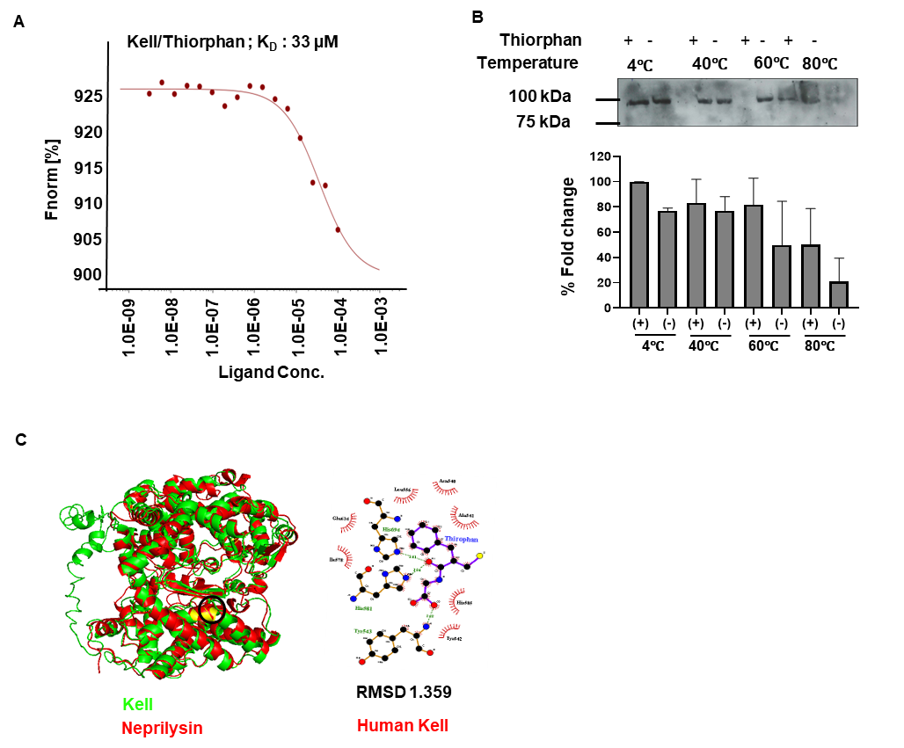
Figure. S4

Figure. S4. Interaction of Kell with Thiorphan (A) MST-based interaction analysis of thiorphan and Kell showed K_{d} of 33 μM. (B) CETSA-based interaction analysis demonstrated that at higher temperatures, thiorphan (at its 2X IC₅₀ concentration) stabilized Kell, quantified via densitometry in the adjoining bar-graph which confirmed increased thermostability of Kell in the presence of thiorphan. (C) In silico interaction analysis elucidates that thiorphan preferentially interacts with the catalytically active pocket of Kell, with a minimum binding energy of -5.83 Kcal/mol.

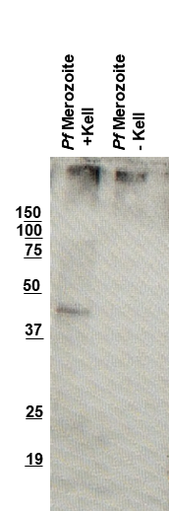
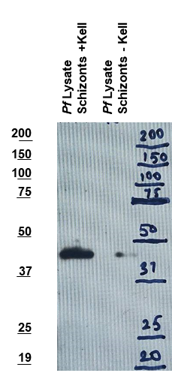
Figure. S5
A)
B)

Figure. S5. Immunoblot showing the processing of MSP-1. (A) The lysates of synchronized schizonts (42–46 h) were incubated in the absence and presence of purified Kell in a reaction buffer (50 mM HEPES, 150 mM NaCl, and 10 µM Zinc) for 2 h. Western blot analysis was performed on both fractions with an MSP-1 antibody to assess the protease, or “sheddase” activity of Kell. Lanes 1 and 2: Schizont lysate incubated in the absence and presence of Kell (n=2). (B) Merozoites were incubated in the absence and presence of purified Kell in separate tubes in a reaction buffer for 2 h. Western blot analysis was conducted on both fractions with an MSP-1 antibody to assess the protease, or “sheddase” activity of Kell. Lanes 1 and 2: Merozoites incubated in the absence and presence of Kell (n=2).

Table EV1: Detail of sgRNA sequence

S.No. | sgRNA location | sgRNA Number | sgRNA sequence (5’-3’)
1 | Exon 1 | E1sgRNA 1 | TCCACTCACTTCAGGAAGG
2 | Exon 1 | E1sgRNA 2 | AGAGCCGAGGGAACGCAGCC
3 | Exon 2 | E2sgRNA | GATAGCTGTCAGCACCCGCC
4 | Exon 6 | sgRNA 1 (C694T) | TTGAGGGGAACATCAAACTC

Table EV2: Detail of Primer sequence

S.No. | Primer Name | Primer sequence (5’-3’)
1 | E1F | ACATTCAGGGGACAGGTTCG
2 | E1R | CAAGATGGGGGTTGAGAGACA
3 | E2F | CCTCACCCAAAACAGTTGACA
4 | E2R | GCCAGGTAATGATCCCGGAG
5 | E6F | GGACTCTTCTTCTCATGCCCC
6 | E6R | GAGGAAGATCCCCATGCCC

Table EV3: Information detail regarding the genome-wide off target site predicted from the Kell target-sequences
Chromosome position | Cut site | Mismatch | Direction  (strand) | Forward  Primer sequence (5’-3’) | Reverse primer sequence (5’-3’)
Chr12:98392696-98392718 | 98392702 | 3 | - | CCCAAGTAGCTGGGATTACAGG | GTGACTTGTCTTGCAGTCACCTC
Chr17:45679352-45679373 | 45679358 | 2 | - | ATGGTGTGGTGTGCCTGCATC | TGGTTCGGCTTCCAAGATGGC
Chr4:142314365-142314386 | 142314371 | 2 | - | AGATCGCAGGGATTCAGCCTGT | GTTTCCAGAAGGCACACACATCAC
Chr11:67277157-67277179 | 67277163 | 3 | - | CCTTTTTACAGCCGAGCCATGTG | TGCTCCACCCTGAGTGGATG
Chr1:111886858-111886879 | 111886864 | 2 | - | CGGCACTCACCTCTTTGACTTC | CCCTCTTCAATTTATTGGGAGGCC
Chr4:42706919-42706941 | 42706935 | 3 | + | TGCAGAGACGGCTAATTGTTTCCC | AGCATCTGAGTGCAAGTGACAACC
Chr12:20811376-20811397 | 20811391 | 2 | + | TAACTGGATAAGTAGGAGTGGGCG | CAGAGCCACAGGCATTTGTATGCA
Chr20:23872340-23872361 | 23872355 | 2 | + | ATAAGAAGCCCCTGGGTGAGGCA | CCCTTTCTCTCTCTTTCCCTCAG
Chr2:220080314-220080336 | 220080330 | 3 | + | CCCGAATCTGTGCTATAACCCATC | CCAGGCAGGTGTCCTAGTAGT
Chr2:43526394-43526415 | 43526409 | 1 | + | GGTCAGAACCAACACTGGCTGTA | GCCAGAGATCTGTCAATAGGGCA

Table EV4: Details of the patients from the malaria-endemic regions of Tripura, India.
S. no. | Name | Age | Para (location) | Kit result (Rapid diagnostic test) | Medicine status
P1 | Adhirung reang | 45 | Dongkarai | Pf | Before medicine
P2 | Purbarung reang | 45 | Dongkarai | Pf | Before medicine
P3 | Ruhit Reang | 12 | Dongkarai | Pf | Before medicine
P4 | Simarung Reang | 16 | Lakhindra para | Pf | Before medicine
P5 | Riya Reang | 8 | Dongkarai | Pf | Before medicine
P6 | Upendra Reang | 17 | Dongkarai | Pf | Before medicine
P7 | Amit Tripura | 7 | acharjee Para | Pf | Before medicine
P8 | Jutirai Reang | 34 | Lakhindra para | Pf | Before medicine
P9 | Pramila Reang | 36 | Dongkarai | Pf | Before medicine
P10 | Hasina Reang | 18 | Dongkarai | Pf | Before medicine
P11 | Sanjurai Tripura | 30 | Bidya Para | Pf | Before medicine
P12 | Nabirung Reang |  |  | Pf | Before medicine
P13 | Mamata Tripura | 6 | Dhansing | Pf | Before medicine
P14 | Bijubala Tripura | 59 | Dhansing | Pf | Before medicine
P15 | Karati Tripura | 31 | Bidya Para | Pf | Before medicine
P16 | Rituparna tripura | 13 | West Ladhua | Pf | Before medicine
P17 | Ubarung Reang | 32 | Birendra Para | Pf+Pv | Before medicine
P18 | Bujanti Tripura | 53 | Bidya Para | Pm | Before medicine
P19 | Satya Rani tripura | 31 | Bidya Para | Pm | Before medicine
P20 | Banita Tripura | 23 | Bidya Para | Pm | Before medicine
P21 | Pariti Tripura | 26 | Bidya Para | Pm | Before medicine
P22 | Banari Tripura | 26 | Dhansing | Pm | Before medicine
P23 | Hemari Tripura | 23 | Dhansing | Pm | Before medicine
P24 | Kripamohan Tripura | 27 | Bidya Para | Pm | Before medicine
P25 | Archana Reang | 18 | Nalsirai Para | Pv | Before medicine
P26 | Biswajoy Tripura | 7 | Dhansing | Pv | Before medicine
P27 | Ranimala Tripura | 80 | Banarai Para | Pv | Before medicine
P28 | Kabita Tripura | 15 | ubal Royaja Para | Pv | Before medicine
P29 | Ratan mohan Tripura | 55 | Acharjee Para | Pv | Before medicine
P30 | Chandi Charan Tripura | 6 | Budhi | Pv | Before medicine
P31 | Sarnasneha Tripura | 8 | Acharjee | Pf | Before medicine
P32 | Manika Tripura | 8 | Acharjee | Pf | Before medicine
P33 | Kwchak Tripura | 11 | Acharjee | Pf | Before medicine
P34 | Mithun Tripura | 7 | Acharjee | Pf | Before medicine
P35 | Palting Reang |  | SATIRAM | Pf | Before medicine
P36 | Dharma manik tripura | 25 | MALDA 1 | Pv | Before medicine

Table EV4 (contd…): Individuals’ details not infected with Plasmodium:
S. no. | Name | Age | Para (location)
S1 | Preeti | 26 | Delhi
S2 | Geeta | 28 | Delhi
S3 | Neha | 25 | Delhi
S4 | Shreeja | 26 | Delhi
S5 | Swati | 36 | Delhi
S6 | Nutan | 33 | Delhi
S7 | Purnendu | 26 | Delhi
S8 | Evanka | 34 | Delhi
S9 | Shailja | 48 | Delhi
S10 | Shailly | 26 | Delhi
S11 | Nitish | 29 | Khowai Tripura
S12 | Rumali | 25 | Agartala Tripura
S13 | Debjani Debnath | 27 | Agartala Tripura
S14 | Depanjan Dasgupta | 30 | Agartala Tripura
S15 | Jyotish Debarma | 29 | Agartala Tripura

