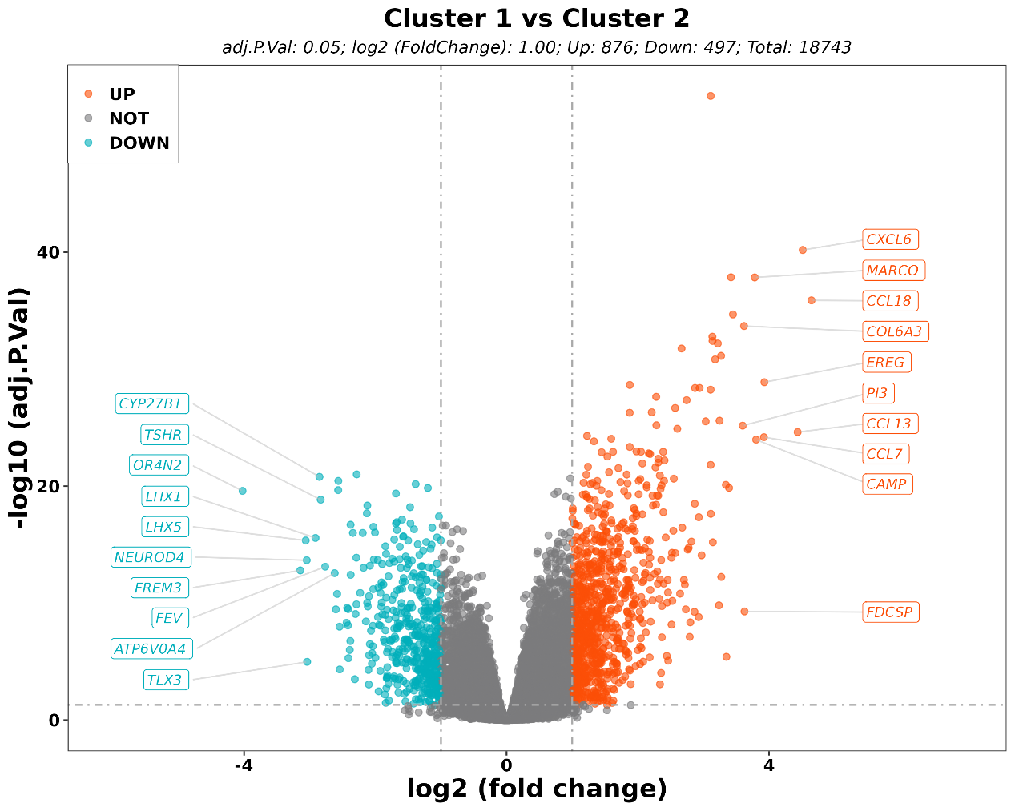
Fig S1 Volcano plot indicating all differentially expressed genes between two clusters.
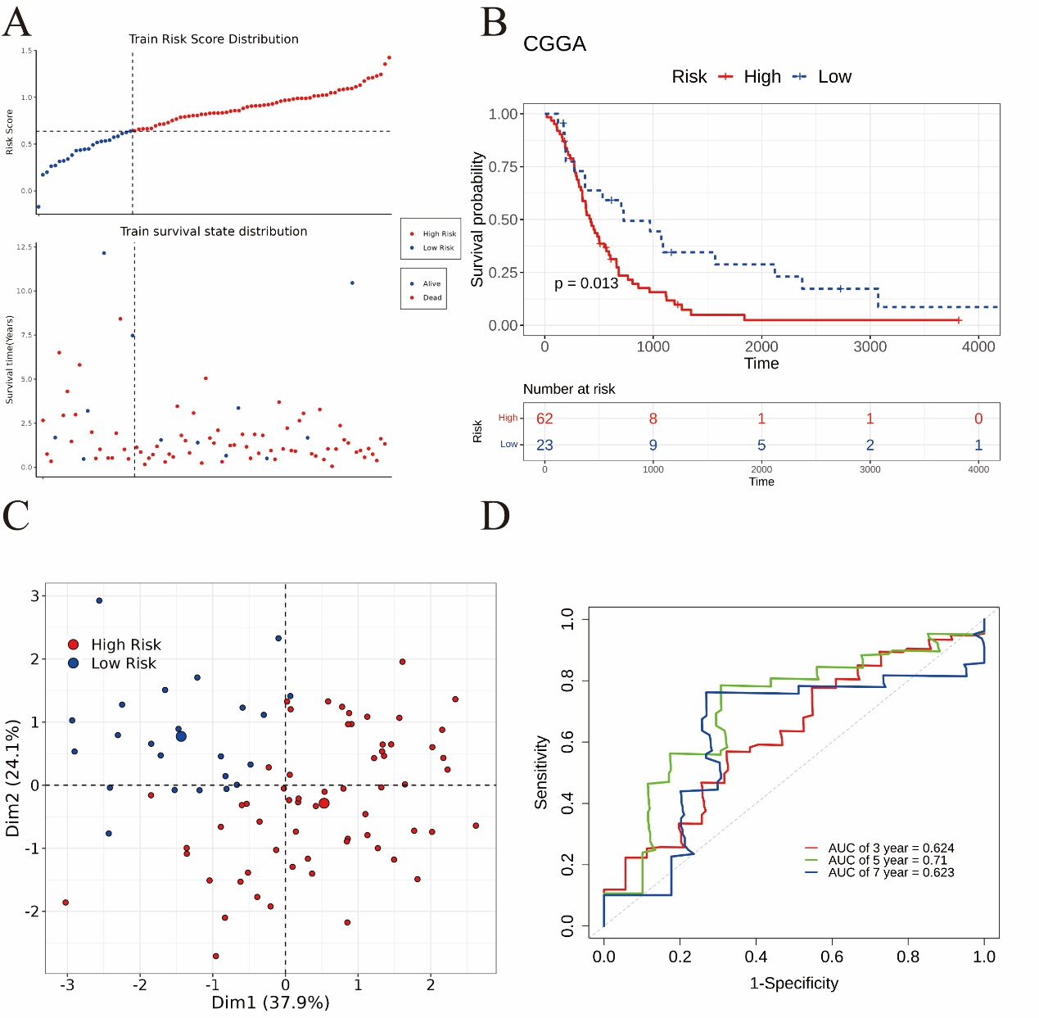
Fig S2 (A) The distribution of the risk score model and survival status of patient. (B) Kaplan–Meier curves for overall survival in the high- and low-risk groups (C) The principal component analysis (PCA) for two groups (D) The receptor operating characteristic (ROC) curve of the risk score in CGGA database. AUC, area under the curve.
Fig S3 Association between MT-RGs risk score and clinical characteristics of GBM by age (A), gender (B) and MGMT status (C). (D) Association between MT-RGs risk score and GBM subtype.
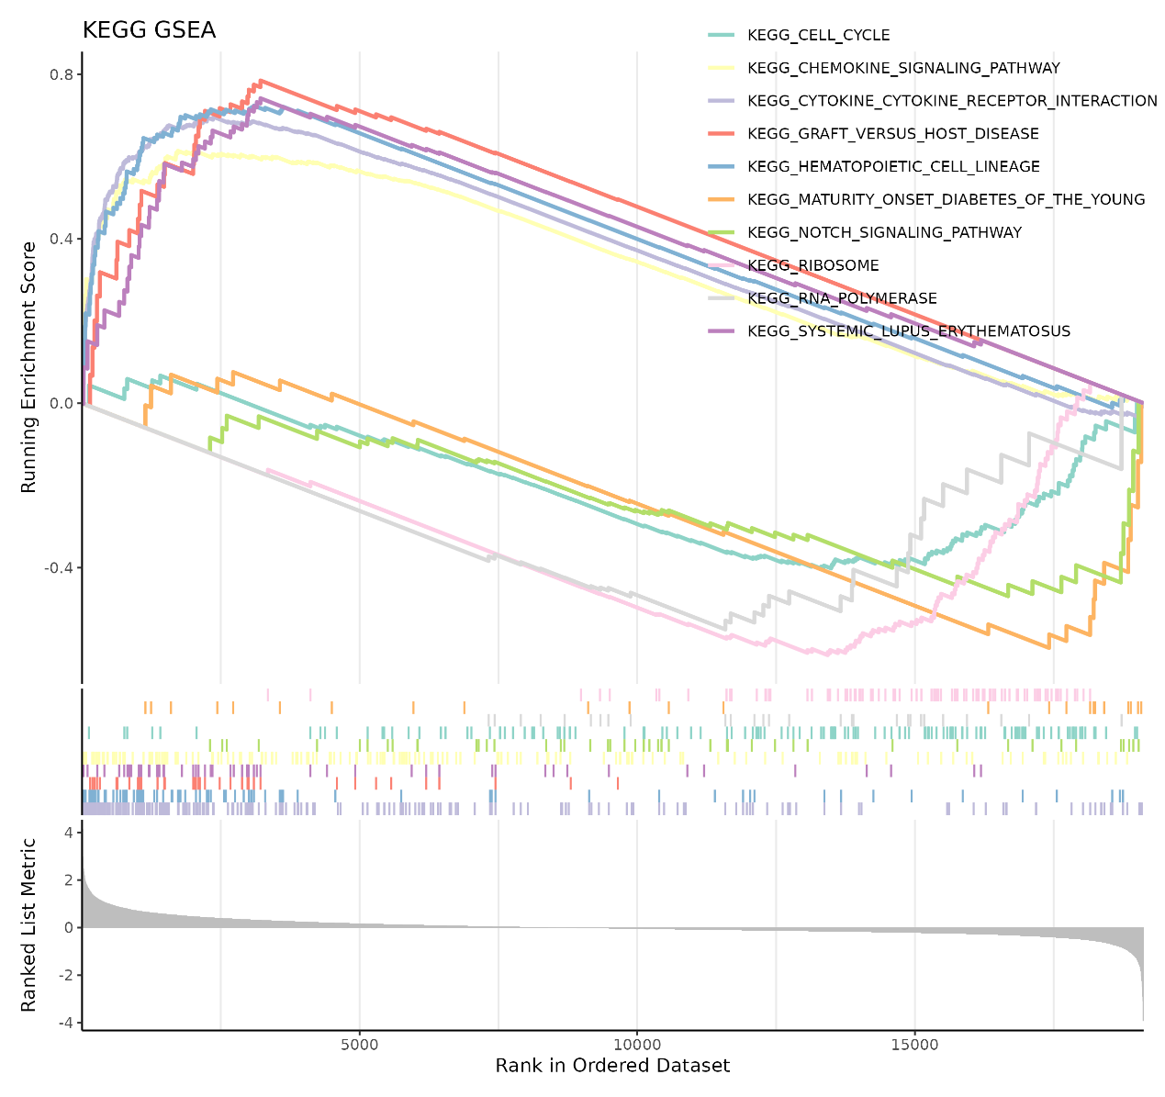
Fig S4 Gene set variation analysis between two subtypes in KEGG.
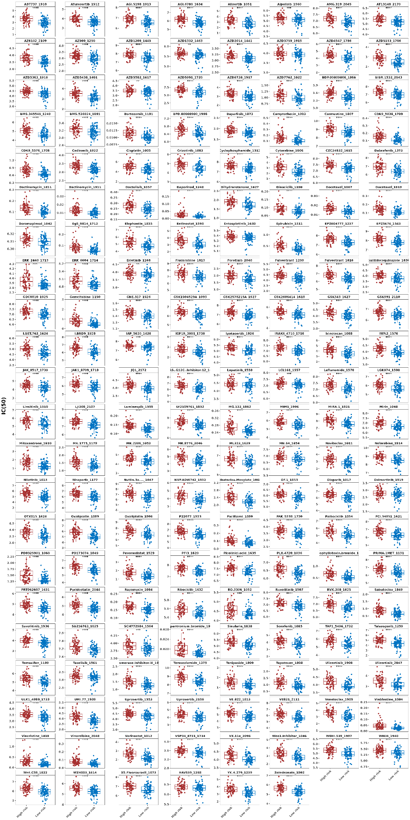
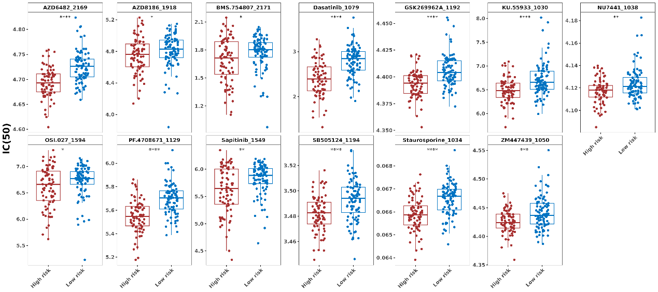

Fig S5. Drug sensitivity analysis. P-values were shown as *p<0.05, **p<0.01, ***P<0.001, ****p<0.0001.
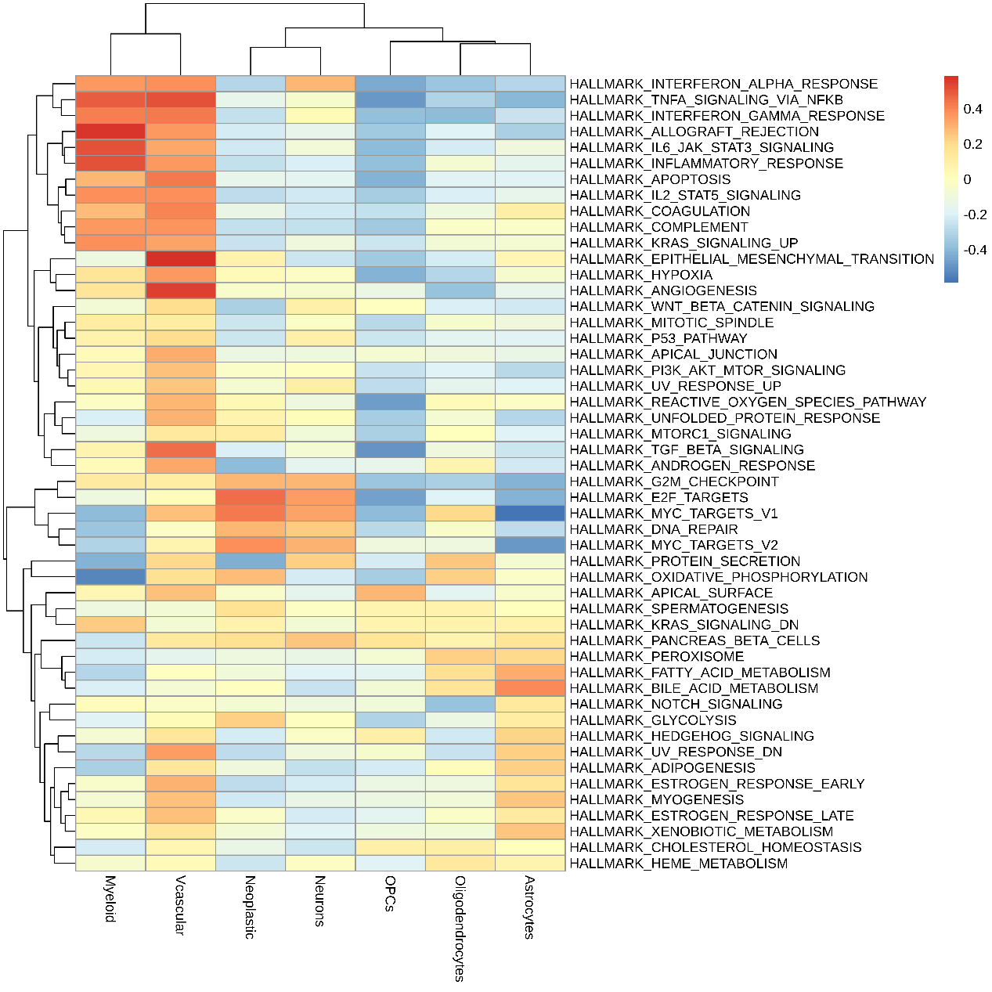
Fig S6. Heatmap depicting the results of gene set enrichment analysis (GSEA) using Hallmark gene sets.
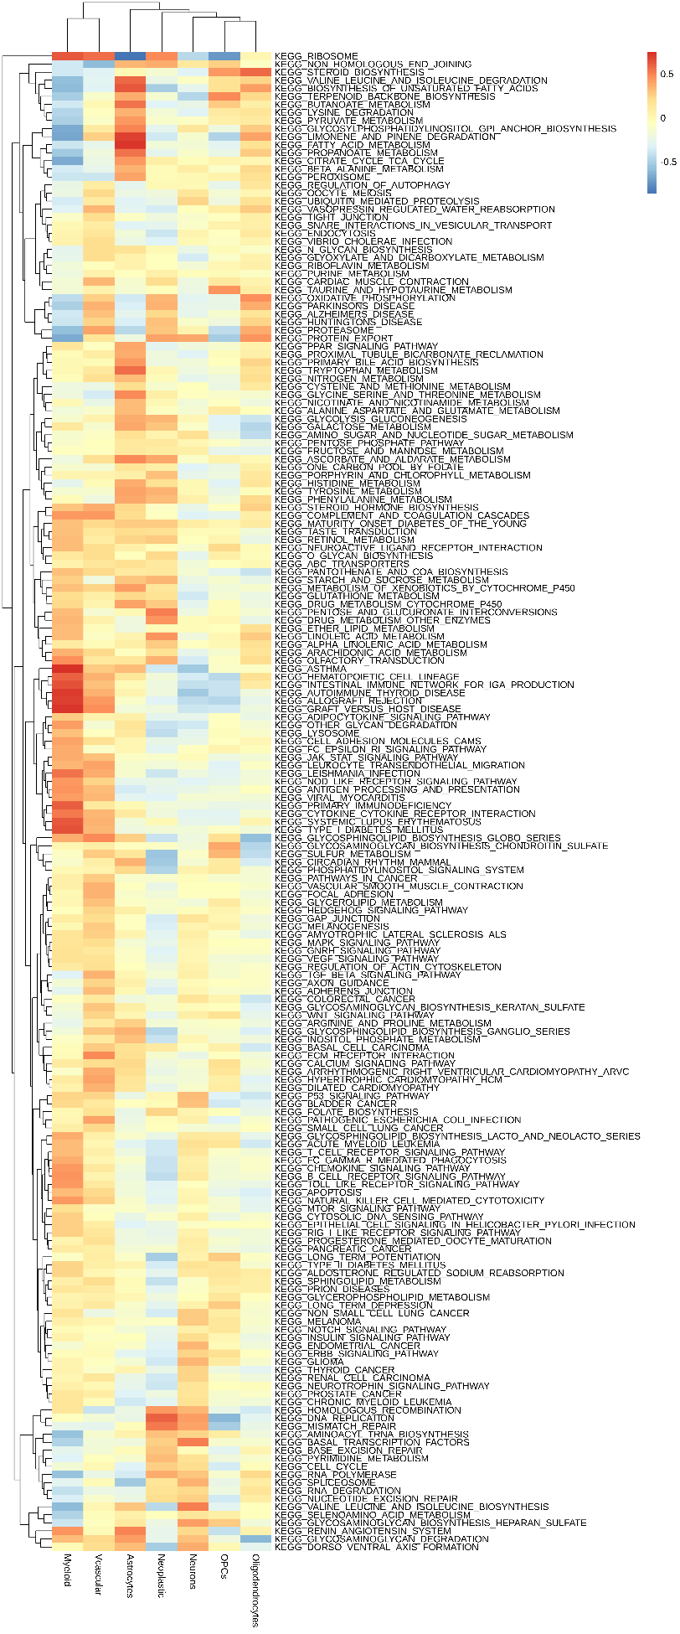
Fig S7. Heatmap depicting the results of gene set enrichment analysis (GSEA) using KEGG gene sets.

