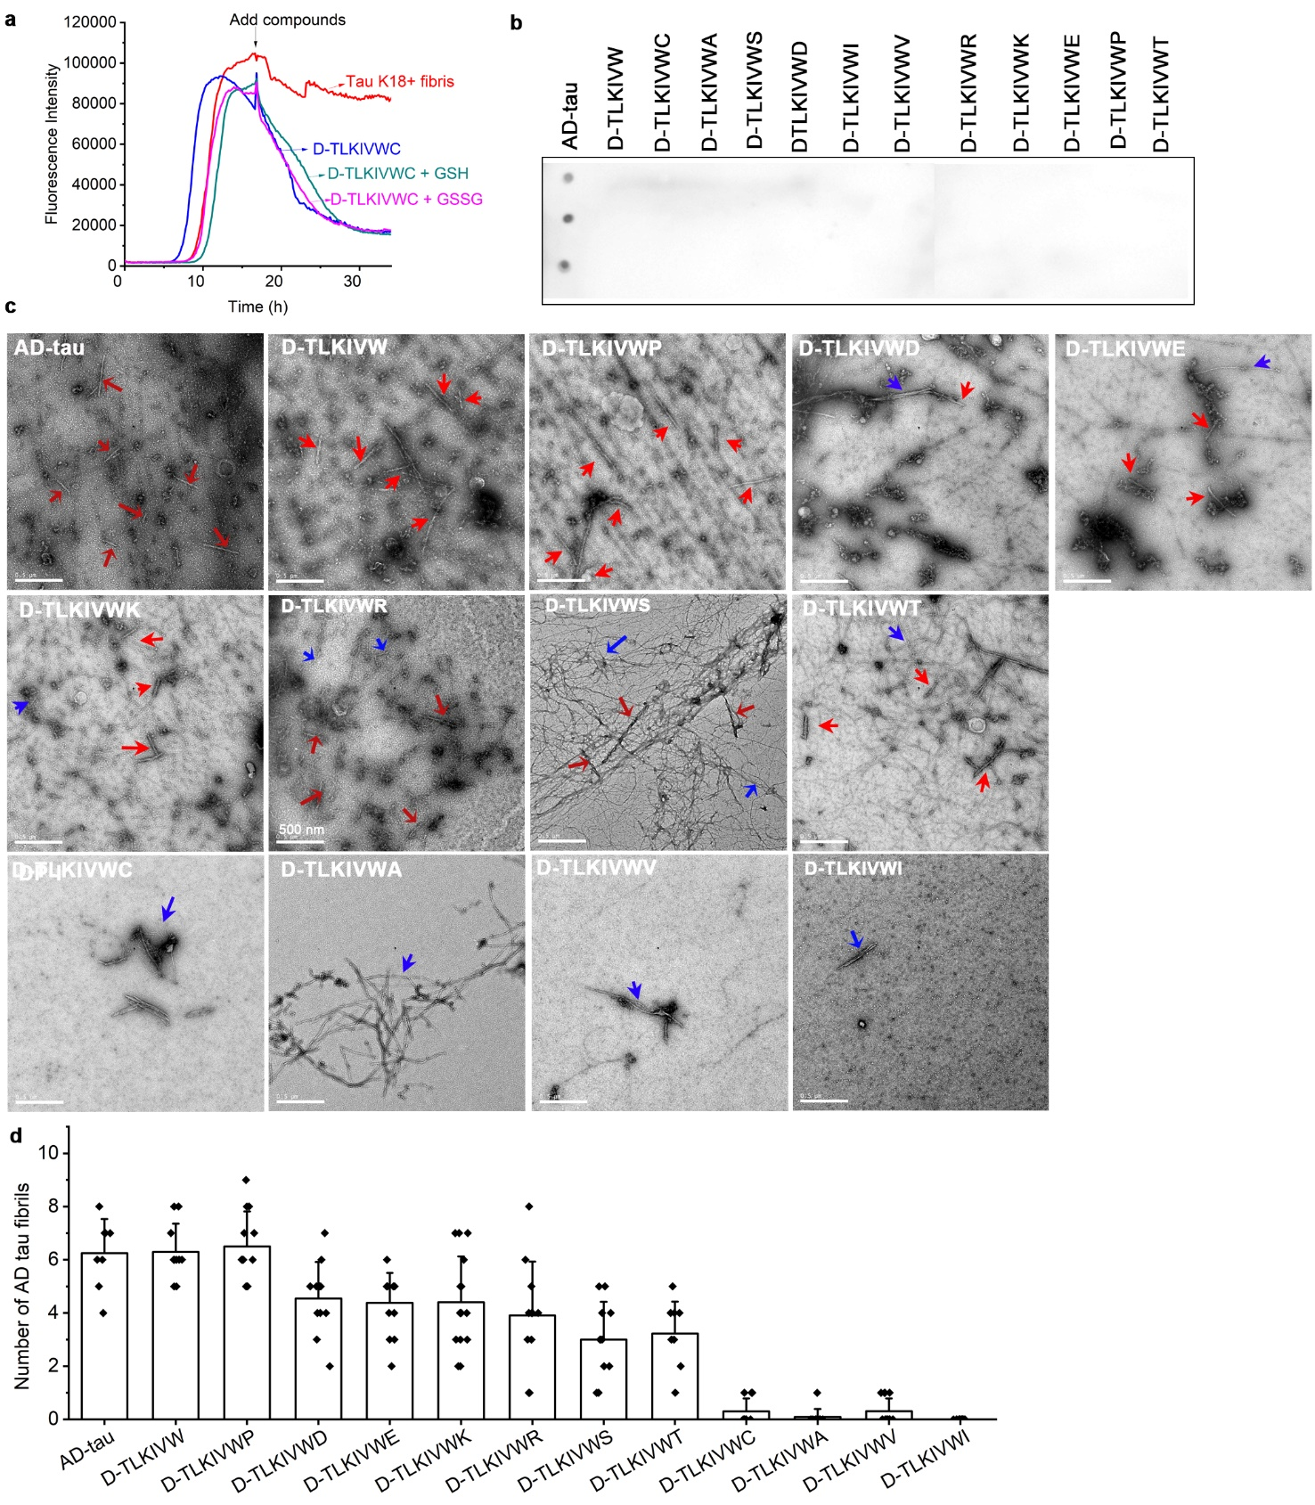
Extended Data Fig. 1. Variations of the sequence D-TLKIVWX (X = A, C, S, D, I, V, R, K, E, P, T) show varying efficacy in disassembling AD-tau fibrils. a, Thioflavin T (ThT) assay of 20 μM tau K18+ fibrils added with H₂O, 50 μM D-TLKIVWC, a mix of 50 μM D-TLKIVWC and 100 μM glutathione (GSH), or a mix of 50 μM D-TLKIVWC and 100 μM Glutathione disulfide (GSSG), respectively. b, Dot blot staining of D-TLKIVW, D-TLKIVWX (X= C, A, S, D, I, V, R, K, E, P, T) alone using the GT38 antibody. AD-tau fibril was stained as a positive control. c, Representative TEM images of AD-tau fibrils after incubation with 500 μM D-TLKIVW or D-TLKIVWX (X= C, A, D, V, K, E, P, T) at 37 ℃ for 48 h. The AD-tau fibrils and newly formed fibrils are labeled by red and blue arrows, respectively. Scale bars, 500 nm. d, Quantification of AD-tau fibrils in panels c. (n = 10 TEM images).

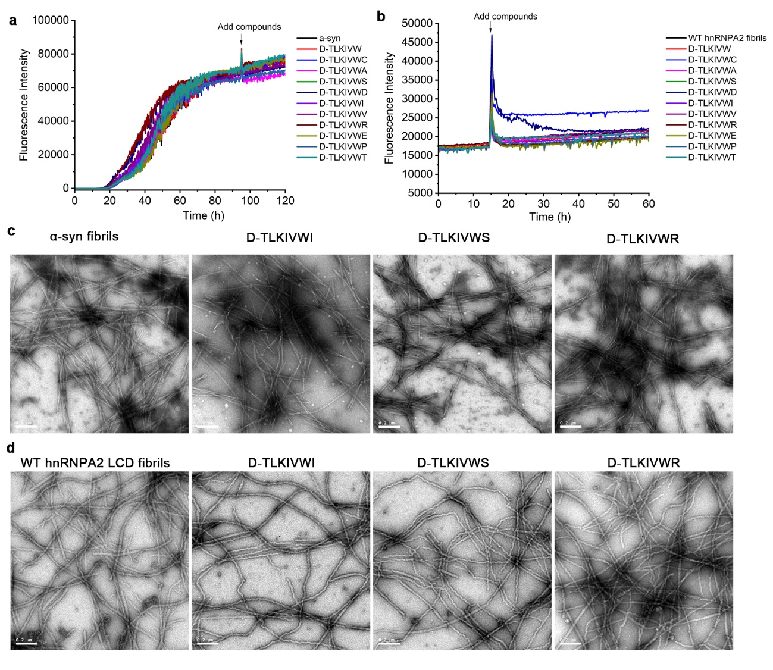
Extended Data Fig. 2. D-TLKIVWX does not disassemble α-syn fibrils or wild-type (WT) hnRNPA2 low complexity domain (LCD) fibrils. a, ThT assay of 25 μM α-syn fibrils incubated with 50 μM fresh D-TLKIVW or D-TLKIVWX (X = C, A, S, D, I, V, R, E, P, T) at 95 h time-point. b, ThT assay of 10 μM WT hnRNPA2 low complexity domain (LCD) fibrils incubated with 100 μM fresh D-TLKIVW or D-TLKIVWX (X = C, A, S, D, I, V, R, E, P, T) at 15 h time-point. c, Representative TEM images of a-syn fibrils alone and after incubation with 50 μM D-TLKIVWX (X = I, S and R) for 24 hours. d, Representative TEM images of WT hnRNPA2 LCD fibrils alone and after incubation with 100 μM D-TLKIVWX (X = I, S and R) for 55 hours. Scale bars, 0.2 µm.

Extended Data Fig. 3. AD-tau disassembly products are non-seeding species in tau biosensor cells. a, Representative fluorescent images of HEK293 cells expressing YFP-labeled tau K18 transfected with AD-tau fibril seeds after overnight disassembly with various concentrations of D-TLKIVWX (X = P, E, R, S, I). Scale bars, 100 μm. b, Quantification of puncta formed in tau biosensor cells after overnight disassembly with various concentrations of special cases D-TLKIVWP and D-TLKIVW. c-f, Quantification of puncta formed in tau biosensor cells after overnight disassembly with various concentrations of (c) D-TLKIVWX (X = D, E), (d) D-TLKIVWX (X = K, R), (e) D-TLKIVWX (X = S, T), (f) D-TLKIVWX (X = A, V, I). g, Cell viability of N2a cells treated with AD-tau fibrils that incubated overnight with D-TLKIVWS, measured by MTT assay. Results shown as Mean + SD of triplicate wells. Statistical significance was analyzed by one-way ANOVA (*p < 0.05).

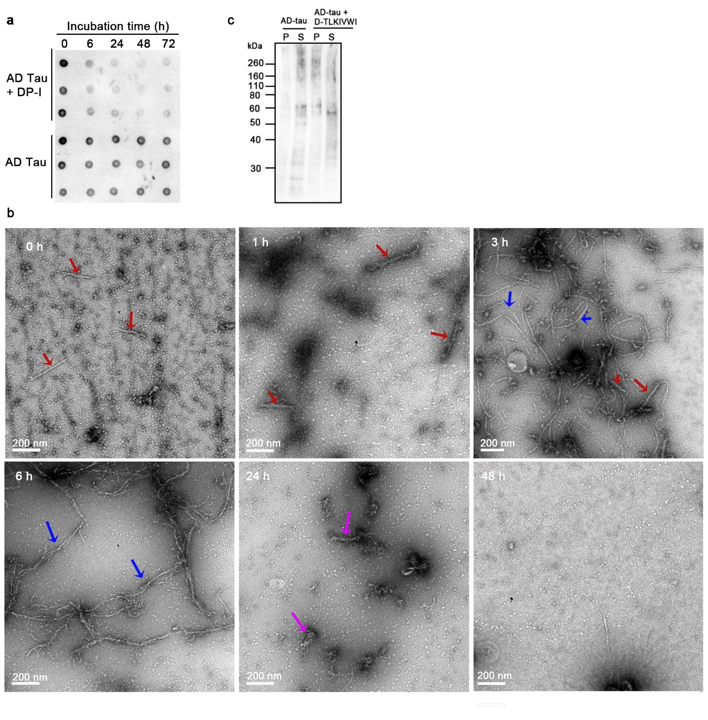
Extended Data Fig. 4. Emergence of new fibrils accompany with the disappearance of AD-tau fibrils. a, Time-course dot blot staining of AD-tau fibrils incubated with 500 μM D-TLKIVWI, probed by GT38 antibody. b, Negative stain electron micrographs of AD-tau fibrils incubated with 500 μM D-TLKIVWI at 0, 1, 3, 6, 24 and 48 h timepoints. AD-tau fibrils, newly formed D-TLKIVWI fibrils, and amorphous products are labeled by red, blue, and magenta arrows, respectively. c, Western blot of the supernatant and pellet of AD-tau fibrils before and after incubation with D-TLKIVWI for 48 h. The Dako antibody used here recognizes a linear tau epitope and so is unspecific for conformation. P: pellet, S: supernatant.

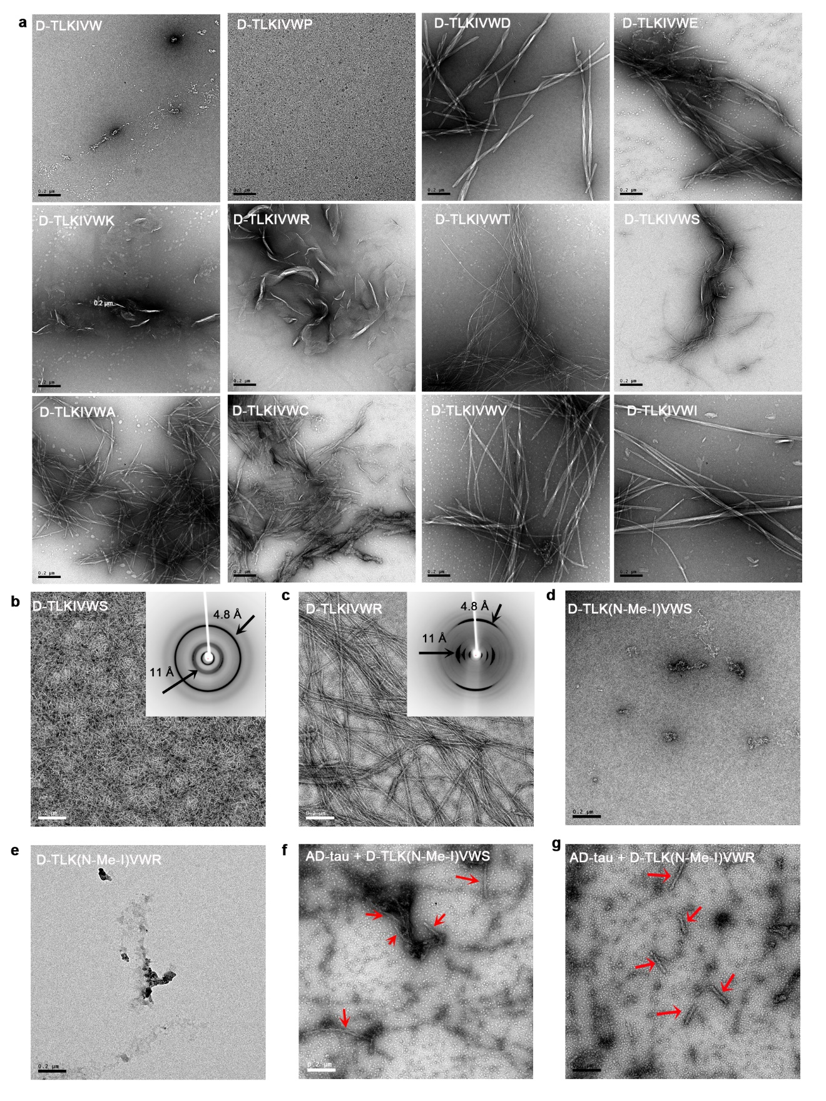
Extended Data Fig. 5. Aggregate ability of D-TLKIVWX is essential to the disassembly of AD-tau fibrils. a, TEM images of 500 μM D-TLKIVW, and 500 μM D-TLKIVWX (X = P, D, E, K, R, T, S, A, C, V, I) after incubation in 20 mM Tris-HCl, pH 7.4, 100 mM NaCl for 48 hours. Scale bars, 0.2 μm. b-c, Negative stain TEM and X-ray diffraction pattern (insets) of 10 mM (b) D-TLKIVWS, (c) D-TLKIVWR after left static in deionized water at room temperature for three days. d-e, Negative stain TEM image of 500 μM (d) D-TLK(N-Me-I)VWS, (e) D-TLK(N-Me-I)VWR in 20 mM Tris-HCl, pH 7.4, 100 mM NaCl at 37 ℃ for 48 hours. f-g, Representative TEM images of AD-tau fibrils after incubation with 500 μM (f) D-TLK(N-Me-I)VWS, (g) D-TLK(N-Me-I)VWR at 37 ℃ for 48 hours. AD-tau fibrils are labeled by red arrows. Scale bars, 0.2 μm.

Extended Data Fig. 6. AFM and Cryo-EM studies of D-TLKIVWX (X = I, S and R) amyloid fibrils. a, AFM images of 18 polymorphs of D-TLKIVWI fibrils. Scale bar, 100 nm. b-d, Cryo-EM imaging and data analysis of (b) D-TLKIVWI fibrils, (c) D-TLKIVWS fibrils and (d) D-TLKIVWR fibrils. Notice that all three peptide fibrils have a right-handed twist.

Extended Data Fig. 7. Structural explanation of why the absence of a seventh residue in D-TLKIVW prohibits its fibril formation. a, Schematic model of the amyloid-like fibrils formed by D-TLKIVWI. b, Views perpendicular to the fibril axis (upper row) and down the fibril axis (lower row) of one steric zipper of D-TLKIVWX amyloid-like fibrils. c, D-TLKIVW fails to form stable amyloid fibrils like D-TLKIVWX due to its reduced number of backbone hydrogen bonds (10 vs. 14) and the increased distance between the negatively charged C-terminal carboxyl group and the positively charged N-terminal amine group of the adjacent strand (5.0 Å vs. 2.8 Å), as compared between the left- and right-side panel c.

Extended Data Fig. 8. Cryo-EM data analysis workflow of the three complexes D-TLKIVWX (X = I, S and R)-disassembling AD-tau fibrils. a-c, Cryo-EM imaging and data analysis of (a) D-TLKIVWI-, (b) D-TLKIVWS-, and (c) D-TLKIVWR-disassembling AD-tau fibrils.

Extended Data Fig. 9. D-TLKIVWX (X = I, S and R) binds to the Val313–Thr319 residues of tau PHF. a, Cross-sectional cryo-EM density map and atomic models of tau PHF. A sharpened, high-resolution map is shown in dark salmon. Unsharpened, a 7 Å low pass filtered density map is shown in light salmon. b, 7 Å low-pass filtered cryo-EM maps of tau PHF control, and D-TLKIVWX (X = I, S, R)-disassembling tau PHF. The density map interpreted as peptide steric zippers is indicated by arrows. c, ¹H-¹⁵N-HSQC spectral overlay of free ¹⁵N,¹³C-labeled tau K18+ (salmon) and with 10-fold molar excess of D-TLKIVWS peptide after incubating for 1 month at 4 ℃ (marine). Representative residues with significant chemical shift changes are labeled and resonance shifts indicated with arrows. d, Chemical shift perturbation between free and D-TLKIVWI peptide bound ¹⁵N,¹³C-labeled tau K18+ monomer resonances.

Extended Data Fig. 10. L-TLKIVWX peptides display diminished efficacy in disassembling AD-tau fibrils compared to their enantiomers D-TLKIVWX. a, Dot blot staining of AD-tau fibrils before and after incubation with 500 μM D/L-TLKIVW, D/L-TLKIVWX (X= C, S, I, R) at 37 ℃ for 48 hours, probed by the GT38 antibody. Each sample was analyzed in triplicate. b, Quantification of the level of AD-tau fibrils in panel a by ImageJ. c, Negative stain TEM image of 500 μM L-TLKIVWI after incubation in 20 mM Tris-HCl, pH 7.4, 100 mM NaCl for 48 hours. Scale bar, 0.2 μm. d, ¹H-¹⁵N-HSQC spectral overlay of free ¹⁵N,¹³C-labeled tau K18+ (salmon) and with 10-fold molar excess of L-TLKIVWI peptide after 2.5 months of incubation at 4 °C (black). All residues with backbone chemical shift assignments are labeled. e, Comparison of fraction of tau K18+ that are bound by L- and D-TLKIVWI measured by peak intensities of representative residues (I308, V309, Y310, K311, S316, and V318). Both bound and residual free tau peak intensities were from the peptide bound spectra of tau K18+ in panel d and Fig. 4d. The slightly lower efficacy of L-TLKIVWI binding tau monomers was possible due to the slow exchange regime on NMR chemical exchange timescale.

