Supplementary Materials

Hybridizing mechanistic mathematical modeling with deep learning methods to predict individual cancer patient survival after immune checkpoint inhibitor therapy

Joseph D Butner, Prashant Dogra, Caroline Chung, Eugene J Koay, James W Welsh, David S Hong, Vittorio Cristini, Zhihui Wang

Figure S1
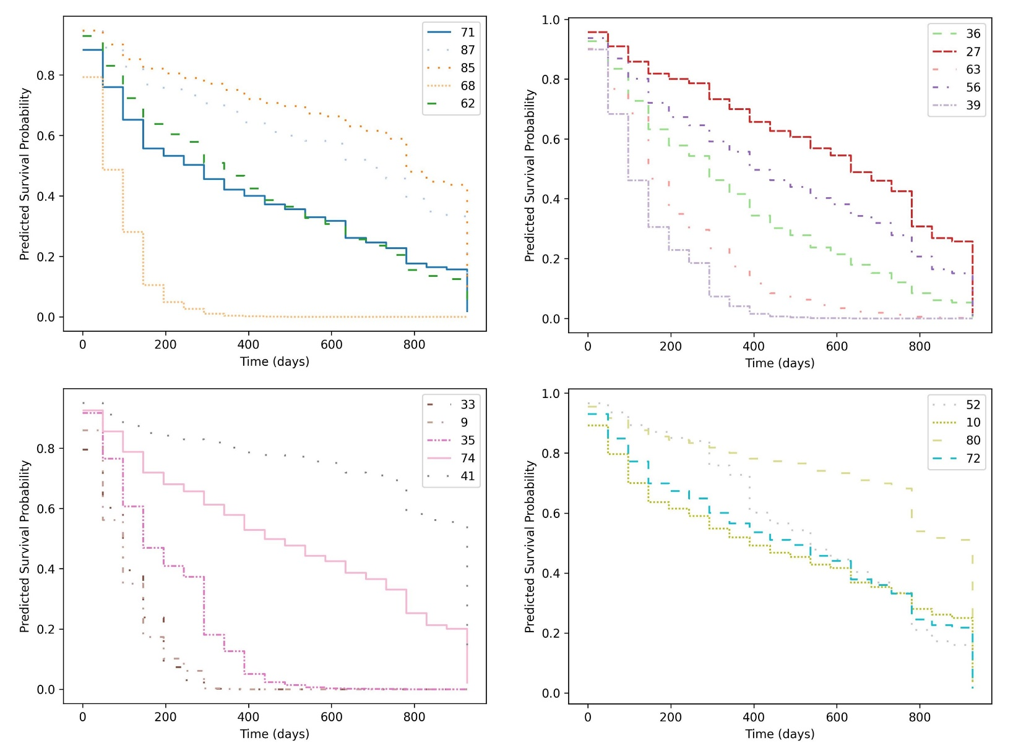
Figure S1: Predicted per-patient survival curves in the test set. The survival curves shown in Fig 3 (main text) are shown split across multiple plots for increased readability. Curves are separated based on the (random) ordering shown in Fig 3, and curve colors and styles correspond to Fig 3.

Figure S2
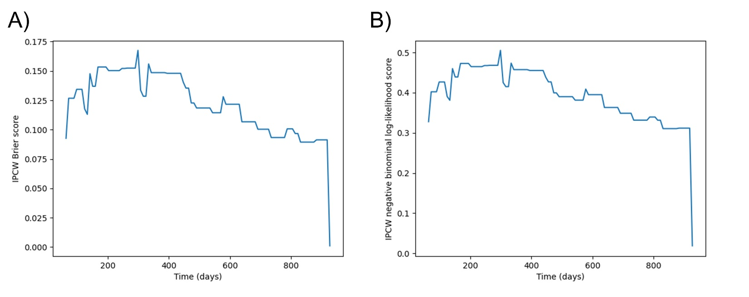
Figure S2: Assessment of overall model predictive accuracy across all patients vs. time for the hybrid (mechanistic model-derived + clinical measures) model by A) IPCW Brier score [29, 45] and 2) ICPW negative binominal log-likelihood score [45]. These may be integrated under the curve over time to provide a single numeric score, which are the scores reported in the main text. Error is observed to increase as predicted events are farther in the future. Extreme tails of the curve correspond to the trivial cases of predicting all patients are alive at time t=0 and all are dead as $t→∞$, and as such are often disregarded. In both cases, a score of zero corresponds to perfect accuracy (zero error).

Figure S3
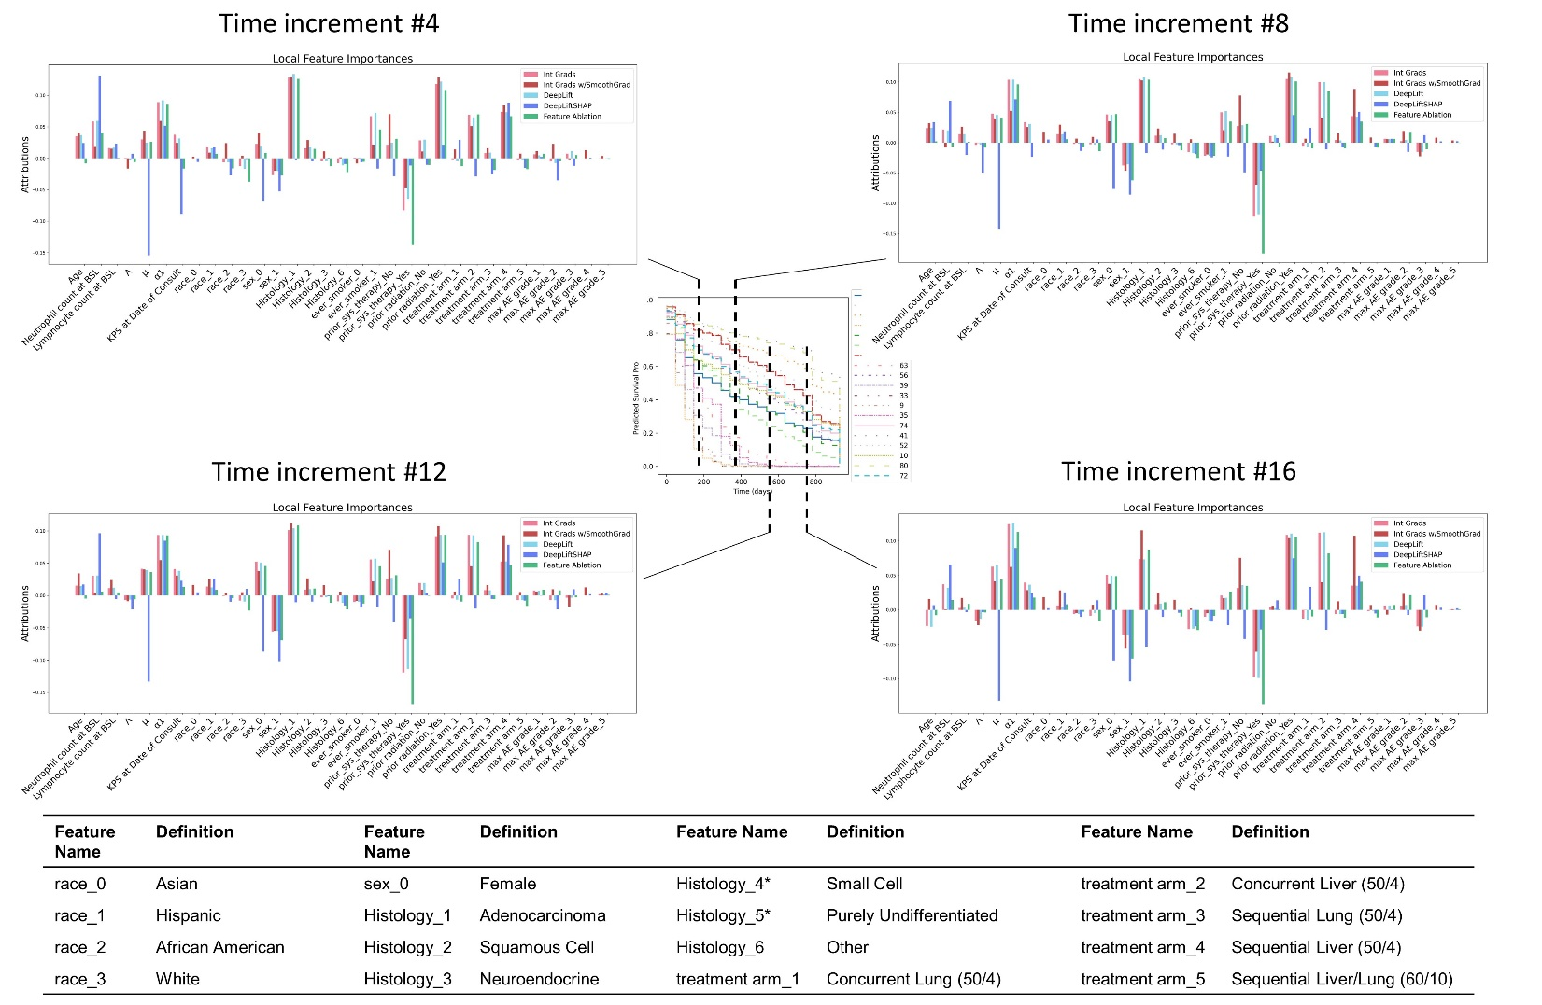
Figure S3: Examples of local feature importances at different time increments. The individual predicted survival probability curves from Fig. 3 are inset. Importances for how each feature were calculated using several backpropagation methods (integrated gradients, integrated gradients with smoothing, DeepLift, and DeepLiftSHAP) and also using feature ablation (a leave-one-feature-out method). Bars depict the importance for the indicated time increments (see methods and Fig. 2D), and sign indicates a positive or negative association with increased likelihood of seeing an event (in our case, patient death). Predicted survival curves (center panel) is the same as shown in Fig. 3, main text. Magnitudes are smaller than observed in Fig. 4, where importances across all time increments are summed into global effects. BSL = baseline, race_0 = Asian, race_1 = Hispanic, race_2 = African American, race_3 = White.

Figure S4
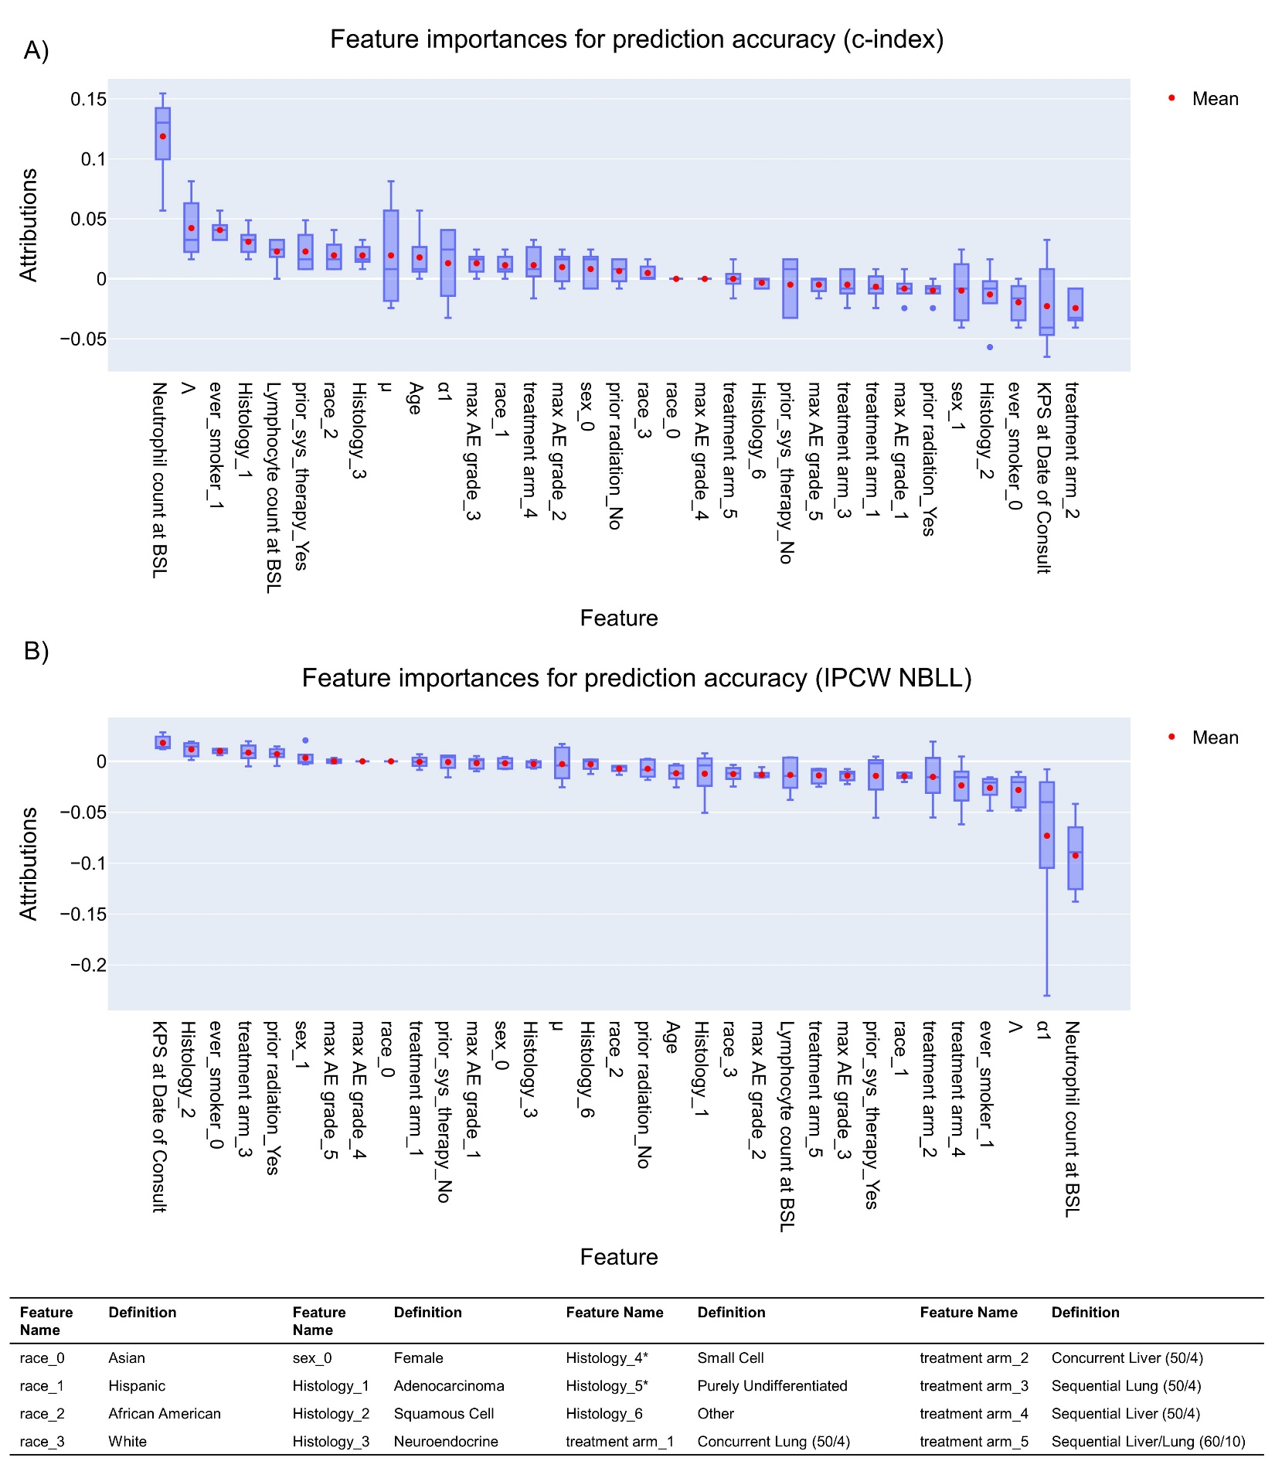
Figure S4: Feature importances for accuracy of model predictions based on A) Antolini c-index and B) IPCW negative binomial log-likelihood (NBLL). Note NBLL is a measure of error, so prediction accuracy is improved as they are minimized (this is the opposite of the c-index, meaning features with highest importance are shown on the right). Boxes represent upper and lower linear quartiles, the dividing line shows the median (middle quartile), whiskers show range excluding outliers, the mean is shown by a red point, and blue points indicate outliers, defined as greater than 4Q1-3Q3 or less than 4Q3-3Q1. BSL = baseline, AE= adverse event, KPS = Karnofsky performance scale.

Figure S5
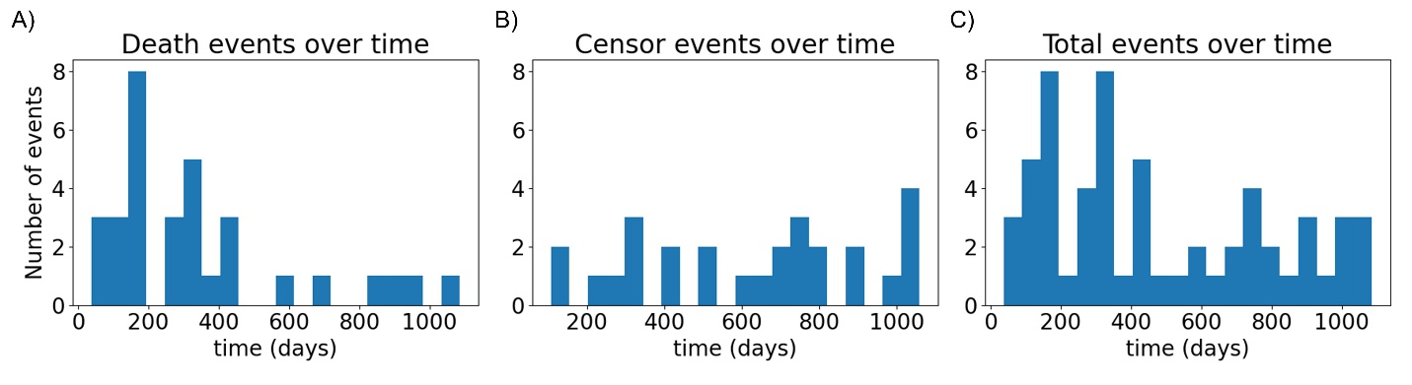
Figure S5: Event counts over time in the training set. Total events = death + censor events.

Table S1
Pt. # | Race | Age | N Ct. | L Ct. | Λ | μ | α1 | Sex | KPS | Hist | Smoker | Prior ST | Prior RT | Arm | Max AE | Death | Days
71 | 1 | 83 | 4.02 | 1.42 | 0.205578 | 0.04022 | 0.0104316 | 1 | 0.8 | 6 | 0 | Yes | No | 4 | 3 | 1 | 263
87 | 3 | 30 | 6.57 | 0.66 | -0.18261 | -0.005862 | 0.0095642 | 1 | 0.9 | 6 | 0 | Yes | Yes | 5 | 3 | 1 | 331
85 | 2 | 77 | 3.89 | 1.08 | 0.0683548 | 0.007255 | 0.0054013 | 1 | 0.8 | 1 | 1 | Yes | Yes | 5 | 2 | 1 | 807
68 | 3 | 63 | 11.7 | 0.62 | 0.793467 | 0.00829 | 0.0127021 | 1 | 0.9 | 2 | 0 | No | Yes | 4 | 3 | 0 | 96
62 | 3 | 68 | 7.36 | 1.75 | 0.319476 | 0.017798 | 0.0120633 | 1 | 0.8 | 1 | 1 | Yes | No | 4 | 5 | 1 | 63
36 | 3 | 63 | 4.93 | 1.08 | -0.218447 | -0.004708 | 0.0141216 | 1 | 0.9 | 1 | 1 | Yes | Yes | 3 | 2 | 1 | 309
27 | 3 | 56 | 3.96 | 1.51 | 0.0252717 | 0.00959 | 0.0037226 | 0 | 0.8 | 3 | 0 | Yes | Yes | 2 | 1 | 1 | 574
63 | 1 | 64 | 5.81 | 0.6 | 0.530757 | 0.013766 | 0.0102681 | 1 | 0.8 | 1 | 1 | Yes | Yes | 4 | 3 | 1 | 67
56 | 3 | 60 | 4.35 | 1.31 | 0.953493 | 0.051072 | 0.0049386 | 1 | 0.8 | 1 | 1 | Yes | Yes | 4 | 3 | 1 | 447
39 | 1 | 65 | 9.29 | 1.25 | 2.5896 | 0.003605 | 0.0147128 | 0 | 0.8 | 1 | 1 | Yes | No | 3 | 2 | 1 | 128
33 | 3 | 54 | 5.63 | 1.02 | -0.002371 | -0.026163 | 0.0297092 | 0 | 0.8 | 6 | 1 | Yes | Yes | 2 | 3 | 0 | 120
(9 | 3 | 41 | 3.29 | 0.89 | 1.47832 | 0.000902 | 0.0241044 | 0 | 0.9 | 1 | 0 | No | Yes | 1 | 3 | 1 | 71
35 | 3 | 47 | 4.14 | 1.12 | -0.018245 | -0.016042 | 0.0289333 | 1 | 1 | 6 | 0 | Yes | Yes | 2 | 1 | 0 | 301
74 | 3 | 67 | 5.31 | 0.82 | -0.281298 | -0.01589 | 0.014004 | 1 | 0.8 | 1 | 1 | Yes | No | 5 | 3 | 1 | 140
41 | 3 | 65 | 4 | 1.16 | 3.69955 | 0.002782 | 0.0033859 | 0 | 0.9 | 6 | 0 | Yes | Yes | 3 | 2 | 0 | 880
52 | 3 | 72 | 2.65 | 1.78 | 0.847609 | 0.011391 | 0.0063989 | 0 | 0.8 | 1 | 1 | Yes | Yes | 3 | 2 | 0 | 454
10 | 3 | 79 | 4.88 | 0.43 | -2.94133 | -0.006465 | 0.0120712 | 1 | 0.8 | 2 | 0 | Yes | No | 1 | 3 | 1 | 162
80 | 3 | 60 | 2.59 | 1.09 | 0.0112055 | 0.006434 | 0 | 0 | 0.9 | 1 | 0 | Yes | Yes | 5 | 3 | 0 | 927
72 | 3 | 59 | 3.12 | 1.2 | 0.913843 | 0.006208 | -0.001233 | 1 | 0.9 | 1 | 0 | Yes | No | 4 | 3 | 0 | 469

Table S1: Individual patient model inputs for the test set. Patient ordering corresponds to Fig. 3. Days indicates days to death or censor after administration of first ICI treatment. Column header abbreviations: N Ct., neutrophil count at baseline; L Ct., lymphocyte count at baseline; KPS, Karnofsky Performance Scale; Hist, Primary Disease Histology; Prior ST, prior systemic therapy; Prior RT, prior radiotherapy; Arm, treatment arm; Max AE, maximum adverse event. Encodings: Race 1, Hispanic; Race 2, African American; Race 3, white; sex 0, female; sex 1, male; Histology 1, adenocarcinoma; Histology 2, squamous cell; Histology 3, neuroendocrine; Histology 6, other; smoker 0, no; smoker 1, yes; Arm 1, Concurrent Lung (50/4); Arm 2, Concurrent Liver (50/4); Arm 3, Sequential Lung (50/4); Arm 4, Sequential Liver (50/4); Arm 5, Sequential Liver/Lung (60/10); Death 1, yes; Death 0, no (patient was censored). Adverse Events (Max AE) were documented according to the Recommended Adverse Event Recording Guidelines for Phase I protocol according to the Code of Federal Regulations, Good Clinical Practices; in this study, all adverse events were binned according to the maximum AE reported. Units: Age (years), neutrophil count (×10³/μl), lymphocyte count (×10³/μl), μ (days⁻¹), α (days⁻¹), Days (days); all others unitless.

