Knowledge, practices, and barriers to access of emergency contraceptive pills in married women and men - a cross-sectional study from outpatient clinics in Karachi, Pakistan

Supplementary File

Table of Contents:
Content | Page number
Table 1. Percentages of respondents who correctly answered the questions of knowledge about emergency contraceptive pills (ECPs) | 2
Table 2. Chi-squared table of association between ECP knowledge and various factors. | 3
Figure 1. Project Summary Map | 4
Table 3. Study Questionnaire | 5-13

Serial # | Question | N (%)
1. | ECPs can completely (100%) prevent pregnancy. | 120 (30.6)
2. | ECPs are more effective in preventing pregnancy than COCs  (combined oral contraceptive pills). | 67 (17.1)
3. | ECPs can be used as usual contraception (e.g., combined oral  contraceptive pills). | 73 (21.1)
4. | The most effective time for taking ECPs is before sexual  intercourse. | 98 (25.5)
5. | The second tablet of ECPs should be taken 12 hours after the first  tablet. | 42 (11.3)
6. | ECPs should be taken within 72 hours after sexual intercourse. | 178 (46.2)
7. | The most effective time for taking ECPs is within 12 hours after  sexual intercourse. | 124 (32.2)
8. | More than 4 tablets of ECPs can be taken in a month. | 13 (4.0)
9. | ECPs can prevent sexually transmitted diseases. | 44 (11.4)
10. | Nausea and vomiting are the side effects of ECPs. | 122 (32.0)
11. | Vaginal bleeding is a side effect of ECPs. | 89 (23.2)
12. | Ectopic pregnancy is a side effect of ECPs. | 52 (14.9)
13. | ECPs are safe to use in pregnant women. | 38 (9.9)
14. | ECPs can cause abortion. | 55 (14.2)
15. | ECPs can treat pimples. | 98 (26.4)

Table 1: Percentages of respondents who correctly answered the questions of knowledge about emergency contraceptive pills (ECPs) (n=393)

S.no# |  |  | Low knowledge | Moderate-high knowledge | Chi-squared score | p-value
1. | Gender | Male  Female | 112  215 | 16  40 | 1.2271 | 0.268
2. | Age | Young  Old | 163  149 | 36  20 | 2.7724 | 0.096
3. | Contraception Use | Yes  No | 153  184 | 37  19 | 8.2163 | 0.004
4. | Family  Counselling | Yes  No | 52  284 | 16  40 | 5.7410 | 0.017
5. | Educational Level | Low  High | 108  229 | 10  46 | 4.6024 | 0.032
6. | Employment Status | Employed  Unemployed | 170  167 | 32  24 | 0.8624 | 0.353
7. | Future ECP Need | Yes  No | 70  267 | 26  30 | 17.1237 | <0.001

Table 2: Chi-squared table of association between ECP knowledge and various factors.

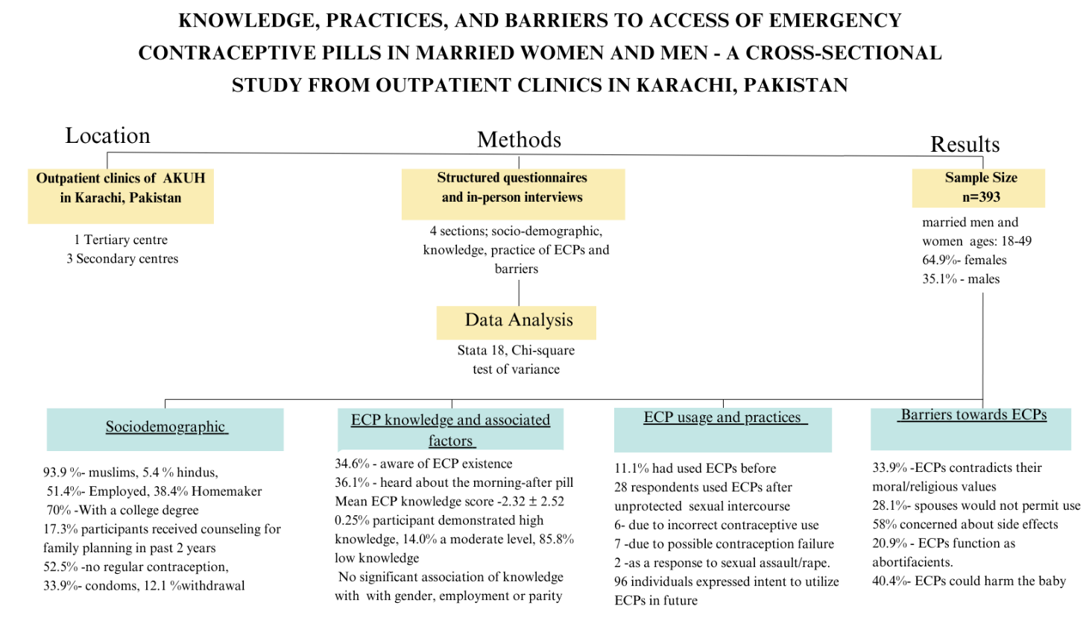
Figure 1: Project Summary Map

Section: A Sociodemographic data
S. no |  | Question | Code | Skip
01. |  | What is your age?
02. |  | What is your gender? | - Male  - Female  - Prefer not to disclose
04. |  | What is your religion? | - Islam  - Christianity  - Hindus  - Others (please specify)
05. |  | What is your educational status? | - No formal education  - Primary (1-5)  - Secondary (6-8)  - Matric  - Intermediate  - Undergraduate  - Postgraduate
07. |  | What is your employment status? | - Employed  - Unemployed  - Homemaker  - Student  - Retired
08. | What is your monthly income? (PKR) |  | - <25,000  - 25,000 – 100,000  - 100,000 – 500,000  - >500,000
09. | Parity? |  | - 0  - 1–2  - 3–4  - 5–6  - 6+
 | Use of family planning
10. | What family planning method do you currently use? |  | - Condom  - Withdrawal  - Intrauterine device  - Oral contraceptives  - Surgical methods (vasectomy, tubal ligation)  - None  - Other: _________
11. | Have you received counseling for family planning in the past 2 years? |  | - Yes  - No
12. | Have you had any experience of unintended pregnancy? |  | - Yes  - No
13. | If yes, what was the outcome of the unintended pregnancy/pregnancies? |  | - Curettage or spontaneous loss  - Labor
14. | Have you ever received help to end a pregnancy? |  | - Yes  - No
15. | Have you heard of the term “emergency contraception”? |  | - Yes  - No
16. | Have you heard of morning-after pills (ECP)? |  | - Yes  - No
17. | Is postcoital prevention of pregnancy possible? |  | - Yes  - No

Section B: Knowledge
S. no | Question | Code | Skip
 | Please indicate whether you agree or disagree with the following statements (Yes/No/Not Aware)
01. | Can ECPs completely (100%) prevent pregnancy? | - Yes  - No  - Not Aware
02. | Are ECPs more effective to prevent pregnancy than COCs? | - Yes  - No  - Not Aware
03. | Can ECPs be used as usual contraception (e.g. combined oral contraceptive pills; COCs)? | - Yes  - No  - Not Aware
04. |  | - Yes  - No  - Not Aware
  Is the most effective time for taking ECPs before sexual intercourse?
05. |  | - Yes  - No  - Not Aware
  Is the most effective time for taking ECPs within 12 h after sexual intercourse?
06. |  | - Yes  - No  - Not Aware
  Should the second tablet of ECPs be taken 12 h after the first tablet?
07. |  | - Yes  - No  - Not Aware
  Should ECPs be taken within 72 h after sexual intercourse?
8. | Is ECPs safe in pregnant women? | - Yes  - No  - Not Aware
9. | Can ECPs be taken more than 4 tablets a month? | - Yes  - No  - Not Aware
10. | Can ECPs prevent sexually transmitted diseases? | - Yes  - No  - Not Aware
11. | Are nausea and vomiting side effects of ECPs? | - Yes  - No  - Not Aware
12. | Is vaginal bleeding a side effect of ECPs? | - Yes  - No  - Not Aware
13. |  | - Yes  - No  - Not Aware
  Is ectopic pregnancy a side effect of ECPs?
14. | Can ECPs cause abortion? | - Yes  - No  - Not Aware
15. |  | - Yes  - No  - Not Aware
  Can ECPs treat pimples?

Section: C Practices
S.  no | Question | Code | Skip
01. | Have you ever used the morning-after pills? | - Yes  - No  - Don’t know
02. | How many times have you used morning-after pills? | - Once  - Twice or more
03. | When was the last time you used emergency contraception? | - 0-1 months  - 2-6 months  - > 6 months
04. | What was your main reason for using emergency contraception? | - Unprotected sexual intercourse  - Incorrect use of other contraceptive methods  - Possible contraceptive failure  - Sexual assault without contraceptive coverage
05. | What was the method of emergency contraception used? | - Oral contraceptive pill  - Intrauterine contraceptive device
06. | From where were you able to acquire emergency contraceptive? | - Pharmacy shop/drug store  - Community clinic/hospital  - Others
07. | Would you like to use the morning-after pills if you need them? (Yes/No) | - Yes  - No  - Don’t know

Section: D Barriers
S. no | Question | Code | Skip
01. | Can Emergency contraception act as an abortifacient | - Yes  - No  - Don’t know
02. | Does emergency contraception lead to an increase in unprotected intercourse? | - Yes  - No  - Don’t know
03. | Do you have sufficient information about emergency contraception? | - Yes  - No  - Don’t know
04. | Are emergency contraceptive pills expensive? | - Yes  - No  - Don’t know
05. | Can the use of emergency contraceptives potentially discourage the use of condoms? | - Yes  - No  - Don’t know
06. | Could the use of emergency contraceptives potentially result in harm to the baby if a pregnancy occurs? | - Yes  - No  - Don’t know
07. | Are you concerned about the side effects of using emergency contraception? | - Yes  - No  - Don’t know
08. | Could the use of emergency contraceptives potentially discourage my regular contraceptive use? | - Yes  - No  - Don’t know
09. | Are the pills available without a prescription? | - Yes  - No  - Don’t know
10. | Are the pills legal? | - Yes  - No  - Don’t know
11. | Is it embarrassing to talk to the pharmacist about emergency contraception, even in a private conversation? | - Yes  - No  - Don’t know
12. | Would it be particularly uncomfortable to discuss emergency contraception with a male pharmacist? | - Yes  - No  - Don’t know
13. | Can the pharmacist be trusted to keep any personal information confidential when providing EC? | - Yes  - No  - Don’t know
14. | Do you believe that using emergency contraception contradicts your moral and/or religious values? | - Yes  - No  - Don’t know
15. | Would the spouse disapprove of the use of emergency contraception? | - Yes  - No  - Don’t know
16. | Does emergency contraception work effectively? | - Yes  - No  - Don’t know
17. | Could a doctor or pharmacist view women who ask for emergency contraception as irresponsible? | - Yes  - No  - Don’t know
18. | Is emergency contraception available in Pakistan? | - Yes  - No  - Don’t know
19. | Do you have information about which pharmacy provides it? | - Yes  - No  - Don’t know

