Supplementary Appendix to:

Racial/Ethnic Differences in Occurrence of Post-acute Sequelae of SARS-CoV-2 Infection (PASC) and Associated Symptoms in Children and Adolescents: Findings from Difference-in-Differences Analyses Using an EHR-Based Cohort from the RECOVER Program
Table of Contents
Section S1 Supplemental Methods 2
A. Modeling strategy for the difference-in-difference analyses 2
B. Difference-in-differences analyses equipped with negative control outcomes 2
C. List of negative control outcomes 2
D. Study Variables 3
E. Code Sets for Systemic and Syndromic Features of PASC 5
Section S2 Supplemental Results: negative control experiment 5
A. AAPI vs. NHW 6
B. Hispanic vs. NHW 8
C. NHB vs. NHW 11
Section S3 Supplemental Results: sensitivity analysis using standard regression models 14
Section S4 Supplemental Results: sensitivity analysis for COVID-19 patients with a positive PCR/antigen test only 15
Section S5 Supplemental Results: sensitivity analysis excluding patients in the first wave of the pandemic (March to May 2020) 18
Section S6 Supplemental Results: stratified analysis by age group 21
A. < 5 years 21
B. 5 to <12 years 24
C. 12 to <21 years 27
Section S7 Supplemental Results: stratified analysis by virus variant period 30
A. Pre-Delta variant period 30
B. Delta variant period 33
C. Omicron variant period 36
Section S8 Supplemental Results: patient characteristic balance between race/ethnicity groups 39
A. Propensity-score (PS) models and matching 39
B. Patient characteristic balance in the primary analysis 39

Section S1 Supplemental Methods

A. Modeling strategy for the difference-in-difference analyses
We use a categorical indicator $R$ as the racial/ethnic groups ($R=0$ for NHW, $R=1$ for NHB, $R=2$ for Hispanic, $R=3$ for AAPI), $M$ as the status of documented SARS-CoV-2 infection ($M=1$ for documented infections vs. $M=0$ for no infections), and $Y$ to denote the occurrence of the specific potential PASC symptoms and conditions. A Poisson regression model was fitted by regressing the long COVID outcome on racial/ethnic groups, SARS-CoV-2 infection status, and the interaction between racial/ethnic groups and SARS-CoV-2 infection status:

$$h\left(Y\right)=β_{0}+β_{1}*R+β_{2}*M+β_{3}*R*M,$$

where $h\left(Y\right)$ is the log link function. The coefficient of the interaction term, $β_{3}$, represents the differential increase of racial/ethnic differences that are attributable to SARS-CoV-2 infection.

B. Difference-in-differences analyses equipped with negative control outcomes
The difference-in-differences analysis is a quasi-experimental design that uses observational data from intervention groups to control groups.[1,2] To estimate the effect of a specific intervention, this methodology contrasts changes in outcomes before and after the intervention between the group receiving the intervention and those without it. However, the difference-in-differences analyses rely on the parallel trends assumption, that is, in the absence of intervention, the outcome difference between the intervention and control groups remains constant over time. In other words, the effect of the unmeasured confounders or the unmeasured confounder bias is constant over time. Essentially, this assumes that the effect of unmeasured confounders or the bias from such confounders remains consistent over time. It is crucial to acknowledge that this assumption may not always hold in observational studies, potentially introducing inaccuracies in difference-in-differences analyses and undermining their validity.

To account for the time-varying unmeasured confounder bias in our study, we proposed a novel approach to difference-in-differences analyses, integrating the calibration with negative control outcomes. Specifically, we first conducted the difference-in-differences analyses for 31 negative control outcomes. We believe that there is no effect of race/ethnicity on the increased prevalence of negative control outcomes after COVID-19. To estimate the empirical null distribution, we subsequently utilized the estimated effects from these negative control outcome analyses. This distribution was then employed to calibrate the estimates of race/ethnicity impact on the increased prevalence of PASC symptoms and conditions via difference-in-differences analyses.

C. List of negative control outcomes
Table S1. The 31 Negative control outcomes used in the analysis.
Health Condition
Acne
Closed fracture of distal end of radius
Closed injury of head
Concussion
Contact dermatitis
Diaper rash
Displacements - bone
Falls
Foreign body in ear
Impetigo
Inguinal hernia
Injury of finger
Injury of free lower limb
Injury of head
Injury of left leg
Injury of right foot
Injury of right hand
Injury of right leg
Injury of upper extremity
Insect bite
Plagiocephaly
Scoliosis
Snoring/Obstructive sleep apnea
Speech delay
Speech dysfunction
Sprain of ankle
Tinea capitis
Tinea corporis
Tongue tie
Umbilical hernia
Wax in ear/impacted cerumen

D. Study Variables
Table S2. Confounding Variables used in the propensity model and other variables for eligible criteria.

Variable | Functional form |  | Values |  | Detail |  | Codes/references
Confounding variables
Age (years) | Linear | NA |  | Based on records in the person domain. |  | Age is defined as the integer of (date – birth date)/365.25
Sex | Indicator | Male/Female |  | Based on records in the person domain. |  | NA
Obesity | Indicator | Yes/No |  | Based on records in the measurement domain.  If measured at age < 24*30.5 days, NHANES weight z score > 1.64  If measured at 24*30.5 < age <240*30.5, NHANES BMI z score > 1.64  If measured at age ≥ 240*30.5, BMI kg/m2 > 30 |  | NA
PMCA (Pediatric Medical Complexity Algorithm) | 3 categories | No chronic condition (PMCA = 0)  Non-complex chronic condition (PMCA = 1)  Complex chronic condition comorbidities (PMCA = 2) |  | Based on the condition occurrence and visit occurrence domains. |  | Simon, T. D., Haaland, W., Hawley, K., Lambka, K., & Mangione-Smith, R. (2018). Development and validation of the Pediatric Medical Complexity Algorithm (PMCA) version 3.0. Academic pediatrics, 18(5), 577-580.
Number of visits to emergency department in 18 months to 179 days prior to the entry | 4 categories | 0  1  2  ≥3 |  | Based on the condition occurrence and visit occurrence domains. |  | NA
Number of inpatient visits in 18 months to 179 days prior to the entry | 4 categories | 0  1  2  ≥3 |  | Based on the condition occurrence and visit occurrence domains, including Inpatient Hospital Stay, Emergency Department Admit to Inpatient Hospital Stay, and Observation Stay |  | NA
Number of outpatient visits in 18 months to 179 days prior to the entry | 4 categories | 0  1  2  ≥3 |  | Based on the condition occurrence and visit occurrence domains including Ambulatory/Outpatient Visit (With a Physician) and Interactive Telemedicine Service |  | NA
Number of unique medications in 18 months to 179 days prior to the entry | 4 categories | 0  1  2  ≥3 |  | Based on the drug exposure domain |  | RxNorm code
Diagnosis of each chronic condition cluster in 18 months to 179 days prior to the entry | Indicator | Yes/No |  | 205 chronic condition clusters were defined based on the condition occurrence and visit occurrence domains. |  | Rao, S., Lee, G. M., Razzaghi, H., Lorman, V., Mejias, A., Pajor, N. M., ... & Forrest, C. B. (2022). Clinical features and burden of post-acute sequelae of SARS-CoV-2 infection in children and adolescents: an exploratory EHR-based cohort study from the RECOVER program. medRxiv, 2022-05.
Other variables for eligibility criteria
Prior encounter in 18 months to 179 days prior to the entry | Indicator | Yes/No |  | Based on the condition occurrence and visit occurrence domains. |  | NA

Note: All of the domains in the table above are based on the PEDSnet common data model (CDM). More details are available through this link: https://data-models-service.research.chop.edu.

E. Code Sets for Systemic and Syndromic Features of PASC

Table S3. Code sets for systemic and Syndromic Features of PASC symptoms and conditions.
Syndromic (symptoms, signs, non-specific laboratory abnormalities) | Systemic (diagnosed health conditions)
- abdominal pain  - abnormal liver enzyme  - cardiovascular signs and symptoms  - changes in taste and smell  - chest pain  - cognitive functions  - fatigue and malaise  - fever and chills  - generalized pain  - hair loss  - headache  - mental health disorders  - musculoskeletal pain  - respiratory signs and symptoms  - skin symptoms | - acute kidney injury  - acute respiratory distress syndrome  - arrhythmias  - fluid and electrolyte  - heart disease  - myocarditis  - myositis  - Postural Orthostatic Tachycardia Syndrome (POTS) or dysautonomia  - thrombophlebitis and thromboembolism

Section S2 Supplemental Results: negative control experiment

In this section, we presented the results of difference-in-difference analysis on negative control outcomes. The estimated RR and 95% CI were presented for each negative control outcome, and in each setting, the systematic error was also presented.

A. AAPI vs. NHW
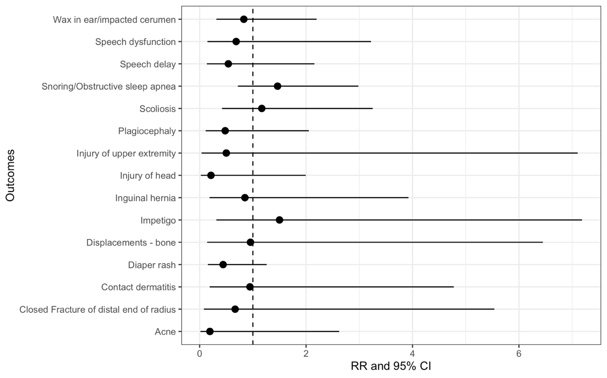
Figure S1. The differential increase related to COVID-19 for prevalence of negative control outcomes among severe COVID-19-positive patients, AAPI vs. NHW.
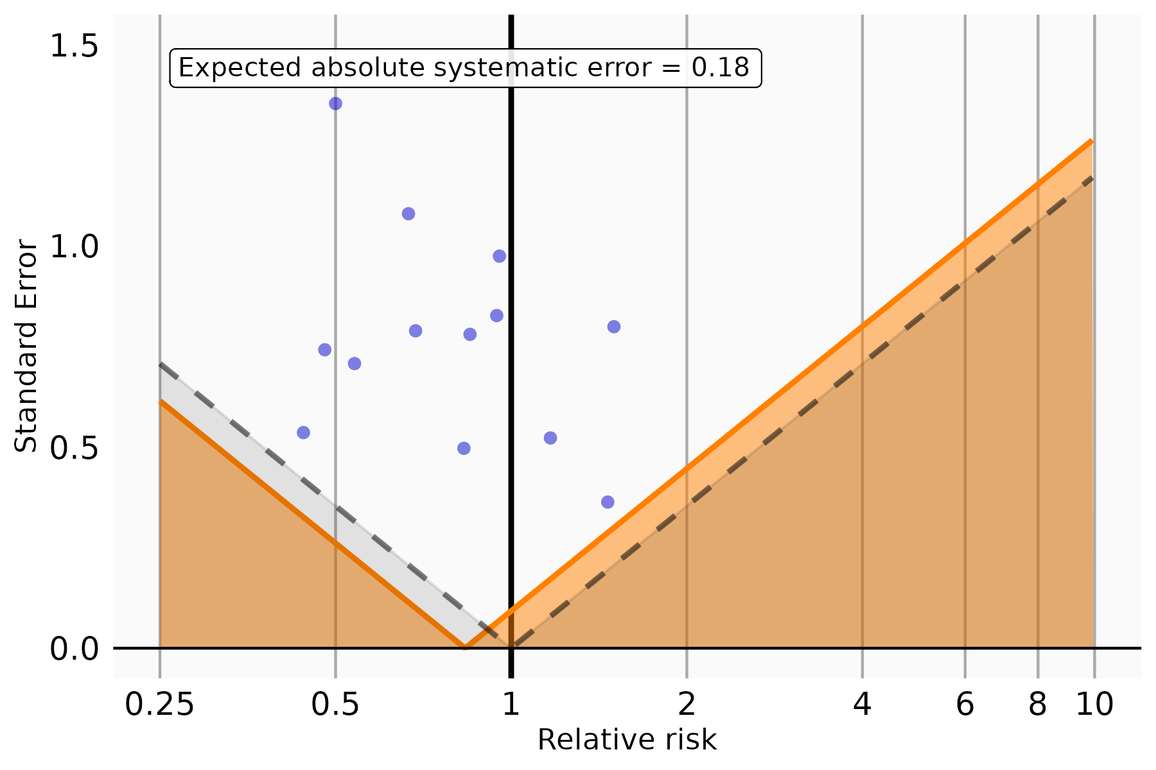
Figure S2. The expected absolute systematic error among severe COVID-19-positive patients, AAPI vs. NHW.
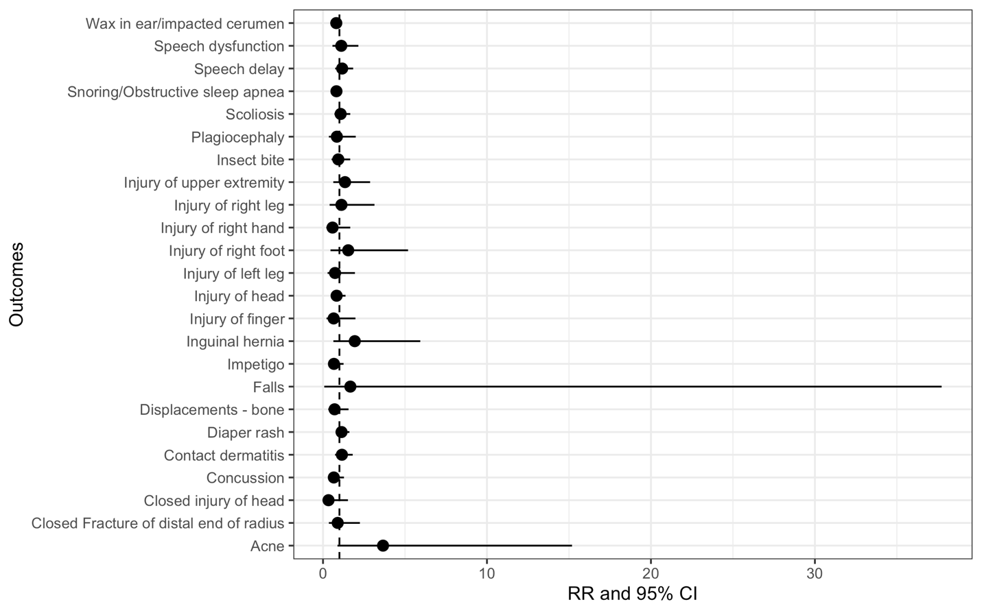
Figure S3. The differential increase related to COVID-19 for prevalence of negative control outcomes among non-severe COVID-19-positive patients, AAPI vs. NHW.
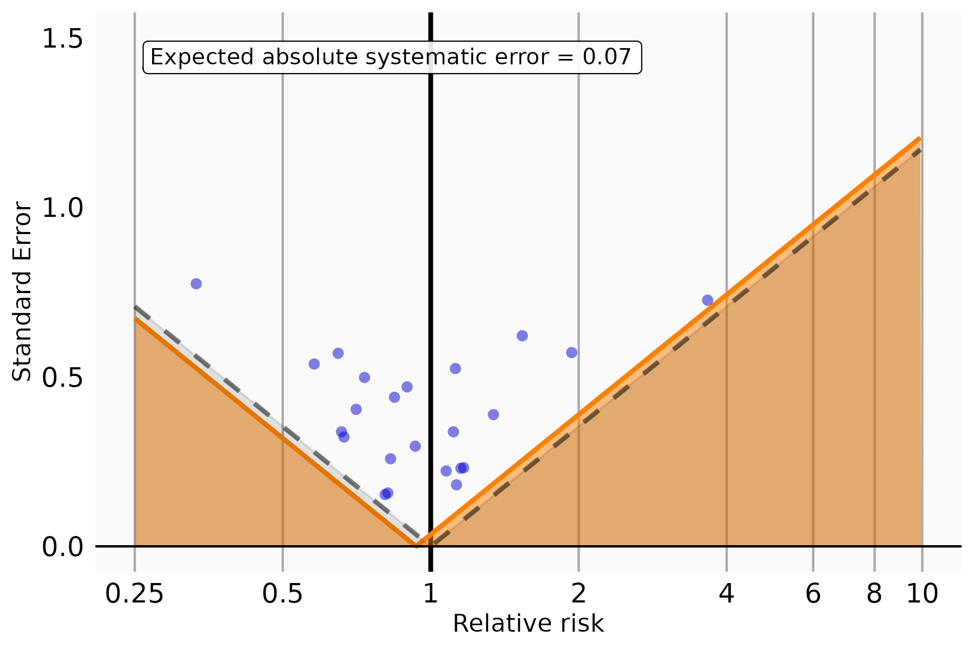
Figure S4. The expected absolute systematic error among non-severe COVID-19-positive patients, AAPI vs. NHW.

B. Hispanic vs. NHW
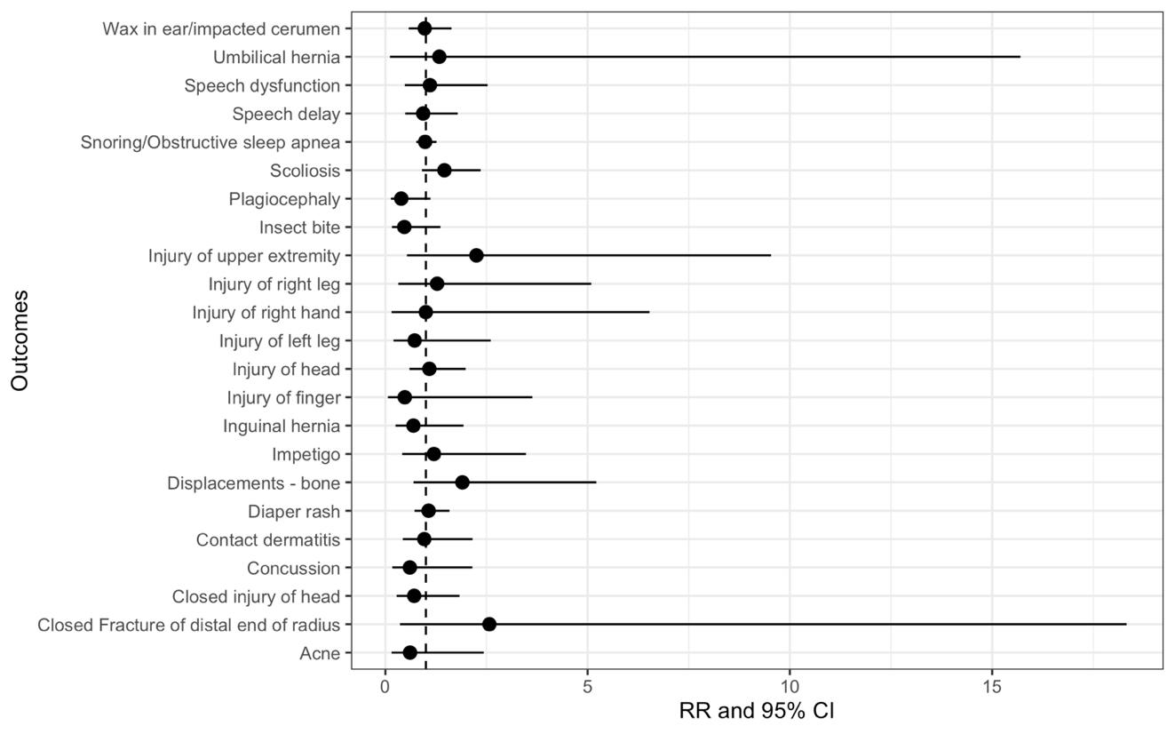
Figure S5. The differential increase related to COVID-19 for prevalence of negative control outcomes among severe COVID-19-positive patients, Hispanic vs. NHW.
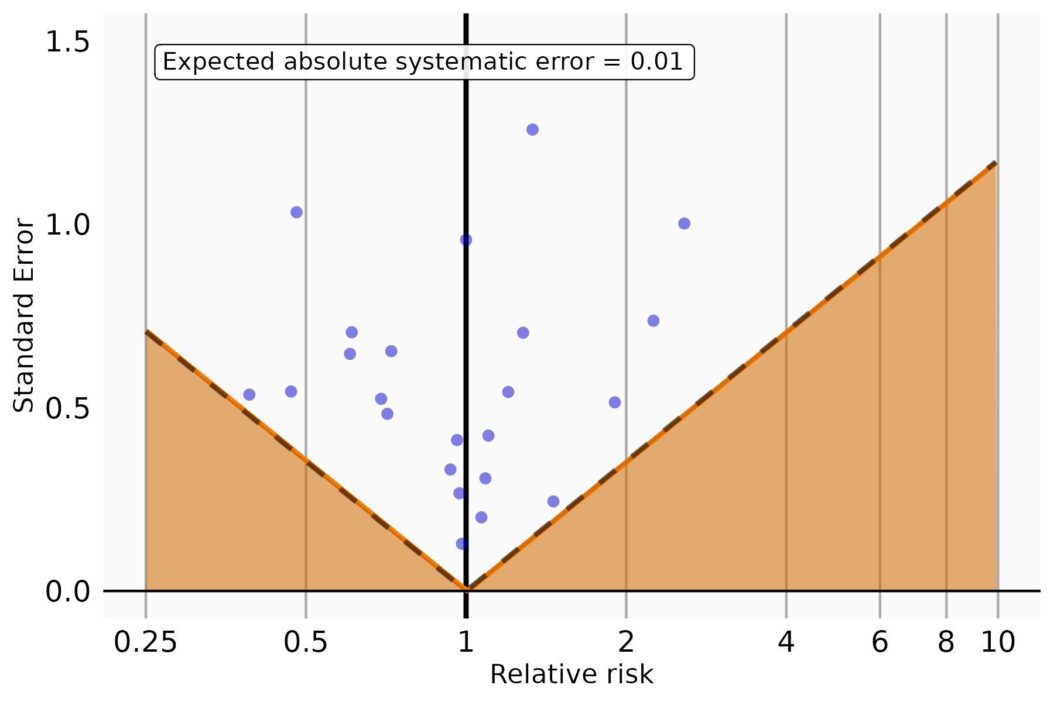
Figure S6. The expected absolute systematic error among severe COVID-19-positive patients, Hispanic vs. NHW.
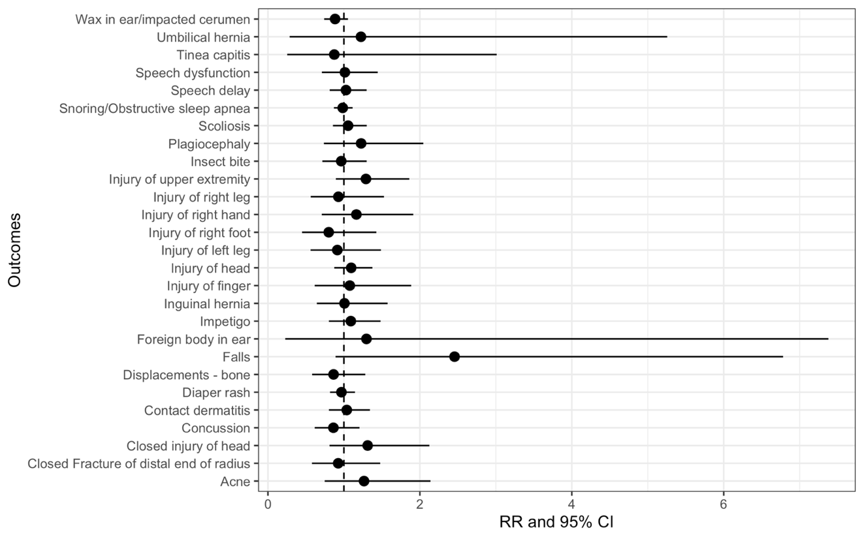
Figure S7. The differential increase related to COVID-19 for prevalence of negative control outcomes among non-severe COVID-19-positive patients, Hispanic vs. NHW.
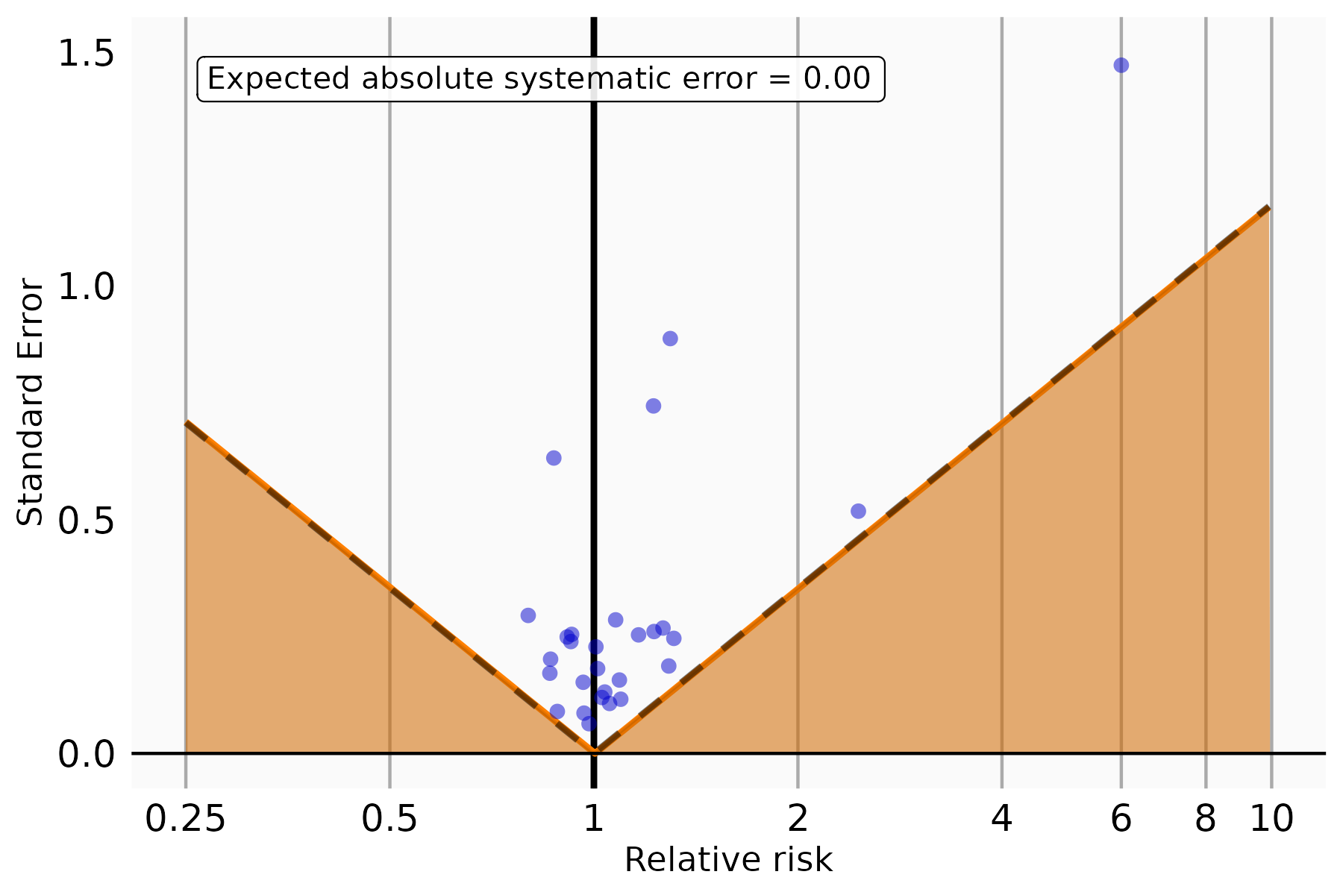
Figure S8. The expected absolute systematic error among non-severe COVID-19-positive patients, Hispanic vs. NHW.

C. NHB vs. NHW
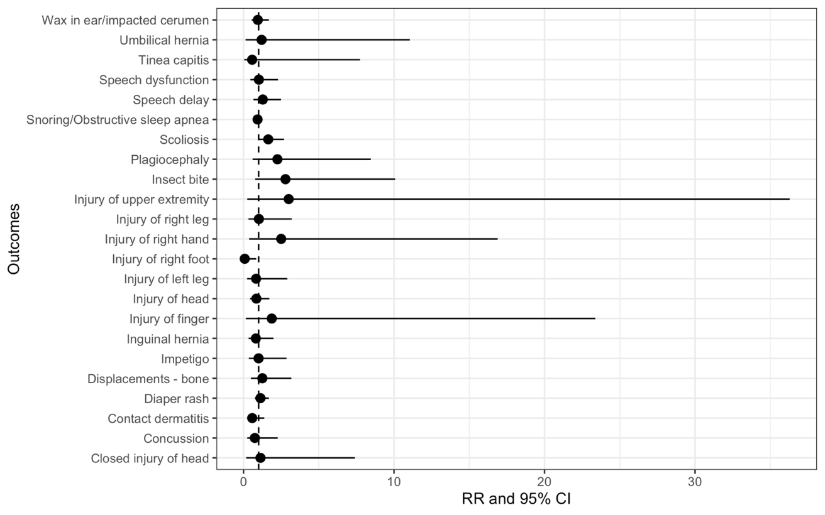
Figure S9. The differential increase related to COVID-19 for prevalence of negative control outcomes among severe COVID-19-positive patients, NHB vs. NHW.
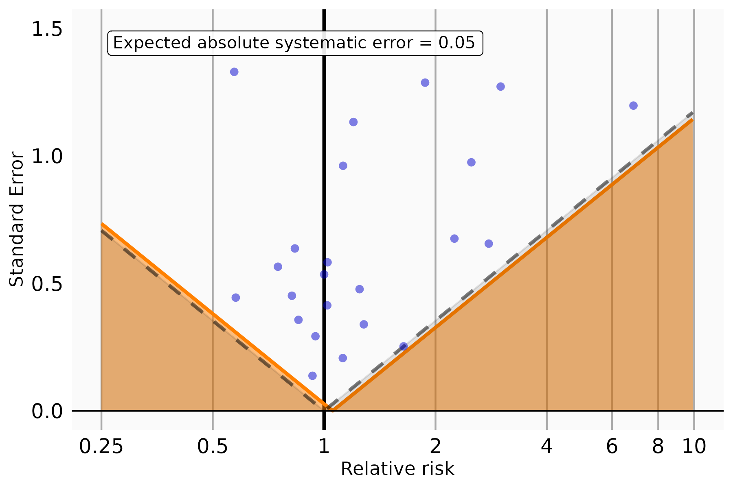
Figure S10. The expected absolute systematic error among severe COVID-19-positive patients, NHB vs. NHW.
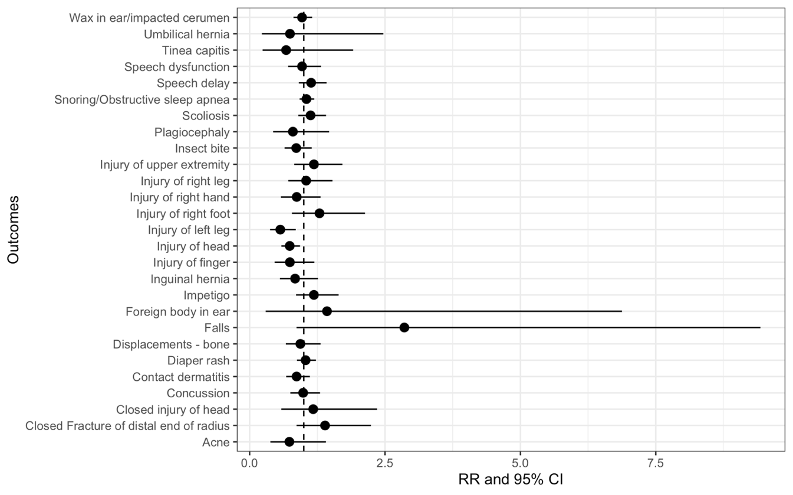
Figure S11. The differential increase related to COVID-19 for prevalence of negative control outcomes among non-severe COVID-19-positive patients, NHB vs. NHW.
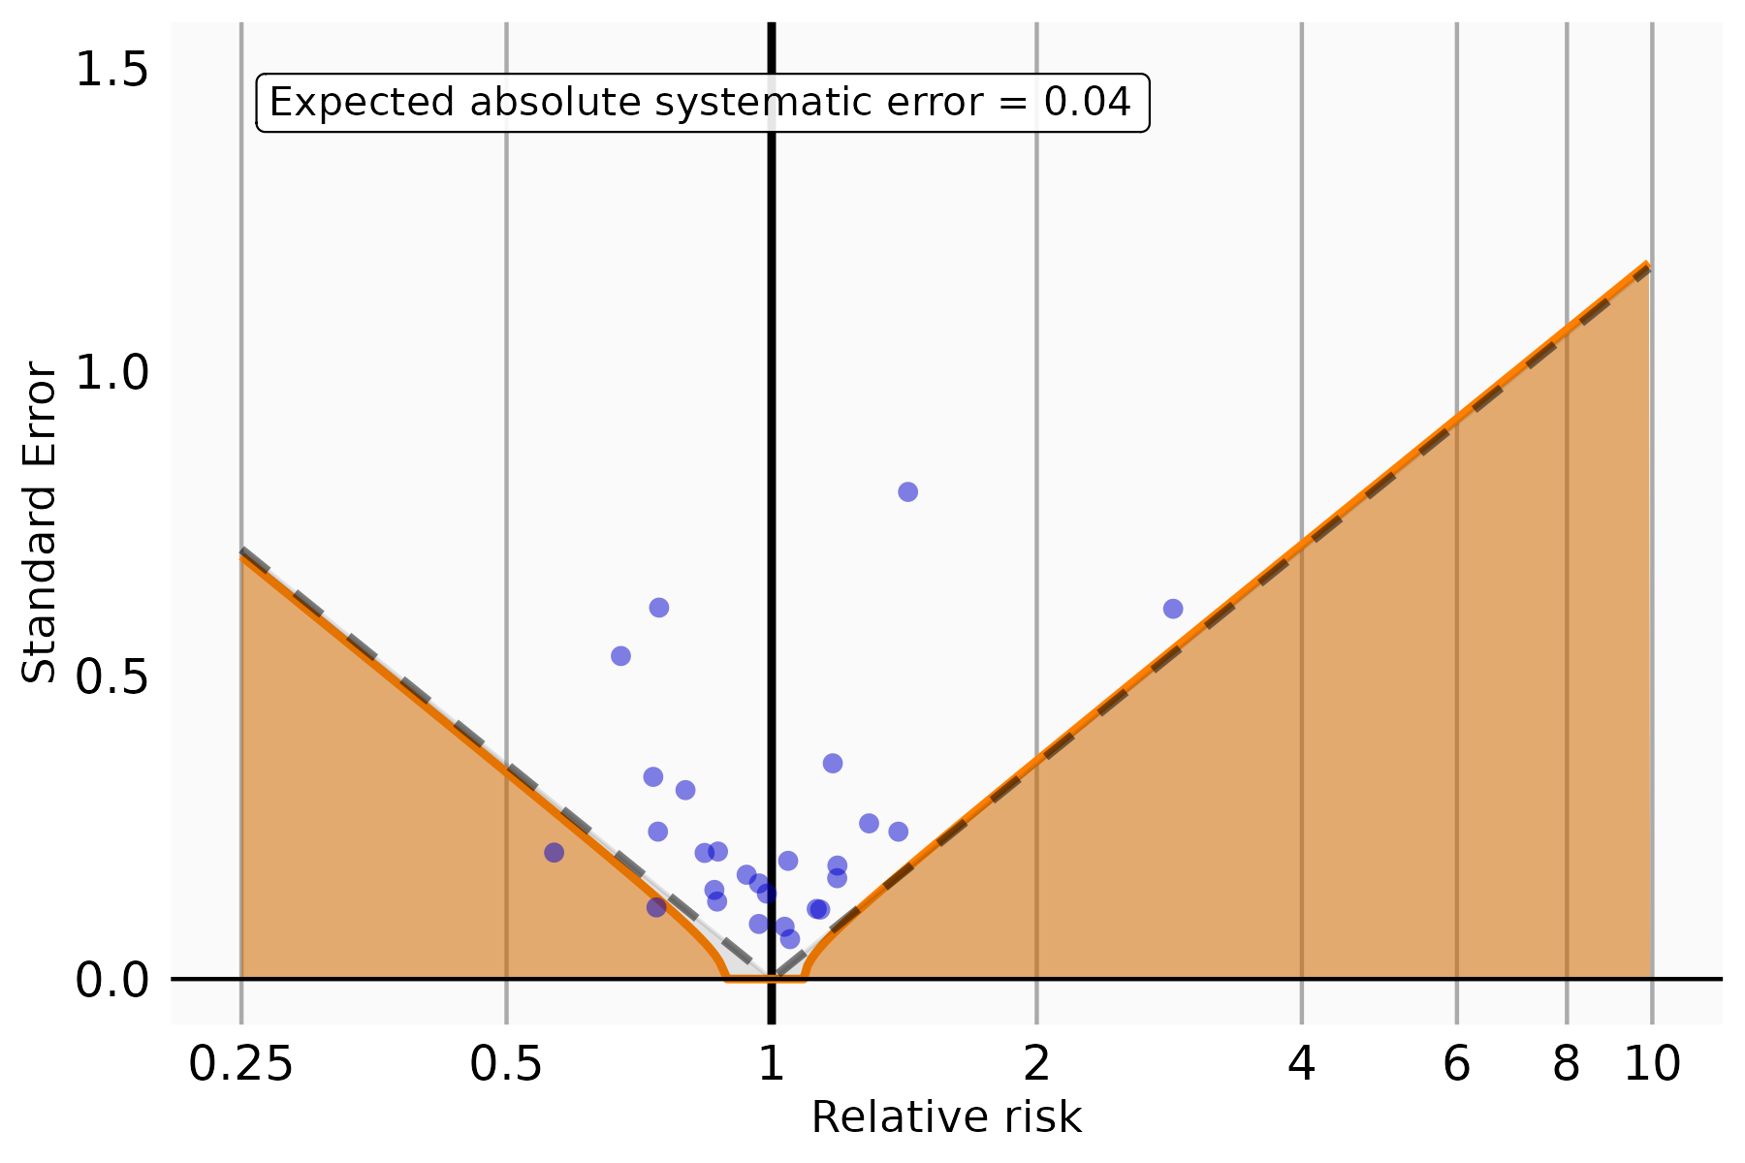
Figure S12. The expected absolute systematic error among non-severe COVID-19-positive patients, NHB vs. NHW.

Section S3 Supplemental Results: sensitivity analysis using standard regression models
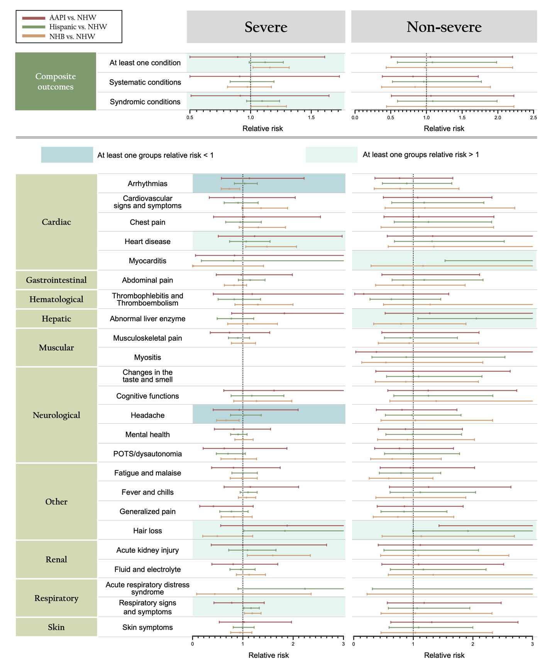
Figure S13. Racial/Ethnic Differences that are attributable to COVID-19 estimated from the difference-in-differences (DiD) analyses for prevalence of potential PASC symptoms and conditions among COVID-19-positive patients using standard regression models, by race/ethnicity and severity status.

Section S4 Supplemental Results: sensitivity analysis for COVID-19 patients with a positive PCR/antigen test only

Table S4. Raw incidence of potential PASC symptoms and conditions comparing COVID-19 positive and negative patients with PCR or antigen test only.

 | COVID-19 positive (%) |  |  | COVID-19 negative (%)
 | All  (N=98,924) | Severe  (N=4,340) | Non-severe  (N=94,584) | All  (N=674,666) | Severe  (N=143,533) | Non-severe  (N=531,133)
At least one condition | 24.93 | 32.3 | 24.68 | 21.4 | 19.79 | 21.79
Systematic conditions | 2.21 | 5.52 | 2.08 | 1.85 | 2.92 | 1.58
Syndromic conditions | 24.4 | 31.62 | 24.15 | 20.79 | 18.76 | 21.31
Abdominal pain | 2.82 | 3.5 | 2.79 | 2.27 | 2.15 | 2.3
Abnormal liver enzyme | 0.24 * | 1.01 | 0.2 | 0.24 * | 0.43 | 0.18
Acute kidney injury | 0.13 | 0.96 | 0.09 | 0.15 | 0.42 | 0.08
Acute respiratory distress syndrome | 0.01 | 0.21 | 0 * | 0.01 | 0.03 | 0.01 *
Arrythmias | 1.15 | 2.93 | 1.07 | 0.94 | 1.56 | 0.78
Cardiovascular signs and symptoms | 1.02 | 1.66 | 0.99 | 0.88 | 0.86 | 0.89
Changes in the taste and smell | 0.13 | 0.09 | 0.13 | 0.04 | 0.02 | 0.05
Chest pain | 1.28 | 1.68 | 1.26 | 0.73 | 0.68 | 0.75
Cognitive functions | 0.67 * | 1.13 | 0.65 | 0.67 * | 0.62 | 0.68
Fatigue and malaise | 1.57 | 2.7 | 1.53 | 1.29 | 1.74 | 1.17
Fever and chills | 5.21 | 9.88 | 5.02 | 3.72 | 3.31 | 3.83
Fluid and electrolyte | 0.37 * | 2.42 | 0.29 | 0.38 * | 0.92 | 0.24
Generalized pain | 1.2 | 1.59 | 1.18 | 0.91 | 1.02 | 0.88
Hair loss | 0.22 | 0.51 | 0.21 | 0.14 | 0.14 | 0.14
Headache | 2.02 | 2.21 | 2.01 | 1.51 | 1.23 | 1.59
Heart disease | 0.26 | 1.25 | 0.22 | 0.28 | 0.62 | 0.19
Mental health | 6.02 | 7.79 | 5.94 | 5.44 | 5.05 | 5.54
Musculoskeletal pain | 3.47 | 3.87 | 3.46 | 2.78 | 2.71 | 2.8
Myocarditis | 0.02 | 0.02 * | 0.02 | 0 | 0.02 * | 0
Myositis | 0.02 | 0.12 | 0.02 | 0.02 | 0.02 | 0.01
POTS/dysautonomia | 0.86 | 0.96 | 0.85 | 0.7 | 0.72 | 0.7
Respiratory signs and symptoms | 8.66 | 15.18 | 8.4 | 7.26 | 6.77 | 7.38
Skin symptoms | 3.35 | 5.1 | 3.28 | 2.68 | 2.66 | 2.69
Thrombophlebitis and thromboembolism | 0.06 | 0.64 | 0.03 | 0.1 | 0.33 | 0.04
Note: * no evidence of statistical significance
Red Symptom: COVID-19 positive higher incidence
Blue Symptom: COVID-19 positive lower incidence

Table S5. Adjusted differential increase related to COVID-19 for prevalence of potential PASC symptoms and conditions among severe COVID-19-positive patients with PCR or antigen test only, by race/ethnicity.
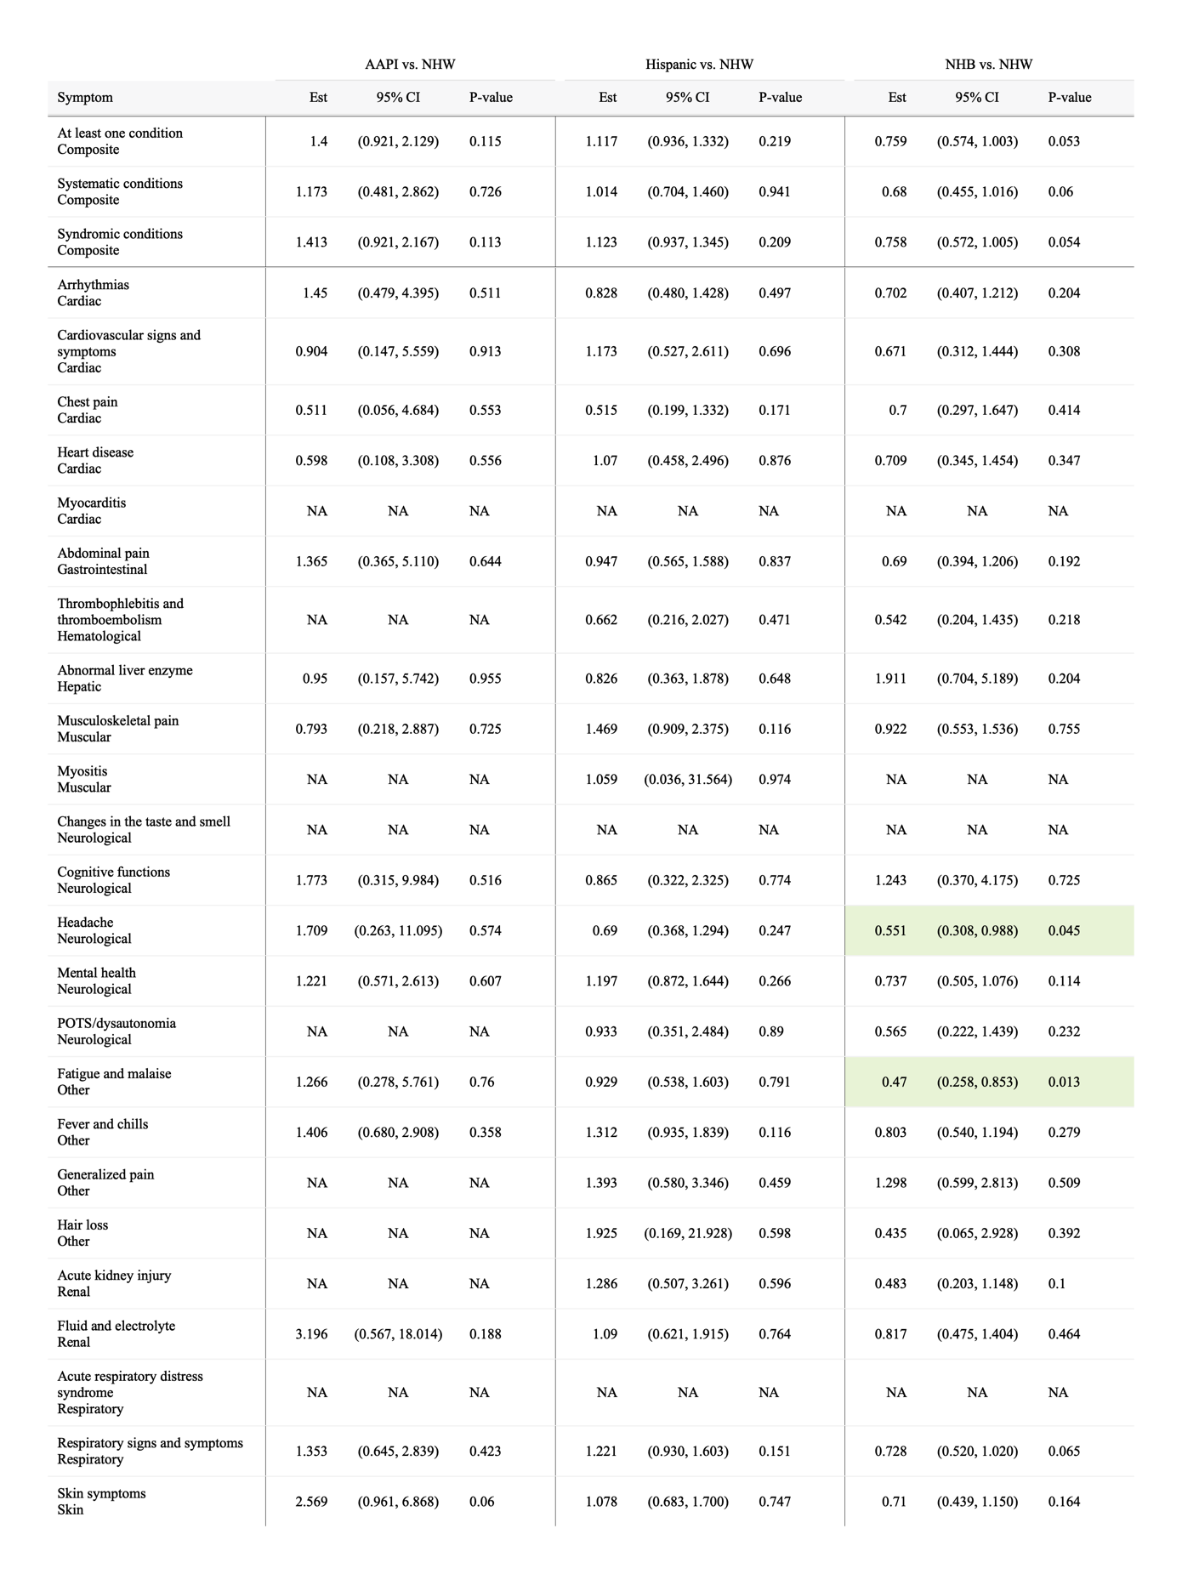
Table S6. Adjusted differential increase related to COVID-19 for prevalence of potential PASC symptoms and conditions among non-severe COVID-19-positive patients with PCR or antigen test only, by race/ethnicity.
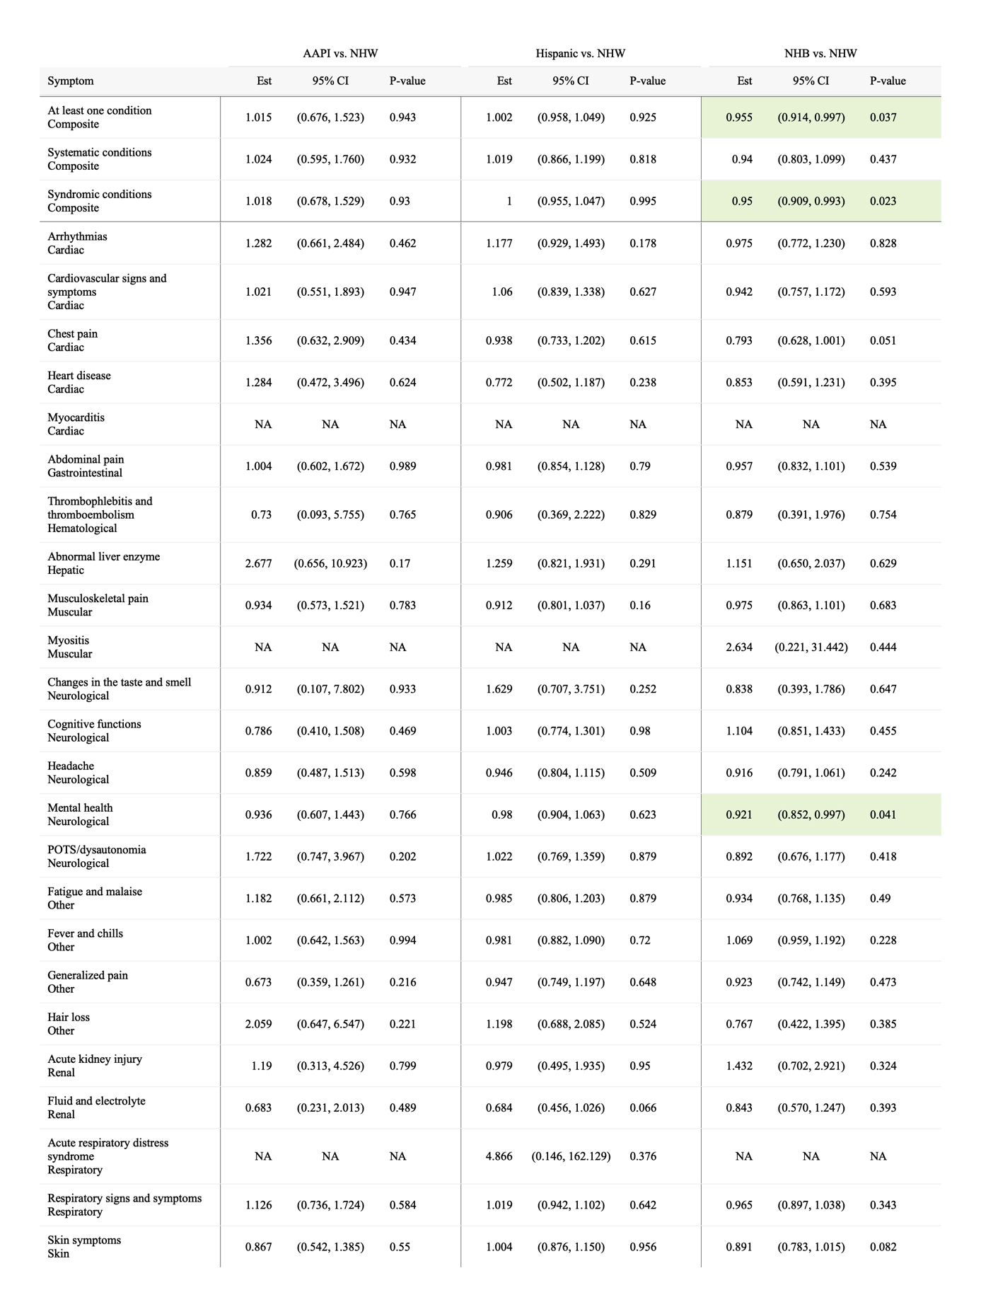

Section S5 Supplemental Results: sensitivity analysis excluding patients in the first wave of the pandemic (March to May 2020)

Table S7. Raw incidence of potential PASC symptoms and conditions comparing COVID-19 positive and negative patients not in the first wave of the pandemic.

 | COVID-19 positive (%) |  |  | COVID-19 negative (%)
 | All  (N=223,459) | Severe  (N=16,544) | Non-severe  (N=206,915) | All  (N=663,183) | Severe  (N=138,504) | Non-severe  (N=524,679)
At least one condition | 26.91 | 34.26 | 26.48 | 21.49 | 19.89 | 21.87
Systematic conditions | 2.68 | 7.39 | 2.36 | 1.86 | 2.91 | 1.6
Syndromic conditions | 26.21 | 32.57 | 25.81 | 20.89 | 18.87 | 21.39
Abdominal pain | 3.04 | 3.64 | 2.99 | 2.28 | 2.16 | 2.31
Abnormal liver enzyme | 0.31 | 1.15 | 0.25 | 0.24 | 0.43 | 0.19
Acute kidney injury | 0.21 | 1.31 | 0.13 | 0.15 | 0.41 | 0.08
Acute respiratory distress syndrome | 0.03 | 0.24 | 0.01 | 0.01 | 0.04 | 0.01
Arrythmias | 1.42 | 4.35 | 1.21 | 0.94 | 1.56 | 0.78
Cardiovascular signs and symptoms | 1.16 | 1.68 | 1.12 | 0.89 | 0.86 | 0.89
Changes in the taste and smell | 0.16 | 0.07 | 0.16 | 0.04 | 0.02 | 0.05
Chest pain | 1.39 | 1.69 | 1.37 | 0.74 | 0.69 | 0.75
Cognitive functions | 0.68 | 0.99 | 0.66 | 0.67 | 0.62 | 0.68
Fatigue and malaise | 1.74 | 3.18 | 1.63 | 1.29 | 1.72 | 1.18
Fever and chills | 5.69 | 9.12 | 5.44 | 3.76 | 3.35 | 3.86
Fluid and electrolyte | 0.55 | 3.27 | 0.35 | 0.38 | 0.9 | 0.24
Generalized pain | 1.26 | 1.77 | 1.22 | 0.9 | 1.01 | 0.88
Hair loss | 0.23 | 0.47 | 0.21 | 0.14 | 0.14 | 0.14
Headache | 2.2 | 2.3 | 2.19 | 1.52 | 1.24 | 1.59
Heart disease | 0.36 | 1.64 | 0.27 | 0.28 | 0.61 | 0.19
Mental health | 6.31 | 8 | 6.19 | 5.44 | 5.06 | 5.54
Musculoskeletal pain | 3.53 | 3.99 | 3.49 | 2.78 | 2.7 | 2.8
Myocarditis | 0.03 | 0.16 | 0.02 | 0.01 | 0.02 | 0
Myositis | 0.02 | 0.07 | 0.02 | 0.02 | 0.02 | 0.01
POTS/dysautonomia | 1.03 | 1.35 | 1.01 | 0.71 | 0.72 | 0.7
Respiratory signs and symptoms | 9.72 | 15.1 | 9.35 | 7.31 | 6.87 | 7.43
Skin symptoms | 3.61 | 5.01 | 3.51 | 2.69 | 2.65 | 2.7
Thrombophlebitis and thromboembolism | 0.13 | 1.01 | 0.06 | 0.1 | 0.32 | 0.04
Note: * no evidence of statistical significance
Red Symptom: COVID-19 positive higher incidence
Blue Symptom: COVID-19 positive lower incidence

Table S8. Adjusted differential increase related to COVID-19 for prevalence of potential PASC symptoms and conditions among severe COVID-19-positive patients not in the first wave of the pandemic, by race/ethnicity.
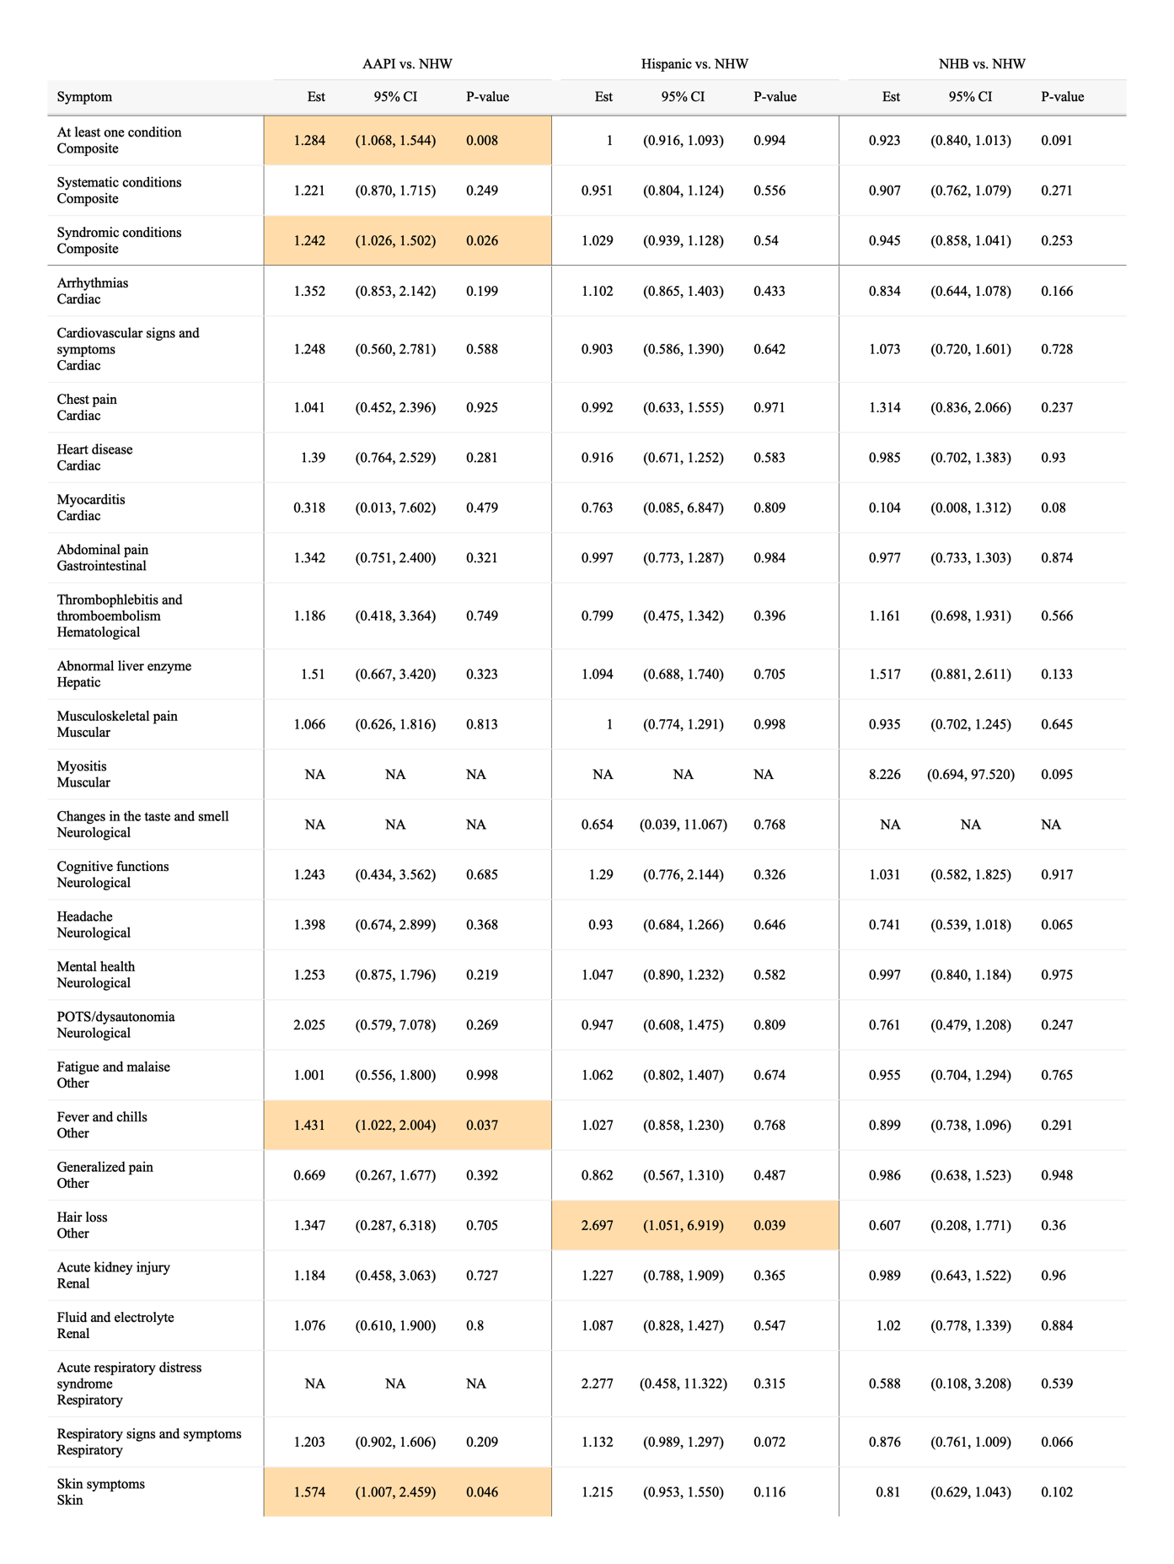
Table S9. Adjusted differential increase related to COVID-19 for prevalence of potential PASC symptoms and conditions among non-severe COVID-19-positive patients not in the first wave of the pandemic, by race/ethnicity.
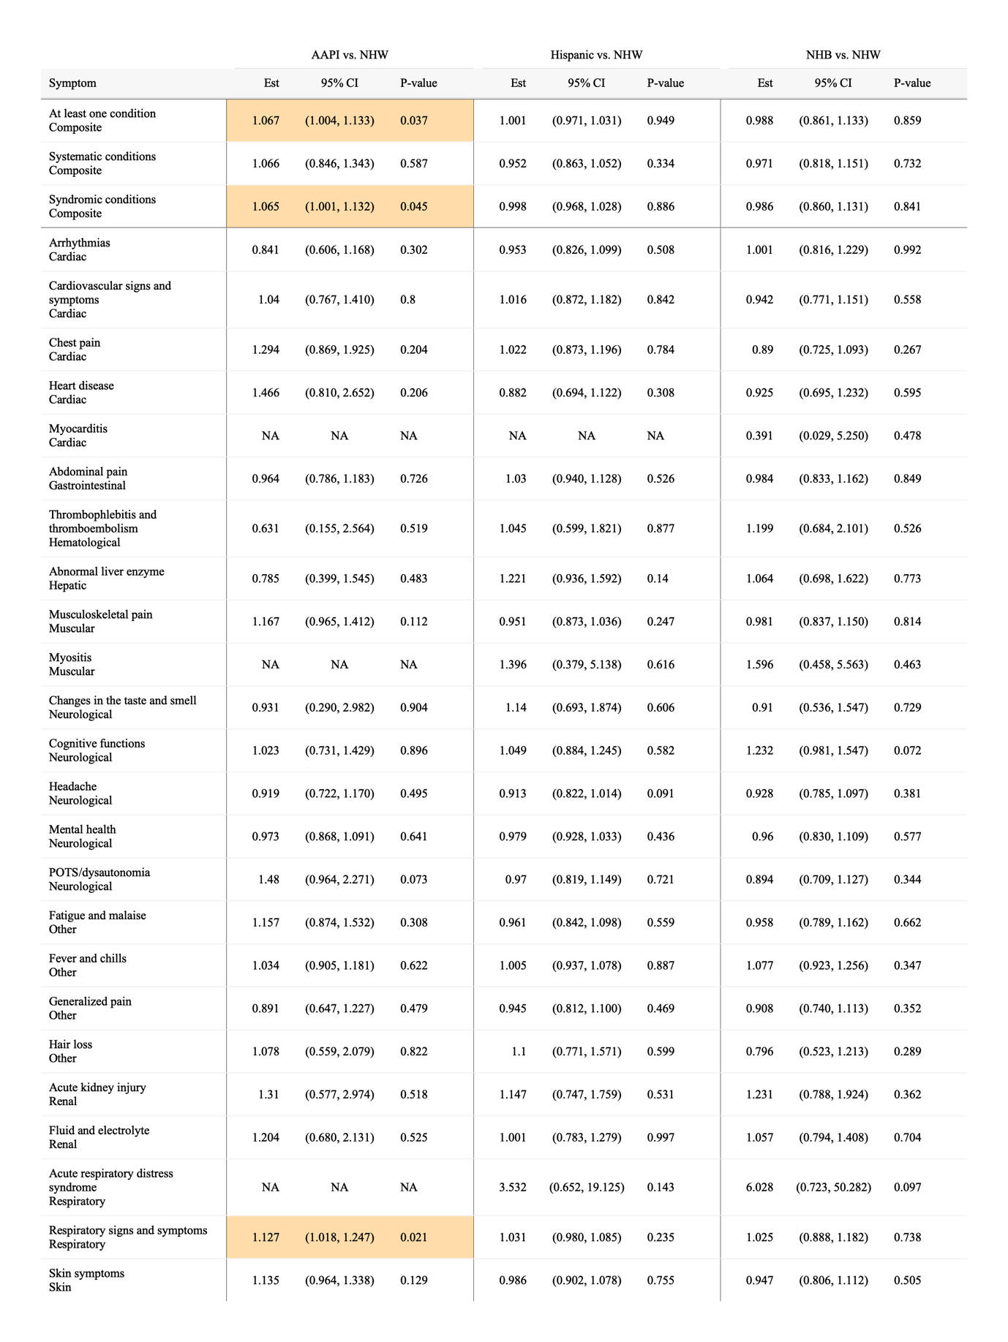

Section S6 Supplemental Results: stratified analysis by age group

A. < 5 years
Table S10. Raw incidence of potential PASC symptoms and conditions comparing COVID-19 positive and negative patients aged <5.

 | COVID-19 positive (%) |  |  | COVID-19 negative (%)
 | All  (N=75,634) | Severe  (N=8,315) | Non-severe  (N=67,319) | All  (N=257,358) | Severe  (N=60,770) | Non-severe  (N=196,588)
At least one condition | 28.92 | 34.27 | 28.39 | 22.28 | 21.39 | 22.55
Systematic conditions | 1.57 | 4.82 | 1.22 | 1.19 | 2.29 | 0.87
Syndromic conditions | 28.61 | 33.41 | 28.11 | 21.89 | 20.59 | 22.28
Abdominal pain | 1.38 | 1.71 | 1.34 | 1.04 | 1.11 | 1.02
Abnormal liver enzyme | 0.23 | 0.85 | 0.16 | 0.16 | 0.31 | 0.11
Acute kidney injury | 0.17 | 0.8 | 0.1 | 0.11 | 0.28 | 0.06
Acute respiratory distress syndrome | 0.04 | 0.23 | 0.01 | 0.02 | 0.04 | 0.01
Arrythmias | 0.99 | 3.16 | 0.75 | 0.7 | 1.29 | 0.52
Cardiovascular signs and symptoms | 1.17 | 1.78 | 1.1 | 0.99 | 1.08 | 0.96
Changes in the taste and smell | 0 * | 0 * | 0 * | 0 * | 0 * | 0 *
Chest pain | 0.18 | 0.24 | 0.18 | 0.1 | 0.11 | 0.1
Cognitive functions | 1.28 | 1.41 | 1.27 | 1.19 | 1.02 | 1.24
Fatigue and malaise | 1.01 | 2.08 | 0.88 | 0.74 | 1.1 | 0.64
Fever and chills | 11.84 | 13.58 | 11.63 | 7.09 | 5.88 | 7.47
Fluid and electrolyte | 0.71 | 2.92 | 0.46 | 0.48 | 0.99 | 0.32
Generalized pain | 0.23 | 0.57 | 0.19 | 0.17 | 0.21 | 0.15
Hair loss | 0.12 | 0.28 | 0.1 | 0.08 | 0.08 | 0.08
Headache | 0.35 | 0.48 | 0.33 | 0.26 | 0.25 | 0.26
Heart disease | 0.33 * | 1.29 | 0.22 * | 0.32 * | 0.68 | 0.21 *
Mental health | 4.52 | 5.58 | 4.39 | 3.99 | 4.13 | 3.94
Musculoskeletal pain | 1.11 | 1.71 | 1.03 | 0.98 | 1 | 0.98
Myocarditis | 0 | 0.01 | 0 | 0 | 0 | 0
Myositis | 0.01 * | 0.04 | 0.01 | 0.01 * | 0.01 | 0.01
POTS/dysautonomia | 0.13 | 0.28 | 0.11 | 0.1 | 0.15 | 0.09
Respiratory signs and symptoms | 14.98 | 19.66 | 14.46 | 11.12 | 10.81 | 11.21
Skin symptoms | 4.82 | 5.19 | 4.77 | 3.37 | 3.14 | 3.44
Thrombophlebitis and thromboembolism | 0.1 * | 0.51 | 0.05 | 0.09 * | 0.26 | 0.04
Note: * no evidence of statistical significance
Red Symptom: COVID-19 positive higher incidence
Blue Symptom: COVID-19 positive lower incidence

Table S11. Adjusted differential increase related to COVID-19 for prevalence of potential PASC symptoms and conditions among severe COVID-19-positive patients aged <5, by race/ethnicity.
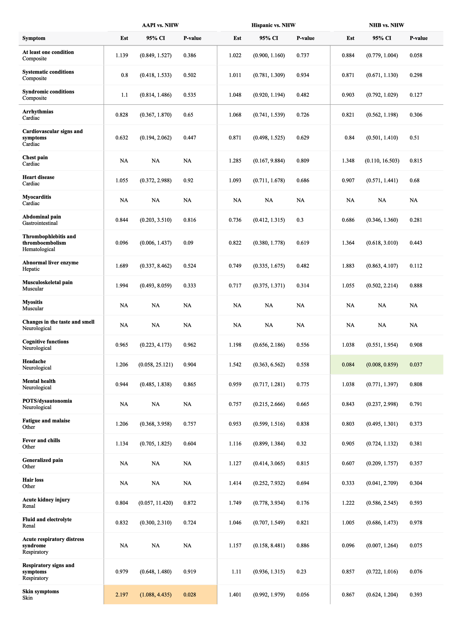
Table S12. Adjusted differential increase related to COVID-19 for prevalence of potential PASC symptoms and conditions among non-severe COVID-19-positive patients aged <5, by race/ethnicity.
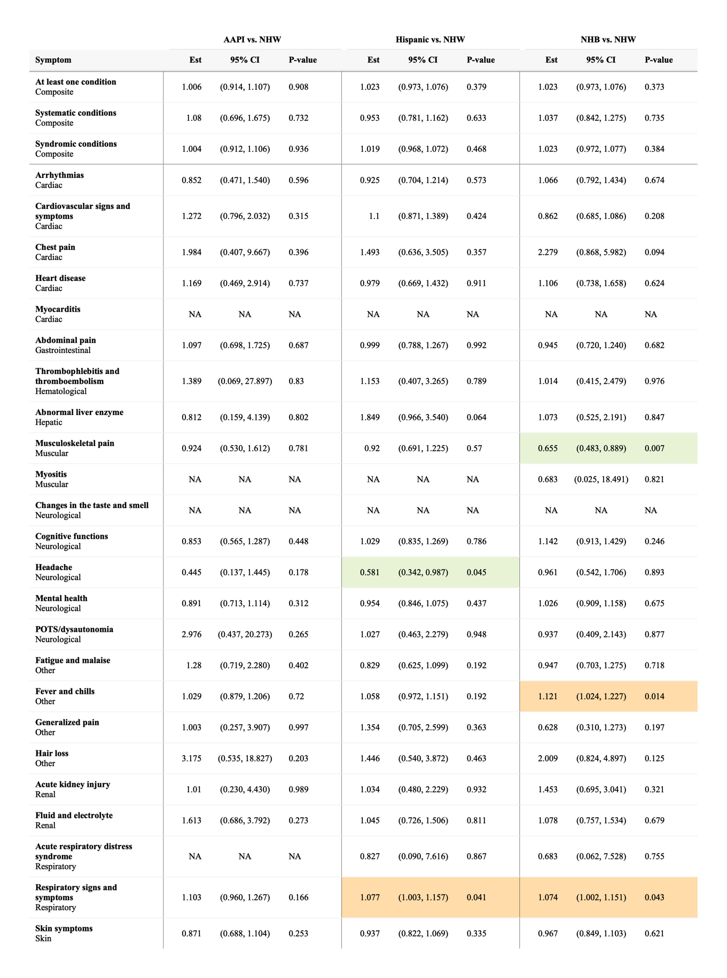

B. 5 to <12 years
Table S13. Raw incidence of potential PASC symptoms and conditions comparing COVID-19 positive and negative patients aged 5 to 12.

 | COVID-19 positive (%) |  |  | COVID-19 negative (%)
 | All  (N=64,301) | Severe  (N=3,367) | Non-severe  (N=60,934) | All  (N=204,795) | Severe  (N=38,374) | Non-severe  (N=166,421)
At least one condition | 24.98 | 30.57 | 24.76 | 19.92 | 16.48 | 20.62
Systematic conditions | 1.9 | 7.84 | 1.64 | 1.33 | 2.28 | 1.12
Syndromic conditions | 24.5 | 29.37 | 24.3 | 19.44 | 15.74 | 20.21
Abdominal pain | 3.8 | 5.48 | 3.72 | 2.77 | 2.44 | 2.84
Abnormal liver enzyme | 0.29 | 1.34 | 0.24 | 0.22 | 0.42 | 0.18
Acute kidney injury | 0.16 | 1.49 | 0.09 | 0.11 | 0.36 | 0.05
Acute respiratory distress syndrome | 0.02 | 0.27 | 0 * | 0.01 | 0.03 | 0 *
Arrythmias | 0.96 | 4.22 | 0.8 | 0.66 | 1.14 | 0.55
Cardiovascular signs and symptoms | 1.17 | 1.77 | 1.13 | 0.81 | 0.66 | 0.84
Changes in the taste and smell | 0.07 | 0.09 | 0.07 | 0.04 | 0.03 | 0.04
Chest pain | 1.35 | 1.89 | 1.32 | 0.75 | 0.72 | 0.76
Cognitive functions | 0.49 | 0.76 | 0.47 | 0.43 | 0.39 | 0.44
Fatigue and malaise | 1.36 | 3.52 | 1.25 | 1.04 | 1.47 | 0.95
Fever and chills | 4.44 | 7.3 | 4.3 | 2.71 | 2.08 | 2.85
Fluid and electrolyte | 0.42 | 3.69 | 0.25 | 0.24 | 0.72 | 0.14
Generalized pain | 1.01 | 1.69 | 0.97 | 0.75 | 0.85 | 0.73
Hair loss | 0.18 | 0.48 | 0.17 | 0.12 | 0.12 | 0.12
Headache | 2.62 | 2.79 | 2.61 | 1.82 | 1.42 | 1.91
Heart disease | 0.28 | 1.8 | 0.2 | 0.19 | 0.43 | 0.13
Mental health | 6.15 | 10.24 | 5.95 | 5.27 | 5.09 | 5.31
Musculoskeletal pain | 3.45 | 4.85 | 3.38 | 2.81 | 2.7 | 2.83
Myocarditis | 0.01 | 0.03 | 0.01 | 0 | 0.01 | 0
Myositis | 0.04 | 0.12 | 0.03 | 0.02 | 0.04 | 0.02
POTS/dysautonomia | 0.67 | 1.23 | 0.64 | 0.48 | 0.56 | 0.46
Respiratory signs and symptoms | 9.06 | 12.13 | 8.91 | 6.56 | 5.23 | 6.85
Skin symptoms | 2.94 | 4.35 | 2.87 | 2.19 | 2.05 | 2.22
Thrombophlebitis and thromboembolism | 0.09 | 1.12 | 0.04 | 0.05 | 0.19 | 0.02
Note: * no evidence of statistical significance
Red Symptom: COVID-19 positive higher incidence
Blue Symptom: COVID-19 positive lower incidence

Table S14. Adjusted differential increase related to COVID-19 for prevalence of potential PASC symptoms and conditions among severe COVID-19-positive patients aged 5 to 12, by race/ethnicity.
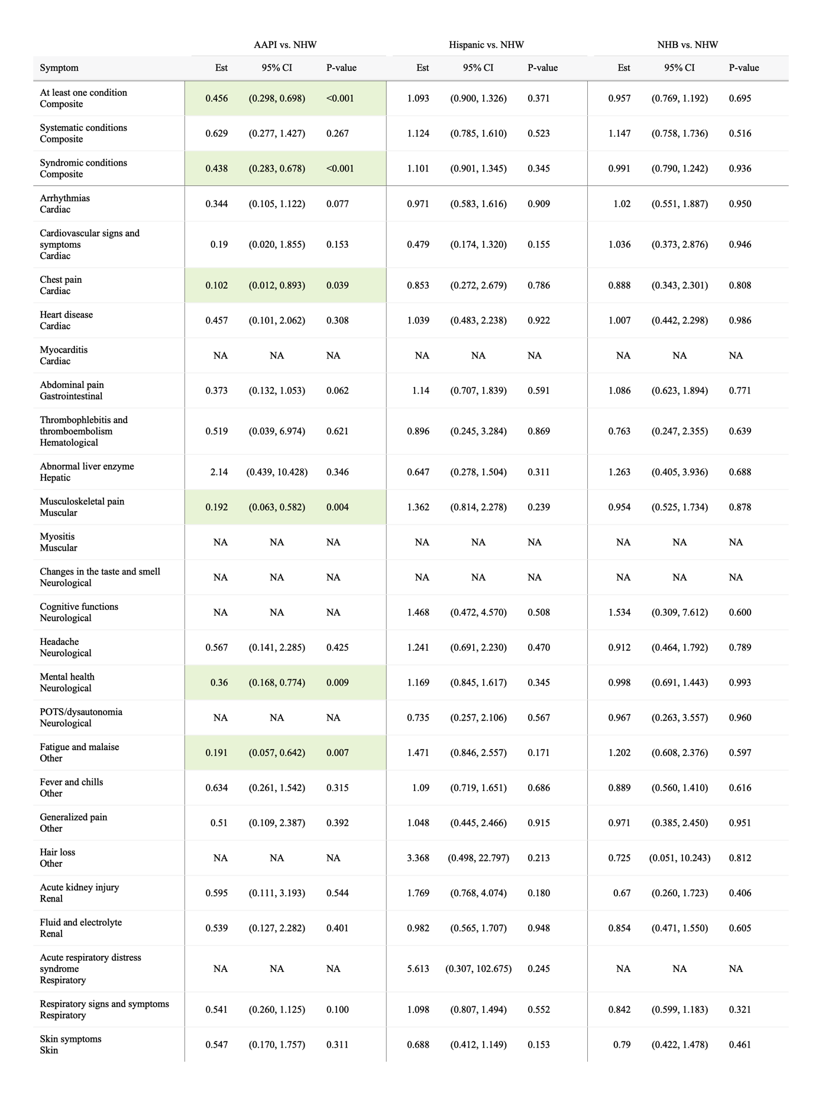
Table S15. Adjusted differential increase related to COVID-19 for prevalence of potential PASC symptoms and conditions among non-severe COVID-19-positive patients aged 5 to 12, by race/ethnicity.
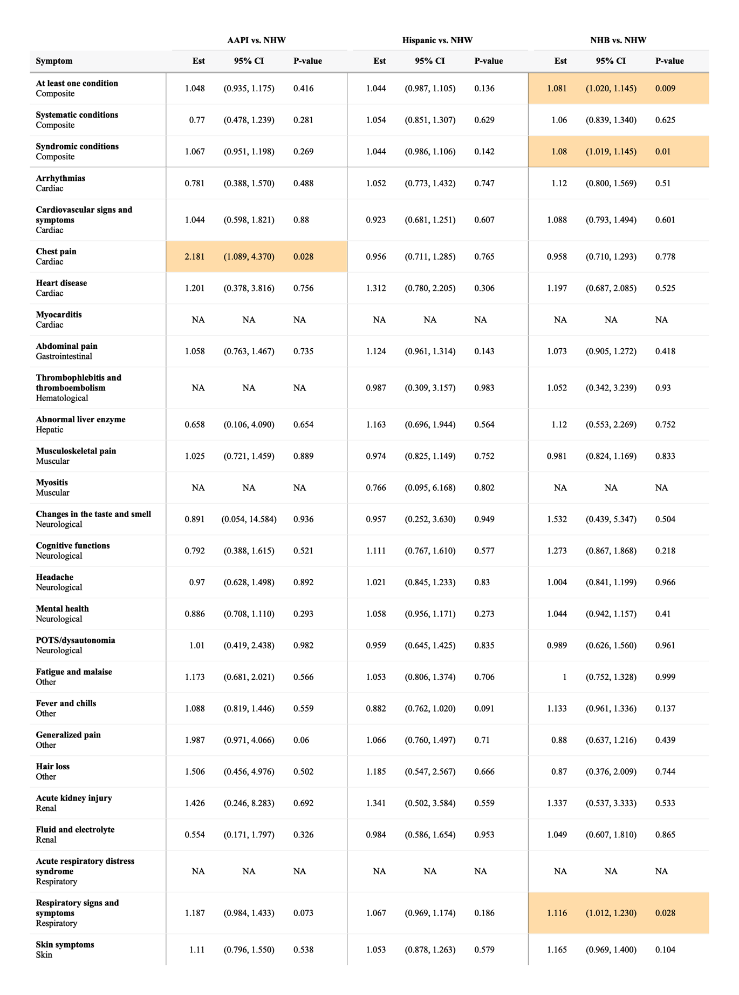

C. 12 to <21 years
Table S16. Raw incidence of potential PASC symptoms and conditions comparing COVID-19 positive and negative patients aged 12 to 21.

 | COVID-19 positive (%) |  |  | COVID-19 negative (%)
 | All  (N=85,788) | Severe  (N=5,180) | Non-severe  (N=80,608) | All  (N=215,295) | Severe  (N=44,448) | Non-severe  (N=170,847)
At least one condition | 26.39 | 36.9 | 25.98 | 21.91 | 20.35 | 22.25
Systematic conditions | 4.35 | 12.17 | 3.96 | 3.29 | 4.47 | 3
Syndromic conditions | 25.11 | 32.84 | 24.79 | 20.83 | 18.54 | 21.35
Abdominal pain | 4.04 | 6.18 | 3.92 | 3.41 | 3.52 | 3.38
Abnormal liver enzyme | 0.41 | 1.58 | 0.34 | 0.35 | 0.61 | 0.29
Acute kidney injury | 0.29 | 2.05 | 0.18 | 0.25 | 0.67 | 0.14
Acute respiratory distress syndrome | 0.03 | 0.23 | 0.01 | 0.01 | 0.03 | 0
Arrythmias | 2.17 | 6.7 | 1.92 | 1.54 | 2.33 | 1.35
Cardiovascular signs and symptoms | 1.15 | 1.51 | 1.13 | 0.83 | 0.72 | 0.86
Changes in the taste and smell | 0.36 | 0.21 | 0.37 | 0.1 | 0.05 | 0.11
Chest pain | 2.55 | 4.16 | 2.45 | 1.52 | 1.48 | 1.53
Cognitive functions | 0.31 | 0.51 | 0.3 | 0.27 | 0.29 | 0.27
Fatigue and malaise | 2.7 | 4.99 | 2.57 | 2.25 | 2.92 | 2.08
Fever and chills | 2.04 | 4.1 | 1.92 | 1.12 | 1.14 | 1.11
Fluid and electrolyte | 0.54 | 3.76 | 0.35 | 0.41 | 1 | 0.26
Generalized pain | 2.42 | 4.01 | 2.33 | 2.01 | 2.39 | 1.92
Hair loss | 0.38 | 0.82 | 0.35 | 0.23 | 0.26 | 0.22
Headache | 3.68 | 5.61 | 3.57 | 2.86 | 2.52 | 2.94
Heart disease | 0.47 | 2.21 | 0.36 | 0.34 | 0.7 | 0.24
Mental health | 8.39 | 11.94 | 8.2 | 7.74 | 6.48 | 8.08
Musculoskeletal pain | 6.14 | 8.19 | 6.02 | 5.3 | 5.68 | 5.21
Myocarditis | 0.07 | 0.5 | 0.04 | 0.02 | 0.06 | 0.01
Myositis | 0.03 | 0.12 | 0.02 | 0.02 | 0.03 | 0.02
POTS/dysautonomia | 2.15 | 3.28 | 2.08 | 1.69 | 1.68 | 1.69
Respiratory signs and symptoms | 6.32 | 10.53 | 6.08 | 3.91 | 3.3 | 4.07
Skin symptoms | 3.11 | 5.09 | 2.99 | 2.4 | 2.54 | 2.36
Thrombophlebitis and thromboembolism | 0.19 | 1.8 | 0.09 | 0.17 | 0.54 | 0.08
Note: * no evidence of statistical significance
Red Symptom: COVID-19 positive higher incidence
Blue Symptom: COVID-19 positive lower incidence

Table S17. Adjusted differential increase related to COVID-19 for prevalence of potential PASC symptoms and conditions among severe COVID-19-positive patients aged 12 to 20, by race/ethnicity.
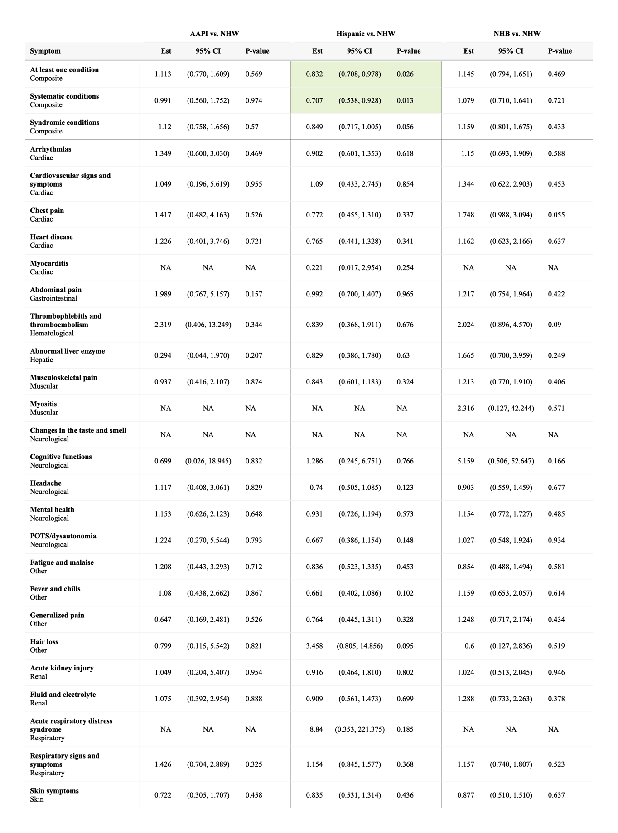
Table S18. Adjusted differential increase related to COVID-19 for prevalence of potential PASC symptoms and conditions among non-severe COVID-19-positive patients aged 12 to 20, by race/ethnicity.
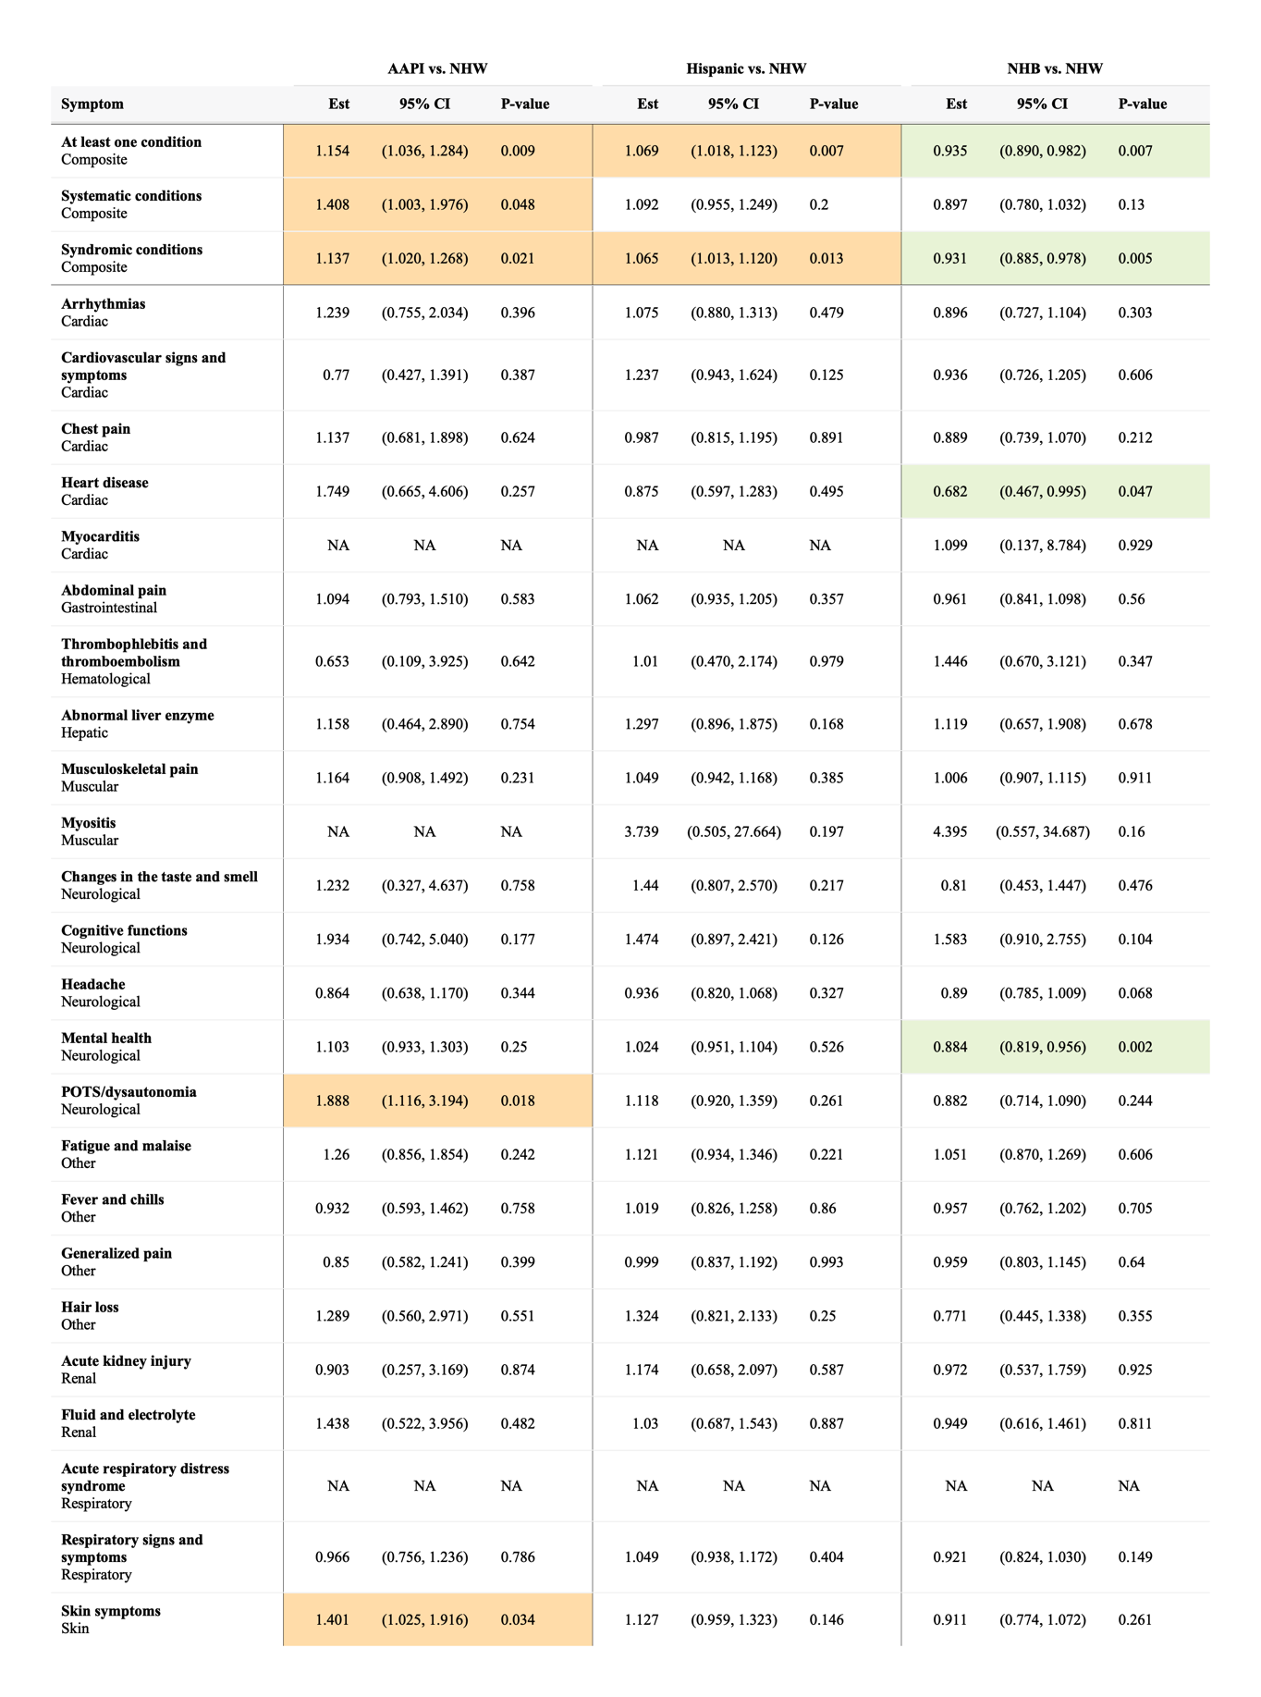

Section S7 Supplemental Results: stratified analysis by virus variant period

A. Pre-Delta variant period
Table S19. Raw incidence of potential PASC symptoms and conditions comparing COVID-19 positive and negative patients during the pre-Delta variant period.

 | COVID-19 positive (%) |  |  | COVID-19 negative (%)
 | All  (N=66,774) | Severe  (N=3,540) | Non-severe  (N=63,234) | All  (N=275,553) | Severe  (N=65,164) | Non-severe  (N=210,389)
At least one condition | 23.14 | 31.09 | 22.84 | 18.73 | 16.92 | 19.25
Systematic conditions | 2.82 | 9.74 | 2.52 | 1.9 | 2.79 | 1.65
Syndromic conditions | 22.36 | 29.03 | 22.09 | 18.09 | 15.87 | 18.73
Abdominal pain | 2.83 | 4.11 | 2.77 | 2.1 | 2.07 | 2.12
Abnormal liver enzyme | 0.41 | 1.63 | 0.35 | 0.27 | 0.46 | 0.21
Acute kidney injury | 0.2 | 1.57 | 0.12 | 0.17 | 0.43 | 0.09
Acute respiratory distress syndrome | 0.03 | 0.23 | 0.02 | 0.01 | 0.03 | 0
Arrythmias | 1.56 | 5.77 | 1.36 | 0.99 | 1.52 | 0.83
Cardiovascular signs and symptoms | 1.11 | 2.04 | 1.06 | 0.76 | 0.76 | 0.76
Changes in the taste and smell | 0.31 | 0.23 | 0.32 | 0.07 | 0.03 | 0.08
Chest pain | 1.64 | 2.56 | 1.59 | 0.73 | 0.69 | 0.75
Cognitive functions | 0.55 | 0.83 | 0.53 | 0.59 | 0.55 | 0.6
Fatigue and malaise | 1.82 | 3.73 | 1.72 | 1.46 | 1.93 | 1.31
Fever and chills | 3.17 | 6.86 | 2.99 | 2.38 | 1.99 | 2.51
Fluid and electrolyte | 0.51 | 4.08 | 0.33 | 0.39 | 0.86 | 0.25
Generalized pain | 1.42 | 2.48 | 1.36 | 1.01 | 1.14 | 0.97
Hair loss | 0.27 | 0.68 | 0.25 | 0.13 | 0.14 | 0.12
Headache | 2.3 | 3.61 | 2.23 | 1.53 | 1.28 | 1.61
Heart disease | 0.41 | 2.01 | 0.33 | 0.31 | 0.6 | 0.22
Mental health | 6.48 | 9.73 | 6.32 | 5.62 | 5.38 | 5.7
Musculoskeletal pain | 4 | 5.51 | 3.92 | 3.03 | 3.03 | 3.03
Myocarditis | 0.04 | 0.17 | 0.04 | 0.01 | 0.02 | 0
Myositis | 0.02 | 0.11 | 0.01 * | 0.01 | 0.02 | 0.01 *
POTS/dysautonomia | 1.09 | 1.96 | 1.04 | 0.73 | 0.71 | 0.73
Respiratory signs and symptoms | 6.72 | 12.55 | 6.45 | 5.13 | 4.32 | 5.37
Skin symptoms | 3.3 | 5.06 | 3.21 | 2.46 | 2.41 | 2.48
Thrombophlebitis and thromboembolism | 0.15 | 1.49 | 0.07 | 0.13 | 0.33 | 0.06
Note: * no evidence of statistical significance
Red Symptom: COVID-19 positive higher incidence
Blue Symptom: COVID-19 positive lower incidence

Table S20. Adjusted differential increase related to COVID-19 for prevalence of potential PASC symptoms and conditions among severe COVID-19-positive patients during the pre-Delta period, by race/ethnicity.
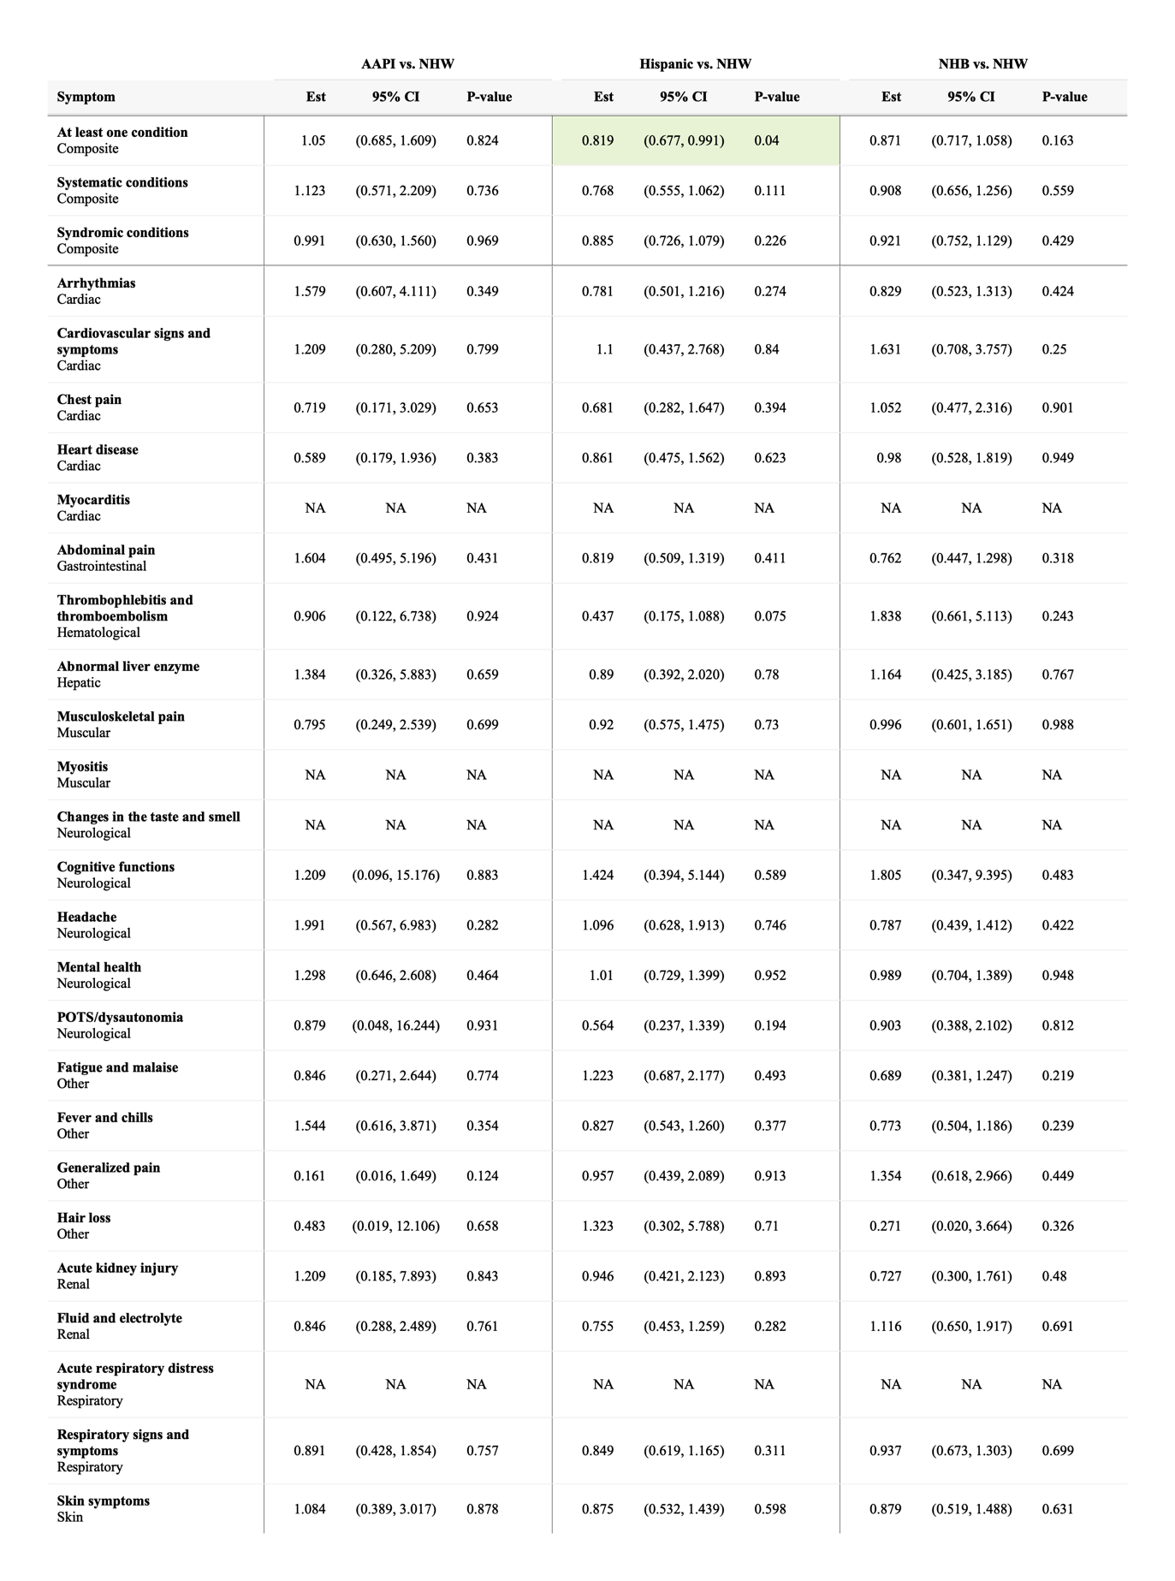
Table S21. Adjusted differential increase related to COVID-19 for prevalence of potential PASC symptoms and conditions among non-severe COVID-19-positive patients during the pre-Delta period, by race/ethnicity.
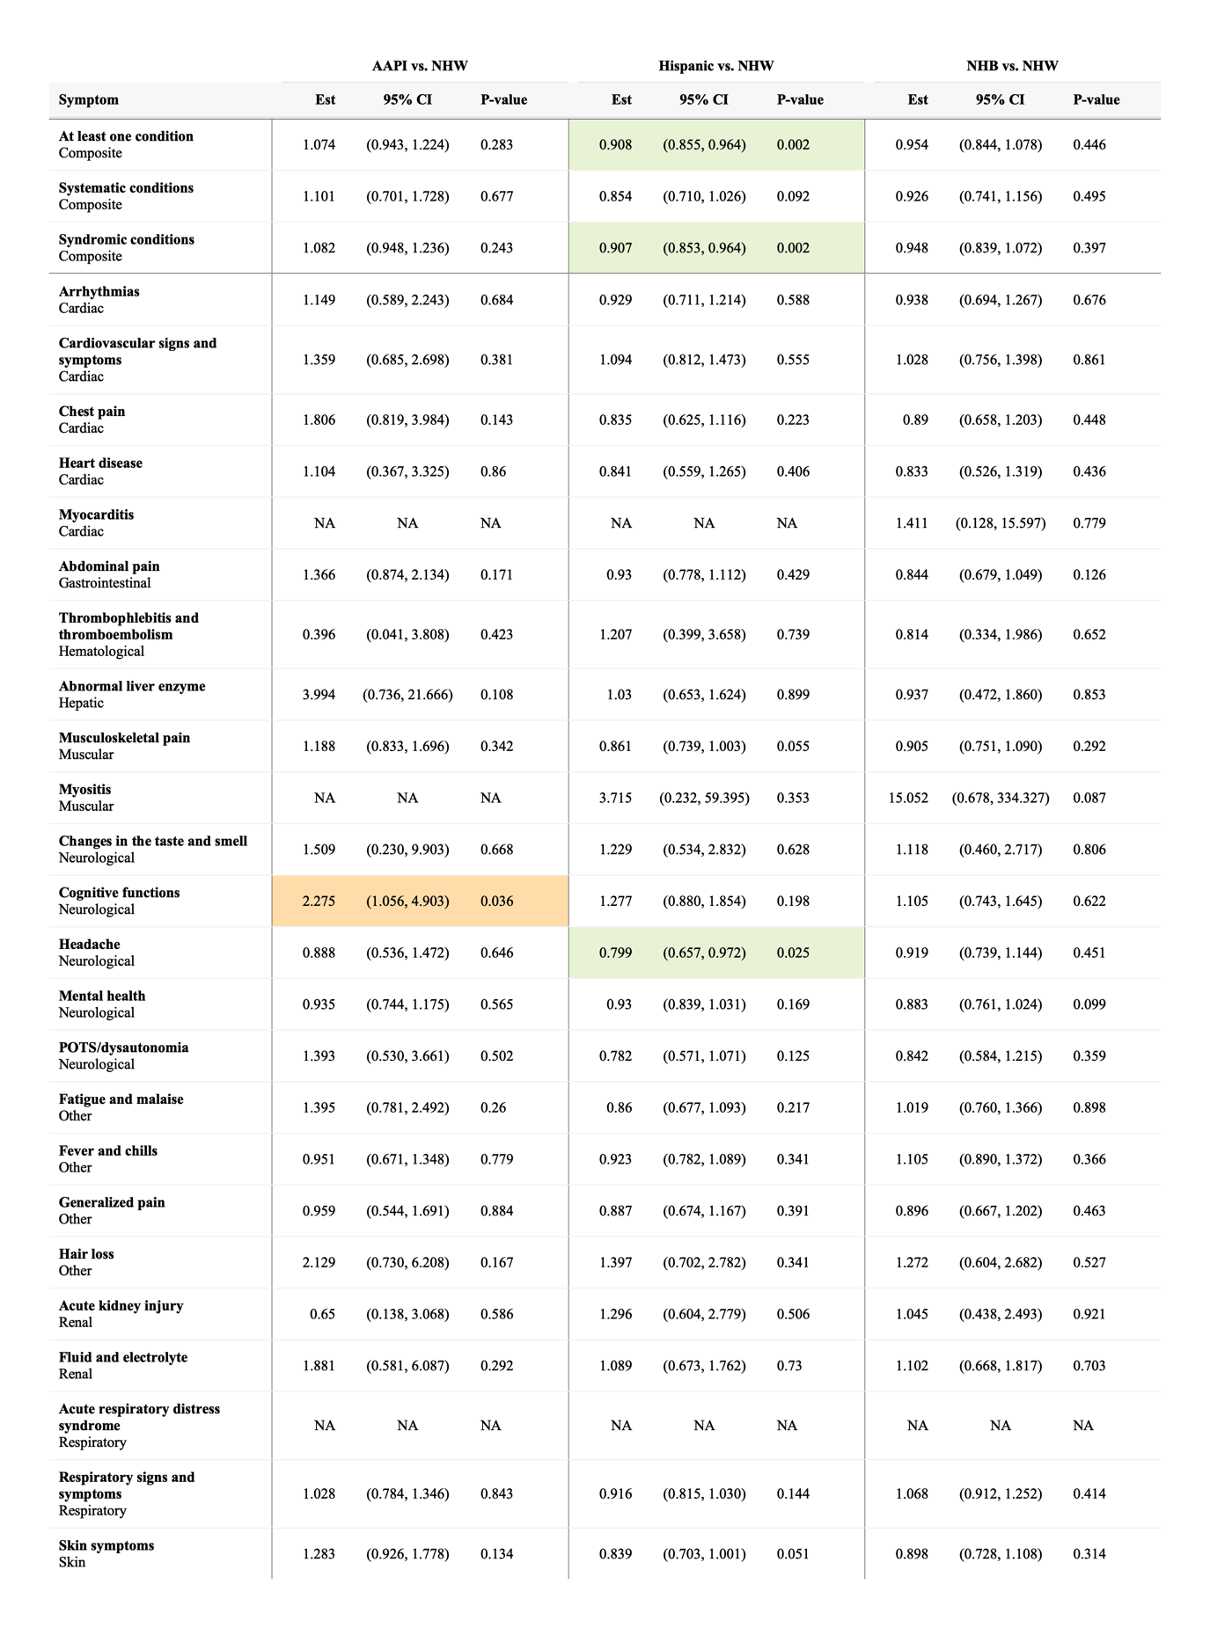

B. Delta variant period
Table S22. Raw incidence of potential PASC symptoms and conditions comparing COVID-19 positive and negative patients during the Delta variant period.

 | COVID-19 positive (%) |  |  | COVID-19 negative (%)
 | All  (N=36,414) | Severe  (N=2,489) | Non-severe  (N=33,925) | All  (N=159,361) | Severe  (N=27,147) | Non-severe  (N=132,214)
At least one condition | 27.07 | 34.4 | 26.66 | 21.07 | 20.12 | 21.25
Systematic conditions | 2.61 | 7.64 | 2.3 | 1.61 | 2.63 | 1.41
Syndromic conditions | 26.36 | 31.62 | 26.05 | 20.59 | 19.24 | 20.84
Abdominal pain | 3.38 | 3.82 | 3.35 | 2.32 | 1.99 | 2.39
Abnormal liver enzyme | 0.27 | 1.08 | 0.21 | 0.19 | 0.33 | 0.16
Acute kidney injury | 0.25 | 1.71 | 0.14 | 0.1 | 0.34 | 0.05
Acute respiratory distress syndrome | 0.03 | 0.36 | 0.01 * | 0.01 | 0.04 | 0.01 *
Arrythmias | 1.33 | 4.22 | 1.13 | 0.75 | 1.29 | 0.65
Cardiovascular signs and symptoms | 1.1 | 1.57 | 1.06 | 0.87 | 0.91 | 0.87
Changes in the taste and smell | 0.21 | 0.04 * | 0.22 | 0.04 | 0.03 * | 0.04
Chest pain | 1.58 | 2.27 | 1.53 | 0.74 | 0.64 | 0.76
Cognitive functions | 0.6 | 0.78 | 0.59 | 0.66 | 0.65 | 0.67
Fatigue and malaise | 1.82 | 3.32 | 1.72 | 1.14 | 1.44 | 1.08
Fever and chills | 5.11 | 7.45 | 4.95 | 3.41 | 3.45 | 3.4
Fluid and electrolyte | 0.58 | 3.37 | 0.39 | 0.3 | 0.83 | 0.19
Generalized pain | 1.37 | 1.85 | 1.33 | 0.81 | 0.81 | 0.81
Hair loss | 0.3 | 0.53 | 0.28 | 0.12 | 0.12 | 0.12
Headache | 2.62 | 2.19 | 2.65 | 1.58 | 1.07 | 1.69
Heart disease | 0.35 | 1.49 | 0.27 | 0.23 | 0.55 | 0.16
Mental health | 6.53 | 7.71 | 6.45 | 5.36 | 4.64 | 5.51
Musculoskeletal pain | 3.77 | 5.1 | 3.67 | 2.66 | 2.45 | 2.7
Myocarditis | 0.02 | 0.2 | 0.01 | 0.01 | 0.02 | 0
Myositis | 0.02 | 0.08 | 0.02 | 0.01 | 0.02 | 0.01
POTS/dysautonomia | 1.01 | 1.44 | 0.98 | 0.66 | 0.66 | 0.66
Respiratory signs and symptoms | 10.46 | 14.5 | 10.19 | 7.68 | 7.8 | 7.66
Skin symptoms | 2.89 | 4.5 | 2.78 | 2.4 | 2.55 | 2.36
Thrombophlebitis and thromboembolism | 0.11 | 1.11 | 0.04 | 0.07 | 0.27 | 0.03
Note: * no evidence of statistical significance
Red Symptom: COVID-19 positive higher incidence
Blue Symptom: COVID-19 positive lower incidence

Table S23. Adjusted differential increase related to COVID-19 for prevalence of potential PASC symptoms and conditions among severe COVID-19-positive patients during the Delta period, by race/ethnicity.
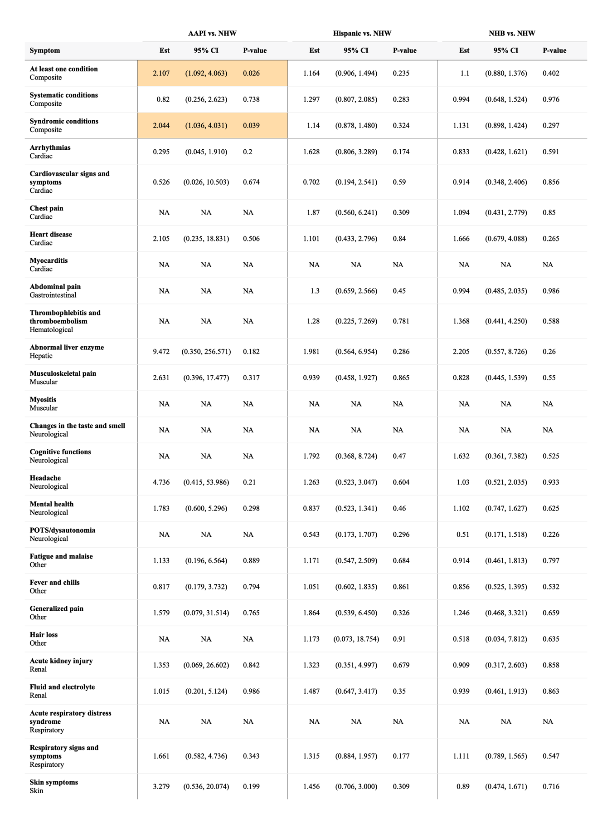
Table S24. Adjusted differential increase related to COVID-19 for prevalence of potential PASC symptoms and conditions among non-severe COVID-19-positive patients during the Delta period, by race/ethnicity.
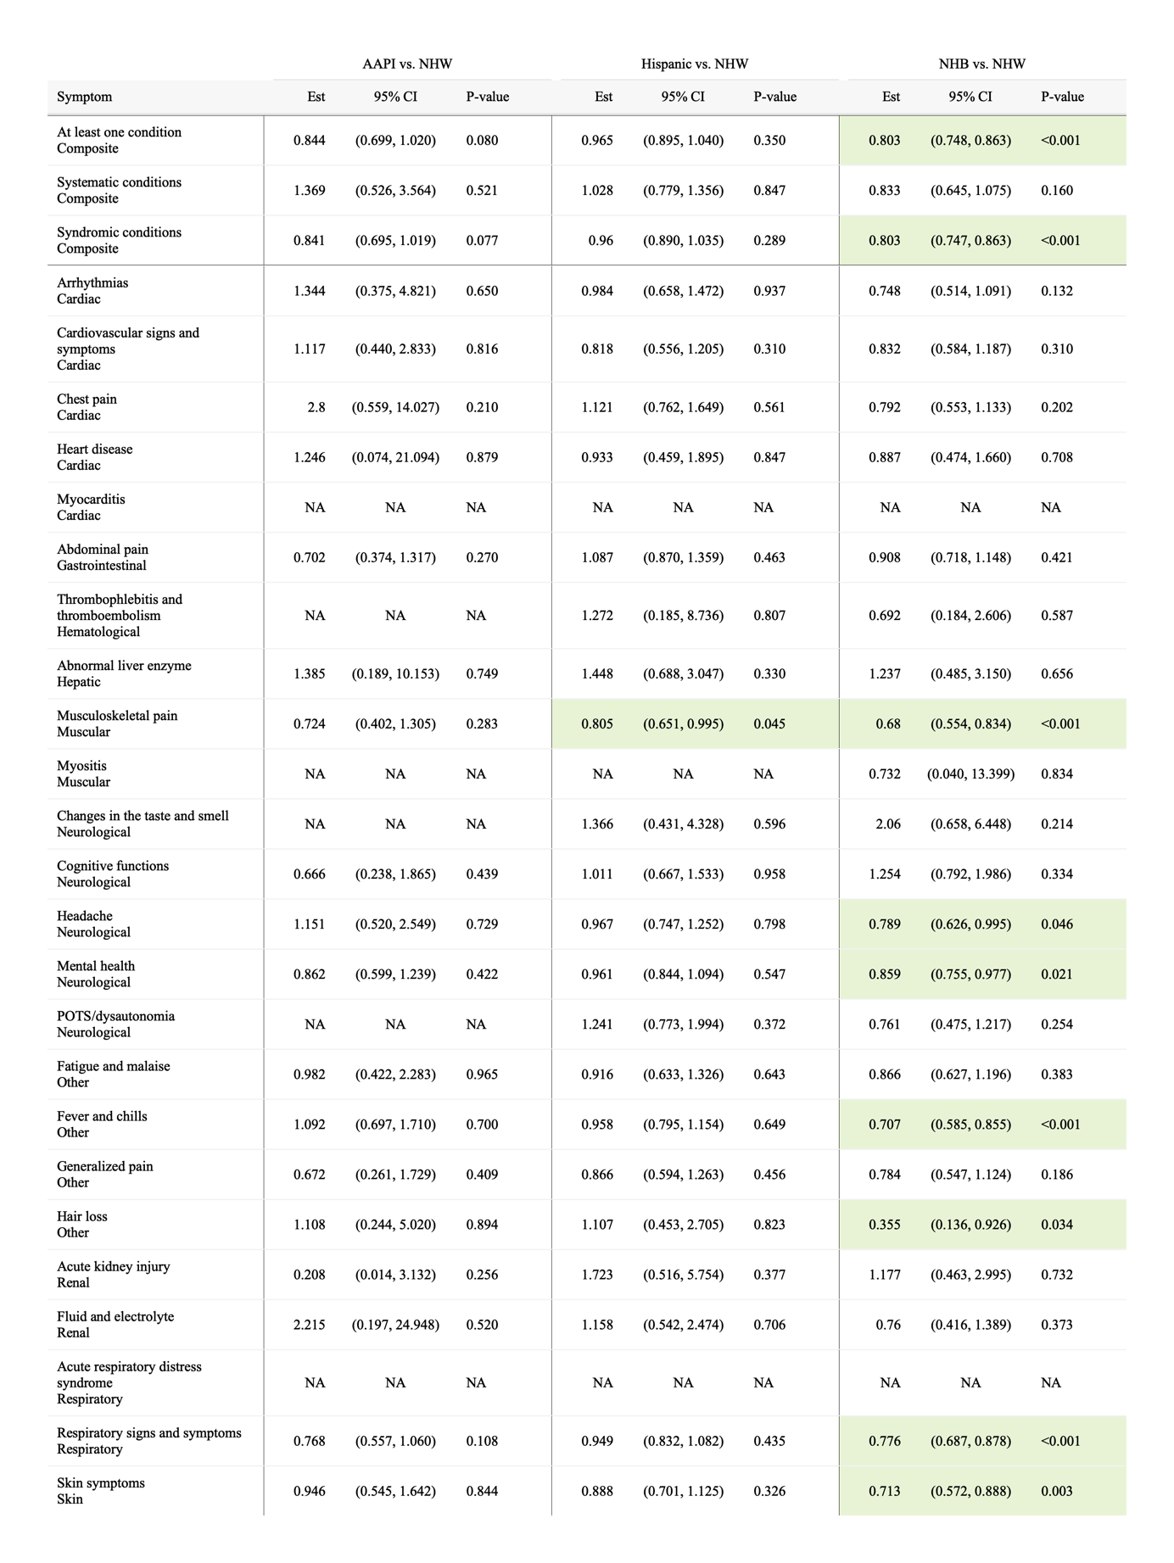

C. Omicron variant period
Table S25. Raw incidence of potential PASC symptoms and conditions comparing COVID-19 positive and negative patients during the Omicron variant period.

 | COVID-19 positive (%) |  |  | COVID-19 negative (%)
 | All  (N=103,603) | Severe  (N=9,355) | Non-severe  (N=94,248) | All  (N=190,173) | Severe  (N=40,596) | Non-severe  (N=149,577)
At least one condition | 29.31 | 35.31 | 28.85 | 25.48 | 24.03 | 25.84
Systematic conditions | 2.67 | 6.83 | 2.33 | 2.08 | 3.37 | 1.76
Syndromic conditions | 28.64 | 34 | 28.2 | 24.8 | 22.8 | 25.32
Abdominal pain | 3.04 | 3.42 | 3 | 2.46 | 2.35 | 2.49
Abnormal liver enzyme | 0.28 | 1.07 | 0.21 * | 0.25 | 0.44 | 0.2 *
Acute kidney injury | 0.22 | 1.16 | 0.13 | 0.19 | 0.48 | 0.11
Acute respiratory distress syndrome | 0.03 | 0.23 | 0.01 | 0.02 | 0.05 | 0.01
Arrythmias | 1.4 | 4.13 | 1.15 | 1.08 | 1.84 | 0.88
Cardiovascular signs and symptoms | 1.2 | 1.55 | 1.17 | 1.06 | 1 | 1.08
Changes in the taste and smell | 0.05 | 0.03 | 0.05 | 0.01 | 0.01 | 0.02
Chest pain | 1.16 | 1.28 | 1.15 | 0.75 | 0.73 | 0.76
Cognitive functions | 0.77 * | 1.1 | 0.74 | 0.76 * | 0.69 | 0.78
Fatigue and malaise | 1.69 | 3.1 | 1.56 | 1.22 | 1.65 | 1.11
Fever and chills | 7.41 | 10.5 | 7.13 | 5.96 | 5.33 | 6.13
Fluid and electrolyte | 0.59 | 3.07 | 0.36 | 0.48 | 1.11 | 0.31
Generalized pain | 1.12 | 1.53 | 1.08 | 0.86 | 0.97 | 0.83
Hair loss | 0.2 | 0.4 | 0.18 | 0.16 | 0.17 | 0.16
Headache | 1.98 | 1.85 | 1.99 | 1.46 | 1.28 | 1.51
Heart disease | 0.36 | 1.62 | 0.24 | 0.3 | 0.69 | 0.19
Mental health | 6.19 | 7.73 | 6.05 | 5.35 | 4.95 | 5.45
Musculoskeletal pain | 3.2 | 3.34 | 3.18 | 2.56 | 2.43 | 2.59
Myocarditis | 0.03 | 0.17 | 0.01 | 0.01 | 0.02 | 0
Myositis | 0.03 | 0.08 | 0.03 * | 0.03 | 0.03 | 0.02 *
POTS/dysautonomia | 1.02 | 1.19 | 1.01 | 0.73 | 0.77 | 0.72
Respiratory signs and symptoms | 11.44 | 16.03 | 11.04 | 10.06 | 10.09 | 10.06
Skin symptoms | 4.04 | 5.07 | 3.94 | 3.27 | 3.15 | 3.3
Thrombophlebitis and thromboembolism | 0.13 | 0.82 | 0.06 | 0.11 | 0.37 | 0.04
Note: * no evidence of statistical significance
Red Symptom: COVID-19 positive higher incidence
Blue Symptom: COVID-19 positive lower incidence

Table S26. Adjusted differential increase related to COVID-19 for prevalence of potential PASC symptoms and conditions among severe COVID-19-positive patients during the Omicron period, by race/ethnicity.
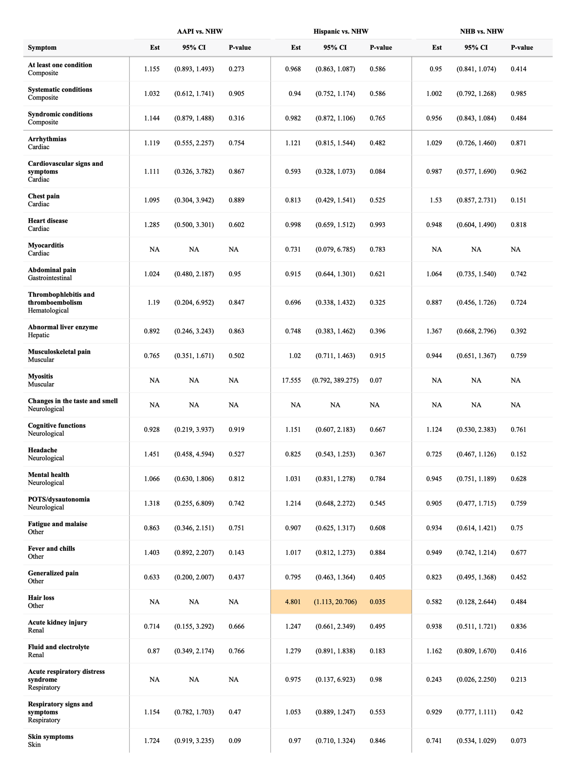
Table S27. Adjusted differential increase related to COVID-19 for prevalence of potential PASC symptoms and conditions among non-severe COVID-19-positive patients during the Omicron period, by race/ethnicity.
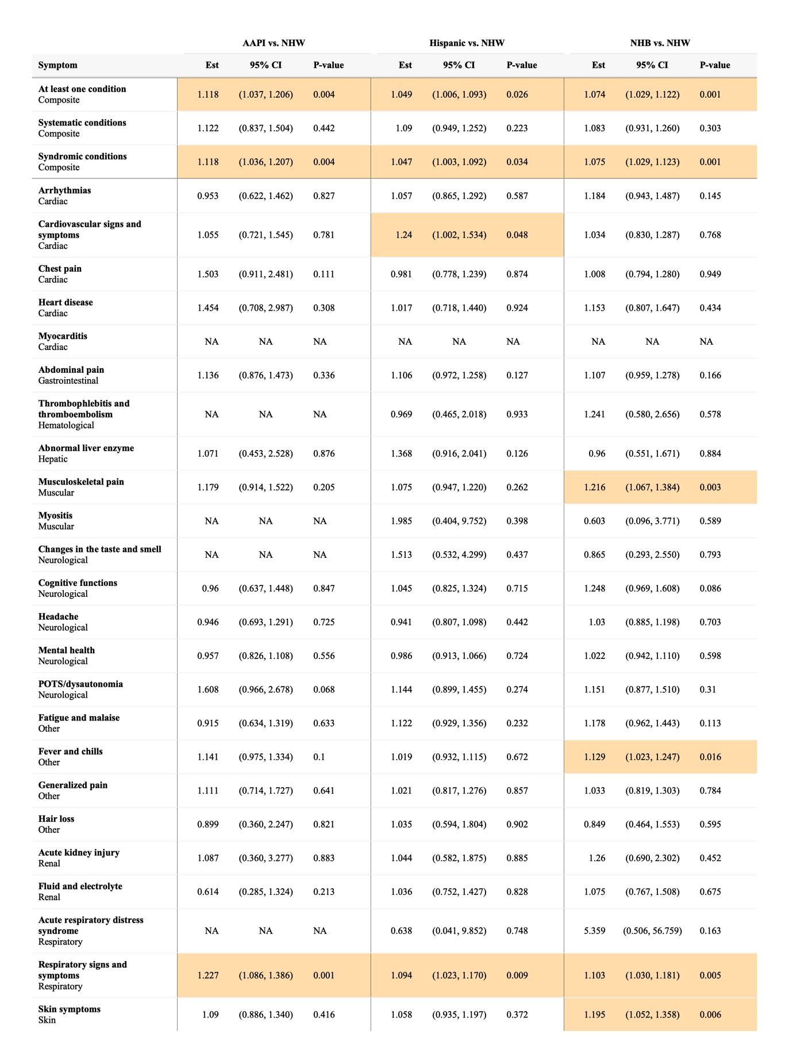

Section S8 Supplemental Results: patient characteristic balance between race/ethnicity groups

A. Propensity-score (PS) models and matching
We built large-scale PS models for each of the cohorts with baseline patient characteristics including
- Demographics (age at index date; race/ethnicity; gender)
- Obesity
- Chronic condition indicator as defined by the Pediatric Medical Complexity Algorithm (PMCA)
  - No chronic condition (PMCA = 0)
  - Non-complex chronic condition (PMCA = 1)
  - Complex chronic condition comorbidities (PMCA = 2)
- Healthcare utilization 18 months ~ 179 days prior to index date categorized to 0,1,2,>=3
  - Number of outpatient visits
  - Number of inpatient visits
  - Number of ED visits
  - Number of unique medications/prescriptions
  - Number of COVID tests
- Cohort entry date (index date) categorized to 1 month
- Hospital index
- Existence of a list of 205 chronic conditions 18 months ~ 179 days prior to the index
- Vaccine dosage prior to index categorized to 0,1, >=2
- Duration from last immunization date categorized to no vaccine, <4 months, >= 4 months

We exclude all covariates that occur in fewer than 1% of participants in the cohort for computational efficiency. The minor race/ethnicity group patients were then matched using the propensity score to NHW group patients with caliper 0.2. The propensity score is estimated by the lasso model.

B. Patient characteristic balance in the primary analysis
We evaluate the balance of patient characteristics using the standardized difference of means (SMD). Figure S14-S19 presents the SMD of three cohorts before and after PS score matching.

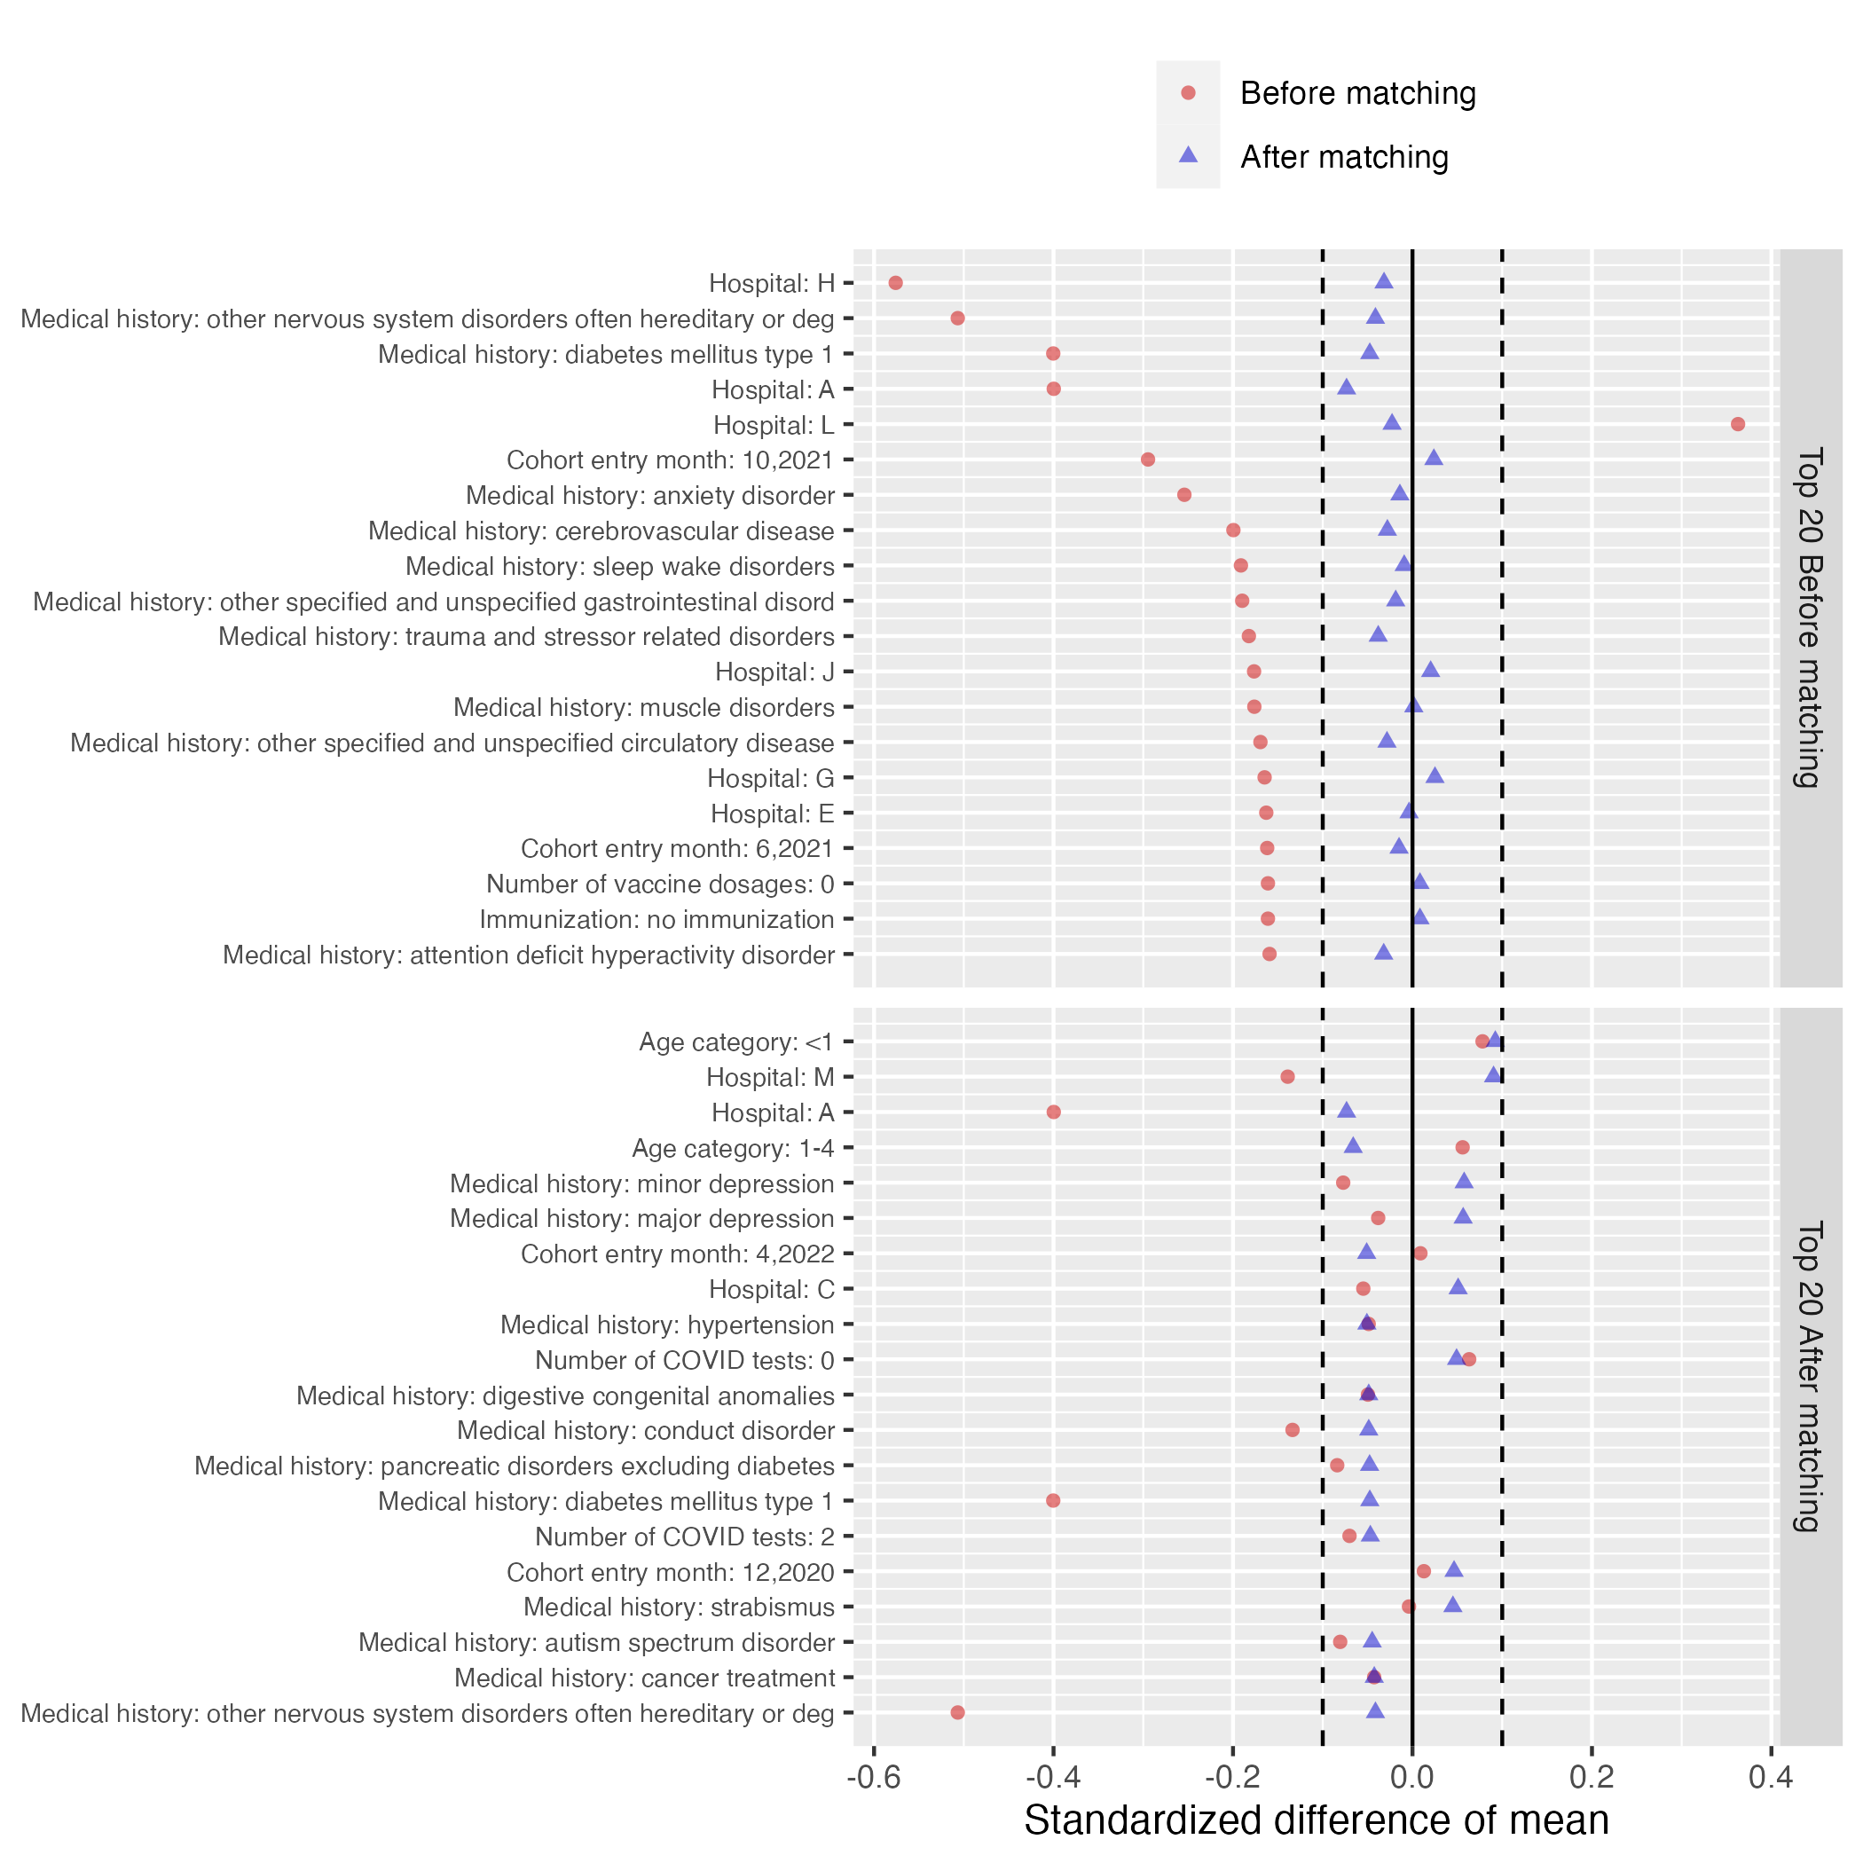Figure S14: Patient characteristic balance for severe COVID-19 AAPI vs. NHW patients before and after large-scale PS matching. The upper panel displays the top 20 covariates with the largest standardized difference of means before PS matching, while the lower panel displays the top 20 covariates with the largest standardized difference of means after PS matching.

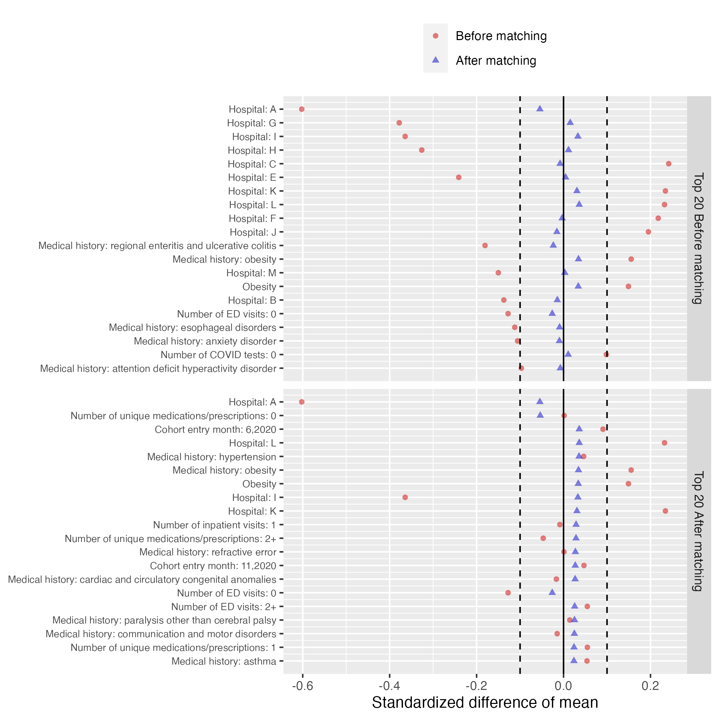
Figure S15: Patient characteristic balance for severe COVID-19 Hispanic vs. NHW patients before and after large-scale PS matching. The upper panel displays the top 20 covariates with the largest standardized difference of means before PS matching, while the lower panel displays the top 20 covariates with the largest standardized difference of means after PS matching.

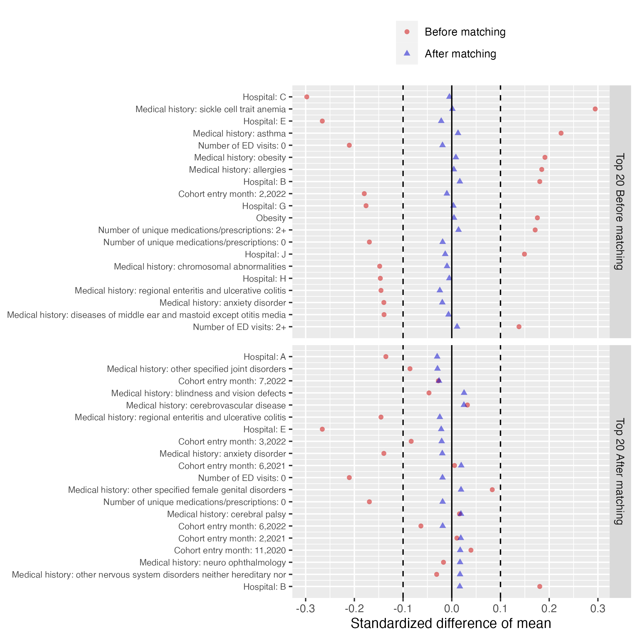
Figure S16: Patient characteristic balance for severe COVID-19 NHB vs. NHW patients before and after large-scale PS matching. The upper panel displays the top 20 covariates with the largest standardized difference of means before PS matching, while the lower panel displays the top 20 covariates with the largest standardized difference of means after PS matching.

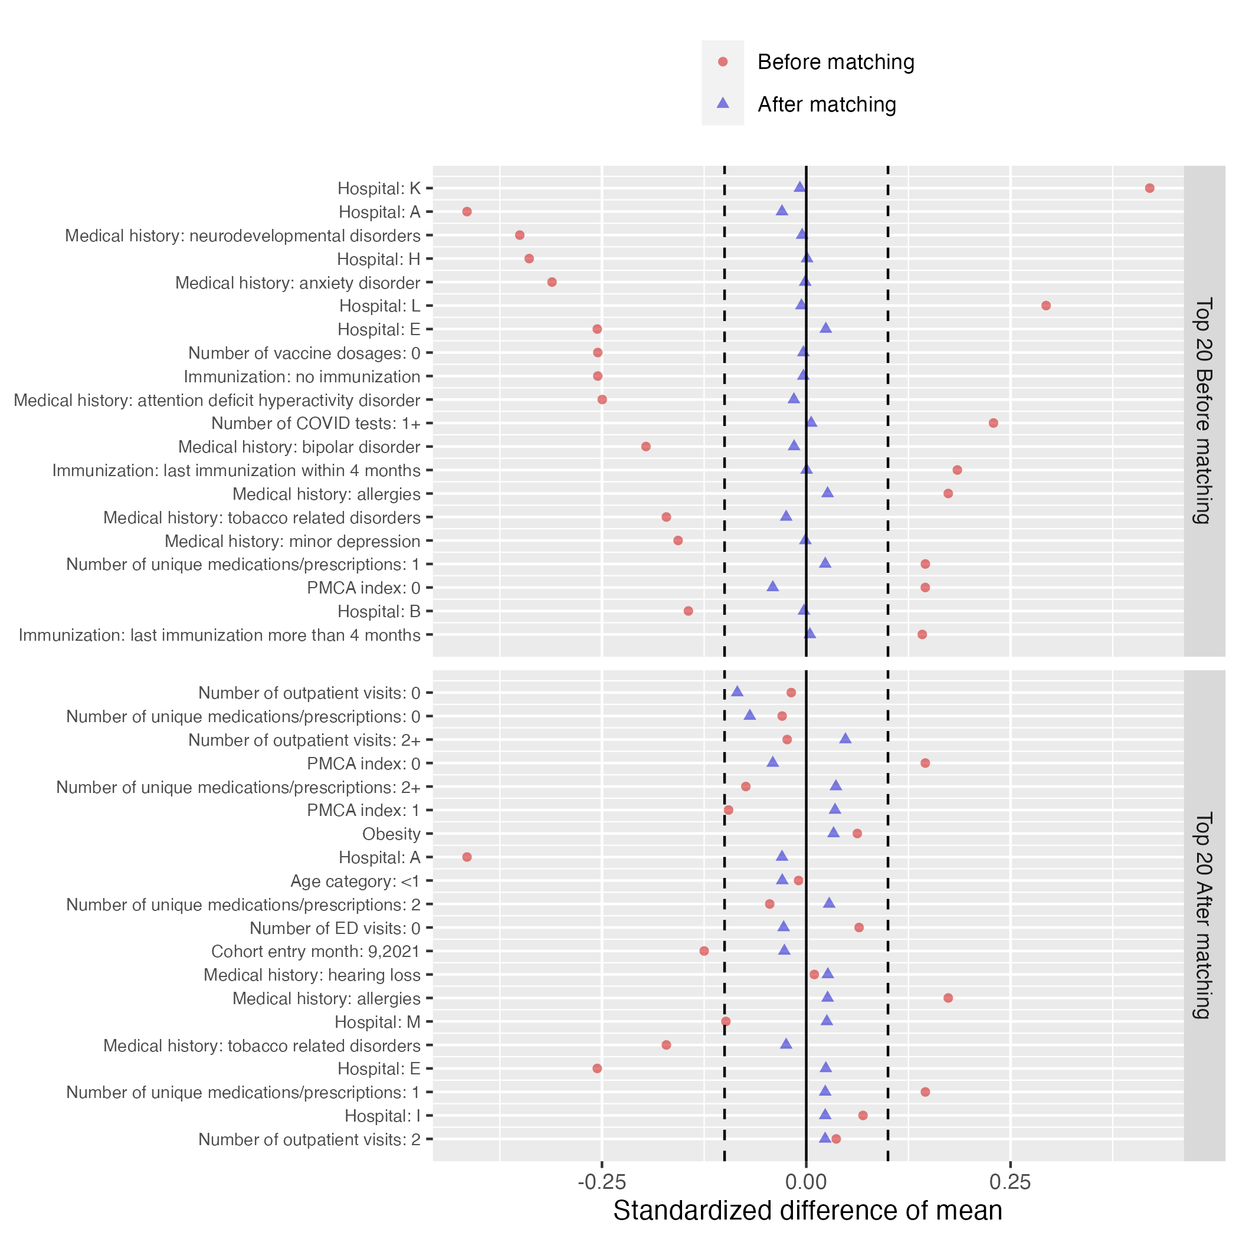
Figure S17: Patient characteristic balance for non-severe COVID-19 AAPI vs. NHW patients before and after large-scale PS matching. The upper panel displays the top 20 covariates with the largest standardized difference of means before PS matching, while the lower panel displays the top 20 covariates with the largest standardized difference of means after PS matching.

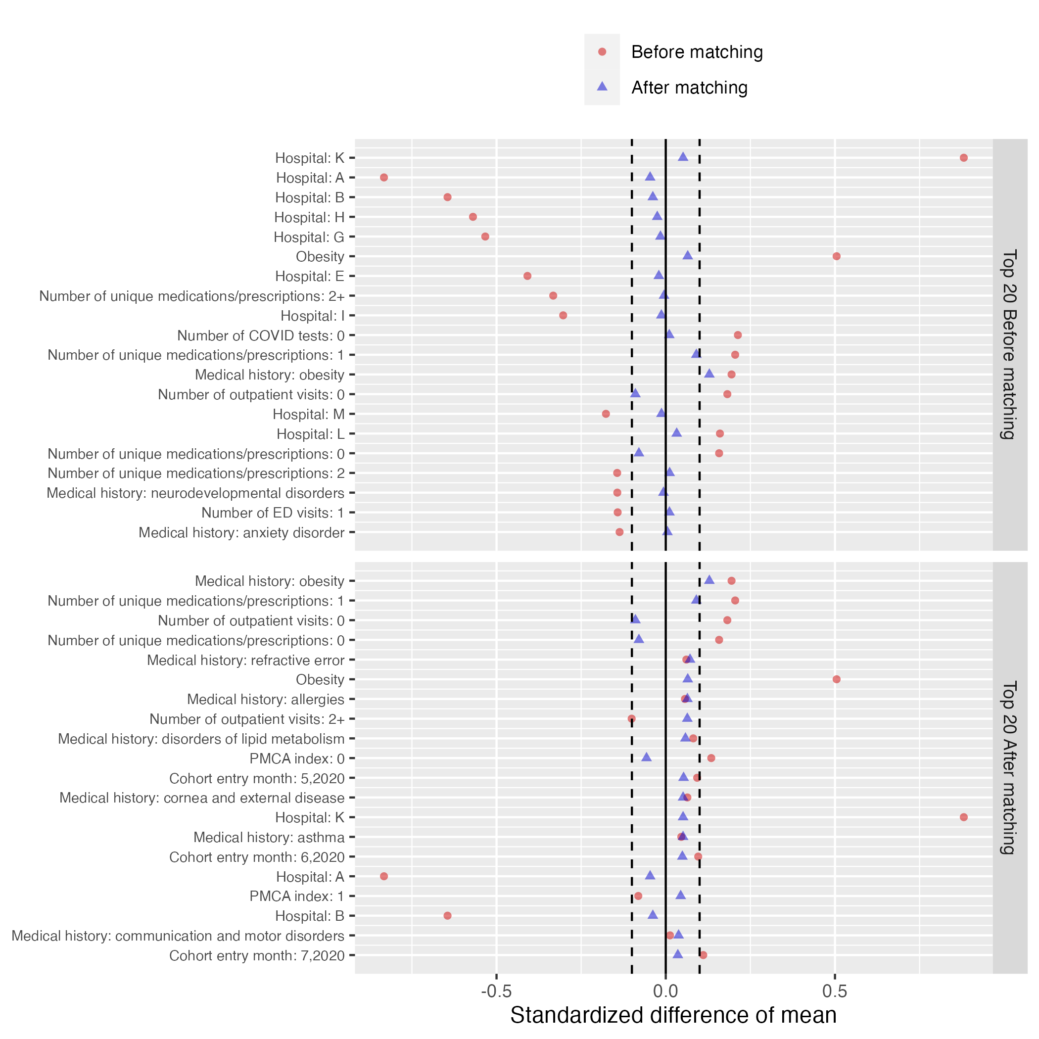
Figure S18: Patient characteristic balance for non-severe COVID-19 Hispanic vs. NHW patients before and after large-scale PS matching. The upper panel displays the top 20 covariates with the largest standardized difference of means before PS matching, while the lower panel displays the top 20 covariates with the largest standardized difference of means after PS matching.

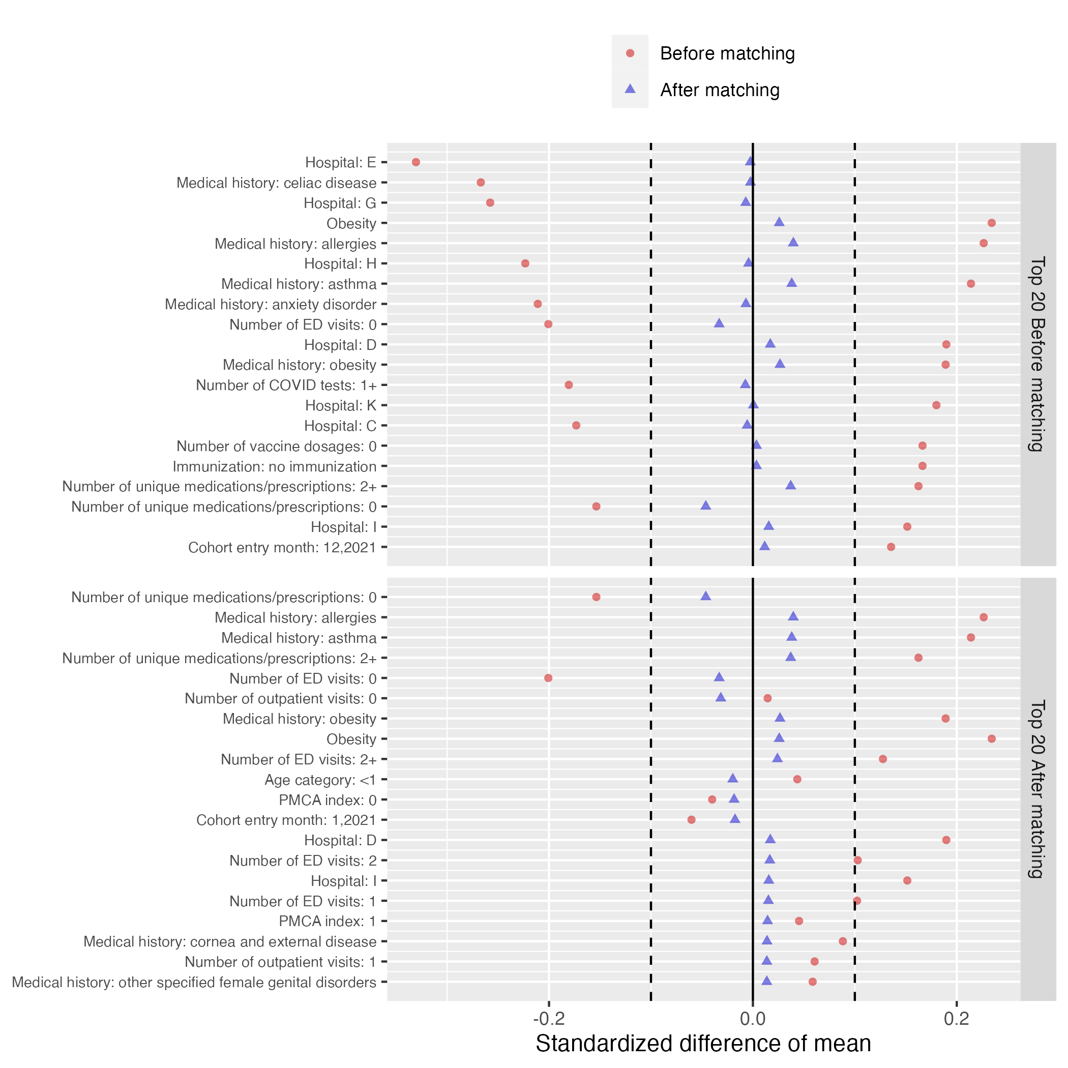
Figure S19: Patient characteristic balance for non-severe COVID-19 NHB vs. NHW patients before and after large-scale PS matching. The upper panel displays the top 20 covariates with the largest standardized difference of means before PS matching, while the lower panel displays the top 20 covariates with the largest standardized difference of means after PS matching.

