Supplementary Materials

This PDF file includes:
Materials and methods
Figs. S1 to S4
Tables S1 to S11

Figure S1
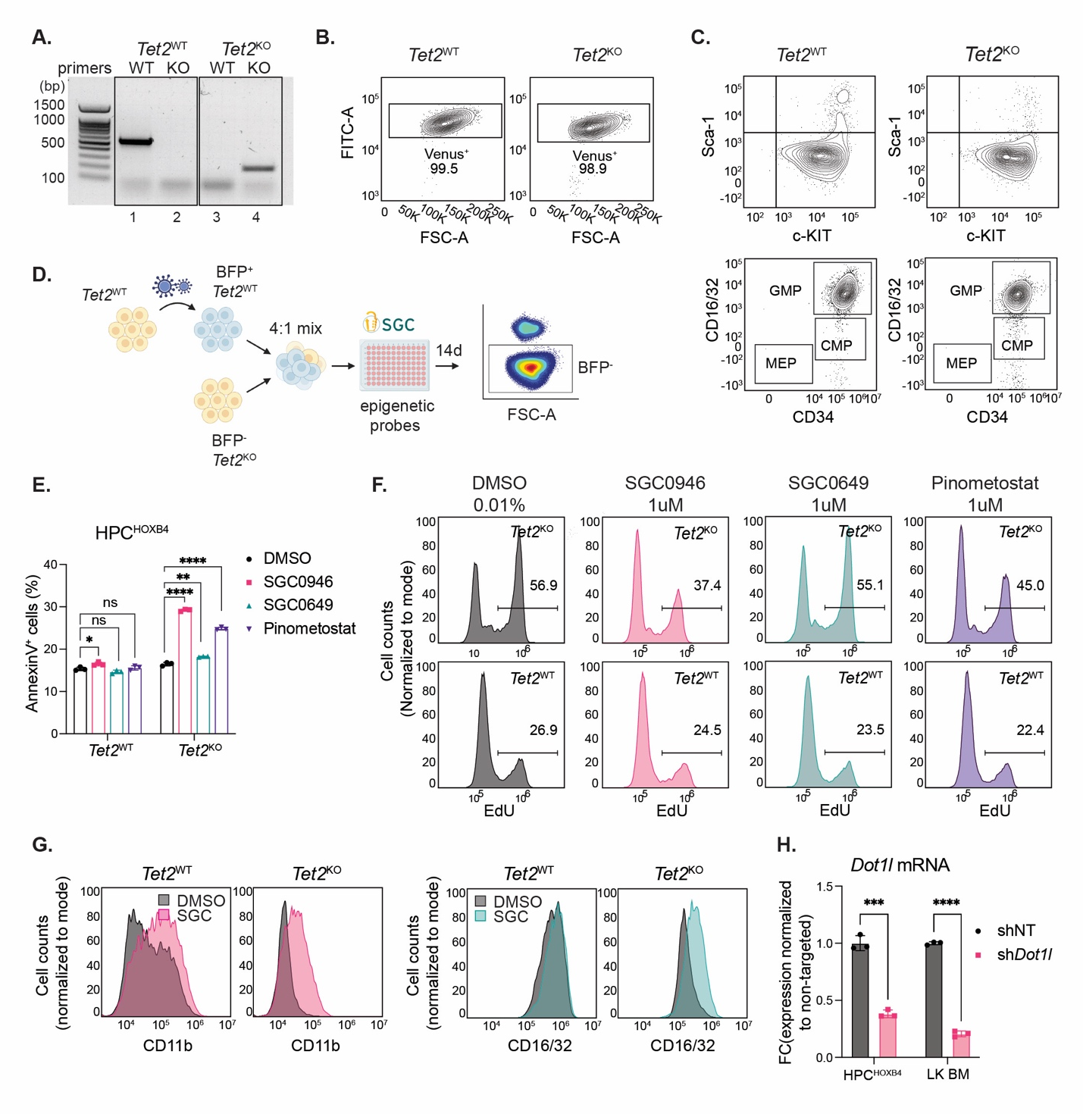
fig S1. Tet2^{KO} HSPCs are dependent on DOT1L activity. (A) Genotyping results of Tet2^{WT} (lane 1 and 2) and Tet2^{KO} (lane 3 and 4) HPC^{HOXB4} cells. WT denotes Tet2^{WT} primer pair. KO denotes Tet2^{KO} primer pair. Expected Tet2^{WT} product size is around 480bp and Tet2^{KO} product size is 200bp. (B) Venus fluorescence in Tet2^{WT} and Tet2^{KO} HPC^{HOXB4} cells. (C) Expression of Sca-1 and c-Kit (top panels) and CD16/32 and CD34 (bottom panels) on Tet2^{WT} and Tet2^{KO} HPC^{HOXB4} cells by flow cytometry staining. (D) Schematic diagram showing the workflow of the chemical library screen. (E) Percentage of apoptotic cells by Annexin V staining in Tet2^{WT} and Tet2^{KO}HPC^{HOXB4} after treatment with DMSO or the indicated compounds at 1μM for 10 days. n=3 experimental replicates. (F) Cell proliferation assay by EdU staining in Tet2^{WT} and Tet2^{KO}HPC^{HOXB4} cells treated with DMSO or the indicated compounds at 1μM for 10 days. Data shown are representative of 3 experimental replicates. (G) Expression of CD11b and CD16/32 on Tet2^{WT} and Tet2^{KO} HPC^{HOXB4} treated with DMSO or SGC0946 at 1μM for 7 days. Data shown are representative of 3 experimental replicates. (H) Normalized Dot1l mRNA level in Tet2^{WT} HPC^{HOXB4} and bone marrow Lin⁻Kit⁺ HSPCs transduced with shRNA targeting Dot1l or non-targeting (NT) shRNA vector. Data shown are mean ± SD. p* <0.05; p** <0.01; p***< 0.001; p***<0.0001.

Figure S2
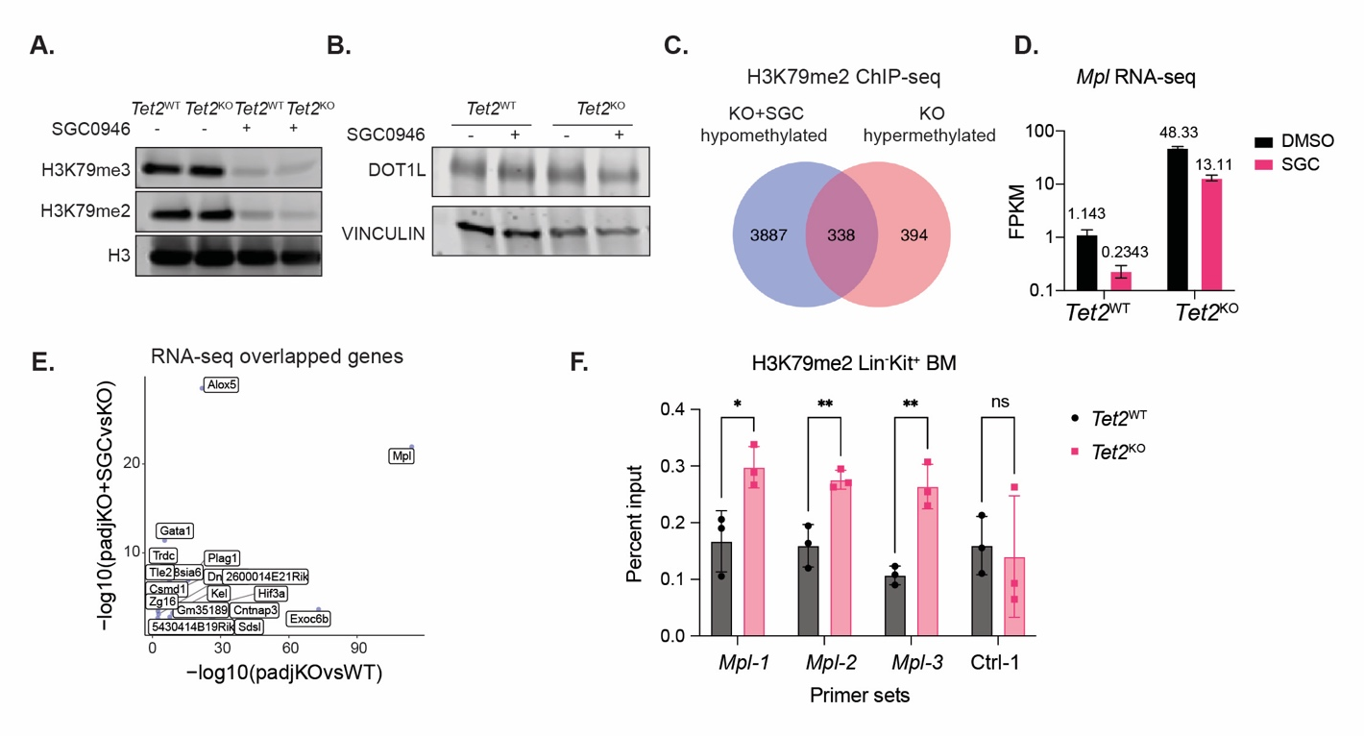fig S2. Mpl expression is upregulated and associated with increased H3K79me2 at the gene locus in Tet2^{KO} HSPCs. (A) Total H3K79me2, H3K79me3, and histone H3 levels in Tet2^{WT} and Tet2^{KO} HPC^{HOXB4} cells treated with (+) or without (-) SGC0946 at 1μM for 7 days. Representative data of 3 independent experiments shown. (B) DOT1L protein level in Tet2^{WT} and Tet2^{KO}HPC^{HOXB4} cells treated with (+) or without (-) SGC0946 at 1μM for 7 days. Vinculin served as loading control. Representative date of 3 independent experiments shown. (C) Venn diagram showing the overlap of genes with increased H3K79me2 in Tet2^{KO} HPC^{HOXB4} cells and decreased H3K79me2 in SGC0946-treated Tet2^{KO} HPC^{HOXB4} cells based on ChIP-seq analysis. (D) FPKM of Mpl count reads in Tet2^{WT} and Tet2^{KO} HPC^{HOXB4} cells treated with DMSO or SGC0946 from RNA-seq data. n=3 experimental replicates. Data shown are mean ± SD. (E) Scatter plot showing the adjusted P values for the comparisons in expression of the 20 overlapping DEGs in Fig. 2B. The values on the X-axis represent the comparison between Tet2^{KO} and Tet2^{WT} HPC^{HOXB4} cells. The values on the Y-axis represent the comparison between SGC0946-treated Tet2^{KO}HPC^{HOXB4} cells and untreated Tet2^{KO}HPC^{HOXB4} cells. (F) H3K79me2 levels at Mpl or negative-control regions in Tet2^{WT} and Tet2^{KO} Lin⁻Kit⁺ bone marrow HSPCs measured by ChIP-qPCR using percent input method. n=3 experimental replicates. Data shown are mean ± SEM. p* <0.05; p** <0.01; p***< 0.001; p***<0.0001.

Figure S3
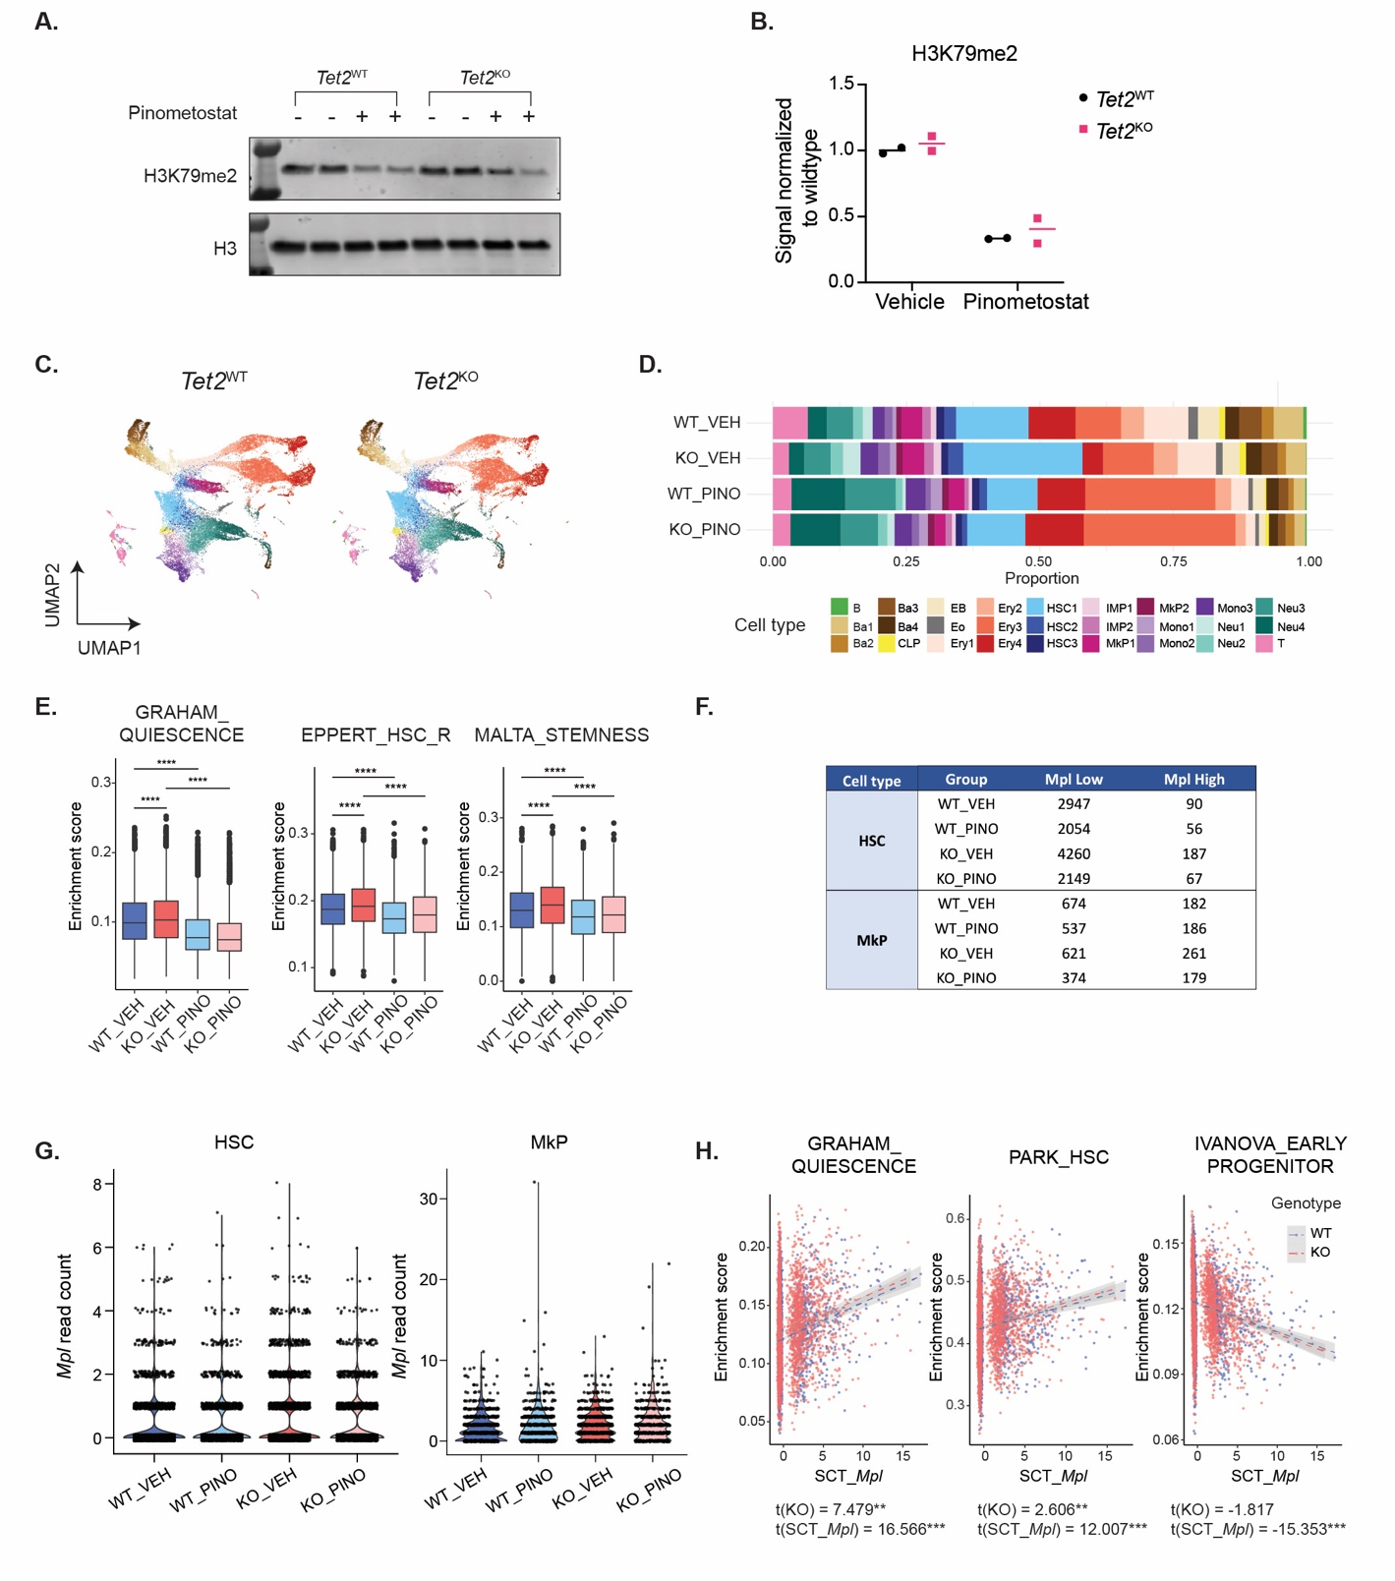
fig S3. DOT1L enhances self-renewal of Tet2^{KO} HSCs through differentially regulating Mpl expression.
(A) H3K79me2 in Tet2^{WT} and Tet2^{KO} bone marrow Lin⁻Kit⁺ HSPCs harvested from lethally irradiated recipients with pinometostat (+) or vehicle (-) treatment. (B) Quantification of western blot results in fig.S3A. Each data point represents one mouse. The lines represent the means of each group. Signals were normalized to the mean band intensity of vehicle treated Tet2^{WT} cells. (C) UMAP clustering of all cells in Tet2^{WT} and Tet2^{KO} samples. (D) Percent of cells from each transcriptional cluster. For each genotype and treatment group, values shown represent the average from two biological replicates. (E) Enrichment score of gene sets grouped by genotype and treatment calculated using the AUCell package. (F) Count of cells that are Mpl-low (<3 transcripts) and Mpl-high (≥ 3 transcripts) in the HSC and megakaryocyte progenitor fractions. Values shown represent the sum of two biological replicates. (G) Distribution of normalized counts of Mpl in HSC (left) and MkP (right) fractions in each genotype and treatment group. (H) Scatterplot of enrichment scores of individual HSCs for each gene set within the HSC-1 cluster contingent on the vehicle-treated samples. The dashed lines represent the linear regression lines calculated for each genotype using the formula fit = lm(Gene set ~ Genotype + SCT_Mpl) and grey shades represent 95% confidence intervals. The t scores for Genotype and SCT_Mpl and significance levels were indicated. p* <0.05; p** <0.01; p***< 0.001; p***<0.0001.

Figure S4
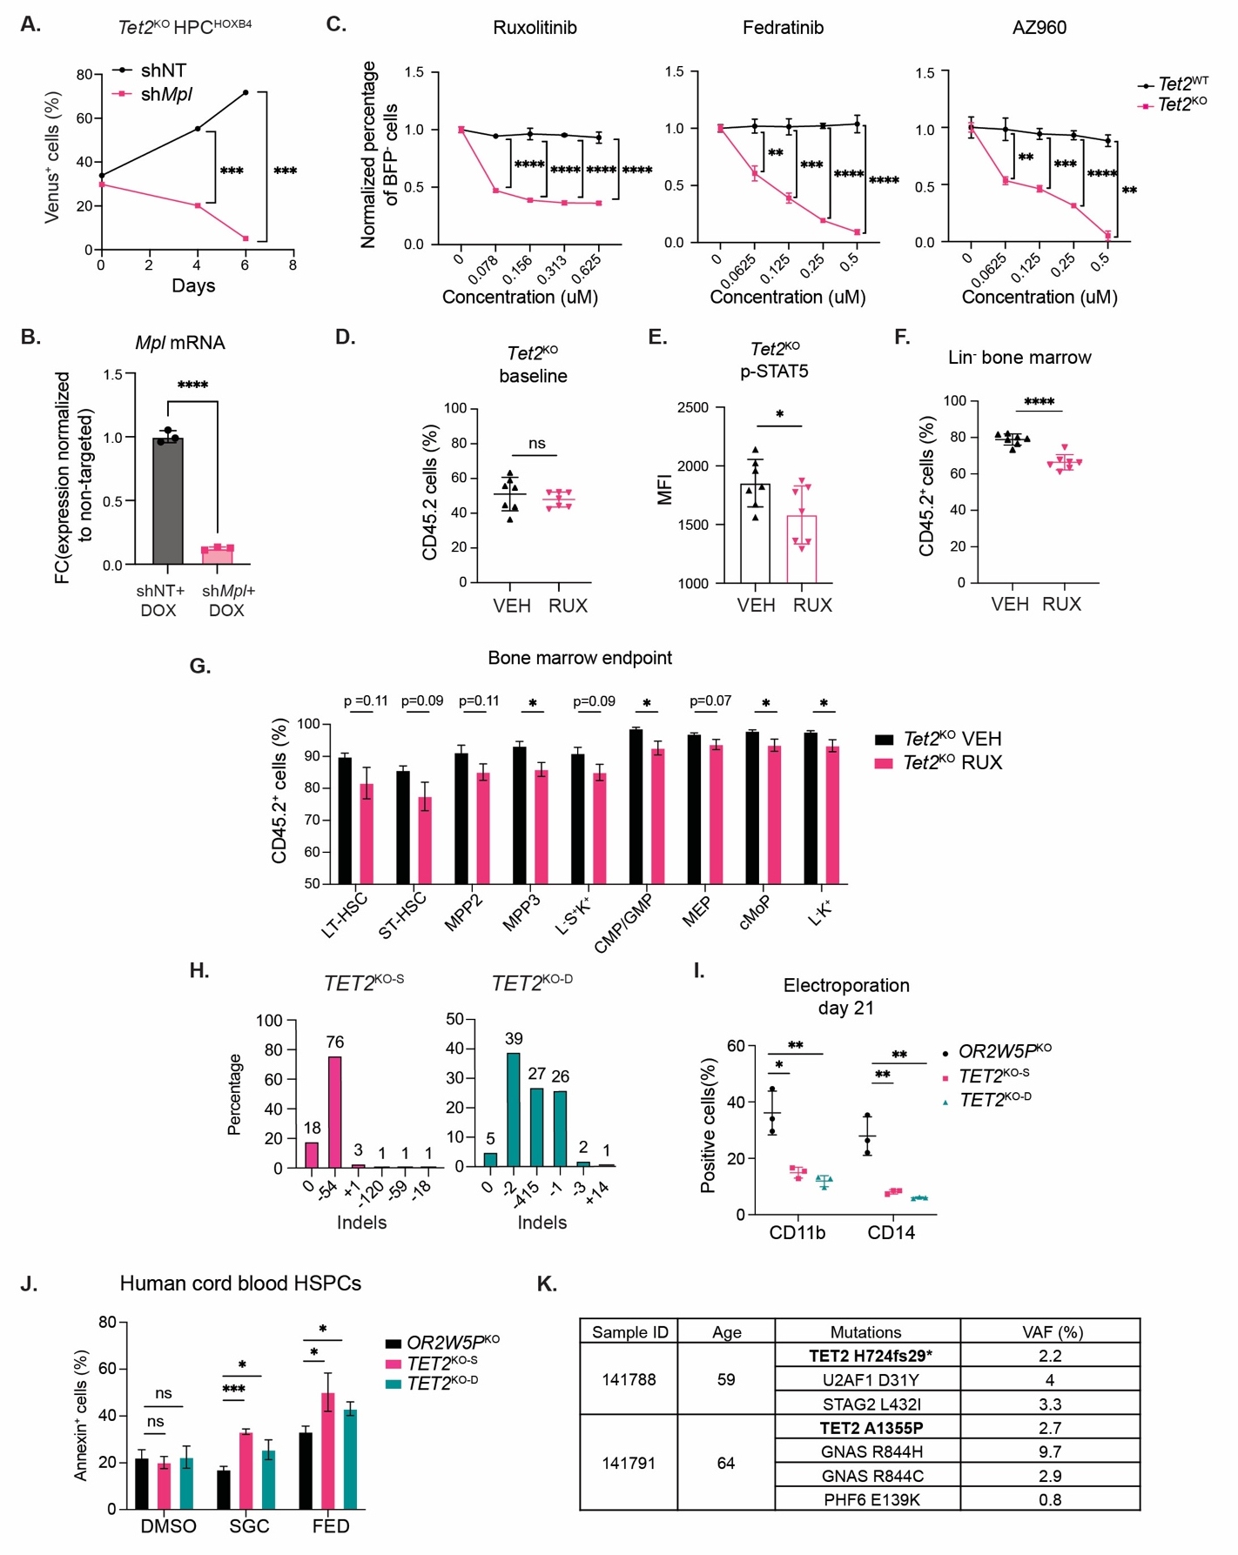
fig S4. Inhibition of the TPO-R/JAK2/STAT5 signaling axis reduces the competitive advantage of murine and human Tet2^{KO} HSPCs.
(A) Percentage of Venus⁺Tet2^{KO} HPC^{HOXB4} cells in competition with Venus‒Tet2^{WT}HPC^{HOXB} cells at the indicated time points after starting the experiment. Both cell types were transduced with a lentiviral vector expressing a non-targeting (NT) or Mpl shRNA and sorted prior to the competition assay. (B) Quantification of Mpl mRNA levels in Lin⁻ bone marrow HSPCs expressing non-targeting shRNA (shNT) or shRNA targeting Mpl (shMpl) by qPCR. Bone marrow samples from biological replicates from each group were mixed. (C) Proportion of BFP‒Tet2^{WT} or BFP‒Tet2^{KO} HPC^{HOXB4} cells in competition with BFP⁺Tet2^{WT}HPC^{HOXB4} cells after treatment with the indicated JAK2 inhibitors at different concentrations for 7 days. Data are normalized to the untreated control for each cell type. n=3 experimental replicates. (D) Percentage of CD45.2⁺ Tet2^{KO} cells in the peripheral blood of mice assigned to vehicle or ruxolitinib treatment at baseline (prior to drug treatment). Each data point represents an individual mouse. (E) Median fluorescent intensity (MFI) of phospho-STAT5 (Tyr694) intracellular staining minus MFI of isotype control intracellular staining in CD45.2⁺Tet2^{KO} Lin⁻ BM cells from mice treated with vehicle or ruxolitinib (RUX) after 13 weeks. Each data point represents an individual animal. Data shown are mean ± SEM. (F) Percentage of CD45.2⁺Tet2^{KO} cells in the Lin⁻ fraction of BM samples after treatment with vehicle (VEH) or ruxolitinib (RUX) for 9 weeks. Each data point represents an individual mouse. n=7 per treatment group. (G) Percentage of CD45.2⁺ Tet2^{KO} cells in the indicated HSPC fractions isolated from the BM of mice treated with vehicle or ruxolitinib (RUX) after 13 weeks. The fractions are defined as the following immunophenotypes: LT-HSC (Lin⁻Sca-1⁺c-Kit⁺CD150⁺CD48⁻), ST-HSC (Lin⁻Sca-1⁺c-Kit⁺CD150⁻CD48⁻), MPP2 (Lin⁻Sca-1⁺c-Kit⁺CD150⁺CD48⁺), MPP3 (Lin⁻Sca-1⁺c-Kit⁺CD150⁻CD48⁺), LSK (Lin⁻Sca-1⁺c-Kit⁺), CMP/GMP (Lin⁻Sca-1⁻c-Kit⁺CD34⁺CD16/32⁺CD115⁻), MEP (Lin⁻Sca-1⁻c-Kit⁺CD34⁻CD16/32⁻), cMoP (Lin⁻Sca-1⁻c-Kit⁺CD34⁺CD16/32⁺CD115⁺), and LK (Lin⁻Sca-1⁻c-Kit⁺). (H) ICE analysis of CRISPR-mediated knockout of TET2 in cord blood progenitor cell pools using two multi-guide designs (KO-S and KO-D). Estimated percentages of different indels for each design are shown based on Sanger sequencing of the target regions. Genomic DNA samples for sequencing were extracted 1 day after nucleofection of the Cas9 RNP complex. (I) Percentage of cells expressing CD11b or CD14 in cord blood progenitor cell pools at 21 days after nucleofection with Cas9 RNPs targeting OR2W5P (negative control) or TET2 (KO-S or KO-D). n=3 biological replicates. (J) Percentage of apoptotic cells by Annexin V staining in cord blood HSPC cell pools nucleofected with Cas9 RNPs targeting OR2W5P (negative control) or TET2 (KO-S or KO-D) and treated with DMSO, SGC0946 (SGC; 1μM), or fedratinib (FED; 0.25μM) for 7 days. n=3 biological replicates. (K) Variant allele frequencies (%) of the mutations detected in the indicated mPB samples. Data from (F) to (I) shown as mean ± SEM. Other data shown are mean ± SD. p* <0.05; p** <0.01; p***< 0.001; p***<0.0001.

Table S1. Sequence of PCR primers used for Tet2 genotyping.
Target | Forward sequence 5’ > 3’ | Reverse sequence 5’ > 3’
Tet2^{WT} allele | AGCTGATGGAAAATGCAAGC | TCTCAGAGCAAAGAGGACTGC
Tet2^{KO} allele | GCCACTTTAGAAGCCTATTGGA | TCTCAGAGCAAAGAGGACTGC

Table S2. List of sgRNA sequences
Species | Target | Sequence 5’ > 3’
Homo sapiens | TET2 KO-S | AGAGCUCAUCCAGAAGUAAA
Homo sapiens | TET2 KO-S | UUAUGGAAUACCCUGUAUGA
Homo sapiens | TET2 KO-S | AGUGUUUGCAAAAUGGAGGA
Homo sapiens | TET2 KO-D | UGGAGAAAGACGUAACUUCG
Homo sapiens | TET2 KO-D | CGAUGGGUGAGUGAUCUCAC
Homo sapiens | OR2W5P | GACAACCAGGAGGACGCACU
Homo sapiens | OR2W5P | UGCGACGUCCACACCGGGAG
Aequorea victoria | Venus | GGGCGAGGAGCUGUUCACCG

Table S3. List of epigenetic probes used in the chemical library screen.
Compound | Concentration (μM) | Compound | Concentration (μM)
GSK2801 | 3 | UNC0642 | 1
BAZ2-ICR | 1 | A-366 | 1
JQ1 | 0.2 | MRK-740 | 3
BI-9564 | 1 | MS023 | 0.1
TP-472 | 1 | MS049 | 5
I-BRD9 | 1 | TP-064 | 1
GSK6853 | 1 | GSK591 | 1
BAY-299 | 1 | LLY-283 | 0.5
SGCCBP30 | 1 | SGC3027 | 3
NVS-CECR2-1 | 1 | A-196 | 1
GSK J4 | 5 | OICR-9429 | 3
GSKLSD1 | 1 | GSK864 | 0.3
GSK484 | 10 | L-Moses | 5
PFI-3 | 1 | OF-1 | 1
UNC1215 | 1 | PFI-2 | 1
SGC0946 | 1 | NI-57 | 1
UNC1999 | 3 | BAY598 | 1
GSK343 | 3 | SGC707 | 1

Table S4. List of antibodies and dyes used for flow cytometry.
Target | Host Species | Dilution | Manufacturer | Cat No. | RRID
mouse CD34 | rat | 1:100 | BD | 560230 | AB_1645199
mouse CD34 | hamster | 1:100 | Biolegend | 128614 | AB_2715985
mouse lineage cocktail | rat | 1:100 | Biolegend | 133310 | AB_11150779
mouse lineage cocktail | hamster | 1:100 | Biolegend | 133302 | AB_1069700
mouse CD16/32 | rat | 1:100 | BD | 101318 | AB_2104156
mouse/human CD11b | rat | 1:100 | Biolegend | 101216 | AB_312799
mouse Gr-1 | rat | 1:100 | Biolegend | 108443 | AB_2562549
mouse CD45.1 | mouse | 1:100 | Biolegend | 110752 | AB_2629806
mouse CD45.2 | mouse | 1:100 | Biolegend | 109822 | AB_493731
human CD14 | mouse | 1:100 | Biolegend | 560180 | AB_1645464
mouse TER-119 | rat | 1:100 | Biolegend | 116206 | AB_313707
mouse B220 | rat | 1:100 | Biolegend | 103208 | AB_312993
mouse CD3 | hamster | 1:100 | Biolegend | 100312 | AB_312677
human TPOR/MPL | mouse | 1:50 | Biolegend | 393812 | AB_2750511
mouse CD117 | rat | 1:100 | BD | 553355 | AB_394806
mouse Sca-1 | rat | 1:100 | Biolegend | 108128 | AB_2563064
mouse CD115 | rat | 1:100 | BD | 16590 | AB_394806
mouse CD48 | hamster | 1:100 | Biolegend | 103412 | AB_571997
mouse CD150 | rat | 1:100 | Biolegend | 115941 | AB_2629660
human CD34 | mouse | 1:100 | Biolegend | 343510 | AB_1877153
human CD38 | mouse | 1:100 | Biolegend | 356604 | AB_2561900
mouse/human p-STAT5 | rabbit | 1:100 | CST | 9359S | AB_823649
mouse IgG2b, κ Isotype | mouse | 1:100 | Biolegend | 400342 | AB_10898160
rabbit IgG XP Isotype | rabbit | 1:100 | CST | 2985S | AB_1196589
anti-rabbit-Alexa 647 conjugate | goat | 1:500 | CST | 4414S | AB_10693544
APC annexin V | N/A | 1:400 | Biolegend | 640941 | N/A
SYTOX green | N/A | 1:1000 | Thermo fisher | S34860 | N/A

Table S5. Sequence of primers for quantitative PCR.
Target | Forward sequence 5’ > 3’ | Reverse sequence 5’ > 3’
Dot1l | TGGAGAAGGACAACAGCGAGCT | CTCTTTCCGCAGGTTCTCCAAG
Mpl | TCCTTGTAGAGGTGACCACAGC | ACTCCAGCCTTCCACTTGAGAC
Actb | CATTGCTGACAGGATGCAGAAGG | TGCTGGAAGGTGGACAGTGAGG

Table S6. Sequence of primers for ChIP-qPCR.
Target | Forward sequence 5’ > 3’ | Reverse sequence 5’ > 3’
Mpl-1 | GATGCCCTTACCCACACTATC | TGAAGTGCGCCTCTTCTTTC
Mpl-2 | GAATCCTCTGATAGGGCCAAAG | CGAGGGTAGGTTCTGGGCTG
Mpl-3 | TGAGAACAGAGATGGTGAGTTG | GGGGATATGGGGTAAGAGAC
Ctrl-1 | TCTGAGGTATGTGTCTGATTTG | CATGAAGCCAGGTAAGGTTAT

Table S7. List of antibodies used for Western Blots.
Target | Host Species | Dilution | Manufacturer | Cat No. | RRID
Beta actin | mouse | 1:5000 | CST | 3700S | AB_2242334
STAT5 | rabbit | 1:1000 | CST | 94205S | AB_2737403
p-STAT5 (Tyr694) | rabbit | 1:1000 | CST | 9359S | AB_823649
DOT1L | rabbit | 1:1000 | CST | 90878S | AB_2800165
VINCULIN | mouse | 1:2000 | CST | 13901S | AB_2728768
Histone H3K79me2 | rabbit | 1:1000 | CST | 5427S | AB_10693787
Histone H3K79me3 | rabbit | 1:1000 | CST | 74073S | AB_2799849
Histone H3 | rabbit | 1:2000 | CST | 9717S | AB_331222
Donkey anti-mouse IgG | donkey | 1:2000 | Licor | 926-68073 | AB_10954442
Donkey anti-rabbit IgG | donkey | 1:2000 | Licor | 926-32213 | AB_2715510

Table S8. List of ddPCR primers and probes
Samples | 141788 | 141791
Forward primer | GAGCCATTTTCAAACTCACACCTTT | CTACTTTCGCATTCACACACACTTT
Reverse primer | ACTCTGGGATGGTTGTGTTTGTG | GGACGGCCTTCCTTCAGA
WT probe | CATAAGCCTCATAAACAG | ATGAACACAGAGCACCAG
Mutant probe | AACATAAGCCTCAAACAG | ATGAACACAGACCACCAG

Table S9. List of drugs and inhibitors.
Drug name | Manufacturer | Cat no.
SGC0946 | Cayman | 13967
Pinometostat | Cayman | 16175
Pinometostat | MedChemExpress | HY-15593
SGC0649 | SGC | N/A
Fedratinib | MedChemExpress | HY-10409A-5MG
AZ960 | Cayman | 16731-1
Ruxolitinib | MedChemExpress | HY-50856
Ampicilin | Thermo Fisher | 14417-25
Doxycycline | MedChemExpress | 24390-14-5
Doxycycline | Gold Biotechnology | #D-500-10

Table S10. List of shRNAs sequences
Species | Target | Sequence 5’ > 3’
Mus musculus | Dot1l | CGGCAGAATCGTATCCTCAAA
Mus musculus | Mpl | AGTGTTATTCACATCCTTGTA

Table S11. Sequence of PCR primers used for CRISPR knockout validation.
Target | Forward PCR primer 5’ > 3’ | Reverse PCR primer 5’ > 3’
TET2 KO-S | CCCCGAAGCAAGCCTGAT | CGGAGACATTTGGTTGACTGC
TET2 KO-D | CCAAGTGTTTGCAAAATGGAGG | AGACGCTAGCTTTGTGGTTCC
OR2W5P | TCGGCCTGGACTGGAGAAAA | GAGACCACTGTGAGGTGAGA

