A multivariate study of the rGO/g-C₃N₄ composite for the photocatalytic degradation of bisphenol A: Characterization, degradation kinetics, products identification, and ecotoxicity
Chubraider Xavier¹*, Bianca Rebelo Lopes², Caue Ribeiro³, Eduardo Bessa Azevedo¹

¹São Carlos Institute of Chemistry, University of São Paulo, 13560-970, São Carlos, Brazil
²Departament of Chemistry, Federal University of São Carlos, 13565-905, São Carlos, Brazil
*Corresponding author. Tel.: +55 1799611-2155. E-mail address: chubraiderxavier@usp.br

Supplementary Material

- Additional Information about the experimental procedures

  - Details regarding the GrO synthesis
Graphite powder (1.00 g) was mixed with 70 mL of concentrated sulfuric acid under vigorous magnetic stirring in a 2-L beaker. To this mixture, 9.00 g of potassium permanganate were added within 5 min. The system was heated to 40°C and magnetically stirred for 40 min. Then, 150 mL of ultrapure water was poured within 5 min with the aid of a separatory funnel. The temperature was kept below 95°C during this operation, by the careful dropwise addition of water. Finally, 500 mL of ultrapure water were added to the flask. It was magnetically stirred for 15 min more and 10.0 mL of concentrated hydrogen peroxide (10 mol L⁻¹) were slowly added within 3 min.
This mixture was magnetically stirred for 20 min and vacuum filtered using a quantitative filter paper for recovering the material. The material was suspended in 250 mL of hydrochloric acid 1.0 mol L^{–1} and vacuum filtered on a quantitative paper filter. The collected material was then dried at room temperature and protected from direct exposure to light. The amount of synthesized GrO required for all experiments was prepared and homogenized. The solid was previously frozen with liquid nitrogen, grounded with a porcelain mortar/pestle and dialyzed with a membrane capable of removing ions from 8,000 to 14,000 Da. The membranes (20 cm) were filled with 4.0 g of GrO and 60 mL of ultrapure water. The bags were kept in a 2-L beaker filled with ultrapure water (1.5 L) kept under magnetic stirring. That water was renovated every 2 h during the first day, every 4 h during the second one, and then every 12 h thereafter, until the spent water pH matched the one of ultrapure water (pH meter Marconi PA 200). The purified material was air-dried at room temperature for seven days, frozen with liquid nitrogen, and lyophilized for six days. This material was ground into an agate mortar/pestle and transferred to Falcon® tubes (50 mL) which were also kept away from light.
1.2 Optimization of the rGO/g-C₃N₄ synthesis
The factors were coded to prevent any biases due to their magnitude using Equation 1, in which $x_{c}$ is a coded factor, $x_{r}$a factor in real units, $L_{upper}$ is the upper level, and $L_{lower}$ is the lower level (Bruns et al., 2006).

 | $$x_{c}=\frac{x_{r}-\left(\frac{L_{upper}+L_{lower}}{2}\right)}{\frac{L_{upper}-L_{lower}}{2}}$$ | (SM1)

The experiments were randomly performed to minimize systematic errors. The experimental error was determined by Equation 2, in which $s$ is the experimental error, $ν_{i}$ and $s_{i}^{2}$are the degree of freedom and the variance of each duplicate.

 | $$s=\sqrt{\frac{ν_{1}s_{1}^{2}+ν_{2}s_{2}^{2}+⋯+ν_{n}s_{n}^{2}}{ν_{1}+ν_{2}+⋯+ν_{n}}}$$ | (SM2)

Second, based on the obtained results, a polynomial was adjusted to the data and a set of experiments were performed along with the path of steepest ascent, i.e., towards increased BPA degradation.

1.3 Characterization
X-ray diffraction (XRD) − X-ray diffractograms were obtained in a Brucker D8 advance 6000 using a Cu Kα, with nickel filter, emission at 0.154 nm. Routine: angular step of 0.02° and integration time of 4 s, scan from 5 to 90°.

Fourier Transform Infrared Spectrophotometry (FTIR) − infrared spectra were obtained in a Bruker spectrophotometer, model Equinox 55, equipped with an Attenuated Total Reflectance (ATR) accessory. Acquisition in the range from 400 to 4000 cm⁻¹, with resolution of 4 cm⁻¹.

N₂ physisorption using the Brunnauer-Emmett-Teller (BET) isotherm − specific surface area measurements were performed in a Micromeritcs, model ASAP 2020, and in a Quantachrome NOVA 1000 version 10.02. The samples were previously degassed at 150°C and 6 μmHg for 3 h. The temperature during the analysis was that of liquid nitrogen and graphite was used as reference.

Dynamic light scattering – zeta potentials (ZP) were measured within the 2 to 12 pH range, adjusted with HCl 0.25 mol L⁻¹ and NaOH 0.25 mol L⁻¹, in a Malvern Zeta-Sizer, model nano-ZS. The measurements were performed in DTS1070 cells using the Smoluchowski model.

Scanning Electron Microscopy with Field Emission Gun (SEM-FEG) – the particles morphology was observed in a Jeol microscope, model JSM-6701F, and in a Hitachi TM 3000 one, for precursors and composite, respectively.

Energy Dispersive Spectroscopy (EDS) – the relative elemental composition was obtained in a Hitachi TM 3000 coupled to a Quanta EDS Bruker, Karlsruhe X-ray dispersive system.

Diffuse Reflectance Spectroscopy (DRS) – the reflectance spectra were obtained in a Varian Cary 5G and in a Shimadzu (ISR-603 Integrating Sphere Attachment) for precursors and composite, respectively. The scan range was from 190 to 800 nm. The data were submitted to the Kubelka-Munk transformation and then used for a Tauc plot aiming at estimating the band gap, according to Khan et al. (2016) approach.

Elemental Analysis (CHNSO) – the elemental analysis was performed in duplicate in a Thermo Fisher Scientific flash smart model analyzer. The sample was kept at 950°C for 720 s for C, H, N, and S determination and at 1060°C for 400 s to determine O.

- Additional Information about the Results and Discussion

  - About the pre optimization experiments
At pH 3.0, the surface charge of g-C₃N₄ and the exfoliated GrO (called graphene oxide, GO) are approximately +7.96 and −32.7 mV (Figure SM1).
Figure SM1 – Zeta potential versus pH curve of g-C₃N₄ and GO

  - Optimization of the formation of rGO/g-C₃N₄
Table SM1 shows the results of the 2³ initial full factorial experimental design.

Table SM1 – Factors, levels, experimental matrix, and results of the initial 2³ full factorial design
Factors |  |  |  |  | Levels
 |  |  |  |  | Low (−1) |  | High (+1)
%GrO  Sonication time (min)  Mass ratio N₂H₄:GrO |  |  |  |  | 4  10  1:4 |  | 10  20  1:1
Run # | $$x_{1}$$  %GrO | $$x_{2}$$  sonication  time (min) | $$x_{3}$$  weight ratio  N₂H₄:GrO | Degradation (%)
 |  |  |  | Replicate 1 |  | Replicate 2
1 | –1 | –1 | –1 | 28.5 |  | 24.3
2 | +1 | –1 | –1 | 21.1 |  | 23.1
3 | –1 | +1 | –1 | 19.8 |  | 22.2
4 | +1 | +1 | –1 | 23.6 |  | 22.7
5 | –1 | –1 | +1 | 22.2 |  | 23.8
6 | +1 | –1 | +1 | 25.8 |  | 29.0
7 | –1 | +1 | +1 | 11.6 |  | 14.6
8 | +1 | +1 | +1 | 30.7 |  | 33.0

The generated model for Table SM1 experimental design, by linear regression, is shown in equation SM4. The statistical significance of main and interaction effects (95% confidence interval) is presented in the Figure SM2. The standardized effects estimates are plotted as bars whose sizes are proportional to those effects (absolute values). Bars crossing the red line (p = 0.05) mean statistically significant effects (95% confidence interval).

 | $$Removal \left(\%\right)=23.5+5.25x_{1}-2.45x_{2}+5.20x_{1}x_{2}+6.32x_{1}x_{3}$$ | (SM3)
± 0.465 ± 0.930 ± 0.930 ± 0.930 ± 0.930

Figure SM2 – Pareto’s chart for the 2³ full factorial design
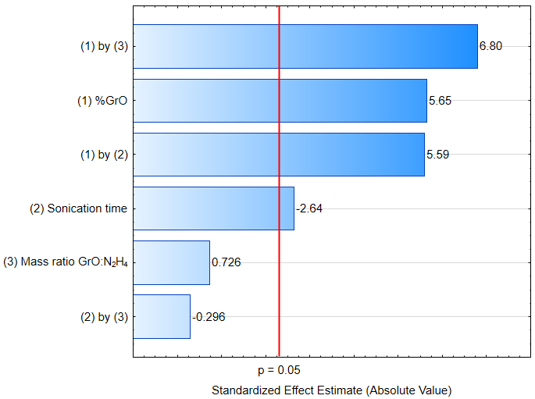

The conditions for the experiments along the path of steepest ascent were defined by taking the greatest factor coefficient (absolute value) as a reference, which was the one for %GrO (5.25). Therefore, for each increase in %GrO (${∆x}_{\%GrO}$), a correspondent decrease in the sonication time was calculated (${∆x}_{sonication time}$), taking into consideration the other factor coefficient (2.45), as shown in Equation SM4 (coded factors). The experiments performed in real units and their respective responses are shown in Table SM2.

 | $${∆x}_{sonication time}=\frac{5.25}{2.45}{∆x}_{\%GrO}$$ | (SM4)

Table SM2 – Path of steepest ascent
Run # | %GrO | Sonication  time (min:s) | Removal  (%)
9 | 7 | 15:00 | 24.1
10 | 10 | 12:40 | 37.7
11 | 13 | 10:20 | 57.5
12 | 16 | 8:00 | 64.9
13 | 19 | 5:40 | 42.3
14 | 22 | 3:20 | 43.9

As the best BPA removal was achieved in run 12, the respective experimental conditions were used as the central point of a CCD. Table SM3 presents factors, levels, experimental matrix, and results of that design. One adjusted a polynomial (Equation SM5) to the obtained results.

Table SM3 – Factors, levels, experimental matrix, and results of the CCD
Factors |  |  | Levels
 |  |  | Low (−1) |  | High (+1)
%GrO |  |  | 13 |  | 19
Sonication time (min) |  |  | 5 |  | 11
Run # | $$x_{1}$$  %GrO | $$x_{2}$$  sonication  time (min) |  | Removal  (%)
15 | +1.414 | 0 |  | 48.7
16 | 0 | 0 |  | 60.0
17 | 0 | 0 |  | 60.1
18 | −1 | −1 |  | 50.9
19 | +1 | −1 |  | 35.7
20 | 0 | 0 |  | 62.8
21 | −1.414 | 0 |  | 40.5
22 | 0 | +1.414 |  | 53.0
23 | +1 | +1 |  | 43.7
24 | −1 | +1 |  | 40.0
25 | 0 | +1.414 |  | 40.8

 | $$Removal \left(\%\right)=61.0-8.65x_{1}-2.52x_{2}+4.73x_{1}x_{2}-8.98x_{1}^{2}-7.83x_{2}^{2}+5.78x_{1}^{3}$$ | (SM5)
± 0.917 ± 1.78 ± 0.562 ± 0.794 ± 0.669 ± 0.669 ± 1.12

Equation SM5 generates the surface in Figure SM3 (in real units). The model was considered adjusted by an ANOVA (Table SM4) and the Fisher’s statistics. However, as MS_{R}/MS_{r} was not ten times higher than the critical value of F_{6,4}, the model cannot be used as a predictive one [1].

Figure SM3 – CCD response surface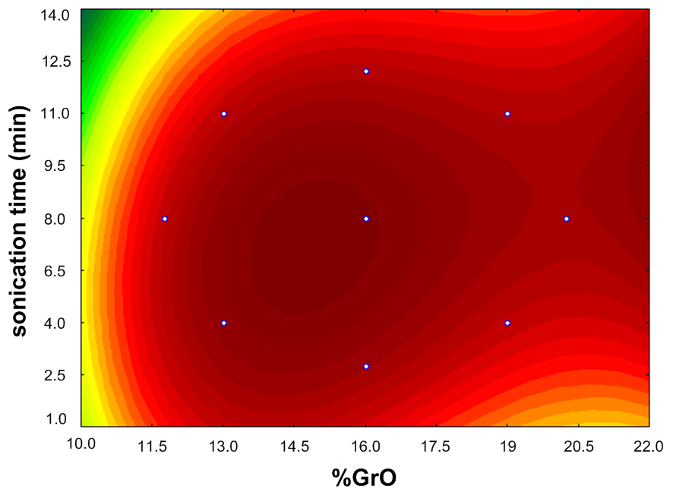

Table SM4 – ANOVA analysis
Variation source | SS | DF | MS
Regression (R) | 828.2 | 6 | 138
Residues (r) | 50.9 | 4
Lack of fit (lof) | 48.85 | 2 | 12.73
Pure error (pe) | 5.047 | 2
Total | 879.1 | 10
% maximum explained variation (R²): |  |  | 0.942
% maximum explanable variation: |  |  | 0.994
MS_{R}/MS_{r} | 10.85
F_{6,4} (critical) | 6.163
MS_{lof}/MS_{pe} | 9.086
F_{2,2} (critical) | 19.00
Note: SS − sum of squares; DF − degrees of freedom; MS − mean square

As the model was well adjusted, its maximum (optimum synthetic conditions) can be estimated: $x_{1}$ = − 0.039 and $x_{2}$ = − 0.26, i.e., %GrO = 15% and sonication time = 7 min e 20 s, respectively.

  - About the characterizations
Figure SM4 – Zeta Potential versus pH curve for the optimized composite

Figure SM5 – EDS (a) distribution and (b) spectrum for g-C₃N₄
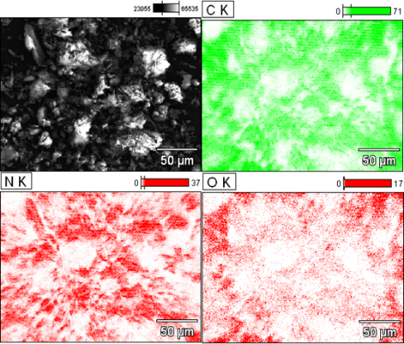 | 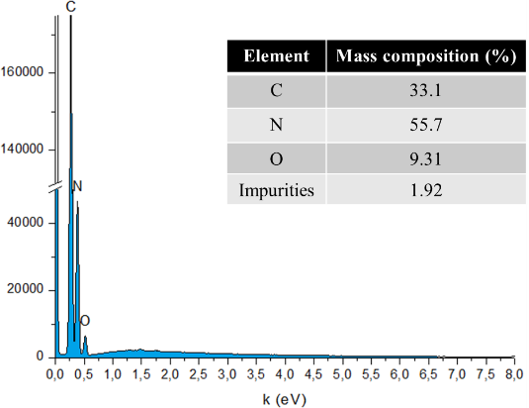
(a) | (b)

Figure SM6 – EDS (a) distribution and (b) spectrum for GrO
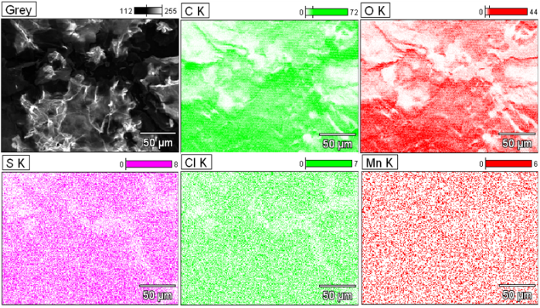 | 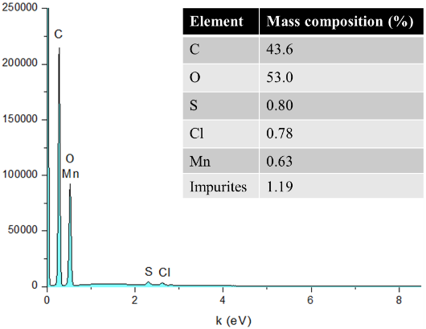
(a) | (b)

The VB and CB potentials for g-C₃N₄ were estimated by the empiric Equations SM6-8 (Mousavi et al., 2016), in which: χ is the eletronegativity of the material; x(I) is the eletronegativity of element I; i is the number of atoms of element I, n is the total number of atoms, and N is the number of different atoms, all of them in the composite empirical formula; $E_{VB}$ and $E_{CB}$ are the potentials of VB and CB bands, respectively; $E^{e}$ is the (constant) energy of the free electrons measured against the Normal Hydrogen Electrode (NHE), whose value is 4.5 eV; and $E_{g}$ is the (measured) energy of the band gap.

 | $$χ=\sqrt[\sum_{i=1}^{n}{i}]{\prod_{j=1}^{N}{{x\left(I_{j}\right)}^{i_{I_{j}}}}}$$ | (SM6)
 | $E_{CB}$= χ − $E^{e}$− 0.5$E_{g}$ | (SM7)
 | $E_{VB}$= $E_{CB}$ + $E_{g}$ | (SM8)

2.4 Regarding the degradation products identification and ecotoxicity

Figure SM7 – Mass Spectra for BPA, DP1, and DP2
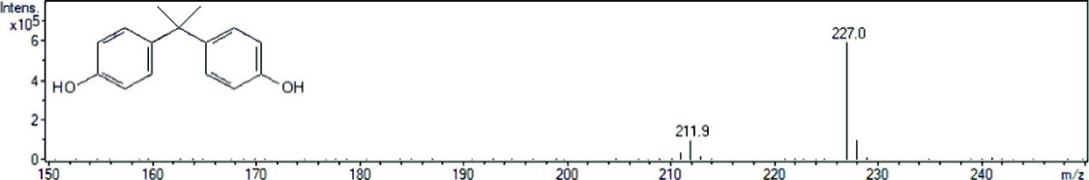
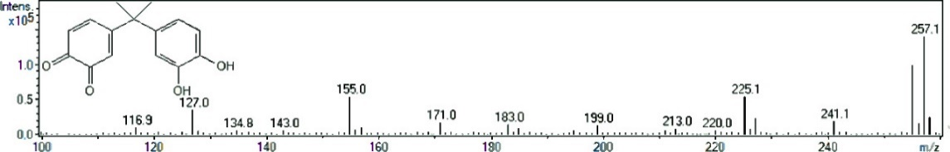
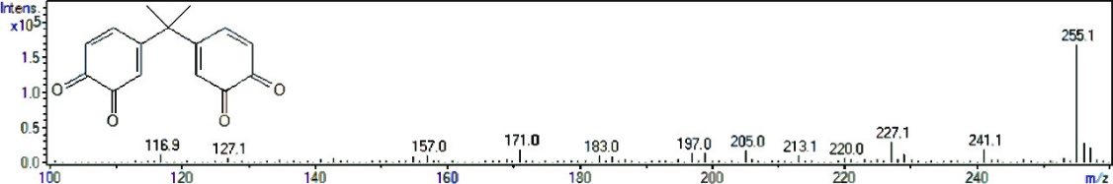

REFERENCES

[1] R. E. Bruns, I. S. Scaramino, B Barros Neto. Statistical Design – Chemometrics. First edition, Elsevier: Amsterdam, 422 p., 2006. ISBN-13: 978-0444521811

[2] H. Khan, M. G. Rigamonti, G. S. Patience, D. C. Boffito. Spray dried TiO₂/WO₃ heterostructure for photocatalytic applications with residual activity in the dark. Appl. Catal. B-Environ., 226 (2017), 311-323. DOI: 10.1016/j.apcatb.2017.12.049

[3] M. Mousavi, A. Habibi-Yangjeh, M. Abitorabi. Fabrication of novel magnetically separable nanocomposites using graphitic carbon nitride, silver phosphate and silver chloride and their applications in photocatalytic removal of different pollutants using visible-light irradiation. J. Colloid Interf. Sci., 480 (2016), 218-231. DOI: 10.1016/j.jcis.2016.07.021

