Extended Data Information for:

Abiotic nitrous oxide formation driven by sunlight in fresh and marine waters
Elizabeth Leon-Palmero^{12*}, Rafael Morales-Baquero¹, Bo Thamdrup², Carolin Löscher², and Isabel Reche^{1,3}
¹Departamento de Ecología, Universidad de Granada, E-18071 Granada, Spain
²Nordcee, Department of Biology, University of Southern Denmark, E-5230, Odense, Denmark
³Research Unit Modeling Nature (MNat), Universidad de Granada, E-18071 Granada, Spain
*Current address: Department of Geosciences, Princeton University, E-08544 Princeton, NJ, USA
Correspondence should be addressed to EL-P (email: el23@princeton.edu)

Content:

Extended Data Figs. 1 – 6

Extended Data Tables 1 – 4

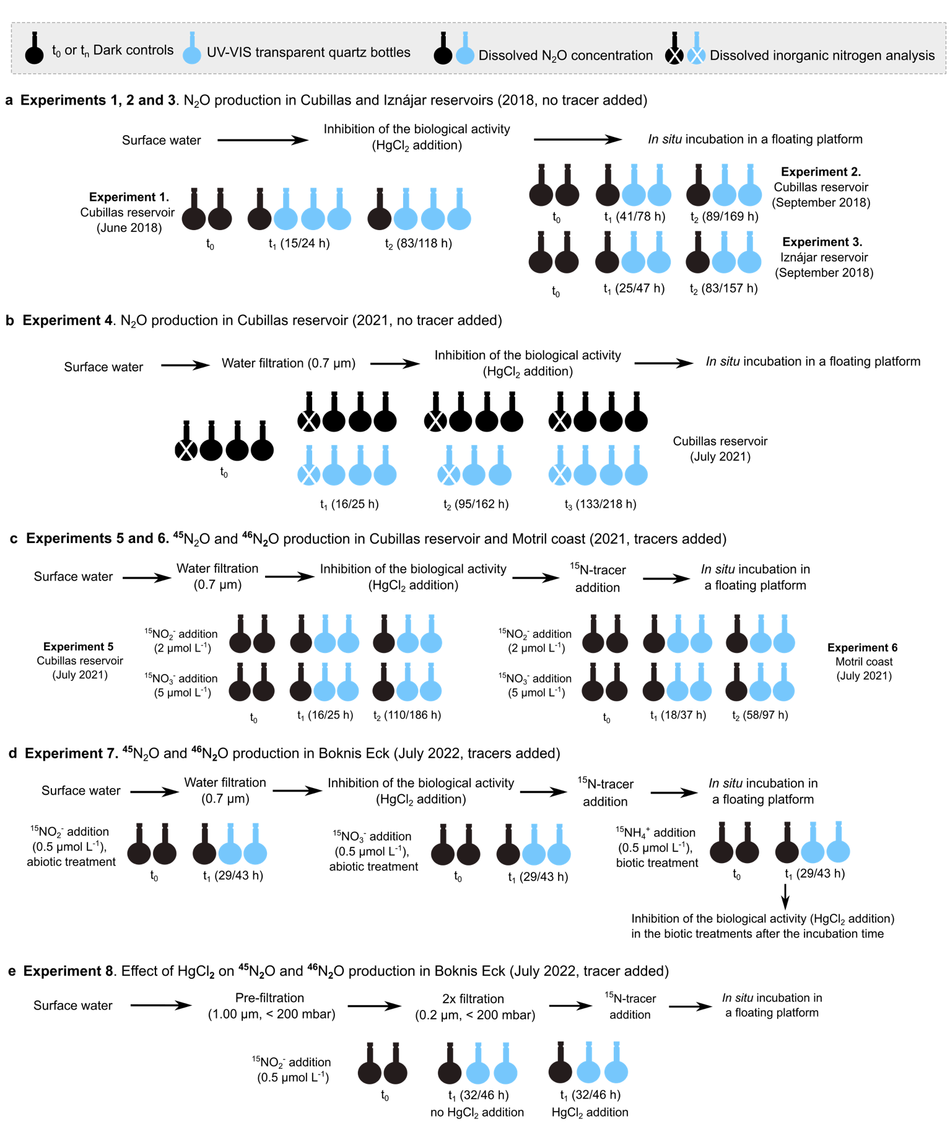

Extended Data Figure 1 | Scheme of the experimental design and procedure. We performed experiments 1 to 4 to measure the effect of sunlight on N₂O concentration, experiments 5 to 7 to measure the effect of sunlight on ⁴⁵N₂O and ⁴⁶N₂O concentrations using ¹⁵N-labelled substrates, and experiment 8 to test the effect of HgCl₂ on the N₂O photoproduction rates. We used dark controls and sunlight treatments over a time course in all experiments. Sunlight hours and total incubation hours are shown (e.g., 15/24 h). More details are provided in the Method section and in the main text.

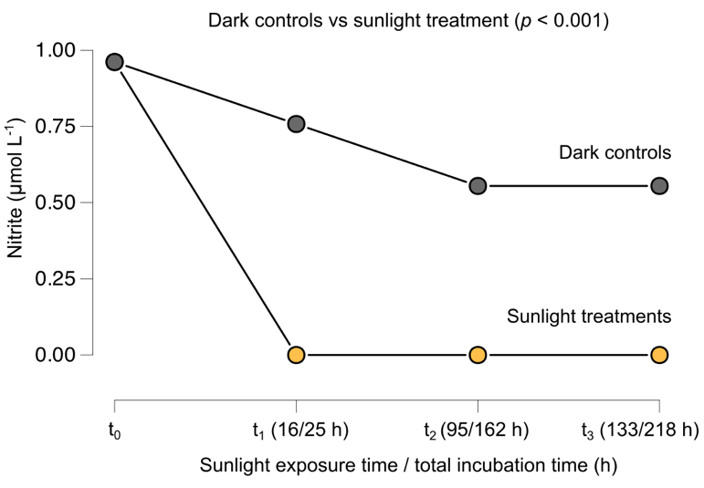

Extended Data Figure 2 | Effect of sunlight on nitrite concentration over time. Dissolved nitrite concentrations over time in the incubation experiment 4 (i.e., sunlight/total incubation hours), performed in Cubillas in July 2021. We show dark controls in dark grey and sunlight treatments in yellow. Nitrite concentration was below detection limit (0.50 µmol L⁻¹) in the sunlight treatments (t₁ – t₃). The differences between sunlight treatments and dark controls were significant (p < 0.001). The decrease over time in the dark controls was not significant (p = 0.39).

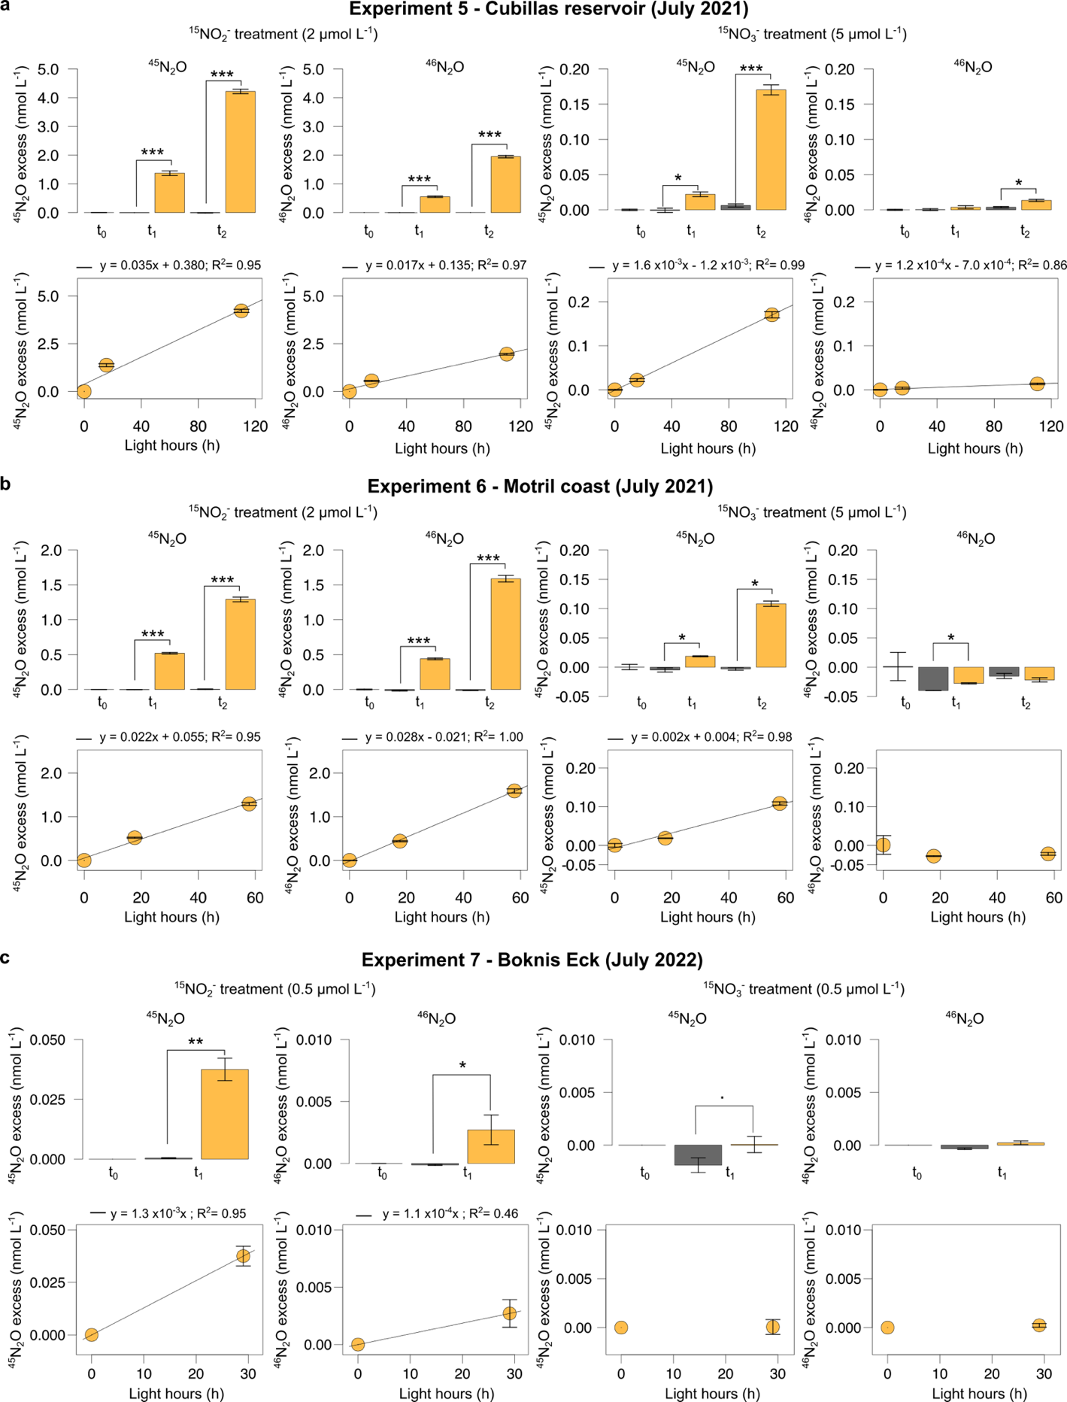

Extended Data Figure 3 | Photoproduction of ⁴⁵N₂O and ⁴⁶N₂O from ¹⁵N-NO₂⁻ and ¹⁵N-NO₃⁻. ⁴⁵N₂O and ⁴⁶N₂O excess (nmol L⁻¹) over time (light hours) in the incubation experiments in (a) Cubillas reservoir, (b) Motril coast, and (c) Boknis Eck. Bars represents the mean values ± standard errors over the time course (t₀-t₂), including dark controls (dark grey bars) and sunlight treatments (yellow bars). Linear regression analyses are shown below each barplot. Note the different scales in the y axes. The significance of the sunlight treatments is included for each experiment: . stands for p<0.1; * stands for p < 0.05; ** stands for p < 0.01; and *** stands for p < 0.001. The photoproduction rates as function of the area, volume and radiation are presented in Extended Data Table 3, and the statistical details in Supplementary Table 2.

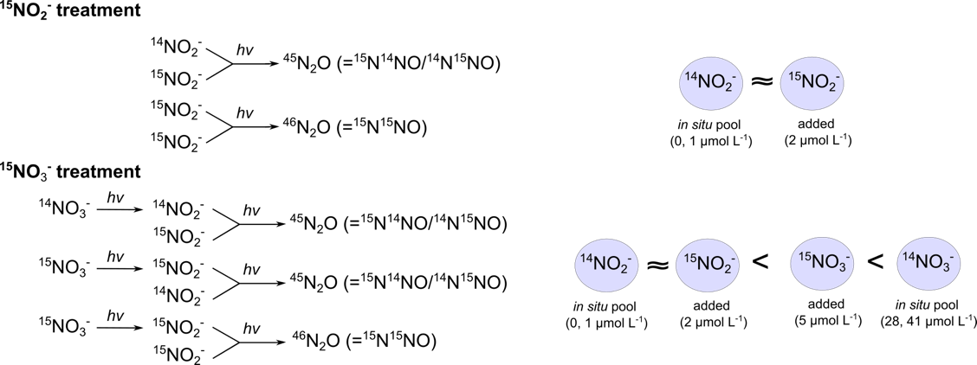

Extended Data Figure 4 | Scheme of the reactions explaining the formation of ⁴⁵N₂O and ⁴⁶N₂O from ¹⁵NO₂⁻ and ¹⁵NO₃⁻ in experiments 5 and 6 (Cubillas reservoir and Motril coast in July 2021). The differences detected in the production of ⁴⁵N₂O and ⁴⁶N₂O in experiments 5 and 6, despite using the same amount of tracer, may be driven by the differences in the in situ ¹⁴N-NO₂⁻ and ¹⁴N-NO₃⁻ availabilities. While the production of ⁴⁵N₂O from ¹⁵N-NO₂⁻ was higher in experiment 5, the production of ⁴⁵N₂O from ¹⁵N-NO₃⁻ were greater in experiment 6. The production of ⁴⁶N₂O from ¹⁵N-NO₂⁻ was similar between both systems, but the ⁴⁶N₂O production from ¹⁵N-NO₃⁻ was only significant in experiment 5. in situ nitrite concentration was higher in the Cubillas reservoir than in the Motril coast, while nitrate showed the opposite trend.

Extended Data Figure 5 | The effect of HgCl₂ on the photoproduction rates from ¹⁵N-NO₂⁻. ⁴⁵N₂O (a) and ⁴⁶N₂O (b) excess (nmol L⁻¹) over time (i.e., light hours) in the incubation experiments. Bars represents the mean values ± standard errors over the time course (t₀-t₁), including dark controls (dark grey bars) and sunlight treatments without HgCl₂ (dark yellow bars) and with HgCl₂ (light yellow bars). The significant effects were included for each experiment: * stands for p < 0.05. Statistical details are provided in Supplementary Table 3.

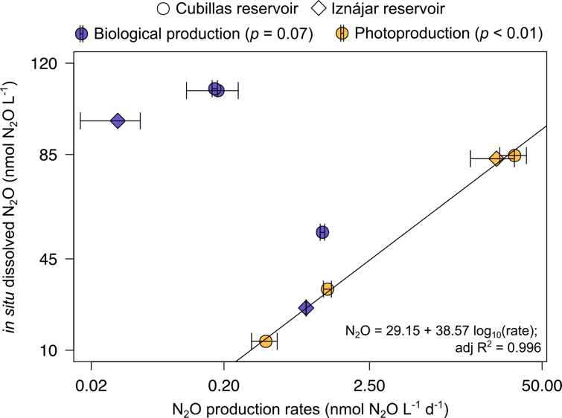

Extended Data Figure 6 | In situ N₂O concentration (nmol N₂O L⁻¹ d⁻¹) in Cubillas and Iznájar reservoirs as function of N₂O production rates (nmol N₂O L⁻¹ d⁻¹) by ammonia oxidation (purple), and by abiotic N₂O photoproduction (yellow). Only experiments 1 to 4 were included in the analysis.

Extended Data Table 1 | Date, location, and basic description of the experiments mentioned along this work. in situ salinity (psu) and inorganic nitrogen concentrations (μmol L⁻¹) are also shown. < DL = below detection level.
Experiment | Date | Study system | Incubation location | Salinity (psu) | NO₃⁻ (μmol L⁻¹) | NO₂⁻ (μmol L⁻¹) | NH₄⁺  (μmol L⁻¹) | Description | Main variable addressed
Experiment 1 | 6/22/2018 | Cubillas reservoir  (37.27ºN, 3.68ºW) | Granada, Spain  (37.18ºN, 3.61ºW) | 0.3 | 375.5* | 13.8* | 1.6* | No tracer used, abiotic rates | N₂O conc.
Experiment 2 | 9/4/2018 | Cubillas reservoir  (37.27ºN, 3.68ºW) | Granada, Spain  (37.18ºN, 3.61ºW) | 0.3 | 177.7 | 19.3 | 2.5 | No tracer used, abiotic rates | N₂O conc.
Experiment 3 | 9/9/2018 | Iznájar reservoir  (37.26ºN, 4.33ºW) | Granada, Spain  (37.18ºN, 3.61ºW) | 0.4 | 335.3 | 22.9 | < DL | No tracer used, abiotic rates | N₂O conc.
Experiment 4 | 7/7/2021 | Cubillas reservoir  (37.27ºN, 3.68ºW) | Granada, Spain  (37.18ºN, 3.61ºW) | 0.3 | 28.2 | 1.1 | < DL | No tracer used, abiotic rates | N₂O and NO₂⁻ conc.
Experiment 5 | 7/7/2021 | Cubillas reservoir  (37.27ºN, 3.68ºW) | Granada, Spain  (37.18ºN, 3.61ºW) | 0.3 | 28.2 | 1.1 | < DL | ¹⁵NO₂⁻ and ¹⁵NO₃⁻ used as tracers, abiotic rates | ⁴⁵N₂O and ⁴⁶N₂O conc.
Experiment 6 | 7/19/2021 | Motril coast  (Mediterranean Sea,  36.71ºN, 3.51ºW) | Granada, Spain  (37.18ºN, 3.61ºW) | 37.5 | 41.4 | < DL | < DL | ¹⁵NO₂⁻ and ¹⁵NO₃⁻ used as tracers, abiotic rates | ⁴⁵N₂O and ⁴⁶N₂O conc.
Experiment 7 | 7/1/2022 | Boknis Eck  (Baltic Sea,  54.53ºN, 10.04ºE) | Odense, Denmark  (55.37ºN, 10.43ºE) | 13.9 | < DL | < DL | < DL | ¹⁵NO₂⁻ and ¹⁵NO₃⁻ used as tracers, abiotic rates | ⁴⁵N₂O and ⁴⁶N₂O conc.
Experiment 7 | 7/1/2022 | Boknis Eck  (Baltic Sea,  54.53ºN, 10.04ºE) | Odense, Denmark  (55.37ºN, 10.43ºE) | 13.9 | < DL | < DL | < DL | ¹⁵NH₄⁺ used as tracer, biotic rates
Experiment 8 | 7/1/2022 | Boknis Eck  (Baltic Sea,  54.53ºN, 10.04ºE) | Odense, Denmark  (55.37ºN, 10.43ºE) | 13.9 | < DL | < DL | < DL | ¹⁵NO₂⁻ used as tracer, abiotic rates with and without HgCl₂ | ⁴⁵N₂O and ⁴⁶N₂O conc.
Experiment 9** | 7/4/2018 | Cubillas reservoir  (37.27ºN, 3.68ºW) | Granada, Spain  (37.18ºN, 3.61ºW) | 0.3 | 376 | 13.8 | 1.6 | ¹⁵NH₄⁺ used as tracer, biotic rates | ⁴⁵N₂O and ⁴⁶N₂O conc.
Experiment 9** | 7/9/2018 | Iznájar reservoir  (37.26ºN, 4.33ºW) | Granada, Spain  (37.18ºN, 3.61ºW) | 0.5 | 177.8  and 176.7 | 19.3 | 2.5  and < DL | ¹⁵NH₄⁺ used as tracer, biotic rates | ⁴⁵N₂O and ⁴⁶N₂O conc.
Experiment 9** | 9/4/2018 | Cubillas reservoir  (37.27ºN, 3.68ºW) | Granada, Spain  (37.18ºN, 3.61ºW) | 0.3 | 367.6 | 20.6 | < DL | ¹⁵NH₄⁺ used as tracer, biotic rates | ⁴⁵N₂O and ⁴⁶N₂O conc.
Experiment 9** | 9/7/2018 | Iznájar reservoir  (37.26ºN, 4.33ºW) | Granada, Spain  (37.18ºN, 3.61ºW) | 0.5 | 335.3 | 22.9 | < DL | ¹⁵NH₄⁺ used as tracer, biotic rates | ⁴⁵N₂O and ⁴⁶N₂O conc.
*The N₂O photoproduction rate was measured in Cubillas reservoir in June 2018 (sampling performed on June 22nd), but the in situ concentration of inorganic nitrogen was measured in Cubillas reservoir on July 4th 2018. **Results from Experiment 9 are part of a previous study, and included in this work for comparison²⁶.

Extended Data Table 2 | Concentrations of dissolved inorganic nitrogen and N₂O measured in situ, rates of N₂O photoproduction per volume, area, and UVB and Photosynthetically Active Radiation (PAR) received, and the percentage of increase in N₂O per day. This % corresponds to the production of N₂O per volume in relation to the initial concentration in a day. SE = standard error. n.d. = not determined.

 | In situ concentration |  |  |  | N₂O photoproduction |  |  |  | N₂O per day
 | NO₃⁻ | NO₂⁻ | NH₄⁺ | Dissolved N₂O | $${\text{R}}_{{\text{N-N}}_{\text{2}}\text{O-Volume}}$$ | $${\text{R}}_{{\text{N-N}}_{\text{2}}\text{O-Area}}$$ | $${\text{R}}_{{\text{N-N}}_{\text{2}}\text{O-PAR}}$$ | $${\text{R}}_{{\text{N-N}}_{\text{2}}\text{O-UVB}}$$ | Increase in N₂O per day*
 | µmol L⁻¹ | µmol L⁻¹ | µmol L⁻¹ | nmol L⁻¹  (mean ± SE) | nmol N-N₂O  L⁻¹ d⁻¹ | nmol N-N₂O  m⁻² d⁻¹ | nmol N-N₂O  W⁻¹ PAR | nmol N-N₂O  W⁻¹ UVB | %
Experiment 1 -  Cubillas reservoir (June 2018) | 375.5* | 13.8* | 1.6* | 33.4 ± 0.3 | 2.96 ± 0.20 | 40.58 ± 2.80 | n.d. | n.d. | 4.5
Experiment 2 –  Cubillas reservoir (September 2018) | 177.7 | 19.3 | 2.5 | 84.6 ± 3.2 | 66.56 ± 15.11 | 680.72 ± 154.55 | n.d. | n.d. | 39.3
Experiment 3 –  Iznájar reservoir, (September 2018) | 335.3 | 22.9 | 0.0 | 83.4 ± 0.8 | 47.86 ± 17.44 | 489.49 ± 178.34 | n.d. | n.d. | 28.7
Experiment 4 –  Cubillas reservoir (July 2021) | 28.2 | 1.1 | 0.0 | 13.4 ± 0.2 | 1.01 ± 0.22 | 8.15 ± 1.78 | 2.6 x 10⁻⁹  ± 5.5 x 10⁻¹⁰ | 2.3 x 10⁻⁵  ± 4.6 x 10⁻⁶ | 3.8
*The N₂O photoproduction rate was measured in Cubillas reservoir in June 2018 (sampling performed on June 22nd), but the in situ concentration of inorganic nitrogen was measured in Cubillas reservoir on July 4th.

Extended Data Table 3 | Rates of ¹⁵N-N₂O photoproduction per volume (${\text{R}}_{{\text{N-N}}_{\text{2}}\text{O}}$; nmol N-N₂O L⁻¹ d⁻¹), bottle area (${\text{R}}_{{\text{N-N}}_{\text{2}}\text{O-Area}}$; nmol N-N₂O m⁻² d⁻¹), and solar radiation dose (${\text{R}}_{{\text{N-N}}_{\text{2}}\text{O-PAR}}$ and ${\text{R}}_{{\text{N-N}}_{\text{2}}\text{O-UVB}}$; nmol N-N₂O W⁻¹). UVB radiation was not measured during experiment 7. The samples to measure the biological production of N₂O in experiment 7 were incubated in darkness (covered by aluminum foil) or exposed to a natural day-night cycle, together to the samples for abiotic photoproduction rates. More details in the method section. n.s. = not significant rate. n.d. = not determined.

Experiment | Tracer added  (final concentration) | Incubation | $${\text{R}}_{{\text{N-N}}_{\text{2}}\text{O}}$$  (nmoles N-N₂O L⁻¹ d⁻¹) | ${\text{R}}_{{\text{N-N}}_{\text{2}}\text{O-Area}}$  (nmoles N-N₂O m⁻² d⁻¹) | $${\text{R}}_{{\text{N-N}}_{\text{2}}\text{O-PAR}}$$  (nmoles N-N₂O W⁻¹) | $${\text{R}}_{{\text{N-N}}_{\text{2}}\text{O-UVB}}$$  (nmoles N-N₂O W⁻¹)
Experiment 5 –  Cubillas reservoir, 2021 | ¹⁵N-NO₂⁻  (2 µmol L⁻¹) | Abiotic | 1.586 ± 0.141 | 21.71 ± 1.93 | 5.8 x 10⁻⁸  ± 4.5 x 10⁻⁹ | 5.1 x 10⁻⁴  ± 3.8 x 10⁻⁵
Experiment 5 –  Cubillas reservoir, 2021 | ¹⁵N-NO₃⁻  (5 µmol L⁻¹) | Abiotic | 0.174 ± 0.012 | 2.38 ± 0.17 | 6.7 x 10⁻⁹  ± 4.1 x 10⁻¹⁰ | 5.9 x 10⁻⁵  ± 3.7 x 10⁻⁶
Experiment 6 –  Motril coast, 2021 | ¹⁵N-NO₂⁻  (2 µmol L⁻¹) | Abiotic | 1.132 ± 0.040 | 15.49 ± 0.55 | 4.0 x 10⁻⁸  ± 1.4 x 10⁻⁹ | 3.4 x 10⁻⁴  ± 1.3 x 10⁻⁵
Experiment 6 –  Motril coast, 2021 | ¹⁵N-NO₃⁻  (5 µmol L⁻¹) | Abiotic | 0.263 ± 0.019 | 3.60 ±0.26 | 9.3 x 10⁻⁹  ± 6.4 x 10⁻¹⁰ | 7.9 x 10⁻⁵  ± 5.0 x 10⁻⁶
Experiment 7 –  Boknis Eck, 2022 | ¹⁵N-NO₂⁻  (0.5 µmol L⁻¹) | Abiotic | 0.026 ± 0.003 | 0.11 ± 0.01 | 4.3 x 10⁻⁹  ± 4.9 x 10⁻¹⁰ | n.d.
Experiment 7 –  Boknis Eck, 2022 | ¹⁵N-NO₃⁻  (0.5 µmol L⁻¹) | Abiotic | n.s. |  |  | n.d.
Experiment 7 –  Boknis Eck, 2022 | ¹⁵N-NH₄⁺  (0.5 µmol L⁻¹) | Biotic | 0.015 (± 0.002)(darkness)  0.007 (± 0.002) (day-night cycle) | 0.06 (± 0.01)(darkness)  0.03 (± 0.01) (day-night cycle) | 7.6 x 10⁻¹⁰  ± 1.7 x 10⁻¹⁰  (day-night cycle) | n.d.

Extended Data Table 4 | Increase in N₂O (nmol-N₂O L⁻¹ d⁻¹) per radiation received over time. n.s. = not significant rate determined. n.d. = not determined.

 |  | Increase in N-N₂O per  PAR radiation dose (W m⁻²) |  |  | Increase in N-N₂O per  UVB radiation dose (W m⁻²)
 |  | Slope ± std. error | adj R² | p value | Slope ± std. error | adj R² | p value
No tracer added | Experiment 4,  Cubillas reservoir, 2021 | 5.9 x 10⁻⁶ ± 1.2 x 10⁻⁶ | 0.69 | < 0.001 | 0.051 ± 0.010 | 0.70 | < 0.001
¹⁵N-NO₂⁻ incubation | Experiment 5,  Cubillas reservoir, 2021 | 6.0 x 10⁻⁶ ± 4.6 x 10⁻⁷ | 0.97 | < 0.001 | 0.053 ± 0.000 | 0.97 | < 0.001
¹⁵N-NO₂⁻ incubation | Experiment 6,  Motril coast, 2021 | 6.4 x 10⁻⁶ ± 1.6 x 10⁻⁷ | 1.00 | < 0.001 | 0.054 ± 0.002 | 1.00 | < 0.001
¹⁵N-NO₂⁻ incubation | Experiment 7,  Boknis Eck, 2022 | 6.9 x 10⁻⁶ ± 1.4 x 10⁻⁶ | 0.89 | < 0.05 | n.d.
 | Experiments 5 – 7 combined | 6.3 x 10⁻⁶ ± 2.4 x 10⁻⁷ | 0.98 | < 0.001 | 0.054 ± 0.002 | 0.98 | < 0.001
¹⁵N-NO₃⁻ incubation | Experiment 5,  Cubillas reservoir, 2021 | 1.6 x 10⁻⁷ ± 8.5 x 10⁻⁹ | 0.99 | < 0.001 | 1.4 x 10⁻³ ± 7.5 x 10⁻⁵ | 0.98 | < 0.001
¹⁵N-NO₃⁻ incubation | Experiment 6,  Motril coast, 2021 | 1.6 x 10⁻⁷ ± 1.1 x 10⁻⁸ | 0.98 | < 0.001 | 1.4 x 10⁻³ ± 8.5 x 10⁻⁵ | 0.98 | < 0.001
¹⁵N-NO₃⁻ incubation | Experiment 7,  Boknis Eck, 2022 | n. s.
¹⁵N-NO₃⁻ incubation | Experiments 5 and 6 combined | 1.6 x 10⁻⁷ ± 5.8 x 10⁻⁹ | 0.99 | < 0.001 | 1.4 x 10⁻³ ± 4.9 x 10⁻⁵ | 0.99 | < 0.001

