Supplementary Information 1 The symbols, sets, and related parameters
- $Φ=\{ϕ_{1},ϕ_{2},⋯,ϕ_{l},⋯,ϕ_{L}\}$ denotes the set consisting of customer l;
- $Q=\{q_{1},q_{2},⋯,q_{l},⋯,q_{L}\}$ denotes the set consisting of demand transportation volume $q_{l}$ by customer l;
- $Q^{'}=\{q_{1}^{'},q_{2}^{'},⋯,q_{l}^{'},⋯,q_{L}^{'}\}$ denotes the set consisting of actual transportation volume $q_{l}^{'}$ by customer l, where the actual transportation volume for each customer is planned based on the service principle of "small first, large later" (we will elaborate on it in the following section)
- $S=\{s_{1},s_{2},⋯,s_{l},⋯,s_{L}\}$ denotes the set consisting of the satisfaction $s_{l}$ by customers l, where $s_{l}=\frac{q_{l}^{'}}{q_{l}},s_{l}ϵ[0,1]$;
- $\overline{S}$ denotes average customer satisfaction and $\overline{S}=\frac{1}{L}\sum_{l=1}^{L}{s_{l}}$;
- q denotes total demand transportation volume and $q=\sum_{l=1}^{L}{q_{l}}$;
- $q^{'}$denotes total actual transportation volume and $q^{'}=\sum_{l=1}^{L}{q_{l}^{'}}$;
- N denotes the set of all transportation nodes i (where O is the start node and D is the end node);
- M denotes the set of all transportation modes m;
- $d_{ij}^{m}$ denotes the distance to move the cargo from node i to node j using transport mode m;
- $c_{ij}^{m}$ and $e_{ij}^{m}$ denote the unit transport cost and unit carbon emission cost to move the cargo from node i to node j using transport mode m, respectively;
- ${ct}_{j}^{mn}$ and ${et}_{j}^{mn}$ denote the unit transfer cost and unit carbon emission cost when the cargo is transferred from mode m to mode n at node j, respectively;
- $τ_{i}$ denotes the moment when the cargo arrives at node i;
- $\left[{ET}_{i},{LT}_{i}\right]$ denotes the time window for the customer to receive the cargo, where ${ET}_{i}$ and ${LT}_{i}$ denote the earliest and latest arrival times acceptable to node i, respectively;
- ${τx}_{ij}^{m}$ denotes the unit transportation time to move the cargo from node i to node j using transport mode m;
- ${τy}_{j}^{mn}$ denotes the unit transfer time when the cargo is transferred from mode m to mode n at node j;
- $v_{m}$ denotes the average driving speed of transportation mode m;
- $τ$ denotes the total transportation time when the cargo from the start node to the end node;
- $τ_{min}$ and $τ_{max}$ denote the minimum and maximum time allowed when the cargo from the start node to the end node, respectively;
- $q_{ij}^{m}$ denotes the maximum transportation capacity to move the cargo from node i to node j using transport mode m;
- ${qt}_{j}^{mn}$denotes the maximum transfer capacity when the cargo is transferred from mode m to mode n at node j;
- C and E denote the maximum value of the total economic cost and carbon emission cost, respectively;
- $c_{1}$denotes the unit inventory cost when cargo arrive earlier than the customer's requested time;
- $c_{2}$ denotes the unit penalty cost when cargo arrive later than the customer's requested time;
- 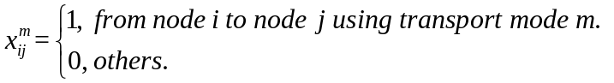;
- 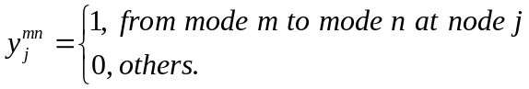.

Supplementary Information 2 Calculation of various types of costs
1. Economic cost
Economic efficiency is the key element to maintain the normal operation of the enterprise, but also one of the key assessment indicators of the enterprise. Transportation cost account for a large proportion of the total logistics costs, and reasonable routes can effectively reduce the total economic expenditure and improve the economic efficiency for logistics enterprises. Therefore, we mainly consider the transportation cost between the nodes, the transfer cost at the nodes and the time window penalty cost generated by not arriving within the specified time.
(1) Transportation cost
The transportation cost for multimodal transportation is the economic cost incurred by the customer's actual transportation volume $q_{l}^{'}$ between two different nodes through transportation mode m. The unit transportation cost $c_{ij}^{m}$is determined by the current transportation mode m and distance $d_{ij}^{m}$. Therefore, we obtain the calculation method of transportation cost through the positive correlation between transportation cost and transportation distance as shown in Eq. (1),
$y_{1}=\sum_{l=1}^{L}{q_{l}^{'}}{∙c}_{ij}^{m}∙d_{ij}^{m}$ (S.1)
(2) Transfer cost
The composition of transfer cost is relatively complex, including cargo loading and unloading costs and waiting (inventory) cost. For ease of calculation, we calculate the transfer cost based on unit transfer cost $ct_{j}^{mn}$ and actual transportation volume $q_{l}^{'}$, as shown in Eq. (2),
$y_{2}=\sum_{l=1}^{L}{q_{l}^{'}}∙ct_{j}^{mn}$ (S.2)
(3) Time window penalty cost
To ensure that inventory levels are controlled within a safe range, the receiving party usually sets a time window for the delivery of cargo, known as the receiving time window. If the cargo arrived earlier than the receiving time window, there will be an inventory cost; otherwise, there will be a penalty cost. The calculation method for the time window penalty cost is shown in Eq. (3),
$y_{3}=\sum_{l=1}^{L}{q_{l}^{'}}.\left[c_{1}∙\max\left({ET}_{i}-τ_{i},0\right)+c_{2}∙\max\left(τ_{i}-{LT}_{i},0\right)\right]$ (S.3)
2. Carbon emission cost
Multimodal transportation mainly includes transportation, transfer, and warehousing links. The carbon emissions in the warehousing link can be ignored. Therefore, we will focus on analyzing the carbon emissions generated in transportation and transfer links. We use the "emission factor method" to measure carbon emissions. That is, carbon emissions = activity data * emission factors.
Therefore, the carbon emission cost $e_{1}=\sum_{l=1}^{L}{q_{l}^{'}}.d_{ij}^{m}{.e}_{ij}^{m}$and $e_{2}=\sum_{l=1}^{L}{q_{l}^{'}}.y_{j}^{mn}.et_{j}^{mn}$ in the transportation and transfer links, respectively.
3. Time cost
The transportation, transfer, and warehousing links of multimodal transportation all consume a lot of time. For ease of calculation, we mainly consider the time spent on transportation and transfer links. Since data on the transportation time ${τx}_{ij}^{m}$ are not easily available, we calculated an approximate transportation time ${{τx}_{ij}^{m}=d}_{ij}^{m}$/$v_{m}$ based on distance $d_{ij}^{m}$ and transportation speed $v_{m}$.
4. Customer satisfaction
With the continuous improvement of socio-economic level, customer demands are also developing towards diversification. Customer satisfaction has also become an important indicator pursued by the transportation service industry. Therefore, we defined a calculation method for customer satisfaction based on the satisfaction of customer demands. Without losing generality, we assume that the set of customers l is $Φ=\{ϕ_{1},ϕ_{2},⋯,ϕ_{l},⋯,ϕ_{L}\}$; the set consisting of demand transportation volume $q_{l}$ by customer l is $Q=\{q_{1},q_{2},⋯,q_{l},⋯,q_{L}\}$; the set consisting of actual transportation volume $q_{l}^{'}$ by customer l is $Q^{'}=\{q_{1}^{'},q_{2}^{'},⋯,q_{l}^{'},⋯,q_{L}^{'}\}$. Then, customer satisfaction of customer l can be defined as $s_{l}=\frac{q_{l}^{'}}{q_{l}},s_{l}ϵ[0,1]$. Therefore, the set consisting of the satisfaction $s_{l}$ by customers l is $S=\{s_{1},s_{2},⋯,s_{l},⋯,s_{L}\}$; the average satisfaction of customer l is $\overline{S}=\frac{1}{L}\sum_{l=1}^{L}{s_{l}}$.
It is worth noting that to ensure the highest possible average customer satisfaction, when the actual total transportation volume cannot meet the demand total transportation volume, we adopt the service principle of "small first, large later" (i.e. satisfying customers with small transportation volume first, and then satisfying customers with large transportation volume) to plan the actual transportation volume of customers. Next, we will use a simple example to illustrate the basic principle of the "small first, big later" service principle. When L=3, assume $Q=\{1,3,5\}$. If the actual total transportation volume $q_{l}^{'}$= 8 at this time. then we can have the following two transportation methods.
(1) "small first, large later":${Q_{1}}^{'}=\{1,3,4\}$; (2) "large first, small later":${Q_{2}}^{'}=\{0,3,5\}$. Correspondingly,$S_{1}=\{1,1,4/5\};S_{2}=\{0,1,1\}$. Then,$\overline{S_{1}}$=14/15,$\overline{S_{2}}$=10/15. Obviously, $\overline{S_{1}}>\overline{S_{2}}$. Therefore, when the actual total transportation volume cannot meet the demand total transportation volume, we follow the principle of "small first, large later" for transportation planning.

Supplementary Information 3 Tables
Supplementary table 1
when $M$=3, the IGD values of different algorithms on the test problems
Problem | $$M$$ | $$D$$ | NSGAIII | MOEAD | MaOEACSS | RVEA | MOEADAWA | FONSGAIII
DTLZ1 | 3 | 54 | 8.1466e+1 - | 9.2935e+1 - | 5.8109e+1 - | 1.2639e+2 - | 8.0319e+1 - | 7.12E+00
DTLZ2 | 3 | 54 | 5.5509e-2 - | 5.6577e-2 - | 5.6873e-2 - | 5.7209e-2 - | 5.5832e-2 - | 5.47E-02
DTLZ3 | 3 | 54 | 2.2292e+2 - | 3.3506e+2 - | 2.1925e+2 - | 4.0832e+2 - | 2.4054e+2 - | 2.37E+01
DTLZ4 | 3 | 54 | 2.1787e-1 - | 5.4733e-1 - | 5.7506e-2 + | 9.1554e-2 - | 2.5003e-1 - | 7.10E-02
DTLZ5 | 3 | 54 | 1.5395e-2 - | 3.1646e-2 - | 2.2548e-2 - | 9.6448e-2 - | 1.2446e-2 + | 1.36E-02
DTLZ6 | 3 | 54 | 5.6006e+0 - | 1.2640e+1 - | 2.8253e+0 - | 6.6185e+0 - | 4.7968e+0 - | 1.77E+00
DTLZ7 | 3 | 54 | 9.3800e-2 - | 1.9796e-1 - | 1.0209e-1 - | 1.8867e-1 - | 1.3862e-1 - | 8.41E-02
MaF1 | 3 | 54 | 6.4280e-2 = | 7.0596e-2 - | 4.7244e-2 + | 8.2625e-2 - | 6.2247e-2 + | 6.35E-02
MaF2 | 3 | 54 | 3.8640e-2 - | 5.5208e-2 - | 3.1173e-2 + | 4.4728e-2 - | 4.0341e-2 - | 3.59E-02
MaF3 | 3 | 54 | 6.1845e+4 - | 3.1066e+4 - | 8.4788e+4 - | 1.2212e+5 - | 5.7684e+4 - | 4.67E-02
MaF4 | 3 | 54 | 7.4265e+2 - | 5.6884e+2 - | 6.4337e+2 - | 8.3874e+2 - | 7.2945e+2 - | 3.75E-01
MaF5 | 3 | 54 | 8.2023e-1 - | 2.1378e+0 - | 3.5560e-1 - | 2.8792e-1 + | 5.3734e-1 - | 3.22E-01
MaF6 | 3 | 54 | 3.1504e-2 - | 3.4362e-1 - | 2.3419e-1 - | 5.8256e-1 - | 3.4698e-2 - | 1.90E-02
MaF7 | 3 | 54 | 9.3828e-2 - | 1.5416e-1 - | 1.0260e-1 - | 1.9056e-1 - | 1.3487e-1 - | 7.72E-02
+/-/= |  |  | 0/13/1 | 0/14/0 | 3/11/0 | 1/13/0 | 2/12/0
Supplementary table 2
when $M$=4, the IGD values of different algorithms on the test problems
Problem | $$M$$ | $$D$$ | NSGAIII | MOEAD | MaOEACSS | RVEA | MOEADAWA | FONSGAIII
DTLZ1 | 4 | 54 | 9.2071e+1 - | 7.5908e+1 - | 3.0819e+1 - | 7.7042e+1 - | 6.7245e+1 - | 4.12E-02
DTLZ2 | 4 | 54 | 1.2212e-1 - | 1.2210e-1 - | 1.2004e-1 + | 1.2196e-1 - | 1.2061e-1 + | 1.21E-01
DTLZ3 | 4 | 54 | 1.9950e+2 - | 2.8312e+2 - | 1.4544e+2 - | 2.8388e+2 - | 1.8327e+2 - | 1.22E-01
DTLZ4 | 4 | 54 | 1.8921e-1 = | 5.9569e-1 - | 1.2266e-1 = | 1.3314e-1 - | 4.2943e-1 - | 1.23E-01
DTLZ5 | 4 | 54 | 7.8683e-2 - | 2.7305e-2 + | 3.3624e-2 + | 1.9287e-1 - | 5.9866e-2 - | 4.67E-02
DTLZ6 | 4 | 54 | 6.4838e+0 - | 9.2066e+0 - | 3.3792e-1 - | 3.1659e+0 - | 6.7032e-1 - | 9.10E-02
DTLZ7 | 4 | 54 | 2.0247e-1 - | 3.7274e-1 - | 2.0745e-1 - | 2.8019e-1 - | 3.0489e-1 - | 1.83E-01
MaF1 | 4 | 54 | 1.5499e-1 = | 1.8625e-1 = | 8.6435e-2 + | 1.7686e-1 - | 1.3192e-1 + | 1.54E-01
MaF2 | 4 | 54 | 9.1137e-2 - | 9.3391e-2 - | 6.2245e-2 + | 9.4215e-2 - | 9.0518e-2 - | 8.54E-02
MaF3 | 4 | 54 | 4.0599e+4 - | 4.9988e+3 - | 4.5284e+4 - | 5.3478e+4 - | 8.4448e+3 - | 6.47E-02
MaF4 | 4 | 54 | 1.3323e+3 - | 3.6094e+2 - | 9.3525e+2 - | 1.4069e+3 - | 9.2210e+2 - | 1.17E+00
MaF5 | 4 | 54 | 1.1791e+0 - | 3.7350e+0 - | 1.4248e+0 - | 1.1638e+0 - | 1.9165e+0 - | 9.07E-01
MaF6 | 4 | 54 | 6.7796e+0 - | 4.2770e-1 - | 2.7805e-1 - | 1.7446e-1 - | 2.0319e-2 + | 3.32E-02
MaF7 | 4 | 54 | 2.0452e-1 - | 3.7287e-1 - | 2.0499e-1 - | 2.8020e-1 - | 3.0415e-1 - | 1.77E-01
+/-/= |  |  | 0/12/2 | 1/12/1 | 4/9/1 | 0/14/0 | 3/11/0
Supplementary table 3
Transportation volume required by customers
q | q = 80 | q = 180 | q = 420
The demand transportation volume $q_{l}$ for each customer l | L=1, [80]  L=2, [40,40]  L=3, [10,25,45]  L=4, [5,20,20,35]  L=5, [5,15,16,17,27]  L=6, [4,12,13,13,14,24]  L=7, [4,4,11,12,13,17,19]  L=8, [2,2,8,10,10,12,17,18]  L=9, [2,4,7,9,9,9,11,14,15]  L=10, [2,4,6,8,8,8,8,10,12,14] | L=1, [180]  L=2, [90,90]  L=3, [30,60,90]  L=4, [20,45,45,70]  L=5, [18,36,36,36,54]  L=6, [10,25,30,30,35,50]  L=7, [10,20,25,25,25,35,40]  L=8, [8,12,18,20,20,22,35,45]  L=9, [8,12,18,20,20,20,22,28,32]  L=10, [6,6,6,16,18,18,20,28,30,32] | L=1, [420]  L=2, [210,210]  L=3, [80,140,200]  L=4, [60,105,105,150]  L=5, [42,84,84,84,126]  L=6, [30,60,70,70,80,110]  L=7, [20,20,50,60,70,90,110]  L=8, [18,22,50,55,55,60,70,90]  L=9, [15,15,40,50,50,50,60,65,85]  L=10, [10,12,14,40,42,42,44,70,72,74]
Supplementary table 4
Distance between nodes $d_{ij}^{m}$ (unit: km)
City node | Highway | Railway | Waterway
Nanjing→Shanghai | 394 | 303 | 376
Nanjing→Hangzhou | 352 | 429 | 661
Nanjing→Ningbo | 432 | 628 | 557
Shanghai→Xiamen | 1016 | 1109 | 1185
Shanghai→Fuzhou | 1107 | 1173 | 846
Hangzhou→Xiamen | 874 | 1194 | －
Hangzhou→Fuzhou | 894 | 972 | －
Ningbo→Xiamen | 822 | 795 | 1000
Ningbo→Fuzhou | 554 | 577 | 665
Xiamen→Shantou | 242 | 515 | 237
Xiamen→Zhuhai | 717 | － | 670
Xiamen→Shenzhen | 580 | 456 | 554
Fuzhou→Shantou | 481 | 996 | 574
Fuzhou→Zhuhai | 960 | － | 959
Fuzhou→Shenzhen | 823 | 581 | 837
Shantou→Guangzhou | 439 | 535 | 524
Zhuhai→Guangzhou | 124 | － | 198
Shenzhen→Guangzhou | 136 | 147 | 159
Supplementary table 5
Parameters related to transport
Transport mode | Highway | Railway | Waterway
Unit transport costs $c_{ij}^{m}$ (unit: yuan/t∙km) | 0.4 | 0.3 | 0.15
Unit carbon emissions $e_{ij}^{m}$ (unit: kg/t∙km) | 0.796 | 0.028 | 0.049
Average driving speed $v_{m}$ (unit: h/km) | 76 | 60 | 20
Supplementary table 6
Parameters related to transfer
Transfer mode | Highway－Railway | Railway－Waterway | Highway－Waterway
Unit transfer costs ${ct}_{j}^{mn}$  (unit: yuan/t) | 3.09 | 26.62 | 5.23
Unit carbon emissions ${et}_{j}^{mn}$  (unit: kg/t) | 1.56 | 3.12 | 6
Average transfer time ${ty}_{j}^{mn}$  (unit: h/t) | 1 | 2 | 1
Supplementary table 7
Maximum transportation capacity between nodes $q_{ij}^{m}$
City node | Highway | Railway | Waterway
Nanjing→Shanghai | 160 | 180 | 200
Nanjing→Hangzhou | 190 | 200 | 175
Nanjing→Ningbo | 168 | 190 | 185
Shanghai→Xiamen | 110 | 200 | 210
Shanghai→Fuzhou | 210 | 220 | 190
Hangzhou→Xiamen | 180 | 195 | －
Hangzhou→Fuzhou | 100 | 110 | －
Ningbo→Xiamen | 220 | 230 | 210
Ningbo→Fuzhou | 170 | 140 | 200
Xiamen→Shantou | 150 | 195 | 182
Xiamen→Zhuhai | 90 | － | 100
Xiamen→Shenzhen | 180 | 200 | 210
Fuzhou→Shantou | 230 | 220 | 230
Fuzhou→Zhuhai | 400 | － | 390
Fuzhou→Shenzhen | 220 | 190 | 198
Shantou→Guangzhou | 180 | 220 | 215
Zhuhai→Guangzhou | 215 | 228 | －
Shenzhen→Guangzhou | 200 | 220 | 219

Supplementary table 8
Maximum transfer capacity at the node $q_{j}^{mn}$
City node | Highway－Railway | Railway－Waterway | Highway－Waterway
Nanjing | － | － | －
Shanghai | 200 | 210 | 220
Hangzhou | 170 | 210 | 230
Ningbo | 160 | 190 | 180
Xiamen | 180 | 165 | 210
Fuzhou | 210 | 220 | 180
Shantou | 190 | 180 | 210
Zhuhai | － | 190 | －
Shenzhen | 200 | 190 | 210
Guangzhou | － | － | －
Supplementary table 9
Time window of the node $\left[{ET}_{i},{LT}_{i}\right]$
City node | Shanghai | Hangzhou | Ningbo | Xiamen | Fuzhou | Shantou | Zhuhai | Shenzhen | Guangzhou
Time window | [8, 10] | [15, 20] | [16, 20] | [25, 30] | [27, 32] | [31, 35] | [35, 40] | [33, 38] | [30, 80]
Supplementary table 10
Different settings for weight $β_{m}$
Case | $$β_{1}$$ | $$β_{2}$$ | $$β_{3}$$ | $$β_{4}$$
Ⅰ | 0.25 | 0.25 | 0.25 | 0.25
Ⅱ | 0.4 | 0.2 | 0.2 | 0.2
Ⅲ | 0.2 | 0.4 | 0.2 | 0.2
Ⅳ | 0.2 | 0.2 | 0.4 | 0.2
Ⅴ | 0.2 | 0.2 | 0.2 | 0.4
Supplementary table 11
IDs for different city nodes and transportation modes
City node | Nanjing | Shanghai | Hangzhou | Ningbo | Xiamen
Number | 1 | 2 | 3 | 4 | 5
City node | Fuzhou | Shantou | Zhuhai | Shenzhen | Guangzhou
Number | 6 | 7 | 8 | 9 | 10
Transportation mode | Highway | Railway | Waterway
Number | ① | ② | ③
Supplementary table 12
When q=80 and L=1, the corresponding costs for each transportation scheme
Scheme | $$f_{1}(x)$$ | $$f_{2}(x)$$ | $$f_{3}(x)$$ | $$f_{4}(x)$$ | Transportation route | Transportation mode
1 | 390115.7737 | 1927.116 | 31.8553 | 1 | 1-4-6-7-10 | ①-①-①-①
2 | 2113242.311 | 2193.336 | 213.1974 | 1 | 1-3-6-8-10 | ①-①-①-①
3 | 401919.1684 | 1517.176 | 25.0789 | 1 | 1-3-6-8-10 | ①-①-①-①
4 | 422635.8421 | 1854.68 | 30.6579 | 1 | 1-3-6-8-10 | ①-①-①-①
5 | 1182122.216 | 1746.776 | 111.7211 | 1 | 1-3-6-8-10 | - -①-①-①
Supplementary table 13
when q=80 and L=1，normalized costs for each transportation scheme.
Scheme | $$f_{1}(x)$$ | $$f_{2}(x)$$ | $$f_{3}(x)$$ | $$f_{4}(x)$$ | Transportation route | Transportation mode
1 | 0 | 0.6063 | 0.0360 | 1 | 1-4-6-7-10 | ①-①-①-①
2 | 1 | 1 | 1 | 1 | 1-3-6-8-10 | ①-①-①-①
3 | 0.0068 | 0 | 0 | 1 | 1-3-6-8-10 | ①-①-①-①
4 | 0.0189 | 0.49911 | 0.0297 | 1 | 1-3-6-8-10 | ①-①-①-①
5 | 0.4596 | 0.3396 | 0.4606 | 1 | 1-3-6-8-10 | - -①-①-①
Supplementary table 14
when q=80 and L=1, the optimal transportation plan under different weights $β_{m}$.
Case | $$β_{1}$$ | $$β_{2}$$ | $$β_{3}$$ | $$β_{4}$$ | $$minf(x)$$ | Optimal route | Transportation mode
Ⅰ | 0.25 | 0.25 | 0.25 | 0.25 | 0.2517 | 1-4-6-7-10 | ①-①-①-①
Ⅱ | 0.4 | 0.2 | 0.2 | 0.2 | 0.2027 | 1-4-6-7-10 | ①-①-①-①
Ⅲ | 0.2 | 0.4 | 0.2 | 0.2 | 0.2014 | 1-4-6-7-10 | ①-①-①-①
Ⅳ | 0.2 | 0.2 | 0.4 | 0.2 | 0.2014 | 1-4-6-7-10 | ①-①-①-①
Ⅴ | 0.2 | 0.2 | 0.2 | 0.4 | 0.4014 | 1-4-6-7-10 | ①-①-①-①

Supplementary Information 4 Figures
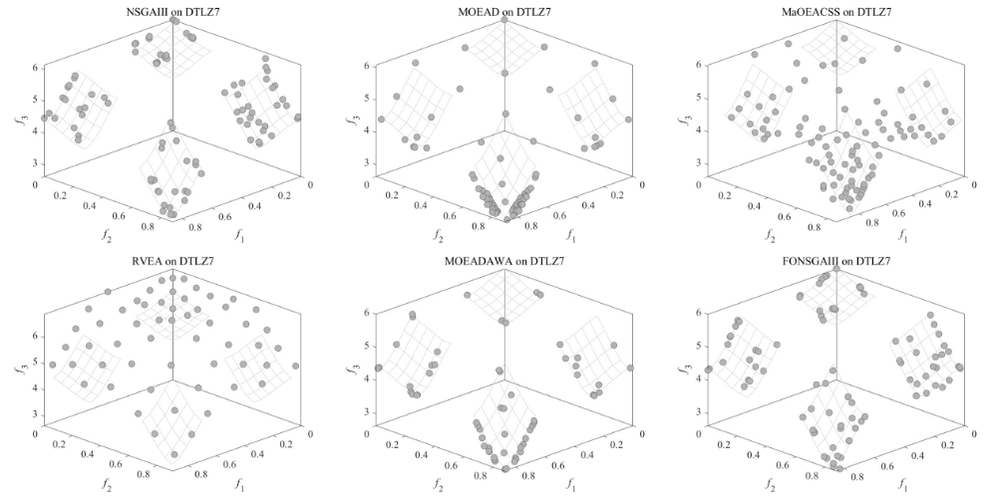
Supplementary figure 1 The final solution distribution of different algorithms on the 3-objective DTLZ7.
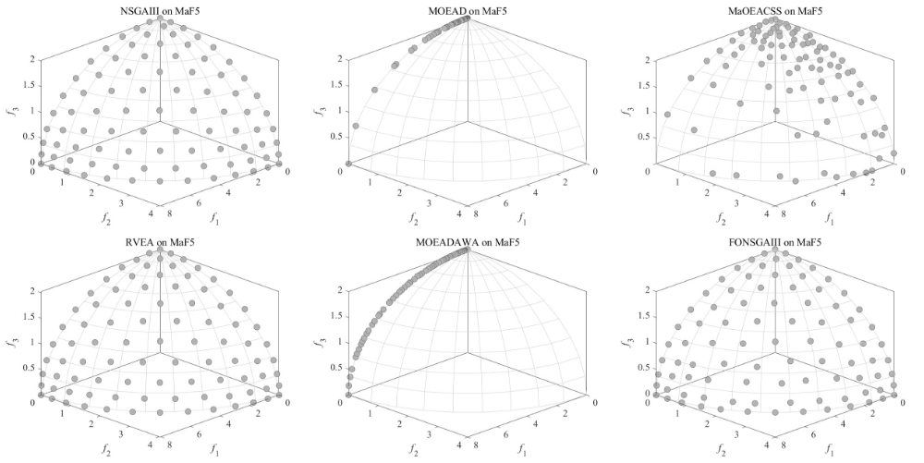
Supplementary figure 2 The final solution distribution of different algorithms on the 3-objective MaF5.
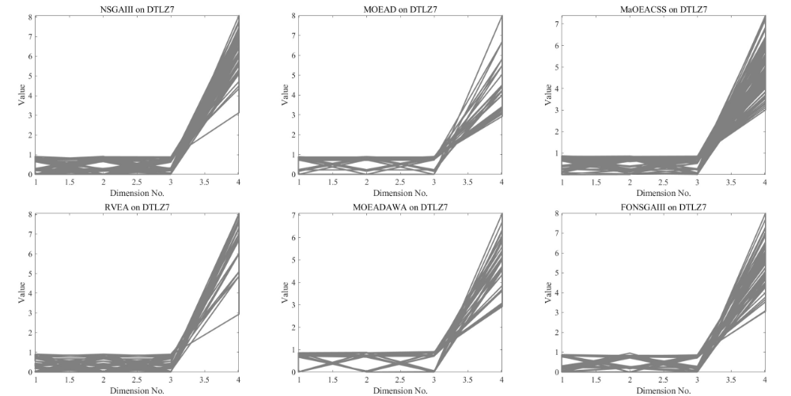
Supplementary figure 3 The final solution distribution of different algorithms on the 4-objective DTLZ7
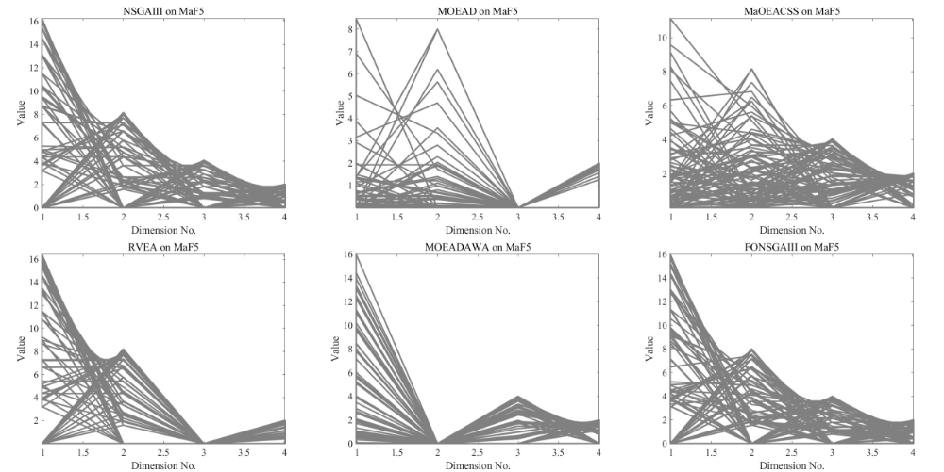
Supplementary figure 4 The final solution distribution of different algorithms on the 4-objective MaF5.

Supplementary figure 5 Schematic diagram of the multimodal transportation network
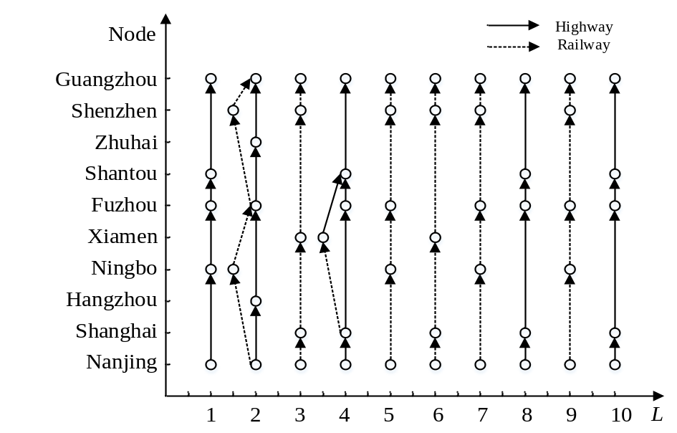
Supplementary figure 6 When q=80, the optimal transportation route for different customers L
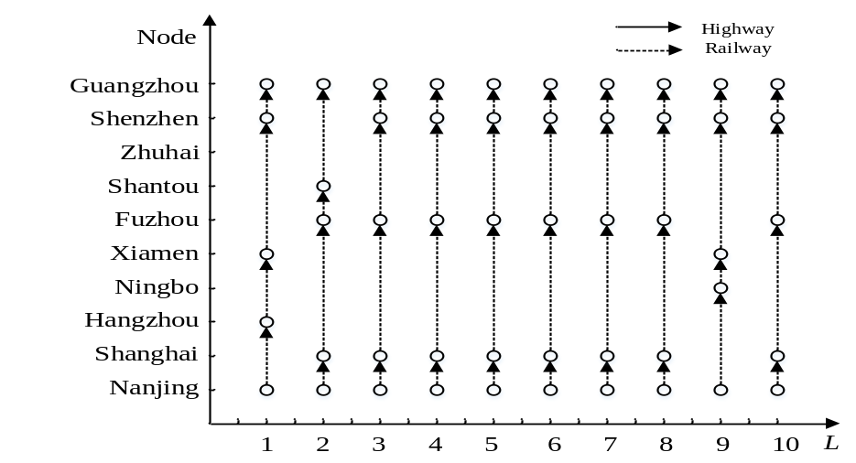
Supplementary figure 7 When q=180, the optimal transportation route for different customers L
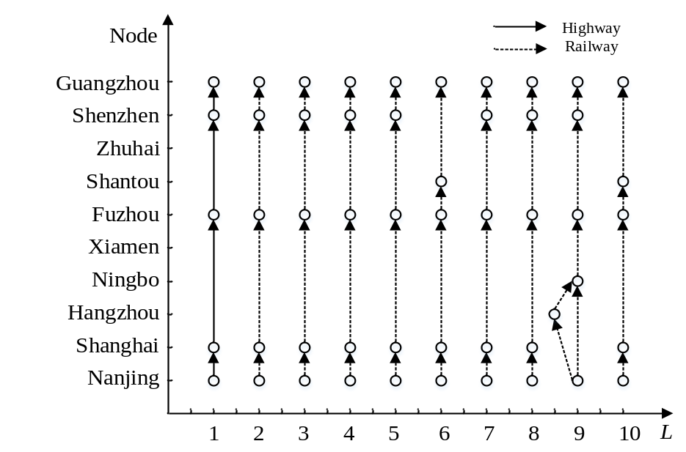
Supplementary figure 8 When q=420, the optimal transportation route for different customers L

