SUPPLEMENTARY FIGURES
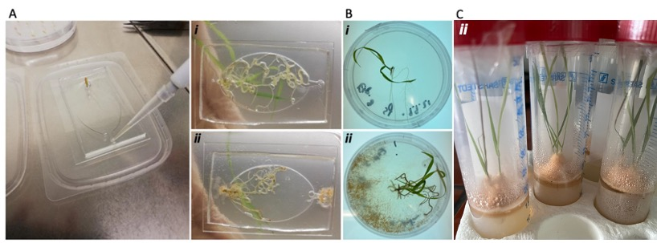
SFig. 1: Co-cultivation of B. distachyon and N. crassa in an EcoFab device with fluid medium (A) and on solid medium in Petri dishes (B) and falcon tubes (C). Uninfected plants (i), infected plants (ii)

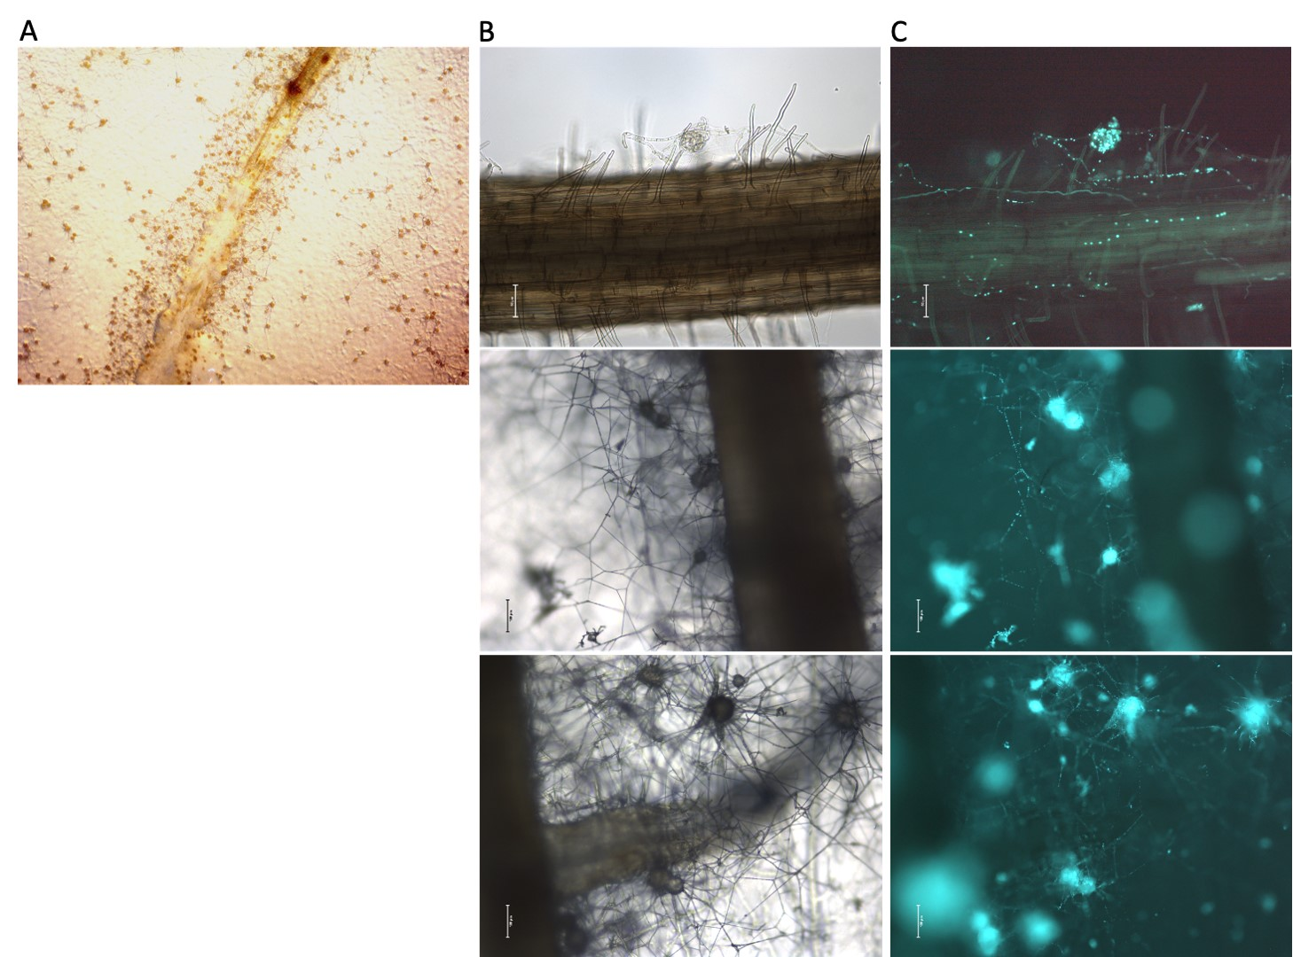
SFig. 2: Extensive proto-perithecia formation of N. crassa FGSC #9518 strain in co-cultivation experiments with B. distachyon. (A) Stereo microscopic image of an infected root at the root hair zone with several proto-perithecia (small spots). (B) Bright-field and (C) fluorescent images of the hyphal network with several proto-perithecia surrounding the plant root.
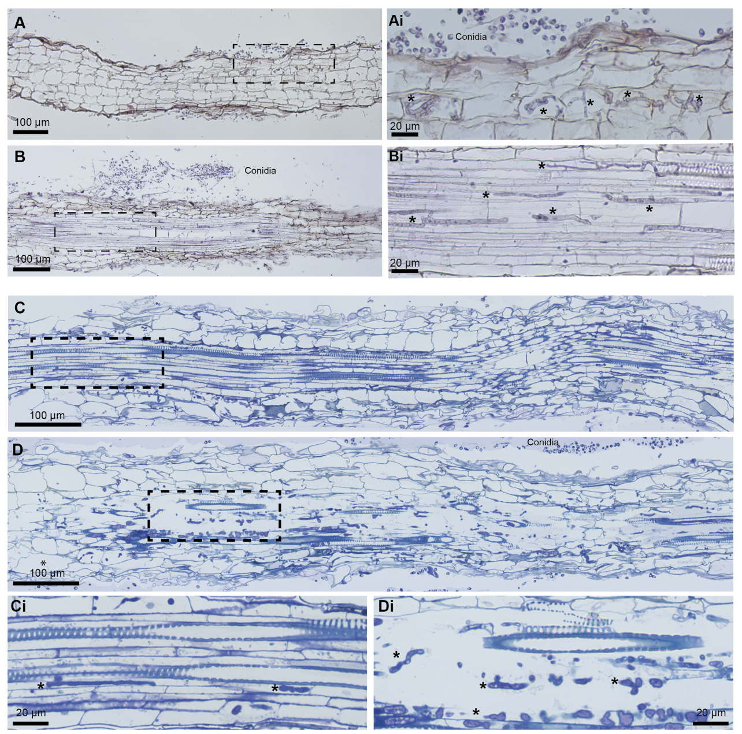
SFig. 3: Histological analysis of B. distachyon roots infected with N. crassa. (A, B) Paraffin sections, 7 μm, stained with hematoxylin and eosin. Conidia outside the root (A, B). Hyphae (*) seen inside a few plant root cortical cells whereas the majority of root cortical cells do not appear to be infected (A). Hyphae (*) growing through the vascular bundle (B). (C, D) Epon sections, 1 μm, stained with Richardson solution. Hyphae (*) growing inside the vascular bundle of a moderately infected root with vascular elements preserved (C), and of a strongly infected root with disrupted vascular elements (D). Xylem elements can be recognized by secondary wall thickenings. Panels (i) display details of boxed areas. Asterisk (*): hypha.

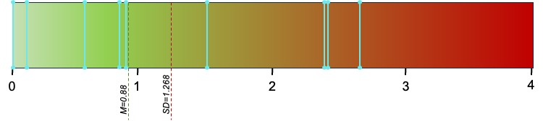
SFig. 4: Extent of vascular bundle colonization of different B. distachyon roots by N. crassa. Blue lines represent individual plant samples. For each plant sample, the extent of infection was evaluated on serial paraffin sections through app. 1 mm long root segments collected up to 1 cm away from the root tip. Two to four segments were analyzed for each plant sample. The score was assigned on a scale from 0 (no hypha) through 4 (extensive growth of hypha). M: median; SD: standard deviation

