Global Basins under Climate Mitigation & Adaptation targets

Muhammad Awais^{1,2}, Adriano Vinca¹, Edward Byers¹, Marina Andrijevic¹, Mathijs Harmsen^{3,4}, Hassan Niazi⁵, Isabela Schmidt Tagomori³, Andrew Rowe², Madeleine McPherson², Volker Krey¹, Keywan Riahi^{1,2,4}
¹ Energy, Climate & Environment Program, International Institute of Applied Systems Analysis, Austria
² Institute for Integrated Energy Systems, University of Victoria, Canada
³ PBL Netherlands Environmental Assessment Agency, The Hague, The Netherland
⁴ Copernicus Institute of Sustainable Development, Utrecht University, The Netherlands
⁵ Joint Global Change Research Institute, Pacific Northwest National Laboratory, College Park, USA
⁶ Technical University Graz, Austria

Correspondence to: Muhammad Awais (awais@iiasa.ac.at)

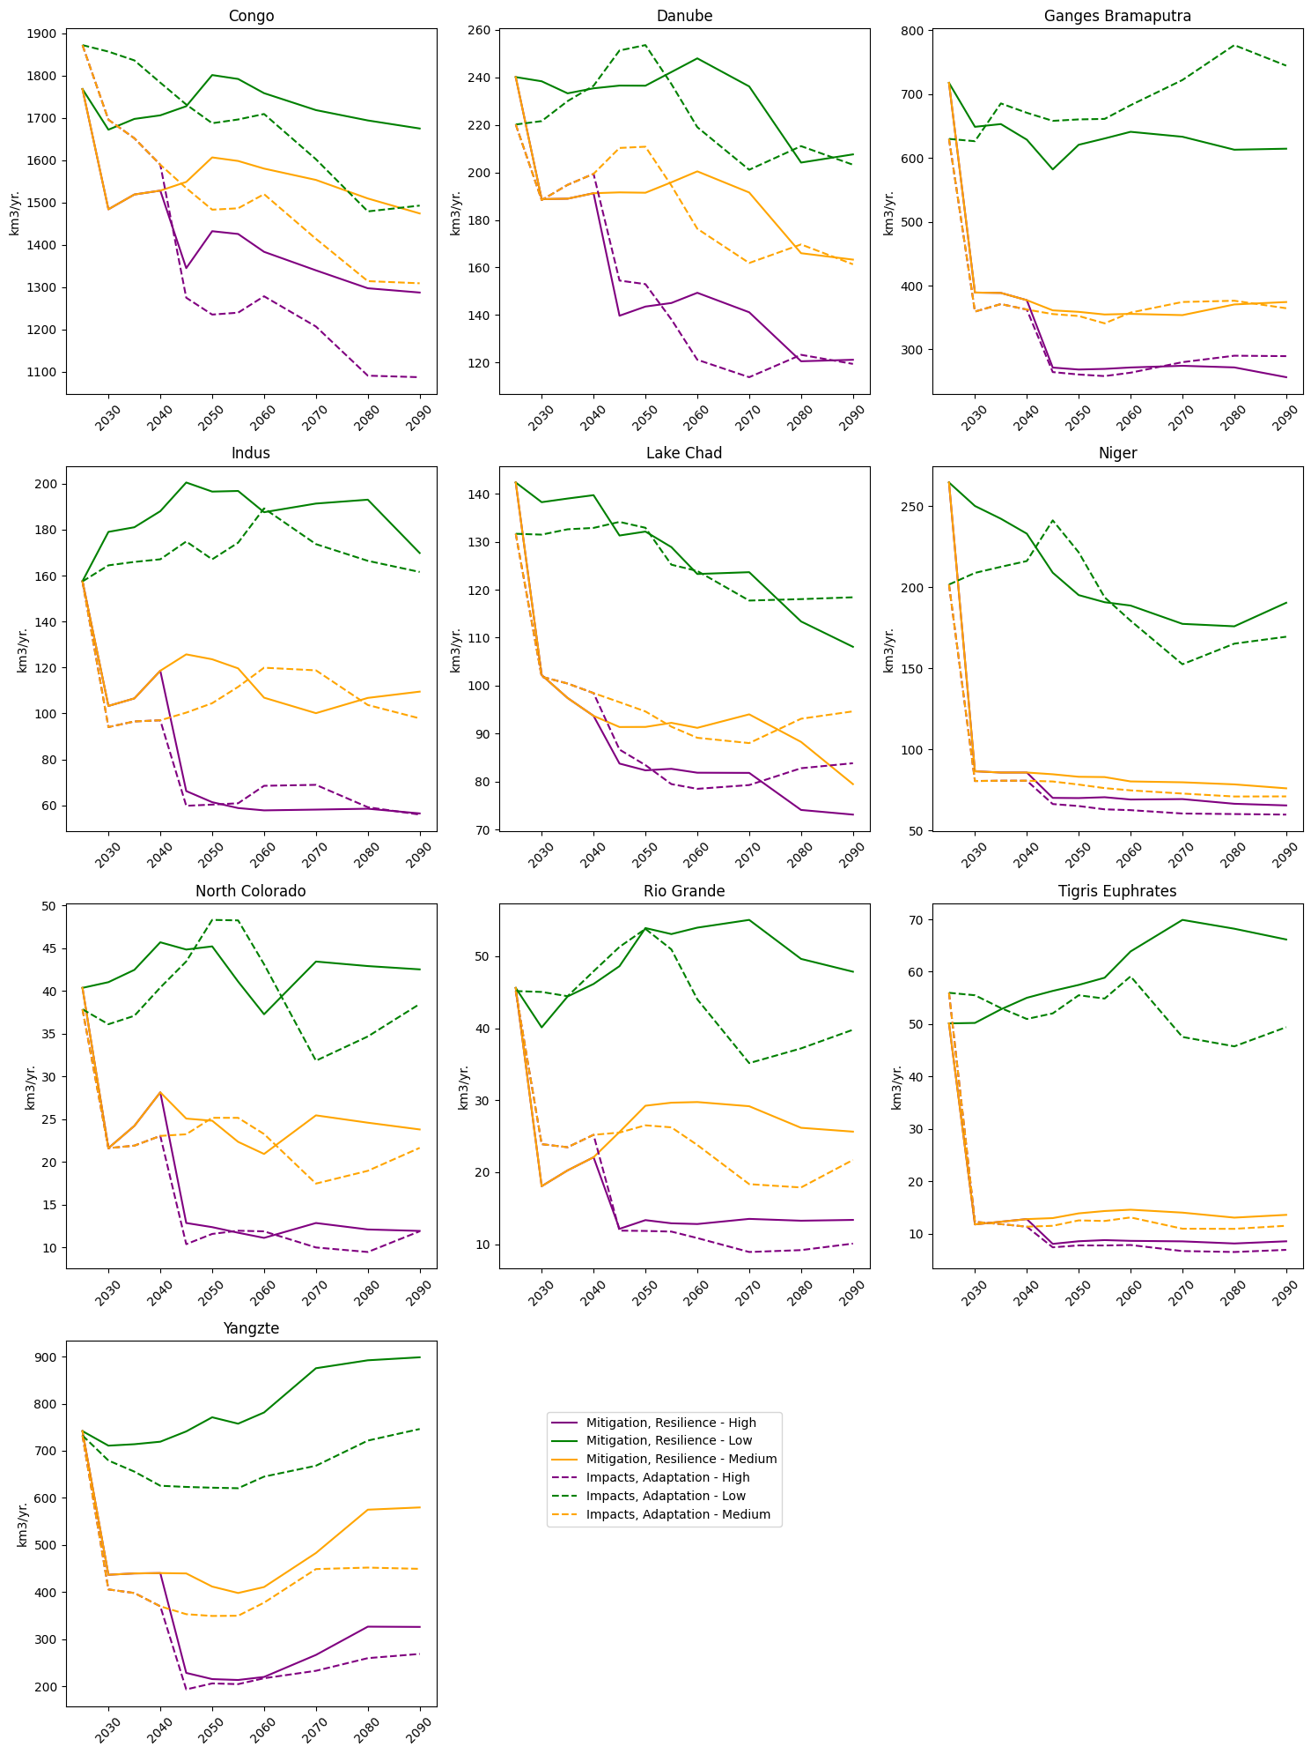
Supplementary Figure 1: Renewable water supply variation across scenarios
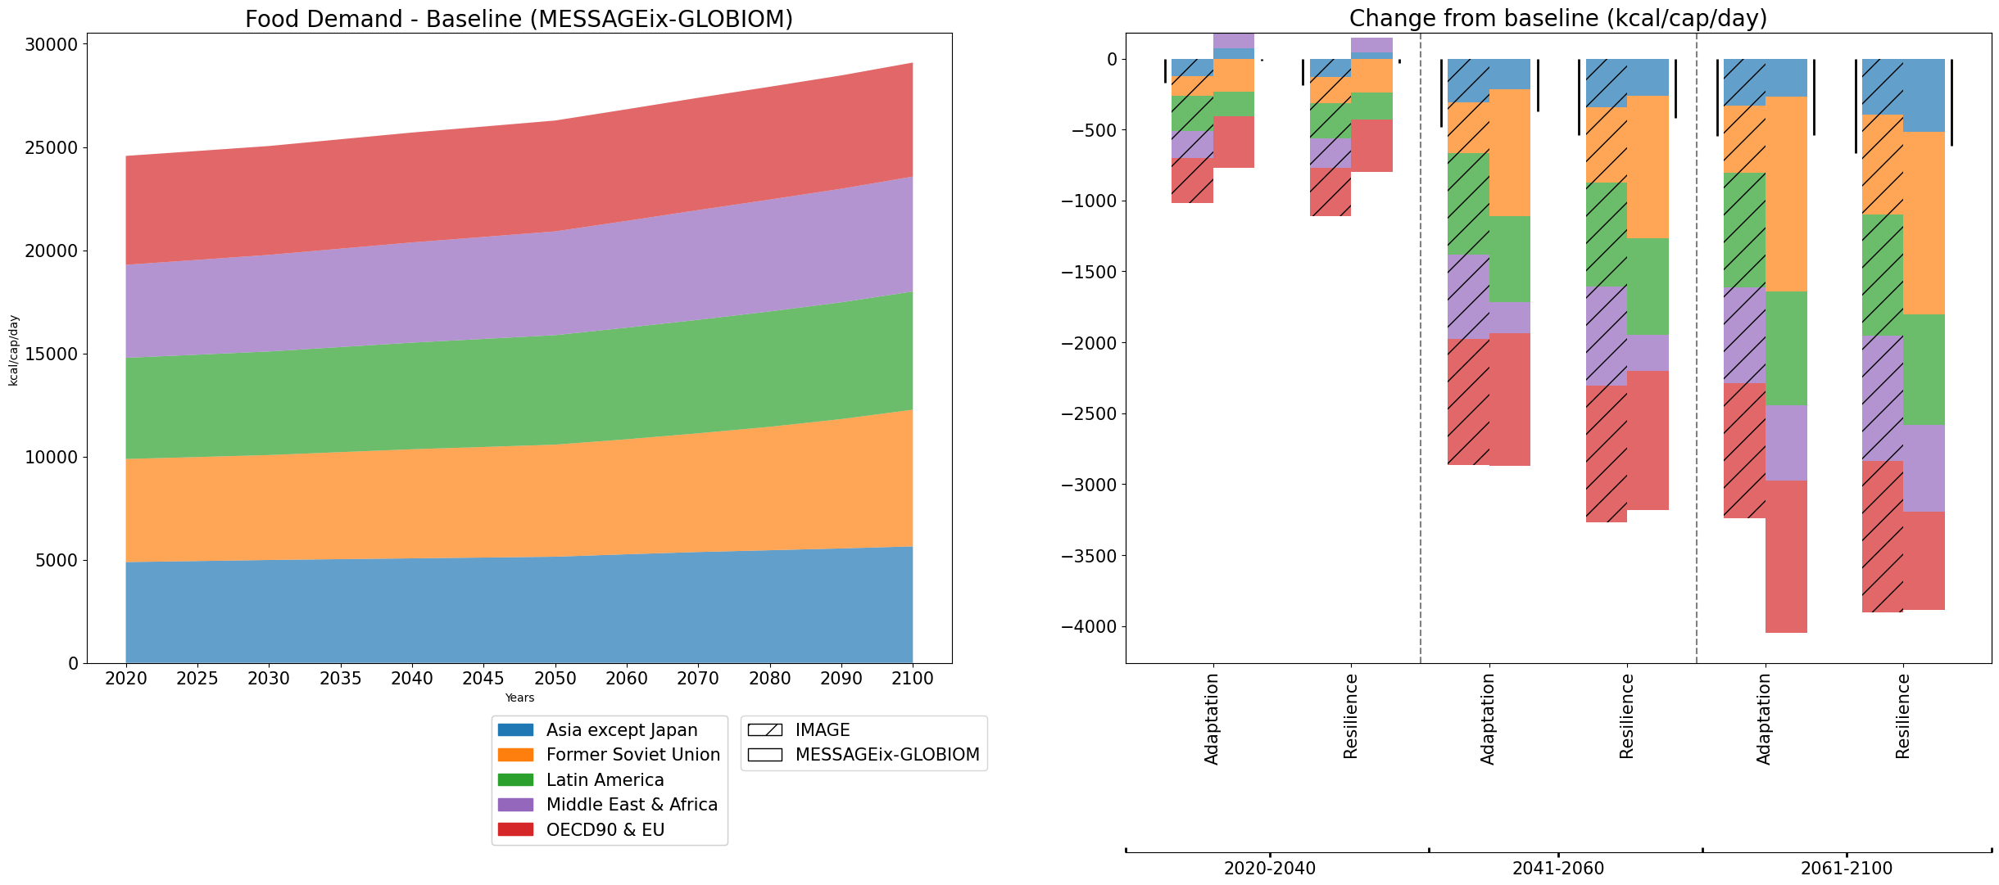
Supplementary Figure 2: Regional food demand and its variation across scenarios from both IAMs. F

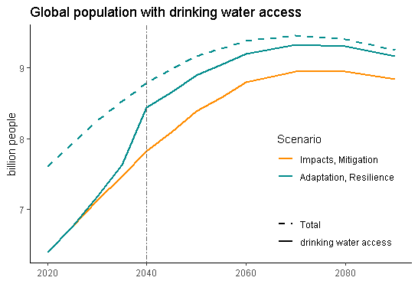
Supplementary Figure 3: Population with access to clean drinking water across scenarios. The assumption for increased access in Adaptation & Resilience scenarios starts from 2040. This drives municipal water demand and subsequently piped infrastructure investments in the model.

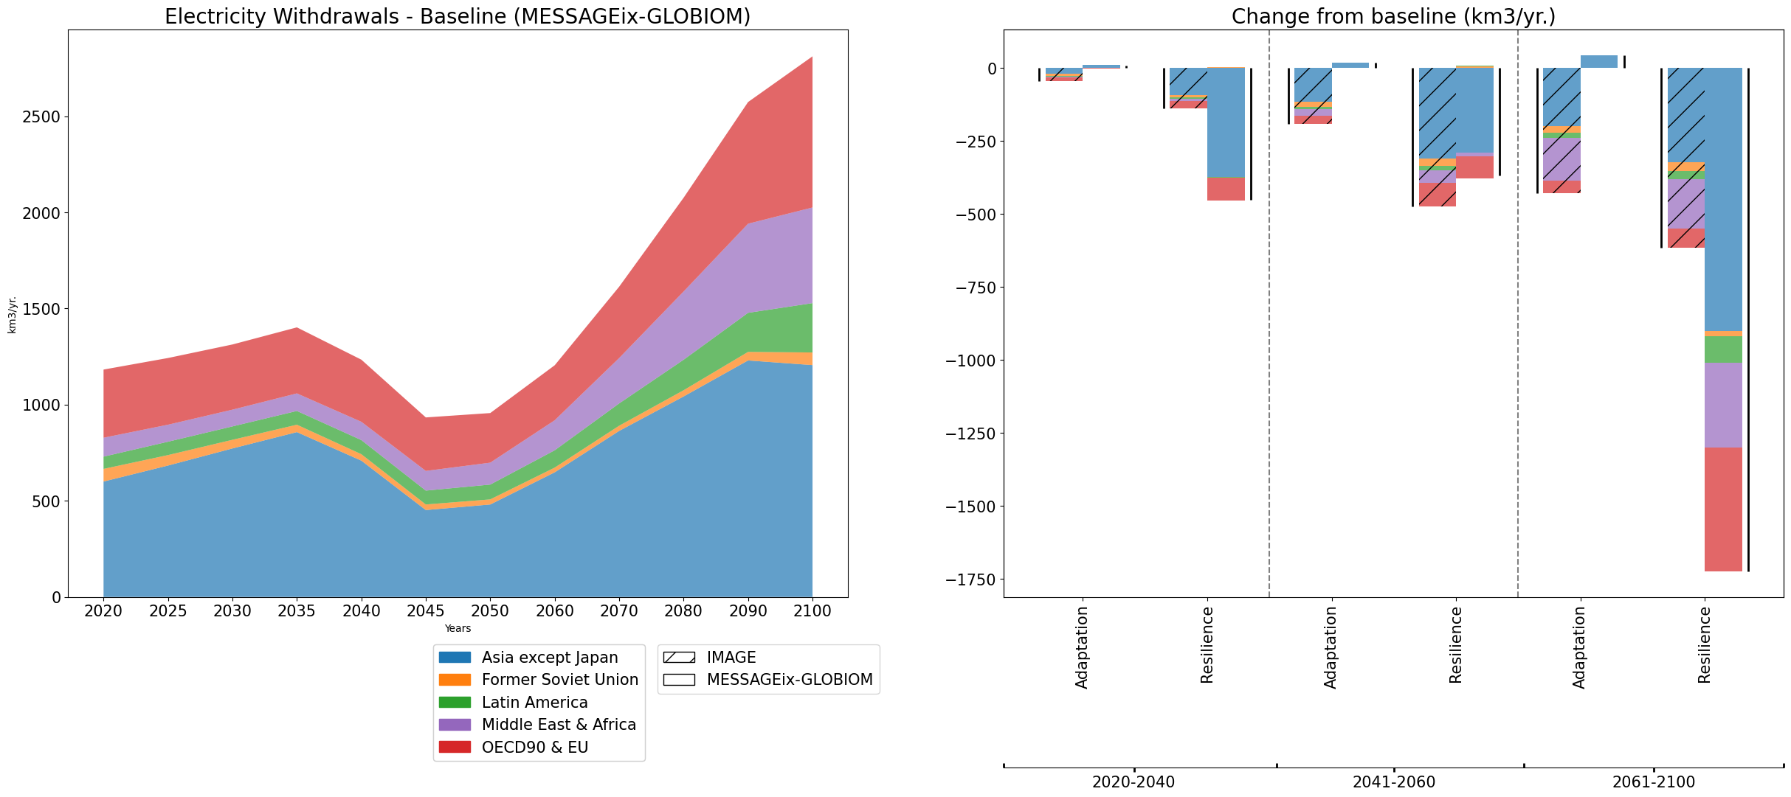

Supplementary Figure 4: Water withdrawals for electricity (including energy resource and cooling of thermal power plants) and its variation across scenarios.

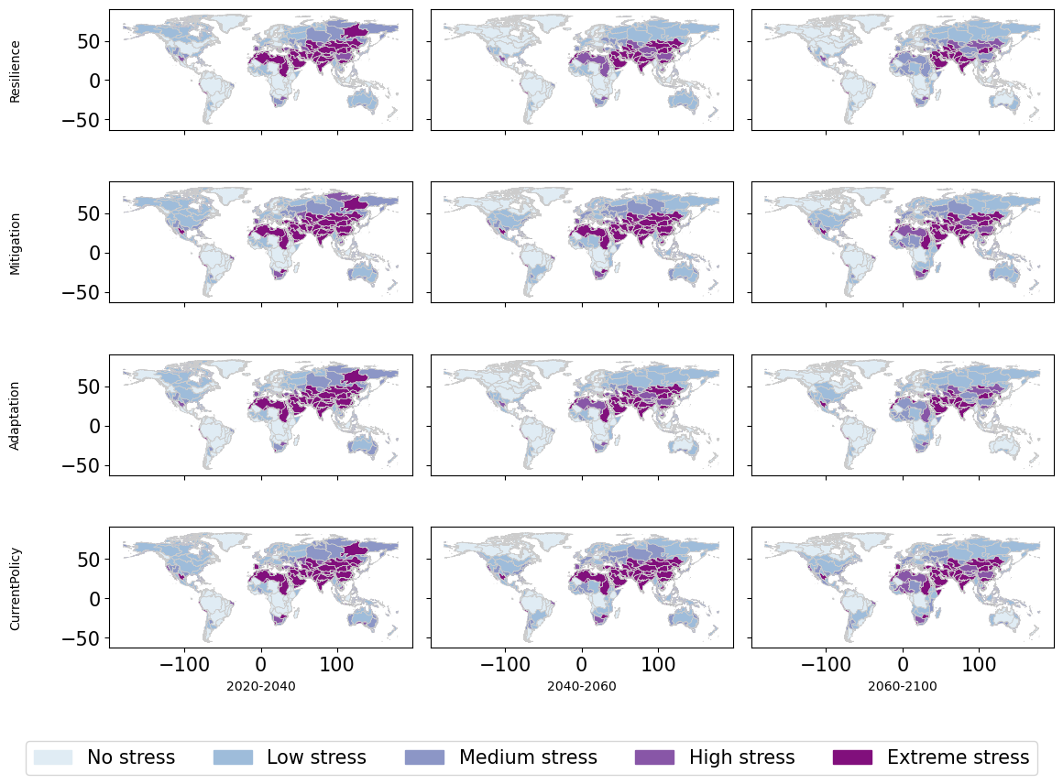

Supplementary Figure 4: Water Stress (ratio of available renewable water to water demands) from MESSAGEix-GLOBIOM

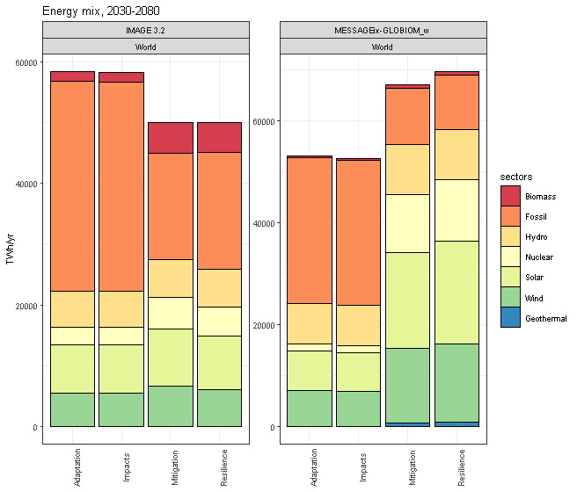
Supplementary Figure 5: Primary Energy Mix from both IAMs averaged between 2030-2080 across scenarios.

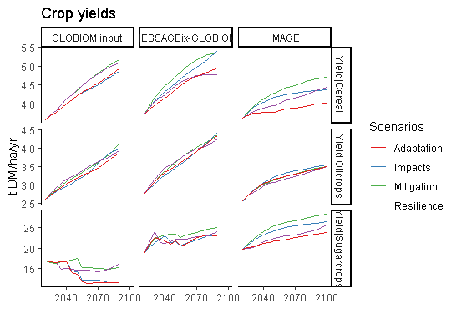
Supplementary Figure 6: Crop Yields by three crop types across the horizon. The GLOBIOM input suggests the yields calculated by EPIC crop model before land allocation. MESSAGEix-GLOBIOM crop yields are the outputs after land allocation with socio-economic and climate constraints. IMAGE uses LPJmL crop yields.

