Supplementary material
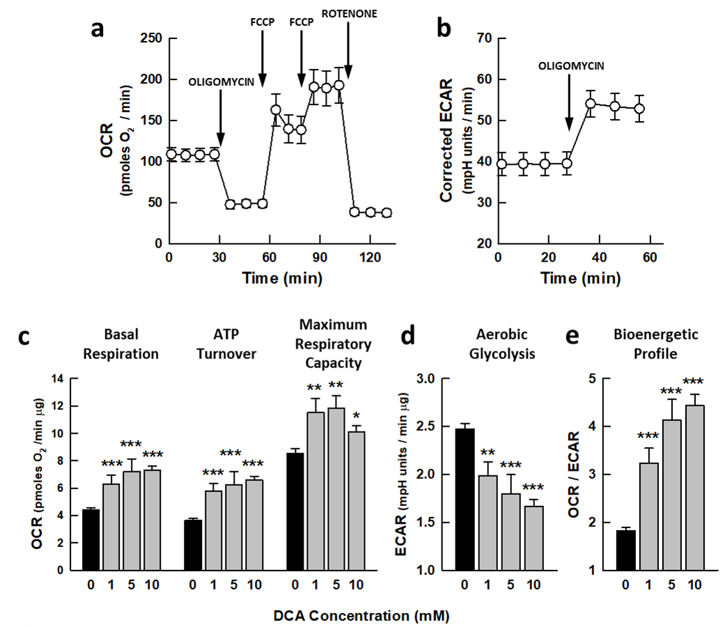

Supplemental Fig. 1. DCA alters the energy metabolism of the cell line MRC5.
(a, b) Characterization of MRC5 bioenergetics cells using a mitochondrial stress protocol. (a) Average profile of the changes in cellular respiration (OCR) upon the addition of oligomycin (1 $µ$M) followed by the two additions of the uncoupler FCCP (0.6 and 0.4 $µ$M) and finally, rotenone (1 $µ$M) plus antimycin A (1 $µ$M). (b) Changes in aerobic glycolysis (ECAR changes corrected to subtract the CO₂ contribution) and the effect of oligomycin (1 $µ$M). (c-d) The effect of DCA in the bioenergetic parameters of MRC5 cells calculated using the mitochondrial stress protocol described in a-b. (c) Basal respiration, ATP turnover and maximum respiratory capacity. (d) Basal aerobic glycolysis. (e) Bioenergetic profile (OCR/ECAR ratio). The data points in (a-b) represent the mean ± s.e.m. of 14 biologically independent experiments, and in (c-e), the bars represent the mean ± s.e.m. of 4-5 biologically independent experiments. The significance of the differences between the values in the presence of DCA relative to the controls was calculated using a one-way ANOVA. *P < 0.05; **P < 0.01; ***P < 0.01.

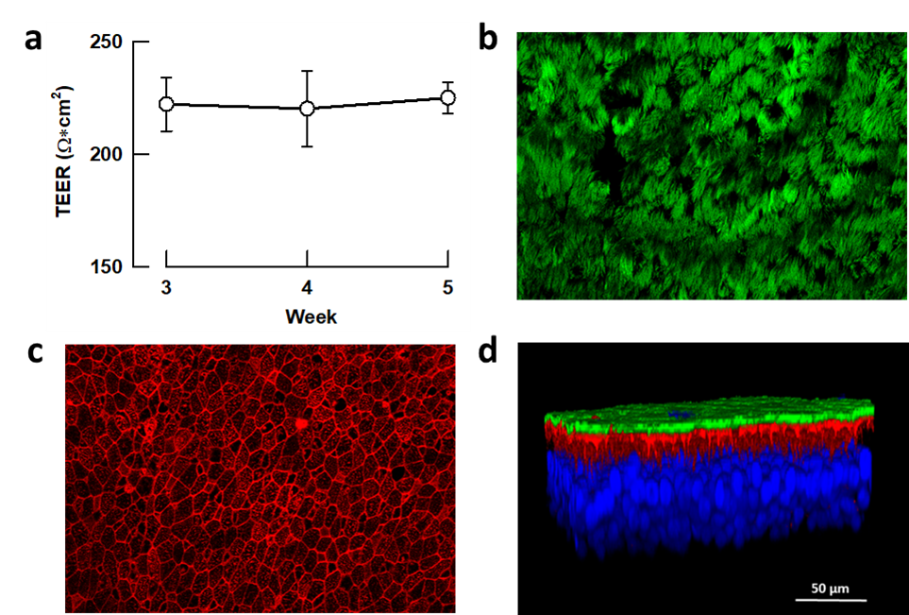

Supplemental Fig. 2. Characterization of the polarized human alveolar pseudo-stratified epithelia used in the studies.
a Barrier integrity of the differentiated epithelia assessed by the trans-epithelial electrical resistance (TEER). The data points represent the mean ± s.e.m. of 3-5 independent differentiation plates, averaging measurements from 6 randomly selected inserts in each. (b-d) Confocal images of the epithelia: Top view of the epithelia co-stained for (b) α-tubulin and (c) F-actin; (d) Representative 3D reconstruction of the pseudo-stratified epithelia stained for α-tubulin (cilia, green), F-actin (red) delineating the borders of the upper cellular layer of the epithelia and the staining of nuclei (DAPI, blue).

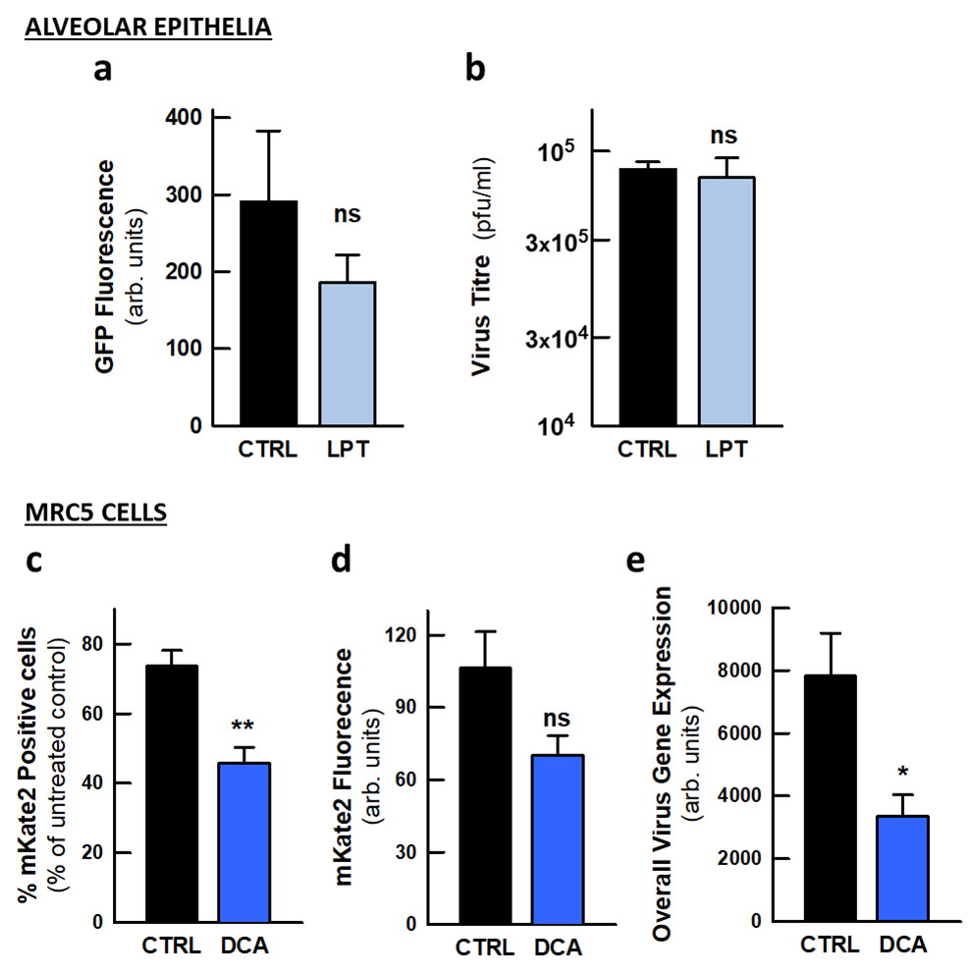
Supplemental Fig. 3. Weak antiviral activity of LPT in alveolar epithelia infected with the coronavirus HCoV-229E and of DCA in MRC5 cells infected with the pneumovirus RSV.
(a, b) Antiviral effect of LPT (5 M) in alveolar epithelia infected with HCoV-229E: (a) GFP fluorescence of the epithelia at 72 hpi and (b) virus titre in the mucus recovered from the apical phase of the epithelia at 72 hpi. (c – e) Antiviral effect of DCA (10 mM) infected with the pneumovirus RSV: (c) Percentage of infected cells; (d) Mean GFP fluorescence of the infected cells; (e) Overall virus gene expression calculated from the percentage of infected cells and the mean fluorescence intensity. The bars represent the mean ± s.e.m., and the number of inserts evaluated were 12 for each condition in graph “a” and 12 (control) and 7 (LPT-treated) for graph “b”. In histograms (c – e), the number of biological independent experiments was 8 (control) and 5 (DCA). The significance of the differences was calculated using an unpaired Student’s t test. **P < 0.01; *P < 0.05; n.s., not significant difference.

