Table 4 Binding mode and molecular interactions of the selected hits.
Compounds | Interactions Type | Binding Pocket | 3-D ligand interaction
Oxyacanthine | Pi-cation, Charge-charge  Positive-Positive | 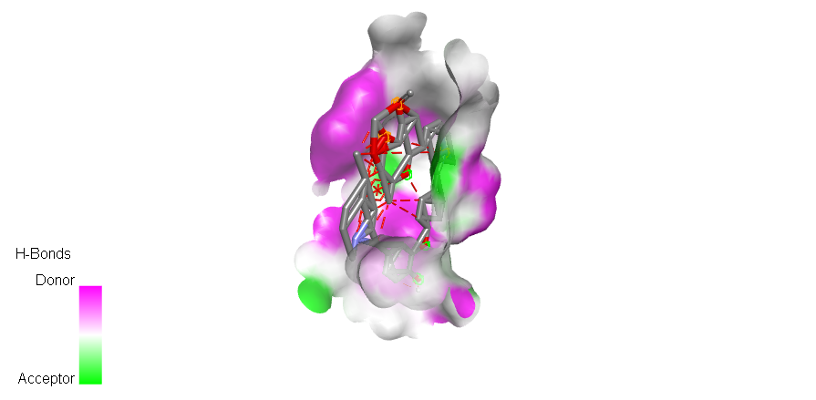 | 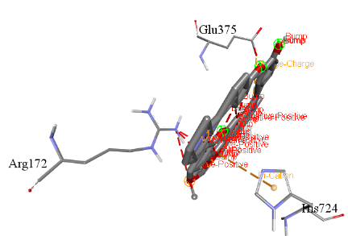
Neferine | Pi-alkyl, alkyl, Conventional, Pi-stacked, Pi-Pi Donor, Pi cation, Carbon hydrogen, Charge-Charge | 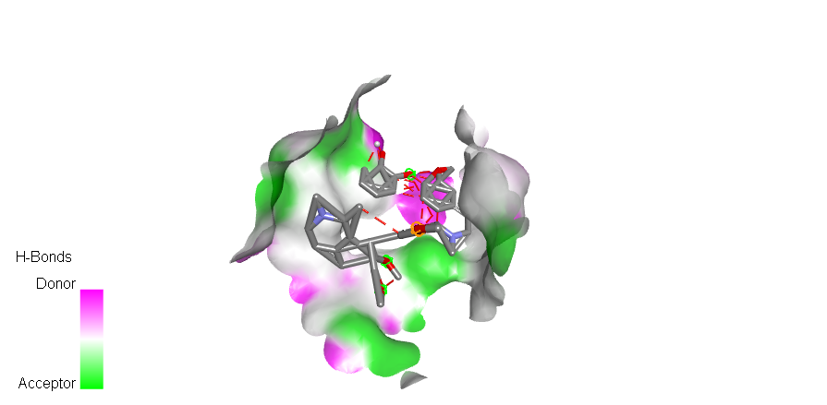 | 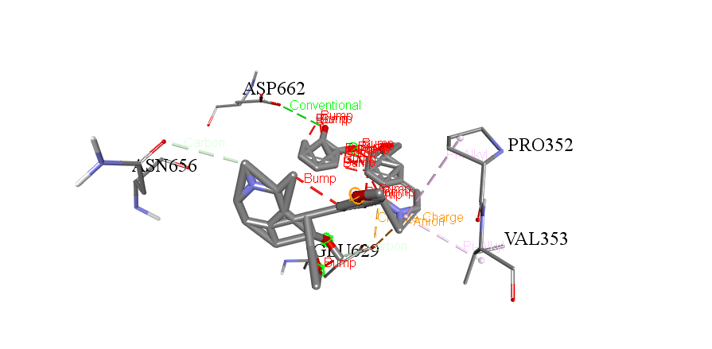
Magnoflorine | Pi-Pi cation, Conventional hydrogen, Positive-Positive | 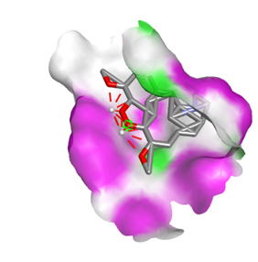 | 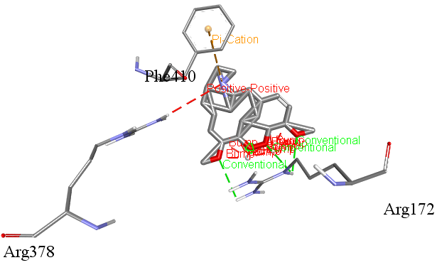
Corynoline | Pi-Pi cation, Conventional hydrogen , Positive-Positive | 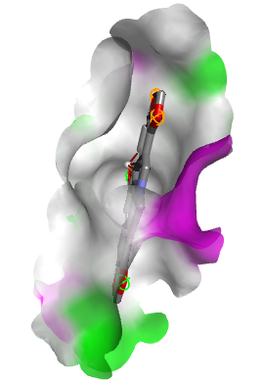 | 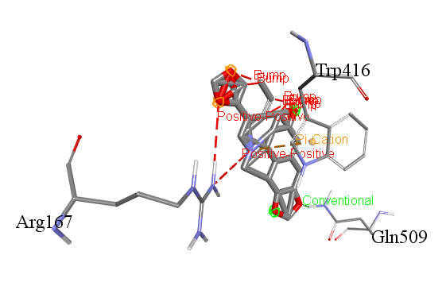
Columbamine | Conventional hydrogen, Positive-Positive | 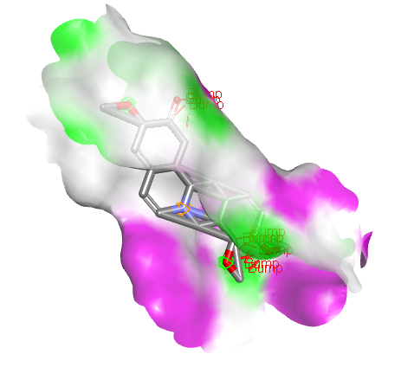 | 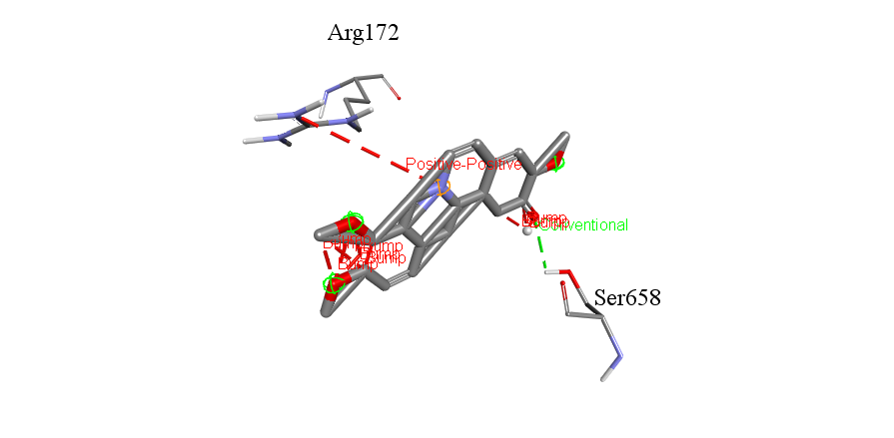
Berberine | Carbon hydrogen, Pi-Pi cation, Positive-Positive | 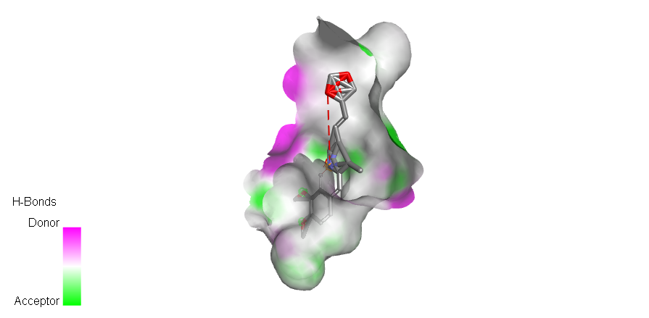 | 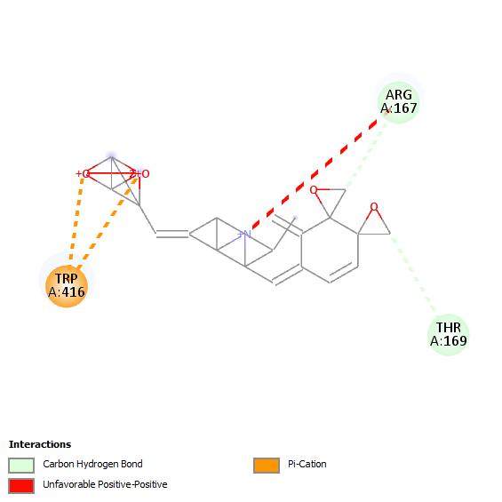
Berbamine | Carbon hydrogen, Pi-Pi cation, Positive-Positive | 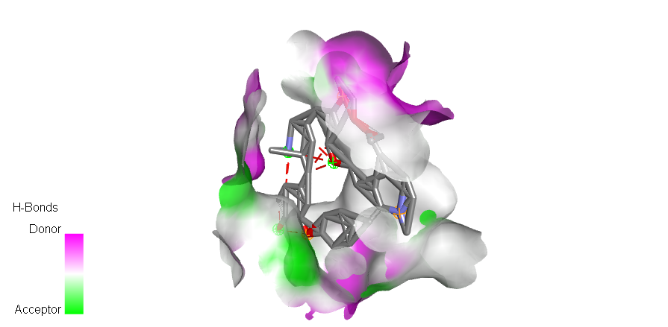 | 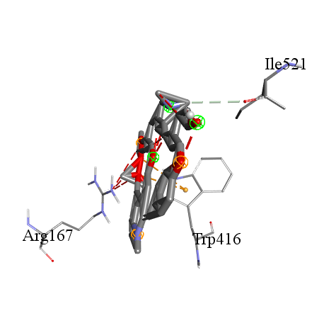
Palmatine | Carbon hydrogen,  Positive-Positive | 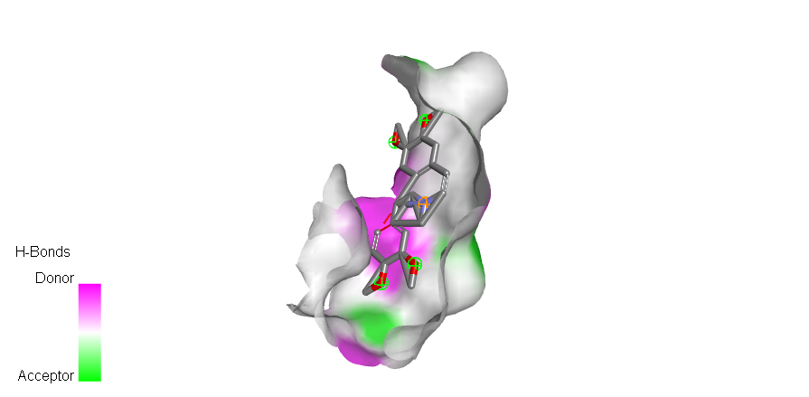 | 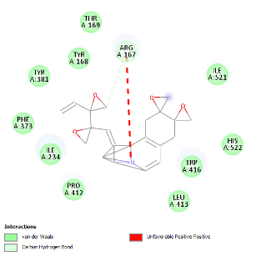
Tranilast  (Synthetic Positive Control) | Carbon hydrogen,  Positive-Positive, Pi-Pi cation | 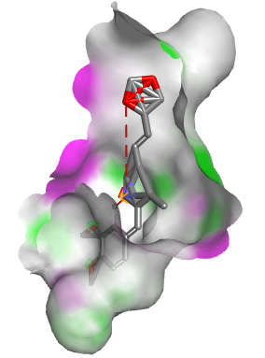 | 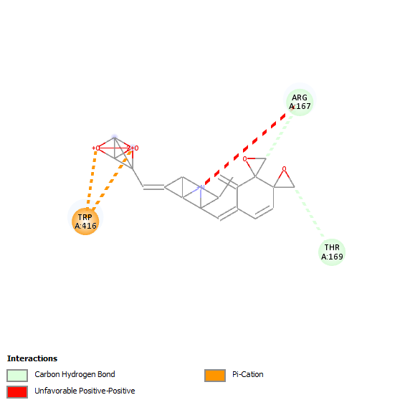
Oridonin  (Natural Positive Control) | Conventional,  Carbon hydrogen, Bump Conventional hydrogen | 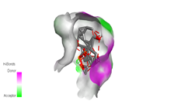 | 