Pre-pregnancy intrauterine device use is associated with a reduced risk of subsequent preterm birth: a large population-based cohort study
Supplementary Material
Table of contents
Appendix S1. Detailed descriptions of covariates and multiple imputation methods.
Table S1. Sensitive analyses of association between pre-pregnancy contraceptive methods and preterm birth.
Figure S1. Causal diagram showing selection of covariates for confounding control.

Appendix S1. Detailed descriptions of covariates and multiple imputation methods.
Information on women's characteristics and their pregnancy outcomes was retrieved from the National Free Preconception Health Examination Project (NFPHEP) in Yunnan Province, China. These included women’s age (<20 years, 20-24 years, 25-29 years, 30-34 years, and >35 years), women’s occupation (farmer, other), women’s education level (primary school or below, junior high school, senior high school, college or above), women’s ethnicity (Han, Yi, other), socioeconomic development level of the county where the women lived (county development status: normal, low, very low), pre-pregnancy body mass index (BMI) (underweight: <18.5, normal: 18.5-23.9, overweight or obese: >24), anemia (yes, no), smoking status during pregnancy (yes, no), and alcohol consumption during pregnancy (yes, no).

The frequency of missing data in our main analysis was relatively low: 0.04% for women’s age, 1.7% for women’s education level, 0.08% for women’s BMI before pregnancy, 0.7% for anemia, 0.3% for smoking status during pregnancy, and 0.5% for alcohol drinking status during pregnancy.

Multiple imputation methods imputed with 10 replications was used to deal with missing values in this study. We imputed missing variables using the fully conditional specification (FCS) method in which logistic regression was used for categorical variables. The imputation model included the following variables: women’s age (<20 years, 20-24 years, 25-29 years, 30-34 years, and ≥35 years), women’s occupation (farmer, others), women’s education level (primary school or below, junior high school, senior high school, college or above), women’s ethnicity (Han, Yi, others), socioeconomic development level of the county where the women lived (county development status: normal, low, very low), women’s pre-pregnancy body mass index (BMI) (underweight: <18.5, normal: 18.5-23.9, overweight or obesity: ≥24), women’s pre-conception contraceptive methods (non-use, IUDs, others), anemia (yes, no), smoking status during pregnancy (yes, no), alcohol drinking status during pregnancy (yes, no), and preterm birth status (yes, no). The distributions of observed and imputed variables were similar.
Table S1. Sensitive analyses of association between pre-pregnancy contraceptive methods and preterm birth.
 | Exposure | No. of PTB | No. of total | PTB rate (%) | aRR¹ (95%CI) | aRR² (95%CI)
Adjusting for adverse pregnancy history | Non-use | 4191 | 83203 | 5.04 | reference | 0.99 (0.93-1.05)
Adjusting for adverse pregnancy history | IUDs | 1935 | 44831 | 4.32 | 0.83 (0.79-0.88) | 0.83 (0.77-0.89)
Adjusting for adverse pregnancy history | Other methods | 1494 | 30839 | 4.85 | 1.01 (0.95-1.07) | reference
Singleton births | Non-use | 7458 | 155732 | 4.79 | reference | 1.00 (0.95-1.06)
Singleton births | IUDs | 1898 | 45505 | 4.17 | 0.83 (0.79-0.88) | 0.85 (0.79-0.91)
Singleton births | Other methods | 1780 | 39404 | 4.52 | 0.99 (0.94-1.05) | reference
Excluding individuals exposed to chronic disease | Non-use | 7586 | 154288 | 4.92 | reference | 0.84 (0.71-0.99)
Excluding individuals exposed to chronic disease | IUDs | 1932 | 44707 | 4.32 | 0.84 (0.80-0.89) | 0.84 (0.71-0.99)
Excluding individuals exposed to chronic disease | Other methods | 1786 | 38103 | 4.69 | 1.00 (0.94-1.05) | reference
Excluding individuals using multiple contraceptive methods | Non-use | 7743 | 156602 | 4.94 | reference | 0.99 (0.93-1.05)
Excluding individuals using multiple contraceptive methods | IUDs | 1960 | 45371 | 4.32 | 0.83 (0.78-0.88) | 0.82 (0.76-0.88)
Excluding individuals using multiple contraceptive methods | Other methods | 1866 | 39630 | 4.71 | 1.01 (0.95-1.08) | reference
Abbreviation: PTB: preterm birth; IUDs: intrauterine devices.
Non-use: including women who reported not using any contraceptive method before pregnancy.
IUDs: including women who reported that the method used before pregnancy was IUDs.
Other methods: including women who used a method other than an IUD before pregnancy.
Adverse pregnancy history: including preterm birth, overdue birth, spontaneous abortion, induced abortion, and stillbirth.
Chronic disease: including hypertension, diabetes, heart disease, epilepsy, hepatitis B, tuberculosis, thyroid disease, tumors and so on.
aRR¹: Non-use is the control.
aRR²: Other methods is the control.

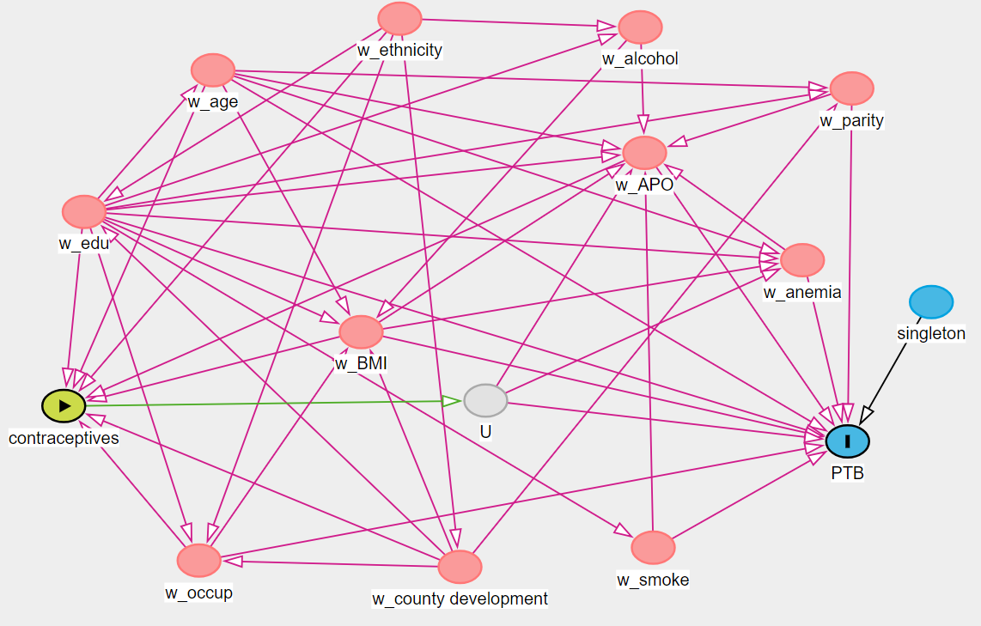
Figure S1. Causal diagram showing selection of covariates for confounding control.
Abbreviation: ª w_age: women’s age, w_edu: women’s education level, w_occup: women’s occupation, w_county development: socioeconomic development level of the county where the women lived, w_ethnicity: women’s ethnicity, w_BMI: women’s BMI before pregnancy, w_parity: women’s parity, w_anemia: women’s anemia status, w_APO: women’s history of adverse pregnancy outcomes, w_smoke: women’s smoking status during pregnancy, w_alcohol: women’s alcohol drinking status during pregnancy; U: unmeasured variables

