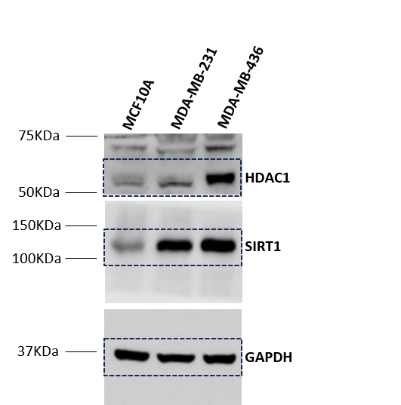

Uncropped western blotting membranes of Figure 2C. Abbreviations: HDAC1, histone deacetylase 1; SIRT1, sirtuin 1.

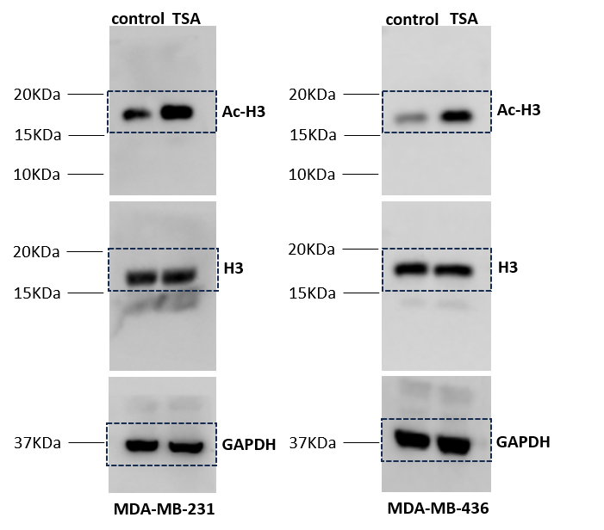
Uncropped western blotting membranes of Figure 2F. Abbreviations: Ac-H3, acetyl histone 3; H3, histone 3.

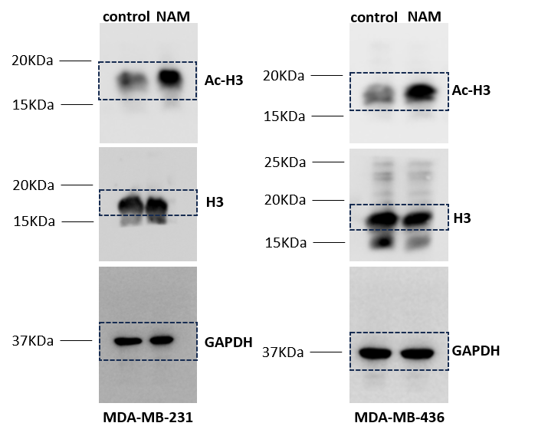
Uncropped western blotting membranes of Figure 2G. Abbreviations: Ac-H3, acetyl histone 3; H3, histone 3.

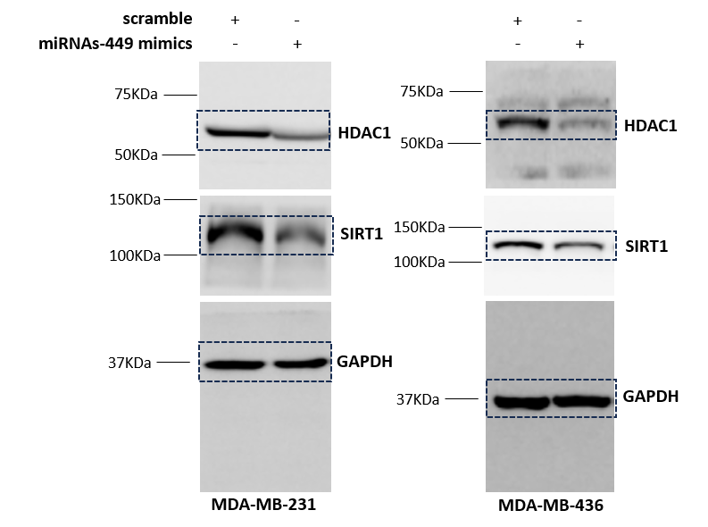
Uncropped western blotting membranes of Figure 3C. Abbreviations: HDAC1, histone deacetylase 1; SIRT1, sirtuin 1.

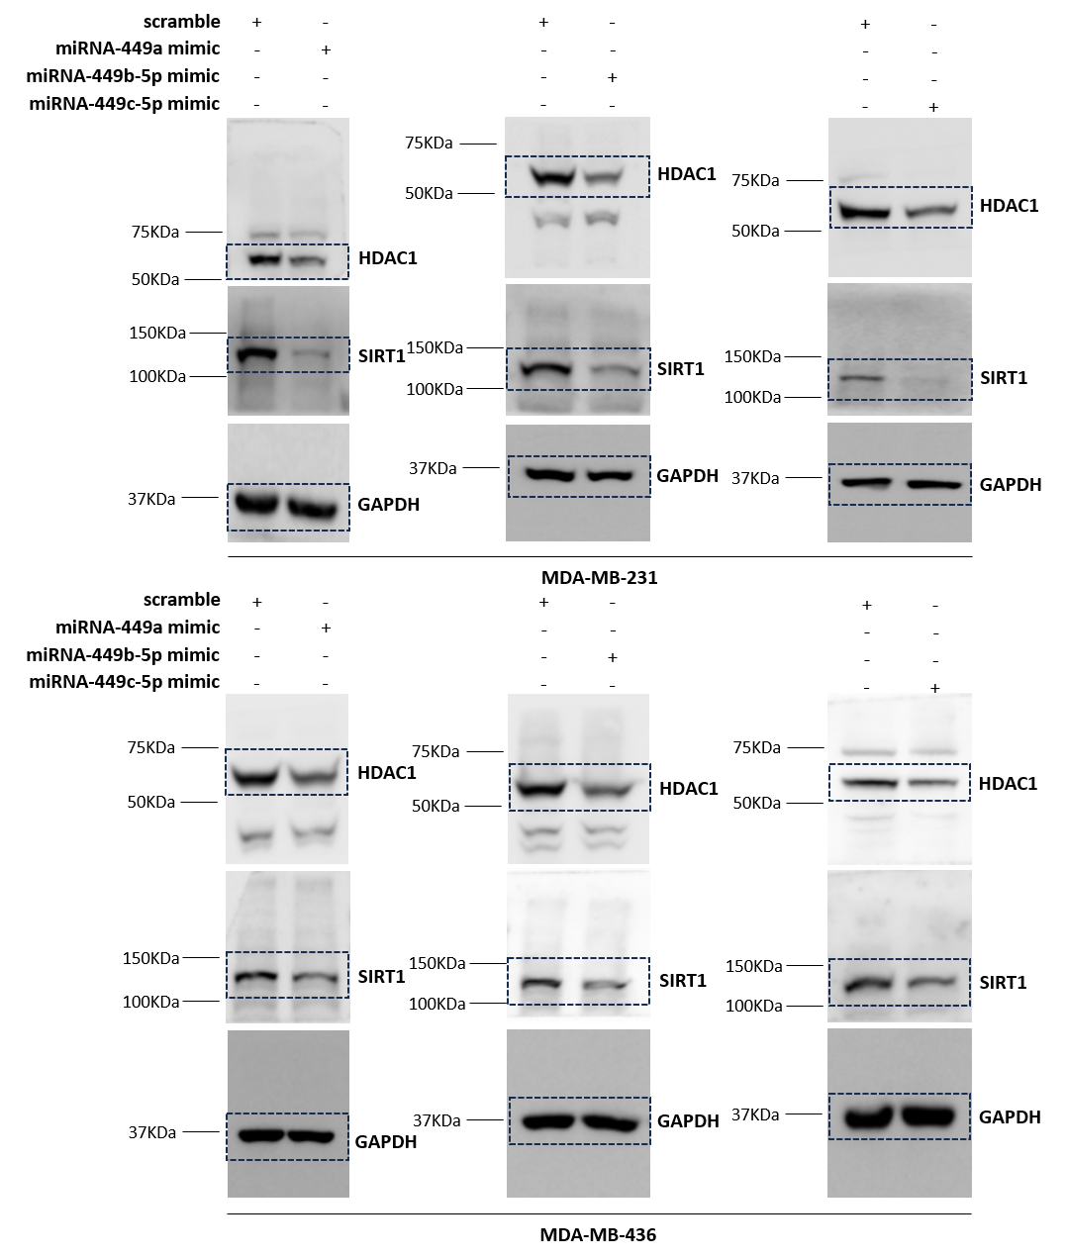
Uncropped western blotting membranes of Figure 3F. Abbreviations: HDAC1, histone deacetylase 1; SIRT1, sirtuin 1.

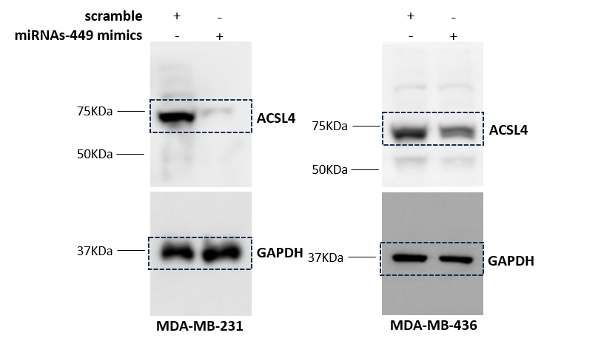
Uncropped western blotting membranes of Figure 4C. Abbreviations: ACSL4, acyl-CoA synthetase long-chain family member 4.

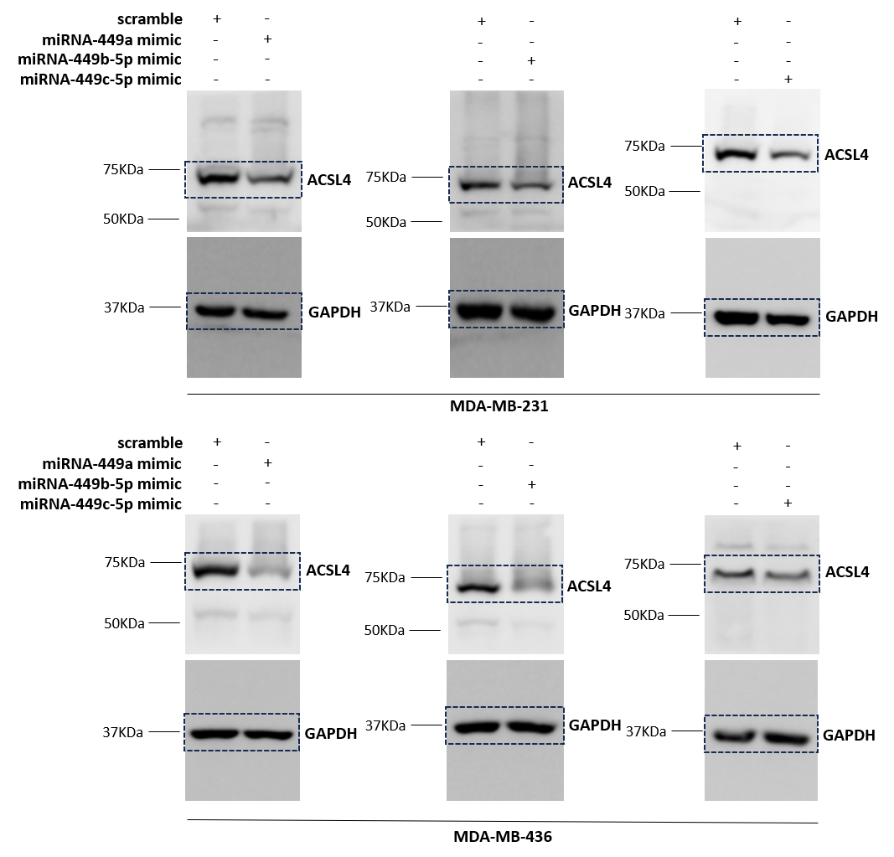
Uncropped western blotting membranes of Figure 4E. Abbreviations: ACSL4, acyl-CoA synthetase long-chain family member 4.

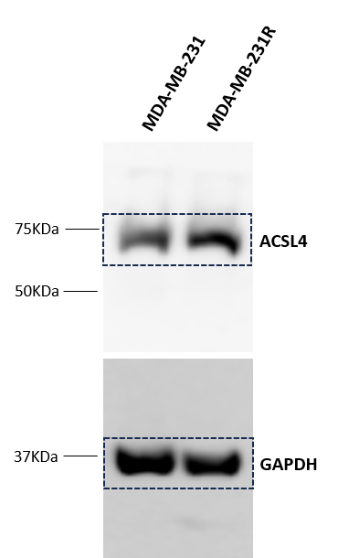
Uncropped western blotting membranes of Figure 5C. Abbreviations: ACSL4, acyl-CoA synthetase long-chain family member 4.

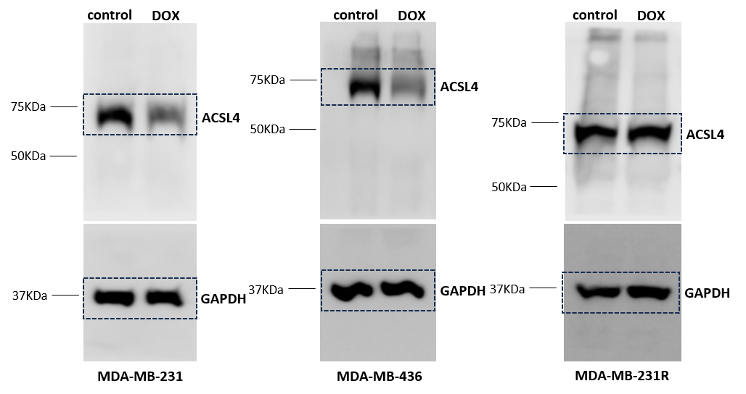
Uncropped western blotting membranes of Figure 6B. Abbreviations: ACSL4, acyl-CoA synthetase long-chain family member 4.

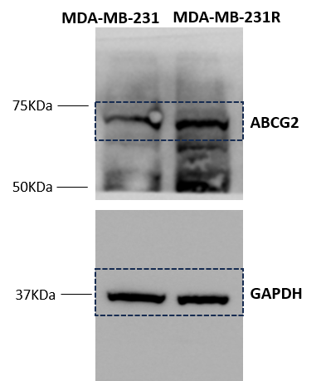
Uncropped western blotting membranes of Figure 7B. Abbreviations: ABCG2, ATP Binding Cassette Subfamily G Member 2.

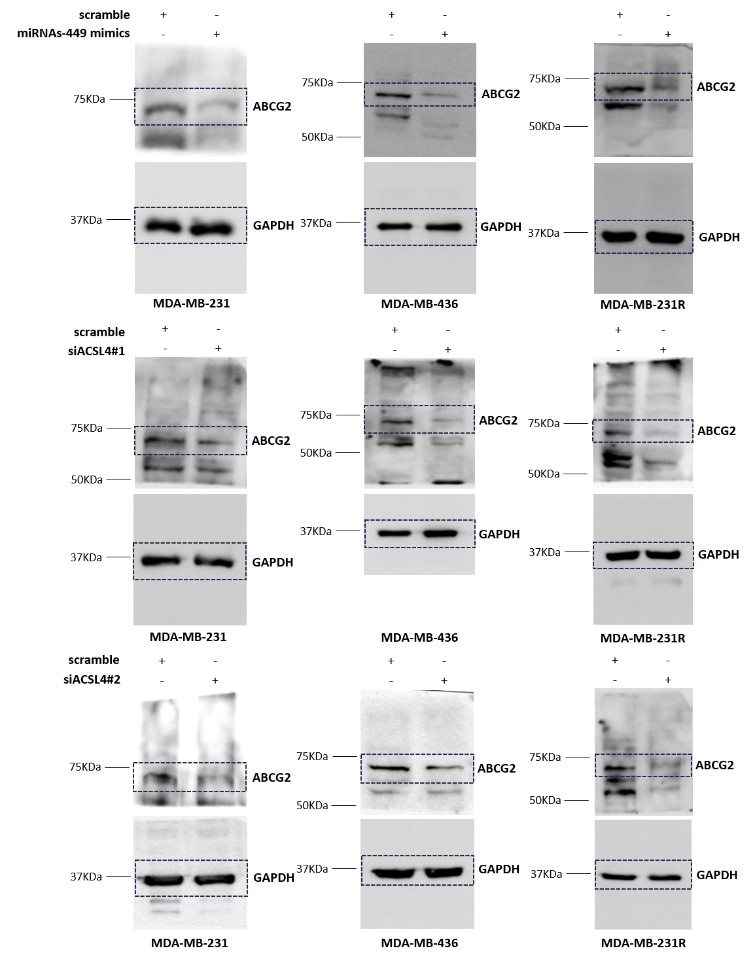
Uncropped western blotting membranes of Figure 7C. Abbreviations: ABCG2, ATP Binding Cassette Subfamily G Member 2.

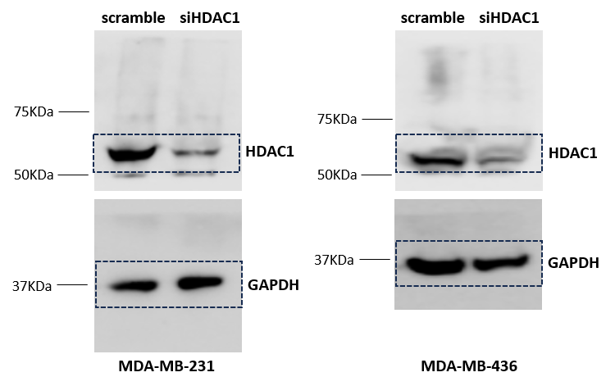
Uncropped western blotting membranes of Figure S2B. Abbreviations: HDAC1, histone deacetylase 1.

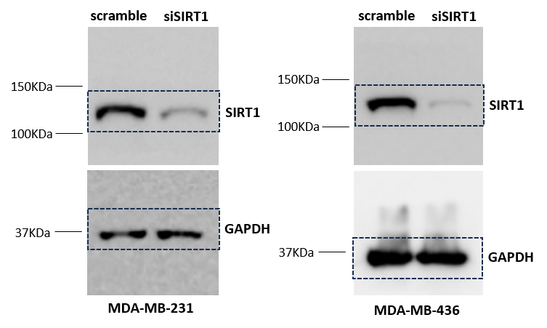
Uncropped western blotting membranes of Figure S2D. Abbreviations: SIRT1, sirtuin 1.

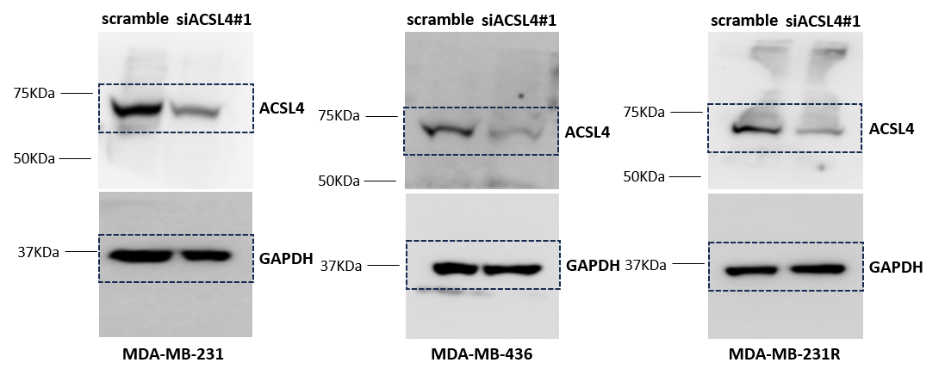
Uncropped western blotting membranes of Figure S2K. Abbreviations: ACSL4, acyl-CoA synthetase long-chain family member 4.

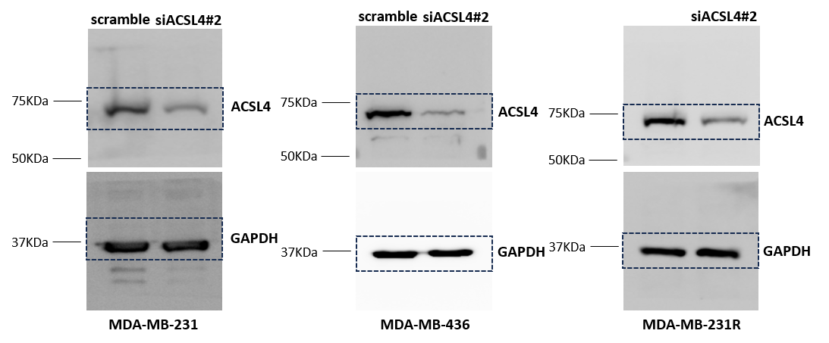
Uncropped western blotting membranes of Figure S2L. Abbreviations: ACSL4, acyl-CoA synthetase long-chain family member 4.

