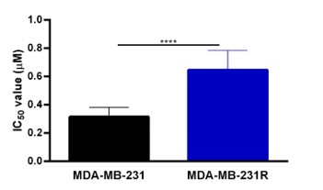

Fig. S1: MDA-MB-231R presents doxorubicin-acquired resistance. The IC₅₀ values were determined by WST-1 after treatment with different concentrations of doxorubicin for 48 hours in MDA-MB-231 (0.32 ± 0.07 µM) and MDA-MB-231R (0.65 ± 0.14 µM) cell lines (mean ±. SD) **** p < 0.0001.

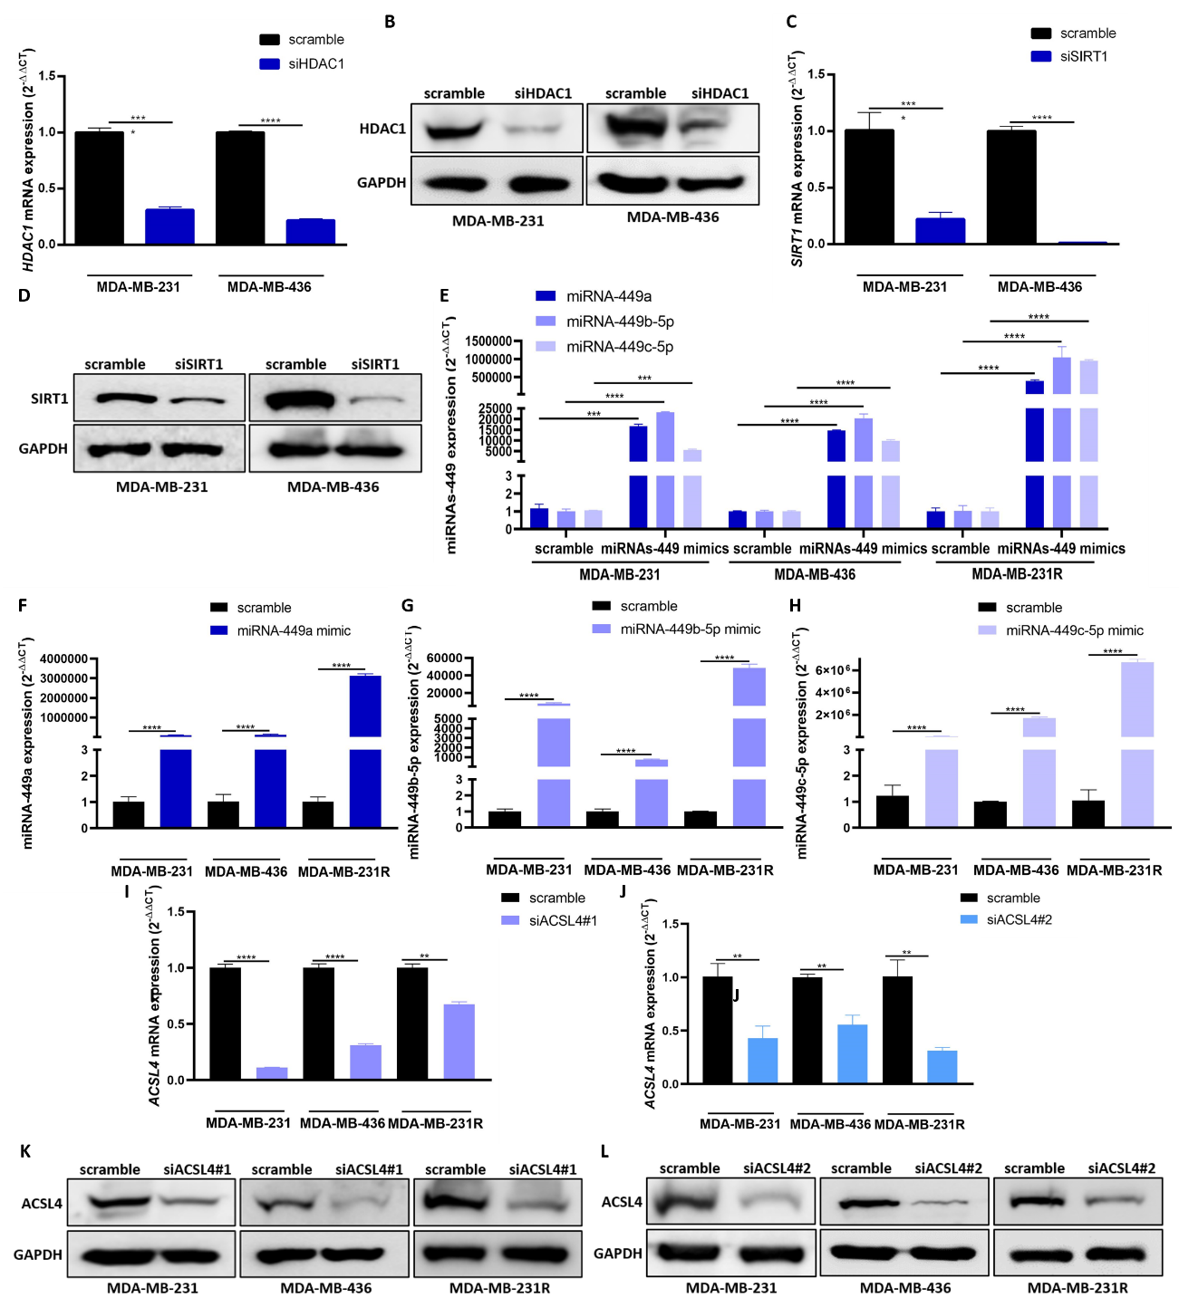
Fig. S2: Confirmation of cell transfection in TNBC cell lines. (A-B) HDAC1 expression was analyzed by RT-qPCR (A) (mean ±. SD) and Western blot (B) in MDA-MB-231 and MDA-MB-436 cell lines after siHDAC1 transfection. (C-D) SIRT1 expression was analyzed by RT-qPCR (c) (mean ±. SD) and Western blot (D) in MDA-MB-231 and MDA-MB-436 cell lines after siSIRT1 transfection. (E) MiRNAs-449 expression was analyzed by RT-qPCR in MDA-MB-231, MDA-MB-436 and MDA-MB-231R cell lines after miRNAs-449 mimic transfection (mean ±. SD). (F) miRNA-449a, (G) miRNA-449b-5p and (H) miRNA-449c-5p expression were analyzed by RT-qPCR in MDA-MB-231, MDA-MB-436 and MDA-MB-231R cell lines after miRNA-449a, miRNA-449b-4p and miRNA-449c-5p mimics transfection separately, respectively (mean ±. SD). (I-L) ACSL4 expression was analyzed by RT-qPCR (I, J) (mean ±. SD) and Western blot (K, L) in MDA-MB-231, MDA-MB-436, and MDA-MB-231R cell lines after two siRNAs targeting ACSL4 (siACSL4#1 and siACSL4#2). **p < 0.01, ***p < 0.001, ****p < 0.0001.
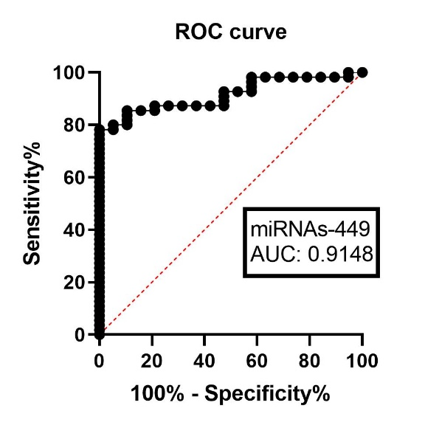
Fig. S3: The signature of miRNAs-449 as a diagnostic biomarker. ROC curve analyses were performed for miRNAs-449 signature in TNBC tissue samples (n = 55) and healthy tissue samples (n = 23).

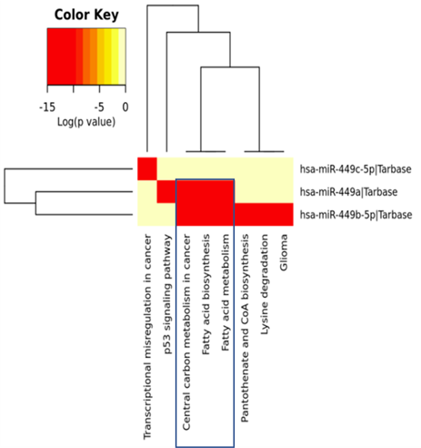
Fig. S4: MiRNAs-449 modulate fatty acid metabolism. MiRpath software analysis of miRNAs-449 targeted pathways. The color indicates a logarithmic transformation of Fisher’s Exact test-adjusted p-values (red for lower p-values).

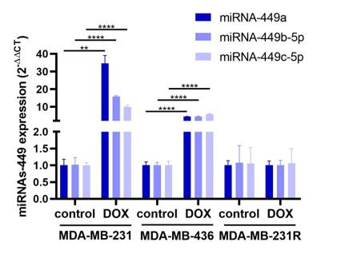
Fig. S5: MiRNAs-449 are upregulated after doxorubicin treatment in doxorubicin-sensitive but not in doxorubicin-resistant cells. MiRNA-449 family (miRNA-449a, miRNA-449b-5p, and miRNA-449c-5p) expression was analyzed by RT-qPCR in MDA-MB-231, MDA-MB-436, and MDA-MB-231R cell lines after doxorubicin treatment (1 µM, 48 hours) (mean ±. SD). **p < 0.01, ****p < 0.0001.

Table S1: Clinicopathological characteristics of TNBC patients and controls for miRNAs-449 analyses expression.
Characteristics | TNBC patients | Control
Number | 55 | 19
Grade group, n (%)
1 | 0(0%) | n.a
2 | 11(20%) | n.a
3 | 41(74.55%) | n.a
Unknown | 3(5.45%) | n.a
Clinical stage, n (%)
1 | 13(23.64%) | n.a
2 | 33(60%) | n.a
3 | 8(14.54%) | n.a
4 | 0(0%) | n.a
Unknown | 1(1.82%) | n.a
Treatment, n (%)
Neoadjuvant | 37(67.27%) | n.a
Adjuvant | 0(0%) | n.a
Neoadjuvant and Adjuvant | 18(32.73%) | n.a
RCB, n (%)
0 | 22(40%) | n.a
1 | 5(9.1%) | n.a
2 | 16(29.1%) | n.a
3 | 6(10.9%) | n.a
Unknown | 6(10.9%) | n.a
Ki67, n (%)
<30 | 4(7.27%) | n.a
30-59.9 | 15(27.27%) | n.a
≥60 | 33(60%) | n.a
Unknown | 3(5.46%) | n.a
Regional lymph node metastasis, n (%)
Yes | 19(34.54%) | n.a
No | 35(63.64%) | n.a
Unknown | 1(1.82%) | n.a
Distant metastasis, n (%)
Yes | 0(0%) | n.a
No | 54(98.18%) | n.a
Unknown | 1(1.82%) | n.a

TNBC: Triple-negative breast cancer; RCB: Residual Cancer Burden; n.a: not applicable

Table S2: Clinicopathological characteristics of relapse and non-relapse TNBC patients after chemotherapy treatment for ACSL4 analysis expression.
Characteristics | TNBC no relapse patients | TNBC relapse patients
Number | 12 | 20
Grade group, n (%)
1 | 0(0%) | 0(0%)
2 | 4(33.33%) | 3(15%)
3 | 7(58.34%) | 17(85%)
Unknown | 1(8.33%) | 0(0%)
Clinical stage, n (%)
1 | 6(50%) | 2(10%)
2 | 5(41.67%) | 14(70%)
3 | 1(8.33%) | 4(20%)
4 | 0(0%) | 0(0%)
Unknown | 0(0%) | 0(0%)
Treatment, n (%)
Neoadjuvant | 11(91.67%) | 14(70%)
Adjuvant | 0(0%) | 0(0%)
Neoadjuvant and Adjuvant | 1(8.33%) | 6(30%)
RCB, n (%)
0 | 10(83.34%) | 7(35%)
1 | 1(8.33%) | 1(5%)
2 | 1(8.33%) | 9(45%)
3 | 0(0%) | 2(10%)
Unknown | 0(0%) | 1(5%)
Ki67, n (%)
<30 | 1(8.33%) | 1(5%)
30-59.9 | 3(25%) | 4(20%)
≥60 | 7(58.34%) | 15(75%)
Unknown | 1(8.33%) | 0(0%)
Regional lymph node metastasis, n (%)
Yes | 3(25%) | 6(30%)
No | 9(75%) | 13(65%)
Unknown | 0(0%) | 1(5%)
Distant metastasis, n (%)
Yes | 0(0%) | 0(0%)
No | 12(100%) | 19(95%)
Unknown | 0(0%) | 1(5%)

TNBC: Triple-negative breast cancer; RCB: Residual Cancer Burden; n.a: not applicable.

