Bergenia purpurascens is a non-specific ACE2 inhibitor

Figure S1 Photographs of plant specimens for identification
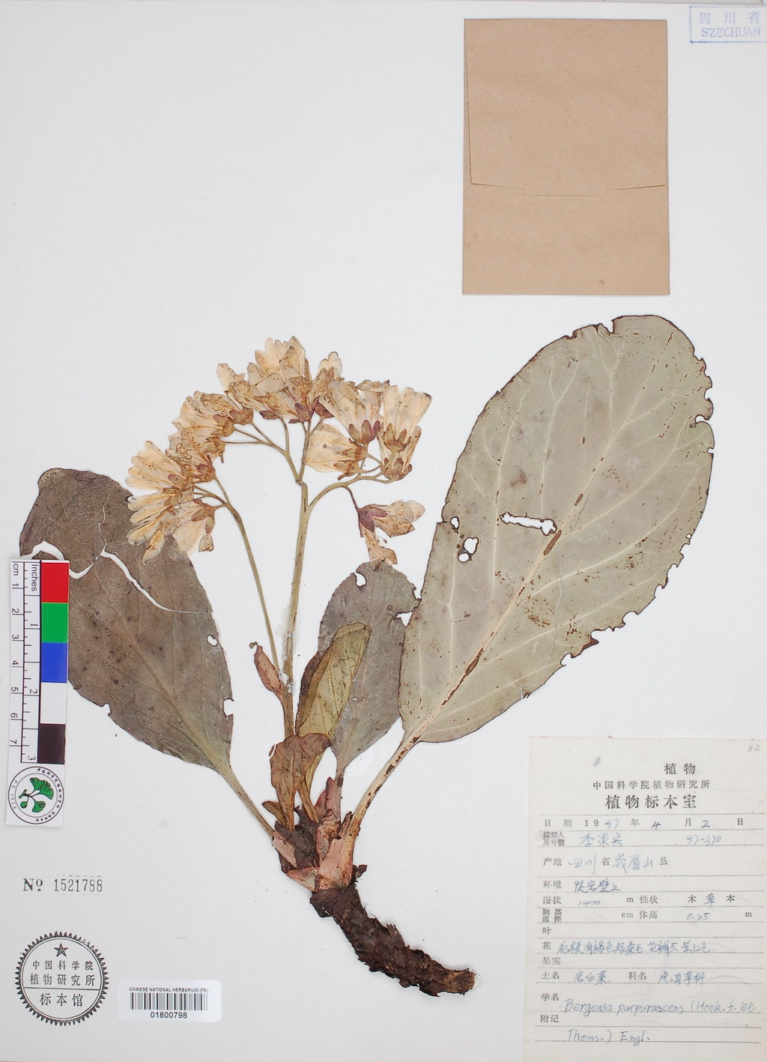
Figure S2A
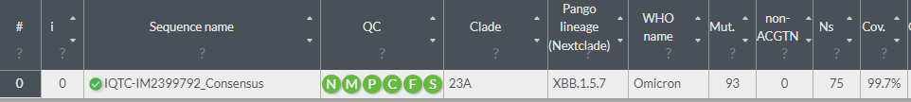
Figure S2B
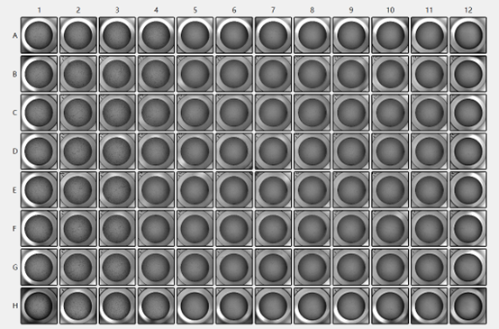
The whole genome of the variant strain of the virus used in this study was uploaded to the Nextclade database, which revealed that the clade of the COVID-19 virus used in this study was 23A, with a Pango lineage of XBB1.5.7.
As shown in Figure S2B, the black dots in the cell wells of the 96-well plate represent the cytopathic effect (CPE) observed under the treatment of the virus. By observing and counting, it was found that there was no CPE at a dilution of 10⁻⁶, 2 out of 8 wells showed CPE at a dilution of 10⁻⁵, and all 8 wells showed CPE at a dilution of 10⁻⁴. According to the Reed-Muench method, the virus titer of the original solution was calculated to be 5.62×10⁵ TCID₅₀/mL.

Figure S3A
Figure S3B
Figure S3 depicts the process of immobilizing either the S1 protein or the ACE2 protein onto a CM5 chip. After the equipment baseline stabilizes, a mixture of EDC/NHS is added to activate the carboxyl groups on the chip surface. The EDC/NHS mixture is then rinsed away. Next, the protein intended for immobilization, either S1 or ACE2, is passed over the chip surface and allowed to sit for a period of time. Excess proteins are then washed away, and it can be observed that the proteins are successfully immobilized on the chip surface. The ΔRU value for the chip with S1 protein immobilization is 5838.4 (Figure S3A), and for the chip with ACE2 protein immobilization, it is 3795.6 (Figure S3B). The successful immobilization of the chips is confirmed.

Table S1 Screening the Biological Activity of 53 Traditional Tibetan Medicines
No. | Botanical name | Activity value | SD
1 | Arenaria kansuensis Maxim. | 4.22 | 0.06
2 | Juniperus formosana Hayata | 3.07 | 0.48
3 | Rheum tanguticum (Maxim.ex Regel) Maxim.ex Balf. | 2.36 | 0.45
4 | Sinopodophyllum hexandrum (Wall. Ex Royle) T.S.Ying | 2.68 | 0.95
5 | Hypecoum Leptocarpum Hook.f et Thoms. | 2.71 | 0.15
6 | Corydalis impatiens (Pall.)Fisch.ex DC. | 1.73 | 0.56
7 | Corydalis hendersonii Hemsl. | 1.53 | 0.34
8 | Meconopsis quintuplinervia Regel | 3.92 | 0.25
9 | Chrysosplenium nudicaule Bge. | 2.93 | 0.97
10 | Saxifraga tangutica Engl. | 2.58 | 0.38
11 | Bergeria purpurascens (Hook.f.et Thoms.) Engel. | 4.99 | 0.01
12 | Oxytropis falcata Bunge | 0.38 | 0.16
13 | Myricaria germanica (L.) Desv. | 4.75 | 0.06
14 | Sphallerocarpus gracilis (Bess.ex Trevir.) K.-Pol. | 0.15 | 0.20
15 | Rhododendron anthopogonoides Maxim. | 4.35 | 0.61
16 | Swertia mussotii Franch. | 2.73 | 0.05
19 | Lagotis brevituba Maxim. | 2.97 | 0.43
20 | Lagotis integra W. Smith. | 1.58 | 0.06
21 | Pterocephalus hookeri(C.B.Clarke)Hoeck | 3.46 | 0.24
22 | Artemisia sieversiana Willd. | 4.41 | 0.41
23 | Ixeris chinensis(Thunb.)Nakai | 1.59 | 0.39
24 | Saussurea brunneopilosa H.-M. | 4.58 | 0.71
26 | Carthamnus tinctorius L. | 1.16 | 0.23
27 | Gymnadenia conopsea(L.)R.Br. | 3.84 | 0.27
28 | Anisodus tanguticus (Maxim.)Pasher | 0.71 | 0.32
29 | Terminalia chebula Retz. | 4.90 | 0.03
30 | Terminalia billerica （Gaertn.）Roxb. | 4.33 | 0.00
32 | Mirabilis himalaica (Edgew.)Heim. | 2.13 | 0.46
33 | Herpetospermum penduculosum(Ser.)Baill. | 4.34 | 0.06
34 | Aucklandia lappa Decne. | 0.25 | 0.23
35 | Entada phaseoloides (L.)Merr. | 3.09 | 0.11
36 | Nardostachys jatamansi (D.Don)DC. | 4.86 | 0.17
38 | Aegle malmelos (L.) Correa | -0.03 | 0.17
39 | Rubus biflorus Buch.-Ham.ex Smith | 3.93 | 0.22
41 | Butea monosperma(Lamk.)O.ktze. | 4.42 | 0.05
42 | Momordica cochinchinensis (Lour.) Spreng. | 4.47 | 0.24
44 | Laccifer lacca Kerr. | 2.79 | 0.28
46 | Stryrax tonkinensis (Pierre)Craib ex Hart. | 1.08 | 0.50
47 | Nigella glandulifera Freyn | 4.82 | 0.19
48 | Holarrhena antidysenterica Wall.ex A.DC. | -0.30 | 0.25
49 | Syzygium cumini (L.) Skeels | 3.93 | 0.01
50 | Malba verticillata L. | 3.87 | 0.08
53 | Aconitum tanguticum(Maxim.)Stapf | 1.05 | 0.23
54 | Gentiana nubigena Edgew. | 2.43 | 0.72
55 | Gentiana veitchiorum Hemsl. | 1.03 | 0.70
56 | Gentiana urnula H.Smith. | 3.28 | 0.54
57 | Saussurea obvallata(DC.)Sch.-Bip. | 4.36 | 0.14
58 | Ranunculus brotherusii Freyn var.tanguticus (Maxim.)Tamura | 2.84 | 0.18
59 | Dracocephalum heterophyllum Benth. | 4.56 | 0.34
61 | Meconopsis horridula Hook.f.et Thoms. | 0.52 | 0.07
62 | Meconopsis integrifolia (Maxim.) Franch. | 3.62 | 0.05
64 | Aconium gymnandrum Maxim. | 2.27 | 0.14
65 | Biebersteinia heterostemon Maxim. | 3.38 | 0.14
68 | Saussurea stella | 4.22 | 0.53

