Enhanced compatibility and toughness of PHBV/PCL blends by ring-opening polymerization and hydrogen bonding of epoxy-terminated hyperbranched polyester
Jiawei Huang¹, Yiqi Fang¹, Sudan Zhou¹, Rui Tie¹, Shuyi Zhou¹, Yujuan Jin^{1,2*}, Huafeng Tian^{1,2*}, Rakesh Kumar^{3*}
1 School of Chemistry and Materials Engineering, Beijing Technology and Business University, Beijing, P. R. China, 100048
2 Beijing Key Laboratory of Quality Evaluation Technology for Hygiene and Safety of Plastics, Beijing Technology and Business University, Beijing, P. R. China,100048
3 Department of Biotechnology, Central University of South Bihar, Gaya, India, 824236
Email: jinyujuan@th.btbu.edu.cn or tianhuafeng@th.btbu.edu.cn or krrakesh72@gmail.com
Tel: +86-13621399877
Fax: +86-10-68985380

Experimental
Materials
PHBV (Y1000P, M_{w}=2.67×10⁵, HV=3%, PDI=2.21) were provided by Ningbo Tian'an Biological Materials Co., Ltd. (Ningbo, Zhejiang Province, China). P-toluenesulfonic acid, boron trifluoride diethyl ether and sodium hydroxide were obtained from Sinopharm Chemical Reagent Co., Ltd. 2,2-Bis(hydroxymethyl)-propionic acid (DMPA) was purchased from Tianjin Weiyi chemical technology Co., Ltd. Trimethylolpropane (TMP) were obtained from Tianjin Bodi Chemical Co., Ltd. Trichloromethane was purchased from Beijing Chemical Works. Epichlorohydrin was purchased from Chengdu Huaxia Chemical Reagent Co., Ltd. PCL was supplied by Shenzhen eSUN industrial CO., Ltd.
Synthesis of epoxy‑terminated EHBP
All of samples were stored at room temperature and about 50% humidity. Trimethylolpropane (5.0 g), 2,2-Bis(hydroxymethyl)-propionic acid (105.0 g) and P-toluenesulfonic acid (0.25 g) were mixed and poured into a three-mouth flask. The target product is G3-Hydroxyl terminated hyperbranched polyester (HBPE) (as shown in Fig .1), so the molar ratio between TMP and DMPA is 1:21. The agitator and the reflux condensing tube were connected into the three mouth flasks, and then the three mouth flasks was put into the oil bath. The oil bath was preheated to 120 ℃, then the temperature was raised to 140 ℃. When the reactants in the three-mouth flask were fully melted, then the melt was allowed to react at atmospheric pressure for 2 hours under the N₂ atmosphere. Vacuum distillation was carried for 2 hours, so that the water was completely steamed out and the reaction can be stopped. When the product cooled, a hard and brittle translucent solid (HBPE) was formed.
Boron trifluoride diethyl ether was added into the HBPE at 80 °C. 100 mL Epichlorohydrin was then added dropwise. After the reaction was carried out for 2 h, the excess of moisture, epichlorohydrin and small molecular by-products were pumped off under reduced pressure. Saturated sodium hydroxide solution was thereafter added and the reaction was continued at 80 °C for 2 h. After adding 300 mL of chloroform at room temperature, the product was dissolved in 30 min. The mixture was filtered and the filtrate was purified first using a rotary evaporator and then under vacuum to obtain the desired product as an orange viscous liquid.
Preparation of the blends
PHBV was dried at 80 °C for 8 h in a vacuum drying oven. PCL was dried at 40 °C for 4 h in a vacuum drying oven. After that, PHBV resin particles and PCL were weighed at a ratio of 8/2, and mixed with different contents (0phr, 1phr, 2phr, 3phr, 4phr) of EHBP. An internal Mixer (SHR-10A, Zhangjiagang Hongji Machinery Co., Ltd.) was used to evenly blend the PHBV, PCL and EHBP. The mixing was carried out at 180 °C for 9 min at a speed of 60 rpm. For the purposes of comparison, pure PHBV/PCL resins were also melt-blended under the same processing conditions. The blends were then cooled down to room temperature before crushing and granulating through a Crushing Machine (HP-150, Beijing Huanyatianyuan Mechanical and Technical Co., Ltd.). The standard splines were made through injection molding by an injection-molding machine (TY400, HangZhou DaYu Machinery Co., Ltd). The injection temperature was set to 180 °C, and the injection pressure was 50 bar.

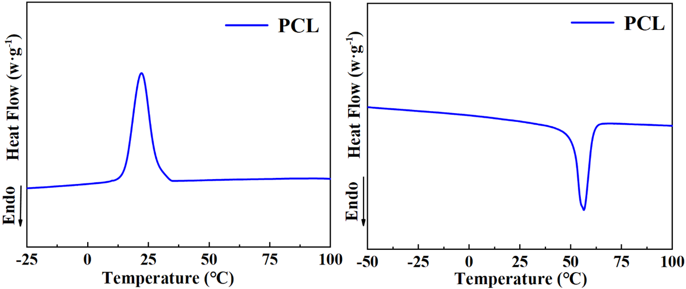
Figure S1 DSC curves of PCL:
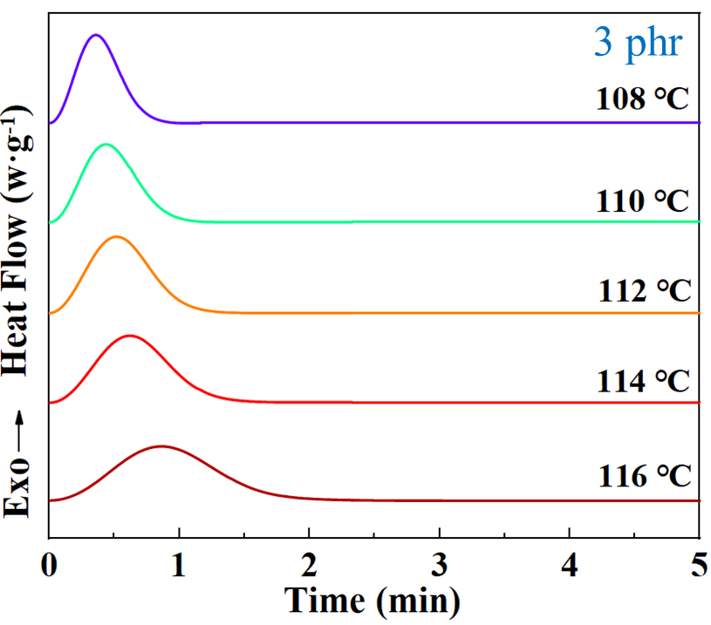
Figure S2 Crystallization curve of temperature and time at 3phr

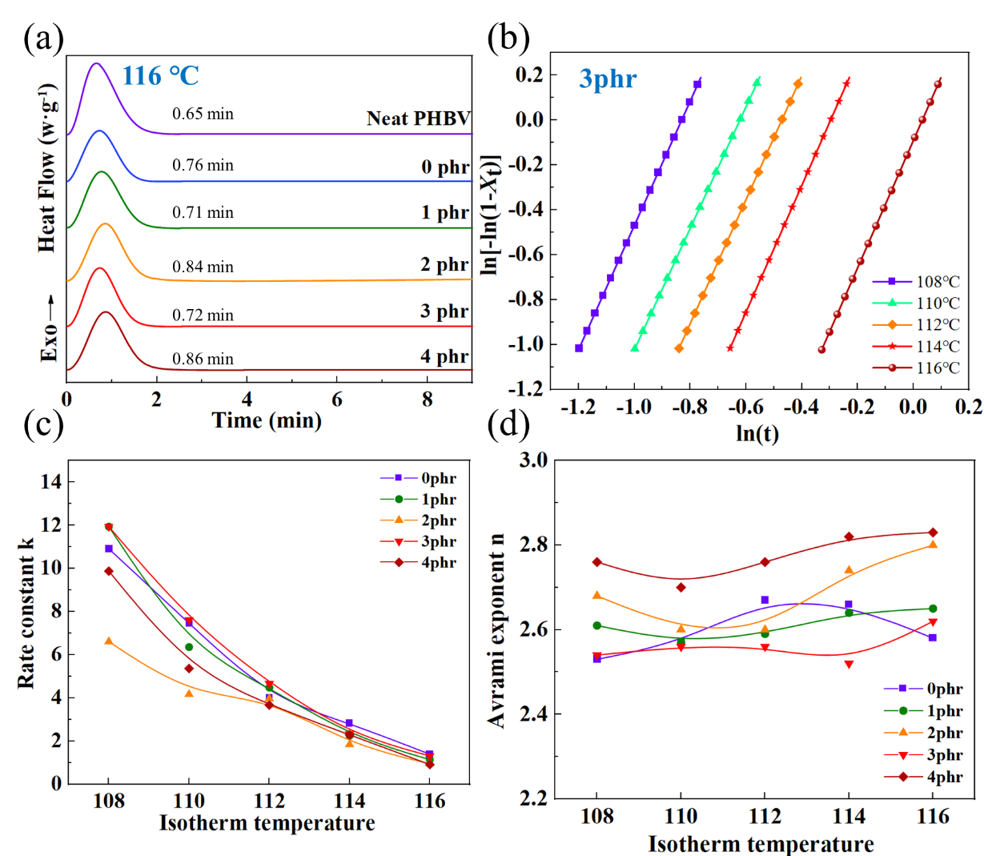
Figure S3. (a) isothermal crystallization curve, (b) Avrami plots of PHBV/PCL blends with 3phr EHBP content isothermally crystallized at different temperature, (c) the Avrami exponent n and (d) the crystallization rate K.
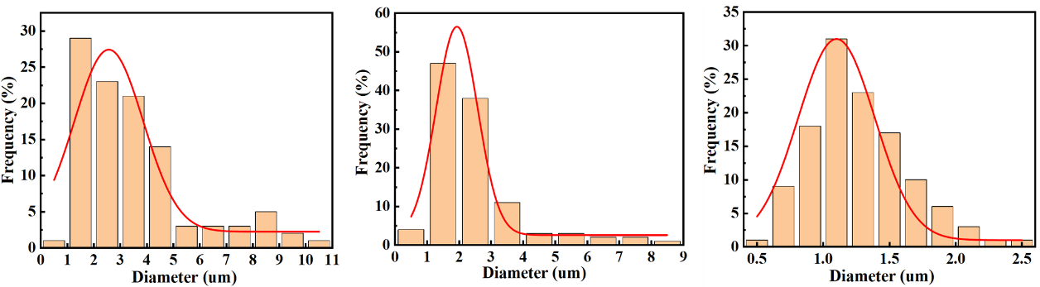
Figure S4. porosity of the composite after etching (0,1,3phr)
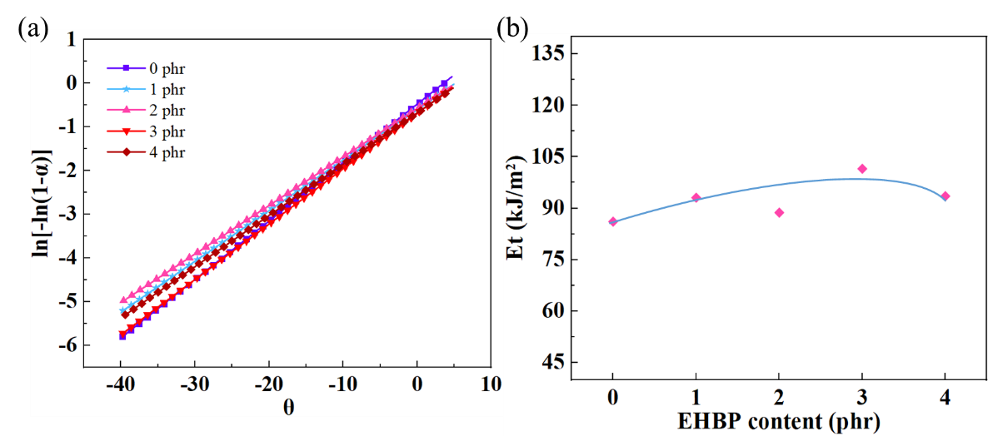
Figure S5. (a) linear slope of ln[ln(1−α)-1] relative to θ, (b) E_{t} curves.
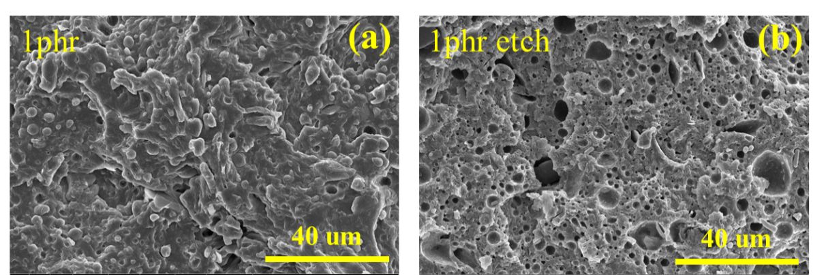
Figure S6. SEM images of impact-fractured surfaces. (a) 1phr, (b) the morphology of blends after etching the PCL phase (1phr)

