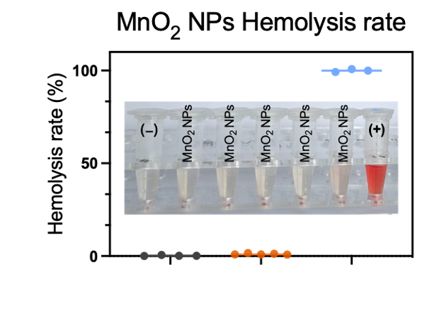
Figure S1. The hemolysis rates at varying concentrations of MnO₂ NPs from 10, 20, 50, 100, 200 μg/mL.

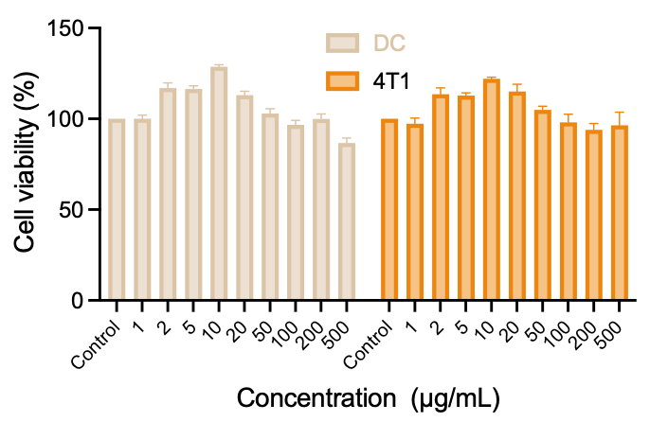
Figure S2. The Cell viability of DC and 4T1 cells after incubating with different concentrations of MnO₂ NPs for 48 h.

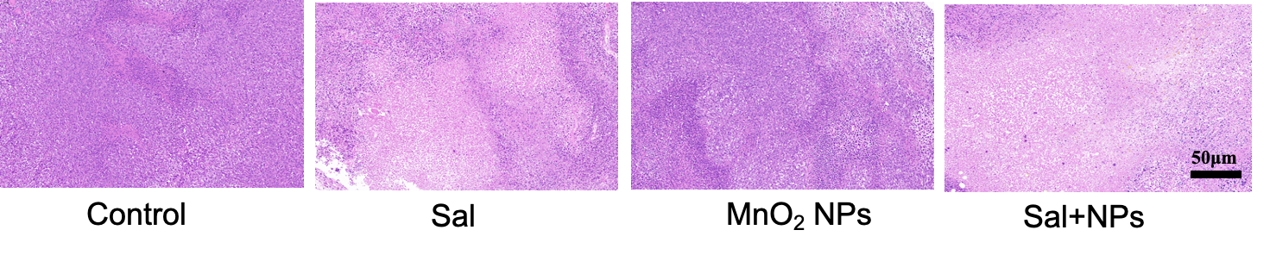
Figure S3. The H&E staining of tumor post different treatments.

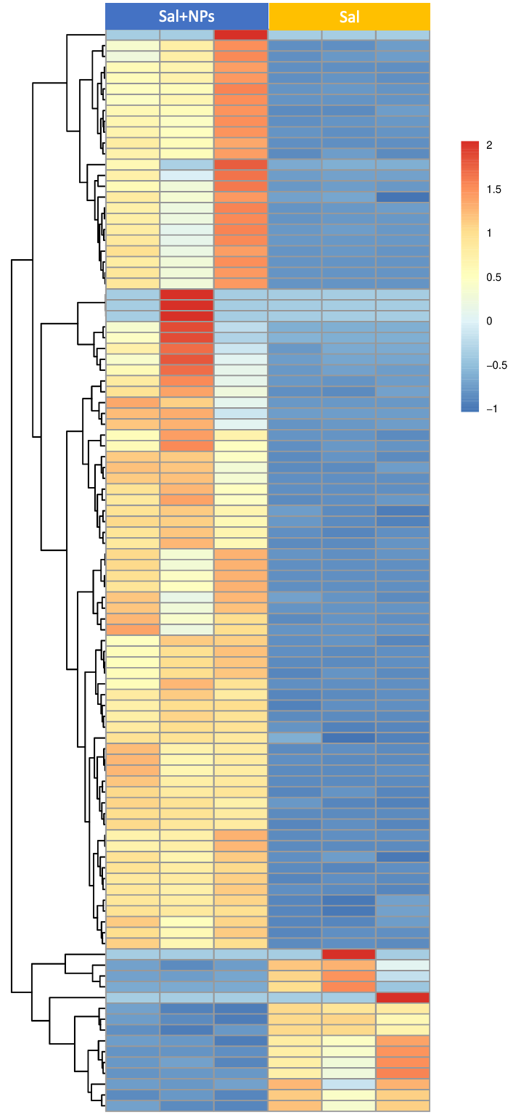
Figure S4. (A) The mRNA transcriptome sequencing heatmaps of tumor tissue post different treatments.

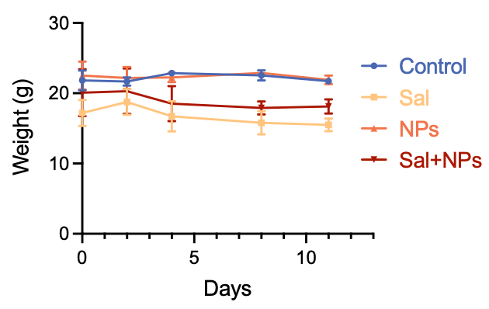
Figure S5. The weight curve of the mice across all treatment groups.
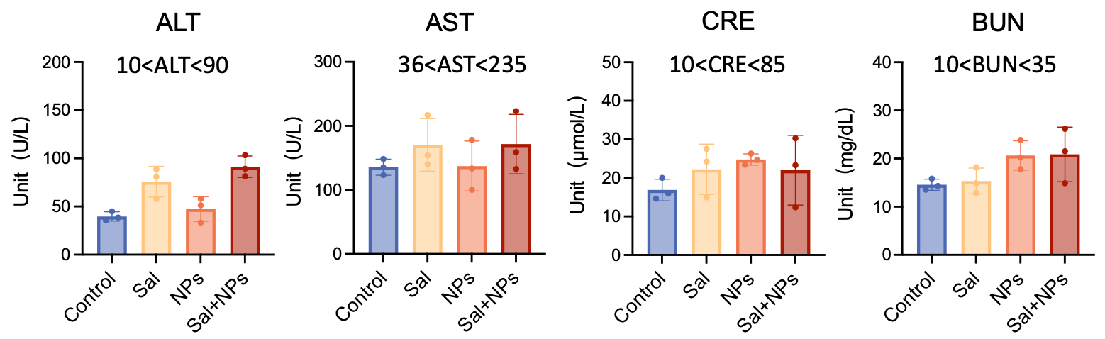
Figure S6. The post-treatment serum analysis of the biochemical indicators.

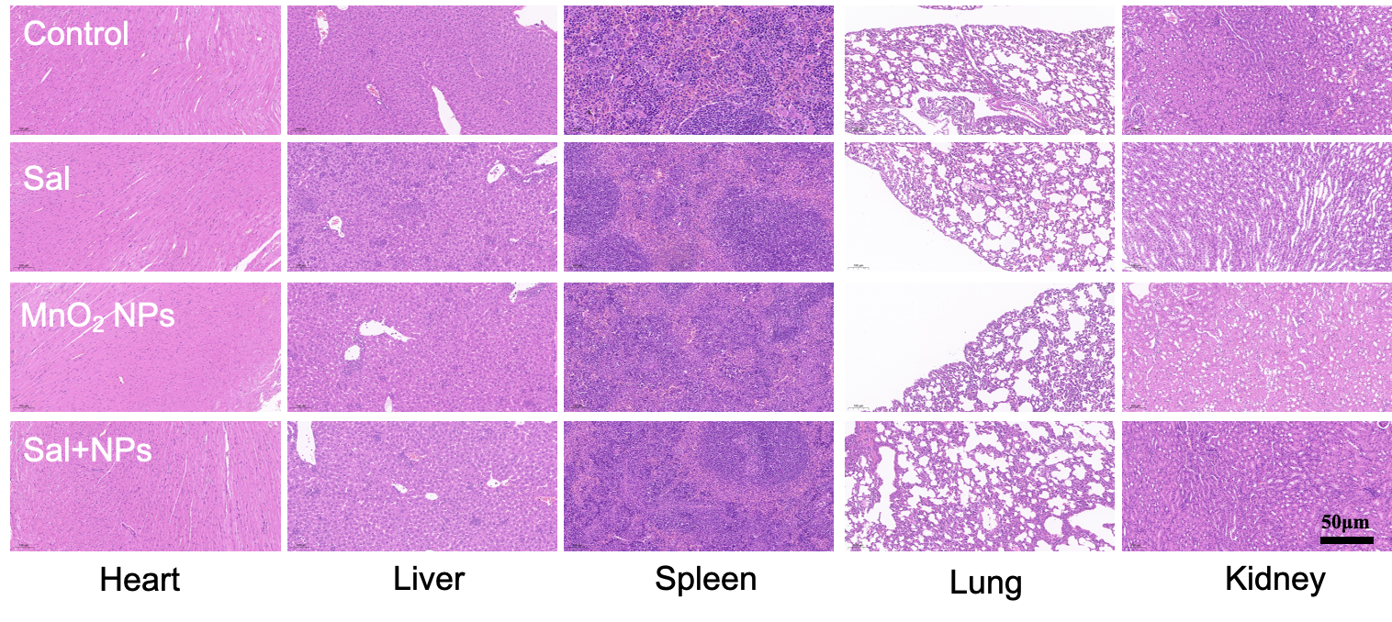
Figure S7. The H&E staining analysis of the major organs in the mice.

