Fig.S1 Sequence alignment of AhSTP3, AhSTP9, AhSTP19 and AhSTP28 in subsp. hypogaea and subsp. fastigiata. (A) The first intron alignment of AhSTP9 and AhSTP28 in subsp. hypogaea and subsp. fastigiata. (B, C) The CDS and protein sequence alignment of AhSTP3 in subsp. hypogaea and subsp. fastigiata. (D, E) The promoter region sequence alignment of AhSTP3 and AhSTP19 in subsp. hypogaea and subsp. fastigiata.
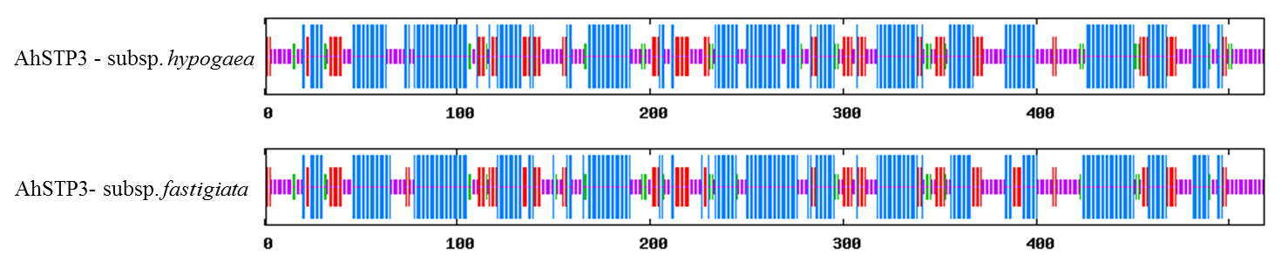
Fig.S2 Protein secondary structure prediction of AhSTP3 in subsp. hypogaea and subsp. fastigiata. The blue line in the figure indicate alpha helix, the red line indicate extended strand, the green line indicate beta turn, and purple line represents random coil.
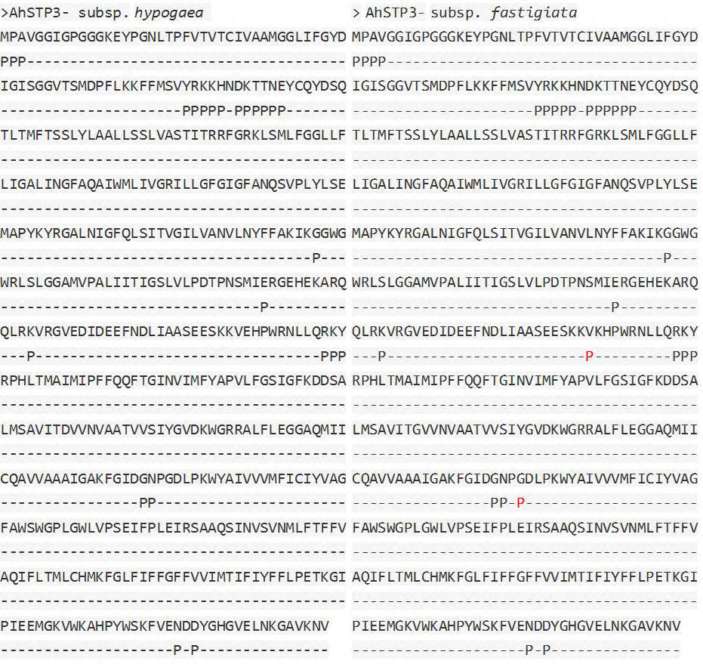
Fig.S3 Protein-protein binding site prediction of AhSTP3 in subsp. hypogaea and subsp. fastigiata.

