Supplementary Information
Supplementary Table 1: Table of next-generation sequencing information used in this survey with number of reads per sample and accession numbers per sample.
Supplementary Table 2: Average number of offspring from each set of crosses, either heterospecific or conspecific crosses after 1 week of mating and 1 week of egg laying. Table also shows the sex ratio of offspring and if offspring of each sex are fertile.
Supplementary Table 3: Table showing average synonymous divergence between each species pair.
Supplementary Table 4: Table summarizing genome assembly statistics of each species sequenced and assembled chromosomes, including number of scaffolds for each chromosome, the length of each chromosome, and coding and intronic proportions.
Supplementary Table 5: Summary statistics of genomes sequenced assembled and annotated in this study, including number of genes, the number of these that have orthologs in D. virilis and D. melanogaster, as well as statistics regarding size of these genes.
Supplementary Table 6: Gene categories enriched for high dN/dS (either the upper 95th percentile or dN/dS > 1) across the entire phylogeny and on each species branch, also the upper outliers for D. nigrodunni and D. arawakana relative to the other species.
Supplementary Table 7: Gene categories enriched for duplications on each branch of the D. dunni species phylogeny, relative to unduplicated genes.
Supplementary Table 8: dN/dS statistics calculated using codeML for the entire dunni phylogeny and on each branch.
Supplementary Figure 1: Phylogeny of the dunni group relative to other Drosophila species. Phylogeny was calculated using PhyML (104), finding the consensus of 100 genes, with bootstrap values (the number that match out of 100) shown at nodes. Scale bar shows the branch length of 0.2 substitutions per site.
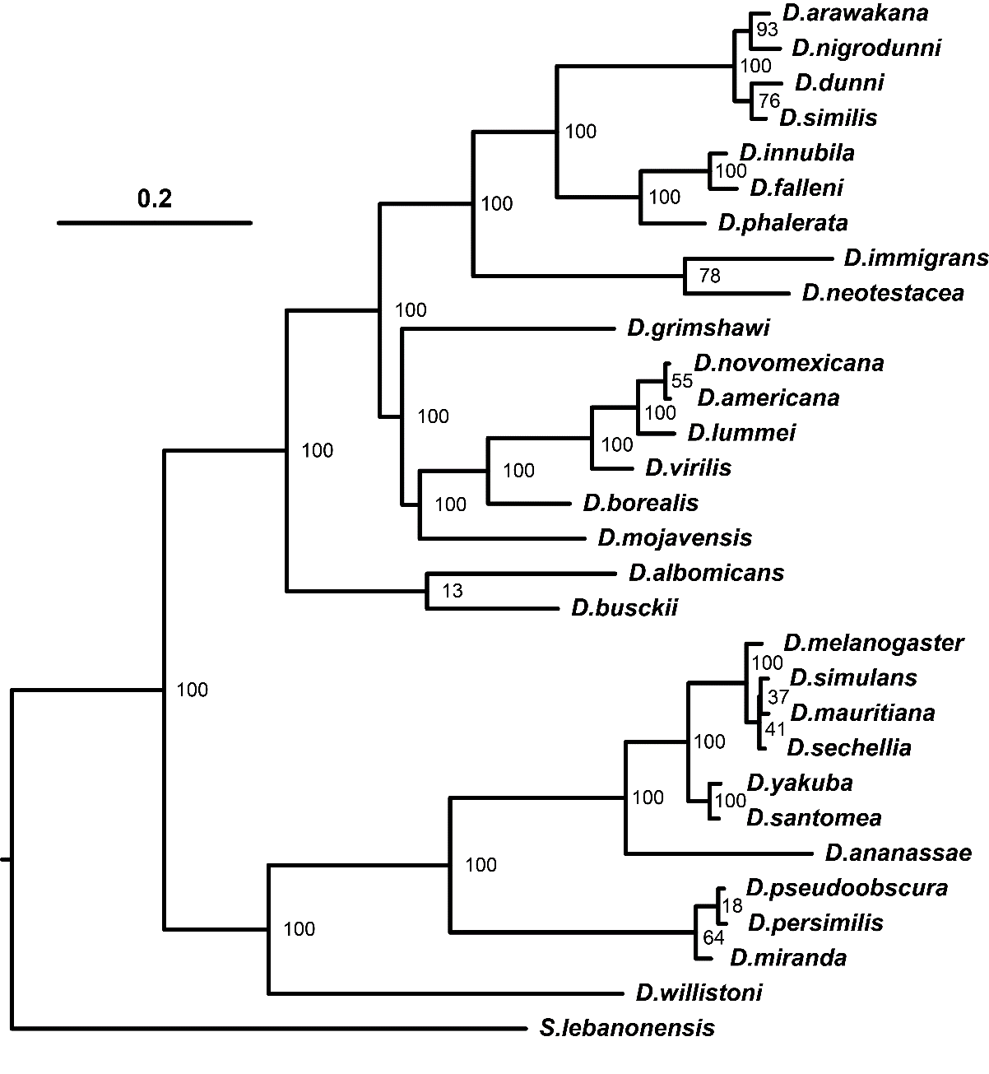
Supplementary Figure 2: Proportion of females surviving each day, for each species used in each cross, compared to virgin female survival. Crosses following curing of the strain with Tetracycline-Hydrochloride. Females are separated by species, and grouped as virgins, conspecific crossed (crossed to own species), heterospecific crossed (crossed to a different species). In the case of heterospecific crosses, D. arawakana is only crossed to D. nigrodunni and D. dunni is only crossed to D. similis.
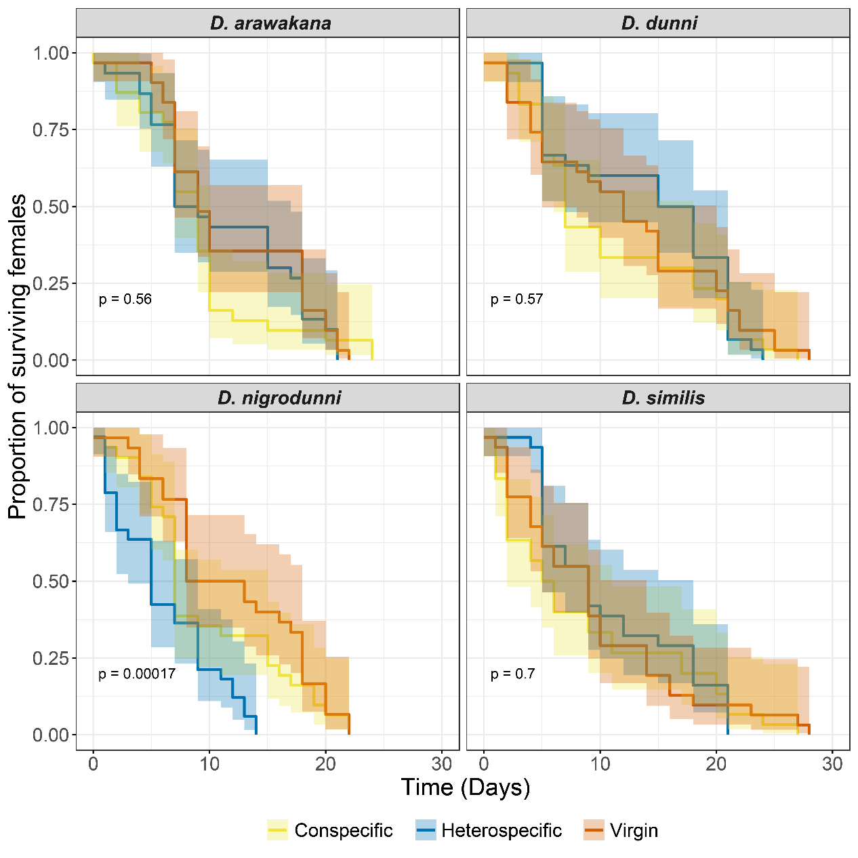
Supplementary Figure 3: Difference in survival for different sets of crosses, comparing between survival of females before and after curing with Tetracycline-Hydrochloride.
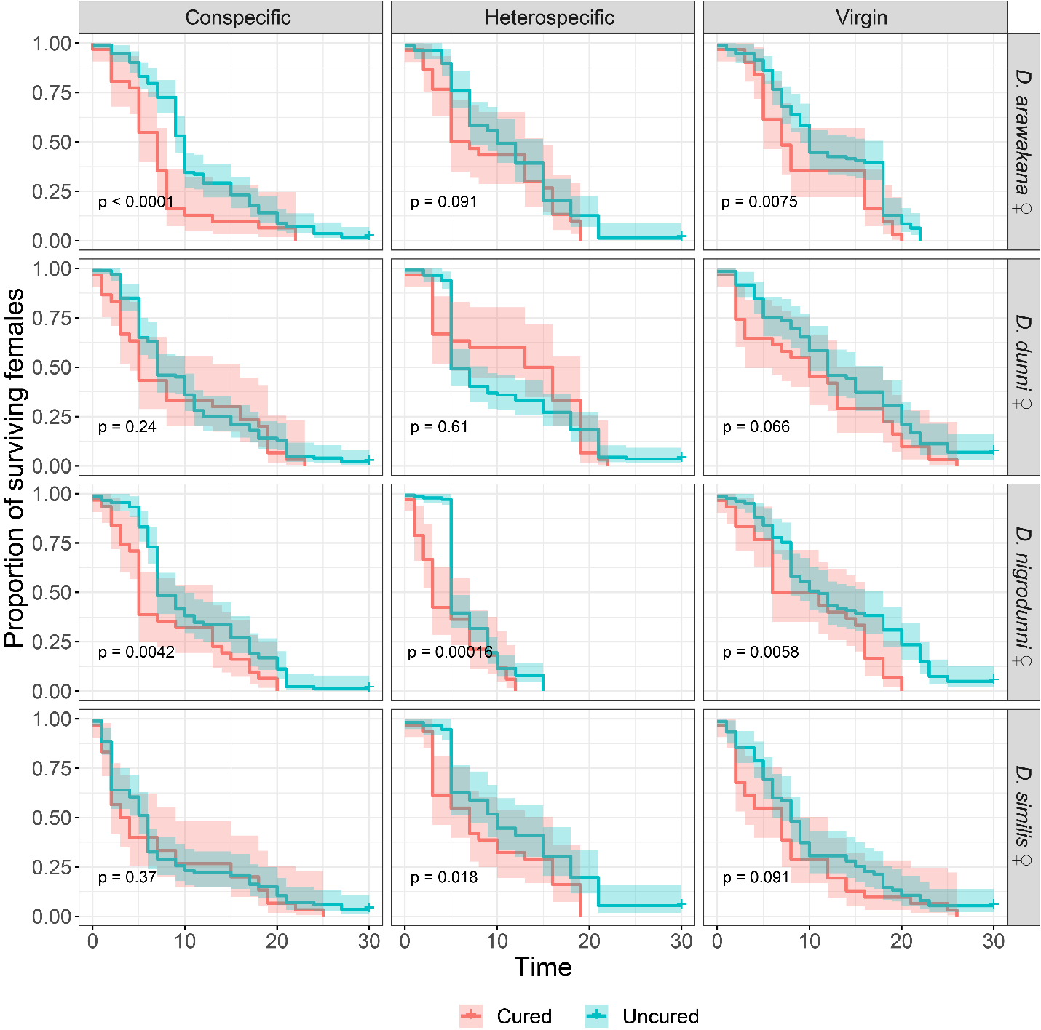
Supplementary Figure 4: Orthologous regions between the D. nigrodunni genome, D. dunni genome and D. innubila genome. Syntenic regions on the same chromosome (shown as Muller elements, A-F) are labelled with grey ribbons, while syntenic regions between difference chromosomes are labelled in red.
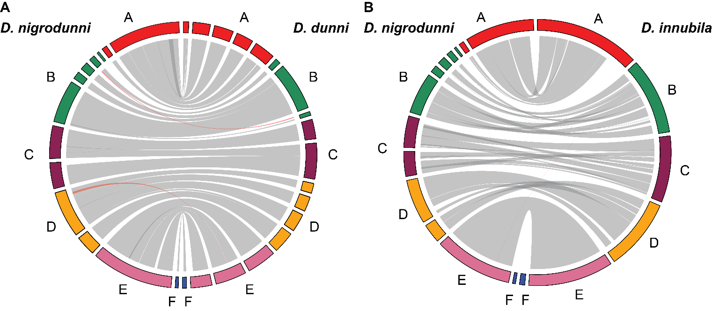
Supplementary Figure 5: Proportion of each genome made up of repetitive content (colored by classification of repetitive content) For simplicity, the satellite category contains Satellites, microsatellites, simple repeats tandem repeats and low complexity regions. A. Comparison of TE annotation between two tools, DNApipeTE and Repeatmodeler. B. Comparison of TE content across species and if that content is shared between species or is unique to one species. 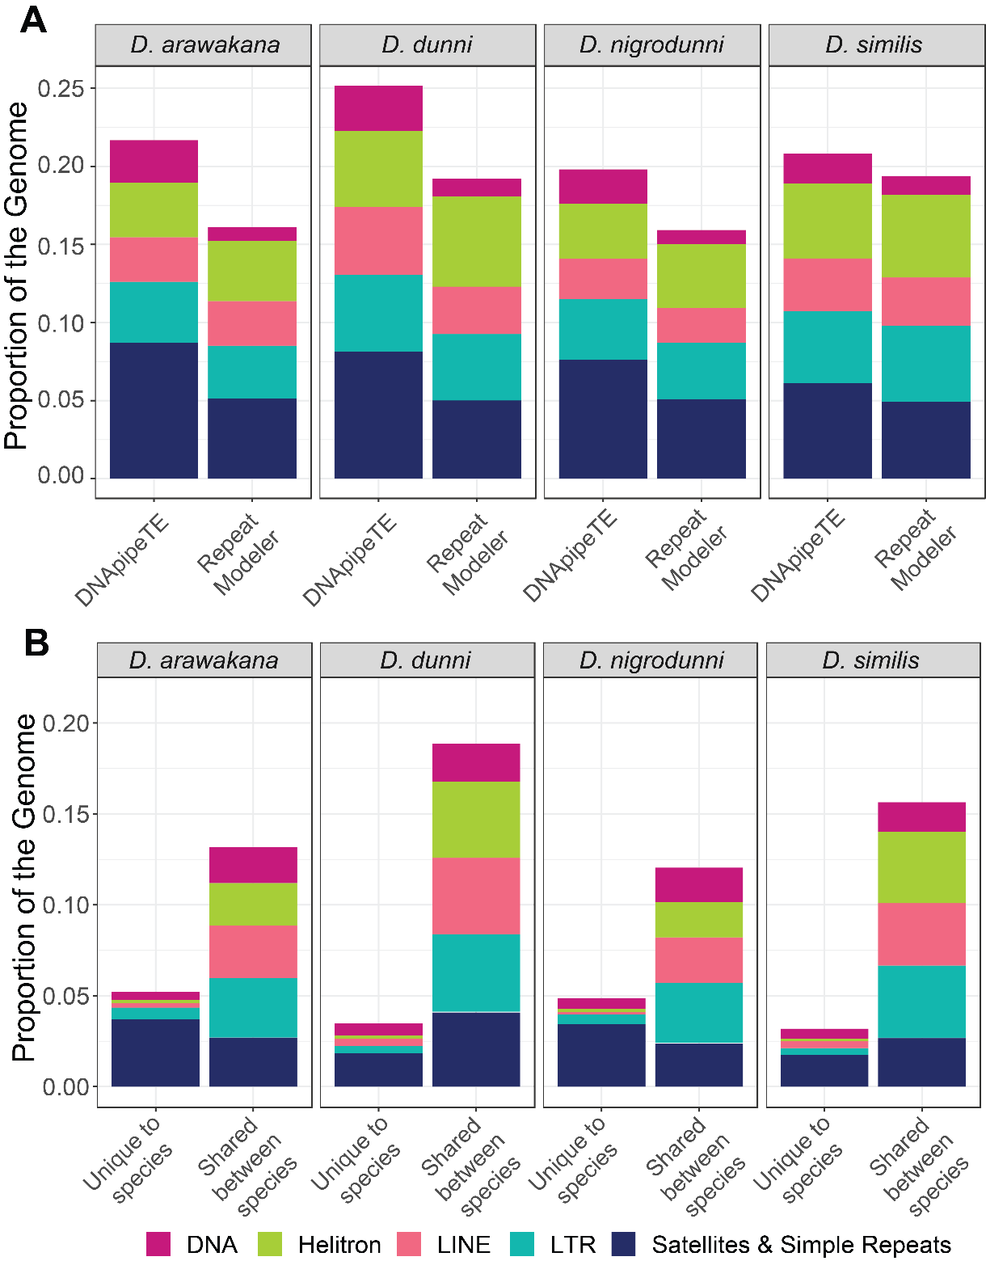
Supplementary Figure 6: Proportion of gene categories with enrichments of duplications in D. nigrodunni (D. nig), D. arawakana (D. ara) or both species. N = number of genes per category.
