SUPPLEMTARY MATERIALS
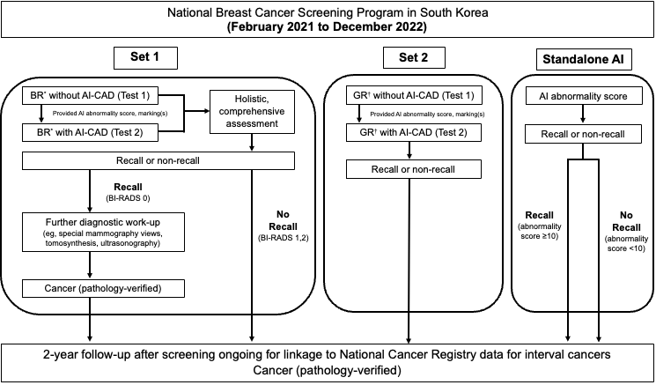
*Experts in breast imaging with more than >10 years of experience
†Radiologists not specializing in breast imaging
Note: AI, artificial intelligence; BI-RADS, Breast Imaging-Reporting and Data System; BR, breast radiologist; CAD, computer-aided detection; GR, general radiologist.
eFigure 1. Overview of the study design.

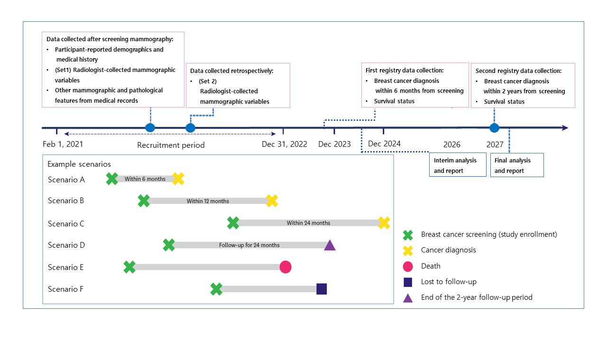
eFigure 2. Overview of the study timeline. Scenarios A and B: Enrolled and diagnosed with cancer at 6 or 12 months; classified as having breast cancer diagnosis within 1 year from screening. Scenario C: Diagnosed with cancer within 24 months of enrollment; classified as having breast cancer diagnosis within 2 years from screening. Scenario D: Not diagnosed with cancer until 24 months after enrollment. Results of Scenarios A–D can be termed positive or negative depending on the cancer diagnosis. Scenario E: Died during the study because of any reason and cannot be included in the study. Scenario F: Lost to follow-up and cannot be included in the study because of no available records.

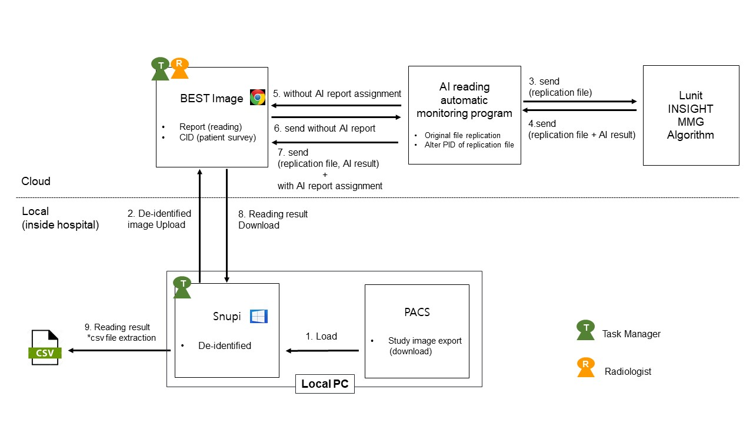
eFigure 3. Image acquisition and data management

