Supporting Information
Thermoresponsive [(PLA)-b-(Car)] based frustum-shaped capsules with extended porosity for biosensing and biomedical applications
Chander Amgoth Pawar^{1a,2}*, David Xu Luo², Divya Rokkala^{1b}, Raju Bura³, Gundeti Bhagyalaxmi^{1c}, Rampilla Sudha Rani^{1d}, Krishna Veni Mannam^{1e}, Kothamasu Suresh Babu^{1f}
¹Department of Humanities and Sciences, Marri Laxman Reddy Institute of Technology and Management, Hyderabad-500043, India
²Department of Biomedical Engineering, Texas A&M University, College Station, TX- 77843, United States
³Department of Chemistry, Institute of Aeronautical Engineering, Hyderabad-500043, India
*Corresponding author: +91 9908812120; E-mail: chander@uohyd.ac.in
Figure S1. (a) Correspond to reaction scheme of [(PLA)-b-(Car)], (b) FTIR and (c) ¹H NMR for [(PLA)-b-(Car)] [1-4].

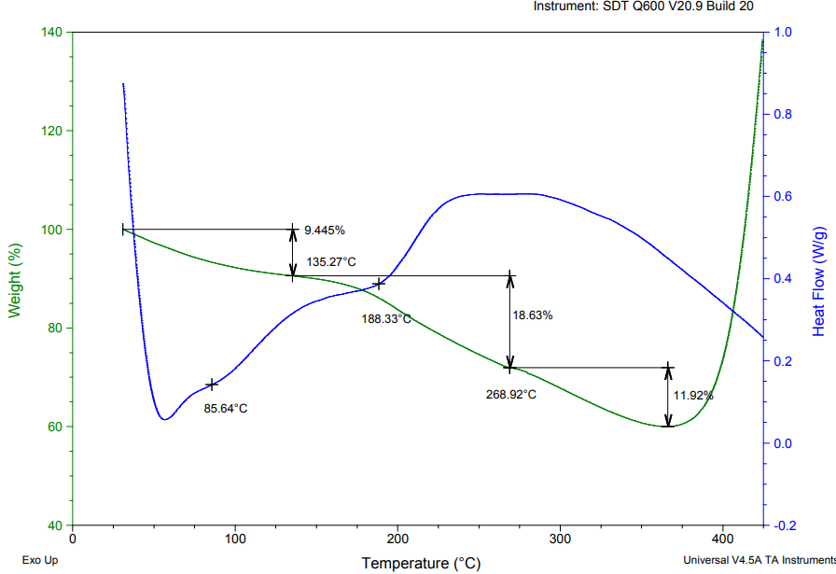
Figure S2. TGA-DSC plots for thermal stability and degradation/weight loss behavior of [(PLA)-b-(Car)] based porous capsules [3-6].

Figure S3. FE-SEM micrographs corroborate (a-d) normal and tilted views of ice-cream cup-shaped frustum nanoparticles. Images from a-d are acquired from lower to higher magnifications with a scale bar of 100 to 200 nm [3-7].
Figure S4. FE-SEM micrographs corroborate (a, b) tilted view of ice-cream cup-shaped frustum nanoparticles. Imaging and characterization parameters (working distance, acceleration voltage, magnification scale bar, etc.) have been appended in the above-shown micrographs (raw data files).
Figure S5. FE-SEM micrographs corroborate (a) tilted side view of elliptical cone-shaped nanoparticles, (b) front view of elliptical cone-shaped nanoparticles, (c) back view of elliptical cone-shaped nanoparticles, and (d) distribution of many elliptical cone-shaped nanoparticles. Images were captured from lower to higher magnification. Imaging and characterization parameters (working distance, acceleration voltage, magnification scale bar, etc.) have been appended in the above-shown micrographs (raw data files) [4-7].
Figure S6. FE-SEM micrographs corroborate the back view of elliptical cone-shaped nanoparticles without any porosity over the surface.
Figure S7. FE-SEM micrographs corroborate (a, b) tilted side view of dome-shaped nanoparticles. Image (c) corroborates the openable lid with surface e porosity and hollowness of the capsule. Image (d) represents the aggregation of dome-shaped porous nanocapsules. Images are acquired from lower to higher magnification. Scale bar from 100 to 200 nm [6-9].
Figure S8. FE-SEM micrographs corroborate (a, b) tilted side view of dome-shaped nanoparticles. Imaging and characterization parameters (working distance, acceleration voltage, magnification scale bar, etc.) have been appended in the above-shown micrographs (raw data files) [8, 9].
Figure S9. AFM 2D phase corroborates the distribution of pores over the capsule surface and line scanning depicts the pore depth (50 nm) and width (100 nm). Further, the threshold map corroborates the pore profile with pore depth and width along with surface texture analysis [9-11].

Figure S10. AFM threshold map corroborates the pore profile with pore depth and width along with surface texture [12-15].

Figure S11. FACS represents the apoptotic results on K562 cells treated with [(PLA)-b-(Car)]-(DOX) nanoformulation.

References
- Y. Liu, et al., Protein-mediated wool-all-like copper sulfide as multifunctional nanozyme for dual fluorescence” turn-on “sensors of cysteine and silver ions, Materials Chemistry B (2020).
- M. Pal, et al., Synthesis of CuS nanoparticles by a wet chemical route and their Photocatalytic activity, J Nanopart Res (2015).
- Roman A, et al., A Core–shell designed scaffolds for drug delivery and tissue engineering, Acta Biomaterialia, (2015).
- April R. et al., Enzyme-Triggered Cargo Release from Methionine Sulfoxide Containing Copolypeptide Vesicles, Biomacromolecules.
- Y.Wang, et al., Multifunctional Super hydrophobic Surfaces Templated from Innately Microstructured Hydrogel Matrix, Nano Lett.
- M. Humenik, et al., Controlled Hierarchical Assembly of Spider Silk-DNA Chimeras into Ribbons and Raft-Like Morphologies, Nano Lett.
- P. Yang, et al., Core-shell structured Gd2O3:Ln@mSiO2 hollow Nanospheres: synthesis, photoluminescence, and drug release properties, J. Mater. Chem. B, 2014.
- Britt. H, et al., Catalytic activity of Au nanoparticles, Nano today, 2, 2007.
- Z. Chu, et al., Designing nanoparticle carriers for enhanced drug efficacy in photodynamic therapy, Biomaterials Science.
- Y.Wang, et al., Multifunctional Super hydrophobic Surfaces Templated from Innately Microstructured Hydrogel Matrix, Nano Lett.
- A.Barhoumi, et al., Photo thermally Targeted Thermosensitive Polymer-Masked Nanoparticles, Nano Lett.
- E. Cabane, et al., Stimuli-Responsive Polymers and Their Applications In Nanomedicine, Bio interphases (2012) 7, 9.
- April R. et al., Enzyme-Triggered Cargo Release from Methionine Sulfoxide Containing Copolypeptide Vesicles, Biomacromolecules.
- Roman A, et al., Core–shell designed scaffolds for drug delivery and tissue engineering, Acta Biomaterialia, (2015).
- M. Pal, et al., Synthesis of CuS nanoparticles by a wet chemical route and their Photocatalytic activity, J Nanopart Res (2015).

