Elastogenesis Stimulation by Minoxidil or Nebivolol Reduces Premature Aging of the Aortic Wall in Diabetic Mice
Auberi Henry^{1#}, Laetitia Vanalderwiert^{1#}, Amandine Wahart¹, Daniel A Carvajal Berrio², Eva M Brauchle^{2 2,3}, Katja Schenke-Layland^{2,3,4}, Juergen Brinckmann⁵, Heiko Steenbock⁵, Laurent Debelle¹, Isabelle Six⁶, Gilles Faury⁷, Stéphane Jaisson^{1,8}, Philippe Gillery^{1,8}, Vincent Durlarch^{1,9}, Hervé Sartelet¹, Pascal Maurice¹, Amar Bennasroune¹, Laurent Martiny¹, Laurent Duca¹, Béatrice Romier¹, Sébastien Blaise^{1*}

SUPPLEMENTAL MATERIAL
High-frequency ultrasound imaging – High-resolution ultrasound imaging was performed with animals anesthetized (isoflurane 4%). The animals were depilated with hair removal cream and placed on a heated table (37°C). For ultrasound measurements, a Vevo3000 ultrasound imaging system (VisualSonics, Toronto, Canada) with a 30 MHz linear signal transducer was used for measurements of anatomical and functional parameters of the left ventricle of the heart needed to determine factors such as ejection fraction, cardiac output, fractional area change, fractional shortening, stroke volume, end-systolic volume (LVESV), and end-diastolic volume (LVEDV).
Cell Culture – To determine the role of potassium channels, MOVAS cells were incubated for 48 h with culture medium containing or not KCl (50mM, which depolarizes the cell membrane). Viability of MOVAS cells was measured by MTT test. This culture medium was associated with 10 μM minoxidil or 10 μM nebivolol.
Western Blot - Proteins were obtained after homogenization of frozen tissue in the following Buffer (50 mM Tris-Cl pH 7.5, 100 mM NaCl, 5 mM EDTA, 5 mM EGTA, 1 mM DTT, 0,5% Triton X-100, 2 mM PMSF) supplemented with complete protease inhibitor tablet (Roche, France) to avoid protein degradation. Protein homogenates were mixed with 4x Laemmli buffer, boiled 5 min at 95°C, separated on 10 % SDS polyacrylamide gels and transferred onto nitrocellulose membranes. After blocking the membranes overnight at 4 °C in 5% milk in TBST, primary antibodies were applied at the specific dilution in 5% milk in TBST buffer and incubated for 1 h at RT or overnight at 4°C depending on the specificity of the antibodies and manufacturer's instructions. After adding the primary antibody, the membranes were washed 5 times with TBST, and horseradish peroxidase-conjugated secondary antibodies (Cell Signaling, UK) were applied for 1 h. After 5 times washing with TBST, membranes were developed using superSignal west Pico kit (Thermo scientific, PEIRCE) and ODYSSEY Fc (Lycor) hardware. The antibodies used for western blot were, the rabbit polyclonal anti- FOXO1, p-FOXO1 (T24), from cell signaling, rabbit polyclonal anti-Elastin (BA4, Sigma), and anti-actin (Santa Cruz Biotechnology). The quantification was determined using the ImageJ software measuring by the gray level of the western blot.

SUPPLEMENTAL FIGURES 1 to 6 AND SUPPLEMENTAL TABLE1

Gene name | Forward sequence (5’ 3’) | Reverse sequence (5’ 3’)
RPS26 | TAGAAGCCGCTGCTGTCAGG | GGCACAGCTCACGCAATAATG
36B4 | AAAGCCTGGAAGAAGGAGGTC | AGATTCGGGATATGCTGTTGG
MMP-1 | CACTCCCTTGGGCTCACTCA | GTTGCACCTGTTGGCTGGAT
MMP-2 | ATCGAGACCATGCGGAAGC | GCCCGAGCAAAAGCATCAT
MMP-8 | AACGGGAAGACATAC | GGGTCCATGGATCTT
MMP-9 | CACGGAGACGGGTATCCCTT | GGGCACCATTTGAGTTTCCAT
MMP13 | CAGTCTCCGAGGAGAAACTATGAT | GGACTTTGTCAAAAAGAGCTCAG
Myosin light-chain kinase (MLCK) | TGGGGGACGTGAAACTGTTTG | GGGGCAGAATGAAAGCTGG
Neutrophil elastase (NE) | TGGAGGTCATTTCTGTGGTG | CTGCACTGACCGGAAATTTAG
Cathepsin-S | GCGTCACTGAGGTGAAATACC | CCCCCACAGCACTGAAAG
Cystatin C | ATGACCAGCCCCATCTGA | CCAGGGCACGCTGTAGAT
Tissue inhibitors of metalloproteinase (Timp1) | TCCCCAGAAATCAACGAGACC | GTACCGGATATCTGCGGCATT
Serine peptidase inhibitor (SERPIN) | TAGGGAGCAAGGGTGACACTC | ACTGTCTGGTCTGTTGAGGGT
Elastin (ELN) | GCTGCTGCTAAGGCTGCTAA | AGCACCTGGGAGCCTAACTC
Fibrillin 1 (FBN1) | GGACGGAAAGAACTGTGAAGAT | ACACATTCCGTTTAGGCACA
Fibulin 5 (FBLN5) | ATCTGCTGATTGGTGAAAACC | ATGGTGAATGGCTGGTCTCT
Lysyl oxidase like 1 (LOXL1) | GAATACTGAGCCAGACTGGC | GGGTCTCATTGAAATTAGTATCC
Lysyl oxidase like 2 (LOXL2) | ATGACCTGCTGAGCCTCAAC | CAGTGTCCTCCAGGCAGAAG
Lysyl oxidase like 3 (LOXL3) | ATGGGTGCCATCCACTTGAG | TGTTCTTGGACGGGCATCTC
Lysyl oxidase like 4 (LOXL4) | GGTTGTGAACCCCACAAACG | CTGCATTGGCTCGGTAGGAA
Lysyl oxidase (LOX) | CTATTCGATCCCACGCTGCT | CCTCACAATGGGGATGTGCT
Latent TGF beta binding protein (Ltbp-4) | CGTCAACGAGTGTGATGAGG | GAGCAAATCCTGGACGACAG
Smooth mucle actin (α—SMA) | ACTGGTATTGTGCTGGACTCTG | TAGTCACGAAGGAATAGCCACG
Smooth muscle (SM22α) | CCCAGACACCGAAGCTACTC | GACTGCACTTCTCGGCTCAT
h-caldesmon | TACACCAATGCAATCGAGGGAA | TACATCTCCTGGCCTCAAGTCA
Supplemental table 1: Sequences used for qPCR.

Supplementary table 2: Relationship between vasocontraction factors and elastogenesis factors in db/db mice treated or not with minoxidil or nebivolol.
mRNA expression | mRNA expression | correlation | Z score | P-value | Range  (inf 95% - sup 95%)
h-Caldesmone | LTPB4 | 0.726 | 4.598 | <0.0001 | 0.484 – 0.865
 | LOXL1 | 0.603 | 3.489 | 0.0005 | 0.297 – 0.797
 | FBLN5 | 0.551 | 3.099 | 0.0019 | 0.224 – 0.766
 | FBN1 | 0.401 | 2.123 | 0.0338 | 0.033 – 0.673
 | ELN | 0.793 | 5.399 | <0.0001 | 0.597 – 0.900
αSMA | LTPB4 | - 0.492 | - 2.694 | 0.0071 | - 0.731 - -0.146
 | LOXL1 | - 0.588 | - 3.375 | 0.0007 | - 0.788 - -0.276
 | FBLN5 | - 0.138 | - 0.695 | 0.4870 | -0.486 – 0.248
 | FBN1 | - 0.028 | 0.138 | 0.8900 | -0.349 – 0.397
 | ELN | - 0.718 | - 4.520 | <0.0001 | -0.861 - -0.471
SM22α | LTPB4 | - 0.526 | -2.921 | 0.0035 | - 0.751 - -0.190
 | LOXL1 | - 0.538 | -3.004 | 0.0027 | -0.759 - -0.206
 | FBLN5 | - 0.161 | -0.811 | 0.4175 | -0.504 – 0.226
 | FBN1 | - 0.151 | 0.754 | 0.4510 | -0.237 – 0.495
 | ELN | - 0.597 | -3.444 | 0.0006 | -0.794 - -0.288
αSMA, alpha- smooth muscle actin - SM22a, smooth muscle 22alpha- LTBP4, Latent Transforming Growth Factor Beta Binding Protein 4 - LOXL1, Lysyl Oxidase Like 1 – FBLN5, Fibulin 5 – FBN1, Fibriline 1 – ELN, Elastin

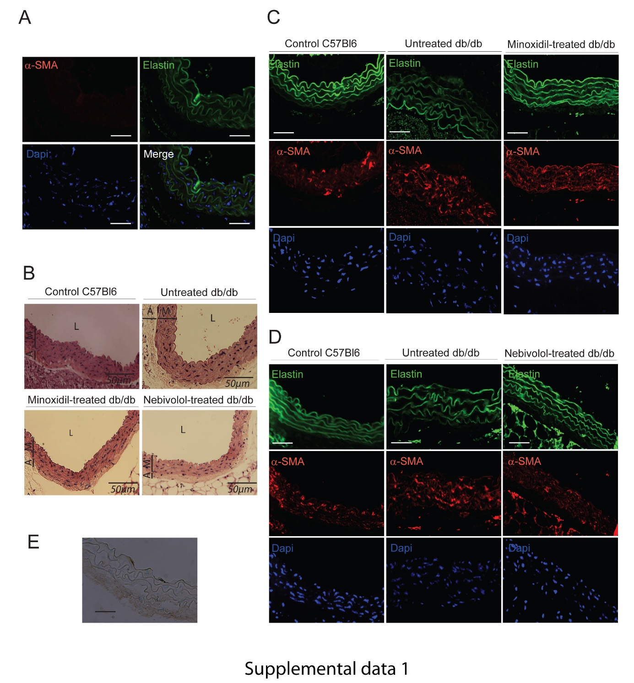
Supplemental figure 1: A- Negative control of immunostaining against alpha-Smooth Muscle Actin (a-SMA, red). Autofluorescence of elastin appears in green and DAPI staining in blue. B- Representative hematoxylin–eosin (H&E) staining. The scale bar represents 50 μm. Bars show the intima–media tunica thickness (M) and adventitia tunica thickness (A). C and D, Immunostaining against aSMA (red), elastin autofluorescence (green) and DAPI staining (Blue) in the media in the db/db mice untreated or treated with minoxidil (C) or Nebivolol (D). E, Negative control of Hart’s staining

.

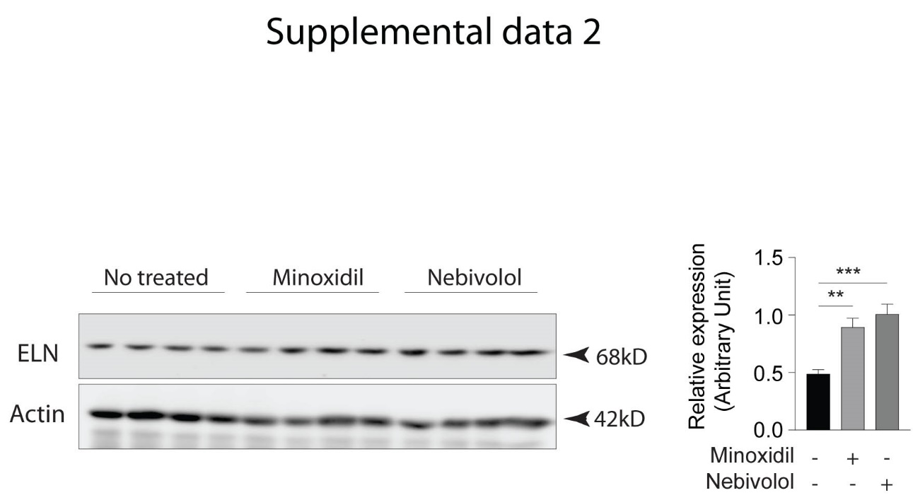
Supplemental figure 2: Impact of treatments with minoxidil and Nebivolol on elastin (ELN) and actin expressions (obtained by western blot) in vivo in treated or untreated db/db mice (n=4/group). The quantification of the expression of elastin is carried out from the level of gray detected by the Image J software. Results shown are the mean ± SEM. Statistically significant differences: Mann-Whitney test, *** p <0.0001, ** p < 0.001, * p < 0.05.

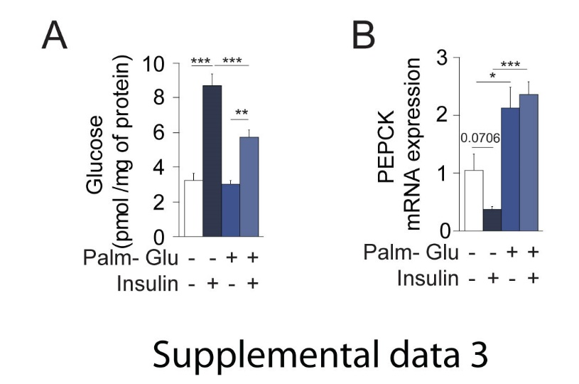
Supplemental figure 3: MOVAS cells incubated with palmitate-glucose develop an insulin-resistance associated to a decrease of glucose up-take (A) and an increase of phosphor-enolpyruvate kinase mRNA expression determined by qPCR (B).

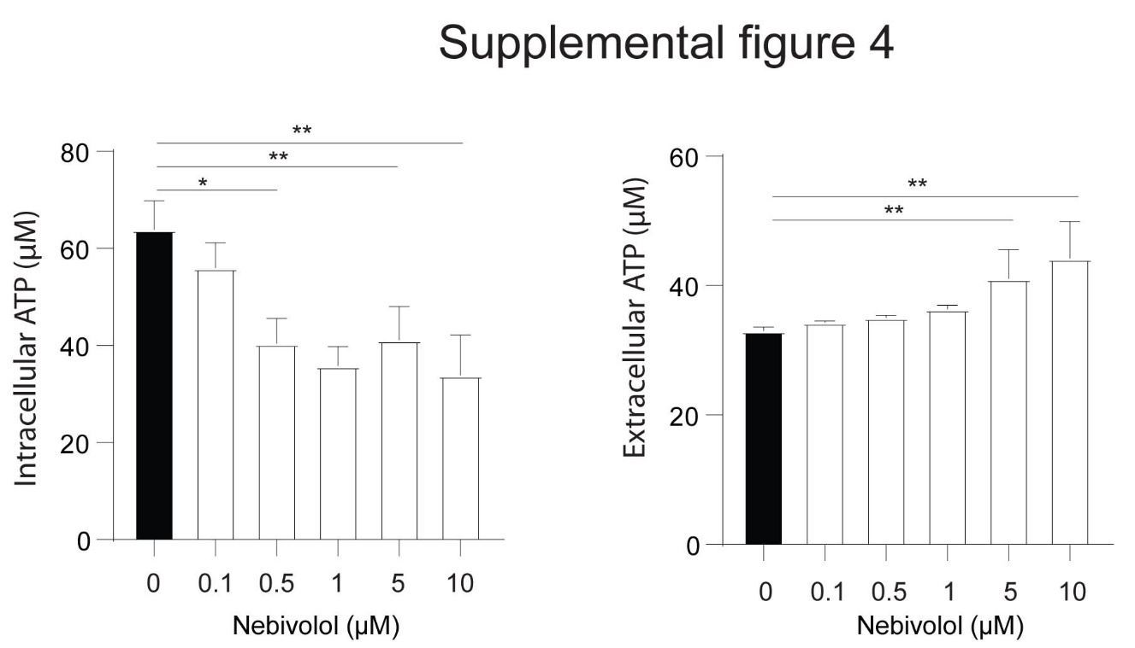
Supplemental Figure 4: Intracellular and extracellular evolutions of ATP concentration, in MOVAS cells stimulated with Nebivolol (n= 4). The results shown are the mean ± SEM. Statistically significant differences: Mann-Whitney test, ** p< 0.001, * p< 0.05.

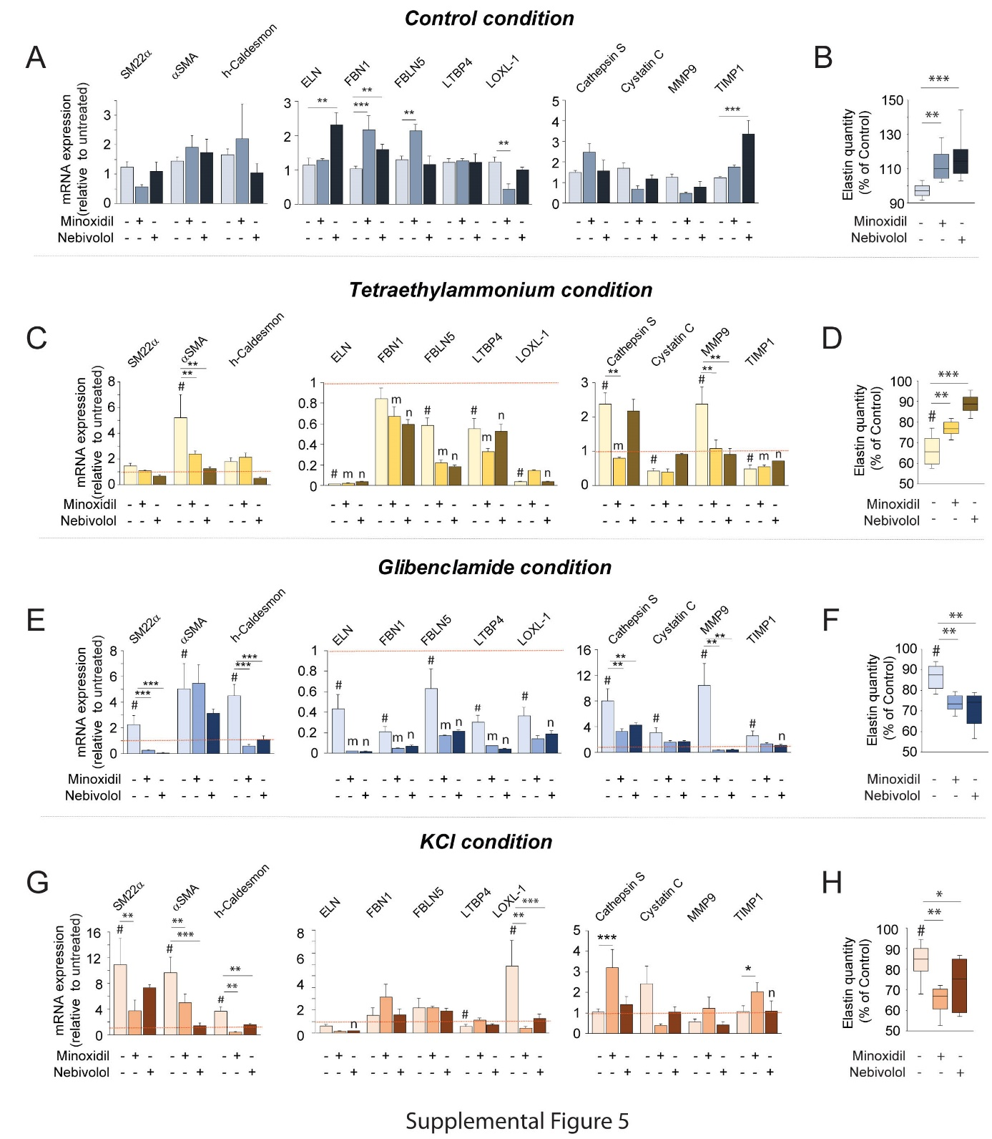
Supplemental Figure 5: Changes of extracellular K+ concentration and stimulation with K+ channel openers modulate the elastogenesis–elastolysis balance in cultured vascular SMCs (MOVAS cell). (A and B) Impact of minoxidil or nebivolol alone on the expression of mRNAs coding for the contractile markers (α-SMA, SM-22α, and h-caldesmon), the elastogenesis markers (elastin (ELN), fibrillin-1 (FBN1), fibulin-5 (FBLN5), latent transforming growth factor beta binding protein 4 (LTBP4), and lysyl oxidase like 1 (LOXL1)) and the elastolysis markers (MMP-9, cathepsin S, TIMP1, and cystatin C) (A) and on the extracellular protein expression of elastin performed by elastin ELISA (B). (C to F) Impact of inhibition of cell K⁺ channel by tetraethylammonium (C and D), a non-selective K⁺ channel blocker or glibenclamide (E and F), a K_{ATP} channel blocker, associated or not with minoxidil or nebivolol, on the expression of mRNAs coding for α-SMA, SM-22α, h-caldesmon, ELN, FBN1, FBLN5, LTBP4, LOXL1, MMP-9, cathepsin S, TIMP1, and cystatin C (C and E) and on the extracellular protein expression of elastin by elastin ELISA (D and F). (G and H) Impact of extracellular accumulation of potassium (addition of 50 mM KCl for 48 h), associated or not with minoxidil or nebivolol, on the expression of mRNAs coding for α-SMA, SM-22α, h-caldesmon, ELN, FBN1, FBLN5, LTBP4, LOXL1, MMP-9, cathepsin S, TIMP1, and cystatin C (G) and on the extracellular protein expression of elastin by elastin ELISA (H). n= 3 per group. The results shown are the mean ± SEM. Statistically significant differences: Mann-Whitney test, *** p<0.0001, ** p< 0.001, * p< 0.05. For panels C, E, G and H, the dotted line (red) represents the basal condition (ie DMEM alone without treatment). #, m and n represent the statistical significance (<0.05) between this basal condition (measured in panel A) and the condition studied. For panels B, D, F, H and J, # represents the statistical significance (<0.05) between this basal condition (ie 100%) and the condition studied.

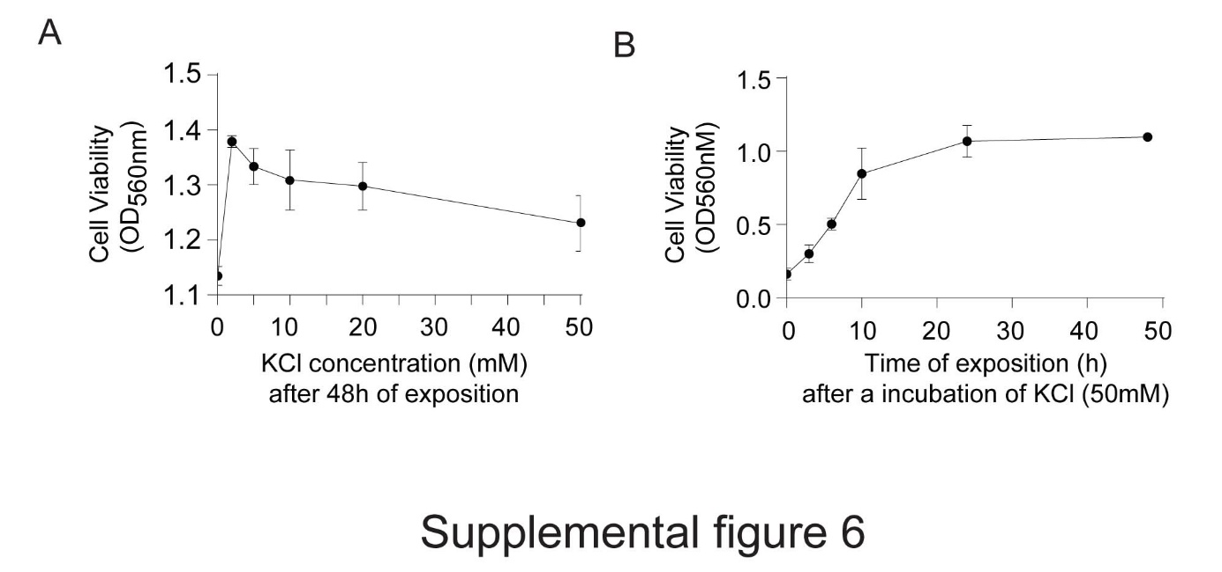
Supplemental Figure 6: In vitro evaluation of the effect of KCl on the cell viability of CMLs (Movas cells). A - Viability of CMLs after a 48-hour incubation with increasing concentrations of KCl (0-50mM). B - Viability of CMLs after an incubation for 2minutes to 48 hours with culture medium containing KCl (50mM).

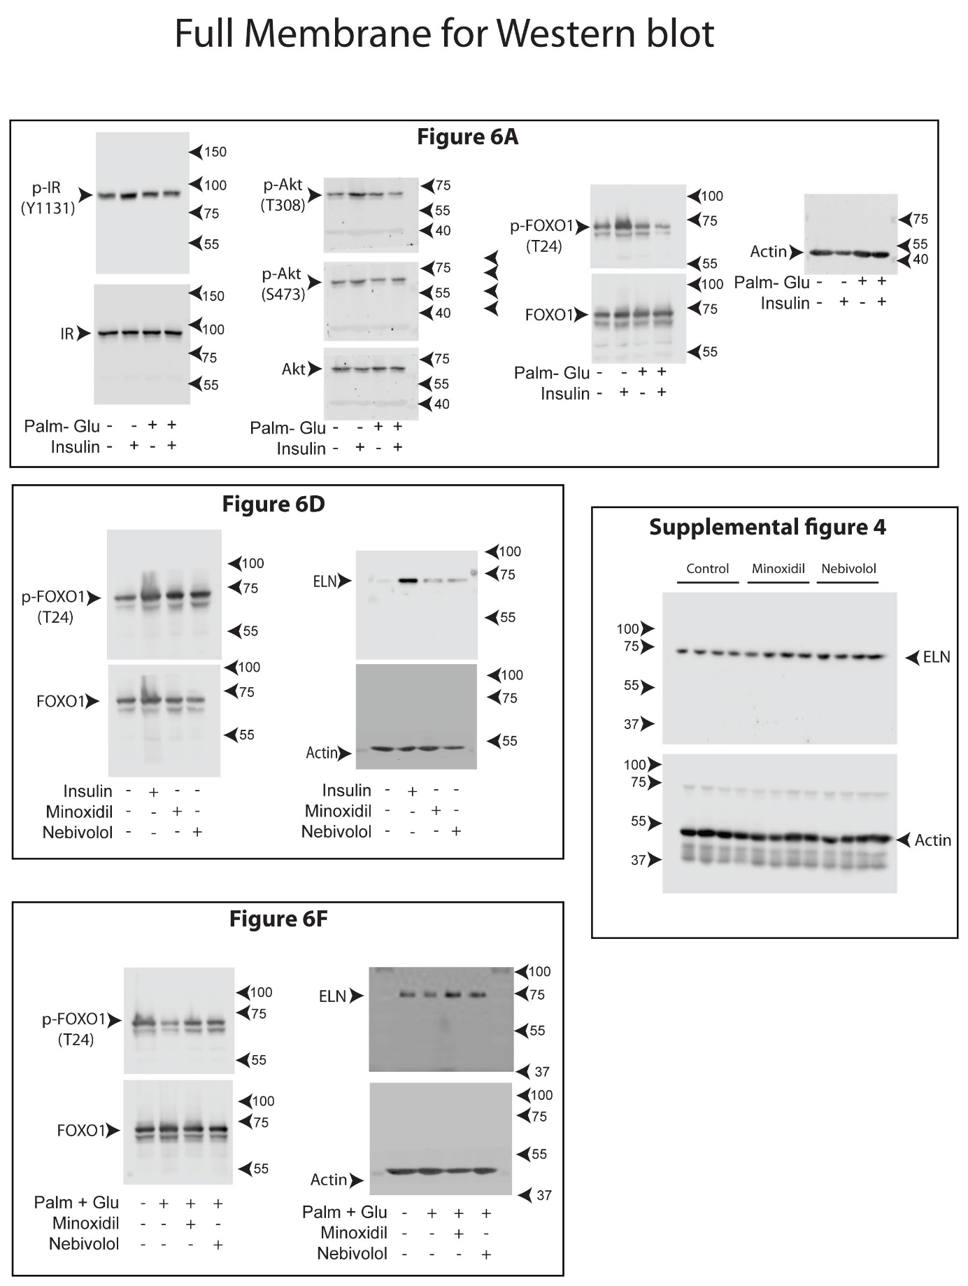
Supplemental Figure 10: Full membranes of western blot presented in figure 6 and in supplemental figure 4.

