Supplemental materials
Table S1 Primer sequences used for p1300-BjuLKP2-GFP, qRT-PCR and GUS staining
Primers names | Sequences | Primers names | Sequences
p1300-BjuLKP2-GFP | 5’-GAGAACACGGGGGACTCTAGA ATGGAGTGGGACAGCGATTCCG-’3 | qBjuCHLH | 5’-ATGGCTTCACTTATGTATTC-’3
p1300-BjuLKP2-GFP | 5’-GCCCTTGCTCACCATTCTAGA  CTAGAAGACCCTCTTCTCTTC-’3 | qBjuCHLH | 5’-CGGTGGGGACGTTGTCTCTC-’3
qBjuLKP2 | 5’-ATGGAGTGGGACAGCGATTC-’3 | qBjuCHLI1 | 5’-ATGGCGTCTCTTCTGGGAAC-’3
qBjuLKP2 | 5’-GGAATCTACTGAGGGATGTC-’3 | qBjuCHLI1 | 5’-CCCTACTTGTTCAGTGGAG-’3
qBjuHEMA1 | 5’-ATGGCTGTCTCGAGTGCC-’3 | qBjuCHLI2 | 5’-ATGGTCTCTCTTCTCGGAAC-’3
qBjuHEMA1 | 5’-GTCAGCTGCAGAGTTCTTG-’3 | qBjuCHLI2 | 5’-CACTGGCCTTGCACTTTCC-’3
qBjuHEMA3 | 5’-GCTATGGCGGTTGCTAGTGC-’3 | qBjuCHLD | 5’-ATGGCGATGACCCCTGTCAC-’3
qBjuHEMA3 | 5’-GCTGCTTCTCTCCTTTGTG-’3 | qBjuCHLD | 5’-GAACTTTCTGCCGTATTCGG-’3
qBjuHEML2 | 5’-ATGTCGGCGACGCTAACGGG-’3 | qBjuCHLM | 5’-ATGCCGATGTCTCCTTCCTTG-’3
qBjuHEML2 | 5’-CGGATTTGAAGGCTCGAAC-’3 | qBjuCHLM | 5’-CCGCCTCCTCTCCGGATCCG-’3
qBjuHEMB1 | 5’-ATGTACTCGCAGACAAAGCG-’3 | qBjuCRD1 | 5’-ATGGCTGCTGAAATGGCG-’3
qBjuHEMB1 | 5’-CGATTACTTTGATCGATGG-’3 | qBjuCRD1 | 5’-CTCCTCGAAGTCCGTCGTG-’3
qBjuHEMB2 | 5’-ATGAAAGGGTTTGAACAGAAG-’3 | qBjuDVR | 5’-ATGTCACTTTCTTCTTCTCC-’3
qBjuHEMB2 | 5’-GCGGTTACGACGTGCGCGTC-’3 | qBjuDVR | 5’-GCTGGGGGTTTTGTTCCTGA-’3
qBjuHEMC | 5’-ATGGAGTTCGCTTCTTCCTC-’3 | qBjuPORA | 5’-ATGGCCCTTCAAGCTTCTTC-’3
qBjuHEMC | 5’-GATGATAGCAGTTCGTGTC-’3 | qBjuPORA | 5’-GACGGATGGGGTTGAAG-’3
qBjuHEMD | 5’-ATGGCGTCGTTTCTGTCTCC-’3 | qBjuPORB | 5’-ATGGCCCTTCAAGCTGCTTC-’3
qBjuHEMD | 5’-GAGCTCTAAAGATGAAATCC-’3 | qBjuPORB | 5’-CCTCAGCGTTTTCTTGCCG-’3
qBjuHEME1 | 5’-ATGGCGAAGAGGATACACC-’3 | qBjuPORC | 5’-CTTCAGGCTGCATATTCTC-’3
qBjuHEME1 | 5’-CCGCCTCGATGGGAGACAG-’3 | qBjuPORC | 5’-CGCCCGAGGAGTTGCAACTG-’3
qBjuHEME2 | 5’-ATGGCAGAGGAGGAGCATC-’3 | qBjuCHLG | 5’-ATGACTTCAATTCTCAAC-’3
qBjuHEME2 | 5’-CTCTAGCTCAGCTGCATGC-’3 | qBjuCHLG | 5’-CCGGCTGCTGGTGCCTTGTC-’3
qBjuHEMF1 | 5’-ATGGCTTCTCTCGTCTCTTC-’3 | qBjuCAO | 5’-ATGAACGCCGCCGTGTTTAC-’3
qBjuHEMF1 | 5’-GAAGAGTGAGTGGAATCATC-’3 | qBjuCAO | 5’-ATGAACTTGCCTTTATAAG-’3
qBjuHEMF2 | 5’-ATGGCTTCTCACTCTTTGAC-’3 | qjuBjuActin2 | 5’-CTGTTCTCTCCTTGTACGCCAG-’3
qBjuHEMF2 | 5’-GAGTGAGTGGAATCGTCGTC-’3 | qjuBjuActin2 | 5’-TAATCAGTAAGGTCACGTCCAGC-’3
qBjuHEMG1 | 5’-ATGGATCTCTCACTTCTCCG-’3 | 1300-GFP | 5’-GAATTCGCATGCCTGCAGGTC-’3
qBjuHEMG1 | 5’-GCAGAGACCGCTGATTCC-’3 | 1300-GFP | 5’-GTGACAGATAGCTGGGCAATG-’3
qBjuHEMG2 | 5’-GAAACGGCACCCTTTGTTGTCG-’3 | p1391-BjuSPL10c | 5’-CAAGCTTGGCTGCAGGTCGACAGT  TGACCTCCACCAACTC-3’
qBjuHEMG2 | 5’-CCCAAATCAAGCCATCATGC-’3 | p1391-BjuSPL10c | 5’-GGTGGACTCCTCTTAGAATTCATAG  ATGAGCAAGTAGTGTG-3’

Table S2. Effects of different 6-BA and NAA combinations on “yonganxiaoye” cotyledon callus induction in B. juncea
6-BA (mg/L) | NAA (mg/L) | Callus color and texture | Callus induction ratio /%
1.0 | 0.05 | Milk white, loose texture | 79%
1.0 | 0.1 | Milk white, loose texture | 76%
1.0 | 0.15 | Milk white, loose texture | 57%
2.0 | 0.05 | Soft green, compact texture | 56%
2.0 | 0.1 | Soft green, compact texture | 83%
2.0 | 0.15 | Soft green, compact texture | 65%
3.0 | 0.05 | Milk white, loose texture | 18%
3.0 | 0.1 | Milk white, loose texture | 6%
3.0 | 0.15 | Milk white, loose texture | 11%

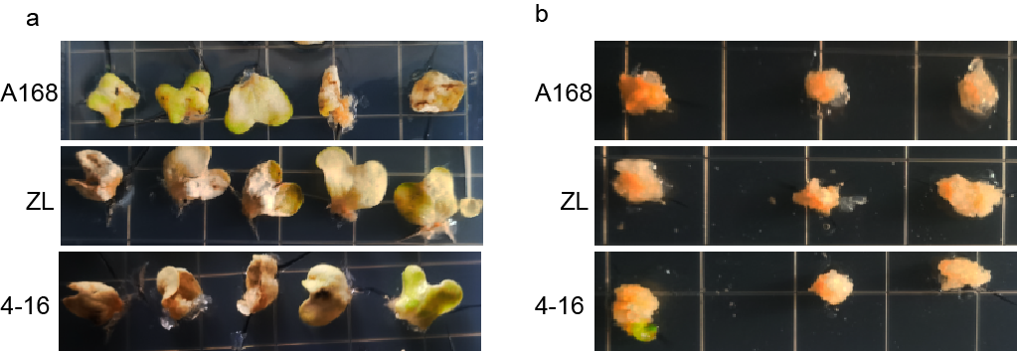

Fig. S1 Regeneration of cotyledons of B. juncea “A168”, “ZL” and “4-16”. a: B. juncea “A168”, “ZL” and “4-16” cotyledon growth in MS medium. b: cotyledon callus growth in MS medium.

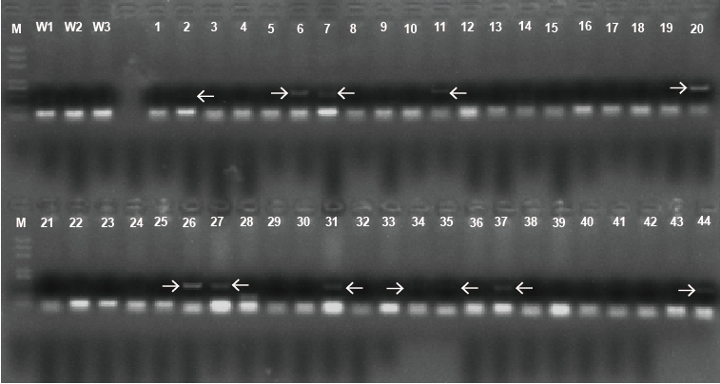

Fig. S2 BjuLKP2 OE lines screening. M: Marker, W1: wild type 1, W2: wild type 2, W3: wild type 3, 1-44: 1-44 BjuLKP2 OE lines.

