Supplementary Information

The RNAi enhancer enoxacin inhibits the growth and migration of esophageal squamous cell carcinoma cells

Parisa Torabi^{1,2#}, Hanieh Torkian^{1,2#}, Seyed Rohullah Miri³, Sharif Moradi^{1*}

1. Department of Stem Cells and Developmental Biology, Cell Science Research Center, Royan Institute for Stem Cell Biology and Technology, ACECR, Tehran, Iran
2. Department of Developmental Biology, University of Science and Culture, ACECR, Tehran, Iran
3. Cancer Research Center, Cancer Institute of Iran, Tehran University of Medical Sciences, Tehran, Iran

*Author for correspondence:
Sharif Moradi, Ph.D.
Royan Institute, Banihashem Sq., Banihashem St., Solaymani Highway, Tehran, Iran
Postal Code: 1665659911, P.O. Box: 16635-148, Tel: +98 21 22306485, Fax: +98 21 23562507
Email: sh.moradi@royan-rc.ac.ir; sharif.moradi@gmail.com

# These authors contributed equally to this work.

Supplementary Figures
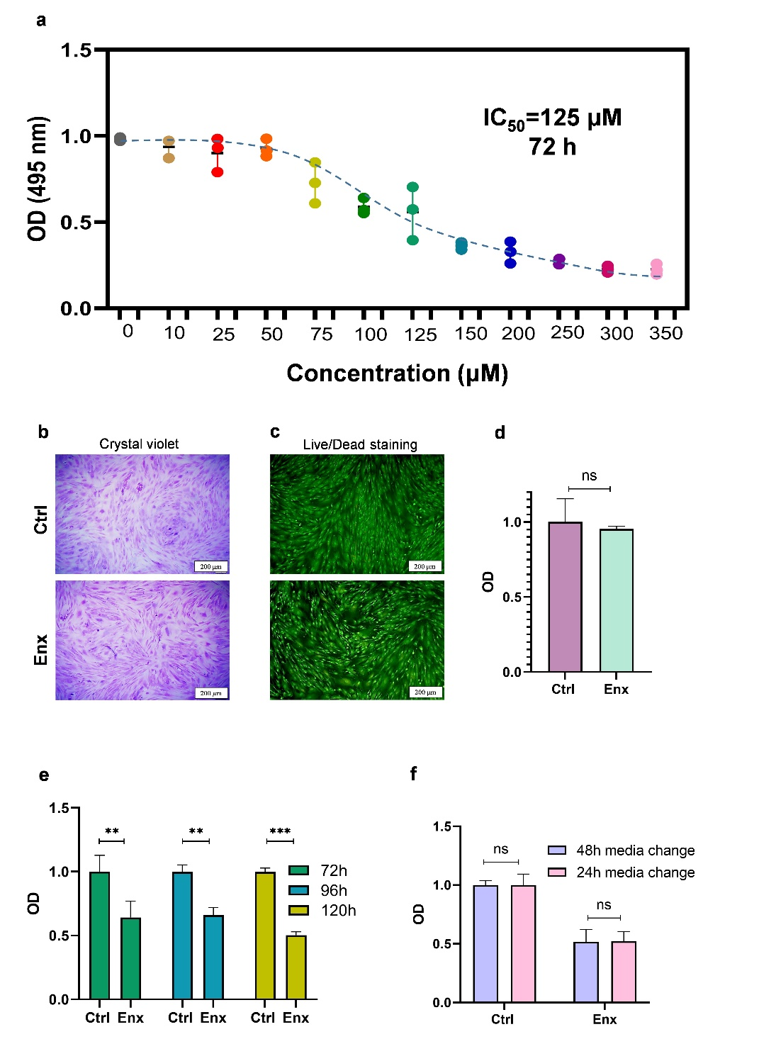
Supplementary Fig. 1) Enoxacin has a dose-dependent, cancer-specific growth inhibitory effect. (a) Half-maximal inhibitory concentration (IC₅₀) of enoxacin in KYSE-30 ESCC cell line. The cells were treated with enoxacin for three days and the experiment was done for each concentration in triplicates. (b) Crystal violet- and (c) live-dead stained human dermal fibroblasts (HDFs) following enoxacin treatment for three days. (d) MTS viability assay of HDFs. (e) MTS assays of ESCC cells for 72, 96, and 120 h treatment durations with enoxacin. (f) MTS assays of ESCC cells with media refreshment every 24 or 48 h. Data are represented as mean ± SD for four replicates. *p value <0.05, **p value <0.01, ***p value <0.001.

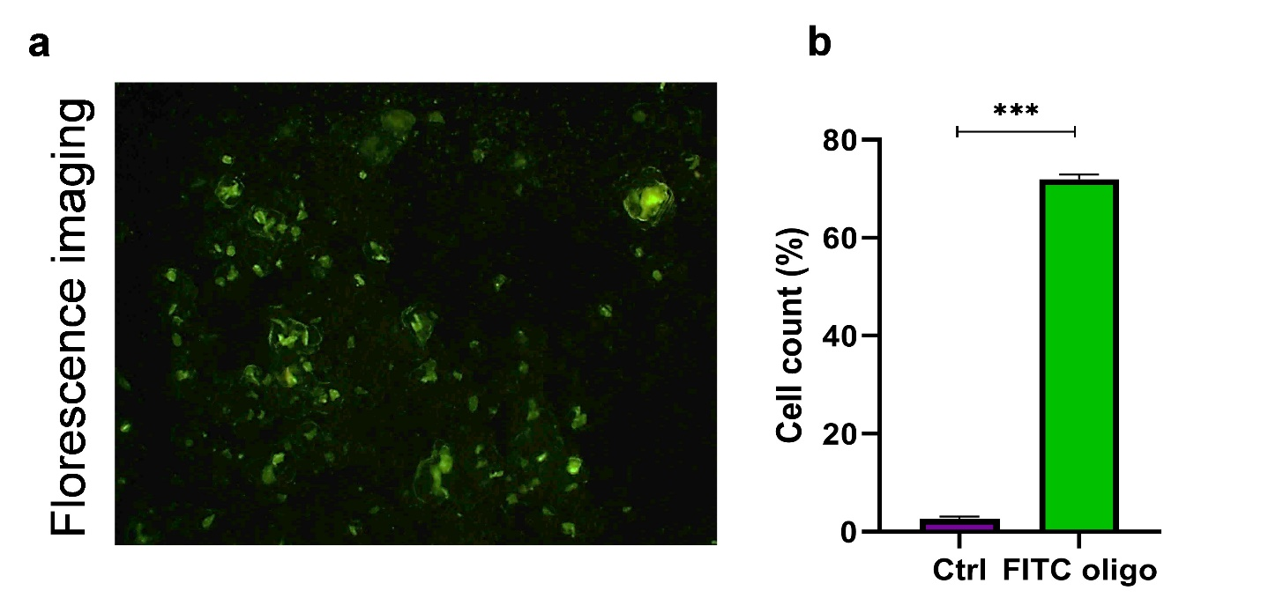
Supplementary Fig. 2) Determining the transfection efficiency of the oligonucleotides. (a) Fluorescent microscopy of ESCC cells transfected with a FITC-conjugated oligonucleotide (FITC oligo) for analyzing the efficiency of oligonucleotide delivery into the cancer cells. (b) Quantification of the results shown in a using flow cytometry.

