Supplemental Figures
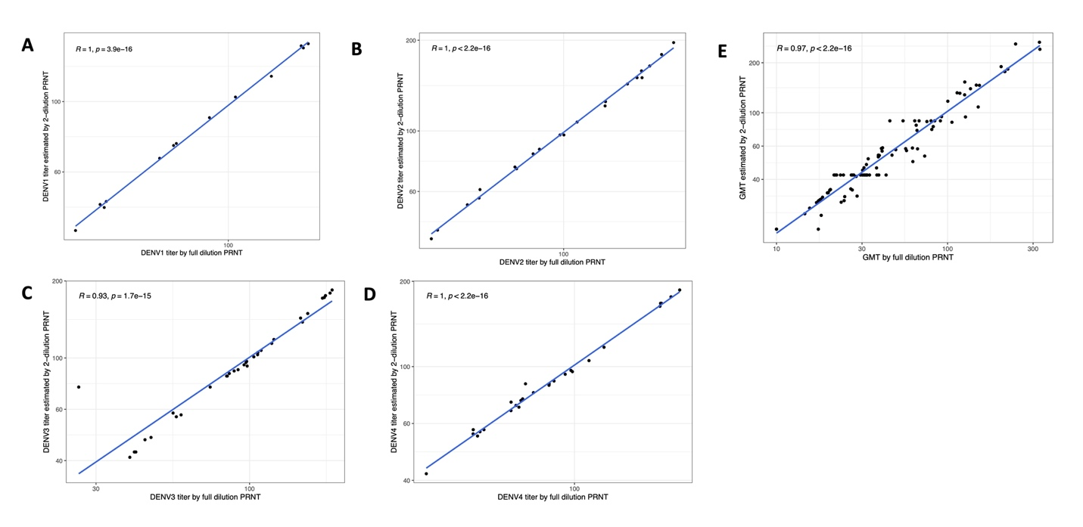
Supplemental Figure 1. Correlations between nAbs against DENV1-4 (A-D) and GMT (E) as measured by full dilution vs. estimated two-dilution PRNT with mature strains in multitypic individuals (n = 30). Titers are log₁₀ values plotted on a linear scale. The correlation coefficients (R) were calculated using Pearson’s test.
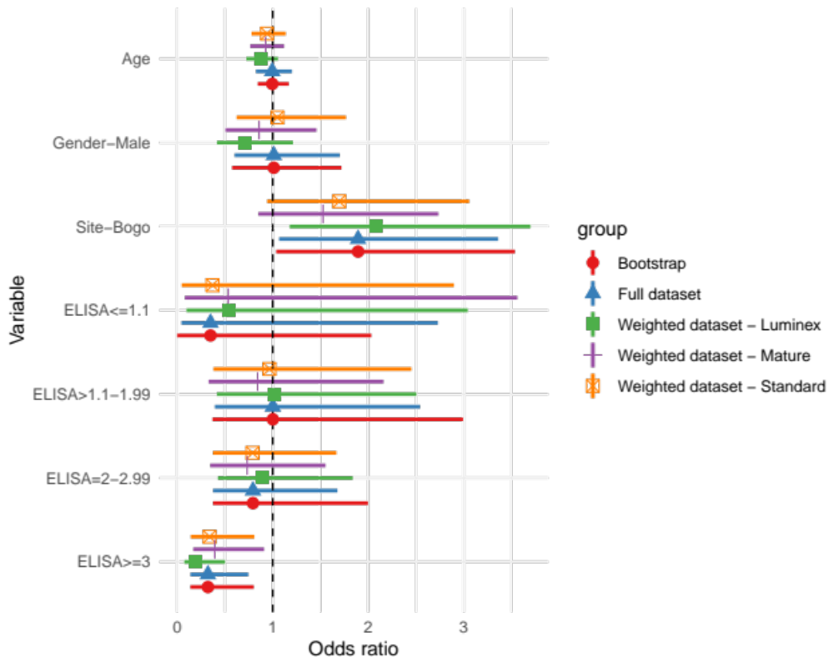
Supplemental Figure 2. Odds ratios and 95% CI from models run with the full ELISA dataset (triangles) compared to those generated by bootstrapping (circles, 2,000 resamples with bias-corrected and accelerated confidence intervals) and by weighted models with data from individuals with EDIII and NS1 binding antibodies measured by luminex (closed squares, n=295) and nAb titers measured with standard reference (open squares, n = 823) or mature clinical strains (crosses, n=293).

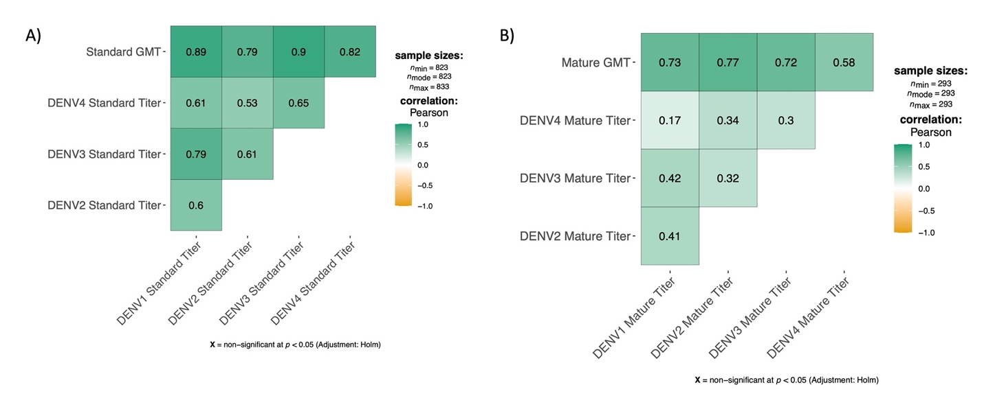
Supplemental Figure 3. Pearson correlations among GMT and nAb titers measured using standard reference (A) or mature clinical (B) strains.
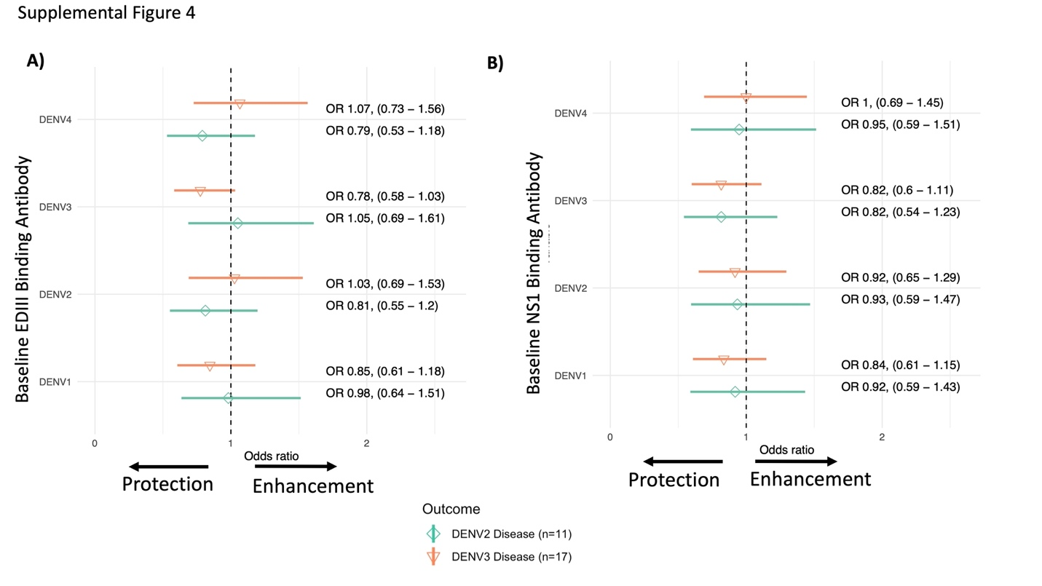
Supplemental Figure 4. The odd ratios and 95% confidence intervals of dengue caused by DENV2 (diamond) and DENV3 (inverted triangle) by baseline binding antibodies against EDIII (A) and NS1 (B) for each dengue type. All models were adjusted for age, sex, and enrollment site, and inverse probability weighting was used to adjust for subset sizes.

Supplemental Tables
Supplemental Table 1. Total number of individuals with or without symptomatic dengue cases by ELISA group and selected for measurement of nAb titers using standard reference viruses.
 | ELISA IgG | Titers by standard virus
Total number of samples assessed | 1,206 | 823
Subset/Total (weight*)
<0.2 no symptomatic dengue | 91/91 (1) | 91/91 (1)
<0.2 symptomatic dengue | 8/8 (1) | 8/8 (1)
0.2-3 no symptomatic dengue | 599/599 (1) | 577/599 (1.04)
0.2-3 symptomatic dengue | 35/35 (1) | 35/35 (1)
>3 no symptomatic dengue | 459/459 (1) | 99/459 (4.64)
>3 symptomatic dengue | 14/14 (1) | 13/14 (1.08)
*Weight was calculated by 1/(subset/total) and applied to each model

Supplemental Table 2. Number of individuals with or without symptomatic dengue selected to assess nAb titers using mature viruses, binding antibodies, and for inapparent infections by standard titer groups (naïve, monotypic, multitypic).
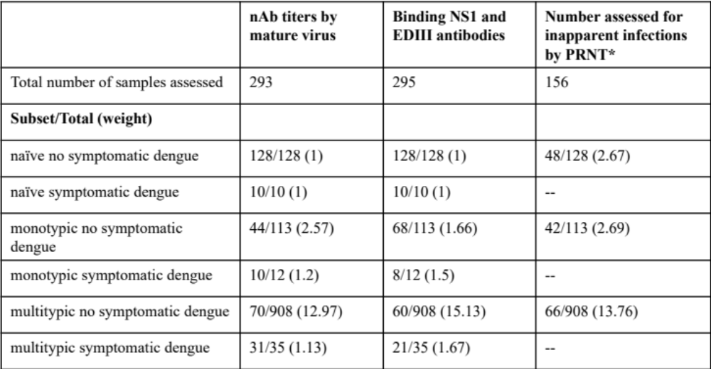
*Only individuals with no symptomatic dengue were assessed for inapparent DENV infection

Supplemental Table 3: Sample sizes and raw case numbers by antibody bins from selected models.
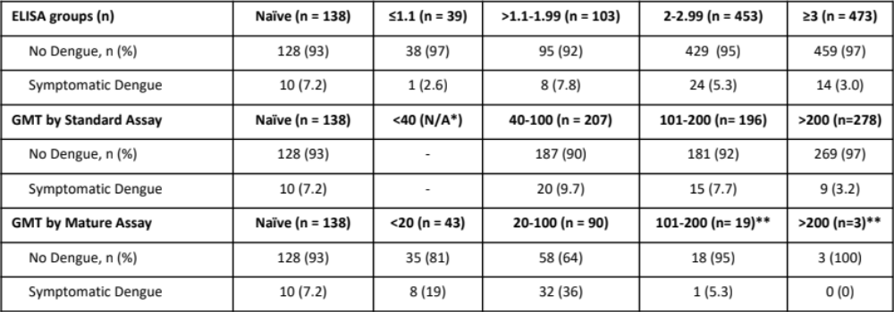
*All individuals with GMT <40 by standard assay were considered naïve
**Due to low sample size in those with mature GMT>200, this group was combined with mature GMT 101-200 in models

Supplemental Table 4: Demographics and Baseline Immune Status in those with Dengue without Warning Signs vs. Dengue with Warning Signs (DWWS)
