Tables
Table 1: Cohort demographics and immune status
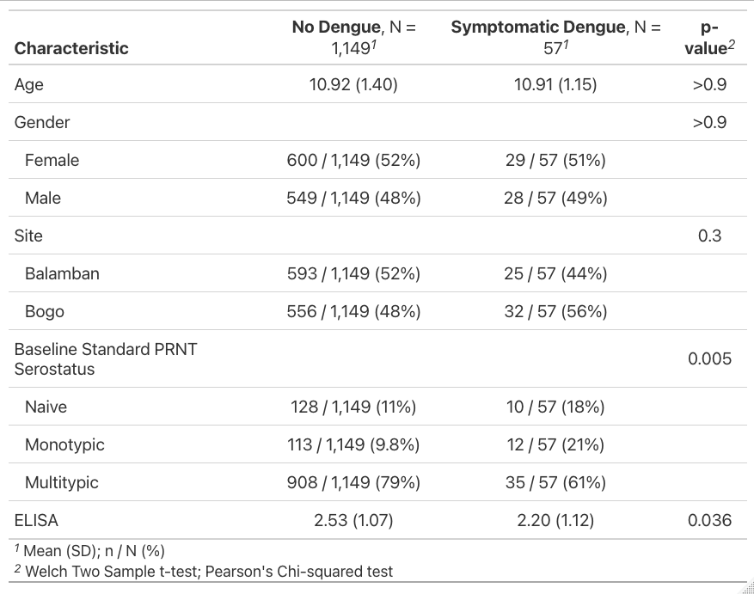

Table 2. Antibody measure associated with disease reduction as predicted by logistic regression adjusted for age, sex, and enrollment site.
