Supplementary material
In this appendix we provide an in-depth description of the model equations and our simulations. In particular, we explain how we use a number of assumptions on the parameters to simplify the computation of the model equilibrium.
The general model equations for an arbitrary number of trematode species are rather complex. This can be seen by counting the number of dynamical variables. For the model with one trematode species, there are 4 variables (M, S, I, C). In the case of two trematode species, there are 8 variables (2*M, 1*S, 3*I, 2*C). In the general case of n trematode species, there are 2^{n} +2n variables (n*M, 1*S, (2^{n}-1)*I, n*C). For example, for n = 10 there are 1044 variables, and hence we would have to solve a system of 1044 equations to find the equilibrium densities.
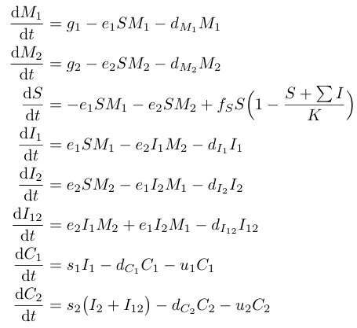
The model complexity, and the computation of the equilibrium, can be drastically reduced by assuming that different trematode species share many trait values. We illustrate this approach for the case of two trematode species. As explained in the main text, we model the Schistosoma species (the first species) to be an inferior competitor. To do so, we assume that snails that are infected by both trematode species only shed cercariae of the second species, with the same rate s₂ as for snails that are only infected by the second species. This gives the following model equations :
(1)

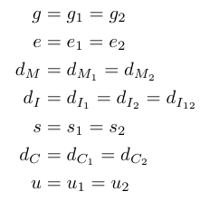
At this point we introduce the assumption that different trematode species have the same value for most model parameters. Concretely, we define common parameters :
(2)

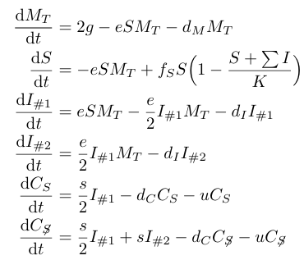
Introducing these assumptions into the equations, we see that variables M₁ and M₂ and also variables I₁ and I₂ have exactly the same dynamics. This implies that at equilibrium (when the initial condition no longer have any effect) we have M₁ = M₂ and I₁ = I₂. We can then simplify the model by introducing the total miracidia density M_{T} = M₁ +M₂, the density of snails infected by one trematode species I_{#1} = I₁+I₂ and the density of snails infected by two trematode species I_{#2} = I₁₂. We also make explicit in our notation that the first trematode species is the Schistosoma species and that the other species is not by writing C_{S} = C₁ and C_{S} = C₂. The dynamical equation become :
(3)

Note that in this way we have reduced the number of equations from 8 to 6.

A very similar approach can be applied to the general model of n trematode species. The trick is again to work with the total miracidia density M_{T} and with the densities of snails infected by one, two, three, ... tremadote species I_{#1}, I_{#2}, I_{#3}, ... The reduced dynamics are :

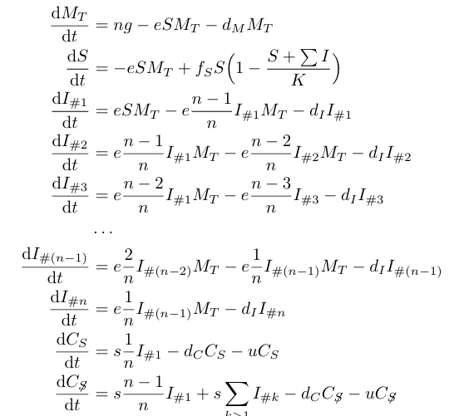
(4)

The prefactors of the terms in these equations are easy to understand. For example, the term $e\frac{n-2}{n} I_{\#2}M_{T}$ appearing in the equations for $\frac{{dI}_{\#2}}{d_{t}}$ (with a minus sign) and for $\frac{{dI}_{\#3}}{d_{t}}$ (with a plus sign) corresponds to an infection by a third trematode species. The prefactor $\frac{n-2}{n}$ excludes infections by one of the two trematode species by which the snail is already infected. As another example, the term $s\frac{1}{n} I_{\#1}$ in the equation for $\frac{{dC}_{s}}{d_{t}}$ corresponds to the shedding of Schistosoma cercariae. This can only originate from snails that are infected by a single trematode species, hence the factor I_{#1} , and the infected trematode should belong to the Schistosoma species, hence the factor $\frac{1}{n}$ .
After the reduction there are n+4 dynamical variables. This is a drastic simplification compared to the number of variables before reduction. For example, for n=10 trematode species, there are only 14 equations in the reduced system, instead of the 1044 equations in the original system.
To generate Fig.2 of the main text, we simulate the model equations until reaching equilibrium. We used the following parameter values:
n | number of trematode species | 1 to 6 | /
g | input rate of miracidia per trematode species | 0.2 | d_{U}/t_{U}
e | infestation rate of snails by miracidia | 0.01 | 1 / (d_{U} t_{U})
f_{S} | fitness of non-infected snails | 3.0 | 1 / t_{U}
K | carrying capacity of snail population | 1, 10, 100 | d_{U}
s | shedding rate by infected snails | 2.0 | 1 / t_{U}
u | uptake rate of cercariae by mammals | 1.0 | 1 / t_{U}
d_{M} | loss rate of miracidia | 0.01 | 1 / t_{U}
d_{I} | loss rate of infected snails | 0.1 | 1 / t_{U}
d_{C} | loss rate of cercariae | 0.1 | 1 / t_{U}

The last column gives the units in which the parameters are expressed. For example, the time unit d_{t} could be month, and the density unit d_{u} could be number of individuals per square meter. Note that the model results do not depend on the choice of these units.
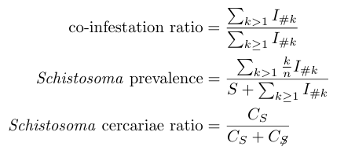
Finally, the plotted variables are computed as follows:
We provide Matlab code to perform the different computations. In particular, running the script divpara_main.m generates Fig. 2 of the main text. This script calls the function divpara_rhs.m to evaluate the right-hand side of the model equations, i.e., the function implements eqs. (4).

